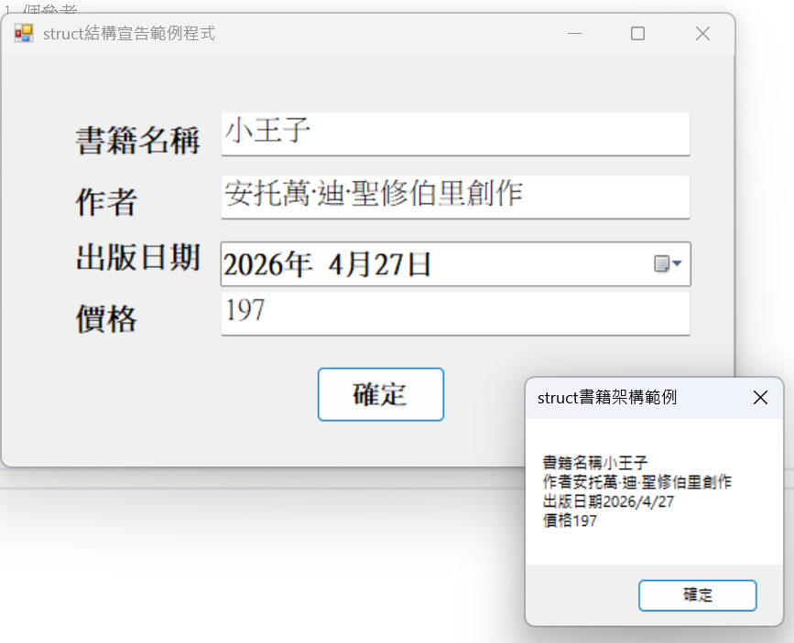
using System;
using System.Collections.Generic;
using System.ComponentModel;
using System.Data;
using System.Drawing;
using System.Linq;
using System.Text;
using System.Threading.Tasks;
using System.Windows.Forms;

namespace WindowsFormsApp1
{
public partial class Form1 : Form
{
public Form1()
{
InitializeComponent();
}
public struct Book
{
public string BookName;
public string Author;
public DateTime PublishDate;
public int Cost;
}

private void btnAdd_Click(object sender, EventArgs e)
{
Book book;
book.BookName = txtBookName.Text;
book.Author = txtAuthor.Text;
book.PublishDate = DTPPublishDate.Value;
book.Cost = int.Parse(txtCost.Text);

string msg = "";
msg = msg + "書籍名稱" + book.BookName + "\n";
msg = msg + "作者" + book.Author + "\n";
msg = msg + "出版日期" + book.PublishDate.ToShortDateString() + "\n";
msg = msg + "價格" + book.Cost;

MessageBox.Show(msg, "struct書籍架構範例");

}
}
}

