**Capstone Project - BookMyConsultation**

Author: Anubhav Apurva  
Email ID: anubhavh3@gmail.com  
Batch: SD C25 Dec'20

**Table of content**

**1.** **Environment Setup** 2

1.1. VPC Setup 2

1.2. EC2 Setup 2

1.3. RDS Setup 3

**2.** **Doctor-Onboarding Service** 5

2.1. Endpoint-1: Collect doctor information 5

2.2. Endpoint-2: Upload doctor documents 7

2.3. Endpoint-3: Approve doctor registration 8

2.4. Endpoint-4: Reject doctor registration 9

2.5. Endpoint-5: Return list of doctors 10

2.5.1. Scenario-1: The status is pending 10

2.5.2. Scenario-2: The status is Active 10

2.5.3 Scenario-2: Based on speciality 11

2.6. Endpoint-6: Return doctors based on doctor-ID 11

# **Environment Setup**

## VPC Setup

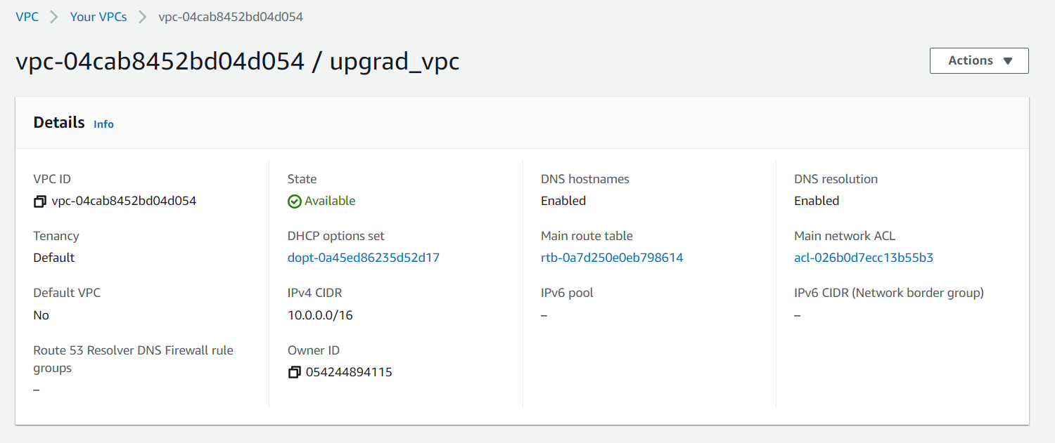

## EC2 Setup

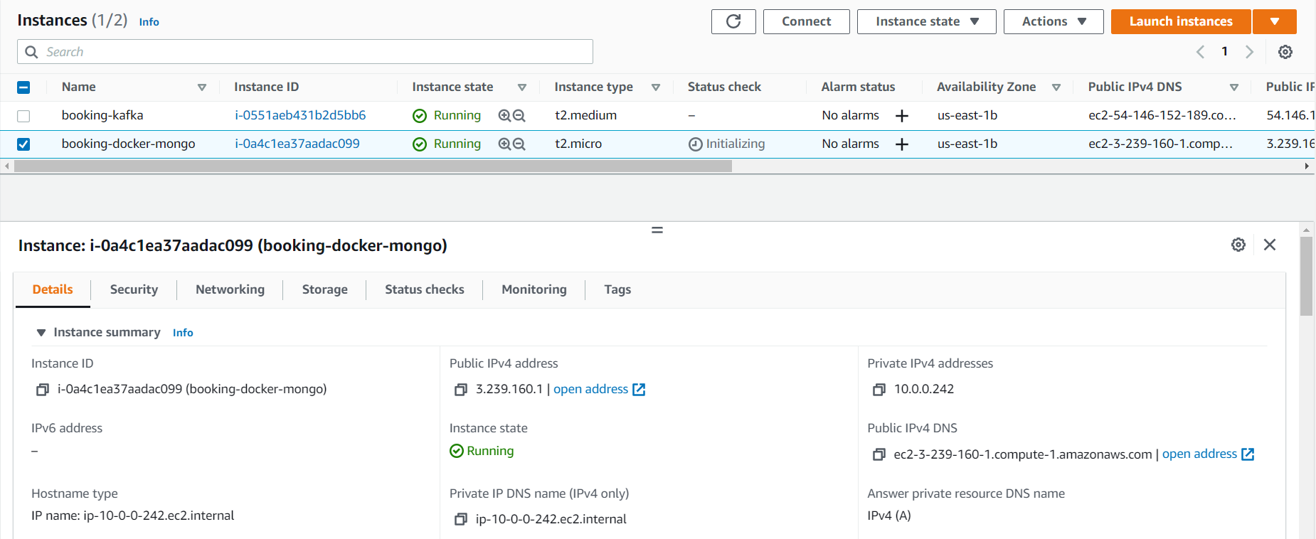

EC2 Security Group Inbound Rules -

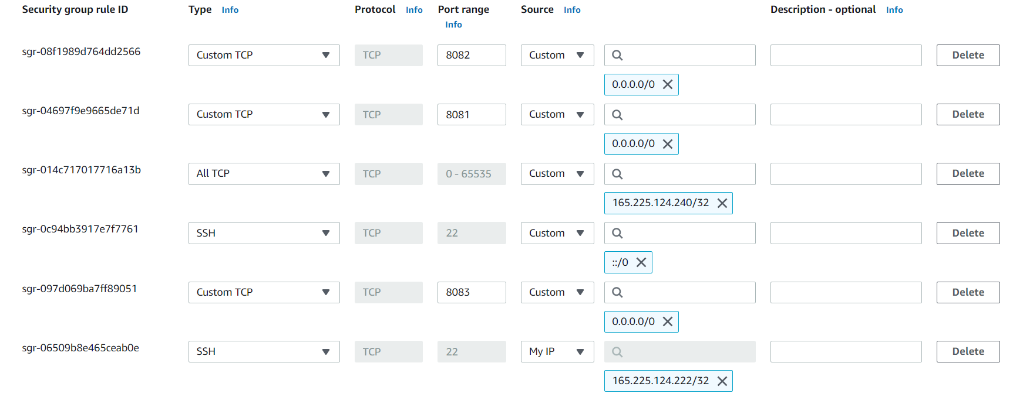

## RDS Setup

## 

RDS Security Group Inbound Rules –

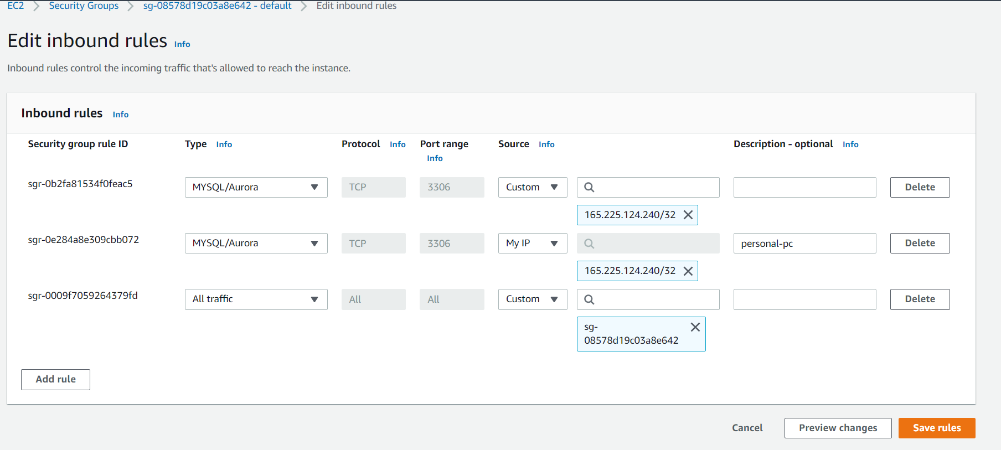

# **Doctor-Onboarding Service**

## Endpoint-1: Collect doctor information

**POST** localhost:8081/doctors

Content-Type application/json

Request Body Ex –

|  |
| --- |
| {      "firstName":"Mishra",      "lastName":"Sanjay",      "dob":"1986-01-14",      "emailId":"drmishra.sanjay@gmail.com",      "mobile":"1234554321",      "pan":"XDALF4215P"  } |

Response Body Ex –

|  |
| --- |
| {      "id": "ca6ad87b-f501-41ba-9a71-dc3d143e8ebd",      "firstName": "Mishra",      "lastName": "Sanjay",      "mobile": "1234554321",      "dob": "1986-01-14",      "emailId": "drmishra.sanjay@gmail.com",      "pan": "XDALF4215P",      "specialization": "GENERAL_PHYSICIAN",      "status": "Pending",      "registrationDate": "21-02-2022"  } |

Calling the endpoint from POSTMAN -

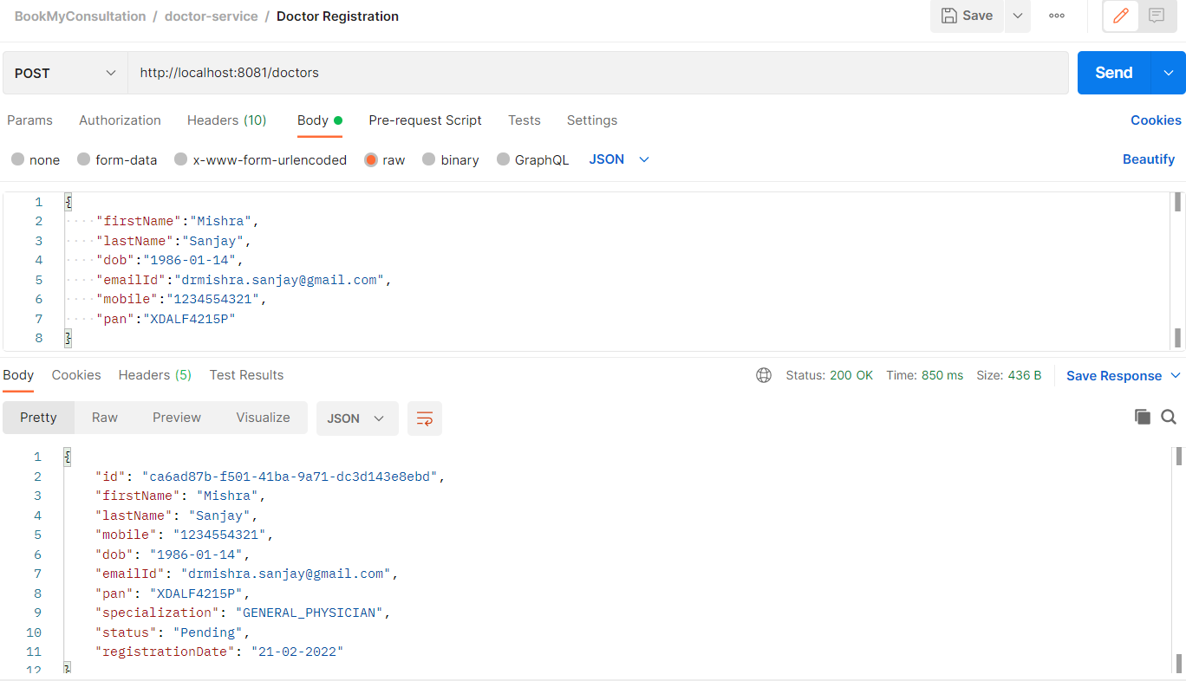

Mongo Collection 'Doctor' -

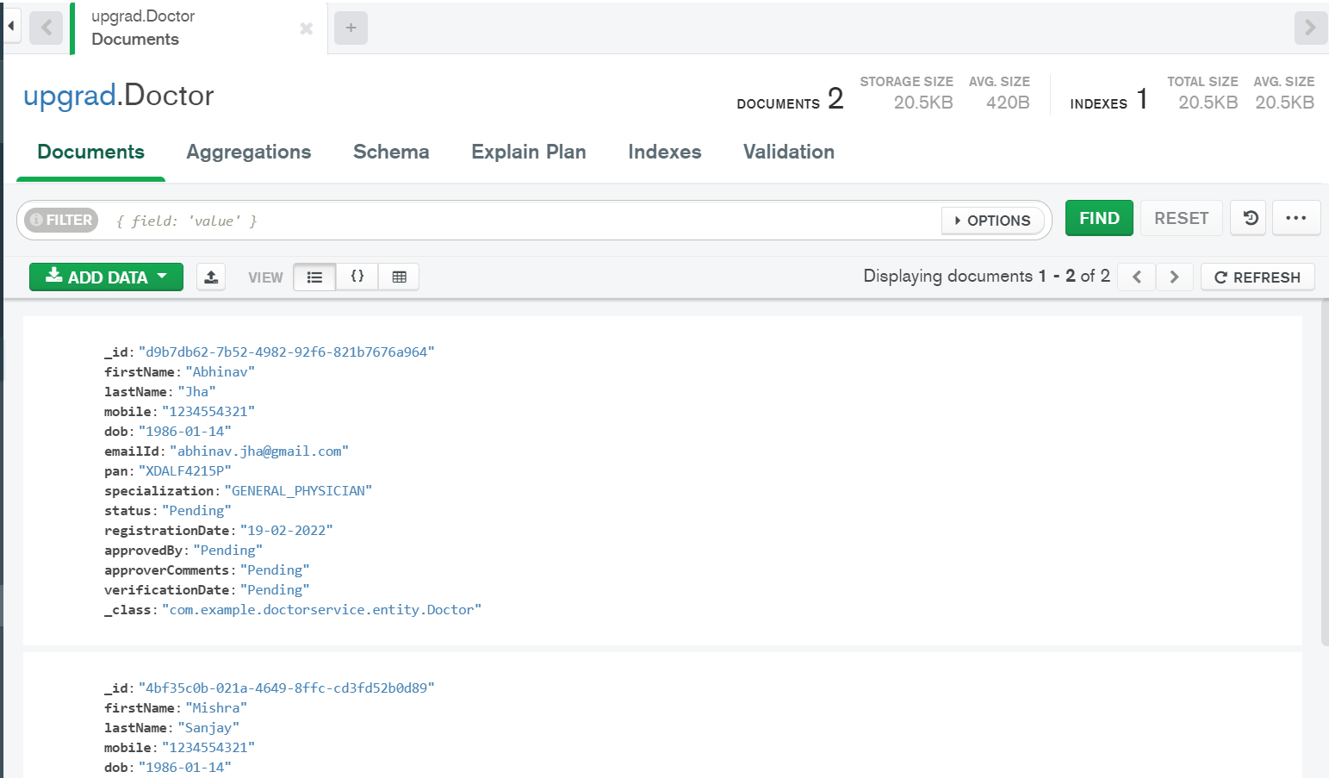

## Endpoint-2: Upload doctor documents

**POST** localhost:8081/doctors/{doctorId}/document

Request Body Ex –

|  |
| --- |
|  |

Response Body Ex –

|  |
| --- |
| File(s) uploaded Successfully. |

Calling the endpoint from POSTMAN -

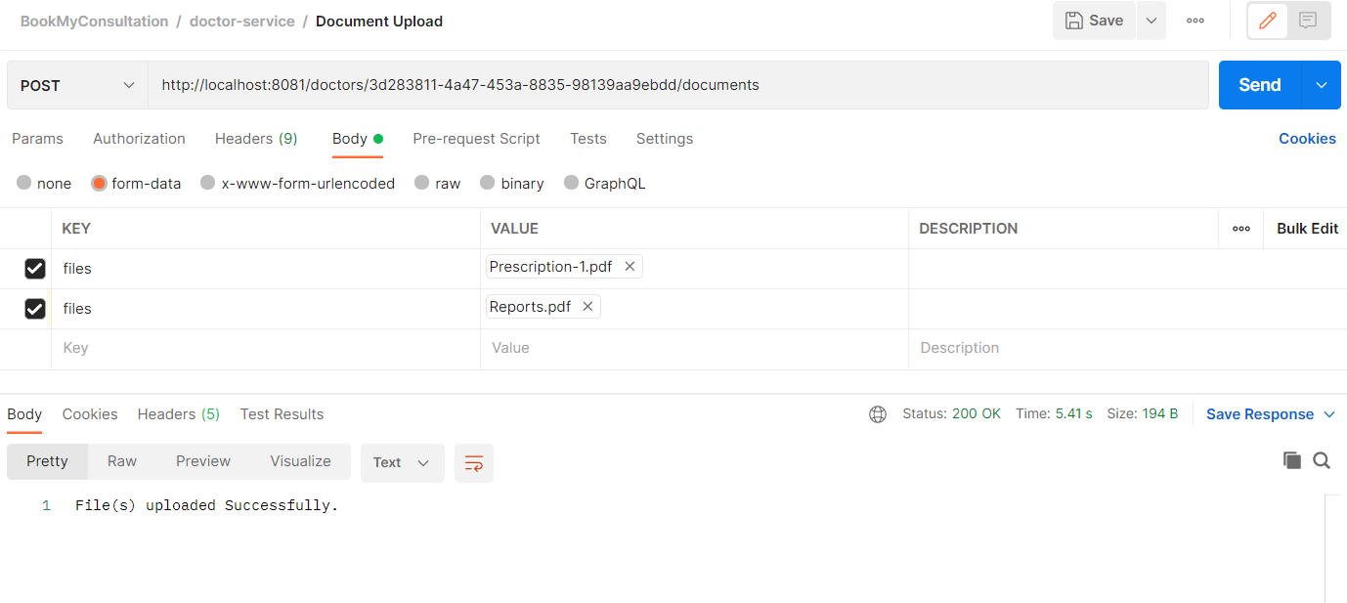

S3 bucket updated with the uploaded documents -

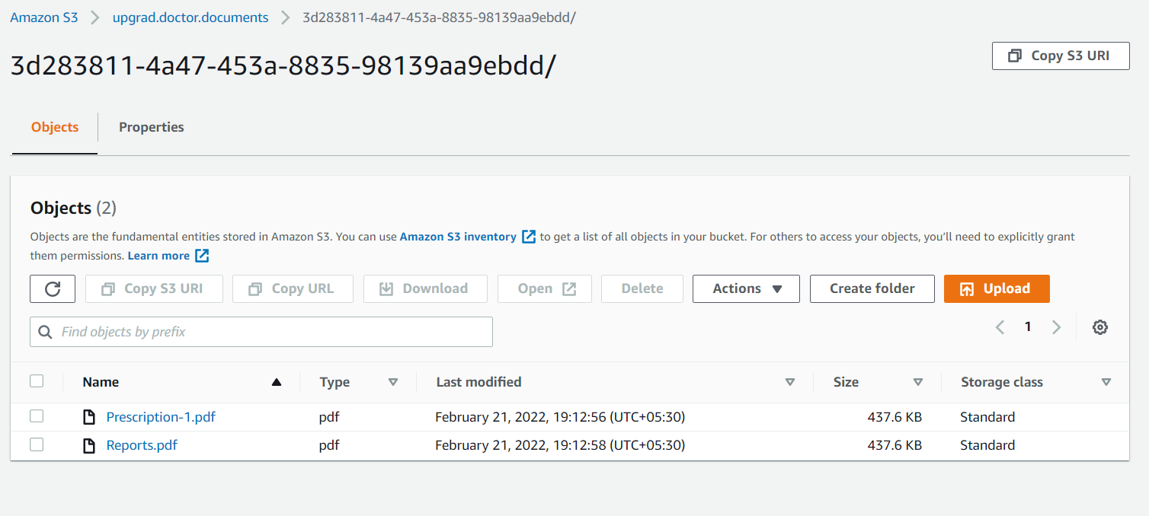

## Endpoint-3: Approve doctor registration

**PUT** localhost:8081/doctors/{doctorId}/approve

Request Body Ex –

|  |
| --- |
| {      "approvedBy":"Ayush",      "approverComments":"Documents Verified"  } |

Response Body Ex –

|  |
| --- |
| {      "id": "ca6ad87b-f501-41ba-9a71-dc3d143e8ebd",      "firstName": "Mishra",      "lastName": "Sanjay",      "mobile": "1234554321",      "dob": "1986-01-14",      "emailId": "drmishra.sanjay@gmail.com",      "pan": "XDALF4215P",      "specialization": "GENERAL_PHYSICIAN",      "status": "Active",      "registrationDate": "21-02-2022",      "approvedBy": "Ayush",      "approverComments": "Documents Verified",      "verificationDate": "21-02-2022"  } |

Calling the endpoint from POSTMAN –

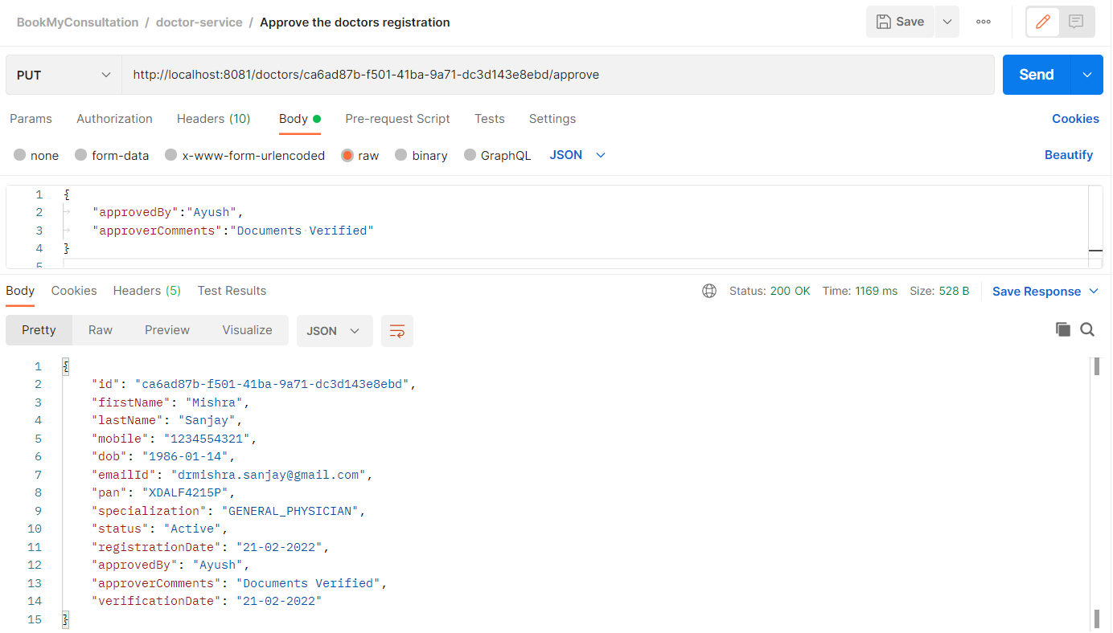

## Endpoint-4: Reject doctor registration

**PUT** localhost:8081/doctors/{doctorId}/reject

Request Body Ex –

|  |
| --- |
| {      "approvedBy":"Abhinav",      "approverComments":"Invalid documents"  } |

Response Body Ex –

|  |
| --- |
| {      "id": "d9b7db62-7b52-4982-92f6-821b7676a964",      "firstName": "Abhinav",      "lastName": "Jha",      "mobile": "1234554321",      "dob": "1986-01-14",      "emailId": "abhinav.jha@gmail.com",      "pan": "XDALF4215P",      "specialization": "GENERAL_PHYSICIAN",      "status": "Rejected",      "registrationDate": "19-02-2022",      "approvedBy": "Abhinav",      "approverComments": "Invalid documents",      "verificationDate": "21-02-2022"  } |

Calling the endpoint from POSTMAN –

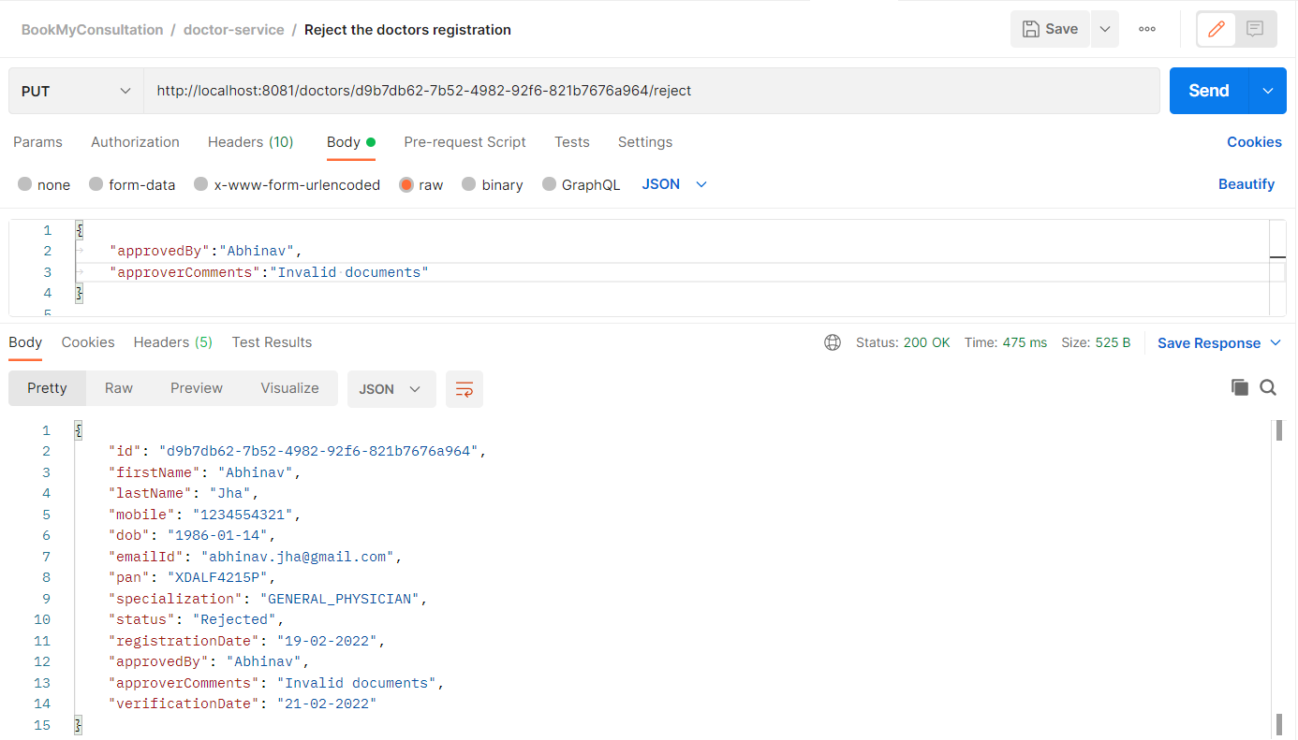

## Endpoint-5: Return list of doctors

## Scenario-1: The status is pending

**GET** localhost:8081/doctors?status=Pending

Calling the endpoint from POSTMAN –

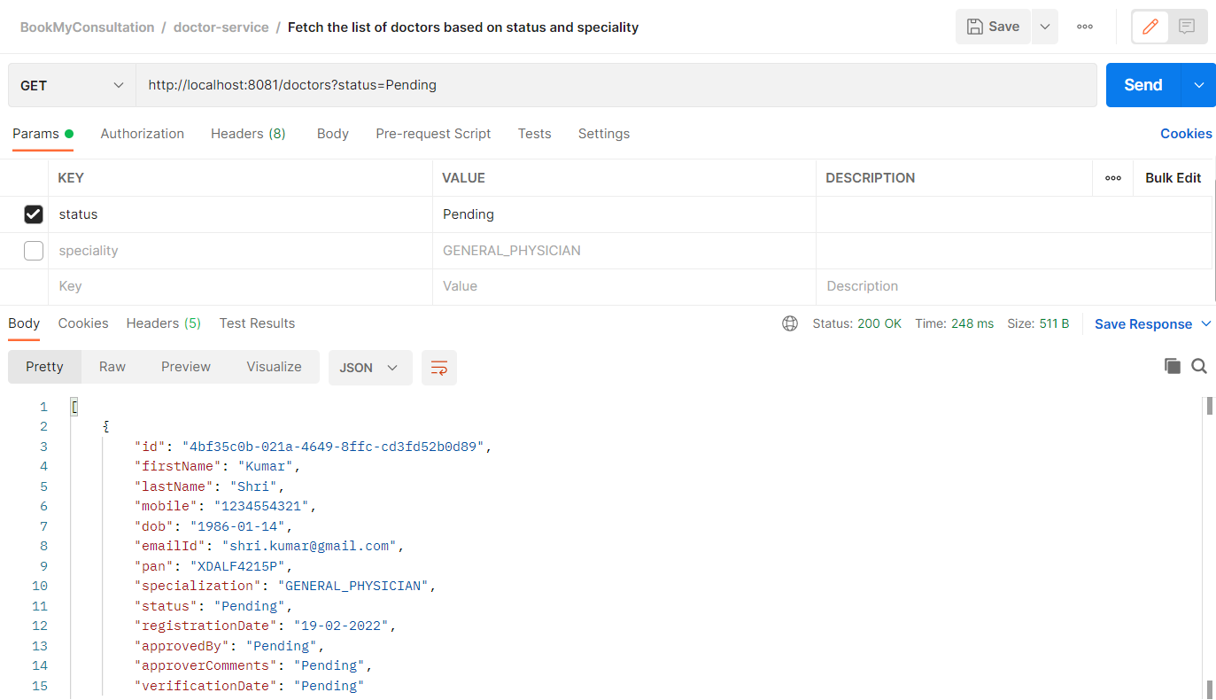

## Scenario-2: The status is Active

**GET** localhost:8081/doctors?status=Active

Calling the endpoint from POSTMAN –

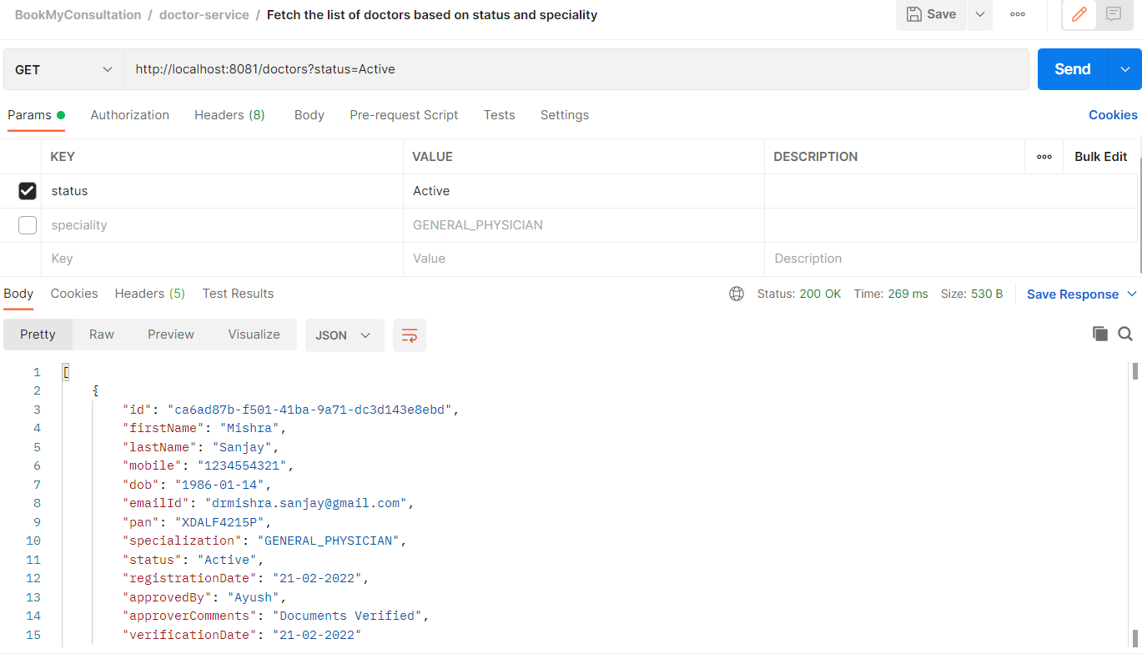

## Scenario-2: Based on speciality

**GET** localhost:8081/status=Active&speciality=GENERAL_PHYSICIAN

Calling the endpoint from POSTMAN –

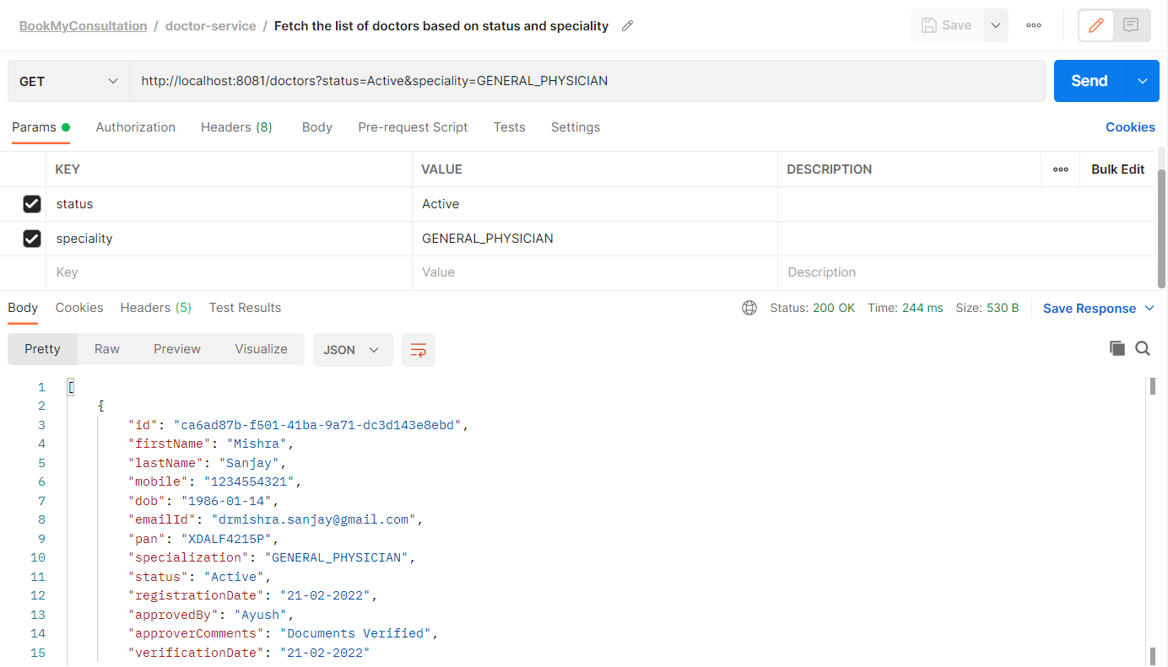

## Endpoint-6: Return doctors based on doctor-ID

**GET** localhost:8081/ /doctors/{doctorId}

Calling the endpoint from POSTMAN –

