1.install:

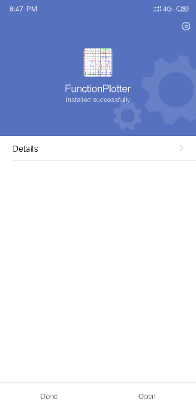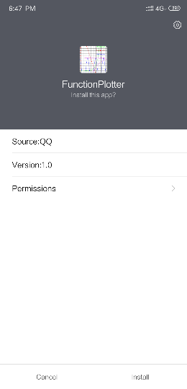**Open FunctionPlotter.apk in your android phone and install it.** 

2. configure:

This app doesn’t need any special configuration.

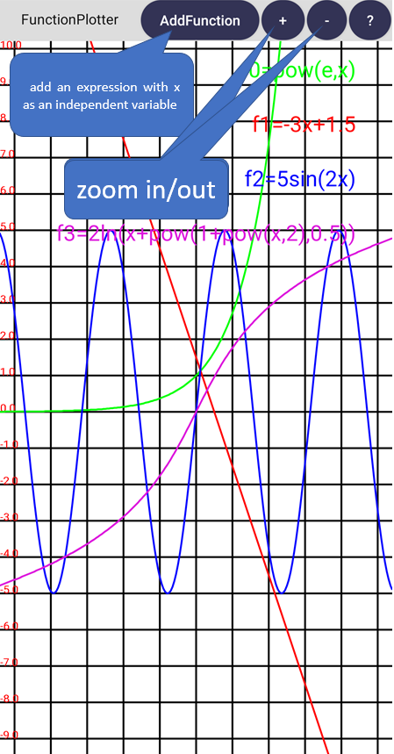3.help:

AddFunction: press this button to add a new function expression with independent variable x, for example, 2cos(3x), then press “finish”.

Then you can see the corresponding curve. For clarity, you can add 7 function expressions at most.

(note: The form of a^b is pow(a,b).)

+: press this button to zoom in.

-:press this button to zoom out.

?:press this button to view help.

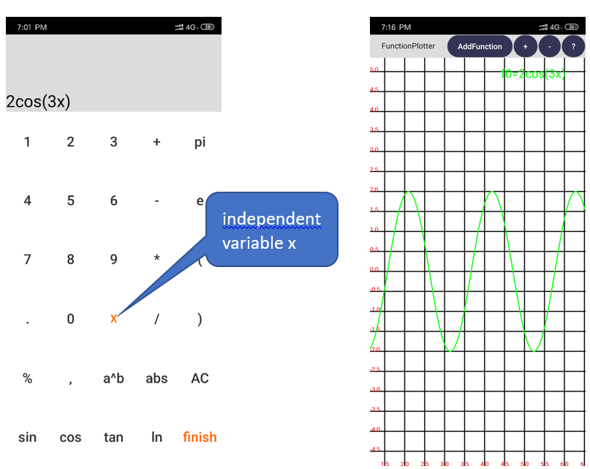Slide the screen to change the center of coordinate system.