# Fundamentals of CI/CD:

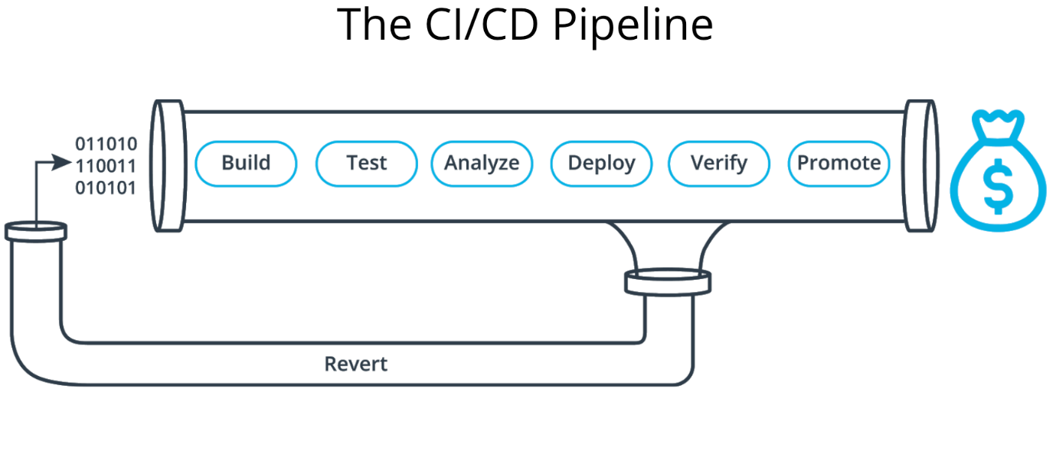

1. **Continuous Integration**

Is merging all developers' working copies to a shared mainline several times a day.

* Compile
* Unit Test
* Static Analysis
* Dependency vulnerability testing
* Store artifact

1. **Continuous Deployment**

A software engineering approach in which the value is delivered frequently through automated deployments.

* Creating infrastructure
* Provisioning servers
* Copying files
* Promoting to production
* Smoke Testing (aka Verify)
* Rollbacks

# Benefits of CI/CD

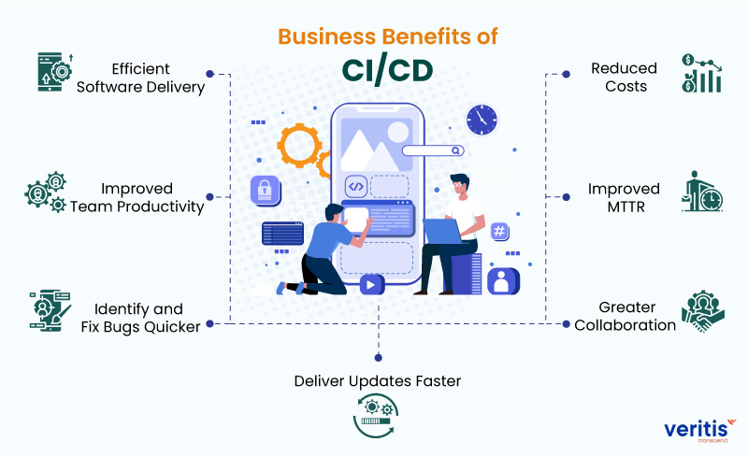

* Less developer time on issues from new developer code
* Reduced downtime from a deploy-related crash or major bug
* Quick undo to return production to working state
* Prevent embarrassing or costly security holes
* Less infrastructure costs from unused resources
* Less human error, Faster deployments
* Less time to market
* Less bugs in production and less time in testing
* We will have Faster time to market, Better code quality, Faster bug fixes, Reduce costs And increase revenue for businesses