* rpm –ivh perl-DBI-1.609…… perl-DBD-MySQL…. //安装
* rpm –Uvh openssl….. mysql-libs- //升级
* rpm –ivh mysql-5.1……. mysql-server-5.1 //安装
* service mysqld start //启动
* /usr/bin/mysqladmin –u root password ‘root’ //设置密码
* mysql –u root –p //进入
* use mysql;
* select host,user,password from user;
* delete from user where password=’’;
* mysql –u root –h [ip] –p //远程连接数据库
* update user set host=’[ip]’; //即可在windows下远程连接
* flush privileges;
* update user set host=’%’; //只要用户名密码正确 任何ip都可以连了
* flush privileges;

# yum命令安装mysql：

* cd
* yum –y install mysql -server

# 搭建主从复制：

* yum –y install mysql-server
* vim /etc/my.cnf

2)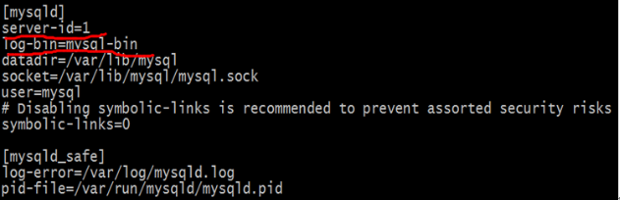

指定当前服务器的id：1

和log日志文件

* service mysqld restart //重启
* 进入数据库🡪 show variables like ‘server_id’; //查看mysql所有属性（like server_id）

开始主从配置：

133:主服务器 mysql>

show master status; //显示其log_file的状态

去从服务器：mysql>

change master to

master_host=’192.168.206.133’,

master_user=’root’,

master_password=’root’,

master_log_file=’mysql-bin.000001’,

master_log_pos=106;

start slave;

show slave status/G; //格式化显示

看：

Slave_IO_Running:Yes //能否与主服务器连接

Slave_SQL_Running:Yes //testSQL

测试：去主服务器mysql>

Create database test_db;

Use test_db;

Create table test_db(id int(4) not null primary key, name char(20));

Insert into test_db values(1, ‘test_1’);

测试从服务器：

mysql> show tables;

mysql>select * from test_db;

mysql>insert into test_db values(2,’test_2’);

双主结构：

在从服务器134上

Mysql> show master status;

去主库中运行

change master to

master_host=’192.168.206.133’,

master_user=’root’,

master_password=’root’,

master_log_file=’mysql-bin.000001’,

master_log_pos=217;

在主库中 show slave

Show slave status\G;

看：

Slave_IO_Running:Yes

Slave_SQL_Running:Yes