CPathoGen: A Framework for Controllable Histopathology Generation for Probing Pathology Foundation Models
Abstract: We introduce CPathoGen, a controllable generative model for histopathology that synthesizes 512×512 dimension Hematoxylin and Eosin (H&E) stained tiles conditioned on cell type and spatial organization derived from weak cell annotations produced using pretrained cell segmentation and classification models from TCGA-BRCA (N = 1.038 Million Tiles). CPathoGen builds on a latent diffusion model (LDM) backbone and adds ControlNet to enforce spatial cell-type layout and FiLM to inject compact, tile-level tumor morphology statistics. In preliminary experiments, the model generates visually plausible H&E tiles and responds to conditioning by placing cell-type patterns in the intended regions, with emerging sensitivity to tumor morphology controls. Using a fixed evaluation protocol with 2,000 real tiles in our preliminary results, we observe FID ≈ 62 on LDM only training and FID ≈ 102 at 15k steps on conditioning (early training; results subject to further stabilization). Our motivation is to use CPathoGen as a tool to probe black-box pathology foundation models by producing counterfactual, human-specified edits to spatial context and tumor morphology, enabling controlled stress tests of model sensitivity and potential failure modes.

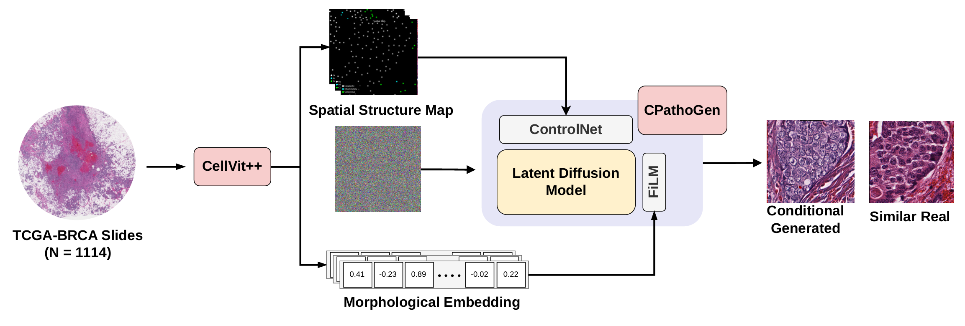
Figure 1 CPathoGen overview. Whole-slide H&E images from TCGA-BRCA (N = 1114) are tiled and processed with CellViT++ to obtain weak cell-type and spatial annotations, which are converted into a spatial structure maps and a compact morphological embedding. A latent diffusion generator is conditioned on the spatial map via ControlNet and modulated by the morphology vector via FiLM to synthesize 512×512 H&E tiles that match the specified cellular organization, alongside visually similar real tiles for qualitative comparison.

