|  |
| --- |
| SOUTHERN CROSS UNIVERSITY |

**ASSIGNMENT COVER SHEET**

For use with online submission of assignments

Please complete all of the following details and then make this sheet the **first page of each file of your assignment – do not send it as a separate document.**

Your assignments must be submitted as either **Word documents, text documents with .rtf extension or as .pdf documents**. If you wish tosubmit in any other file format please discuss this with your lecturer well before theassignment submission date.

|  |  |
| --- | --- |
| Student Name: | **Yangbin Lin** |
| Student ID No.: | **23811502** |
| Unit Name: | **Programming 2** |
| Unit Code: | **PROG2007** |
| Tutor’s name: |  |
| Assignment No.: | **2** |
| Assignment Title: | **Programming** |
| Due date: | **May 21 2021** |
| Date submitted: | **May 21 2021** |

Declaration:

*I have read and understand the Rules Relating to Awards (*[*Rule 3 Section 18 – Academic Misconduct Including Plagiarism*](http://policies.scu.edu.au/view.current.php?id=00140#s18)*) as contained in the SCU Policy Library. I understand the penalties that apply for plagiarism and agree to be bound by these rules. The work I am submitting electronically is entirely my own work.*

|  |  |
| --- | --- |
| Signed:  (please type your name) | Yangbin Lin |
| Date: | May 21 2021 |

Written Exercise 1—

Game background story: The protagonist named K was originally a powerful adventurer, but in an adventure, he was betrayed by his companions who were born and died many times, so his power was also taken away and turned into an ordinary person. To regain his strength and avenge his past comrades, K accumulated strength little by little, and finally he reached the territory of his comrades. Companion sealed K's power in the territory, hoping to swallow K's power one day, he will need to break through the demon prison to gain the power he has lost.

Game settings: There are 8 different rooms in the magic prison, each room has a different number of exits, and some rooms have different props or equipment. What K is looking for are three rings, which represent wisdom, strength, and soul. However, in addition to the three rings, there are other props in the magic prison. However, the upper limit of the items that K can carry is five, so K must be very cautious when carrying props.

List of props (and how to use):

Boots (used automatically after carrying, it can increase K's movement speed).

Hat (used automatically after carrying it, it can increase K's health).

Magic wand (you need to click Q to use it after carrying it, it can increase K's attack power). Robe (used automatically after carrying it, it can increase K's physical defense).

Earrings (you need to point E to use after carrying it, it can increase K's magic defense power).

Belt (used automatically after carrying, it can increase the toughness of K).

Victory condition: Find three rings to get out of the devil.

Written Exercise 2

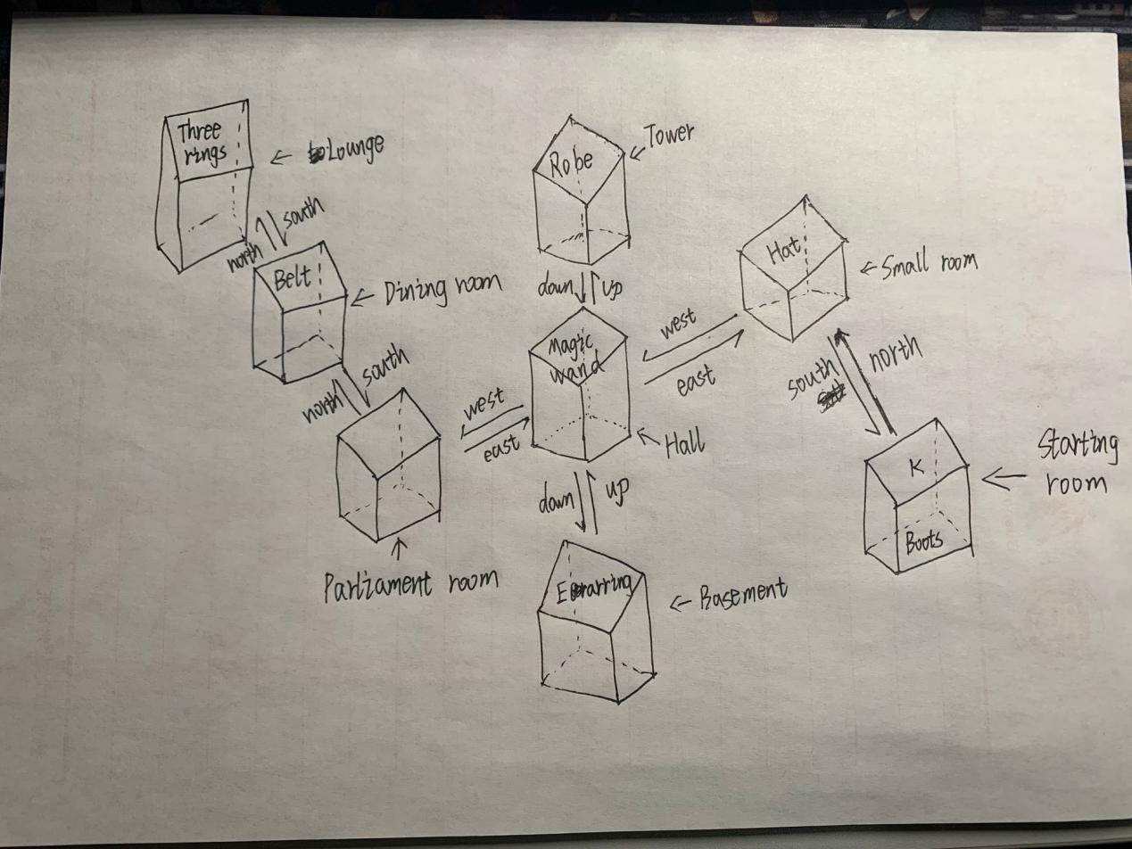

Written Exercise 3

**Class Game**

>

> <u>Instance variables</u>

- Add an instance variable of type Room for the up exit.

- Add an instance variable of type Room for the down exit.

> <u>createRooms method</u>

- Add a new room Startingroom.

-Add a new room Smallroom.

-Add a new room Hall.

-Add a new room Basement.

-Add a new room Tower.

-Add a new room Parliamentroom.

-Add a new room Diningroom.

-Add a new room Lounge.

> <u>play method</u>

- no changes needed

> <u>printWelcome method</u>

- no changes needed

> <u>processCommand method</u>

- no changes needed

> <u>printHelp method</u>

- no changes needed

> <u>goRoom method</u>

- no changes needed

<u>quit method</u>

- no changes needed

Written Exercise 4

Because these two methods need to print the current position information, but neither call the other, because they need to do other things (that is, the tasks of the two are not the same, so they cannot call the other).

Written Exercise 5

Because this method does more than one thing, in the Game class, this design will improve coupling.

Written Exercise 6

> <u>printWelcome method</u>

- A new method is called to describe the room.

> <u>goRoom method</u>

-A new method is called to describe the room.

Written Exercise 7

Yes, the modifications made above have improved the design level of the project. Because the modifications made reduce or even avoid the coupling, the degree of loose coupling is achieved, the code duplication and the use of concise code are avoided, so that the project design presents a high degree of cohesion and achieves a high cohesion effect.