Ovation Golf
Demonstration System Specifications

Table of Contents
Table of Contents 2
1 Introduction 3
1.1 Background 3
2 Definitions 3
3 System Requirements 4
3.1 Objectives 4
3.2 System Context 5
3.2.1 Use Cases 6
4 System Architecture 6
4.1 LabView Demo 7
4.1.1 Windows Tablet/Laptop 7
4.1.2 LabView Application User Interface 8
4.2 GPS System 9
4.3 Wi-Fi Router 9
5 Test Modes 10
5.1 Connectivity Test 10
5.2 Rover Status 11
5.3 Base Station Status 12
6 Demo Process 12
6.1 Setup 12
6.2 Generating Putt Instructions 13
7 Golf Course Information 14
7.1 Riverside Country Club 14
7.2 Shorehaven Golf Club 14
8 Coordinate Transformations 15
8.1 Coordinate systems 16
8.1.1 Additional Reference Information 17
8.2 Tools 18

Introduction

Background
Ovation Golf has developed a unique, innovative system that is able to significantly enhance the putting experience for golfers at all levels of the game. This includes beginners to experienced professionals with a desire to learn how to read a green and execute a successful putt.
The core of the Ovation Golf system is an advanced 3D simulation system that has the following capabilities:
- Enhanced 3D map of the green.
- Able to identify the location of the ball and hole.
- Evaluate hundreds of ball trajectories to determine the ideal putt.
- Communicate to the golfer how to execute a successful putt.
- Educate the golfer on how to read the green.
The Ovation Golf Demonstration System will showcase the functionality of the advanced simulation system by utilizing a COTS GPS system and enhancing existing LabView development software.

Definitions
The following terms are used in the document.
- Latitude: Latitude in WGS84 format.
- Longitude: Longitude in WGS84 format.
- Altitude: Position above the WGS84 ellipsoid (meters).
- Fix Type
  - Fixed: Position fix that indicates the Base Station has achieve sufficient accuracy for RTK operation.
  - Surveyed: Indicates base station has achieved sufficient accuracy for RTK operation.
  - 3D: Position fix that includes horizontal coordinates (XY) plus altitude.
  - 2D: Position fix that includes only horizontal coordinates (XY).
- Satellites: Number of GPS satellites visible to the receiver and being used to calculate the position.
- HDOP: Horizontal Dilution of Precision.
- VDOP: Vertical Dilution of Precision.
- PDOP: Position Dilution of Precision.
  - Best case value of 1, higher numbers indicate worse PDOP.
  - A value of 2 is good.
  - Higher values (>7) are bad.
  - The best PDOP would occur with one satellite directly overhead and three others evenly spaced about the horizon.
  - PDOP could theoretically be infinite, if all the satellites were in the same plane.
- vAcc: Estimated accuracy of Altitude (i.e. the Z axis).
- Fixed Position: Boolean, indicates if the base station has been configured to a coordinate.
- iTOW: GPS Time of Week.
- rpE: Rover Relative Position to Base Station, Easting.
- rpN: Rover Relative Position to Base Station, Northing.
- EPSG Geodetic Parameter Dataset: Public registry of geodetic datums, spatial reference systems, Earth ellipsoids, coordinate transformations and related units of measurement, originated by a member of the European Petroleum Survey Group (EPSG) in 1985.
- EPSG:4326: WGS 84, latitude/longitude coordinate system based on the Earth's center of mass, used by the Global Positioning System among others.
- WKT: Well-known text markup language for representing spatial reference systems and transformations between spatial reference system.
- WGS83: EPSG:4326
- NAD84:EPSG:4269

System Requirements
The following outlines the objectives and system requirements for the Ovation Demonstration System.

Objectives
The goals for the Ovation Demonstration System include the following:
- Upon initiation, such as a button press, automatically perform the following steps:
  - Read GPS location of the ball.
  - Calculate the location using a local grid coordinate system.
    - Cartesian (XYZ) grid based on (0, 0) being a designated corner of the green.
  - Determine the ideal putt trajectory.
  - Display information to a user.
- Use a Windows Laptop
  - Developed in LabView and executed as a Windows x86 compiled executable.
- Use two RoboDot RTK GPS Receivers to form a base station, rover mapping system for highly accurate GPS readings.
- Use a portable Wi-Fi router to establish a Wi-Fi network in field.

System Context
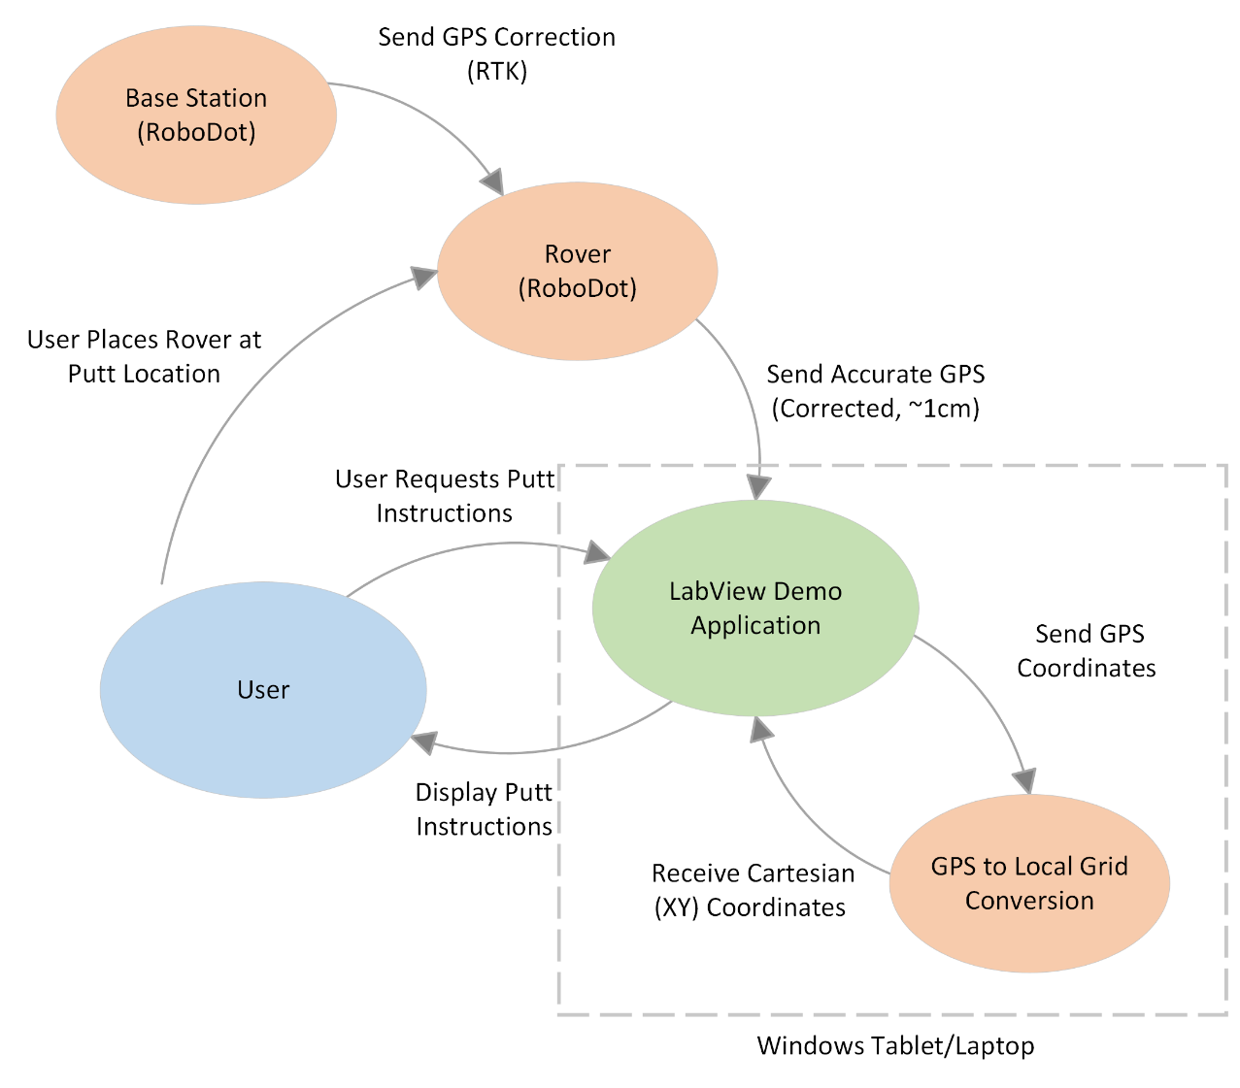

Use Cases
The following use-case table identifies the entities that use the system and for what purposes.
Actor | Use Case | Description
User | User Places Rover at Putt Location | The User places the Rover at the location of the ball (i.e., where they will be putting from)
User | User Requests Putt Instructions | The user will click on a button on the LabView Demo Application to initiate the
LabView Demo Application | Display Putt Instructions | The LabView Demo Application will display the putt instructions as outlined below.
Base Station | Send GPS Correction (RTK) | The Base Station (RoboDot) sends the GPS Correction (RTK) to the Rover.
Rover | Sends Accurate GPS | The Rover will apply the RTK corrections to the generated GPS coordinates and send these accurate GPS coordinates to the LabView Demo Application
LabView Demo Application | Send GPS Coordinates  Receive Cartesian (XY) Coordinates | The LabView Demo Application, through a special module developed in LabView, will receive the GPS coordinates, convert them to a state plane coordinates, and then convert the state plane coordinates to a local XY grid system used by the advanced 3D simulation system.

System Architecture
The follow diagram highlights the functional parts of the system and connection/communication between the different components.
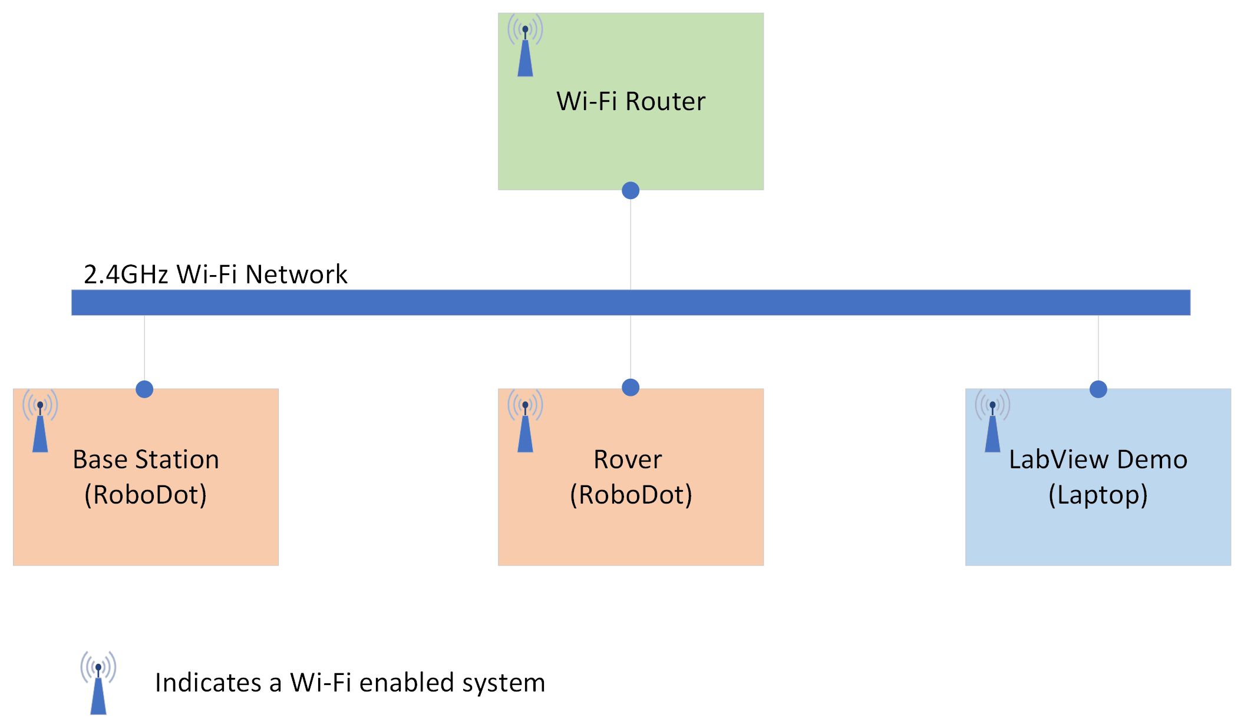

LabView Demo

Windows Tablet/Laptop
The demo project will use the existing Ovation laptop for the demo purposes.
The general requirements to operate the LabView software are:
- Processor: Intel Core i5 or greater
- Memory: 16GB minimum
- Hard Drive: 256GB or larger
- Operating System: Windows 10 and above
- Software Requirements
  - LabView Runtime Version 2021 SP1
- 2.4GHz Wi-Fi

A potential tablet that would meet the requirements is the Microsoft Surface Pro 7+ as shown:
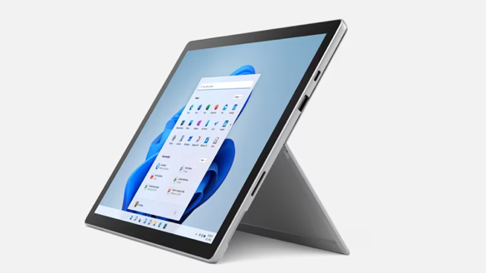

LabView Application User Interface
The objectives of the application user interface is to display the following information:
- Putt Instructions such as
  - Distance to Hole (Direct Line)
  - Distance to Hole (Ideal Putt)
  - Direction (Relative to Hole)
- 3D Topographical Rendering of the Green
- Ideal Putt Trajectory
  - Preferably overlaid on the 3D Topographical Rendering

Example Screen Layout
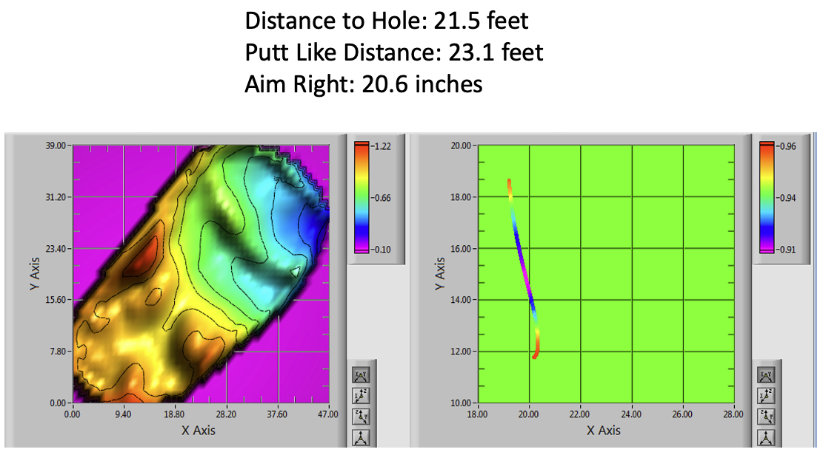

Setting the Position of the Hole
This process to the hole position will be used in the following conditions:
- A different putting green from the last operation is being used.
- The hole has been relocated.
It is anticipated that the LabView software will store/recall the location of the hole.

GPS System
The GPS system will utilize two of the Robota RoboDot RTK GPS Receivers.
https://www.robota.us/solutions/RoboDot

Base Station
One of the RoboDots will be configured as follows:
- Mode: RoboDot Base Mode
- GPS Correction: Sent over the Wi-Fi network as an NTRIP Server
- Absolute Position
  - Absolute Position will be determined using “Average Position” over a period of 4 to 8 hours.
    - Average Position will calculate the base position by averaging readings.
  - Absolute Position can be saved in the RoboDot software and recalled later allowing for:
    - Day 1: Configuration (determining Absolute Position through “Average Position” mode) and testing.
    - Day 2: Demonstration, recall saved position and verify accuracy (TBD)

Rover
The Rover will be used to determine the location of the ball (i.e. where the putt will originate from).
- Mode: Rover (Status page -> Make Rover)
- GPS Correction: Received from Base Station over the Wi-Fi network as an NTRIP Client
*Optional: A mechanical model could be designed and 3D printed allowing the Rover to be placed over the ball.

Wi-Fi Router
A small, portable Wi-Fi router will allow each of the demonstration system devices to connect and communicate between the different components. The requirements for the Wi-Fi router are:

Requirements
- 2.4GHz Wi-Fi
- WPA2 Personal Encryption
- Range: Maximum
- Embedded DHCP Server with support for static IP assignments

Static IP Assignments
Each device will be set up in the Wi-Fi router with its MAC address recorded to provide a static IP address (i.e., the same IP address every time the device connects).
Static IP Assignments
Device | MAC Address | Static IP Address
Wi-Fi Router | 94:83:C4:2F:DD:04 | 192.168.8.1
Laptop | E8:FB:1C:B6:F9:5B | 192.168.8.2
Base Station (RoboDot #271) | C8:C9:A3:FD:E4:14 | 192.168.8.3
Rover (RoboDot #) | 30:AE:A4:2D:1D:B0 | 192.168.8.4

Test Modes
The LabView Demo Software will support the following test modes allowing for evaluation of functionality of the system and/or debugging issues in-field.

Connectivity Test
Displays the information for each device.
- Wi-Fi Router
- Rover
- Base Station
The screen will display the following information:
- Device Name
- IP Address
- Connectivity Status
  - Probably accomplished via an ICMP (ping) or an http GET request.

Other Specifications
- Data updates every 10 seconds.
- Constants or set configuration variables are pulled from the LabView environment.

Rover Status
Displays GPS information from the Rover including:
- Device Information
  - Mode
  - Designator
  - Device
  - IP Address
  - Version
  - Shots
- GPS Information
  - Latitude
  - Longitude
  - Altitude (meters)
  - Fix Type
  - Satellites
  - HDOP
  - VDOP
  - PDOP
  - vAcc
  - Fixed Position
  - iTOW
  - rpE
  - rpN
- Health
  - Run Time
  - Battery
  - Network OK
  - Connected to VRS
  - Connected to AP
  - Memory Card
  - Receive RTCM
- State Plane Coordinate System being used.
- Translated XY Coordinates in State Plane Coordinate System.
- Translated XY Coordinates in local grid system.
- Translated Z Height in local grid system.

Base Station Status
Displays GPS information from the Rover including:
- Device Information
  - Mode
  - Designator
  - Device
  - IP Address
  - Version
  - Shots
- GPS Information
  - Latitude
  - Longitude
  - Altitude (meters)
  - Fix Type
  - Satellites
  - HDOP
  - VDOP
  - PDOP
  - vAcc
  - Fixed Position
  - iTOW
  - rpE
  - rpN
- Health
  - Run Time
  - Battery
  - Network OK
  - Connected to VRS
  - Connected to AP
  - Memory Card
  - Receive RTCM

Demo Process
The following outlines the major activities in using the Demonstration System.

Setup
Steps
- Place the Wi-Fi Router and power it on.
- Place the Base Station at a known location that is pre-designated at the course.
- Turn on the Base Station.

Set Hole Position
- Place the RoboDot on the location of the hole.
- Click on the Set Hole Position on the LabView Application.

Generating Putt Instructions
This process will occur when operating the demonstration system in a typical environment, after setup activities have been completed.
Steps
- Place the RoboDot over the ball (using the RoboDot stand) or next to the ball.
- Click the “Go” button on the LabView Application
- LabView Application verifies the following:
  - Base Station fix type is set to Surveyed.
  - Rover is connected to VRS Server.
  - PDOP is less than 2 value.
- LabView Application generates putting instructions using the location of the hole and the coordinates as received from the RoboDot Rover.

Golf Course Information

Riverside Country Club
https://www.riversidecountryclub.org

Address
2701 N University Ave
Provo, UT 84604

GPS Coordinates
- Latitude: 40.26885607687802
- Longitude: -111.65855888637971

State Plane Coordinate System
- Zone: UT_C
- Zone Name: Utah Central
- FIPS Zone: 4302
- EPSG: 6619
  - https://epsg.io/6619
- GPS Coordinate Format: NAD83

Shorehaven Golf Club
https://www.shorehavengc.org

Address
​14 Canfield Ave
Norwalk CT 06855-2817

GPS Coordinates
- Latitude: 41.0932723
- Longitude: -73.3915444

State Plane Coordinate System
- Zone: CT
- Zone Name: Connecticut
- EPSG: 26956
  - https://epsg.io/26956
- FIPS Zone: 600
- GPS Coordinate Format: NAD83

Coordinate Transformations
The following diagram shows the flow of GPS data from both the Ground Based LiDAR system and the RoboDot through coordinate transformation systems to the local grid system. The physics engine utilizes the local grid system to generate putt instructions.
The RoboDot will be generating GPS coordinates in WGS84 or EPSG:4326.

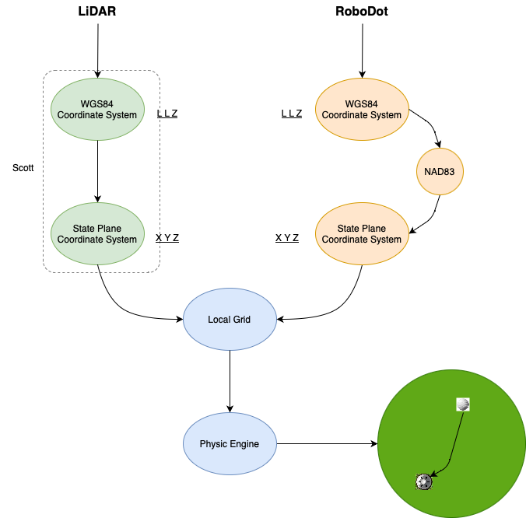

Coordinate systems
State Plane Coordinate Systems provide information to project Spherical coordinates onto a flat coordinate system.
Extracted from http://www.sharpgis.net/post/Spatial-references2c-coordinate-systems2c-projections2c-datums2c-ellipsoids-e28093-confusing.
A coordinate system is simply put a way of describing a spatial property relative to a center. There is more than one way of doing this:
- The Geocentric coordinate system is based on a normal (X,Y,Z) coordinate system with the origin at the center of Earth. This is the system that GPS uses internally for doing it calculations, but since this is very unpractical to work with as a human being (due to the lack of well-known concepts of east, north, up, down) it is rarely displayed to the user but converted to another coordinate system.
- The Spherical or Geographic coordinate system is probably the most well-known. It is based on angles relative to a prime meridian and Equator usually as Longitude and Latitude. Heights are usually given relative to either the mean sea level or the datum.
- The Cartesian coordinate system is defined as a “flat” coordinate system placed on the surface of Earth. In some projections it’s not flat in the sense that it follows the earth’s curvature in one direction and has a known scale-error in the other direction relative to the distance of the origin. The most well-known coordinate system is the Universal Transverse Mercator (UTM), but surveyors define their own little local flat coordinate systems all the time. It is very easy to work with, fairly accurate over small distances making measurements such as length, angle and area very straightforward. Cartesian coordinate systems are strongly connected to projections.
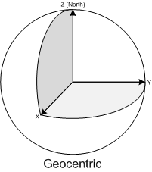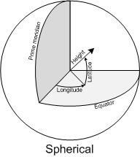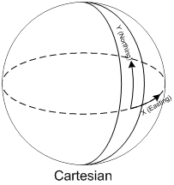
Datums and ellipsoids
Some of the common properties of the above coordinate systems are that they are all relative to the center of Earth and except the Geocentric coordinate system, uses a height system relative to the surface of the earth.
This poses two immediate problems:
- Where is the center of the earth
- What is the shape of the earth?
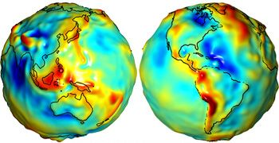
If we define the surface of Earth as being at the mean sea level (often referred to as the Geoid), we don’t get a spheroid or even an ellipsoid. Because of gravitational changes often caused by large masses such as mountain ranges etc, Earth is actually very irregular with variations of +/- 100 meters. Since this is not very practical to work with as a model of earth, we usually use an ellipsoid for approximation. The ellipsoid is defined by its semi-major axis, and either the flattening of the ellipoid or the semi-minor axis.
The center and orientation of the ellipsoid is what we call the datum. So the datum defines an ellipsoid and through the use of a set of points on the ground that we relate to points on the ellipsoid, we define the center of the Earth. This poses another problem, because continental drift moves the points used to define the points around all the time. This is why the name of a datum usually have a year in it, often referring to the position of those points January 1st of that year (although that may vary).
There are a vast amount of datums, some used for measurements all over the world, and other local datums defined so they fit very well with a local area. Some common ones are: World Geodetic Datum 1984 (WGS84), European Datum 1950 (ED50) and North American Datum 1983 (NAD83).
The most well-known is WGS84 used by the GPS systems today.
Projections
The earth isn’t flat, and there is no simple way of putting it down on a flat paper map (or these days onto a computer screen), so people have come up with all sorts of ingenious solutions each with their pros and cons.
Spatial reference
The spatial reference is a combination of all the above. It defines an ellipsoid, a datum using that ellipsoid, and either a geocentric, geographic or projection coordinate system. The projection also always has a geographic coordinate system associated with it. The European Petroleum Survey Group (EPSG) has a huge set of predefined spatial references, each given a unique ID. These IDs are used throughout the industry.
WGS84: The spatial reference ID of this is EPSG:4326.
Spatial References are often defined in a Well-known format defining all these parameters.

Additional Reference Information
http://www.sharpgis.net/post/Spatial-references2c-coordinate-systems2c-projections2c-datums2c-ellipsoids-e28093-confusing
Another article explaining GPS georeferencing (spheroid, datum, projecting).
https://www.directionsmag.com/article/4048
Geodetic Distance vs Grid Distance
https://www.geoweeknews.com/blogs/vol13no16-state-plane-coordinates

Tools
https://geodesy.noaa.gov/NCAT/
- NGS Coordinate Conversion and Transformation Tool: The industry standard for North America coordinate conversion and transformation. Based on NAD84.

https://proj.org/en/9.2/
- This is probably the tool we are going to want to use. There is a python interface built for it as well.

https://proj.org/en/9.2/operations/projections/index.html
- Projections

https://proj.org/en/9.2/usage/ellipsoids.html#ellipsoids
- Ellipsoids

https://pypi.org/project/pyproj/
- Python interface to PROJ

https://hub.arcgis.com/datasets/esri::usa-state-plane-zones-nad83/explore

https://products.aspose.app/gis/transformation

