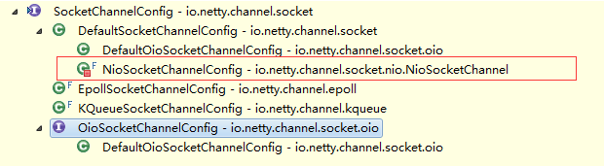
NiosocketChannelConfig
为NioSocketChannel的内部类

