Agile Product Portfolio
Software Engineering Group Coursework
UniHelp Planner - University Student Support Platform
Group number: BUS36
Git repository: To be added after GitHub upload
Student ID | Student Name | Email
CXZ530 | Chenshan Zhang | CXZ530@student.bham.ac.uk

1. Planning

1.1 Personas
Persona Name | Role/User type | Goals | Pain Points | Related User Stories
Alex Chen | International postgraduate student | Submit coursework on time, understand which work is urgent, and find support without searching many university pages. | Several deadlines close together; unfamiliar with university support routes; may delay asking for help until pressure is high. | S1, S2, S3
Dr Sarah Patel | Academic tutor / wellbeing referrer | Encourage students to seek the right support early and make workload discussions more concrete. | Students often describe pressure generally but do not bring structured task or wellbeing information. | S1, S2, S3

1.2 Product Vision
FOR university students WHO struggle to manage academic pressure and find suitable support, UniHelp Planner is a university student support platform THAT helps students prioritise workload, find relevant support resources, and reflect on wellbeing. UNLIKE scattered university webpages and email guidance, OUR PRODUCT gives simple personalised guidance in one workflow.

2. Story Writing

2.1 Product Backlog and User Stories
Story ID | Feature | Story Title | User Story | Acceptance Criteria | Priority | Justification / Trade-off | Owner
S1 | Academic workload management | Prioritise coursework tasks | As a student, I want to add coursework tasks with deadlines so that I can see what I should work on first. | Given I enter a task, deadline, estimated hours, and difficulty, when I submit the form, then the system saves the task and shows it in a prioritised list with advice. | Must | Chosen for Sprint 1 because it demonstrates the core MVP with clear input, processing, output, and testable criteria. | Chenshan Zhang
S2 | Support access | Find relevant support resources | As a student, I want to choose the type of problem I am facing so that I can find relevant university support quickly. | Given I select a support category and urgency, when I search, then the system shows matching resources and contact routes. | Must | Added in Sprint 2 because fragmented support access is a key problem in Challenge 3. | Chenshan Zhang
S3 | Wellbeing reflection | Generate wellbeing guidance | As a student, I want to complete a wellbeing check-in so that I can receive basic guidance on what support action to take. | Given I submit mood, stress, and sleep values, when the check-in is saved, then the system stores it and displays a risk-level recommendation. | Must | Added in Sprint 2 to improve proactive support while avoiding clinical decision-making. | Chenshan Zhang
S4 | Account management | Student login | As a student, I want to log in so that my information is private. | Given valid credentials, when I log in, then I can access my saved information. | Could | Deferred because the brief says login is not a core feature and the project is assessed on user value, not technical breadth. | Chenshan Zhang

2.2 Sprint Summary
Item | Sprint 1 (Weeks 2-6) | Sprint 2 (Weeks 7-11)
Planned stories | S1 | S1 refinement, S2, S3
Delivered stories | S1 | S1 refinement, S2, S3
Stories not completed | S4 login was deferred | S4 remained deferred
Key change | Build smallest useful MVP around workload planning | Improve usability, add support finder and wellbeing check-in
Learning | A simple planner gave clearer end-to-end value than a broad portal. | Personalised recommendations made the prototype better aligned with Challenge 3.

3. Design

3.1 Design Models and Evidence
Diagram | Type | Purpose | Related User Stories | Design decision rationale
D1 | Class | Shows main data entities and the recommendation service. | S1, S2, S3 | Separates stored inputs from recommendation logic so stories can be tested independently.
D2 | Sequence | Shows the task-prioritisation interaction from student input to visible output. | S1 | Documents the Sprint 1 MVP and the end-to-end behaviour expected by the brief.
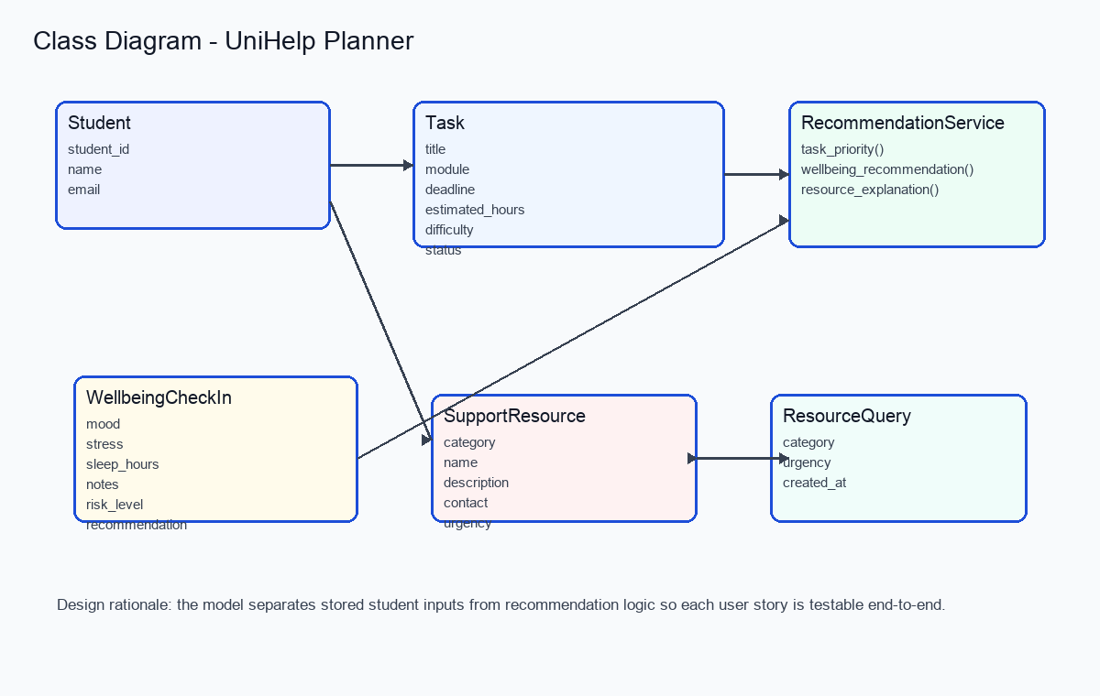
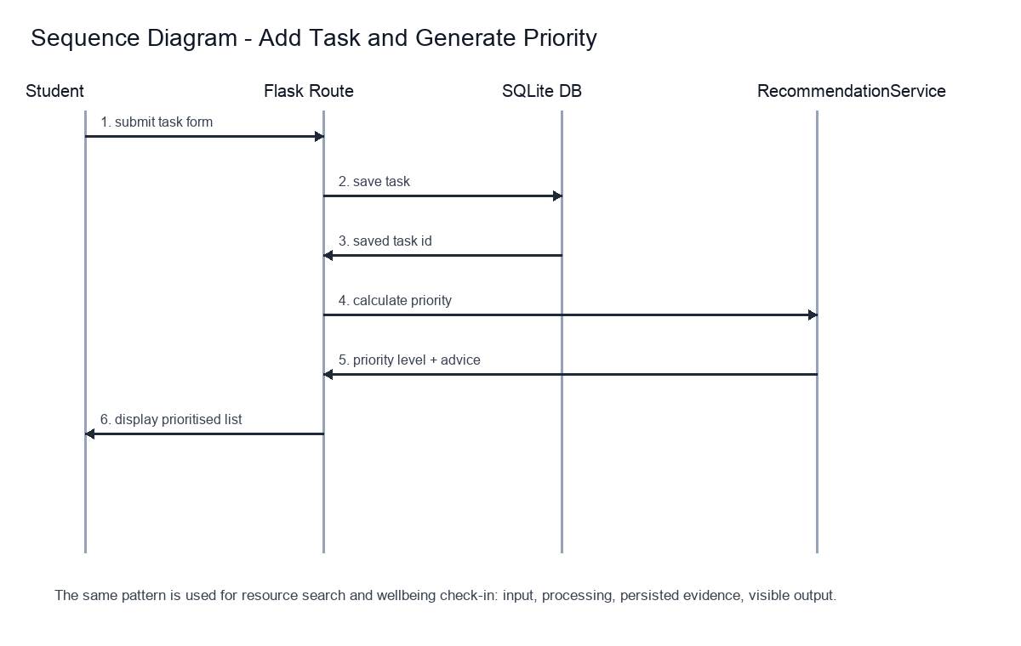

3.2 Stories and Evidence
Story ID | Evidence Type | Reference | Acceptance Criteria Met | Notes
S1 | Source code, automated test, screenshot, video | app/routes.py, app/services.py, tests/test_app.py, workload_screenshot.png, video 0:30-1:25 | Yes | Task data is saved and priority advice is displayed.
S2 | Source code, automated test, video | app/routes.py, app/db.py, tests/test_app.py, video 1:25-2:05 | Yes | Resources are filtered by category and urgency.
S3 | Source code, automated test, video | app/routes.py, app/services.py, tests/test_app.py, video 2:05-2:45 | Yes | Check-in is saved and high/medium/low recommendation is displayed.

4. Working Prototype and Implemented Features
The working prototype is a Flask web application using SQLite and Bootstrap. The prototype video demonstrates three core end-to-end user stories: S1 workload prioritisation, S2 support resource finder, and S3 wellbeing check-in. The video file is unihelp_prototype_demo.mp4 and runs for approximately 3 minutes 3 seconds.

5. Testing and Evaluation
Story ID | Acceptance Criteria | Test Performed | Outcome | Accessibility Checked | Notes
S1 | Task form saves data and displays priority output. | pytest client POST to /tasks plus browser screenshot | Pass | Labels and responsive layout checked | Automated test confirms database row and visible result.
S2 | Selected support category returns matching resources. | pytest client POST to /resources | Pass | Keyboard-selectable form controls | Urgent wellbeing search returns wellbeing and urgent support routes.
S3 | Check-in generates recommendation and stores evidence. | pytest client POST to /wellbeing | Pass | Labels and range controls checked | High stress and low mood return high-pressure recommendation.
Automated test result: 6 passed. Evidence file: submission_evidence/test_results.txt.

Appendix A - Group Contribution
Story ID | Story Title | Predicted hours | Actual hours | Status | Owner name
S1 | Prioritise coursework tasks | 6 | 7 | DONE | Chenshan Zhang
S2 | Find relevant support resources | 5 | 5 | DONE | Chenshan Zhang
S3 | Generate wellbeing guidance | 5 | 6 | DONE | Chenshan Zhang
S4 | Student login | 4 | 0 | TODO / deferred | Chenshan Zhang

Appendix B - Individual Contribution
Team member | Role(s) | Stories Owned | Evidence | What could have been improved with more time?
Chenshan Zhang | Product owner, developer, tester, documentation owner | S1, S2, S3, S4 deferred | Git commits, app source code, tests, screenshots, prototype video | Add authentication, richer university data, more accessibility testing, and TA/customer feedback iteration.

Appendix C - Meeting Logs
Important note: the following logs record the solo development planning evidence available at packaging time. If TA/customer meetings occurred, replace these entries with the real TA meeting details before final submission.
Meeting ID | Team attendees | Customer (TA name) | When | Agenda items | Actions and Owner
M1 | Chenshan Zhang | Not recorded | 2026-04-29 | Define focused MVP for Challenge 3 and select core user stories. | Implement S1 first; owner: Chenshan Zhang.
M2 | Chenshan Zhang | Not recorded | 2026-04-29 | Review prototype scope, testing evidence, and video demonstration. | Complete S2, S3, tests, video, and portfolio; owner: Chenshan Zhang.

