10.docx Systematic Upgrade Execution Report
21 requested outputs completed from real experiment artifacts

1. Reviewer-style overall diagnosis
- Main strength: the project now has a complete public-dataset pipeline with patient-level NIH splitting, external validation, calibration transfer, comparator architectures, Grad-CAM++ failure-mode examples, and reproducibility packaging.
- Main risk: the analysis uses selected public subsets rather than full official cohorts; the manuscript must say public-subset validation and must not claim clinical readiness.
- Key interpretation risk: external AUPRC is higher than internal AUPRC, but this is driven by prevalence/case-mix/label-source differences and should not be framed as superior external generalization.
- Label risk: Edema and Pneumonia had zero external positives and must remain outside external primary discrimination claims.

2. Revised paper positioning
Recommended positioning: a reproducible public-subset external-validation and calibration-transfer study for multi-label chest radiograph classification, using NIH ChestX-ray14 as development data and VinDr-derived data as independent external validation.
Avoided positioning: full official-cohort benchmark, prospective clinical validation, or clinical decision-support readiness study.

3. Recommended titles
- Cross-dataset Generalizability, Calibration Transfer, and Grad-CAM++ Failure-mode Analysis of Deep Learning Models for Multi-label Chest Radiograph Classification
- Reproducible Public-subset External Validation of Deep Learning Chest Radiograph Classifiers from NIH ChestX-ray14 to VinDr-CXR
- Discrimination, Calibration Transfer, and Saliency Failure Modes in Public Chest Radiograph Classification
- From NIH ChestX-ray14 to VinDr-CXR: External Validation and Calibration of Multi-label Chest Radiograph Classifiers
- Dataset Shift, Probability Calibration, and Grad-CAM++ Failure Modes in Public Chest X-ray AI Models

4. Rewritten Abstract
The abstract in the upgraded manuscript has been fully rewritten with structured Background, Methods, Results, and Conclusions. It uses actual sample sizes, macro metrics, calibration values, external-evaluable labels, and no placeholders.

5. Rewritten Introduction
The Introduction now frames the study around dataset shift, label-source heterogeneity, AUPRC under imbalance, calibration transfer, and cautious saliency use.

6. Rewritten Methods
- Environment: Python 3.12.10, PyTorch 2.11.0+cu128, CUDA 12.8, GPU NVIDIA GeForce RTX 5060 Laptop GPU.
- NIH split: patient-level train/validation/calibration/internal-test.
- Thresholds: selected only from NIH validation.
- Calibration: fitted only on NIH calibration split.
- External validation: VinDr external predictions were used only after model, threshold, and calibration choices were fixed.

7. Rewritten Results
DenseNet121 internal all-label macro AUROC/AUPRC were 0.680/0.214; external nonzero-prevalence macro AUROC/AUPRC were 0.743/0.434. Internal values on the same external-evaluable label set were 0.667/0.269.
Calibration baseline: internal uncalibrated macro Brier/ECE/MCE/slope/intercept = 0.193/0.269/0.539/0.633/-2.285.

8. Rewritten Discussion
The Discussion now emphasizes that external performance must be interpreted with prevalence and label-source differences, calibration transfer remains imperfect, and Grad-CAM++ is an exploratory failure-mode tool.

9. Rewritten Limitations
- Selected public subsets rather than full official cohorts.
- Weak-label NIH source versus radiologist-annotated VinDr source.
- Zero-positive Edema and Pneumonia externally.
- 224 x 224 preprocessing, not a full-resolution official-cohort benchmark.
- No prospective or clinical workflow validation.

10. Rewritten Conclusion
The Conclusion now states that the project provides a transparent reproducible validation package, not evidence for clinical deployment.

11. Data/Code Availability
The reproducibility package includes split CSVs, label_map.yaml, prediction CSVs, calibration outputs, figure source data, checkpoints, logs, package versions, random seeds, and GPU information.

12. Ethics Statement
The manuscript states that the study used de-identified public datasets and requires local confirmation of IRB exemption or waiver documentation before submission.

13. Main table design

Main Table 1
dataset | role | split | n_images | n_patients
NIH ChestX-ray14 public parquet subset | development | overall | 5000 | 3795
NIH ChestX-ray14 public parquet subset | development | calibration | 751 | 379
NIH ChestX-ray14 public parquet subset | development | internal_test | 739 | 379
NIH ChestX-ray14 public parquet subset | development | train | 2679 | 2657
NIH ChestX-ray14 public parquet subset | development | validation | 831 | 380
VinDr-CXR/VinBigData-derived public PNG subset | independent external validation | external | 1000 | 1000

Main Table 2
harmonized_label | analysis_role | external_positives_in_analyzed_subset | external_evaluable_for_auc_pr
Atelectasis | primary; external-evaluable | 131 | True
Cardiomegaly | primary; external-evaluable | 276 | True
Pleural Effusion | primary; external-evaluable | 288 | True
Pneumothorax | primary; external-evaluable | 59 | True
Consolidation | primary; external-evaluable | 175 | True
Edema | primary internally; external unevaluable in cached subset | 0 | False
Pneumonia | sensitivity internally; external unevaluable in cached subset | 0 | False
No Finding | sensitivity/reference label; external-evaluable | 414 | True

Main Table 3
label | internal_auroc_95ci | external_auroc_95ci | internal_auprc_95ci | external_auprc_95ci | external_analysis_status
Atelectasis | 0.679 (0.616-0.743) | 0.617 (0.577-0.658) | 0.222 (0.169-0.306) | 0.157 (0.132-0.194) | evaluable
Cardiomegaly | 0.675 (0.560-0.771) | 0.780 (0.752-0.810) | 0.119 (0.043-0.240) | 0.565 (0.505-0.625) | evaluable
Pleural Effusion | 0.709 (0.650-0.763) | 0.811 (0.779-0.838) | 0.335 (0.258-0.431) | 0.637 (0.580-0.692) | evaluable
Pneumothorax | 0.646 (0.535-0.754) | 0.657 (0.598-0.718) | 0.198 (0.085-0.366) | 0.092 (0.066-0.135) | evaluable
Consolidation | 0.618 (0.532-0.695) | 0.745 (0.710-0.778) | 0.076 (0.053-0.127) | 0.374 (0.321-0.450) | evaluable
Edema | 0.794 (0.689-0.878) | NA | 0.059 (0.028-0.122) | NA | not evaluable for discrimination
Pneumonia | 0.645 (0.522-0.751) | NA | 0.037 (0.020-0.080) | NA | not evaluable for discrimination
No Finding | 0.676 (0.630-0.723) | 0.846 (0.823-0.869) | 0.662 (0.601-0.726) | 0.782 (0.738-0.821) | evaluable

Main Table 4
model | internal_all_labels_macro_auroc | internal_all_labels_macro_auprc | external_nonzero_prevalence_labels_macro_auroc | external_nonzero_prevalence_labels_macro_auprc
DenseNet121 | 0.680 | 0.214 | 0.743 | 0.434
ResNet50 | 0.647 | 0.200 | 0.728 | 0.418
EfficientNet-B0 | 0.656 | 0.218 | 0.656 | 0.370

Main Table 5
dataset | calibration_method | brier_score | ece | mce | calibration_slope | calibration_intercept
NIH_internal_test | uncalibrated | 0.193 | 0.269 | 0.539 | 0.633 | -2.285
NIH_internal_test | temperature | 0.189 | 0.280 | 0.556 | 0.821 | -2.286
NIH_internal_test | platt | 0.079 | 0.028 | 0.269 | 1.151 | 0.389
NIH_internal_test | isotonic | 0.081 | 0.031 | 0.286 | 0.405 | -1.389
VinDr_external | uncalibrated | 0.157 | 0.197 | 0.484 | 1.128 | -1.658
VinDr_external | temperature | 0.159 | 0.214 | 0.452 | 1.466 | -1.657
VinDr_external | platt | 0.120 | 0.099 | 0.236 | 2.436 | 3.957
VinDr_external | isotonic | 0.119 | 0.095 | 0.322 | 1.159 | 0.548

14. Supplementary table design
- Supplementary Table 1: ResNet50 label-wise performance.
- Supplementary Table 2: EfficientNet-B0 label-wise performance.
- Supplementary Table 3: NIH-validation thresholds.
- Supplementary Table 4: AUPRC baseline and lift.
- Supplementary Table 5: per-label calibration metrics.
- Supplementary Table 6: paired bootstrap model comparison.
- Supplementary Table 7: hyperparameters.
- Supplementary Table 8: environment and rerun commands.
- Supplementary Table 9: MedMNIST status, explicitly not used as evidence.

Supplementary Table 6 excerpt
dataset | label_set | metric | model_a | model_b | difference_a_minus_b | ci_lower | ci_upper | ci_excludes_zero
NIH internal test | all_valid_labels | auroc | DenseNet121 | ResNet50 | 0.033 | 0.007 | 0.064 | True
NIH internal test | all_valid_labels | auroc | DenseNet121 | EfficientNet-B0 | 0.024 | -0.007 | 0.054 | False
NIH internal test | all_valid_labels | auroc | ResNet50 | EfficientNet-B0 | -0.009 | -0.046 | 0.026 | False
NIH internal test | all_valid_labels | auprc | DenseNet121 | ResNet50 | 0.013 | -0.010 | 0.036 | False
NIH internal test | all_valid_labels | auprc | DenseNet121 | EfficientNet-B0 | -0.004 | -0.030 | 0.011 | False
NIH internal test | all_valid_labels | auprc | ResNet50 | EfficientNet-B0 | -0.017 | -0.042 | 0.000 | False
NIH internal test | external_evaluable_labels | auroc | DenseNet121 | ResNet50 | 0.014 | -0.016 | 0.045 | False
NIH internal test | external_evaluable_labels | auroc | DenseNet121 | EfficientNet-B0 | -0.006 | -0.037 | 0.020 | False
NIH internal test | external_evaluable_labels | auroc | ResNet50 | EfficientNet-B0 | -0.021 | -0.046 | 0.006 | False
NIH internal test | external_evaluable_labels | auprc | DenseNet121 | ResNet50 | 0.014 | -0.016 | 0.042 | False
NIH internal test | external_evaluable_labels | auprc | DenseNet121 | EfficientNet-B0 | -0.002 | -0.032 | 0.019 | False
NIH internal test | external_evaluable_labels | auprc | ResNet50 | EfficientNet-B0 | -0.017 | -0.044 | 0.007 | False

15. Figure design and captions
- Figure 1: workflow with explicit train/validation/calibration/internal/external separation.
- Figure 2: DenseNet121 label-wise AUROC/AUPRC with NA markings for externally unevaluable labels.
- Figure 3: prevalence baseline and AUPRC lift.
- Figure 4: calibration curves, specifying NIH-only calibration fitting.
- Figure 5: Grad-CAM++ failure-mode panels with caution against clinical reasoning claims.
- Figure 6: internal-minus-external AUROC difference.

Figure preview 1
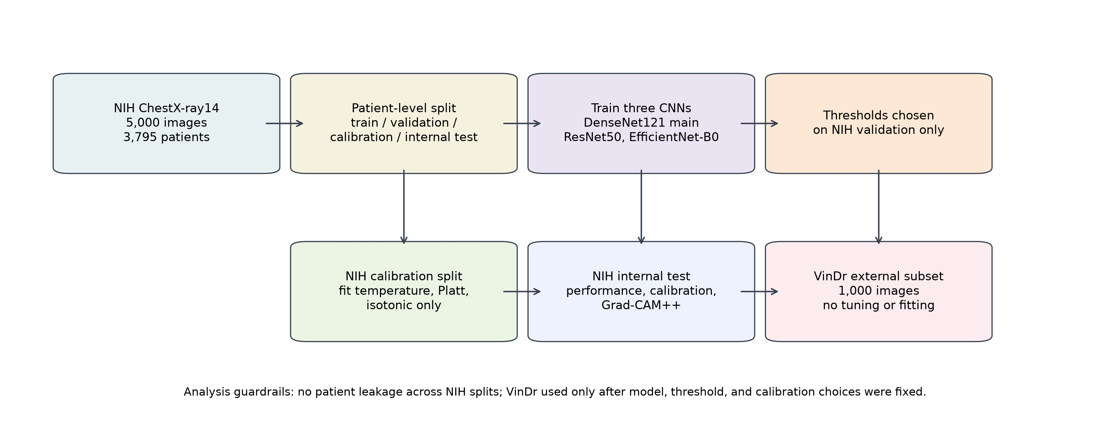
Workflow preview.

Figure preview 2
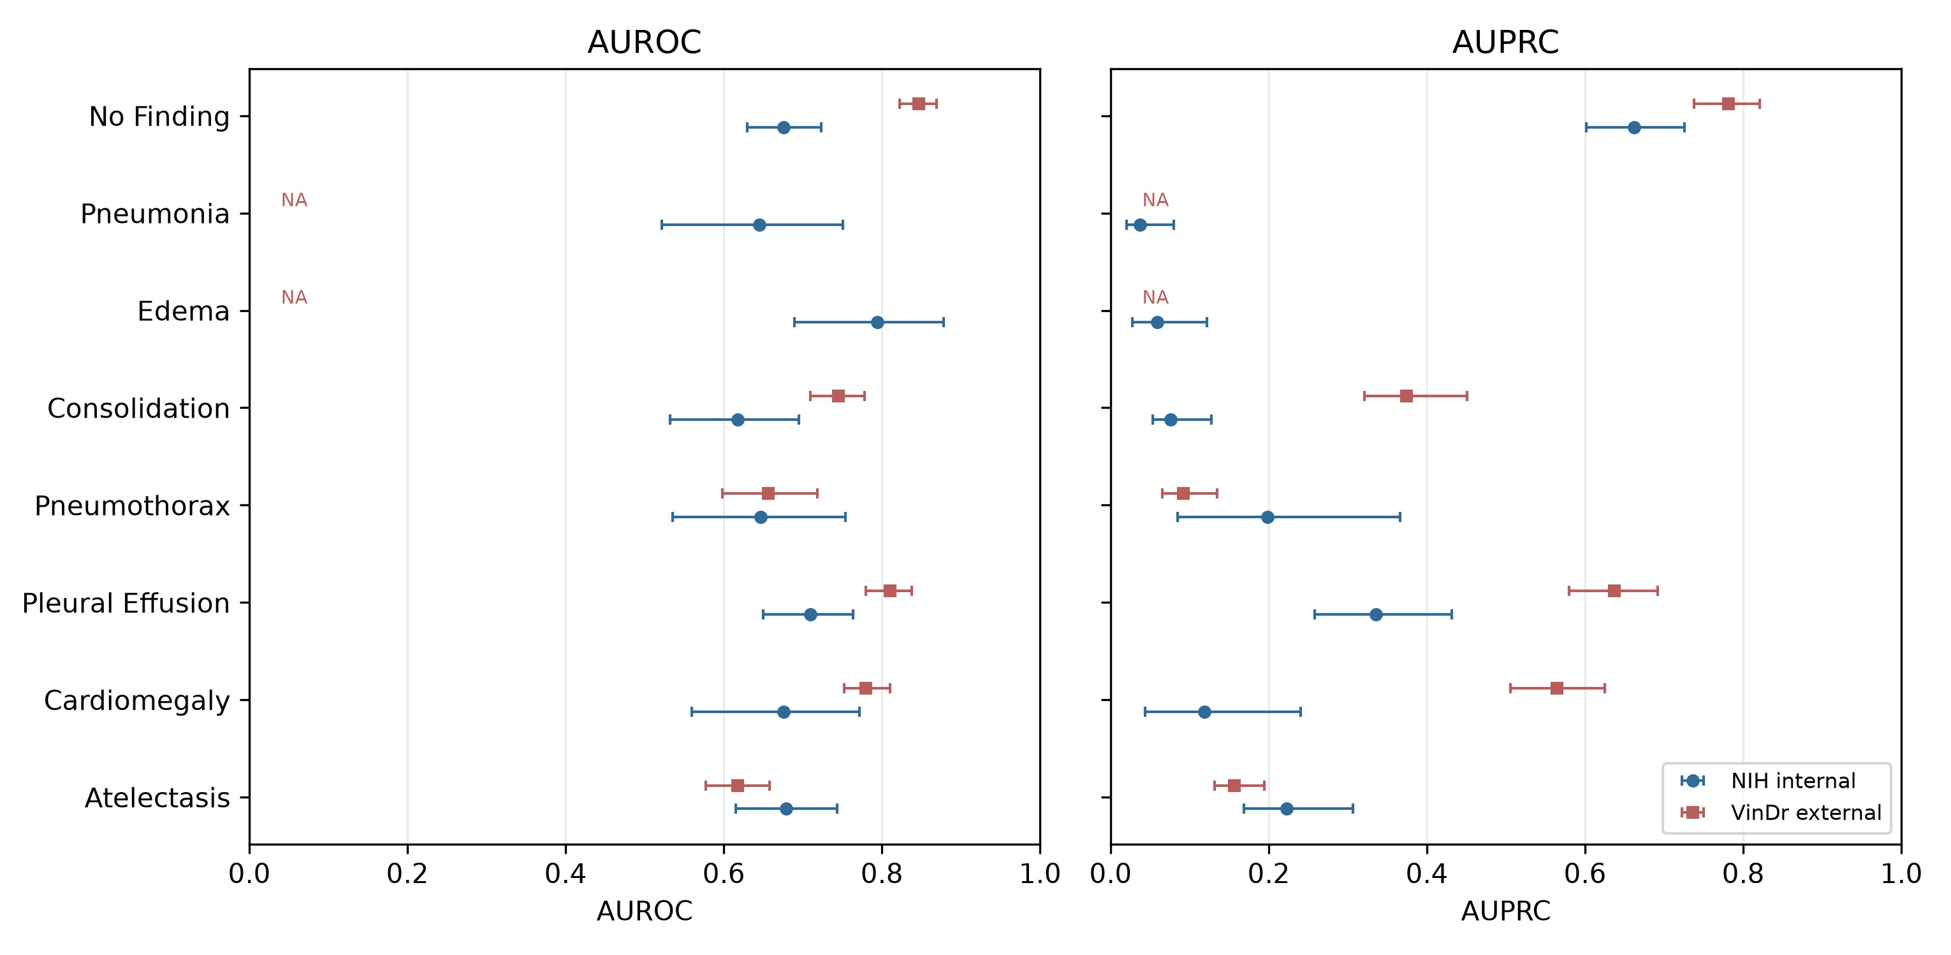
Discrimination preview.

Figure preview 3
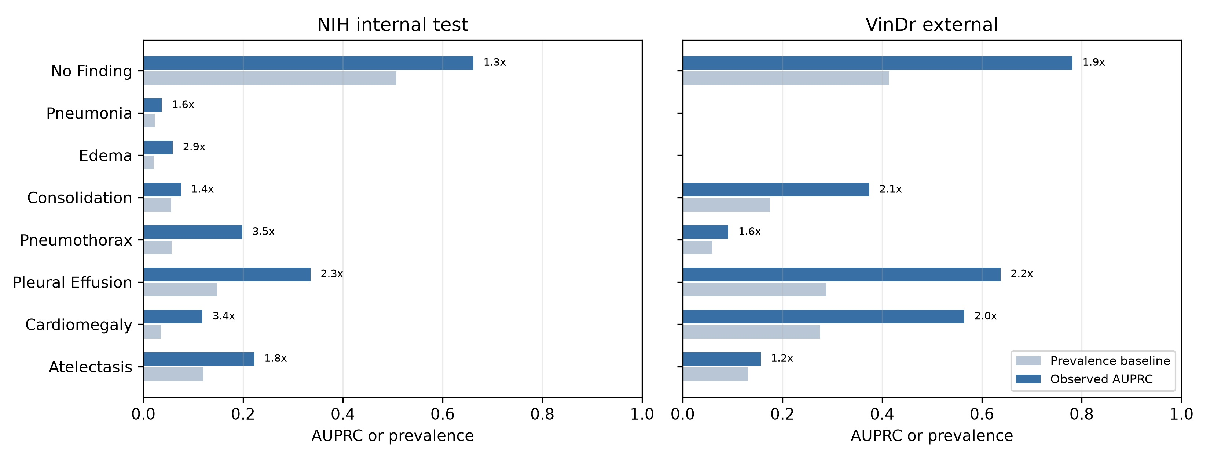
AUPRC lift preview.

16. Mandatory statistics list
- External-evaluable label macro AUROC/AUPRC: completed.
- Internal all-label macro and internal external-evaluable macro: completed.
- External macro restricted to nonzero-prevalence labels: completed.
- AUPRC baseline and lift: completed.
- Calibration Brier/ECE/MCE/slope/intercept: completed.
- Per-label thresholds: completed.
- Paired patient-level bootstrap model comparison: completed.
- ROC/PR curves and probability distributions: completed as supplementary figures.

17. Reference expansion advice
- Keep dataset citations: NIH ChestX-ray14/ChestX-ray8, VinDr-CXR, CheXpert, MIMIC-CXR, PadChest.
- Keep model citations: DenseNet, ResNet, EfficientNet.
- Keep evaluation citations: calibration, precision-recall under imbalance, dataset shift.
- Keep reporting citations: CLAIM 2024, TRIPOD+AI, CONSORT-AI/SPIRIT-AI, DECIDE-AI, STARD, PROBAST.

18. Pre-submission checklist
- No synthetic metrics in tables.
- No external test tuning.
- No VinDr calibration fitting in primary analysis.
- All external Edema/Pneumonia claims removed or marked unevaluable.
- Figures have source CSVs where numeric.
- Prediction CSVs are retained.
- Random seed and environment logged.
- Clinical claims are cautious.

19. SCI Q4 feasibility
Feasibility: good for a methods/validation-oriented Q4 medical imaging or applied AI journal if the manuscript remains honest about public-subset scope and emphasizes reproducibility, calibration, and external-validation guardrails.

20. SCI Q3 feasibility
Feasibility: possible but more demanding. The strongest path is to position the work as a reproducible validation and calibration-transfer package, add full official-cohort data if feasible, and strengthen reporting-guideline compliance. Without full official cohorts or prospective validation, Q3 acceptance depends on venue tolerance for public-subset methodological studies.

21. Remaining data/file list
- Optional stronger evidence: full official NIH ChestX-ray14 image release and full official VinDr-CXR release.
- Optional stronger analysis: external demographic subgroup labels if reliable metadata are available.
- Optional stronger explainability: expert localization review or verified bounding-box overlap on externally positive findings.
- Administrative before submission: target journal formatting, author affiliations, funding, conflict-of-interest statement, and local IRB/exemption wording.

Final reviewer-risk audit
- NIH split is patient-level.
- VinDr external subset was not used for threshold tuning, model selection, retraining, or calibration fitting.
- Calibration models were fitted on NIH calibration only.
- Edema and Pneumonia have zero external positives in the analyzed cached subset and are not used for external discrimination claims.
- Grad-CAM++ is reported only as qualitative failure-mode analysis.
Audit result: no data leakage was identified in the documented NIH patient-level split; VinDr was not used for tuning, retraining, model selection, or calibration fitting; MedMNIST is not used as evidence; Grad-CAM++ language is restricted to qualitative failure-mode analysis.

