Public-subset Cross-dataset Validation and Calibration Transfer of Deep Learning Models for Multi-label Chest Radiograph Classification
Short title: Public-subset chest radiograph validation
Study type: retrospective public-dataset machine-learning validation study

Abstract
Background: Chest radiograph classifiers are vulnerable to dataset shift, case-mix differences, label-source heterogeneity, and imperfect probability calibration. Cross-dataset validation should therefore evaluate discrimination, prevalence-aware precision-recall behavior, calibration transfer, and qualitative failure modes without implying clinical readiness.
Methods: We conducted a retrospective public-dataset machine-learning validation study using a selected NIH ChestX-ray14 public parquet subset as the development dataset and a VinDr-CXR/VinBigData-derived public PNG subset as independent external validation. The NIH subset contained 5000 images from 3795 patients and was split at patient level into training, validation, calibration, and internal-test partitions. The external subset contained 1000 images. DenseNet121 was the prespecified main model, and ResNet50 and EfficientNet-B0 were architecture comparators. Per-label thresholds were selected only by maximizing F1 on the NIH validation split, and temperature scaling, Platt scaling, and isotonic regression were fitted only on the NIH calibration split.
Results: DenseNet121 achieved internal all-label macro AUROC/AUPRC of 0.680/0.214. On the external-evaluable label set, NIH internal macro AUROC/AUPRC were 0.667/0.269, whereas the external nonzero-prevalence macro AUROC/AUPRC were 0.743/0.434. ResNet50 and EfficientNet-B0 external nonzero-prevalence macro AUROC/AUPRC were 0.728/0.418 and 0.656/0.370, respectively. Edema and Pneumonia had zero external positives and were not used for external discrimination claims. DenseNet121 internal uncalibrated macro Brier score, ECE, MCE, slope, and intercept were 0.193, 0.269, 0.539, 0.633, and -2.285. Calibration effects were method-dependent. Grad-CAM++ was used for qualitative failure-mode review of true-positive, false-positive, false-negative, and true-negative examples.
Conclusions: This study provides an auditable public-subset framework for evaluating cross-dataset discrimination, calibration transfer, architecture comparators, and failure-mode saliency in multi-label chest radiograph classification. The results do not establish full official-cohort performance or clinical readiness.
Keywords: chest radiograph; public-subset validation; external-evaluable labels; calibration transfer; Grad-CAM++; NIH ChestX-ray14; VinDr-CXR

Introduction
Chest radiography is among the most frequently used imaging examinations, and public chest radiograph datasets have enabled reproducible research on multi-label deep learning models. However, performance measured within a development dataset may not translate directly to images collected under different acquisition, annotation, and selection processes.
Public chest radiograph datasets differ in domain characteristics, disease prevalence, case mix, and label generation. NIH ChestX-ray14 uses report-mined weak labels, whereas VinDr-CXR provides radiologist-derived annotations. These differences are scientifically useful for external validation but create label-source heterogeneity that must be reflected in the interpretation.
Discrimination metrics alone are incomplete. AUROC evaluates ranking across thresholds, whereas AUPRC is strongly affected by positive-label prevalence and is often more informative for imbalanced findings. Thresholded metrics depend on where thresholds are selected, and predicted probabilities require calibration assessment before they can be interpreted as risk-like outputs.
Saliency methods such as Grad-CAM++ can support qualitative inspection of model failures, including false positives and false negatives. These maps are coarse and method-dependent, and they should not be interpreted as localization ground truth or proof that a model reasons like a radiologist.
We therefore developed a reproducible public-subset pipeline to evaluate cross-dataset discrimination, prevalence-aware precision-recall behavior, calibration transfer, architecture comparators, and Grad-CAM++ failure modes for multi-label chest radiograph classification from NIH ChestX-ray14 to a selected VinDr-derived external subset.

Methods

Study design
This was a retrospective public-dataset machine-learning validation study. All reported numeric results were derived from saved prediction CSV files and metric tables generated by the reproducible project pipeline.

Data sources and subset construction
The development dataset was a selected NIH ChestX-ray14 public parquet subset containing 5000 images from 3795 patients. The independent external validation dataset was a VinDr-CXR/VinBigData-derived public PNG subset containing 1000 images. The external subset was treated as a selected public external subset rather than the full official VinDr-CXR cohort.

Label harmonization and externally evaluable labels
The harmonized label set comprised Atelectasis, Cardiomegaly, Pleural Effusion, Pneumothorax, Consolidation, Edema, Pneumonia, and No Finding. External primary discrimination claims were restricted to external-evaluable labels with both positive and negative cases in the selected external subset: Atelectasis, Cardiomegaly, Pleural Effusion, Pneumothorax, Consolidation, and No Finding. Edema and Pneumonia had zero external positives, so their external AUROC and AUPRC were not calculable and were reported as not applicable.

Data splitting and leakage control
NIH data were split at patient level into training, validation, calibration, and internal-test partitions. The validation split was used for checkpoint selection and per-label threshold selection. The calibration split was used only for fitting calibration models. Internal-test and external data were held out from training, threshold tuning, checkpoint selection, and calibration fitting.

Image preprocessing and augmentation
Images were resized to 224 x 224 pixels, converted to three-channel tensors, and normalized with ImageNet mean and standard deviation. Training augmentation included horizontal flipping with probability 0.5 and random rotation within 7 degrees. The same deterministic resizing and normalization were used for evaluation.

Model architectures and training
DenseNet121 was the prespecified main architecture, and ResNet50 and EfficientNet-B0 were architecture comparators. All models used ImageNet-pretrained torchvision weights. Training used BCEWithLogitsLoss with positive class weights calculated as negative cases divided by positive cases for each label, clamped to the range 1 to 100. AdamW was used with learning rate 0.0001 and weight decay 0.0001. Training used batch size 24, evaluation batch size 48, gradient clipping at norm 1.0, mixed precision when CUDA was available, and early stopping patience 3 based on validation macro AUPRC. The scheduler was ReduceLROnPlateau with mode=max, factor 0.5, and patience 2. The run used 5 planned epochs, random seed 20260614, Python 3.12.10, PyTorch 2.11.0+cu128, CUDA available, and GPU NVIDIA GeForce RTX 5060 Laptop GPU.

Threshold selection
Per-label thresholds were selected by maximizing F1 on the NIH validation split. Thresholds were not re-optimized on the NIH internal-test split or the VinDr-derived external subset.

Calibration methods
Temperature scaling, Platt scaling, and isotonic regression were fitted only on the NIH calibration split. No external calibration fitting was performed in the primary analysis. Calibration transfer was evaluated on NIH internal-test and VinDr external predictions.

Evaluation metrics
Discrimination metrics included AUROC and AUPRC. Thresholded metrics included sensitivity, specificity, F1-score, accuracy, positive predictive value, and negative predictive value. Calibration metrics included Brier score, expected calibration error, maximum calibration error, calibration slope, and calibration intercept. Macro averages excluded labels for which AUROC or AUPRC were not calculable. AUPRC baseline and lift used observed prevalence, with lift defined as AUPRC divided by prevalence.

Statistical analysis
Bootstrap confidence intervals used 500 iterations and percentile intervals. Bootstrap confidence intervals were estimated at the patient level for NIH internal testing. For the cached external subset, where reliable patient-level identifiers were not available, resampling was performed at the image-identifier level and interpreted as an approximation. Paired bootstrap model comparisons were descriptive rather than confirmatory superiority tests.

Grad-CAM++ failure-mode review
Grad-CAM++ heatmaps were generated for representative true-positive, false-positive, false-negative, and true-negative predictions in NIH internal and VinDr external evaluation. These saliency maps were used only for qualitative failure-mode inspection and not as localization ground truth or evidence of radiologist-like reasoning.

Reproducibility package
The reproducibility package includes split CSVs, label mapping, prediction CSVs, calibration outputs, figure source data, model checkpoints, training logs, package versions, random seeds, GPU/environment information, and rerun commands.

Ethics statement
The study used de-identified public datasets, involved no new patient recruitment, no intervention, and no direct patient contact. Local institutional review-board exemption or waiver requirements should be confirmed before journal submission.

Results

Dataset characteristics
The NIH development subset contained 5000 images from 3795 patients. The patient-level split yielded 2679 training images, 831 validation images, 751 calibration images, and 739 internal-test images. The selected VinDr-derived external subset contained 1000 images.

Externally evaluable labels
The external-evaluable labels were Atelectasis, Cardiomegaly, Pleural Effusion, Pneumothorax, Consolidation, and No Finding. Edema and Pneumonia had zero positive cases in the selected external subset; their external AUROC and AUPRC were therefore not calculable and were not used for external primary discrimination claims.

DenseNet121 discrimination performance
DenseNet121 achieved internal all-label macro AUROC/AUPRC of 0.680/0.214. On the same external-evaluable label set used for external macro summaries, NIH internal macro AUROC/AUPRC were 0.667/0.269. External nonzero-prevalence macro AUROC/AUPRC were 0.743/0.434. The external AUPRC should be interpreted with the external prevalence distribution and selected subset composition rather than as evidence of stronger external generalization.

Architecture comparison
ResNet50 achieved internal all-label macro AUROC/AUPRC of 0.647/0.200 and external nonzero-prevalence macro AUROC/AUPRC of 0.728/0.418. EfficientNet-B0 achieved internal all-label macro AUROC/AUPRC of 0.656/0.218 and external nonzero-prevalence macro AUROC/AUPRC of 0.656/0.370. The paired bootstrap comparison favored DenseNet121 over ResNet50 for internal all-label AUROC only (difference 0.033, 95% CI 0.007 to 0.064); most external-evaluable AUROC and AUPRC differences crossed zero.

Prevalence-aware AUPRC interpretation
AUPRC baseline and lift analyses were used to contextualize precision-recall behavior under class imbalance. Because AUPRC is prevalence-sensitive, the numerically higher external AUPRC should be interpreted as a selected-subset result affected by prevalence, case mix, and label-source differences.

Calibration transfer
Calibration effects were method-dependent. On NIH internal testing, the uncalibrated DenseNet121 macro Brier score, ECE, MCE, calibration slope, and intercept were 0.193, 0.269, 0.539, 0.633, and -2.285, respectively. Temperature scaling did not consistently reduce ECE. Platt scaling and isotonic regression reduced apparent Brier score and ECE in this experiment, but slope and intercept behavior indicated that probability-scale interpretation should remain cautious, especially under external transfer.

Subgroup and sensitivity analysis
Available NIH sex and view-position subgroup summaries were descriptive and not powered for fairness inference. The cached external subset lacked reliable demographic metadata for comparable external subgroup analysis.

Grad-CAM++ failure-mode review
Grad-CAM++ panels were generated for true-positive, false-positive, false-negative, and true-negative examples in internal and external evaluation. The panels supported qualitative failure-mode inspection but did not provide localization ground truth or proof of radiologist-like model reasoning.

Discussion
This study completed a reproducible public-subset validation pipeline for multi-label chest radiograph classification, including DenseNet121 as the prespecified main model, ResNet50 and EfficientNet-B0 architecture comparators, NIH-only calibration fitting, external validation, and Grad-CAM++ failure-mode review.
The internal and external differences should be interpreted cautiously. The numerically higher external macro AUROC/AUPRC in this selected public external subset may reflect selected subset composition, positive-label prevalence, case mix, and label-source heterogeneity rather than superior cross-dataset generalization.
The AUPRC baseline and lift analyses are important because precision-recall summaries are prevalence-dependent. A higher external AUPRC can occur when the external subset contains a different distribution of positive cases, and it should not be interpreted without the observed prevalence baseline.
The architecture comparison reduces dependence on a single model family but does not establish a definitive architecture ranking. DenseNet121 remained the prespecified main model, whereas ResNet50 and EfficientNet-B0 provided descriptive comparator evidence under the same split and evaluation rules.
Calibration transfer remained method-dependent. Temperature scaling was not consistently helpful in this experiment. Platt scaling and isotonic regression reduced some apparent Brier and ECE values, but calibration slope and intercept suggested that probability-scale behavior was not fully resolved, especially when transferred to the selected external subset.
Grad-CAM++ saliency panels were useful for illustrating failure modes, but they do not validate localization or clinical reasoning. Their appropriate role is qualitative inspection of representative errors rather than evidence that the model uses radiologist-like diagnostic logic.
The practical contribution is an auditable workflow and reproducibility package for public-subset chest radiograph AI validation. The study supports transparent reporting of discrimination, calibration transfer, and failure-mode saliency, but it does not establish full official-cohort performance, prospective validity, or clinical readiness.

Limitations
This analysis used selected public subsets rather than the full official NIH ChestX-ray14 and VinDr-CXR cohorts. The external subset may therefore introduce selection bias and should be described as a selected public external subset.
The NIH and VinDr-derived labels were produced through different annotation processes: NIH labels are report-mined weak labels, whereas VinDr-CXR labels are radiologist-derived. This label-source heterogeneity can influence both discrimination and calibration estimates.
Edema and Pneumonia had zero positive cases in the selected external subset, so external discrimination metrics for these labels were not calculable and should not be used as external primary claims.
AUPRC is prevalence-sensitive, and external precision-recall performance should be interpreted with observed prevalence and AUPRC lift rather than compared directly with internal all-label macro AUPRC.
Images were resized to 224 x 224 pixels, and the compact training schedule was designed for reproducible public-subset validation rather than leaderboard-optimized full-resolution performance.
The study did not include prospective validation, reader study comparison, or clinical workflow evaluation. External patient identifiers were limited in the cached external subset, so external bootstrap estimates used image-identifier-level resampling as an approximation.
Calibration transfer may be unstable across datasets, particularly for sparse labels and different annotation sources. Grad-CAM++ was qualitative only, and subgroup/fairness analysis was limited by available metadata.

Conclusion
A reproducible NIH ChestX-ray14 to VinDr-derived public-subset pipeline was completed for multi-label chest radiograph classification. DenseNet121, ResNet50, and EfficientNet-B0 were evaluated with validation-derived thresholds, patient-level NIH internal bootstrap intervals, image-identifier-level external bootstrap approximations, NIH-only calibration fitting, and Grad-CAM++ failure-mode review. The study supports transparent evaluation of cross-dataset discrimination, calibration transfer, and architecture comparison, but it does not establish full official-cohort performance or clinical readiness.

Data and Code Availability
Split CSVs, label mapping, prediction CSVs, calibration outputs, figure source data, model checkpoints, logs, package versions, random seeds, GPU/environment information, and rerun commands are included in the reproducibility package. The public repository or archive link should be added before submission: [TO BE FILLED: repository or archive link]. Original images and labels remain under the source dataset licenses; users should follow NIH ChestX-ray14 and VinDr-CXR source license and citation requirements.

Ethics Statement
This study used de-identified public datasets and involved no new patient recruitment, no intervention, and no direct patient contact. Institutional review-board exemption or waiver requirements should be confirmed locally before journal submission.

Main Tables

Table 1. Dataset characteristics and split roles
dataset | role | split | n_images | n_patients_or_identifiers | split_level | used_for_training | used_for_threshold_selection | used_for_calibration_fitting | used_for_final_evaluation
NIH ChestX-ray14 public parquet subset | development | overall | 5000 | 3795 | patient-level split applied within NIH | no | no | no | no
NIH ChestX-ray14 public parquet subset | development | calibration | 751 | 379 | patient-level | no | no | yes | no
NIH ChestX-ray14 public parquet subset | development | internal_test | 739 | 379 | patient-level | no | no | no | yes
NIH ChestX-ray14 public parquet subset | development | train | 2679 | 2657 | patient-level | yes | no | no | no
NIH ChestX-ray14 public parquet subset | development | validation | 831 | 380 | patient-level | no | yes | no | no
VinDr-CXR/VinBigData-derived public PNG subset | independent external validation | external | 1000 | 1000 | image-identifier-level external subset | no | no | no | yes

Table 2. Label harmonization and analysis role
harmonized_label | NIH_terms | VinDr_terms | internal_analysis_role | external_positive_cases | external_evaluable | external_claim_status | caution
Atelectasis | Atelectasis | Atelectasis | primary | 131 | True | external primary/sensitivity claim allowed
Cardiomegaly | Cardiomegaly | Cardiomegaly | primary | 276 | True | external primary/sensitivity claim allowed
Pleural Effusion | Pleural Effusion | Pleural Effusion | primary | 288 | True | external primary/sensitivity claim allowed
Pneumothorax | Pneumothorax | Pneumothorax | primary | 59 | True | external primary/sensitivity claim allowed
Consolidation | Consolidation | Consolidation | primary | 175 | True | external primary/sensitivity claim allowed
Edema | Edema | not present as positive finding in analyzed cached subset | primary internally; external unevaluable in cached subset | 0 | False | not used for external discrimination claims | AUROC/AUPRC are NA when the external subset has no positive cases
Pneumonia | Pneumonia | not present as positive finding in analyzed cached subset | sensitivity internally; external unevaluable in cached subset | 0 | False | not used for external discrimination claims | AUROC/AUPRC are NA when the external subset has no positive cases
No Finding | No Finding | No Finding | sensitivity/reference label | 414 | True | external primary/sensitivity claim allowed

Table 3. DenseNet121 label-wise internal and external performance
label | validation_threshold | internal_prevalence | external_prevalence | internal_AUROC_95CI | external_AUROC_95CI | internal_AUPRC_95CI | external_AUPRC_95CI | external_status
Atelectasis | 0.660 | 0.120 | 0.131 | 0.679 (0.616-0.743) | 0.617 (0.577-0.658) | 0.222 (0.169-0.306) | 0.157 (0.132-0.194) | evaluable
Cardiomegaly | 0.750 | 0.035 | 0.276 | 0.675 (0.560-0.771) | 0.780 (0.752-0.810) | 0.119 (0.043-0.240) | 0.565 (0.505-0.625) | evaluable
Pleural Effusion | 0.550 | 0.147 | 0.288 | 0.709 (0.650-0.763) | 0.811 (0.779-0.838) | 0.335 (0.258-0.431) | 0.637 (0.580-0.692) | evaluable
Pneumothorax | 0.610 | 0.057 | 0.059 | 0.646 (0.535-0.754) | 0.657 (0.598-0.718) | 0.198 (0.085-0.366) | 0.092 (0.066-0.135) | evaluable
Consolidation | 0.680 | 0.055 | 0.175 | 0.618 (0.532-0.695) | 0.745 (0.710-0.778) | 0.076 (0.053-0.127) | 0.374 (0.321-0.450) | evaluable
Edema | 0.600 | 0.020 | 0.000 | 0.794 (0.689-0.878) | NA | 0.059 (0.028-0.122) | NA | not evaluable for discrimination
Pneumonia | 0.210 | 0.023 | 0.000 | 0.645 (0.522-0.751) | NA | 0.037 (0.020-0.080) | NA | not evaluable for discrimination
No Finding | 0.520 | 0.507 | 0.414 | 0.676 (0.630-0.723) | 0.846 (0.823-0.869) | 0.662 (0.601-0.726) | 0.782 (0.738-0.821) | evaluable

Table 4. Macro-level architecture comparison
model | internal_all_label_macro_AUROC | internal_all_label_macro_AUPRC | internal_external_evaluable_macro_AUROC | internal_external_evaluable_macro_AUPRC | external_nonzero_prevalence_macro_AUROC | external_nonzero_prevalence_macro_AUPRC
DenseNet121 | 0.680 | 0.214 | 0.667 | 0.269 | 0.743 | 0.434
ResNet50 | 0.647 | 0.200 | 0.653 | 0.254 | 0.728 | 0.418
EfficientNet-B0 | 0.656 | 0.218 | 0.674 | 0.271 | 0.656 | 0.370

Table 5. Calibration metrics before and after NIH-fitted calibration
dataset | calibration_method | Brier_score | ECE | MCE | calibration_slope | calibration_intercept | external_fitting_used | interpretation
NIH_internal_test | uncalibrated | 0.193 | 0.269 | 0.539 | 0.633 | -2.285 | no | NIH-fitted method evaluated for transfer; interpret with Brier, ECE, MCE, slope, intercept, and prevalence
NIH_internal_test | temperature | 0.189 | 0.280 | 0.556 | 0.821 | -2.286 | no | NIH-fitted method evaluated for transfer; interpret with Brier, ECE, MCE, slope, intercept, and prevalence
NIH_internal_test | platt | 0.079 | 0.028 | 0.269 | 1.151 | 0.389 | no | NIH-fitted method evaluated for transfer; interpret with Brier, ECE, MCE, slope, intercept, and prevalence
NIH_internal_test | isotonic | 0.081 | 0.031 | 0.286 | 0.405 | -1.389 | no | NIH-fitted method evaluated for transfer; interpret with Brier, ECE, MCE, slope, intercept, and prevalence
VinDr_external | uncalibrated | 0.157 | 0.197 | 0.484 | 1.128 | -1.658 | no | NIH-fitted method evaluated for transfer; interpret with Brier, ECE, MCE, slope, intercept, and prevalence
VinDr_external | temperature | 0.159 | 0.214 | 0.452 | 1.466 | -1.657 | no | NIH-fitted method evaluated for transfer; interpret with Brier, ECE, MCE, slope, intercept, and prevalence
VinDr_external | platt | 0.120 | 0.099 | 0.236 | 2.436 | 3.957 | no | NIH-fitted method evaluated for transfer; interpret with Brier, ECE, MCE, slope, intercept, and prevalence
VinDr_external | isotonic | 0.119 | 0.095 | 0.322 | 1.159 | 0.548 | no | NIH-fitted method evaluated for transfer; interpret with Brier, ECE, MCE, slope, intercept, and prevalence

Table 6. Descriptive subgroup and sensitivity analysis
dataset | subgroup_variable | subgroup | n_images | n_patients_or_identifiers | macro_AUROC | macro_AUPRC | analysis_status
NIH internal test | sex | F | 299 | 160 | 0.681 | 0.246 | descriptive; not powered for fairness inference
NIH internal test | sex | M | 440 | 219 | 0.674 | 0.189 | descriptive; not powered for fairness inference
NIH internal test | view_position | AP | 356 | 220 | 0.652 | 0.202 | descriptive; not powered for fairness inference
NIH internal test | view_position | PA | 383 | 249 | 0.678 | 0.232 | descriptive; not powered for fairness inference
VinDr external | age/sex/view_position | not analyzed | 1000 | 1000 | NA | NA | cached external subset lacks reliable age/sex metadata

Figures

Figure 1. Study workflow
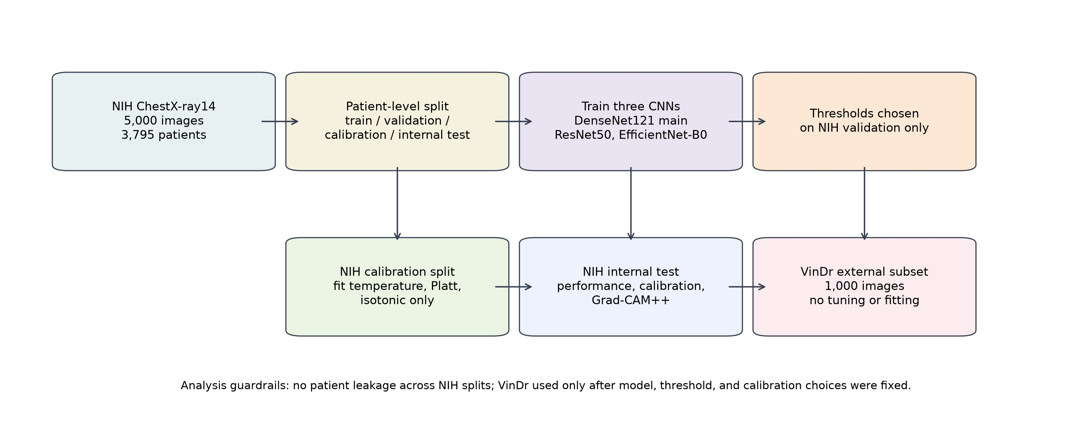
Study workflow for public-subset cross-dataset validation. A selected NIH ChestX-ray14 public parquet subset was used for development and split at patient level into training, validation, calibration, and internal-test partitions. The validation split was used for checkpoint and threshold selection, the NIH calibration split was used for post-hoc calibration fitting, and the internal-test split was used for held-out evaluation. A selected VinDr-CXR/VinBigData-derived public PNG subset was used only as independent external validation.

Figure 2. DenseNet121 internal and external AUROC/AUPRC
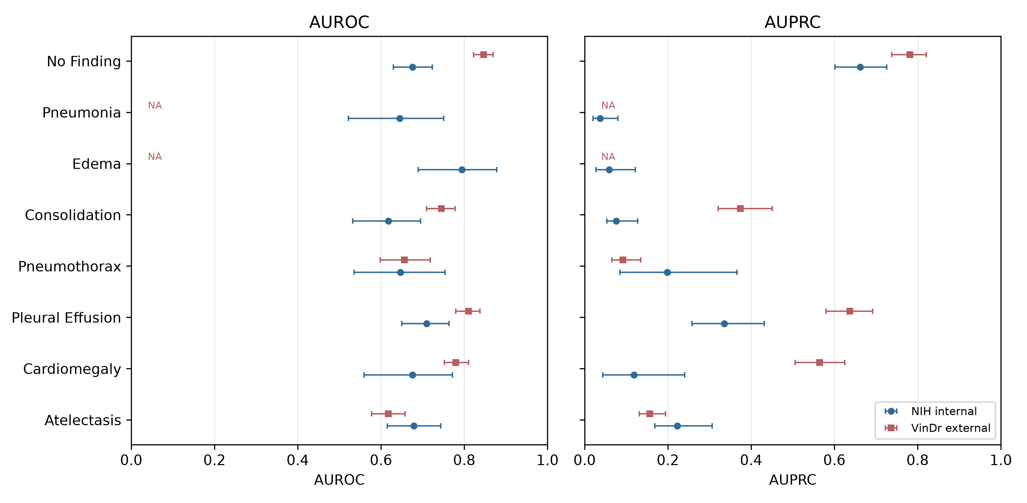
Label-wise DenseNet121 discrimination on NIH internal testing and the selected VinDr-derived external subset. Points and horizontal bars show point estimates and 95% bootstrap intervals. Edema and Pneumonia are marked not applicable externally because the analyzed external subset contained zero positive cases for these labels. Macro summaries were calculated separately for all internal labels and for the external-evaluable label set.

Figure 3. AUPRC baseline and lift
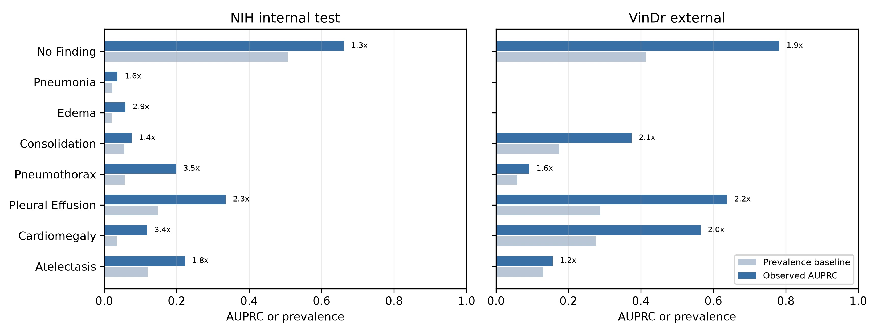
Prevalence-aware AUPRC interpretation. The prevalence baseline is the observed positive-label prevalence, and AUPRC lift is defined as AUPRC divided by prevalence. This panel contextualizes precision-recall behavior under class imbalance; external AUPRC should not be interpreted without considering the external prevalence distribution.

Figure 4. Calibration curves
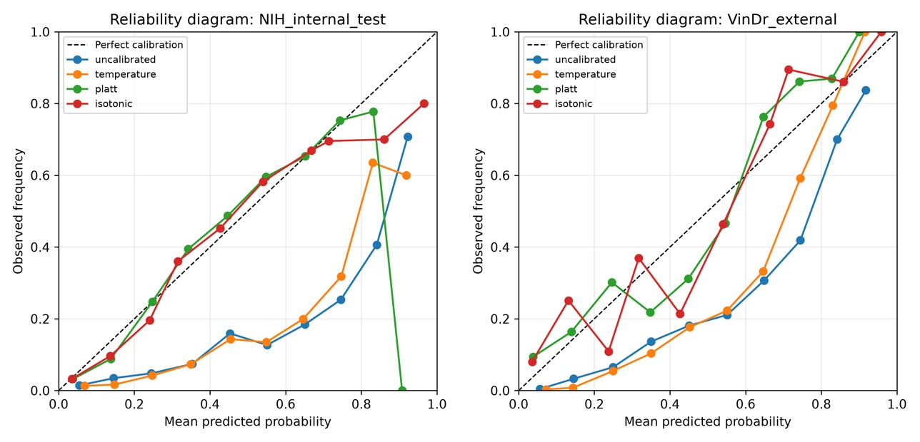
Reliability curves for uncalibrated predictions and NIH-fitted temperature scaling, Platt scaling, and isotonic regression. Calibration methods were fitted only on the NIH calibration split and evaluated on NIH internal-test and selected VinDr external predictions. ECE should be interpreted together with Brier score, MCE, calibration slope, and calibration intercept.

Figure 5. Grad-CAM++ failure-mode panels
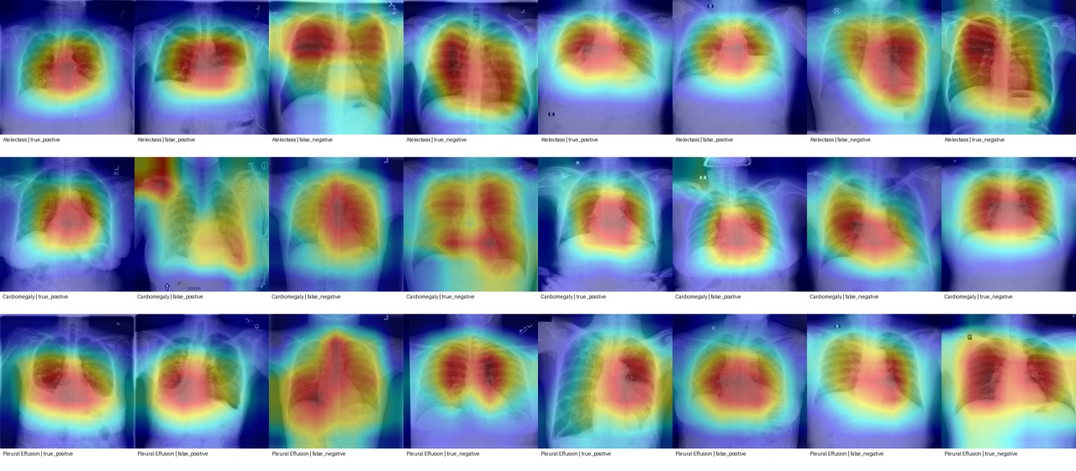
Representative Grad-CAM++ panels for true-positive, false-positive, false-negative, and true-negative predictions from internal and external evaluation. These heatmaps are qualitative failure-mode saliency examples only; they are not localization ground truth and do not demonstrate radiologist-like reasoning.

Figure 6. Internal-minus-external AUROC difference
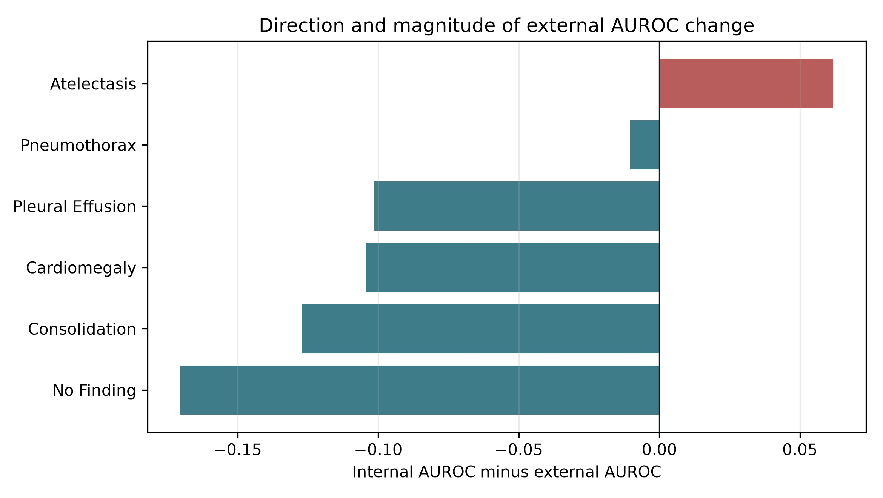
Internal-minus-external AUROC differences for externally evaluable labels. Negative values indicate numerically higher AUROC in the selected external subset. Interpretation is affected by selected subset composition, prevalence, case mix, and label-source heterogeneity.

Supplementary Material Overview
- Supplementary Table 1. ResNet50 label-wise performance.
- Supplementary Table 2. EfficientNet-B0 label-wise performance.
- Supplementary Table 3. Per-label thresholds from NIH validation.
- Supplementary Table 4. AUPRC prevalence baseline and lift.
- Supplementary Table 5. Per-label calibration metrics.
- Supplementary Table 6. Paired bootstrap model comparisons.
- Supplementary Table 7. Hyperparameters and environment.
- Supplementary Table 8. Reproducibility commands.
- Supplementary Table 9. Dataset-source and license summary.

References
1. Wang X, Peng Y, Lu L, Lu Z, Bagheri M, Summers RM. ChestX-ray8: Hospital-scale chest X-ray database and benchmarks on weakly-supervised classification and localization of common thorax diseases. CVPR. 2017.
2. Nguyen HQ, Lam K, Le LT, et al. VinDr-CXR: An open dataset of chest X-rays with radiologist's annotations. Scientific Data. 2022;9:429.
3. Irvin J, Rajpurkar P, Ko M, et al. CheXpert: A large chest radiograph dataset with uncertainty labels and expert comparison. AAAI. 2019.
4. Johnson AEW, Pollard TJ, Berkowitz SJ, et al. MIMIC-CXR, a de-identified publicly available database of chest radiographs with free-text reports. Scientific Data. 2019;6:317.
5. Bustos A, Pertusa A, Salinas JM, de la Iglesia-Vaya M. PadChest: A large chest x-ray image dataset with multi-label annotated reports. Medical Image Analysis. 2020;66:101797.
6. Rajpurkar P, Irvin J, Zhu K, et al. CheXNet: Radiologist-level pneumonia detection on chest X-rays with deep learning. arXiv. 2017.
7. Rajpurkar P, Irvin J, Ball RL, et al. Deep learning for chest radiograph diagnosis: A retrospective comparison of the CheXNeXt algorithm to practicing radiologists. PLoS Medicine. 2018;15:e1002686.
8. Finlayson SG, Subbaswamy A, Singh K, et al. The clinician and dataset shift in artificial intelligence. New England Journal of Medicine. 2021;385:283-286.
9. Guo C, Pleiss G, Sun Y, Weinberger KQ. On calibration of modern neural networks. ICML. 2017.
10. Kuleshov V, Fenner N, Ermon S. Accurate uncertainties for deep learning using calibrated regression. ICML. 2018.
11. Selvaraju RR, Cogswell M, Das A, Vedantam R, Parikh D, Batra D. Grad-CAM: Visual explanations from deep networks via gradient-based localization. ICCV. 2017.
12. Chattopadhyay A, Sarkar A, Howlader P, Balasubramanian VN. Grad-CAM++: Generalized gradient-based visual explanations for deep convolutional networks. WACV. 2018.
13. Huang G, Liu Z, van der Maaten L, Weinberger KQ. Densely connected convolutional networks. CVPR. 2017.
14. He K, Zhang X, Ren S, Sun J. Deep residual learning for image recognition. CVPR. 2016.
15. Tan M, Le QV. EfficientNet: Rethinking model scaling for convolutional neural networks. ICML. 2019.
16. Mongan J, Moy L, Kahn CE Jr. Checklist for artificial intelligence in medical imaging (CLAIM): A guide for authors and reviewers. Radiology: Artificial Intelligence. 2020;2:e200029.
17. Tejani AS, Klontzas ME, Gatti AA, et al. Checklist for artificial intelligence in medical imaging (CLAIM): 2024 update. Radiology: Artificial Intelligence. 2024.
18. Collins GS, Dhiman P, Andaur Navarro CL, et al. Protocol for development of a reporting guideline for prediction model studies using machine learning: TRIPOD+AI. BMJ. 2024.
19. Liu X, Rivera SC, Moher D, Calvert MJ, Denniston AK. Reporting guidelines for clinical trial reports for interventions involving artificial intelligence: CONSORT-AI extension. Nature Medicine. 2020.
20. Rivera SC, Liu X, Chan AW, Denniston AK, Calvert MJ. Guidelines for clinical trial protocols for interventions involving artificial intelligence: SPIRIT-AI extension. BMJ. 2020.
21. Vasey B, Nagendran M, Campbell B, et al. Reporting guideline for the early-stage clinical evaluation of decision support systems driven by artificial intelligence: DECIDE-AI. Nature Medicine. 2022.
22. Bossuyt PM, Reitsma JB, Bruns DE, et al. STARD 2015: An updated list of essential items for reporting diagnostic accuracy studies. BMJ. 2015;351:h5527.
23. Wolff RF, Moons KGM, Riley RD, et al. PROBAST: A tool to assess the risk of bias and applicability of prediction model studies. Annals of Internal Medicine. 2019;170:51-58.
24. Nagendran M, Chen Y, Lovejoy CA, et al. Artificial intelligence versus clinicians: Systematic review of design, reporting standards, and claims. BMJ. 2020;368:m689.
25. Davis J, Goadrich M. The relationship between precision-recall and ROC curves. ICML. 2006.
26. Saito T, Rehmsmeier M. The precision-recall plot is more informative than the ROC plot when evaluating binary classifiers on imbalanced datasets. PLoS ONE. 2015;10:e0118432.

