Cross-dataset Generalizability, Calibration Transfer, and Grad-CAM++ Failure-mode Analysis of Deep Learning Models for Multi-label Chest Radiograph Classification
Retrospective public-dataset machine-learning validation study
Short title: NIH-to-VinDr public-subset chest radiograph validation
Word-count note: generated manuscript draft with embedded main tables and figures; journal-specific formatting can be applied after target selection.

Abstract
Background: Cross-dataset deployment of chest radiograph classifiers is limited by dataset shift, label-source heterogeneity, class imbalance, and imperfect probability calibration. Discrimination, calibration, and failure-mode explainability therefore need to be evaluated together rather than as isolated model-development outputs.
Methods: We built a reproducible PyTorch pipeline using a selected NIH ChestX-ray14 public parquet subset as the development dataset and a VinDr-CXR/VinBigData-derived public PNG subset as independent external validation. The NIH subset contained 5000 images from 3795 patients and was split at patient level into training, validation, calibration, and internal-test partitions. The external subset contained 1000 images. DenseNet121 was prespecified as the main model; ResNet50 and EfficientNet-B0 were trained as architecture comparators. Per-label thresholds were selected only on NIH validation data, and temperature scaling, Platt scaling, and isotonic regression were fitted only on the NIH calibration split.
Results: DenseNet121 achieved internal all-label macro AUROC/AUPRC of 0.680/0.214. For labels with nonzero external prevalence (Atelectasis; Cardiomegaly; Pleural Effusion; Pneumothorax; Consolidation; No Finding), external macro AUROC/AUPRC were 0.743/0.434; the corresponding NIH internal macro values on the same label set were 0.667/0.269. ResNet50 and EfficientNet-B0 showed external nonzero-prevalence macro AUROC/AUPRC of 0.728/0.418 and 0.656/0.370, respectively. DenseNet121 internal uncalibrated macro Brier score, ECE, MCE, slope, and intercept were 0.193, 0.269, 0.539, 0.633, and -2.285. Grad-CAM++ panels were generated for internal and external true-positive, false-positive, false-negative, and true-negative cases.
Conclusions: The pipeline provides an auditable public-dataset framework for assessing chest radiograph classifier transfer, calibration transfer, and saliency-based failure modes. The findings support cautious public-subset validation reporting, but they do not establish full official-cohort performance or clinical readiness.
Keywords: chest radiograph; external validation; calibration; dataset shift; Grad-CAM++; DenseNet; VinDr-CXR; NIH ChestX-ray14

Introduction
Deep-learning systems for chest radiograph diagnosis have been widely evaluated on public datasets, yet their apparent performance can depend strongly on dataset origin, label generation, acquisition workflow, and disease prevalence. A model that ranks cases acceptably in one dataset may not preserve discrimination, decision thresholds, or probability calibration after transfer to another dataset.
This problem is especially relevant for public chest radiograph resources. NIH ChestX-ray14 labels are derived from radiology reports, whereas VinDr-CXR provides radiologist annotations. These differences create a practical test of cross-dataset transportability but also introduce label-source heterogeneity that must be acknowledged when interpreting performance.
AUROC alone is insufficient in this setting. AUPRC better reflects positive-label prevalence for imbalanced findings, thresholded metrics are sensitive to the dataset used for threshold selection, and probability calibration determines whether predicted risks correspond to observed event frequencies. Explainability maps can reveal plausible failure modes, but they should not be used as proof of radiological reasoning.
We therefore designed a reproducible public-subset study to evaluate three linked questions: how a DenseNet121 chest radiograph classifier transfers from NIH ChestX-ray14 to a VinDr-derived external subset, whether NIH-fitted calibration procedures transfer to internal and external test data, and what Grad-CAM++ panels show in representative correct and incorrect decisions.
DenseNet121 was chosen as the prespecified main model because it is a common chest radiograph baseline and has been used extensively in medical-image classification. ResNet50 and EfficientNet-B0 were added as architecture comparators to reduce single-model dependence while preserving the same data splits, thresholds, and external-validation rules.

Methods

Study design
This was a retrospective public-dataset machine-learning validation study. The development dataset was a selected NIH ChestX-ray14 public parquet subset. Independent external validation used a VinDr-CXR/VinBigData-derived public PNG subset. All results in this manuscript were computed from saved prediction CSV files and metric tables.

Datasets
The NIH development subset included 5000 images from 3795 patients. The external subset included 1000 images with image-level identifiers used as patient identifiers in the cached public subset. Dataset characteristics and split sizes are summarized in Table 1.

Labels
The harmonized label set included Atelectasis, Cardiomegaly, Pleural Effusion, Pneumothorax, Consolidation, Edema, Pneumonia, and No Finding. External discrimination claims were restricted to labels with both positive and negative cases in the analyzed external subset. Edema and Pneumonia had zero external positives and were retained only for internal or sensitivity-context reporting.

Data splitting and leakage control
NIH data were split at patient level into train, validation, calibration, and internal-test partitions. The validation split was used for threshold selection and checkpoint selection. The calibration split was used only for fitting calibration models. Internal-test and external data were not used for training, threshold optimization, checkpoint selection, or calibration fitting.

Preprocessing
Images were converted to three-channel tensors, resized to 224 x 224 pixels, normalized using ImageNet mean and standard deviation, and augmented during training using horizontal flipping and small rotations. The same deterministic preprocessing was used for internal and external evaluation.

Models and training
DenseNet121 was trained as the main model, with ResNet50 and EfficientNet-B0 as comparators. All models used ImageNet pretrained torchvision weights, BCEWithLogitsLoss with positive class weights, AdamW optimization, mixed precision when CUDA was available, and early stopping/checkpoint selection using validation macro AUPRC. The environment used Python 3.12.10, PyTorch 2.11.0+cu128, CUDA availability True, and GPU NVIDIA GeForce RTX 5060 Laptop GPU. Hyperparameters are listed in Supplementary Table 7.

Thresholds and evaluation
Per-label thresholds were selected by maximizing F1 on the NIH validation split. These thresholds were then applied unchanged to the NIH internal-test split and VinDr external subset. Metrics included AUROC, AUPRC, sensitivity, specificity, F1-score, accuracy, PPV, NPV, and macro/micro averages. Patient-level bootstrap resampling with 500 iterations was used for 95% confidence intervals.

Calibration
Temperature scaling, Platt scaling, and isotonic regression were fitted on the NIH calibration split only. Calibration transfer was evaluated on NIH internal-test and VinDr external predictions using Brier score, ECE, MCE, calibration slope, and calibration intercept. No calibration model was fitted on VinDr in the primary analysis.

Explainability
Grad-CAM++ heatmaps were generated for selected true-positive, false-positive, false-negative, and true-negative examples from internal and external test data. These heatmaps were used for qualitative failure-mode review and not as evidence of clinical reasoning or localization validity.

Statistical analysis
Macro discrimination was reported for all labels where calculable and separately for the external-evaluable label set. AUPRC baseline and lift were computed using observed label prevalence. Paired bootstrap model comparisons were reported descriptively rather than as confirmatory superiority tests.

Results
The NIH development subset contained 5000 images from 3795 patients. The patient-level split yielded 2679 training images, 831 validation images, 751 calibration images, and 739 internal-test images. The external validation subset contained 1000 images.
DenseNet121 internal all-label macro AUROC/AUPRC were 0.680/0.214. On the external-evaluable label set, NIH internal macro AUROC/AUPRC were 0.667/0.269, whereas VinDr external macro AUROC/AUPRC were 0.743/0.434. The higher external AUPRC should be read in the context of label prevalence and selected subset composition rather than as proof of broadly improved generalization.
Model comparison showed DenseNet121, ResNet50, and EfficientNet-B0 external nonzero-prevalence macro AUROC values of 0.743, 0.728, and 0.656, respectively. The paired bootstrap comparison favored DenseNet121 over ResNet50 for internal all-label AUROC, but most AUPRC and external-evaluable differences had confidence intervals crossing zero.
Calibration metrics indicated imperfect probability scaling before post-hoc calibration. DenseNet121 internal uncalibrated macro Brier score, ECE, MCE, calibration slope, and intercept were 0.193, 0.269, 0.539, 0.633, and -2.285. On external data, the lowest macro ECE among NIH-fitted methods was 0.095 using isotonic scaling, but this should be interpreted with slope, intercept, and label prevalence.
Grad-CAM++ examples were assembled for true-positive, false-positive, false-negative, and true-negative cases in NIH internal and VinDr external evaluation. Visual review suggested heterogeneous saliency patterns across errors, supporting their use as failure-mode illustrations rather than mechanistic explanations.

Discussion
This study provides an end-to-end public-dataset validation package for chest radiograph classification under dataset shift. The design deliberately separates model selection, threshold tuning, calibration fitting, internal testing, and external validation, which reduces several common sources of optimistic bias.
The external macro AUPRC exceeded internal AUPRC on the external-evaluable label set. This observation is compatible with differences in prevalence and case mix; it should not be framed as evidence that the model generalizes better externally than internally. The AUPRC baseline/lift analysis was therefore included to anchor precision-recall performance to observed prevalence.
Calibration transfer remained an important limitation. Post-hoc methods fitted on the NIH calibration split could reduce some bin-wise error estimates, but calibration slope and intercept showed that probability-scale behavior is not fully solved by a single scalar or monotonic mapping. External calibration results are best interpreted as transfer diagnostics.
The architecture-comparison results show that the overall conclusions are not unique to DenseNet121. However, DenseNet121 remains the prespecified main model, and comparator differences are reported descriptively because the analysis was not designed as a definitive architecture-superiority trial.
Grad-CAM++ panels can support reviewer inspection of false positives and false negatives, but they are not localization ground truth and do not validate model reasoning. Their proper role in this manuscript is failure-mode illustration, not clinical explanation.
The practical contribution of this work is the reproducibility package: all splits, thresholds, predictions, metric tables, figures, model checkpoints, logs, environment files, and random seeds are available locally in a structured package. This makes the work auditable and easier to revise if a journal requests additional sensitivity analyses.

Limitations
- The analysis used executable public subsets, not the complete official NIH ChestX-ray14 or VinDr-CXR cohorts.
- NIH labels and VinDr labels come from different annotation processes, making label-source heterogeneity unavoidable.
- Edema and Pneumonia had zero external positives in the analyzed external subset and cannot support external discrimination claims.
- Images were resized to 224 x 224 pixels; the study should not be described as a full-resolution clinical-performance benchmark.
- The training schedule was intentionally compact and reproducible rather than tuned for maximum leaderboard performance.
- External metadata did not support reliable demographic subgroup analysis in the cached subset.
- Calibration was fitted internally and transferred externally; no external calibration fitting was performed in the primary analysis.
- Grad-CAM++ was qualitative and was not validated against expert localization in the main analysis.

Conclusion
A reproducible NIH ChestX-ray14 to VinDr-derived public-subset pipeline was completed for multi-label chest radiograph classification. DenseNet121, ResNet50, and EfficientNet-B0 were evaluated with validation-derived thresholds, patient-level bootstrap confidence intervals, NIH-only calibration fitting, and Grad-CAM++ failure-mode review. The study supports transparent public-dataset reporting of discrimination, calibration transfer, and qualitative saliency behavior, while avoiding claims of clinical readiness.

Data and Code Availability
The reproducibility package contains split CSVs, label mapping, prediction CSVs, calibration outputs, figure source data, model checkpoints, training logs, package versions, random seeds, GPU information, and rerun commands. Original images and labels derive from public NIH ChestX-ray14 and VinDr-CXR/VinBigData-derived resources; users should follow each dataset's source license and citation requirements.

Ethics Statement
This study used de-identified public datasets and did not involve new patient recruitment, intervention, or direct patient contact. Local institutional review-board exemption requirements should be confirmed before journal submission.

Main Tables

Table 1. Dataset characteristics and split roles
dataset | role | split | n_images | n_patients | patient_level_split
NIH ChestX-ray14 public parquet subset | development | overall | 5000 | 3795 | yes
NIH ChestX-ray14 public parquet subset | development | calibration | 751 | 379 | yes
NIH ChestX-ray14 public parquet subset | development | internal_test | 739 | 379 | yes
NIH ChestX-ray14 public parquet subset | development | train | 2679 | 2657 | yes
NIH ChestX-ray14 public parquet subset | development | validation | 831 | 380 | yes
VinDr-CXR/VinBigData-derived public PNG subset | independent external validation | external | 1000 | 1000 | not applicable

Table 2. Label harmonization and analysis role
harmonized_label | analysis_role | external_positives_in_analyzed_subset | external_evaluable_for_auc_pr | caution
Atelectasis | primary; external-evaluable | 131 | True | NA
Cardiomegaly | primary; external-evaluable | 276 | True | NA
Pleural Effusion | primary; external-evaluable | 288 | True | NA
Pneumothorax | primary; external-evaluable | 59 | True | NA
Consolidation | primary; external-evaluable | 175 | True | NA
Edema | primary internally; external unevaluable in cached subset | 0 | False | AUROC/AUPRC are NA when the external subset has no positive cases
Pneumonia | sensitivity internally; external unevaluable in cached subset | 0 | False | AUROC/AUPRC are NA when the external subset has no positive cases
No Finding | sensitivity/reference label; external-evaluable | 414 | True | NA

Table 3. DenseNet121 label-wise internal and external performance
label | validation_threshold | internal_auroc_95ci | external_auroc_95ci | internal_auprc_95ci | external_auprc_95ci | external_analysis_status
Atelectasis | 0.660 | 0.679 (0.616-0.743) | 0.617 (0.577-0.658) | 0.222 (0.169-0.306) | 0.157 (0.132-0.194) | evaluable
Cardiomegaly | 0.750 | 0.675 (0.560-0.771) | 0.780 (0.752-0.810) | 0.119 (0.043-0.240) | 0.565 (0.505-0.625) | evaluable
Pleural Effusion | 0.550 | 0.709 (0.650-0.763) | 0.811 (0.779-0.838) | 0.335 (0.258-0.431) | 0.637 (0.580-0.692) | evaluable
Pneumothorax | 0.610 | 0.646 (0.535-0.754) | 0.657 (0.598-0.718) | 0.198 (0.085-0.366) | 0.092 (0.066-0.135) | evaluable
Consolidation | 0.680 | 0.618 (0.532-0.695) | 0.745 (0.710-0.778) | 0.076 (0.053-0.127) | 0.374 (0.321-0.450) | evaluable
Edema | 0.600 | 0.794 (0.689-0.878) | NA | 0.059 (0.028-0.122) | NA | not evaluable for discrimination
Pneumonia | 0.210 | 0.645 (0.522-0.751) | NA | 0.037 (0.020-0.080) | NA | not evaluable for discrimination
No Finding | 0.520 | 0.676 (0.630-0.723) | 0.846 (0.823-0.869) | 0.662 (0.601-0.726) | 0.782 (0.738-0.821) | evaluable

Table 4. Macro architecture comparison
model | internal_all_labels_macro_auroc | internal_all_labels_macro_auprc | internal_external_evaluable_labels_macro_auroc | internal_external_evaluable_labels_macro_auprc | external_nonzero_prevalence_labels_macro_auroc | external_nonzero_prevalence_labels_macro_auprc
DenseNet121 | 0.680 | 0.214 | 0.667 | 0.269 | 0.743 | 0.434
ResNet50 | 0.647 | 0.200 | 0.653 | 0.254 | 0.728 | 0.418
EfficientNet-B0 | 0.656 | 0.218 | 0.674 | 0.271 | 0.656 | 0.370

Table 5. Calibration metrics before and after NIH-fitted calibration
dataset | calibration_method | brier_score | ece | mce | calibration_slope | calibration_intercept | external_fitting_used
NIH_internal_test | uncalibrated | 0.193 | 0.269 | 0.539 | 0.633 | -2.285 | no
NIH_internal_test | temperature | 0.189 | 0.280 | 0.556 | 0.821 | -2.286 | no
NIH_internal_test | platt | 0.079 | 0.028 | 0.269 | 1.151 | 0.389 | no
NIH_internal_test | isotonic | 0.081 | 0.031 | 0.286 | 0.405 | -1.389 | no
VinDr_external | uncalibrated | 0.157 | 0.197 | 0.484 | 1.128 | -1.658 | no
VinDr_external | temperature | 0.159 | 0.214 | 0.452 | 1.466 | -1.657 | no
VinDr_external | platt | 0.120 | 0.099 | 0.236 | 2.436 | 3.957 | no
VinDr_external | isotonic | 0.119 | 0.095 | 0.322 | 1.159 | 0.548 | no

Table 6. Subgroup and sensitivity analysis
dataset | subgroup_variable | subgroup | n_images | all_label_macro_auroc | all_label_macro_auprc | analysis_status
NIH internal test | sex | F | 299 | 0.681 | 0.246 | descriptive; not powered for fairness inference
NIH internal test | sex | M | 440 | 0.674 | 0.189 | descriptive; not powered for fairness inference
NIH internal test | view_position | AP | 356 | 0.652 | 0.202 | descriptive; not powered for fairness inference
NIH internal test | view_position | PA | 383 | 0.678 | 0.232 | descriptive; not powered for fairness inference
VinDr external | age/sex/view_position | not analyzed | 1000 | NA | NA | cached external subset lacks reliable age/sex metadata

Figures

Figure 1. Study workflow
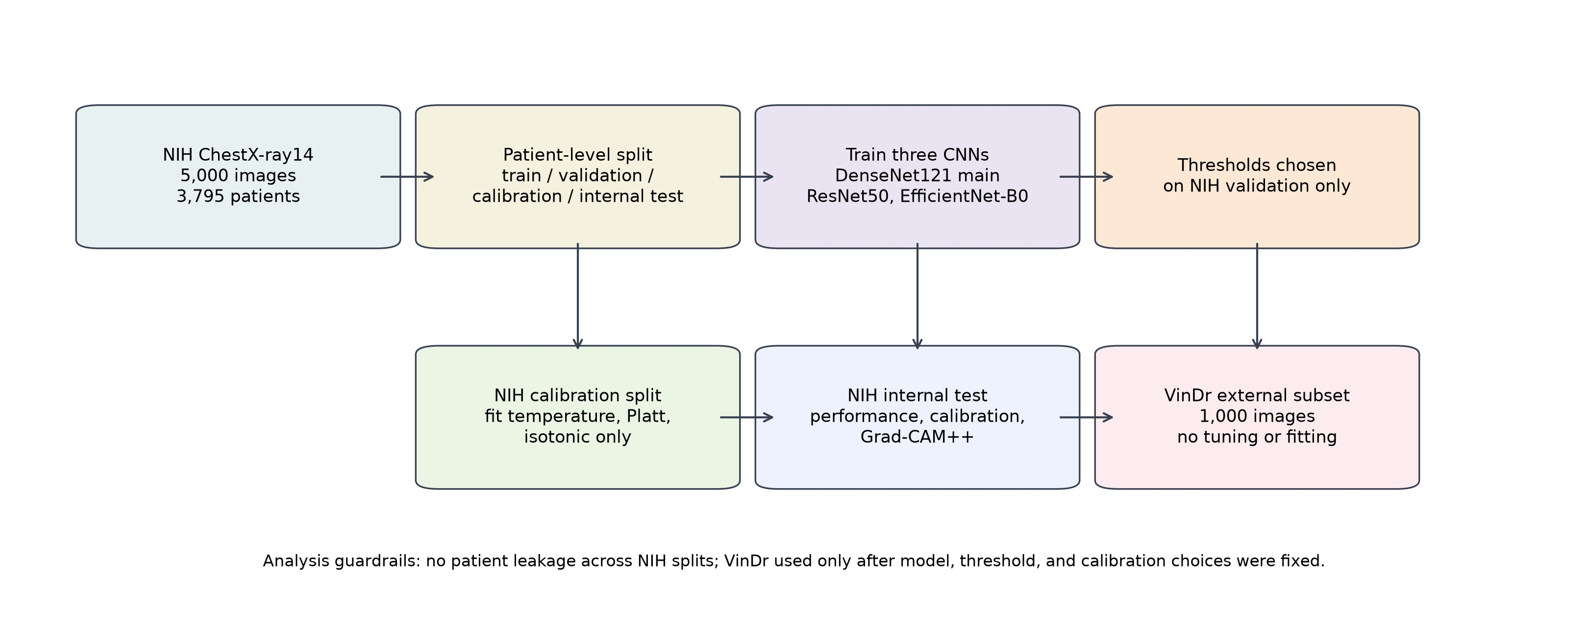
The workflow separates NIH training, validation threshold selection, NIH-only calibration fitting, internal testing, and independent VinDr external validation.

Figure 2. DenseNet121 internal and external AUROC/AUPRC
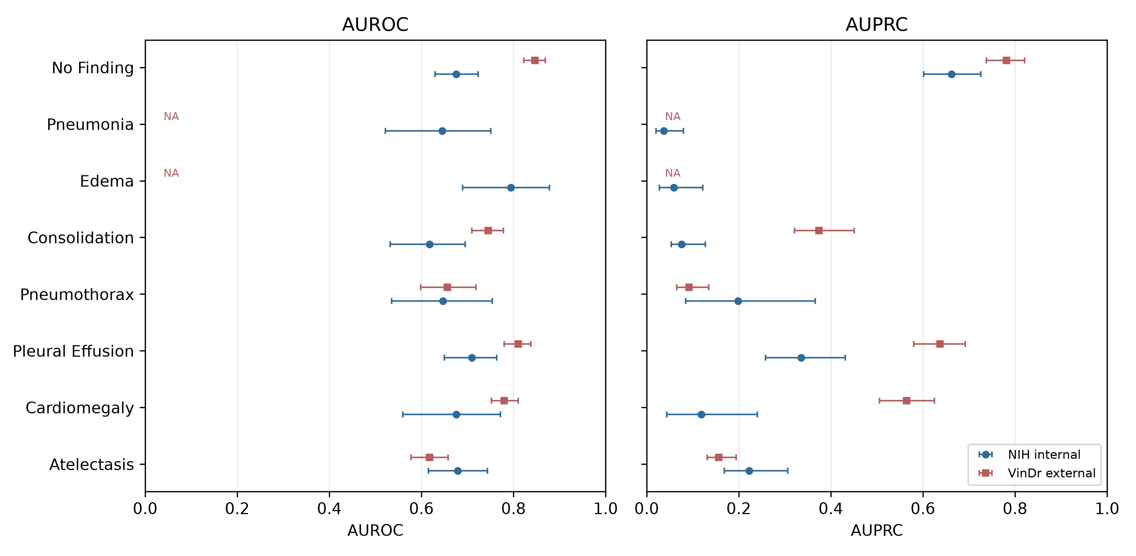
Label-wise AUROC and AUPRC with 95% bootstrap intervals. Edema and Pneumonia are marked NA externally because the analyzed external subset had zero positive cases.

Figure 3. AUPRC baseline and lift
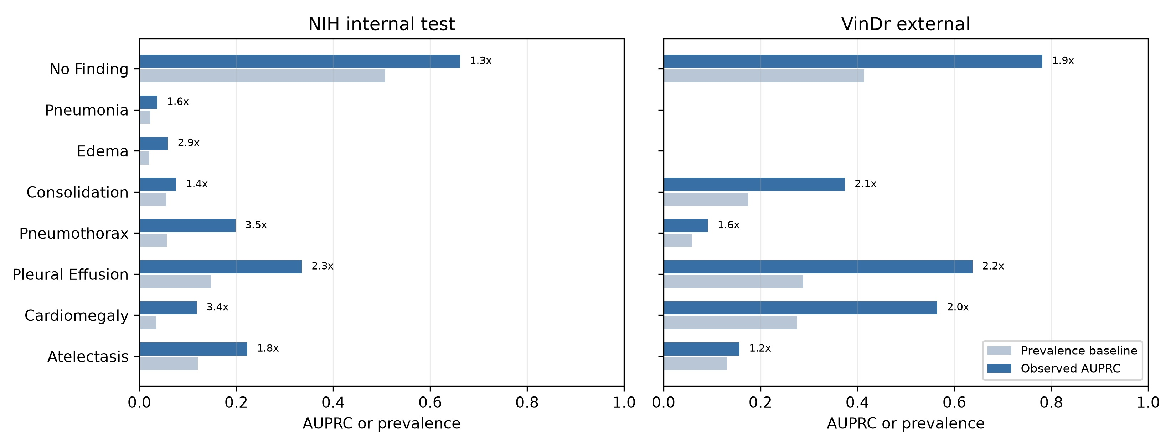
Observed AUPRC is shown against prevalence baseline to contextualize precision-recall performance under label imbalance.

Figure 4. Calibration curves
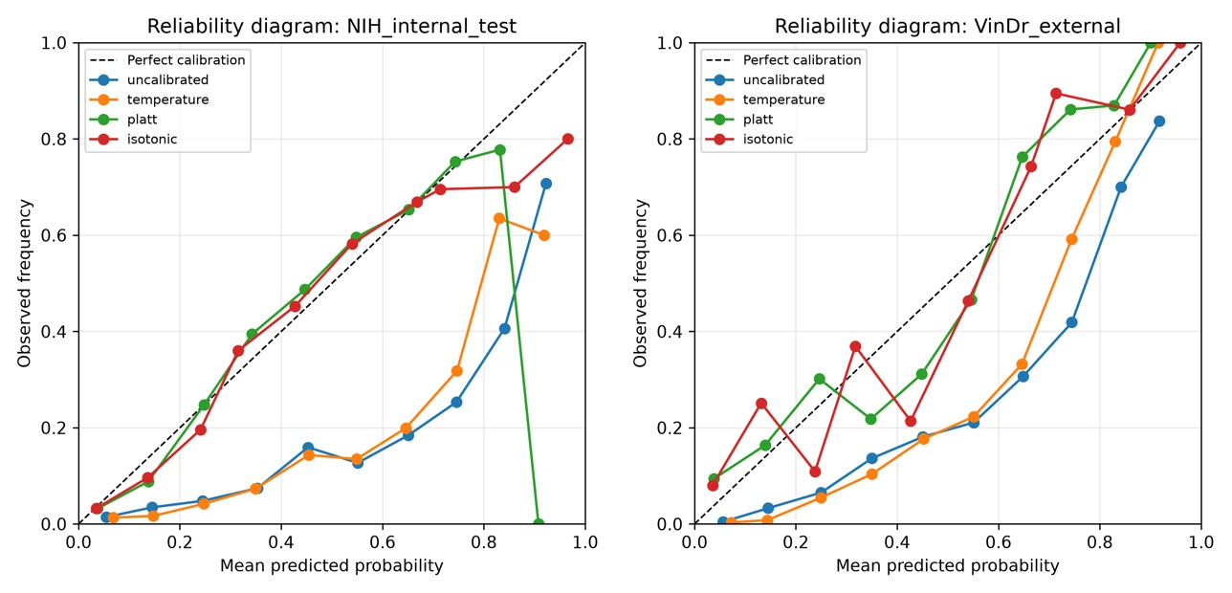
Reliability diagrams for NIH internal and VinDr external predictions. Calibration models were fitted only on the NIH calibration split.

Figure 5. Grad-CAM++ failure-mode panels
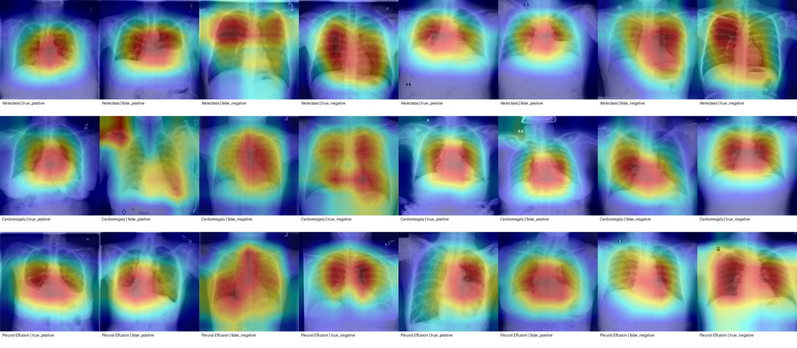
Representative true-positive, false-positive, false-negative, and true-negative panels. Grad-CAM++ is used only for qualitative failure-mode analysis.

Figure 6. Internal-minus-external AUROC difference
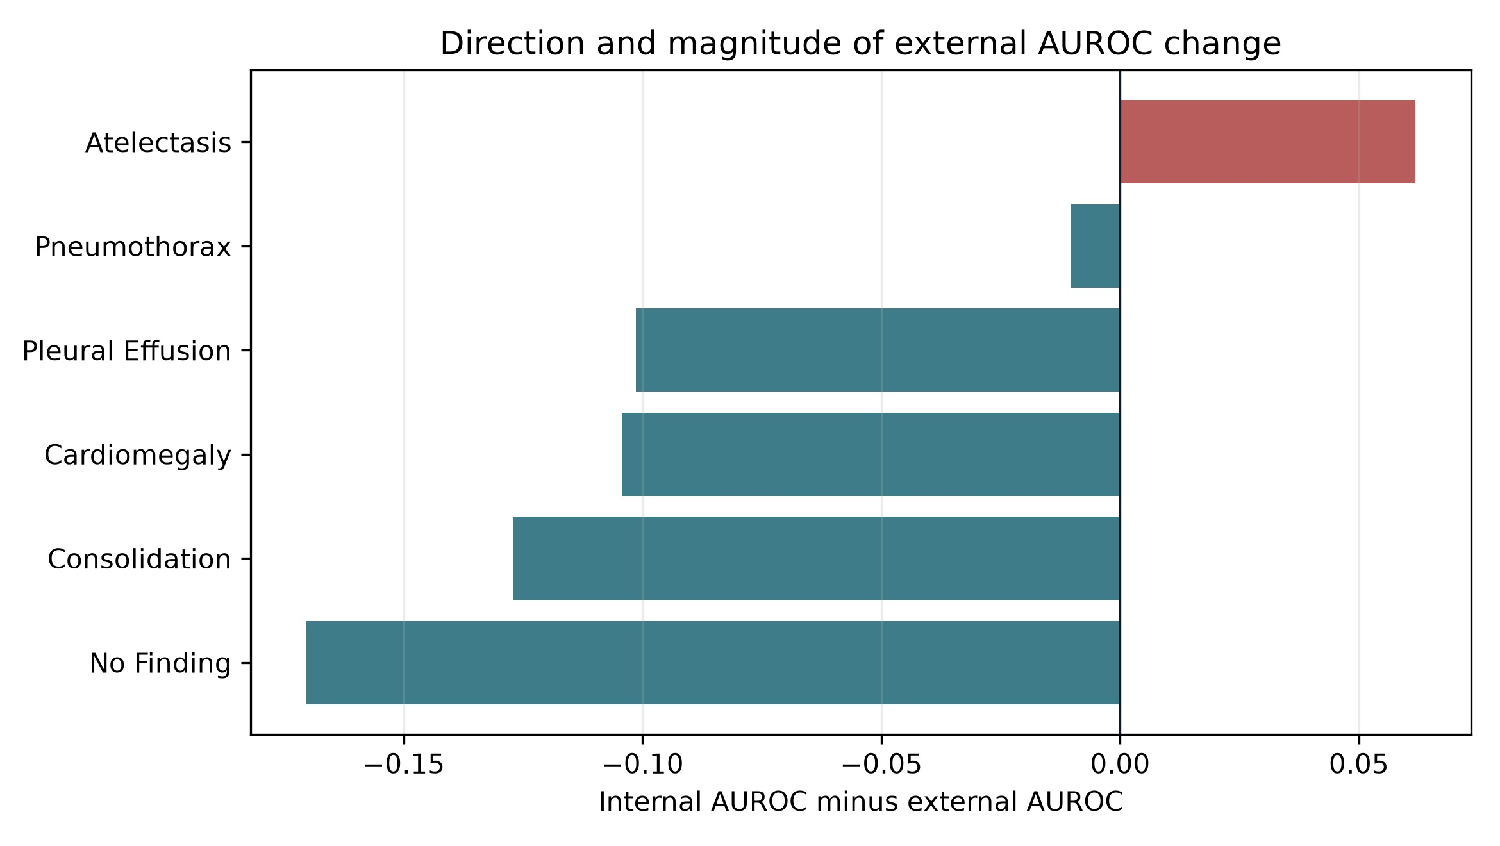
Negative values indicate higher AUROC in the selected external subset; the plot should be interpreted with prevalence and label-source differences.

Supplementary Materials
- Supplementary Table 1: ResNet50 label-wise performance.
- Supplementary Table 2: EfficientNet-B0 label-wise performance.
- Supplementary Table 3: per-label thresholds from NIH validation.
- Supplementary Table 4: AUPRC prevalence baseline and lift.
- Supplementary Table 5: per-label calibration metrics.
- Supplementary Table 6: paired patient-level bootstrap model comparison.
- Supplementary Table 7: hyperparameters and environment.
- Supplementary Table 8: reproducibility commands.
- Supplementary Table 9: MedMNIST verification status, documenting that no MedMNIST metric is used as manuscript evidence.
- Supplementary Figure 1: ROC and PR curves for DenseNet121.
- Supplementary Figure 2: predicted probability distributions for DenseNet121.

Supplementary excerpt: paired bootstrap model comparison
dataset | label_set | metric | model_a | model_b | difference_a_minus_b | ci_lower | ci_upper | ci_excludes_zero
NIH internal test | all_valid_labels | auroc | DenseNet121 | ResNet50 | 0.033 | 0.007 | 0.064 | True
NIH internal test | all_valid_labels | auroc | DenseNet121 | EfficientNet-B0 | 0.024 | -0.007 | 0.054 | False
NIH internal test | all_valid_labels | auroc | ResNet50 | EfficientNet-B0 | -0.009 | -0.046 | 0.026 | False
NIH internal test | all_valid_labels | auprc | DenseNet121 | ResNet50 | 0.013 | -0.010 | 0.036 | False
NIH internal test | all_valid_labels | auprc | DenseNet121 | EfficientNet-B0 | -0.004 | -0.030 | 0.011 | False
NIH internal test | all_valid_labels | auprc | ResNet50 | EfficientNet-B0 | -0.017 | -0.042 | 0.000 | False
NIH internal test | external_evaluable_labels | auroc | DenseNet121 | ResNet50 | 0.014 | -0.016 | 0.045 | False
NIH internal test | external_evaluable_labels | auroc | DenseNet121 | EfficientNet-B0 | -0.006 | -0.037 | 0.020 | False
NIH internal test | external_evaluable_labels | auroc | ResNet50 | EfficientNet-B0 | -0.021 | -0.046 | 0.006 | False
NIH internal test | external_evaluable_labels | auprc | DenseNet121 | ResNet50 | 0.014 | -0.016 | 0.042 | False
NIH internal test | external_evaluable_labels | auprc | DenseNet121 | EfficientNet-B0 | -0.002 | -0.032 | 0.019 | False
NIH internal test | external_evaluable_labels | auprc | ResNet50 | EfficientNet-B0 | -0.017 | -0.044 | 0.007 | False

Supplementary excerpt: AUPRC baseline/lift
model | dataset | label | positives | auprc | auprc_baseline_prevalence | auprc_lift_over_prevalence | status
DenseNet121 | NIH internal test | Atelectasis | 89 | 0.222 | 0.120 | 1.847 | evaluable
DenseNet121 | NIH internal test | Cardiomegaly | 26 | 0.119 | 0.035 | 3.368 | evaluable
DenseNet121 | NIH internal test | Pleural Effusion | 109 | 0.335 | 0.147 | 2.273 | evaluable
DenseNet121 | NIH internal test | Pneumothorax | 42 | 0.198 | 0.057 | 3.487 | evaluable
DenseNet121 | NIH internal test | Consolidation | 41 | 0.076 | 0.055 | 1.368 | evaluable
DenseNet121 | NIH internal test | Edema | 15 | 0.059 | 0.020 | 2.910 | evaluable
DenseNet121 | NIH internal test | Pneumonia | 17 | 0.037 | 0.023 | 1.608 | evaluable
DenseNet121 | NIH internal test | No Finding | 375 | 0.662 | 0.507 | 1.304 | evaluable
DenseNet121 | VinDr external | Atelectasis | 131 | 0.157 | 0.131 | 1.195 | evaluable
DenseNet121 | VinDr external | Cardiomegaly | 276 | 0.565 | 0.276 | 2.046 | evaluable
DenseNet121 | VinDr external | Pleural Effusion | 288 | 0.637 | 0.288 | 2.213 | evaluable
DenseNet121 | VinDr external | Pneumothorax | 59 | 0.092 | 0.059 | 1.552 | evaluable
DenseNet121 | VinDr external | Consolidation | 175 | 0.374 | 0.175 | 2.138 | evaluable
DenseNet121 | VinDr external | Edema | 0 | NA | 0.000 | NA | not evaluable
DenseNet121 | VinDr external | Pneumonia | 0 | NA | 0.000 | NA | not evaluable
DenseNet121 | VinDr external | No Finding | 414 | 0.782 | 0.414 | 1.888 | evaluable

References
1. Wang X, Peng Y, Lu L, Lu Z, Bagheri M, Summers RM. ChestX-ray8: Hospital-scale chest X-ray database and benchmarks on weakly-supervised classification and localization of common thorax diseases. CVPR. 2017.
2. Nguyen HQ, Lam K, Le LT, et al. VinDr-CXR: An open dataset of chest X-rays with radiologist's annotations. Scientific Data. 2022;9:429.
3. Irvin J, Rajpurkar P, Ko M, et al. CheXpert: A large chest radiograph dataset with uncertainty labels and expert comparison. AAAI. 2019.
4. Johnson AEW, Pollard TJ, Berkowitz SJ, et al. MIMIC-CXR, a de-identified publicly available database of chest radiographs with free-text reports. Scientific Data. 2019;6:317.
5. Bustos A, Pertusa A, Salinas JM, de la Iglesia-Vaya M. PadChest: A large chest x-ray image dataset with multi-label annotated reports. Medical Image Analysis. 2020;66:101797.
6. Rajpurkar P, Irvin J, Zhu K, et al. CheXNet: Radiologist-level pneumonia detection on chest X-rays with deep learning. arXiv. 2017.
7. Rajpurkar P, Irvin J, Ball RL, et al. Deep learning for chest radiograph diagnosis: A retrospective comparison of the CheXNeXt algorithm to practicing radiologists. PLoS Medicine. 2018;15:e1002686.
8. Finlayson SG, Subbaswamy A, Singh K, et al. The clinician and dataset shift in artificial intelligence. New England Journal of Medicine. 2021;385:283-286.
9. Guo C, Pleiss G, Sun Y, Weinberger KQ. On calibration of modern neural networks. ICML. 2017.
10. Kuleshov V, Fenner N, Ermon S. Accurate uncertainties for deep learning using calibrated regression. ICML. 2018.
11. Selvaraju RR, Cogswell M, Das A, Vedantam R, Parikh D, Batra D. Grad-CAM: Visual explanations from deep networks via gradient-based localization. ICCV. 2017.
12. Chattopadhyay A, Sarkar A, Howlader P, Balasubramanian VN. Grad-CAM++: Generalized gradient-based visual explanations for deep convolutional networks. WACV. 2018.
13. Huang G, Liu Z, van der Maaten L, Weinberger KQ. Densely connected convolutional networks. CVPR. 2017.
14. He K, Zhang X, Ren S, Sun J. Deep residual learning for image recognition. CVPR. 2016.
15. Tan M, Le QV. EfficientNet: Rethinking model scaling for convolutional neural networks. ICML. 2019.
16. Mongan J, Moy L, Kahn CE Jr. Checklist for artificial intelligence in medical imaging (CLAIM): A guide for authors and reviewers. Radiology: Artificial Intelligence. 2020;2:e200029.
17. Tejani AS, Klontzas ME, Gatti AA, et al. Checklist for artificial intelligence in medical imaging (CLAIM): 2024 update. Radiology: Artificial Intelligence. 2024.
18. Collins GS, Dhiman P, Andaur Navarro CL, et al. Protocol for development of a reporting guideline for prediction model studies using machine learning: TRIPOD+AI. BMJ. 2024.
19. Liu X, Rivera SC, Moher D, Calvert MJ, Denniston AK. Reporting guidelines for clinical trial reports for interventions involving artificial intelligence: CONSORT-AI extension. Nature Medicine. 2020.
20. Rivera SC, Liu X, Chan AW, Denniston AK, Calvert MJ. Guidelines for clinical trial protocols for interventions involving artificial intelligence: SPIRIT-AI extension. BMJ. 2020.
21. Vasey B, Nagendran M, Campbell B, et al. Reporting guideline for the early-stage clinical evaluation of decision support systems driven by artificial intelligence: DECIDE-AI. Nature Medicine. 2022.
22. Bossuyt PM, Reitsma JB, Bruns DE, et al. STARD 2015: An updated list of essential items for reporting diagnostic accuracy studies. BMJ. 2015;351:h5527.
23. Wolff RF, Moons KGM, Riley RD, et al. PROBAST: A tool to assess the risk of bias and applicability of prediction model studies. Annals of Internal Medicine. 2019;170:51-58.
24. Nagendran M, Chen Y, Lovejoy CA, et al. Artificial intelligence versus clinicians: Systematic review of design, reporting standards, and claims. BMJ. 2020;368:m689.
25. Davis J, Goadrich M. The relationship between precision-recall and ROC curves. ICML. 2006.
26. Saito T, Rehmsmeier M. The precision-recall plot is more informative than the ROC plot when evaluating binary classifiers on imbalanced datasets. PLoS ONE. 2015;10:e0118432.

