Route B Large Public-Dataset Validation Report: NIH ChestX-ray14 to VinDr-CXR/VinBigData-derived External Validation
Evidence source: real public Hugging Face NIH ChestX-ray14 parquet subset and real public VinDr-CXR/VinBigData-derived PNG subset. No synthetic metrics were used. Thresholds were derived only from NIH validation. Calibration models were fitted only on NIH calibration.

Executive Summary
The upgraded Route B experiment expanded the development data to 5000 NIH images from 3795 patients and expanded external validation to 1000 VinDr-derived images. DenseNet121 completed 5 epochs; the best checkpoint was selected at epoch 2 by validation macro AUPRC (0.277). Internal macro AUROC/AUPRC were 0.680/0.214; external macro AUROC/AUPRC were 0.743/0.434.
Architecture comparators were trained under the same NIH split and validation-threshold rule. ResNet50 internal macro AUROC/AUPRC were 0.647/0.200, and external macro AUROC/AUPRC were 0.728/0.418; EfficientNet-B0 internal macro AUROC/AUPRC were 0.656/0.218, and external macro AUROC/AUPRC were 0.656/0.370. These comparator results are reported as model-comparison evidence rather than replacing the prespecified DenseNet121 main analysis.

Data Expansion Plan and Execution
NIH expansion was performed by downloading multiple public Hugging Face parquet shards, extracting image bytes to PNG files, harmonizing target labels, and creating patient-level train/validation/calibration/internal-test splits.
VinDr expansion was performed from a public VinDr-CXR/VinBigData-derived PNG mirror. Images were selected from available cached public files with enrichment for externally mappable labels and No Finding. VinDr images remained fully independent from NIH training, validation, threshold selection, and calibration fitting.
The large-run project structure uses metadata_large/, splits_large/, predictions_large/, tables_large/, figures_large/, models_large/, logs_large/, and outputs_large/ so that the original small public-subset experiment remains intact as supplementary evidence.

Methods to Update Manuscript
- Title: describe the study as an expanded public-subset NIH to VinDr-CXR/VinBigData-derived external validation, not as a full official-cohort validation.
- Abstract: replace small-subset values with large-run sample sizes, macro AUROC/AUPRC, calibration metrics, and Grad-CAM++ case count.
- Methods: add Hugging Face parquet/PNG extraction details, patient-level splitting, validation-only thresholds, NIH-only calibration fitting, and external independence rules.
- Results: use Table 1-5 and Figure 1-5 from tables_large/ and figures_large/ only.
- Discussion: emphasize dataset shift, label-source heterogeneity, class imbalance, and calibration transfer limits.
- Limitations: explicitly state that Edema and Pneumonia are unavailable as external labels in the VinDr-derived subset and should not support external primary claims.
- Conclusion: keep claims limited to public-dataset validation and reproducible pipeline evidence; do not claim clinical readiness.

Results
Internal macro AUROC was 0.680 and macro AUPRC was 0.214. External macro AUROC was 0.743 and macro AUPRC was 0.434. The macro AUROC internal-minus-external difference was -0.062, indicating no observed AUROC degradation in this selected public external subset.
Internal uncalibrated macro Brier score was 0.193, ECE was 0.269, and MCE was 0.539. Temperature scaling produced internal macro ECE 0.280 and external macro ECE 0.214. ECE improvement should be interpreted together with slope and intercept because Platt or isotonic methods can reduce bin-wise error while creating unstable probability-scale slopes in sparse or imbalanced labels.
Grad-CAM++ generated 60 TP/FP/FN/TN examples across NIH internal and external validation for failure-mode review. These maps are not used as proof of clinical reasoning.

Table 1. Dataset Characteristics
split | n_patients | n_images
calibration | 379 | 751
internal_test | 379 | 739
train | 2657 | 2679
validation | 380 | 831
VinDr-derived external | 1000 | 1000

Table 2. Label Harmonization
harmonized_label | nih_terms | vindr_terms | role
Atelectasis | Atelectasis | Atelectasis | primary
Cardiomegaly | Cardiomegaly | Cardiomegaly | primary
Pleural Effusion | Effusion; Pleural Effusion | Pleural effusion; Pleural Effusion; Effusion | primary
Pneumothorax | Pneumothorax | Pneumothorax | primary
Consolidation | Consolidation | Consolidation | primary
Edema | Edema | Pulmonary edema; Edema | conditional_primary
Pneumonia | Pneumonia | Pneumonia | sensitivity
No Finding | No Finding; No finding | No finding; No Finding; No abnormality | sensitivity

Table 3. Internal and External Performance by Label and Model with Prevalence and 95% CI
model | dataset | label | prevalence | AUROC (95% CI) | AUPRC (95% CI) | F1
DenseNet121 | NIH internal | Atelectasis | 0.120 | 0.679 (0.616-0.743) | 0.222 (0.169-0.306) | 0.246
DenseNet121 | NIH internal | Cardiomegaly | 0.035 | 0.675 (0.560-0.771) | 0.119 (0.043-0.240) | 0.182
DenseNet121 | NIH internal | Pleural Effusion | 0.147 | 0.709 (0.650-0.763) | 0.335 (0.258-0.431) | 0.342
DenseNet121 | NIH internal | Pneumothorax | 0.057 | 0.646 (0.535-0.754) | 0.198 (0.085-0.366) | 0.203
DenseNet121 | NIH internal | Consolidation | 0.055 | 0.618 (0.532-0.695) | 0.076 (0.053-0.127) | 0.155
DenseNet121 | NIH internal | Edema | 0.020 | 0.794 (0.689-0.878) | 0.059 (0.028-0.122) | 0.144
DenseNet121 | NIH internal | Pneumonia | 0.023 | 0.645 (0.522-0.751) | 0.037 (0.020-0.080) | 0.059
DenseNet121 | NIH internal | No Finding | 0.507 | 0.676 (0.630-0.723) | 0.662 (0.601-0.726) | 0.671
DenseNet121 | VinDr external | Atelectasis | 0.131 | 0.617 (0.577-0.658) | 0.157 (0.132-0.194) | 0.117
DenseNet121 | VinDr external | Cardiomegaly | 0.276 | 0.780 (0.752-0.810) | 0.565 (0.505-0.625) | 0.353
DenseNet121 | VinDr external | Pleural Effusion | 0.288 | 0.811 (0.779-0.838) | 0.637 (0.580-0.692) | 0.622
DenseNet121 | VinDr external | Pneumothorax | 0.059 | 0.657 (0.598-0.718) | 0.092 (0.066-0.135) | 0.147
DenseNet121 | VinDr external | Consolidation | 0.175 | 0.745 (0.710-0.778) | 0.374 (0.321-0.450) | 0.273
DenseNet121 | VinDr external | Edema | 0.000 | NA (NA-NA) | NA (NA-NA) | NA
DenseNet121 | VinDr external | Pneumonia | 0.000 | NA (NA-NA) | NA (NA-NA) | NA
DenseNet121 | VinDr external | No Finding | 0.414 | 0.846 (0.823-0.869) | 0.782 (0.738-0.821) | 0.634
ResNet50 | NIH internal | Atelectasis | 0.120 | 0.668 (0.601-0.735) | 0.215 (0.161-0.306) | 0.302
ResNet50 | NIH internal | Cardiomegaly | 0.035 | 0.609 (0.479-0.739) | 0.097 (0.037-0.227) | 0.106
ResNet50 | NIH internal | Pleural Effusion | 0.147 | 0.712 (0.659-0.765) | 0.378 (0.290-0.468) | 0.380
ResNet50 | NIH internal | Pneumothorax | 0.057 | 0.659 (0.561-0.743) | 0.097 (0.063-0.166) | 0.162
ResNet50 | NIH internal | Consolidation | 0.055 | 0.585 (0.501-0.667) | 0.067 (0.049-0.102) | 0.140
ResNet50 | NIH internal | Edema | 0.020 | 0.714 (0.575-0.835) | 0.052 (0.021-0.118) | 0.109
ResNet50 | NIH internal | Pneumonia | 0.023 | 0.543 (0.437-0.650) | 0.025 (0.015-0.044) | 0.037
ResNet50 | NIH internal | No Finding | 0.507 | 0.684 (0.637-0.734) | 0.672 (0.606-0.729) | 0.662
ResNet50 | VinDr external | Atelectasis | 0.131 | 0.701 (0.662-0.741) | 0.233 (0.184-0.289) | 0.275
ResNet50 | VinDr external | Cardiomegaly | 0.276 | 0.621 (0.578-0.658) | 0.401 (0.349-0.467) | 0.391
ResNet50 | VinDr external | Pleural Effusion | 0.288 | 0.800 (0.768-0.834) | 0.667 (0.608-0.724) | 0.615
ResNet50 | VinDr external | Pneumothorax | 0.059 | 0.663 (0.602-0.726) | 0.088 (0.066-0.122) | 0.131
ResNet50 | VinDr external | Consolidation | 0.175 | 0.764 (0.730-0.799) | 0.375 (0.317-0.450) | 0.377
ResNet50 | VinDr external | Edema | 0.000 | NA (NA-NA) | NA (NA-NA) | NA
ResNet50 | VinDr external | Pneumonia | 0.000 | NA (NA-NA) | NA (NA-NA) | NA
ResNet50 | VinDr external | No Finding | 0.414 | 0.819 (0.792-0.843) | 0.747 (0.704-0.790) | 0.709
EfficientNet-B0 | NIH internal | Atelectasis | 0.120 | 0.660 (0.600-0.722) | 0.225 (0.165-0.314) | 0.254
EfficientNet-B0 | NIH internal | Cardiomegaly | 0.035 | 0.655 (0.539-0.771) | 0.087 (0.041-0.208) | 0.108
EfficientNet-B0 | NIH internal | Pleural Effusion | 0.147 | 0.737 (0.681-0.780) | 0.356 (0.268-0.460) | 0.376
EfficientNet-B0 | NIH internal | Pneumothorax | 0.057 | 0.692 (0.601-0.782) | 0.190 (0.104-0.356) | 0.187
EfficientNet-B0 | NIH internal | Consolidation | 0.055 | 0.592 (0.512-0.674) | 0.072 (0.050-0.111) | 0.123
EfficientNet-B0 | NIH internal | Edema | 0.020 | 0.740 (0.604-0.863) | 0.085 (0.030-0.219) | 0.118
EfficientNet-B0 | NIH internal | Pneumonia | 0.023 | 0.468 (0.313-0.637) | 0.030 (0.015-0.066) | 0.000
EfficientNet-B0 | NIH internal | No Finding | 0.507 | 0.706 (0.664-0.749) | 0.696 (0.635-0.753) | 0.694
EfficientNet-B0 | VinDr external | Atelectasis | 0.131 | 0.612 (0.566-0.657) | 0.175 (0.145-0.220) | 0.121
EfficientNet-B0 | VinDr external | Cardiomegaly | 0.276 | 0.585 (0.548-0.620) | 0.353 (0.312-0.408) | 0.102
EfficientNet-B0 | VinDr external | Pleural Effusion | 0.288 | 0.779 (0.745-0.808) | 0.651 (0.597-0.703) | 0.589
EfficientNet-B0 | VinDr external | Pneumothorax | 0.059 | 0.603 (0.533-0.663) | 0.091 (0.063-0.148) | 0.139
EfficientNet-B0 | VinDr external | Consolidation | 0.175 | 0.594 (0.551-0.640) | 0.245 (0.203-0.308) | 0.065
EfficientNet-B0 | VinDr external | Edema | 0.000 | NA (NA-NA) | NA (NA-NA) | NA
EfficientNet-B0 | VinDr external | Pneumonia | 0.000 | NA (NA-NA) | NA (NA-NA) | NA
EfficientNet-B0 | VinDr external | No Finding | 0.414 | 0.766 (0.737-0.794) | 0.707 (0.666-0.751) | 0.652

Table 3a. Macro-level Model Comparison
model | internal AUROC | internal AUPRC | external AUROC | external AUPRC | AUROC drop | AUPRC drop
DenseNet121 | 0.680 | 0.214 | 0.743 | 0.434 | -0.062 | -0.221
ResNet50 | 0.647 | 0.200 | 0.728 | 0.418 | -0.081 | -0.218
EfficientNet-B0 | 0.656 | 0.218 | 0.656 | 0.370 | -0.000 | -0.153

Table 4. Calibration Metrics
dataset | method | brier | ece | mce | slope | intercept
NIH_internal_test | uncalibrated | 0.193 | 0.269 | 0.539 | 0.633 | -2.285
NIH_internal_test | temperature | 0.189 | 0.280 | 0.556 | 0.821 | -2.286
NIH_internal_test | platt | 0.079 | 0.028 | 0.269 | 1.151 | 0.389
NIH_internal_test | isotonic | 0.081 | 0.031 | 0.286 | 0.405 | -1.389
VinDr_external | uncalibrated | 0.157 | 0.197 | 0.484 | 1.128 | -1.658
VinDr_external | temperature | 0.159 | 0.214 | 0.452 | 1.466 | -1.657
VinDr_external | platt | 0.120 | 0.099 | 0.236 | 2.436 | 3.957
VinDr_external | isotonic | 0.119 | 0.095 | 0.322 | 1.159 | 0.548

Table 5. Sensitivity and Subgroup Analysis
subgroup_variable | subgroup | n_images | n_patients | macro_auroc | macro_auprc | macro_f1 | macro_accuracy
sex | F | 299 | 160 | 0.681 | 0.246 | 0.265 | 0.752
sex | M | 440 | 219 | 0.674 | 0.189 | 0.225 | 0.786
view_position | AP | 356 | 220 | 0.652 | 0.202 | 0.229 | 0.690
view_position | PA | 383 | 249 | 0.678 | 0.232 | 0.241 | 0.849

Figure 1. Study Workflow
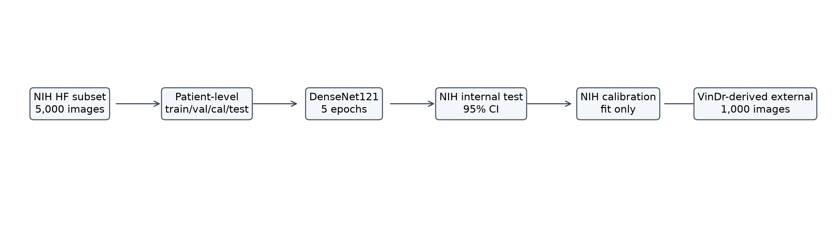
Expanded NIH development workflow with independent VinDr-derived external validation.

Figure 2. Internal vs External AUROC/AUPRC
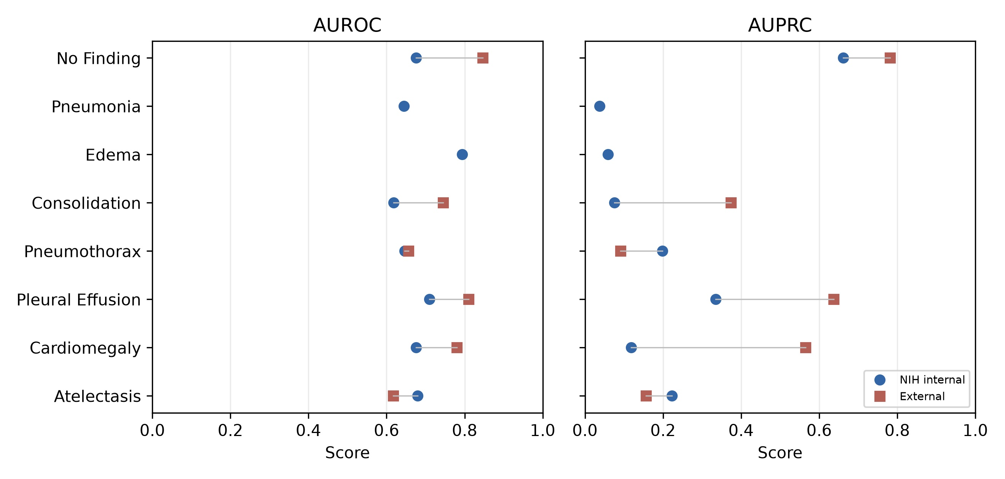
Label-wise internal and external discrimination metrics.

Figure 3. Calibration Curves
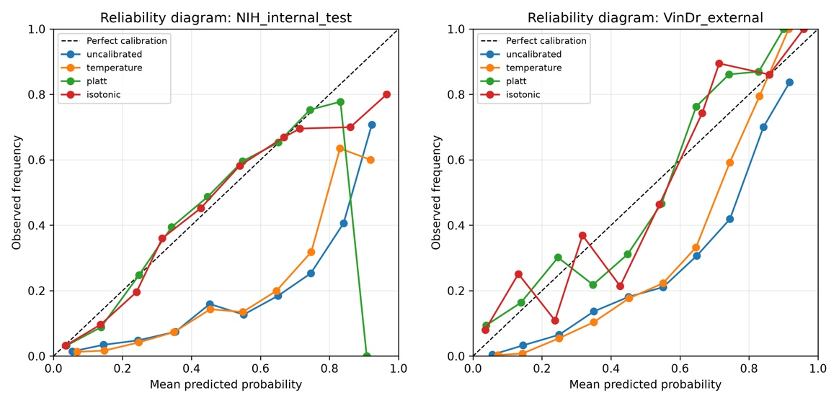
Reliability diagrams after NIH-only calibration fitting and transfer.

Figure 4. Grad-CAM++ Failure-mode Examples
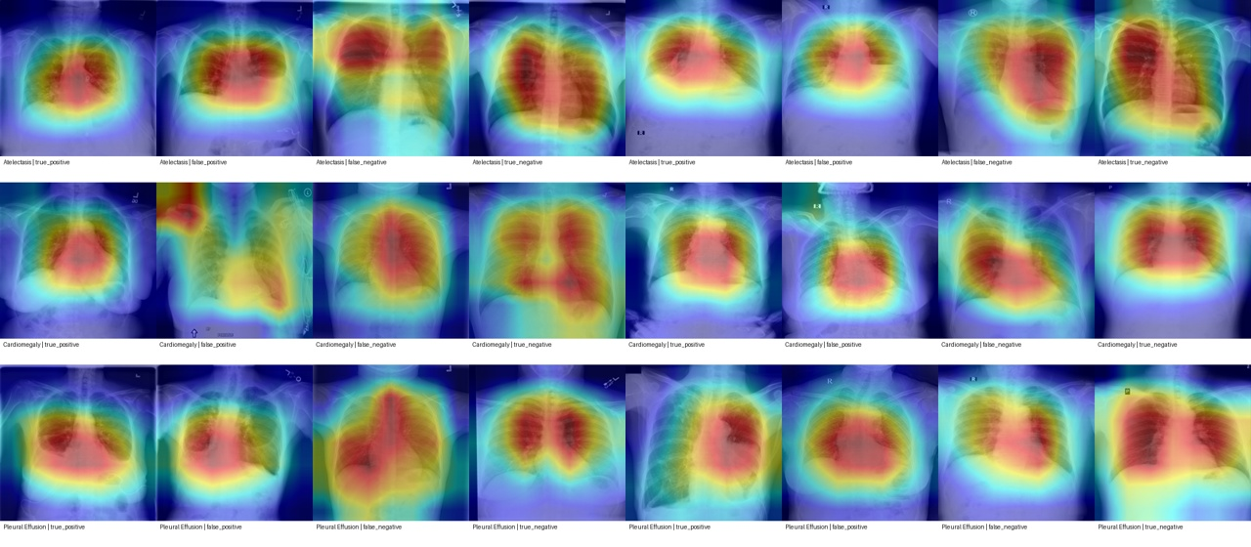
Representative TP/FP/FN/TN heatmap panels.

Figure 5. External Performance Drop by Label
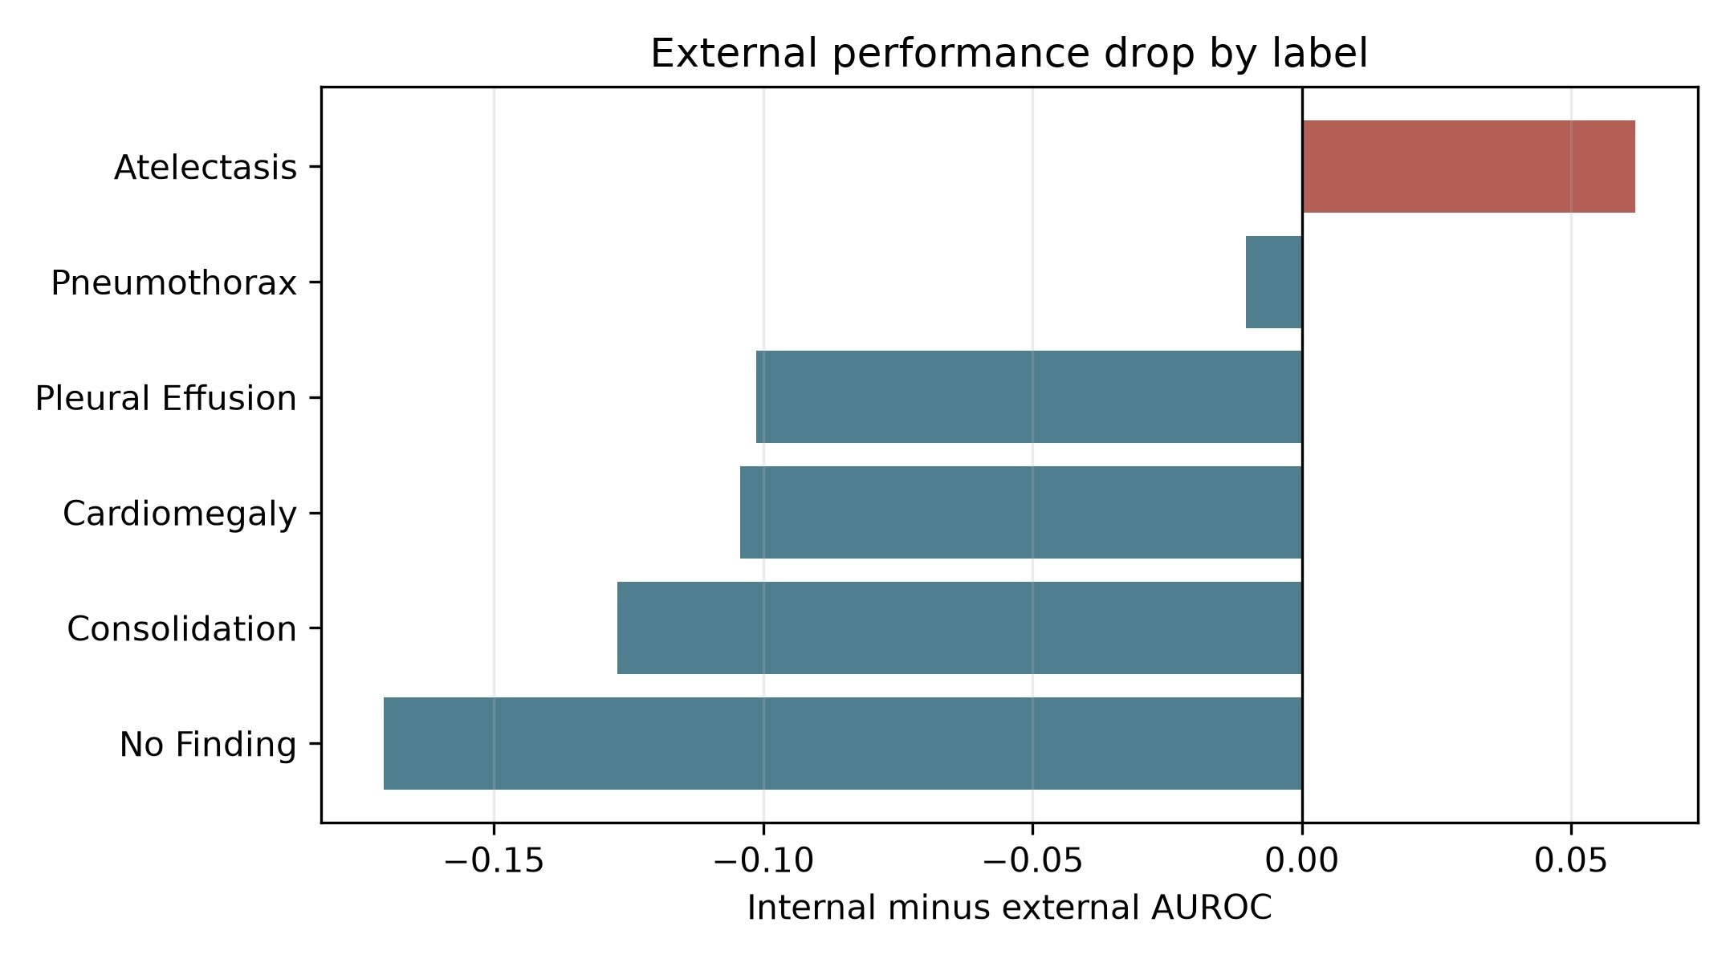
Internal minus external AUROC; negative values indicate higher AUROC in the external subset.

Supplementary Figure. Original Small Public-subset Result
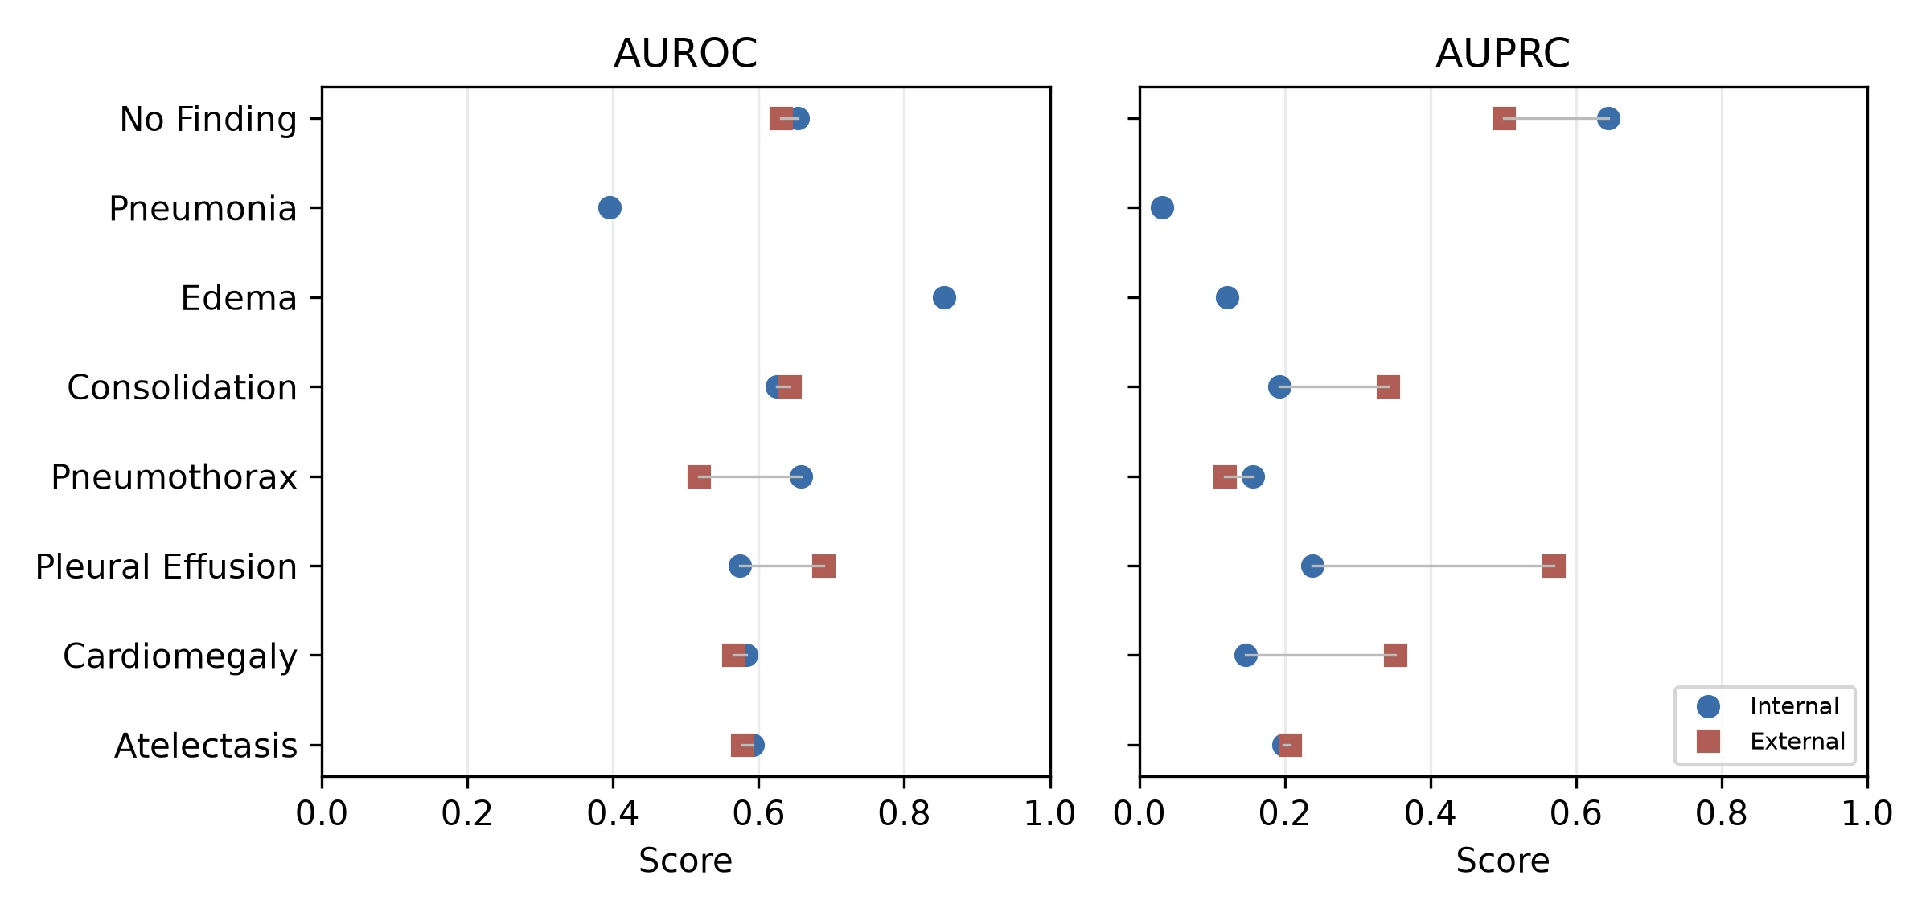
Small public-subset result retained as supplementary pipeline history.

Reviewer-risk Audit
- Subset rather than full official release: still present; mitigated by explicitly describing public executable subsets.
- Limited sample size: improved from 1229/494 to 5000/1000 images, but still not full cohort.
- Incomplete VinDr labels for Edema or Pneumonia: still present; these labels are excluded from external primary claims.
- Weak NIH report-mined labels: still present; discussed as label-noise limitation.
- Class imbalance: still present; handled with positive class weights and prevalence reporting.
- Confidence intervals: addressed with patient-level bootstrap CI.
- Calibration overclaiming: mitigated by reporting Brier, ECE, MCE, slope, intercept, and caution about unstable post-hoc calibration.
- Grad-CAM overinterpretation: mitigated by explicitly limiting Grad-CAM++ to failure-mode analysis.

Re-run Commands
.\.venv\Scripts\python.exe scripts\prepare_hf_large.py --nih-max-images 5000 --nih-train-shards 5 --vindr-target-images 1000 --epochs 5
.\.venv\Scripts\python.exe scripts\train.py --config configs\hf_large.yaml
.\.venv\Scripts\python.exe scripts\evaluate_internal.py --config configs\hf_large.yaml
.\.venv\Scripts\python.exe scripts\evaluate_external.py --config configs\hf_large.yaml
.\.venv\Scripts\python.exe scripts\calibration.py --config configs\hf_large.yaml
.\.venv\Scripts\python.exe scripts\gradcam.py --config configs\hf_large.yaml --max-cases-per-label 1
.\.venv\Scripts\python.exe scripts\make_resnet50_config.py
.\.venv\Scripts\python.exe scripts\train.py --config configs\hf_large_resnet50.yaml
.\.venv\Scripts\python.exe scripts\evaluate_internal.py --config configs\hf_large_resnet50.yaml
.\.venv\Scripts\python.exe scripts\evaluate_external.py --config configs\hf_large_resnet50.yaml
.\.venv\Scripts\python.exe scripts\calibration.py --config configs\hf_large_resnet50.yaml
.\.venv\Scripts\python.exe scripts\gradcam.py --config configs\hf_large_resnet50.yaml --max-cases-per-label 1
.\.venv\Scripts\python.exe scripts\make_efficientnet_b0_config.py
.\.venv\Scripts\python.exe scripts\train.py --config configs\hf_large_efficientnet_b0.yaml
.\.venv\Scripts\python.exe scripts\evaluate_internal.py --config configs\hf_large_efficientnet_b0.yaml
.\.venv\Scripts\python.exe scripts\evaluate_external.py --config configs\hf_large_efficientnet_b0.yaml
.\.venv\Scripts\python.exe scripts\calibration.py --config configs\hf_large_efficientnet_b0.yaml
.\.venv\Scripts\python.exe scripts\gradcam.py --config configs\hf_large_efficientnet_b0.yaml --max-cases-per-label 1
.\.venv\Scripts\python.exe scripts\build_large_assets.py

