**Using Auto Suggest Behavior In Adf**

### Creating the data controls

### Create a new ADF application. For eg, we have created an ADF application named ‘POCAutoSuggest’

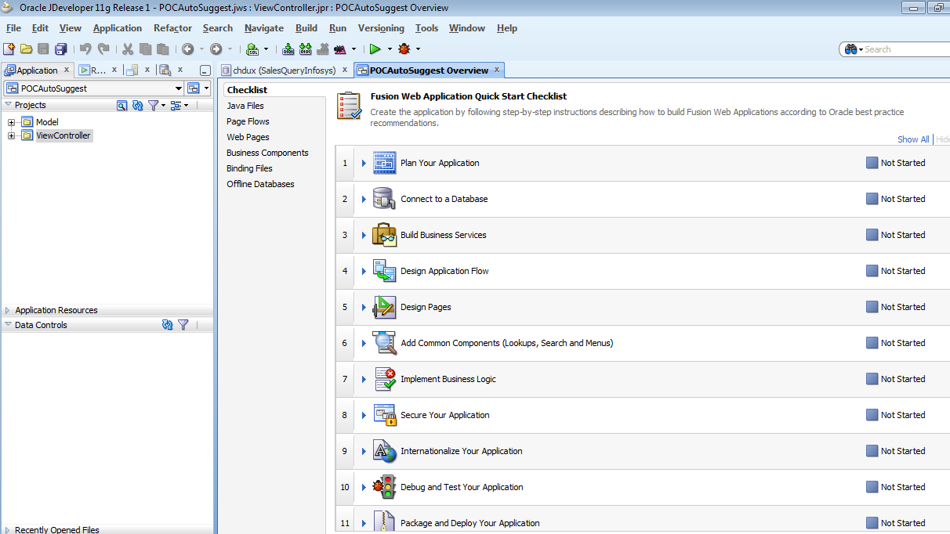

* 1. Create the required business components from which the auto suggest values need to be retrieved/searched upon. Here, we have a simple EO and VO created on a basic table ‘Emp’

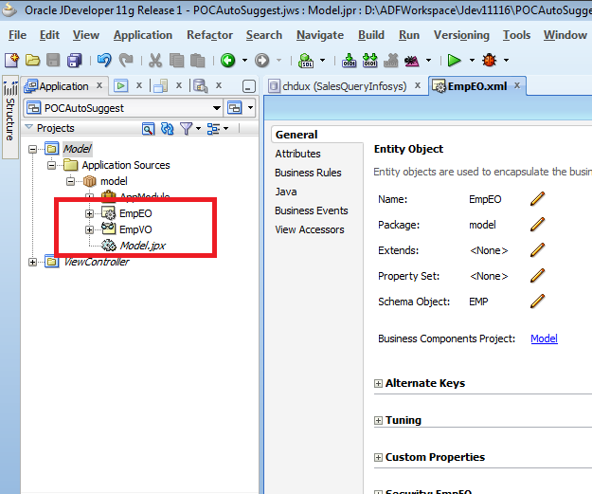

* 1. Test the business components created by right clicking on Application module and then click on Run.

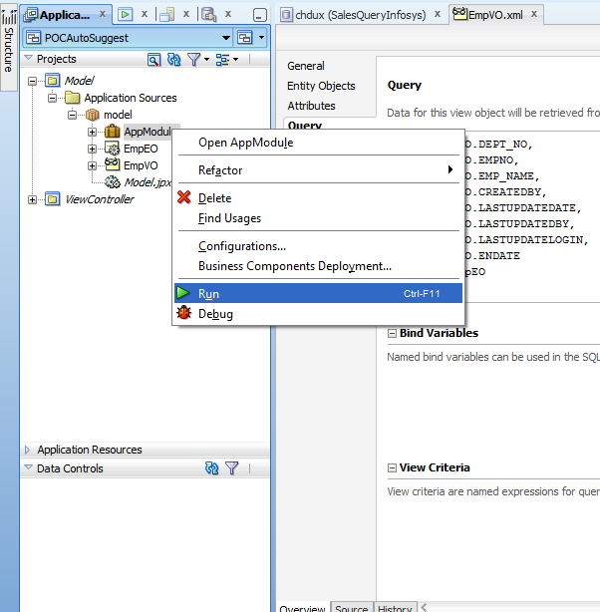

* 1. Right click on the VO (the one just created) in Business Component Browser and click on ‘Show Table’

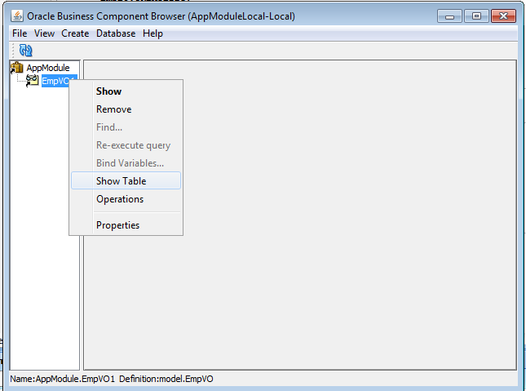

* 1. Observe the result of the VO to verify that it has been created correctly.

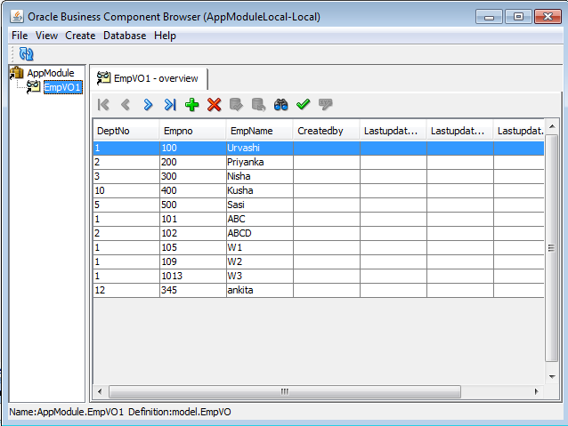

### Configuring LOV in the View Object BC

* 1. In the ‘Attributes’ node of the view object, select the attribute on which auto suggest is to be based upon and then click on ‘+’ in the ‘List of Values’ section to add the respective LOV.

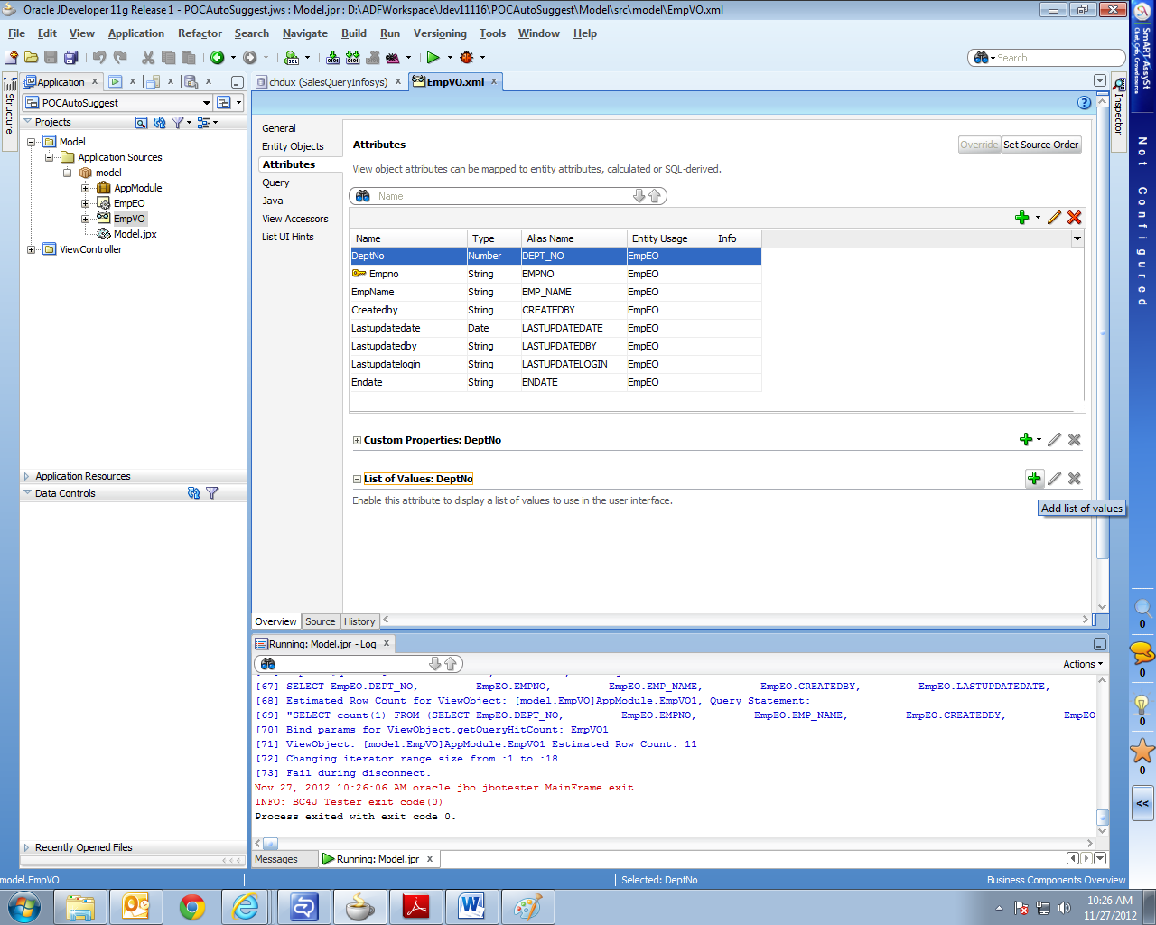

* 1. In the ‘Create List of Values’ window – Configurations tab, select the respective data source and the attribute values and add a new row containing the required attributes in the ‘List Return Values’ section.

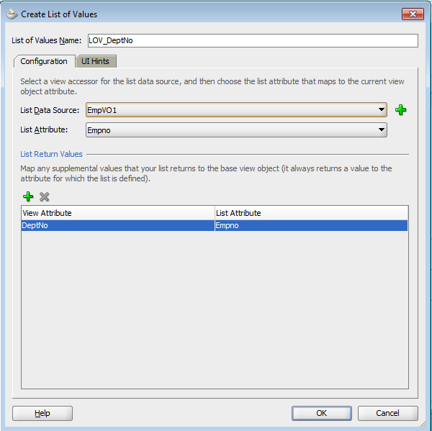

* 1. In the ‘Create List of Values’ window – UI Hints tab, select ‘Choice List’ for Default List Type, shuttle the auto suggest attribute to the Selected section in the ‘Display Attributes’ part and uncheck the Include ‘No Selection’ Item checkbox. Click on OK to finish the LOV configuration.

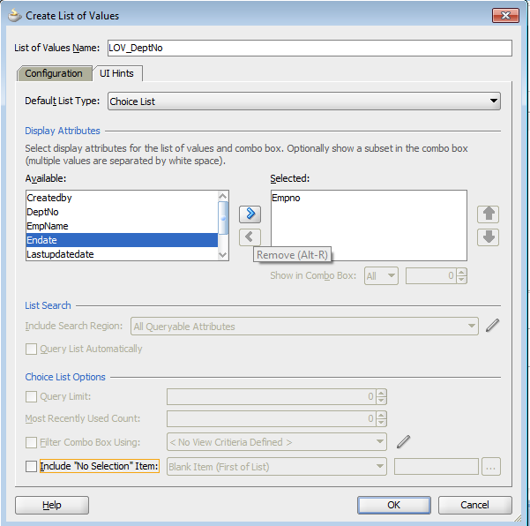

### Using and testing Auto Suggest on ADF screen

* 1. Open the screen on which you need to add the auto suggest feature. Here, for demo purpose, we have created a new jspx page ‘autosuggest.jspx’

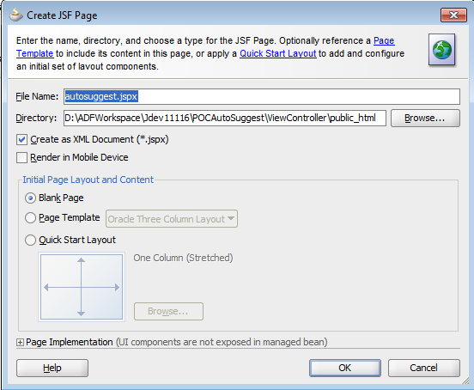

* 1. From the Data Controls section, drag the auto suggest attribute (EmpNo in our case) to the jspx page and select the component List of Values -> ADF LOV Choice List. Please note that the auto suggest feature can also be used in other components like inputText etc.

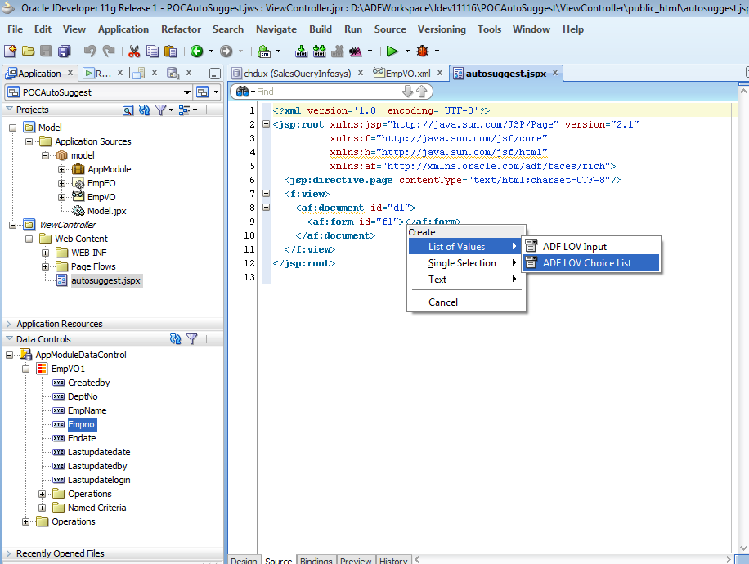

* 1. In the Edit List Binding window, select the Base Data Source as the corresponding VO and select the attribute and the LOV (that was configured in Step 2) in the drop downs as below.

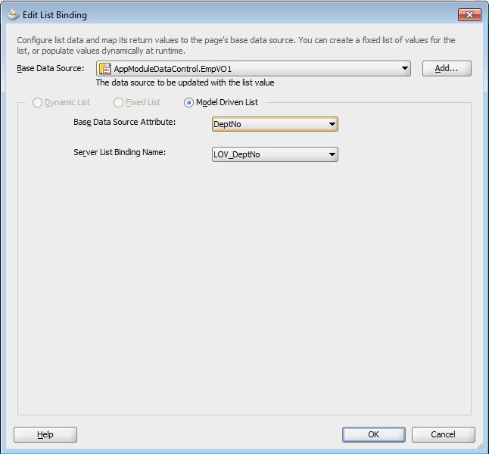

* 1. The jspx page will be seen with the inputComboboxListOfValues source code as below.

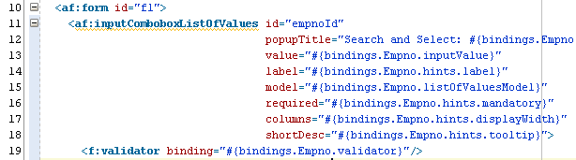

* 1. From the Component palette, drag the Auto Suggest Behavior component and drop it inside the inputComboboxListofValues just created.

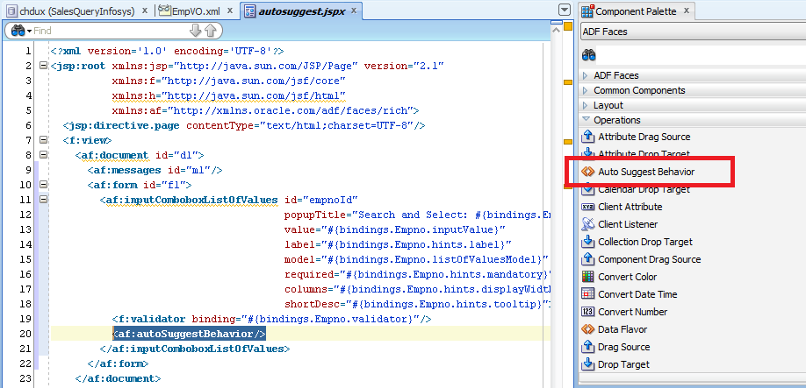

* 1. Add suggestedItems attribute to this autoSuggestBehavior tag as below. This attribute should refer to the same attribute binding on which input component has been created i.e. Empno in our case.

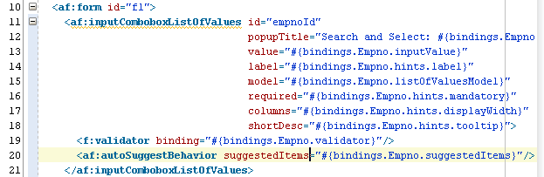

* 1. Run the jspx page to see the result. Enter some value in the input box as a result of which the suggestions for the accurate values from the database are shown. For eg, here we see that on entering value ‘1’ in the Empno field, the values of Empno starting from ‘1’ are being shown as suggestions for the user.

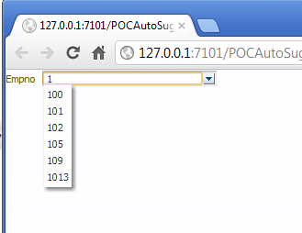

**Reference:**

<http://www.javacup.co.in/AutoSuggetsLov.html>