**Creating Self –Signed Certificate**

**in Web Logic Server**

# **Steps taken to create the SSL Certificate in WebLogic**

## Navigate to the JRE/bin path and execute the keytool.exe to verify if that is installed properly.

## Create the directory csr

mkdir csr

## Execute the keytool command to generate the identity.jks

keytool -genkey -alias testCert -keyalg RSA -keypass privatepassword -keystore identity.jks -storepass password -validity 365

## Enter the information asked for Organization, State, City and Country

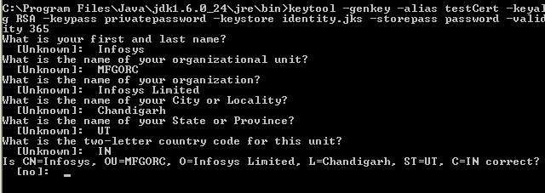

## Now, you need to export the certificate from identity keystore into root.cer

keytool -export -alias testCert -file root.cer -keystore identity.jks

Enter the password- password (mentioned above)



## Now, you need to import the certificate exported into trust.jks

keytool -import -alias testCert -trustcacerts -file root.cer -keystore trust.jks

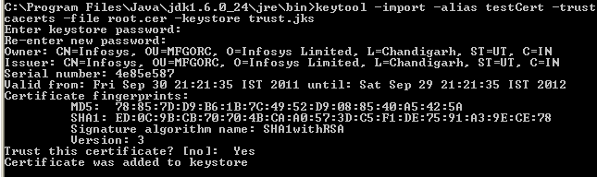

## Log into the Web Logic Server

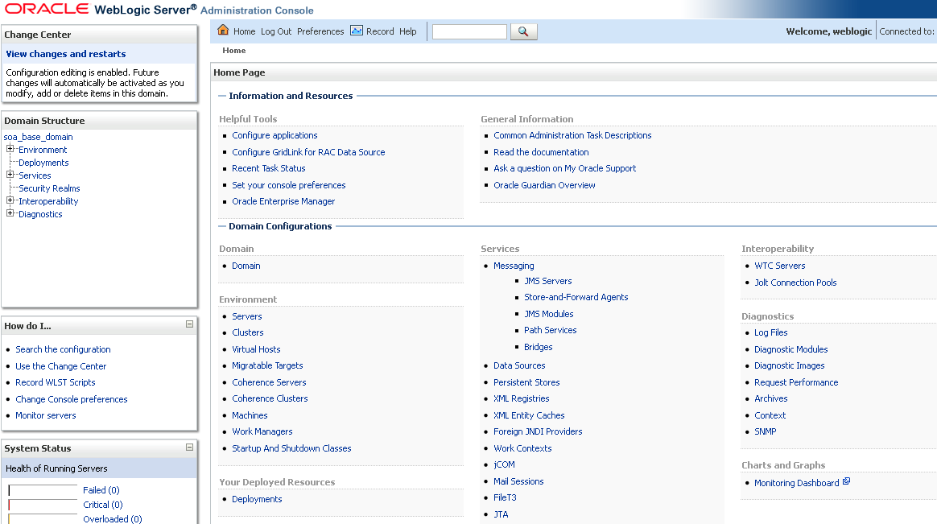

## Click on Servers link

## Click on the Admin Server

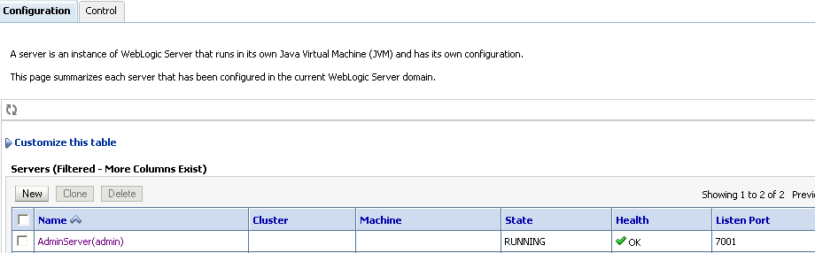

## Click on Key Store tab

## Click on the CHANGE button to modify the key store settings

## Select the custom Identity and Custom Trust from the available option for the key stores

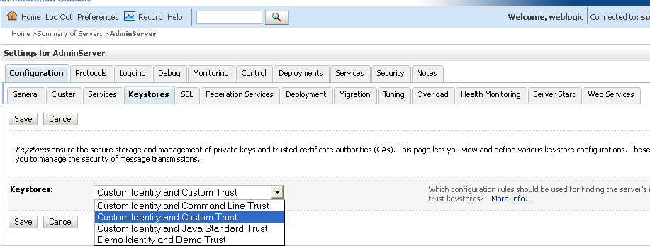

## Copy the generated Identity.jks and keystore.jsk files on the server path so that they can be selected as given below.

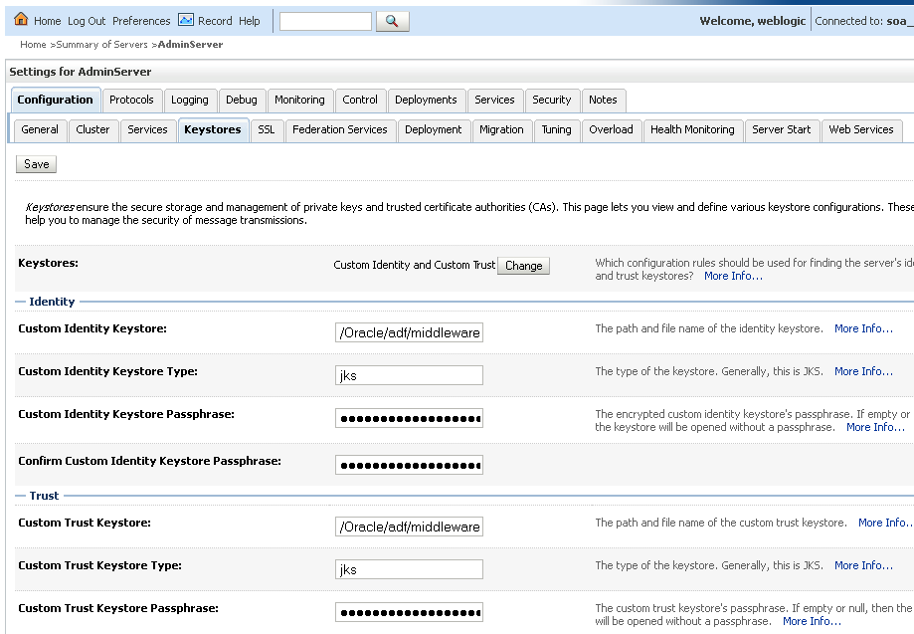

## Click on SAVE

## Activate the changes

## Modify the port for SSL in the General tab with 4443 (default)

[**https://localhost:4443/console/**](https://localhost:4443/console/)

## The message will be prompted by the Internet Explorer saying that Certificate need to be verified.

## Click ‘YES’ to verify the certificate.

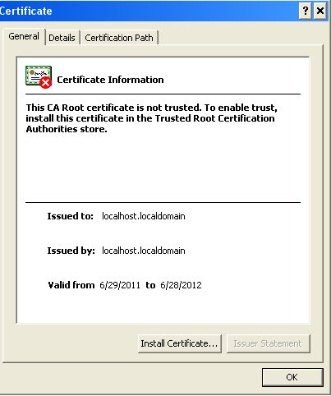

## The Certificate can be imported

