**Springboard Implementation In ADF Mobile Hybrid Application**

**Introduction**

**What is springboard?**

A hybrid ADF application can consist of multiple features each exclusive of each other. This allows user to see a logical differentiation/segregation between different functionalities/modules in the application. Springboard in ADF mobile terminology refers to a screen that would act as a Home screen for your application, which will come up as the first screen after the application is launched, and will allow the users to move to a specific feature as they desire. This facility is provided to the user in the form of link/button to each feature on a single screen.

**Scope of BOK**

This document guides on the steps and options to implement springboard facility, for the users of an ADF Mobile application, in different ways.

Contents

1. Pre-requisites 5

2. Adding a default springboard 7

3. Adding a custom springboard 9

4. Springboard preferences 11

# Pre-requisites

We need to have an ADF Mobile application having 1 or more features.

1.1 Create an ADF Mobile application. This would require ADF Mobile extension to be added to Jdeveloper.

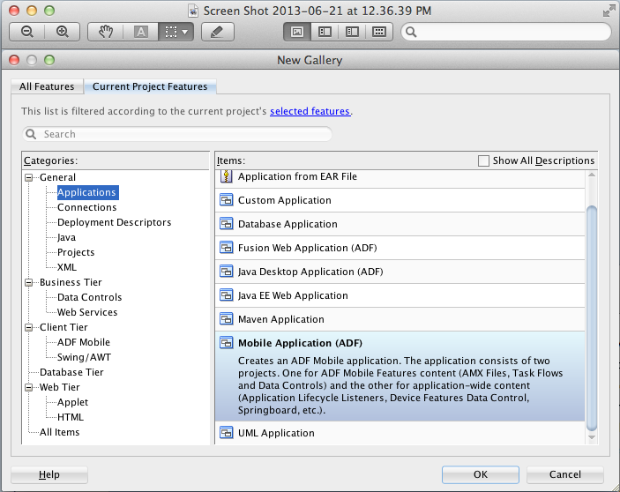

1.2 Create multiple features in the application. Here, for example, we have created 2 features for demonstration.

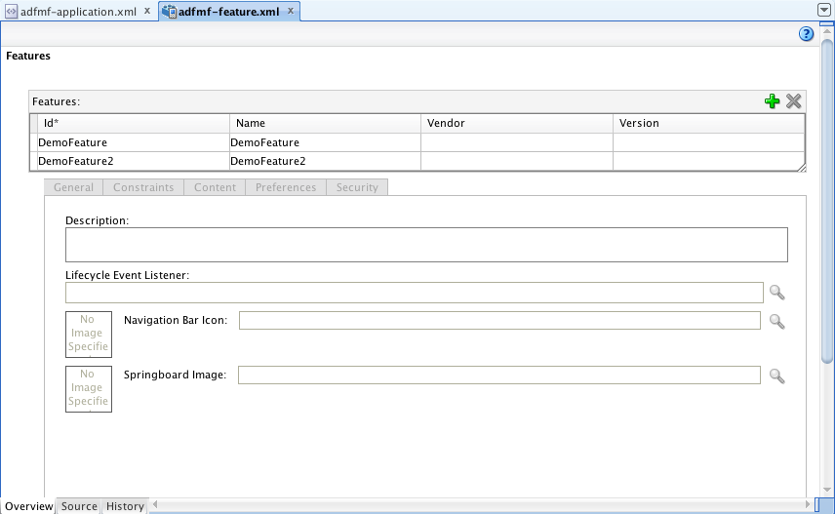

1.3 Here is the sample application as it looks on iPhone simulator. As the application launches, the first feature of the application is loaded by default.

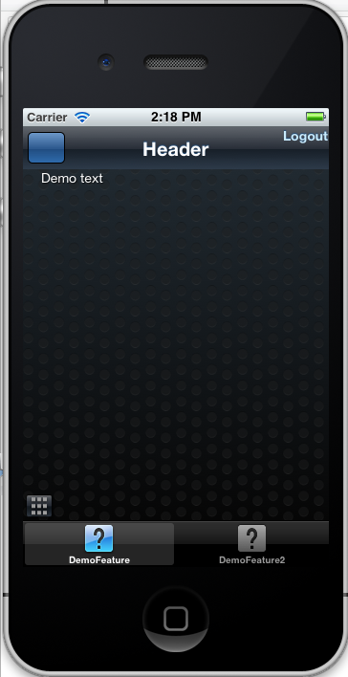

# Adding a default springboard

* 1. Open adfmf-application.xml file which can be found in Application Resources -> Descriptors -> ADF META_INF

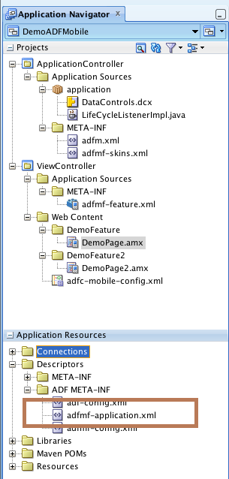

* 1. In the Application tab, Navigation section, select the ‘Default’ radio button and deploy the application to test the results

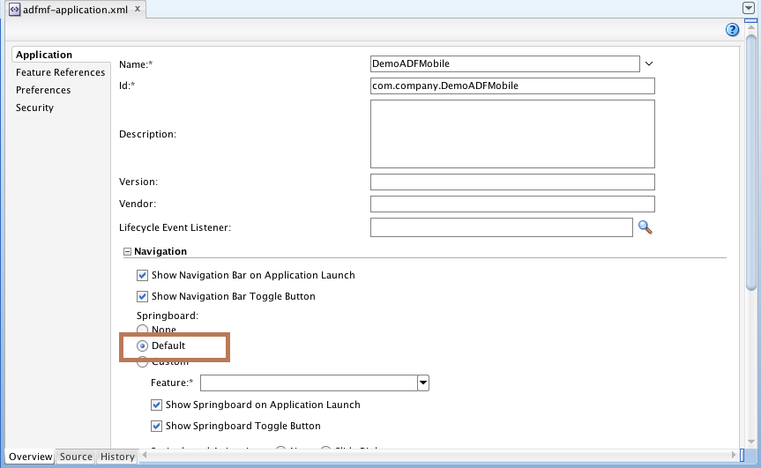

* 1. The application now when launched, will show the following springboard as the first screen.

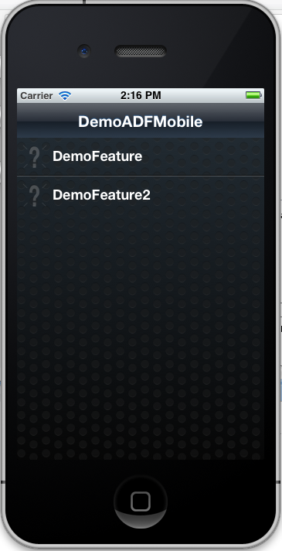

Here, ‘DemoFeature’ and ‘DemoFeature2’ are the feature names which are links that a user can click on to navigate to a specific one as desired.

# Adding a custom springboard

We can use a custom springboard instead of default one in case we need to have some extra components or custom look and feel on springboard.

* 1. Add a new feature to the ADF Mobile application having an AMX page which will act as the custom springboard screen. Here, we have created Springboard feature for this purpose.

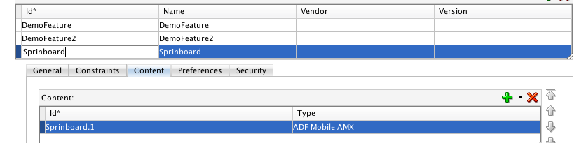

* 1. To add links to the respective features in Springboard amx screen, drag and drop the goToFeature() action from ‘ApplicationFeatures’ module of DataControls section to the page and render it as a button or link as per the need. It will then open up the ‘Edit Action Binding’ dialog box, where specify the parameter value as the name of the feature to which navigation is supposed to happen. Please note that ADF Mobile also provides other default methods for customizing feature/navigation bar experience which are all available in the ApplicationFeatures module. This screen can also be modified to have other components as desired along with the skinning preferences like we can give an image as the background of this screen.

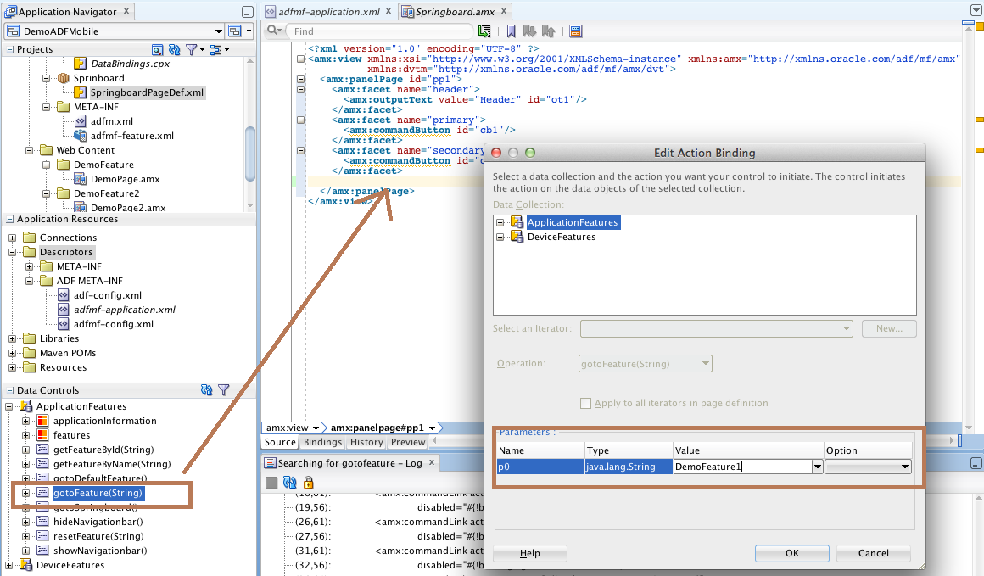

In our case, we have placed the following components on screen – 2 buttons i.e. 1 for each feature.

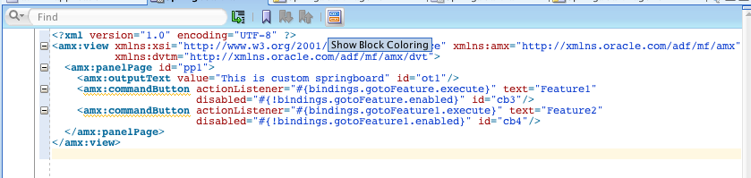

* 1. In the ‘Feature References’ tab of adfmf-application.xml file, change the ‘Show on Navigation Bar’ and ‘Show on Springboard’ options to false for this feature

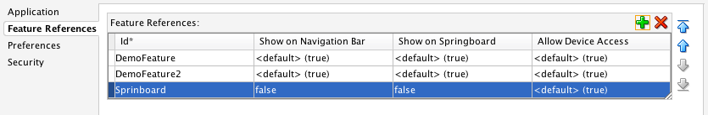

* 1. In the Applications tab, select the ‘Custom’ radio button and select the newly created feature in ‘Feature’ dropdown.

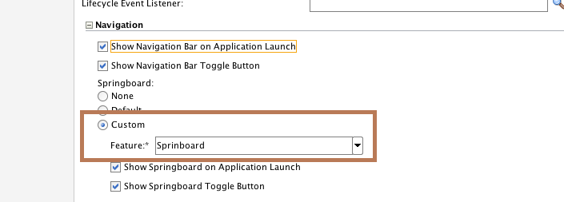

* 1. Deploy the application on simulator to see the custom springboard as below-

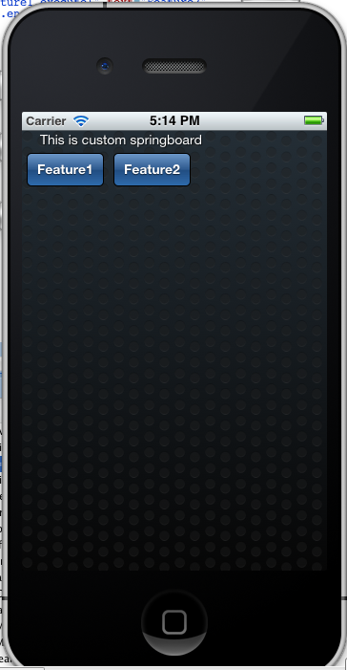

# Springboard preferences

* 1. Show Springboard on Application Launch

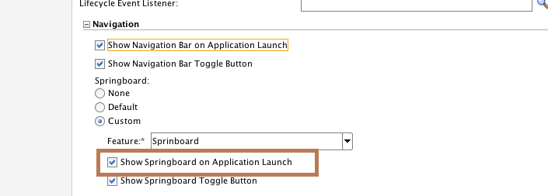

As indicated, this option if checked will ensure that as soon as the application is launched, user will see the springboard as the first screen and will then navigate to a feature as desired. If case a springboard has been configured in the application but this option is unchecked, application will show up the default feature on launch and user may then click on toggle button to view the springboard.

* 1. Show Springboard Toggle Button

This option if checked will show up a toggle button on all the screens in the application. This toggle button will allow the user to navigate back to the springboard from any screen in the application.

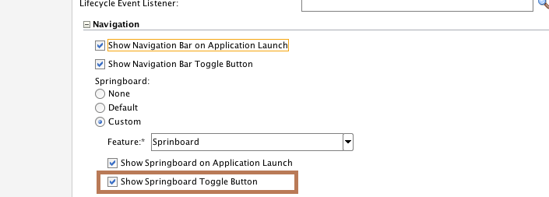

 is the toggle button that appears as a result of this.

**Reference:** NA