Practical Report: CI/CD Pipeline for quakeloc
Aibyn Talgatov, group CSE-2505M, student ID 255308
Astana IT University, Faculty of Computer Science and Engineering
Applied Software Development Project. Instructor: Akanova Akerke

1. Project and links
quakeloc detects earthquakes (STA/LTA), picks P-wave onsets (AIC) and locates epicentres with 95 % error ellipses (Geiger’s method). It is a FastAPI service validated on synthetic data and on a frozen snapshot of the KNET network near Bishkek. Repository: https://github.com/a169n/applied_5. Pipeline: Jenkinsfile. Image: https://hub.docker.com/r/a169n/quakeloc. Steps to reproduce: docs/RUNBOOK.md.

2. Steps
Docker. A multi-stage Dockerfile has separate test, artifacts, data and runtime targets. The runtime image contains no compilers or test tools and runs as a non-root user. It is 516 MB locally and 108.9 MB compressed on Docker Hub. A build fails if its calibration artifacts differ from those the tests validated.
Jenkins. Jenkins runs in Docker and is configured entirely from the repository (Configuration as Code and Job DSL), so one command recreates it. A multibranch job scans GitHub every 2 minutes, because a local Jenkins cannot receive webhooks. The ten stages are checkout, test image, lint, unit and property tests, scientific validation, real-data validation, runtime image, container smoke test, Docker Hub push and Minikube deploy. The last two run only on main. A separate job refreshes the data and never pushes; its first run fetched files identical to the committed snapshot.
Git and automation. Work reached main through a pull request, and every build and test stage has a make target with the same command, so CI failures can be reproduced locally.
Deployment (bonus). Stage 10 deploys the image tagged with the commit SHA to Minikube, runs a smoke Job inside the cluster and rolls back on failure. I tested the rollback manually. The service also serves a small web client at /, where a user picks an earthquake and compares our location with USGS.

3. Results
Green run. main build #1 passed all stages in 2 min 23 s (Figure 1) with 173 tests passing (Figure 3). /version in the cluster returned the SHA of main HEAD, d5ba3ca.
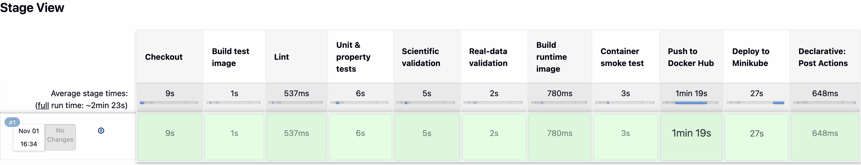
Figure 1. Green pipeline on main, build #1.
Red run. Branch demo/broken-locator negates one column of the location Jacobian. Stage 4 failed with 47 of 162 tests failing, including test_noise_free_exact_inversion (Figure 2). Nothing was pushed or deployed: Docker Hub and the cluster stayed on d5ba3ca. This branch is never merged.
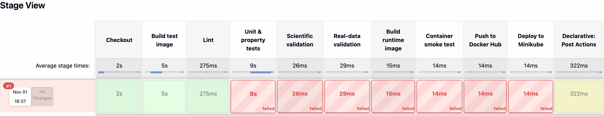
Figure 2. Red pipeline on demo/broken-locator. The console reports stages 5 to 10 as “skipped due to earlier failure”; Stage View paints them as failed.
Delivery. The image reached Docker Hub under its commit SHA and latest (Figure 4), and the cluster runs two ready replicas (Figure 5). The API is documented at /docs (Figure 6). The web client (Figure 7) was added after build #1, so that capture is a local run of the commit that adds it.
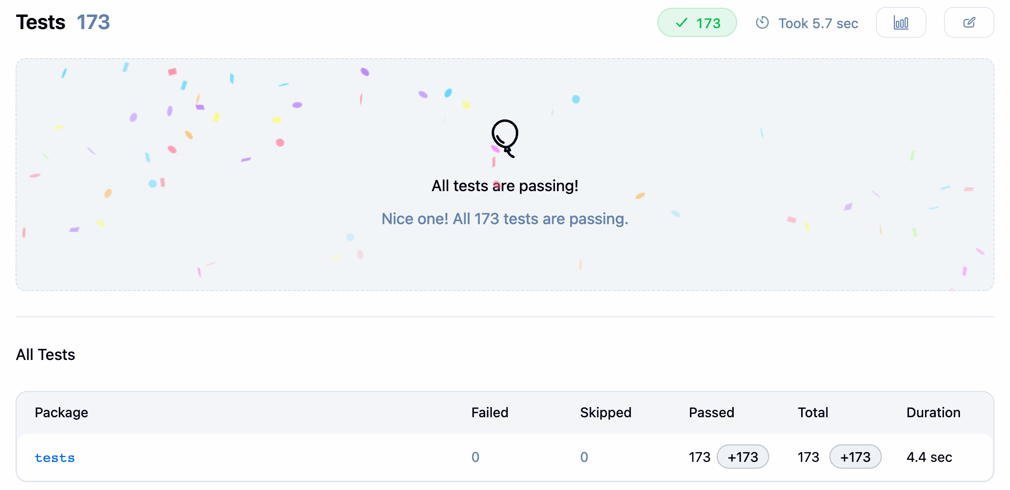  Figure 3. Test report, main build #1. | 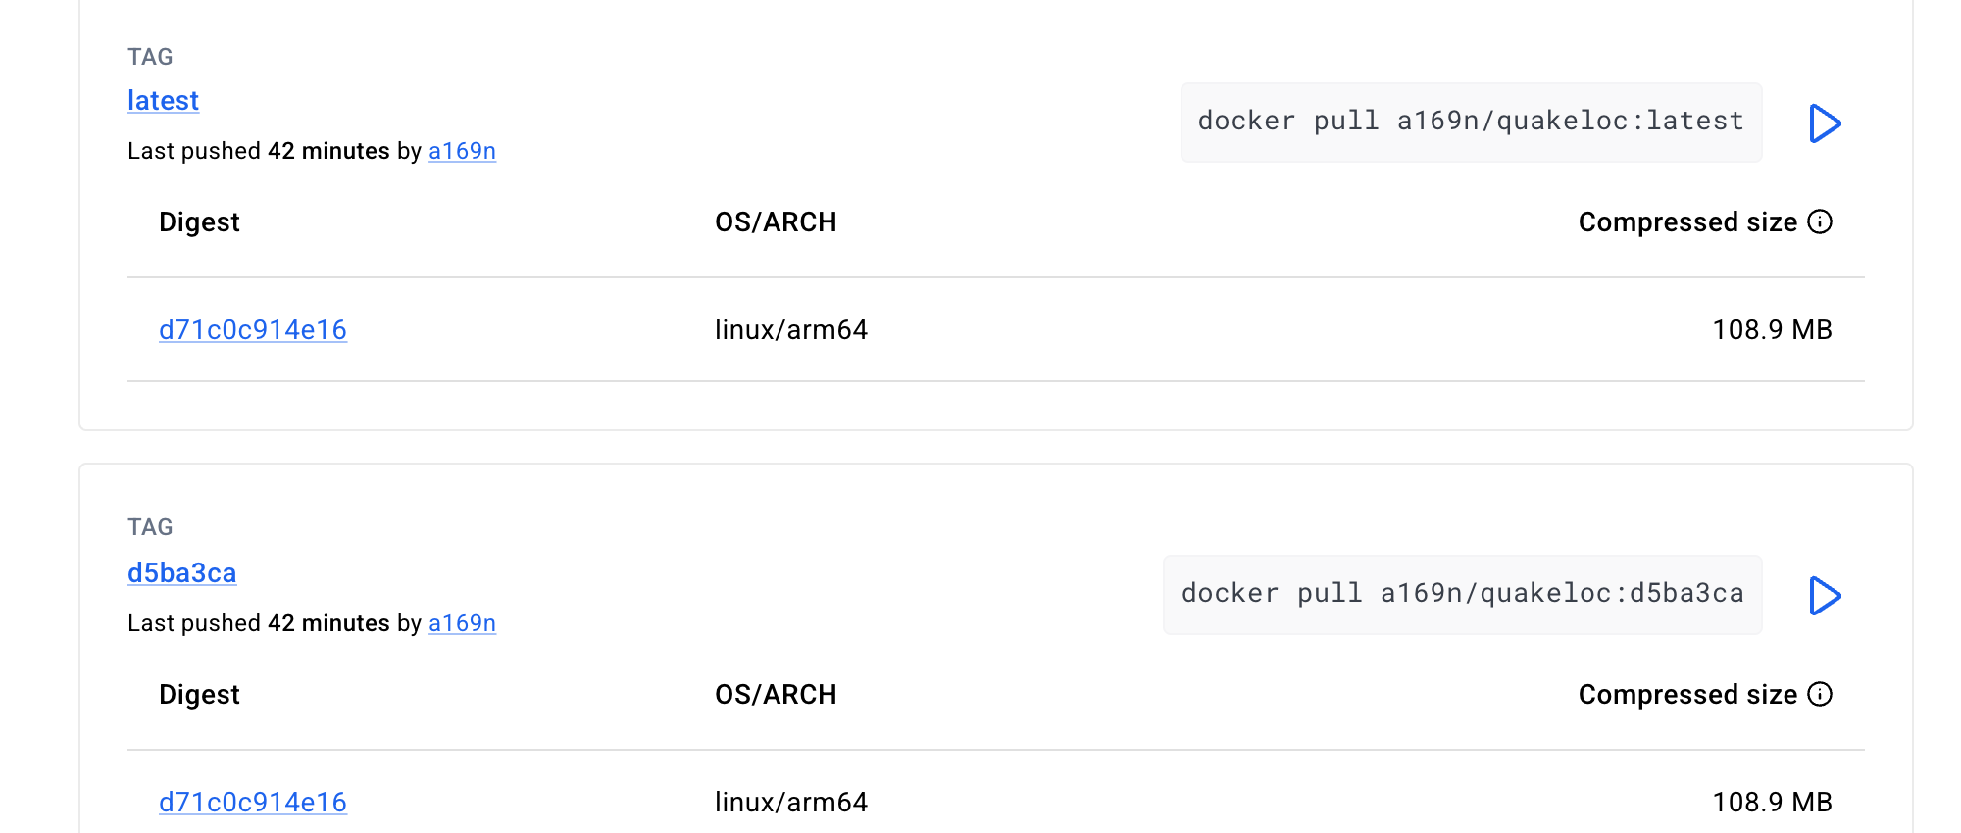  Figure 4. Docker Hub tags.
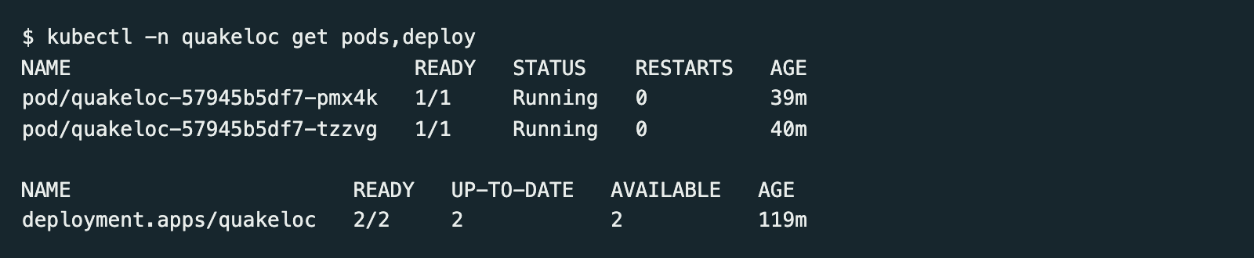  Figure 5. kubectl get pods,deploy output. | 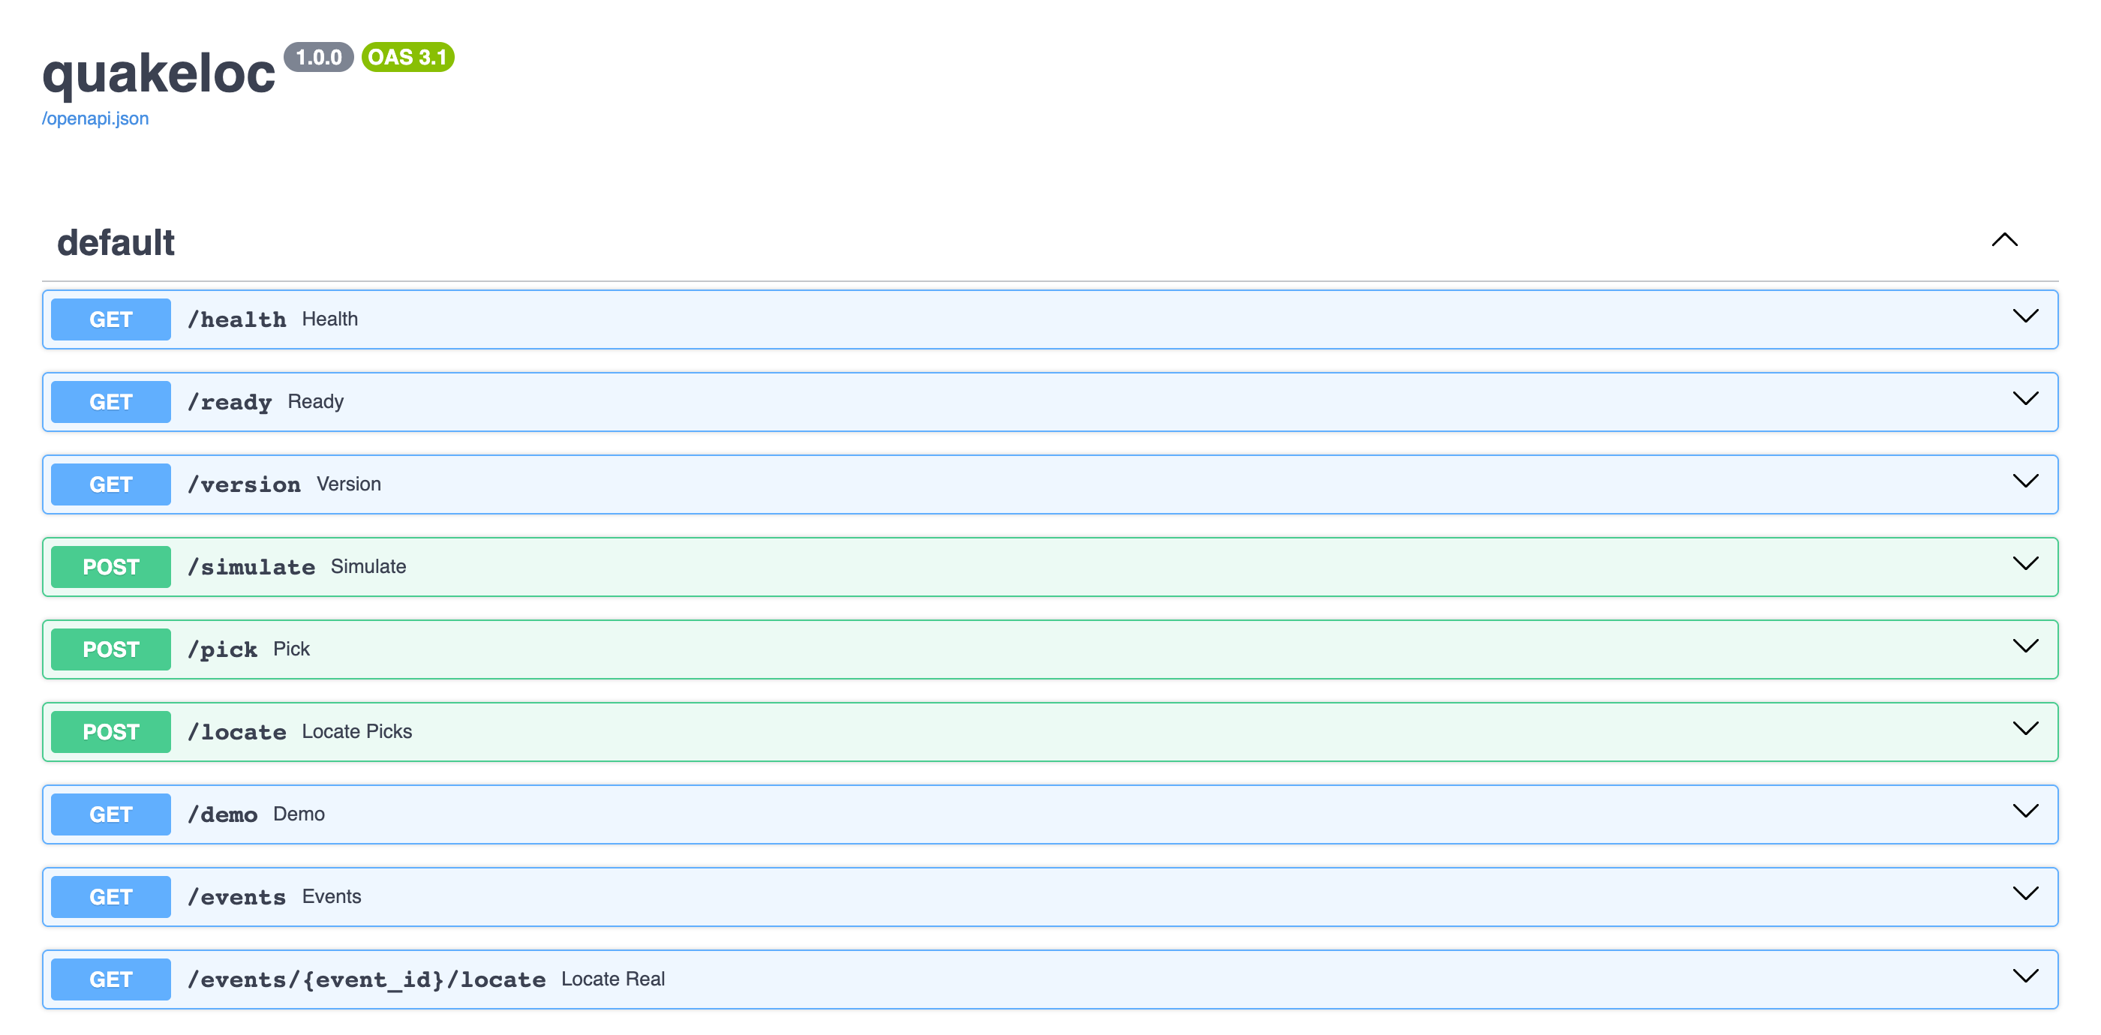  Figure 6. API documentation at /docs.
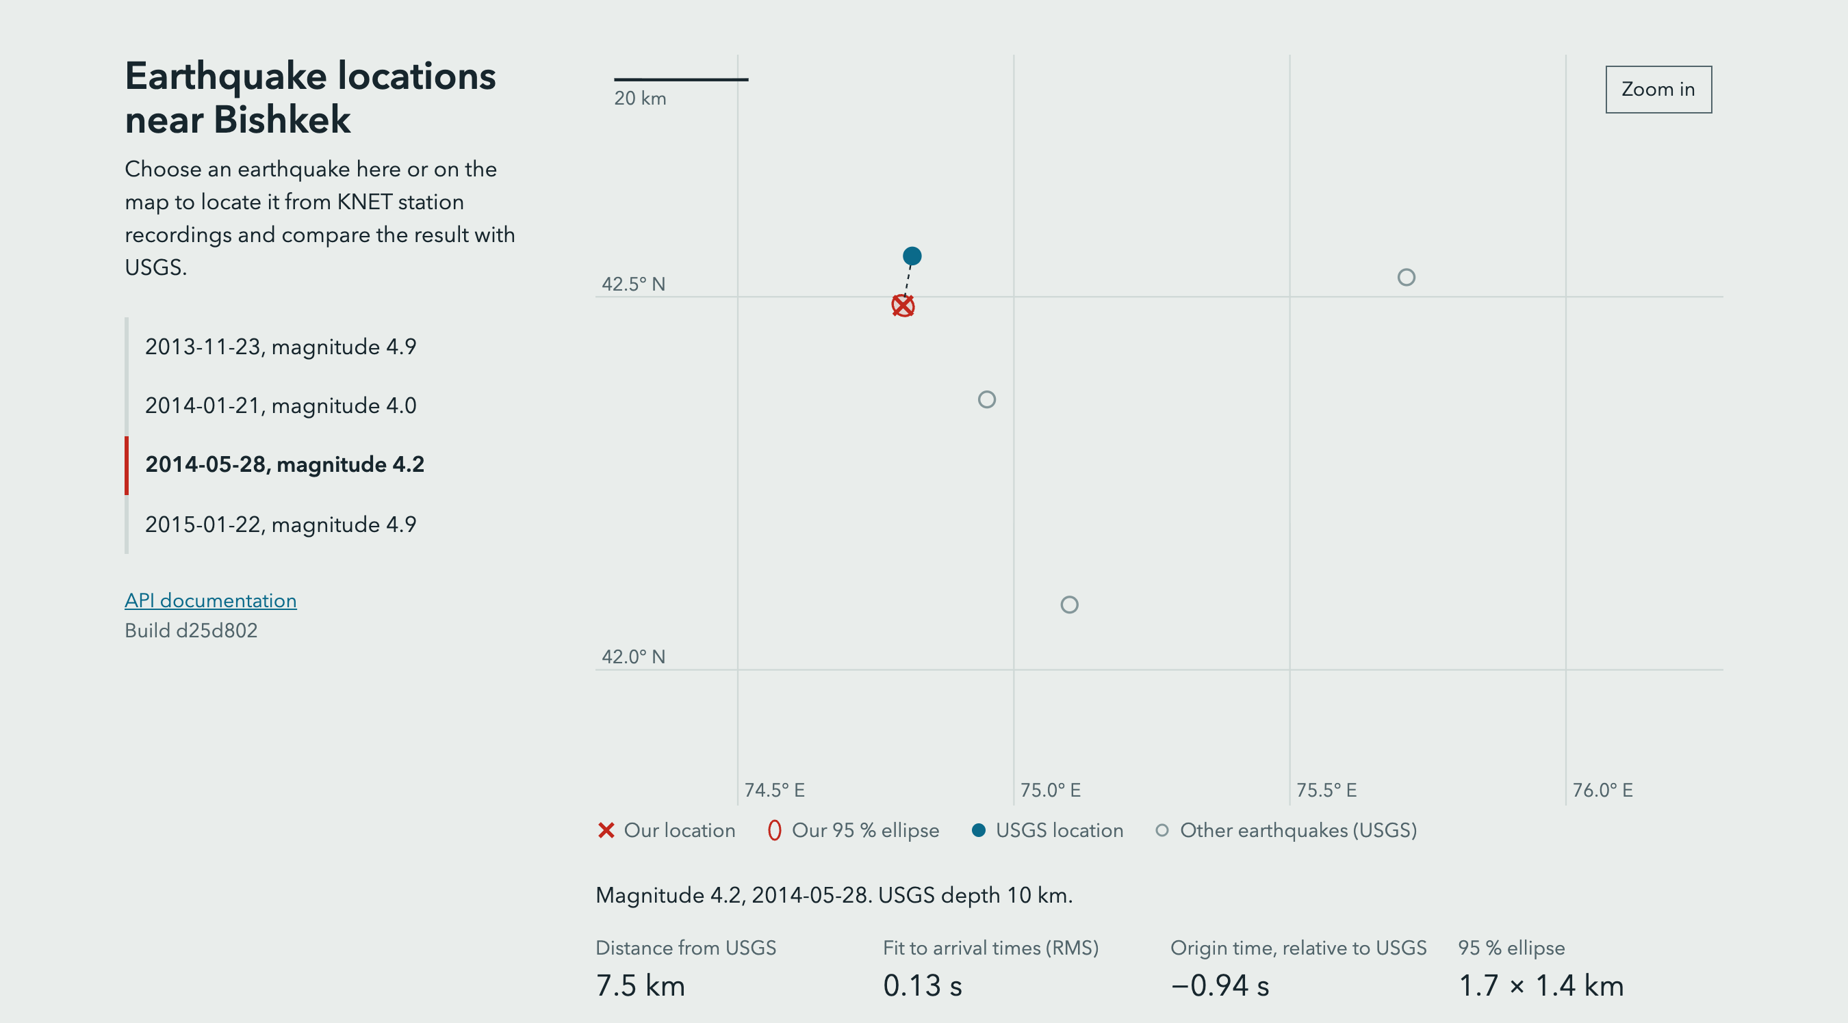  Figure 7. Web client, local run. | 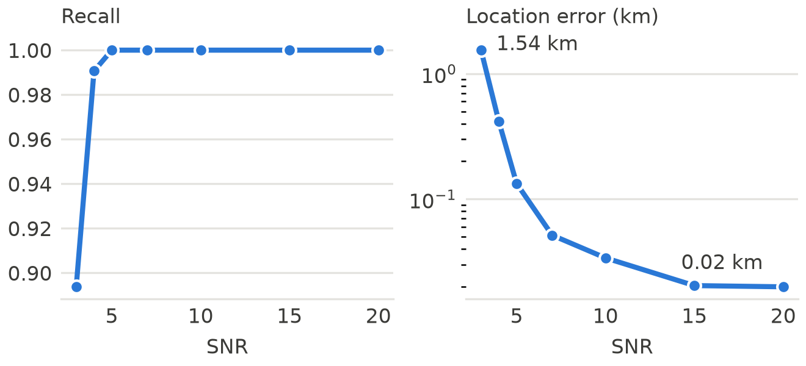  Figure 8. Synthetic SNR sweep, seed 42.
Science. On synthetic data, recall rises from 0.89 at SNR 3 to 1.0 at SNR 5 and above, and mean location error falls from 1.54 km to 0.02 km (Figure 8). On real data all 4 events locate, at 2.8, 7.5, 12.2 and 18.3 km from the USGS epicentres (one response in Figure 9). Four events are a demonstration, not a statistical validation. The ellipses cover pick scatter only, so the USGS epicentre often lies outside them.
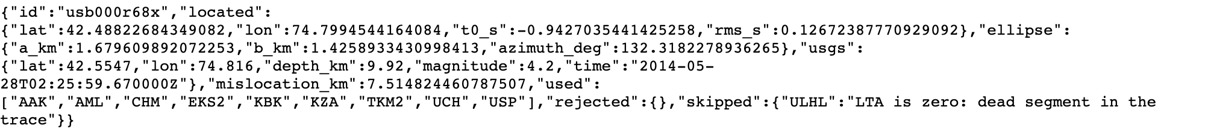
Figure 9. Response of /events/usb000r68x/locate from the Minikube deployment.

4. Difficulties
- Sparse real data. EarthScope returned no KN waveforms for much of the catalog period, so only 4 events qualified and lowering the magnitude limit to 3.5 added none. I kept the 4 events and stated the limit instead of tuning the results.
- Stale artifacts. The identity check failed locally after src/ changed, because the artifacts were older than the code. Recalibrating fixed it, and the runbook now lists this case.
- Jenkins lost its network. Recreating the container dropped its link to the Minikube network, so make jenkins-up now restores it.
- A test hid failures. A stub’s final exit 0 masked simulated kubectl failures, so a commit went in with two failing tests. The next commit fixed the stub.

5. Conclusions
The pipeline turns a merge into a tested, published and deployed service without manual steps, and the red run shows that a scientific bug stops before release. The most useful decision was to test against known answers, since a generic smoke test would not have caught a sign error in the Jacobian. The main limits are the small real-data sample, the one-layer velocity model and a Jenkins instance that runs only on a laptop.

