ASSIGNMENT 3
Software Development and Integration
REPORT
climate-analyzer: a scientific tool for analysing and forecasting the weather of Astana
Student: Aibyn Talgatov
Repository: github.com/a169n/applied_software_3
Astana, 2026

CONTENTS
Introduction 2
1 Stages of the software development process 2
2 Criteria for choosing technologies 4
3 Version control systems: Git and GitHub compared with alternatives 5
4 CI/CD concepts and their implementation 6
5 Features of scientific software development 7
5.1 Results for Astana on real data 8
6 Links to the repository and CI/CD configuration 10
Conclusion 10
References 11

Introduction
The purpose of this assignment is to take a small piece of scientific software through its complete cycle, from design to automated testing and delivery, and to justify the technologies chosen. The practical result is climate-analyzer, an open-source Python package published on GitHub [1]. It loads daily weather records, removes defective values, estimates long-term trends, anomalies and extremes, and forecasts the coming months. The case study is Astana, whose sharply continental climate (about −14 °C in January and +21 °C in July) makes both the seasonal cycle and the data-quality problems easy to see.
The tool works as a command line program (climate-analyzer fetch and analyze), an interactive Streamlit web interface (app.py) and a Python library. The repository also holds a README, an MIT licence, issue and pull request templates, a changelog, 84 automated tests and three GitHub Actions workflows. Unless stated otherwise, the numerical results below were obtained by running the tool on real data for Astana.

1 Stages of the software development process
Software engineering describes the creation of a program as a life cycle of stages: requirements analysis, design, implementation, testing, deployment and maintenance [2]. Life-cycle models differ in how the stages are ordered. In the classical waterfall model each stage is finished before the next begins, which is easy to plan but makes late changes expensive. Iterative and agile models repeat the stages in short cycles, so a working version exists from the start and feedback arrives early. Scientific software is usually developed iteratively, because the requirements are refined as the researcher learns more about the data [6]. The repository history is organised the same way: a series of small commits, each adding one layer, from the project skeleton and the sample data through the analysis modules, the forecast model and the interfaces to the tests, the CI/CD workflows and the documentation.
Requirements. The functional requirements follow from the task: read a CSV file of daily observations, clean it, compute trends, anomalies and extremes, forecast future months and write a report. The non-functional ones mattered as much: reproducible results, no need for a display or internet access on a CI server, and installation with one command on Linux, Windows and macOS.
Requirements specification. Four kinds of user were considered: a researcher who analyses a station file from the command line, a student who explores the result in the web interface, a developer who reuses the pipeline as a library, and a maintainer who needs checks and releases to run without manual steps. They give five use cases: analyse a CSV file and obtain a report (UC1); download real data for a city and analyse it (UC2); try the tool offline on the bundled sample (UC3); explore the result interactively and download the report (UC4); repeat the study on fresh data every month (UC5). Table 1 lists the functional requirements and Table 2 the non-functional ones; every requirement names the test or mechanism that verifies it, so none is left as a wish. The full specification, with data requirements, constraints and acceptance criteria, is in docs/REQUIREMENTS.md. Known limits are part of the requirements: the forecast is statistical and cannot predict individual weather events, and Open-Meteo describes a model grid cell, not a weather station.
Table 1 – Functional requirements and the tests that verify them
ID | Requirement | Verified by
F1 | Read a CSV file with a date column; detect the date column automatically or take it by name | test_io
F2 | Convert placeholder codes such as -999 to missing values; sort rows and remove duplicate dates | test_io
F3 | Download daily history for a city or coordinates from Open-Meteo | test_sources
F4 | Detect outliers relative to the same calendar month (z-score or IQR, configurable, or off) | test_cleaning
F5 | Interpolate gaps of up to 3 days (configurable); longer gaps stay missing | test_cleaning
F6 | Report how many values were removed and filled | test_cleaning
F7 | Aggregate to monthly and yearly values; drop months and years with less than 80 % coverage | test_analysis
F8 | Estimate the annual trend by OLS and by Mann–Kendall with Sen's slope, with p-values | test_analysis
F9 | Compute anomalies against a baseline period, climatology and seasonal decomposition | test_analysis
F10 | Count warm and cold extreme days per year (10th/90th percentile of the same month) | test_analysis
F11 | Fit trend + annual harmonics + AR(1) and forecast N months with a 95 % interval | test_forecast
F12 | Backtest on the last N months and compare the error with the climatology baseline | test_forecast
F13 | Write report.md, summary.json, CSV tables and PNG figures | test_pipeline, test_plotting_cli
F14 | Skip a stage that cannot run with a warning and finish the rest of the analysis | test_pipeline
F15 | Web UI: choose the data source, set options, show interactive charts with explanations, download the report | test_app
F16 | Command line: analyze and fetch commands with options for variable, units, cleaning, baseline, horizon | test_plotting_cli

Table 2 – Non-functional requirements and how they are met
ID | Requirement | How it is met
N1 | Correctness: recover a known trend from data with known defects | Synthetic dataset, +0.35 °C per decade
N2 | Reproducibility: same input gives the same output on any machine | Fixed seed, no display, no network in tests
N3 | Stability: a library update must not change results silently | FutureWarning treated as error
N4 | Honesty: uncertainty is always reported, claims not stronger than evidence | Two trend tests, intervals, backtest
N5 | Portability: Linux, Windows, macOS; Python 3.10–3.13 | CI build matrix
N6 | Installability: one command, pip install -e ".[ui]" | pyproject.toml extras
N7 | Offline use: analysis and tests need no internet | Bundled sample, injectable network layer
N8 | Maintainability: small typed single-purpose modules | src/ layout, mypy, Ruff
N9 | Test quality: at least 90 % statement coverage | CI quality gate (actual 99 %)
N10 | Performance: a 32-year daily series analysed in seconds on a laptop | Vectorised pandas/NumPy
N11 | Security: TLS verification never disabled; read-only CI token | truststore, least-privilege permissions
N12 | Licensing: free and open source | MIT licence, CITATION.cff

Design and implementation. The package consists of small modules with one responsibility each — io, sources, cleaning, analysis, forecast, plotting — joined by a pipeline module. The command line and web interfaces are thin layers over that pipeline, so both always give identical numbers. Network access is isolated in one function that receives its opener as a parameter and can therefore be tested offline. The code is typed Python in the standard src/ layout; Ruff enforces style and mypy checks types.
Web interface. The Streamlit interface (requirement F15) is built for a reader who is not a programmer. The sidebar has three steps: choose the data (offline example, real Open-Meteo data or an uploaded CSV), set the comparison period and the forecast length. The main page opens with a one-sentence verdict and five key figures, and every analysis has its own tab with an interactive chart and a plain-language explanation (Figures 1 and 2).
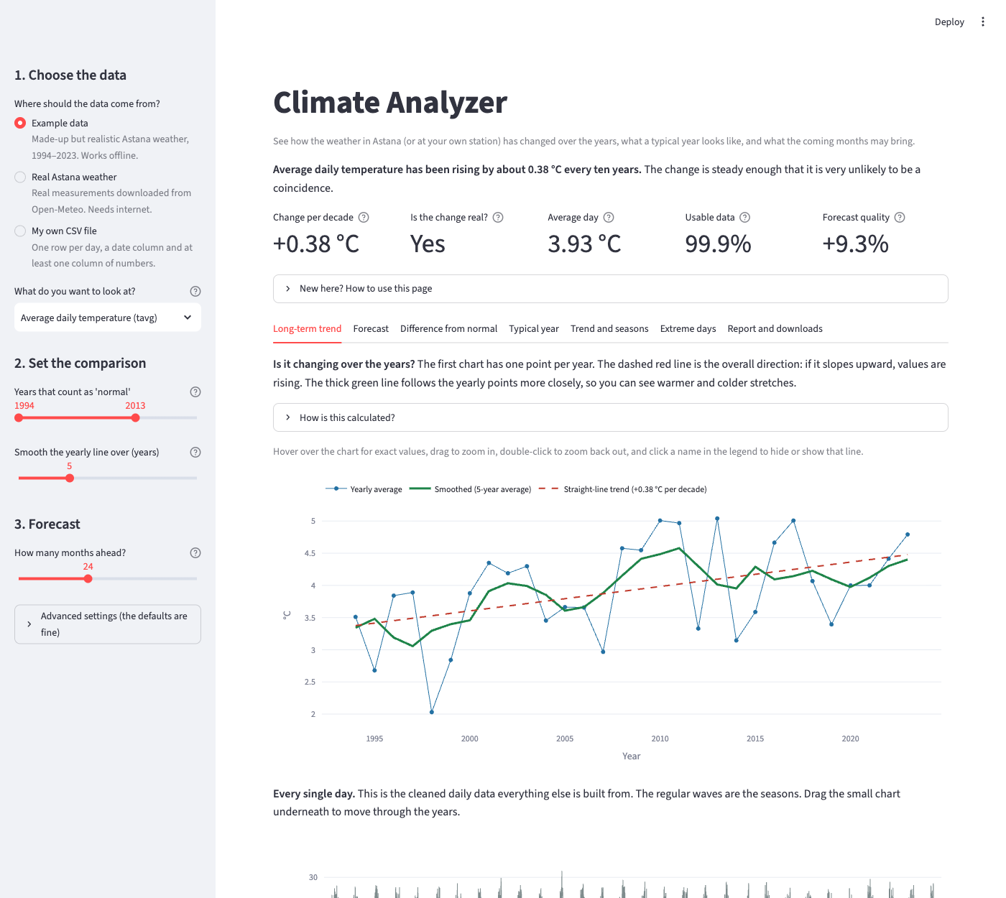
Figure 1 – Web interface: choice of data, key figures and the long-term trend (example data)
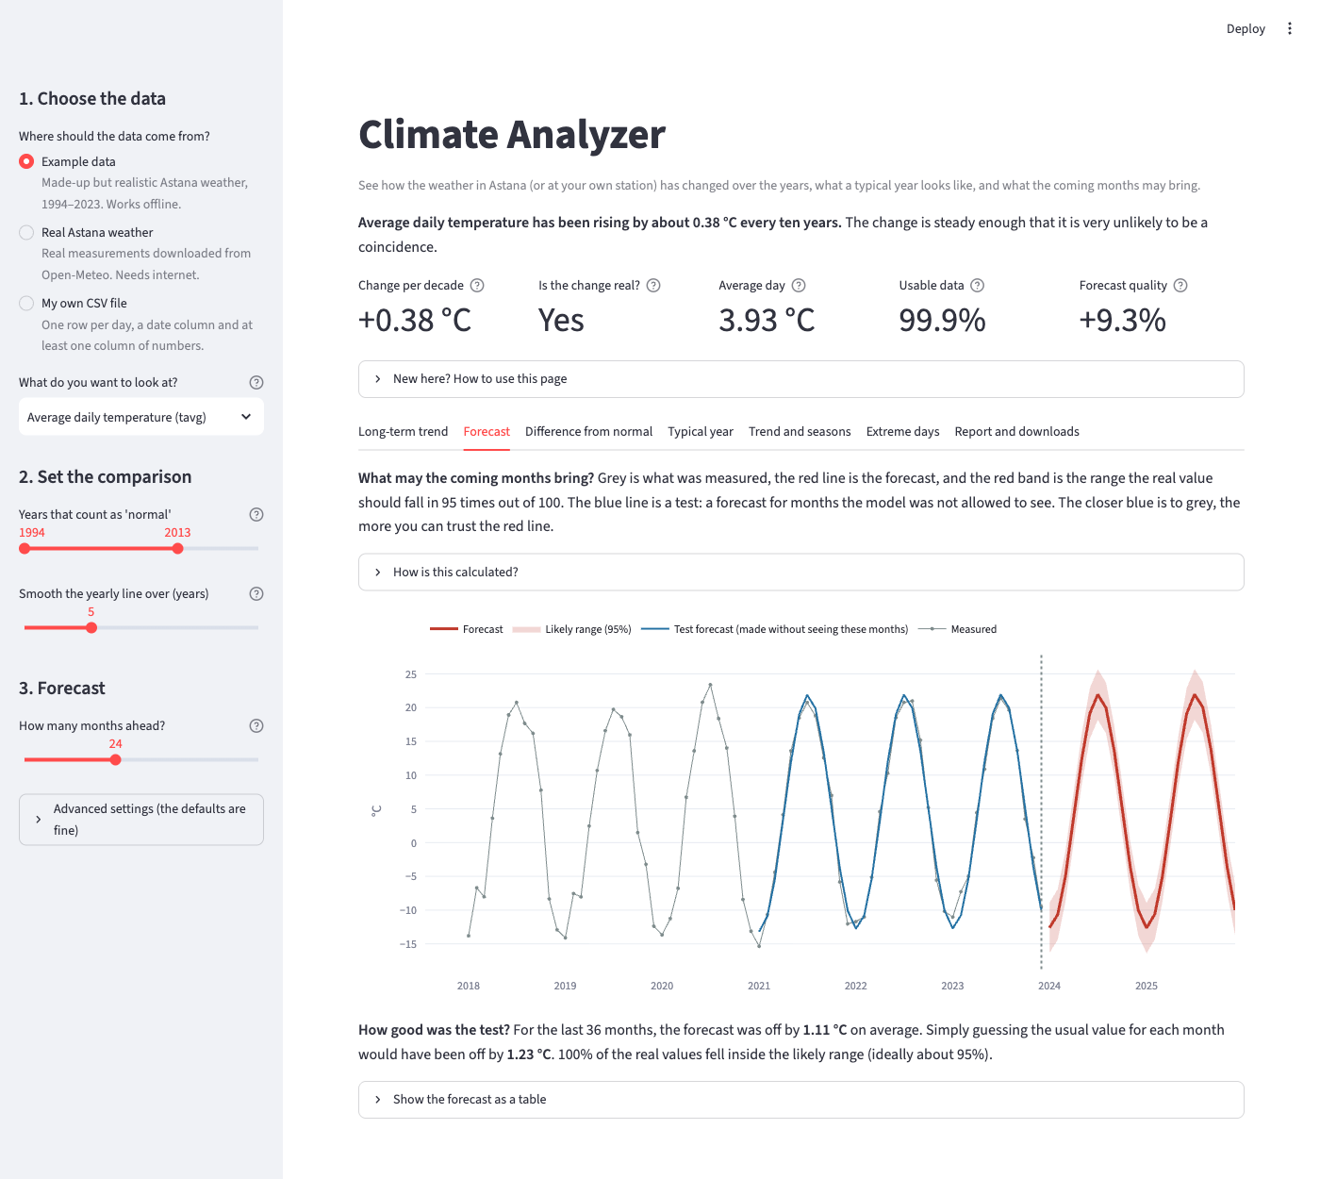
Figure 2 – Web interface: forecast tab with the 95 % range and the test forecast (example data)
Testing. The pytest suite has 84 tests covering 99 % of the statements: unit tests for every module, integration tests of the pipeline and the command line program, and tests of the web interface through Streamlit's AppTest. The central idea is testing against a known answer: the bundled synthetic dataset is generated with a warming of +0.35 °C per decade, and the tests check that the analysis recovers it.
Deployment and maintenance. A version tag starts a workflow that tests the code, builds the package and publishes a GitHub Release. Maintenance relies on the issue tracker, the changelog, semantic versioning and Dependabot. Table 3 maps each stage to the repository.
Table 3 – Stages of the development process and their artefacts in the project
Stage | What was done | Artefacts in the repository
Requirements | Functional and non-functional requirements, known limitations | docs/REQUIREMENTS.md, README.md, issue templates
Design | Modular architecture, shared pipeline, injectable network layer | src/climate_analyzer/, docs/TECHNOLOGY.md
Implementation | Typed package, CLI and web UI | pyproject.toml, cli.py, app.py
Testing | 84 tests, 99 % coverage, lint, type checks | tests/, .github/workflows/ci.yml
Deployment | Automated build and release on a version tag | .github/workflows/release.yml
Maintenance | Scheduled forecast, dependency updates, changelog | astana-forecast.yml, dependabot.yml, CHANGELOG.md

2 Criteria for choosing technologies
Every dependency is a long-term obligation, so the stack was selected by explicit criteria rather than by habit. They are documented in the repository together with the rejected alternatives (docs/TECHNOLOGY.md):
– fitness for scientific work — correct, well-tested numerical methods;
– ecosystem and community — maintained, documented libraries that researchers already know;
– reproducibility — the same input gives the same output on any machine, including a CI server;
– low barrier to entry — free and open source, cross-platform, easy to install;
– testability and automation — good support for automated tests, static analysis and CI/CD.
Python meets all five. R is equally strong in statistics but weaker as a general-purpose language for command line tools, packaging and web interfaces; MATLAB needs a commercial licence; Julia is fast but its ecosystem and CI tooling are less mature. Table 4 lists the main components and the reason for each choice.
Table 4 – Selected technologies and the reasons for choosing them
Technology | Role | Reason; rejected alternatives
pandas, NumPy | Time series, numerics | Calendar-aware resampling, native missing values, least squares.
SciPy | Statistical tests | Reviewed implementations of regression, Kendall's tau and the Theil–Sen slope; hand-written versions would risk errors.
Matplotlib | Figures | Publication-quality images rendered without a display.
Streamlit | Web interface | An interactive application in one Python script; Dash or Flask need far more code.
Plotly | Web charts | Hover, zoom and legend toggling without extra code.
Open-Meteo | Data source | Free, no API key, any coordinates, no gaps; station archives (GHCN, Meteostat) have gaps and heavier formats.
pytest, Ruff, mypy | Quality control | Concise tests; one fast tool instead of flake8, isort and black; static detection of type errors.
GitHub Actions | CI/CD | Built into GitHub, free for public repositories, three operating systems; Jenkins needs its own server.

Comparison with alternatives. Table 5 compares the four candidate languages against the criteria above, and Table 6 does the same for the other components. Python is the only option rated high on every criterion: R matches it in statistics but not in packaging and web interfaces, MATLAB needs a commercial licence, and Julia's tooling is still maturing. For the other components the deciding factor was the amount of code and infrastructure the project would have to maintain itself. The assessments are qualitative judgements based on the documentation of each tool and on this project's needs, not measurements.
Table 5 – Comparison of programming languages against the selection criteria
Criterion | Python | R | MATLAB | Julia
Scientific libraries | Excellent (NumPy, SciPy, pandas) | Excellent (statistics) | Good | Growing
General-purpose use (CLI, web UI, packaging) | Excellent | Limited | Limited | Moderate
Licence cost | Free | Free | Commercial | Free
CI and tooling maturity | Excellent | Good | Limited | Moderate
Use in climate science | Very high (xarray, MetPy) | High | Declining | Niche
Decision | Chosen | Rejected: weak outside statistics | Rejected: licence, CI cost | Rejected: young ecosystem

Table 6 – Alternatives considered for the other components
Component | Option | Assessment
Web UI | Streamlit (chosen) | One Python script, no HTML or JavaScript, AppTest for automated UI tests
 | Dash, Panel | More boilerplate for the same result
 | Flask + JavaScript | A separate front end and much more code
Charts in the UI | Plotly (chosen) | Hover, zoom and legend toggling work out of the box; optional extra
 | Altair | Hover and shaded intervals need extra selection code for each chart
 | Bokeh | Needs its own Streamlit component
 | Matplotlib | Static images only; kept for the command line
Data source | Open-Meteo (chosen) | Free, no API key, any coordinates, continuous daily data; a model grid cell, not a station
 | Meteostat | Real station data, but with gaps
 | NOAA GHCN-Daily | Authoritative, but large station-specific files
 | Kazhydromet | Official source, but no open machine-readable API
CI/CD | GitHub Actions (chosen) | Built into GitHub, free for public repositories, Linux, Windows and macOS
 | GitLab CI | Would need a GitLab mirror of the repository
 | Jenkins | Needs its own server to maintain
Forecast model | Trend + harmonics + AR(1) (chosen) | Transparent, about 150 lines, validated against a baseline
 | statsmodels (ARIMA) | Heavy dependency for what a short tested model does
 | Neural network | About 360 monthly points are far too few

Decisions not to use a technology followed the same criteria. The statsmodels library offers seasonal decomposition and ARIMA, but it is a heavy dependency, while the decomposition and the forecast model take fewer than 200 transparent, fully tested lines here. Deep learning was rejected for a scientific reason: 32 years of monthly data give only 384 points, far too few for a neural network, whereas an interpretable statistical model can be validated honestly against a simple baseline.

3 Version control systems: Git and GitHub compared with alternatives
A version control system (VCS) records every change of the source code with its author, date and explanation. It allows a return to any earlier state, parallel work on several ideas and the merging of contributions. For scientific software it also documents exactly which version of the code produced a published result.
There are two families of systems. In centralised systems such as Subversion (SVN) the history is stored on one server and developers hold only a working copy, so most operations need a network connection and the server is a single point of failure. In distributed systems such as Git and Mercurial every clone contains the complete history; commits, branches and comparisons are local and fast, and any clone can restore the project [3]. Table 7 compares the three best-known open-source systems.
Table 7 – Comparison of version control systems
Criterion | Git | Subversion (SVN) | Mercurial
Architecture | Distributed | Centralised | Distributed
Work offline | Full | A server is needed to commit | Full
Branching and merging | Very cheap; basis of the pull request workflow | Branches are directory copies; merging is harder | Cheap; named branches and bookmarks
Integrity of history | Objects addressed by a cryptographic hash | Sequential revision numbers | Hash-based
Large binary files | Weak without Git LFS | Good, with file locking | Weak without extensions
Learning curve | Steep | Gentle | Gentle
Hosting and ecosystem | GitHub, GitLab, Bitbucket; de facto standard | Mostly corporate servers | Few hosts; Bitbucket dropped it in 2020

Git was chosen for three reasons. Cheap local branches make it natural to isolate every change and verify it before it reaches the main branch. Content hashing guarantees that a commit identifier refers to exactly one state of the code, which matters for reproducibility. And Git is the standard of both industry and open science, so most users and reviewers already know it. Its weaknesses are not significant here: the repository holds only source code and a few small data and image files.
Git itself only manages the history of a repository; a hosting platform adds the collaboration layer. In this project GitHub provides the public repository, the issue tracker with templates, pull requests, releases with downloadable packages, Dependabot and the CI/CD service. Of the alternatives, GitLab offers a comparable built-in CI/CD system and can be self-hosted, which suits closed institutional projects, and Bitbucket integrates with Jira and the other Atlassian tools and is aimed at company teams. GitHub was preferred because it hosts the largest open-source and scientific community, its Actions service is free for public repositories, and a repository can be archived with a citable DOI through Zenodo.

4 CI/CD concepts and their implementation
Continuous integration (CI) is the practice of merging changes into the main branch frequently and verifying each one automatically by building the project and running its tests [4], so that errors are found within minutes. Continuous delivery (CD) extends the idea: after successful verification the software is automatically prepared for release, so publishing a version becomes a routine, repeatable action; in continuous deployment even the final step is automatic [5]. The sequence of automated steps is a pipeline, and its outputs are stored as artefacts.
In GitHub Actions a pipeline is a YAML file in .github/workflows [12]. A workflow is started by an event (a push, a pull request, a schedule, a tag or a manual start) and consists of jobs that run on clean virtual machines called runners. Because the configuration lives in the repository, the pipeline is versioned and reviewed together with the code. The project has three workflows (Table 8).
Table 8 – GitHub Actions workflows of the project
Workflow | Trigger | What it does
ci.yml | Push to main, pull request, manual start | Ruff and mypy checks; tests on Ubuntu (Python 3.10–3.13), Windows and macOS; end-to-end analysis of the sample; package build and install check.
astana-forecast.yml | Monthly schedule, manual start | Downloads real Astana data, analyses temperature and precipitation, publishes the reports as a job summary and an artefact.
release.yml | Tag v* | Checks that the tag matches the package version, runs the tests, builds the package and creates a GitHub Release.

The CI workflow uses several standard techniques. A build matrix repeats the tests in six environments — four Python versions on Ubuntu plus Windows and macOS — and so catches errors that appear on one platform only. Job dependencies form the stages: the end-to-end analysis and the package build start only after the quality checks pass. A quality gate fails the run if coverage drops below 90 %. Concurrency control cancels an outdated run when a newer commit arrives, and least-privilege permissions give the CI token read-only access. Figure 3 shows run #11 on the main branch (commit dcbbb30): all nine jobs finished successfully in 2 minutes 57 seconds.
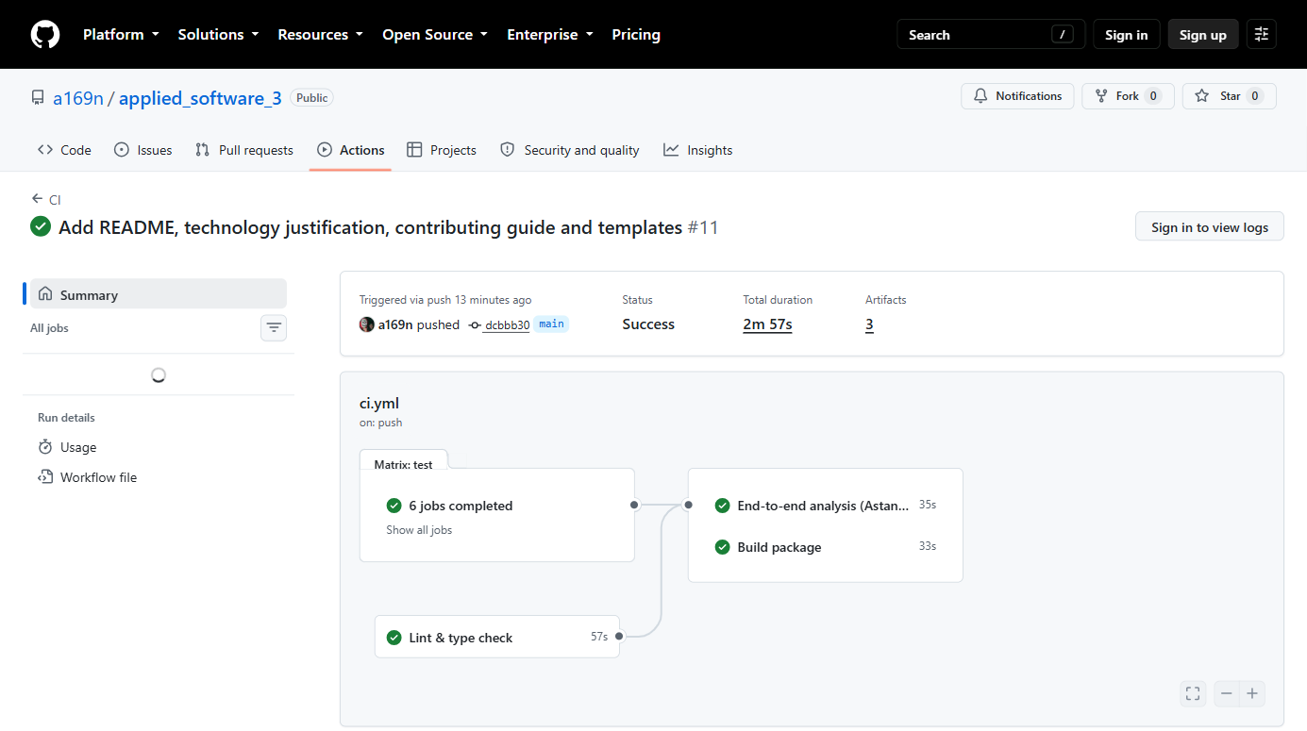
Figure 3 – Successful run #11 of the CI workflow on the main branch
The second workflow uses the CI infrastructure for a scientific task rather than for checking code: every month, or on demand through workflow_dispatch, it repeats the whole study on fresh data on an independent machine.
The third workflow implements continuous delivery. When a version tag is pushed, it checks that the tag matches the package version, repeats the tests, builds the wheel and the source archive and publishes them as a GitHub Release. The workflow therefore cannot publish code that fails its tests; version 0.1.0 was released this way.

5 Features of scientific software development
Scientific software differs from ordinary applications in what counts as a defect. A business application that crashes is obviously broken; a scientific program that silently returns a plausible but wrong number is far more dangerous, because the error passes into publications. Research software engineering therefore stresses a specific set of practices [6, 7], each of which was applied here.
Correctness against a known answer. For real climate data the true trend is unknown, so a result cannot be checked directly. The project solves this oracle problem with a synthetic dataset that imitates Astana's climate, has a known warming and contains deliberate defects (gaps, sensor spikes, -999 codes). The tests require the tool to remove the defects and recover the known trend.
Reproducibility. The sample is generated with a fixed random seed, figures are rendered without a display, tests never use the network, and the test suite turns every FutureWarning — the category pandas and NumPy use to announce coming changes of behaviour — into an error, so that a library update cannot alter the results unnoticed.
Domain-aware data quality. Generic rules fail on climate data: a global outlier threshold would mark every Astana winter day as an anomaly, so outliers are judged against the same calendar month. Gaps of up to three days are interpolated, longer ones are left empty so that weather is not invented, and a month or year with less than 80 % of its days is excluded.
Honest treatment of uncertainty. The trend is estimated twice, by ordinary least squares and by the non-parametric Mann–Kendall test with Sen's slope [8, 9], the standard robust method in climatology. The forecast has a 95 % prediction interval and is scored on data the model has not seen, against the naive climatology forecast (“an average January”).

5.1 Results for Astana on real data
The tool was run on 11 688 daily values for 1 January 1994 – 31 December 2025, downloaded without gaps from the Open-Meteo archive [10]. By default the archive combines the ERA5 and ERA5-Land reanalyses [11] (used here up to 2016) with the operational ECMWF IFS model (from 2017), and it describes a model grid cell near 51.1° N, 71.4° E rather than one weather station. The whole-record means — −14.4 °C in January, +20.6 °C in July — agree with the published 1991–2020 station normals of −14.5 and +20.6 °C [13]. Table 9 gives the main results.
Table 9 – Analysis of Astana air temperature, 1994–2025
Indicator | Value
Mean daily temperature | 4.10 °C
Coldest / warmest year | 1996 (1.29 °C) / 2023 (5.72 °C)
Coldest / warmest daily mean | −39.6 °C (2012-12-15) / +31.6 °C (2008-07-30)
Linear trend (OLS) | +0.35 ± 0.16 °C per decade (± standard error), p = 0.040
Sen's slope; Mann–Kendall test | +0.30 °C per decade; τ = 0.21, p = 0.089
Cold days per year, first / second half of the record | 36.7 / 30.7
Forecast model: variance explained; residual std | R² = 0.96; 2.63 °C
Backtest, 36 months: MAE of model / climatology | 1.80 °C / 1.91 °C (skill +6.0 %)
Forecast for January / July 2026 (95 % interval) | −13.9 °C (−19.0 … −8.8) / +21.7 °C (+16.5 … +26.8)

The annual mean temperature rose by +0.35 °C per decade (Figure 4). This is of the same order as the 0.33 °C per decade that Kazhydromet reports for the Akmola region over the longer period 1976–2023 [14] (the equal value built into the synthetic sample is a coincidence). The result shows why two tests are reported. Least squares gives p = 0.040, formally below 0.05, but the more cautious Mann–Kendall test gives p = 0.089: the least-squares slope is pulled up by the very cold 1996 at the start of the record, and without that single year it falls to +0.23 °C per decade (p = 0.14). The tool therefore reports the trend as not statistically significant at the 5 % level; a program that printed only the first p-value would have overstated the evidence. The number of cold days per year (days below the 10th percentile of the same calendar month in the baseline) fell from 37 in 1994–2009 to 31 in 2010–2025, while warm days (above the 90th percentile) hardly changed (36 and 38), so the warming appears mainly as a loss of cold extremes.
The forecast model — a linear trend, two annual harmonics and first-order autoregressive residuals — explains 96 % of the variance of monthly temperature. In the backtest it was fitted on data up to December 2022 and compared with the next 36 months: its mean absolute error was 1.80 °C against 1.91 °C for climatology, and 97 % of the observations fell inside the 95 % interval (Figure 5). The gain of 6 % is modest, and the README states the reason: a statistical model cannot predict individual weather events months ahead. An out-of-sample check is already possible: against Open-Meteo values for January–September 2026, retrieved separately on 6 October 2026, all nine months fell inside the forecast interval, with a mean absolute error of 2.05 °C against 2.28 °C for climatology. For precipitation the same model explains only 25 % of the variance. The apparent increase of annual totals is not significant (Mann–Kendall p = 0.19) and is inflated by the 2017 change of the underlying model, so it is not interpreted as a climate signal. For temperature the change matters little: ERA5-Land alone gives +0.34 °C per decade (Mann–Kendall p = 0.10), so the cautious verdict does not depend on it.
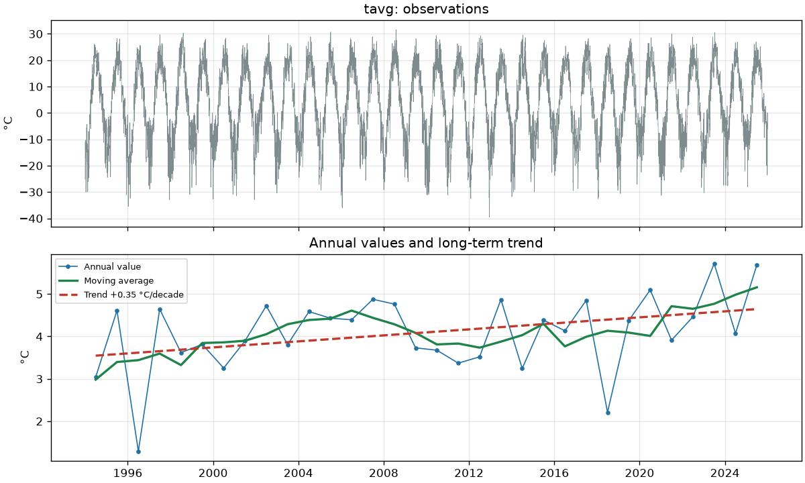
Figure 4 – Daily temperature of Astana and the trend of annual means (real data, 1994–2025)
Real data also exposed a weakness that the synthetic tests could not. The only value that the outlier filter removed, −33.4 °C on 28 November 1998, was a genuine cold wave confirmed by station records, not an error. The effect on the trend is negligible, but a rule designed for sensor faults should not be applied blindly to reanalysis data.
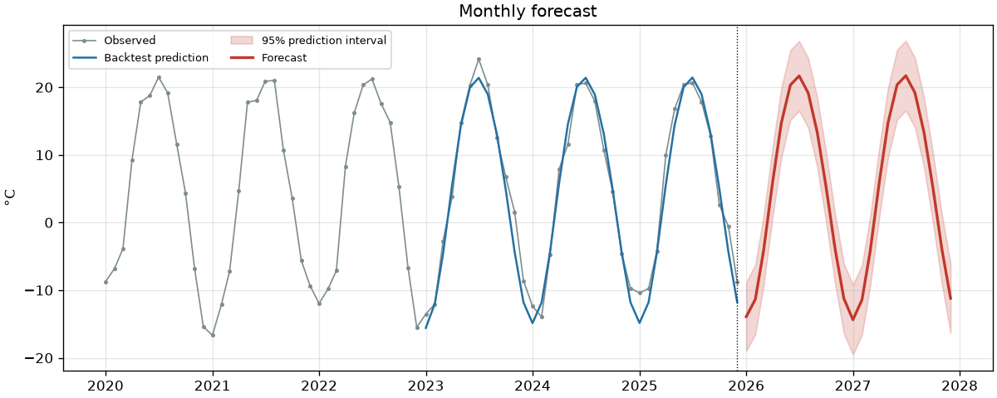
Figure 5 – Backtest and 24-month forecast of monthly mean temperature with the 95 % prediction interval

6 Links to the repository and CI/CD configuration
All materials of the project are public (Table 10). In the PDF every entry is a link; file paths are relative to the main branch of the repository.
Table 10 – Project links
Item | Link
Repository | github.com/a169n/applied_software_3
Justification of technologies | docs/TECHNOLOGY.md
CI workflow | .github/workflows/ci.yml
Forecast workflow | .github/workflows/astana-forecast.yml
Release workflow | .github/workflows/release.yml
CI run #11 (Figure 1) | actions/runs/37423250131
Release v0.1.0 | releases/tag/v0.1.0
Issues | github.com/a169n/applied_software_3/issues

Conclusion
A small scientific tool was taken through every stage of the software development process. The result is a documented, licensed open-source package with 84 automated tests and a CI/CD pipeline that checks every change on three operating systems, repeats the analysis on fresh data and publishes releases. Applied to real data for Astana for 1994–2025, the tool estimated a warming of +0.35 °C per decade and reported, by the more cautious Mann–Kendall test, that this trend is not statistically significant at the 5 % level. It also produced a forecast whose skill and uncertainty were measured rather than assumed.
The main challenges encountered during the work were the following.
– No access to the data source during development. The environment in which the code was first written could not reach the Open-Meteo API. The downloader was therefore designed with an injectable opener and tested on prepared responses, and a synthetic dataset was created. The real download, made later, matched the API response exactly.
– Real data behaves differently from test data. Besides the outlier case above, the first real run showed that the archive changes its underlying model in 2017; the README, written earlier, described the source simply as ERA5 and had to be corrected. Tests on synthetic data could reveal neither problem.
– Machine-specific failures. On the Windows development machine the download failed with a TLS error although the server certificate was valid: the system store held an expired intermediate certificate that Python preferred to the valid chain. On that machine the download was run with the truststore package, which delegates verification to the operating system, instead of switching the check off; the published code was left unchanged. A security policy also blocked the launcher programs that pip generates, so the tools were started as python -m.
– Interpreting statistics honestly. Least squares and the Mann–Kendall test disagreed about the significance of the trend, so the rule for the verdict had to be fixed in advance rather than chosen after seeing the result.
– The pipeline needs maintenance too. Within two minutes of the first push Dependabot opened eight update pull requests. They were closed without merging for now, so the upgrade of actions/upload-artifact, which would remove GitHub's warning about a deprecated Node.js version, remains the first maintenance task.
The main lesson is that version control, automated testing and continuous integration and delivery are not an addition to scientific work but a condition of its reliability: a result recomputed automatically on an independent machine, with tests that know the right answer, can be trusted and reproduced by others.

References
1. Talgatov A. climate-analyzer: source code repository. GitHub, 2026. URL: https://github.com/a169n/applied_software_3
2. Sommerville I. Software Engineering. 10th ed. Pearson, 2016. 816 p.
3. Chacon S., Straub B. Pro Git. 2nd ed. Apress, 2014. URL: https://git-scm.com/book
4. Fowler M. Continuous Integration. 2000 (rewritten 2006, revised 2024). URL: https://martinfowler.com/articles/continuousIntegration.html
5. Humble J., Farley D. Continuous Delivery: Reliable Software Releases through Build, Test, and Deployment Automation. Addison-Wesley, 2010. 512 p.
6. Wilson G. et al. Best Practices for Scientific Computing // PLoS Biology. 2014. Vol. 12, No. 1. e1001745.
7. Wilson G. et al. Good Enough Practices in Scientific Computing // PLoS Computational Biology. 2017. Vol. 13, No. 6. e1005510.
8. Mann H. B. Nonparametric Tests Against Trend // Econometrica. 1945. Vol. 13, No. 3. P. 245–259.
9. Sen P. K. Estimates of the Regression Coefficient Based on Kendall's Tau // Journal of the American Statistical Association. 1968. Vol. 63, No. 324. P. 1379–1389.
10. Zippenfenig P. Open-Meteo.com Weather API. Zenodo, 2023. URL: https://doi.org/10.5281/zenodo.7970649
11. Hersbach H. et al. The ERA5 Global Reanalysis // Quarterly Journal of the Royal Meteorological Society. 2020. Vol. 146, No. 730. P. 1999–2049.
12. GitHub Actions documentation. GitHub Docs. URL: https://docs.github.com/en/actions
13. Pogoda i Klimat. Climate of Astana (station 35188), 1991–2020 normals. URL: http://www.pogodaiklimat.ru/climate/35188.htm
14. Kazhydromet. Annual Bulletin of Monitoring Status and Climate Change of Kazakhstan: 2023. Astana, 2024. 90 p. URL: https://kazhydromet.kz/uploads/files/1891/file_en/675274f0f001bezhegodnyy-byulleten-ik-za-2023_eng_ot_27-11-2024.pdf

