Assignment 2 Report
Project Information
Course Task: Assignment 2
Project Under Test: Inkwell Platform
System Type: Web Application
Team Members: Asqar Nurym | Aibyn Talgatov | Zhansaya Kuanshpek
Group: CSE-2505M
1. Introduction
This report presents the Assignment 2 QA deliverables for the Inkwell Platform, a full-stack blogging web application. The work in this assignment builds directly on the risk assessment, QA strategy, environment setup, and baseline metrics established in Assignment 1.
The purpose of Assignment 2 is to move from planning into controlled implementation. The report therefore focuses on applying automation to the highest-risk parts of the system, defining enforceable quality gates, collecting measurable execution results, and preparing evidence that can be reused in the later research paper sections.
The report is structured according to the required Assignment 2 components:
1. Automated Test Implementation
2. Quality Gate Definition and Integration
3. Metrics Collection
4. Documentation and Reproducibility Evidence
5. Deliverables Checklist
The document is written as an academic QA report. Its purpose is to show (1) what was automated, (2) why those areas were selected, (3) how the automated checks were integrated into CI/CD, and (4) what measurable results were obtained from the current implementation.
2. Automated Test Implementation
The automated implementation followed the risk model defined in Assignment 1. Work began with all P1 modules because those components carry the highest combined probability and impact of failure. After those flows were covered, the automation scope was extended with targeted checks for P2 modules to improve overall confidence and evidence quality.
At the current stage, the repository contains:
- 38 automated API scenarios executed through Vitest + Supertest
- 4 browser smoke scenarios executed through Playwright
- reusable helpers for authentication, seeded test data, and repeatable environment reset
2.1 Identify Test Scope
Table 2.1. Identify Test Scope
Module / Feature | High-Risk Function | Test Priority | Notes / Expected Outcome
C1 Authentication and session lifecycle | registration, login, refresh rotation, logout, authenticated session lookup | High | Invalid credentials must fail, refresh tokens must rotate, revoked sessions must not be reusable
C2 Authorization and admin moderation | admin-only access to users, roles, reports, categories, and tags | High | Non-admin users must be blocked; admins must be able to inspect and moderate controlled resources
C3 Content integrity and moderation workflow | post ownership, publish/archive/restore lifecycle, comments, likes, bookmarks, reports | High | Ownership and lifecycle rules must remain consistent across create, update, moderation, and reporting flows
C4 Profile management and avatar uploads | profile updates, duplicate email validation, avatar MIME and size validation | Medium | Account data must remain unique and uploads must be accepted only for valid image files within size limits
C5 Public browsing and discovery flows | published feed visibility, filters, bookmark/report UI journeys | Medium | Only published content should appear publicly; integrated reader workflows must remain functional

2.2 Define Test Cases
The full implementation contains more scenarios than can be listed compactly in the report, so the table below records representative test cases that cover the critical behaviors required by the assignment.
Table 2.2. Define Test Cases
Test Case ID | Module / Feature | Description | Input Data | Expected Result | Scenario Type | Notes
TC01 | Authentication | Register first platform user | valid name, email, password | user is created as admin and /api/auth/me returns authenticated profile | Positive | verifies bootstrap admin path
TC02 | Authentication | Reject invalid login | valid email with wrong password | login returns 401 with Invalid credentials. | Negative | validates secure failure behavior
TC03 | Session lifecycle | Rotate refresh token and reject reuse | valid refresh cookie, then repeated use of old cookie | first refresh succeeds, reused token returns 401 | Negative | protects against session replay
TC04 | Authorization | Block non-admin user from admin routes | authenticated regular user requests /api/admin/users | response returns 403 with admin access error | Negative | proves role enforcement
TC05 | Content integrity | Allow author to manage own post | authenticated author creates, updates, deletes post | all operations succeed and deleted post returns 404 afterward | Positive | validates ownership flow
TC06 | Content integrity | Prevent outsider from managing another author's post | author, outsider, and admin accounts | outsider receives 403, admin moderation action succeeds | Negative | covers ownership + moderation boundary
TC07 | Editorial workflow | Draft to publish to archive to restore | authenticated author and draft post | status transitions follow draft -> published -> archived -> draft | Positive | validates core lifecycle logic
TC08 | Profile / avatar | Reject unsupported avatar upload | authenticated user uploads text/plain file | upload returns 415 with MIME validation message | Negative | protects upload surface
TC09 | Security hardening | Throttle repeated auth attempts | repeated invalid login from same forwarded client IP | first five attempts return 401, next attempt returns 429 | Negative | validates basic brute-force protection
TC10 | Taxonomy / moderation | Reject duplicate category or tag creation | authenticated admin sends existing category/tag name | API returns 409 conflict | Negative | protects admin data integrity
TC11 | Reader workflow | Bookmark and report published content | authenticated reader bookmarks post and reports post/comment | bookmark is stored and both reports are created | Positive | validates integrated user-facing moderation entry
TC12 | Browser smoke | Review reports queue in UI | admin logs in and opens reports page | open reports are visible and resolvable through UI | Positive | confirms end-to-end moderation path

2.3 Track Script Implementation
Table 2.3. Track Script Implementation
Script ID | Module / Feature | Automation Framework | Script Name / Location | Status | Comments
S01 | Authentication and session lifecycle | Vitest + Supertest | server/src/test/auth.integration.test.ts | Complete | covers registration, duplicate registration, invalid login, refresh rotation, /auth/me, and logout
S02 | Post, comment, and like integrity | Vitest + Supertest | server/src/test/blog.integration.test.ts | Complete | focuses on ownership rules, unauthorized mutation blocking, comment validation, and duplicate-like prevention
S03 | Editorial workflow and moderation | Vitest + Supertest | server/src/test/editorial.integration.test.ts | Complete | covers publish/archive/restore lifecycle, public feed filtering, bookmarks, reports, and admin moderation
S04 | Profile management and admin controls | Vitest + Supertest | server/src/test/profile-admin.integration.test.ts | Complete | validates profile updates, avatar upload rules, admin dashboards, role changes, and last-admin protection
S05 | Taxonomy administration | Vitest + Supertest | server/src/test/taxonomy.integration.test.ts | Complete | covers create, update, delete, duplicate handling, and missing-record paths for categories and tags
S06 | Security hardening checks | Vitest + Supertest | server/src/test/security.integration.test.ts | Complete | verifies response headers, no-store auth responses, and auth rate limiting
S07 | Cross-layer smoke validation | Playwright | tests/e2e/smoke.spec.ts | Complete | validates taxonomy setup, editorial publish flow, bookmark/report path, and report-queue handling through the browser

The implementation was kept maintainable by centralizing common API setup in test helpers, resetting the test database between runs, and keeping the browser suite focused on a small set of high-value integrated workflows instead of broad but fragile UI coverage.
2.4 Version Control Tracking
The table below lists representative repository milestones that show the implementation history of the automation layer and supporting application changes.
Table 2.4. Version Control Tracking
Commit ID / Hash | Date | Module / Feature | Description of Changes | Author
1b2fd21 | 2026-03-15 | QA automation baseline | Added initial QA workflow, backend integration suites, Playwright smoke setup, Docker support, and QA documentation scaffolding | Aibyn
6bd6860 | 2026-03-18 | Editorial API and e2e smoke coverage | Added editorial integration tests and extended Playwright smoke coverage for publish, moderation, and taxonomy flows | Asqar Nyrym
8a875c5 | 2026-04-03 | Assignment 2 automation baseline | Consolidated the Assignment 2 technical state: security hardening, QA reporting, additional integration coverage, updated documentation, and evidence assets | Asqar Nyrym
d84b342 | 2026-04-03 | CI/CD quality-gate reliability | Fixed the GitHub Actions artifact restore step so the qa-gates stage works correctly on the latest remote workflow run | Asqar Nyrym

2.5 Evidence for Research Paper
The automation outputs already generate reproducible evidence artifacts. These files serve as direct input for later reporting, metrics analysis, and screenshot capture during final packaging.
Table 2.5. Evidence for Research Paper
Evidence ID | Module / Feature | Type | Description | File Location / Link
E01 | Authentication and session lifecycle | Log | machine-readable API execution output including auth, refresh, and logout scenarios | .tmp/qa/vitest-report.json
E02 | Content integrity and moderation workflow | Code | source of editorial workflow, bookmark, report, and moderation API checks | server/src/test/editorial.integration.test.ts
E03 | Authorization and admin moderation | Code | source of admin user, role, report, and moderation checks | server/src/test/profile-admin.integration.test.ts
E04 | Cross-layer smoke validation | HTML Report | browser execution report for taxonomy, publishing, bookmark/report, and report-queue scenarios | playwright-report/
E05 | Automation coverage and quality-gate status | Log | unified QA summary combining API results, e2e results, coverage, and gate outcomes | .tmp/qa/qa-summary.json
E06 | Coverage measurement | Report | backend coverage summary used later in quality-gate evaluation | server/coverage/coverage-summary.json

This section demonstrates that the automation work is not only implemented but also traceable through executable scripts, repository history, and reproducible evidence files.
3. Quality Gate Definition and Integration
Assignment 2 requires the automation layer to be more than a collection of runnable tests. It must also define explicit pass/fail criteria and enforce them through a repeatable CI/CD flow. In the current implementation, this requirement is satisfied through a combination of:
- repository-level workflow checks in GitHub Actions
- machine-readable QA artifacts generated by test execution
- a dedicated quality-gate evaluation step that reads those artifacts and fails the pipeline when thresholds are not met
The resulting model keeps release decisions based on measurable results rather than on manual interpretation alone. Compared with Assignment 1, the main improvement in this section is that the pipeline no longer stops at test execution only. It now includes a dedicated quality-gate evaluation stage that checks whether the measured results satisfy the agreed thresholds.
3.1 Define Pass / Fail Criteria
This subsection defines the formal pass/fail rules used by the QA workflow. The thresholds are evaluated from a unified QA summary generated after the automated runs, but the purpose of this subsection is to record the gate definitions themselves rather than the latest measured outcomes.
Table 3.1. Define Pass / Fail Criteria
Quality Gate ID | Metric / Criterion | Threshold / Requirement | Importance | Notes
QG01 | Backend statement coverage | >= 80% | High | protects execution breadth across backend logic
QG02 | Backend line coverage | >= 80% | High | confirms useful execution depth, not only superficial route access
QG03 | API failed tests | 0 allowed | High | any failed API integration scenario blocks the gate
QG04 | E2E failed or flaky tests | 0 allowed | High | flaky browser execution is treated as unacceptable for the smoke layer
QG05 | P1 automation coverage | 100% of P1 modules must be covered | High | proves the risk-based strategy is actually enforced

These gates were selected because they correspond directly to the Assignment 2 goals:
- coverage gates measure whether automation reaches enough of the critical backend surface
- execution gates measure reliability of API and browser automation
- risk-coverage gate measures whether the most important modules from Assignment 1 were actually automated
In addition to the formal QA gates, the CI pipeline also enforces supporting delivery checks:
- format check
- linting
- build verification
- Docker image build verification
These supporting checks are separate from QG01-QG05, but they still act as practical release gates in the workflow.
3.2 Integrate Tests into CI/CD Pipeline
The CI/CD implementation uses a GitHub Actions workflow triggered on both push and pull_request. The pipeline is ordered so that low-cost checks fail early, while heavier automated validation runs only after the repository has passed the earlier gates.
Table 3.2. Integrate Tests into CI/CD Pipeline
Pipeline Step | Description | Tool / Framework | Trigger | Notes
1. lint | checks formatting and source lint rules | Prettier, ESLint, GitHub Actions | push, pull_request | workflow also verifies that lint autofix does not leave uncommitted changes
2. build | compiles frontend and backend workspaces | TypeScript, workspace build scripts | push, pull_request | ensures test execution uses buildable code only
3. api-tests | runs backend integration suite with coverage against PostgreSQL service | Vitest, Supertest, PostgreSQL, GitHub Actions | push, pull_request | uploads vitest-report.json and backend coverage artifacts
4. e2e | runs browser smoke suite after API validation passes | Playwright | push, pull_request | uploads HTML report, failure output, and playwright-report.json
5. qa-gates | restores artifacts and evaluates formal QA thresholds | custom qa:summary and qa:gates scripts | push, pull_request | converts raw test results into explicit pass/fail gate decisions
6. docker-build | verifies backend image can still be packaged successfully | Docker | push, pull_request | protects deployment readiness after the QA gates pass

The artifact flow is also important. The pipeline does not evaluate quality gates directly inside the API or browser jobs. Instead, it first collects the generated reports from those stages and then evaluates them centrally in the dedicated qa-gates stage. This design improves traceability because the same execution evidence can be:
- used for automated gate decisions
- uploaded for reviewer inspection
- reused later as evidence in the report
Figure 1. CI/CD Pipeline Diagram
Figure 2. Successful Workflow Run
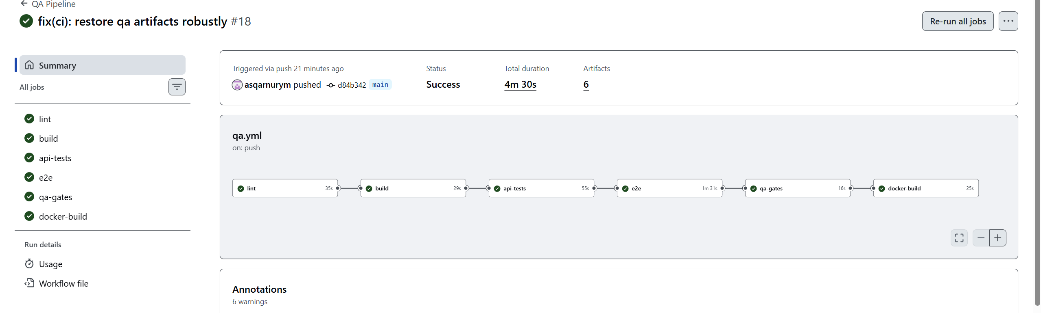
3.3 Alerting and Failure Handling Procedures
The current repository does not include external Slack or email alerting. The effective alerting channel is the GitHub Actions workflow status itself, together with job logs and uploaded artifacts. This is sufficient for the assignment because failures are visible on push and pull_request, and each failed stage exposes the specific logs required for investigation.
Table 3.3. Alerting and Failure Handling Procedures
Scenario / Event | Alert Type | Recipient / Channel | Action Required | Notes
Format or lint failure | failed GitHub Actions job | repository contributors and reviewers through workflow/PR status | correct formatting or lint violations, rerun pipeline | early failure prevents wasting CI time on heavier jobs
Build failure | failed GitHub Actions job | repository contributors and reviewers through workflow/PR status | fix compilation issue before test stages continue | protects against invalid test interpretation on unbuildable code
API integration failure | failed api-tests job + machine-readable test artifact | repository contributors via Actions logs and artifacts | inspect failing API scenario, fix service or test issue, rerun | API execution output preserves reproducible evidence
Browser smoke failure or flake | failed e2e or qa-gates status | repository contributors via Actions logs, HTML report, and test results | inspect Playwright report, screenshots, and traces; stabilize or fix workflow | flakes are treated as failures in the formal QA gate
Coverage below threshold | failed qa-gates job | repository contributors via explicit gate output in workflow logs | expand or improve tests, then rerun | gate output prints actual value and threshold
P1 coverage below target | failed qa-gates job | repository contributors via explicit gate output in workflow logs | add automation for uncovered high-risk module(s) before accepting build | directly tied to Assignment 1 risk model
Docker build failure | failed docker-build job | repository contributors via workflow status and logs | inspect packaging/build changes and repair image build path | acts as final deployment-oriented verification

This failure-handling model is intentionally simple and evidence-driven. Each failure produces a visible status, a reproducible log, and in several cases an uploaded artifact that can be reviewed after the run has completed.
3.4 Current Quality-Gate Results
Section 3.1 defines the pass/fail criteria. This subsection records the most recent measured outcomes against those criteria. The most recent verified QA baseline was executed on 2026-04-03 both locally and through the latest GitHub Actions workflow run. In both cases, the measured gate values were the same and all stages completed successfully.
Table 3.4. Current Quality-Gate Results
Quality Gate ID | Metric | Actual | Threshold | Status
QG01 | backend statement coverage | 83.73 | 80 | Pass
QG02 | backend line coverage | 83.33 | 80 | Pass
QG03 | api failed tests | 0 | 0 | Pass
QG04 | e2e failed or flaky tests | 0 | 0 | Pass
QG05 | P1 automation coverage | 100 | 100 | Pass

The latest successful remote workflow also completed the full CI sequence:
1. lint
2. build
3. api-tests
4. e2e
5. qa-gates
6. docker-build
As a result, both the local QA run and the newest pushed workflow confirmed that the current automation layer satisfies the enforced Assignment 2 thresholds in its present state.
Figure 3. Quality Gate Results
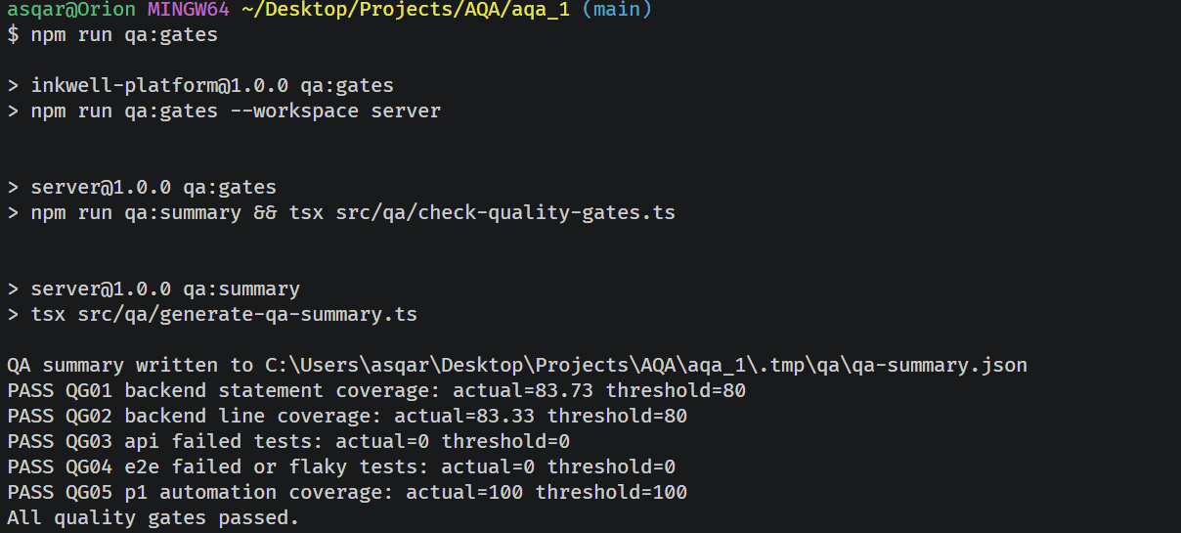
4. Metrics Collection
Assignment 2 requires measurable results, not only implemented scripts. The purpose of this section is therefore to show how much of the risk surface is automated, how long the automated checks take to run, and what the final baseline indicates about defect pressure in relation to the risk model inherited from Assignment 1.
All values in this section reflect the verified baseline from 2026-04-03, after the latest local run and successful remote workflow execution.
4.1 Track Automation Coverage
The risk-based model from Assignment 1 identified five high-risk modules. In the current baseline, all five modules have at least one automated validation layer, and all three P1 modules have full combined coverage through API automation and browser smoke validation.
Because the Assignment 1 risk register was defined at the module level, the coverage calculation below is also performed at module level. The High-Risk Function column shows the specific behaviors inside each module that were automated.
Formula used:
Automation Coverage (%) = (Number of automated high-risk modules / Total high-risk modules) × 100
Table 4.1. Track Automation Coverage
Module / Feature | High-Risk Function | Test Automated? | Coverage (%) | Notes
C1 Authentication and session lifecycle | registration, login, refresh rotation, logout, session lookup | Yes | 100 | covered by API integration and browser smoke flows
C2 Authorization and admin moderation | admin-only access, moderation queue, role control, taxonomy administration | Yes | 100 | covered by API integration and browser smoke flows
C3 Content integrity and moderation workflow | ownership rules, publish/archive/restore, bookmarks, reports | Yes | 100 | covered by API integration and browser smoke flows
C4 Profile management and avatar uploads | profile updates, duplicate email validation, avatar MIME and size validation | Yes | 50 | covered by API integration only; no browser smoke path yet
C5 Public browsing and discovery flows | public feed visibility, filters, bookmark/report reader flow | Yes | 100 | covered through API checks and browser smoke validation

Current coverage interpretation:
- total high-risk module automation coverage: 100% (5/5)
- P1 automation coverage: 100% (3/3)
- partial gap remains in C4, because the profile/avatar area is validated at API level but not yet represented in the browser smoke suite
This result is stronger than the Assignment 1 baseline, where automation coverage for high-risk modules was planned rather than fully demonstrated.
4.2 Track Execution Time
Execution time matters because Assignment 2 does not only ask whether tests exist. It also asks whether they are practical to run repeatedly in CI/CD. The table below records the measured execution time of the automated suites from the latest verified run, using scenario/file durations from .tmp/qa/qa-summary.json. Row values are rounded to two decimals; aggregate totals below use the exact summary values.
Table 4.2. Track Execution Time
Module / Feature | Number of Test Cases | Execution Time per Test Case (avg, sec) | Total Execution Time (sec) | Notes
Authentication and session lifecycle | 6 | 0.31 | 1.85 | API suite for registration, login, refresh rotation, /auth/me, and logout
Content integrity (post/comment/like) | 5 | 0.45 | 2.25 | ownership, mutation blocking, comment validation, and duplicate-like prevention
Database seed/reset support | 4 | 1.01 | 4.04 | support suite that guarantees deterministic state before automated validation
Editorial workflow and moderation | 4 | 0.61 | 2.42 | publish/archive/restore, public feed filtering, bookmarks, reports, and moderation
Profile and admin controls | 10 | 0.39 | 3.95 | largest API suite by scenario count
QA reporting support | 2 | 0.08 | 0.15 | validates summary generation and quality-gate logic itself
Security hardening | 3 | 0.57 | 1.70 | headers, caching, and rate-limit checks
Taxonomy administration | 4 | 0.36 | 1.46 | category and tag administration rules
Browser smoke flows | 4 | 4.51 | 18.03 | scenario-level Playwright duration; excludes browser/app startup and artifact overhead

Additional observed totals:
- total API execution time across all API and support suites: 17.81 seconds
- total Playwright scenario time: 18.03 seconds
- total Playwright suite wall-clock duration in the QA summary: 47.26 seconds
- combined wall-clock automated duration captured by the QA summary: 65.08 seconds
The difference between 18.03 seconds and 47.26 seconds is expected: Playwright scenario durations measure only the executed test bodies, while the suite wall-clock duration also includes browser startup, application bootstrapping, fixture setup, and artifact generation.
The data shows the expected pattern of a healthy test pyramid:
- API automation is relatively fast and carries most of the validation volume
- browser automation is slower, so it is intentionally limited to a small number of critical flows
- the largest API overhead is the deterministic database setup layer, which is acceptable because it protects repeatability of all downstream checks
- the current execution time remains practical for CI use because the smoke layer is controlled and the full QA run still completes in about one minute
Figure 4. Backend Coverage Summary
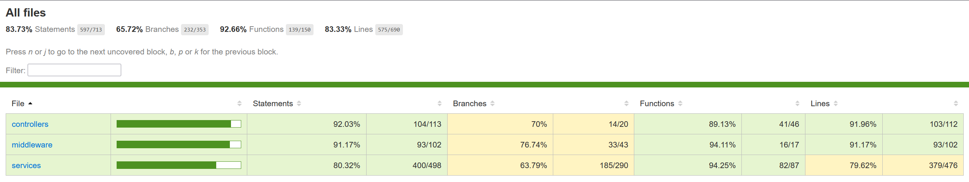
Figure 5. Playwright Smoke Report
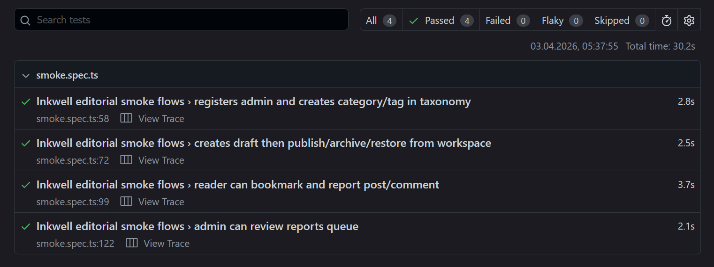
4.3 Track Defects Found vs Expected Risk
The final baseline run completed without open failures, so the table below compares the expected defect pressure from the Assignment 1 risk model against the number of defects observed in the final measured baseline.
For this comparison, the expected defect pressure is recorded as:
- 2 expected defects for each P1 module, derived from the Assignment 1 critical-risk band (16-25)
- 1 expected defect for each P2 module, derived from the Assignment 1 high-risk band (9-15)
This does not claim that exactly that number of bugs must exist. It is a simple reporting scale derived from the higher risk weight assigned in Assignment 1, used to compare forecasted pressure with the stabilized final run. The repository does not maintain a separate historical defect ledger for pre-baseline fixes, so this table reports the defects visible in the final measured automation baseline.
Table 4.3. Track Defects Found vs Expected Risk
Module / Feature | High-Risk Level | Expected Defects | Defects Found | Pass / Fail | Notes
C1 Authentication and session lifecycle | High | 2 | 0 | Pass | session and token handling were stable in the final measured baseline
C2 Authorization and admin moderation | High | 2 | 0 | Pass | admin access and moderation paths passed without visible baseline defects
C3 Content integrity and moderation workflow | High | 2 | 0 | Pass | editorial lifecycle and ownership rules were stable in the final baseline
C4 Profile management and avatar uploads | Medium | 1 | 0 | Pass | upload validation and profile checks passed in the final API baseline
C5 Public browsing and discovery flows | Medium | 1 | 0 | Pass | public browsing and reader smoke flow completed successfully

Interpretation:
- The risk model correctly prioritized the modules that required the most disciplined automation work.
- The final measured baseline shows 0 visible defects, which means the expected defect pressure was addressed before final evidence was captured.
- The absence of failing final results does not reduce the risk importance of P1 modules; instead, it indicates that the automation and hardening work were effective enough to stabilize them before submission.
4.4 Maintain Detailed Logs
The full automation logs contain all 38 API scenarios and 4 browser smoke scenarios. To keep the report readable, the table below includes a representative excerpt from the final measured baseline window (2026-04-03 05:52-05:53, local time) rather than every log line.
Table 4.4. Maintain Detailed Logs
Test Case ID | Module / Feature | Execution Date / Time | Result | Defects Found | Execution Time (sec) | Notes
TC01 | Authentication | 2026-04-03 05:52 | Pass | 0 | 0.39 | first-user registration and authenticated session check
TC03 | Session lifecycle | 2026-04-03 05:52 | Pass | 0 | 0.33 | refresh rotation and revoked-token reuse rejection
TC07 | Editorial workflow | 2026-04-03 05:52 | Pass | 0 | 0.55 | draft-publish-archive-restore lifecycle
TC08 | Profile / avatar | 2026-04-03 05:52 | Pass | 0 | 0.26 | unsupported MIME type rejected correctly
TC09 | Security hardening | 2026-04-03 05:52 | Pass | 0 | 1.14 | repeated invalid auth attempts throttled correctly
TC12 | Browser smoke | 2026-04-03 05:53 | Pass | 0 | 2.77 | admin report queue resolved successfully in UI

This logging approach supports reproducibility because:
- the test runners preserve machine-readable output for the full run
- the report records a concise, human-readable subset of the final measured evidence
- the same evidence can be reviewed both locally and in the GitHub Actions workflow artifacts
- the execution window is traceable to the final artifact timestamps even when the reporters do not emit per-test timestamps for every assertion
4.5 Metrics Reporting and Interpretation
The current metrics provide a coherent picture of QA effectiveness:
- automation coverage of high-risk modules reached 100%
- P1 risk coverage also reached 100%
- backend statement coverage reached 83.73%
- backend line coverage reached 83.33%
- API suite result was 38/38 passed
- browser smoke result was 4/4 passed
- final baseline recorded 0 visible defects and 0 gate failures
Compared with Assignment 1:
- automated API inventory increased from 23 to 38 scenarios
- backend statement coverage improved from 75.87% to 83.73%
- backend line coverage improved from 75.35% to 83.33%
- the CI pipeline expanded from 5 to 6 stages because the explicit qa-gates stage was added
- P1 automation coverage moved from a planning target to a measured 100% outcome
These values are sufficient to support the chart-oriented reporting requested by Assignment 2. The final formatted report should therefore include the following visuals in addition to the tables above:
- bar chart: automation coverage by module
- line chart: execution time by automation suite
- table: expected defect pressure versus defects found in the final baseline
Figure 6. Automation Coverage Chart
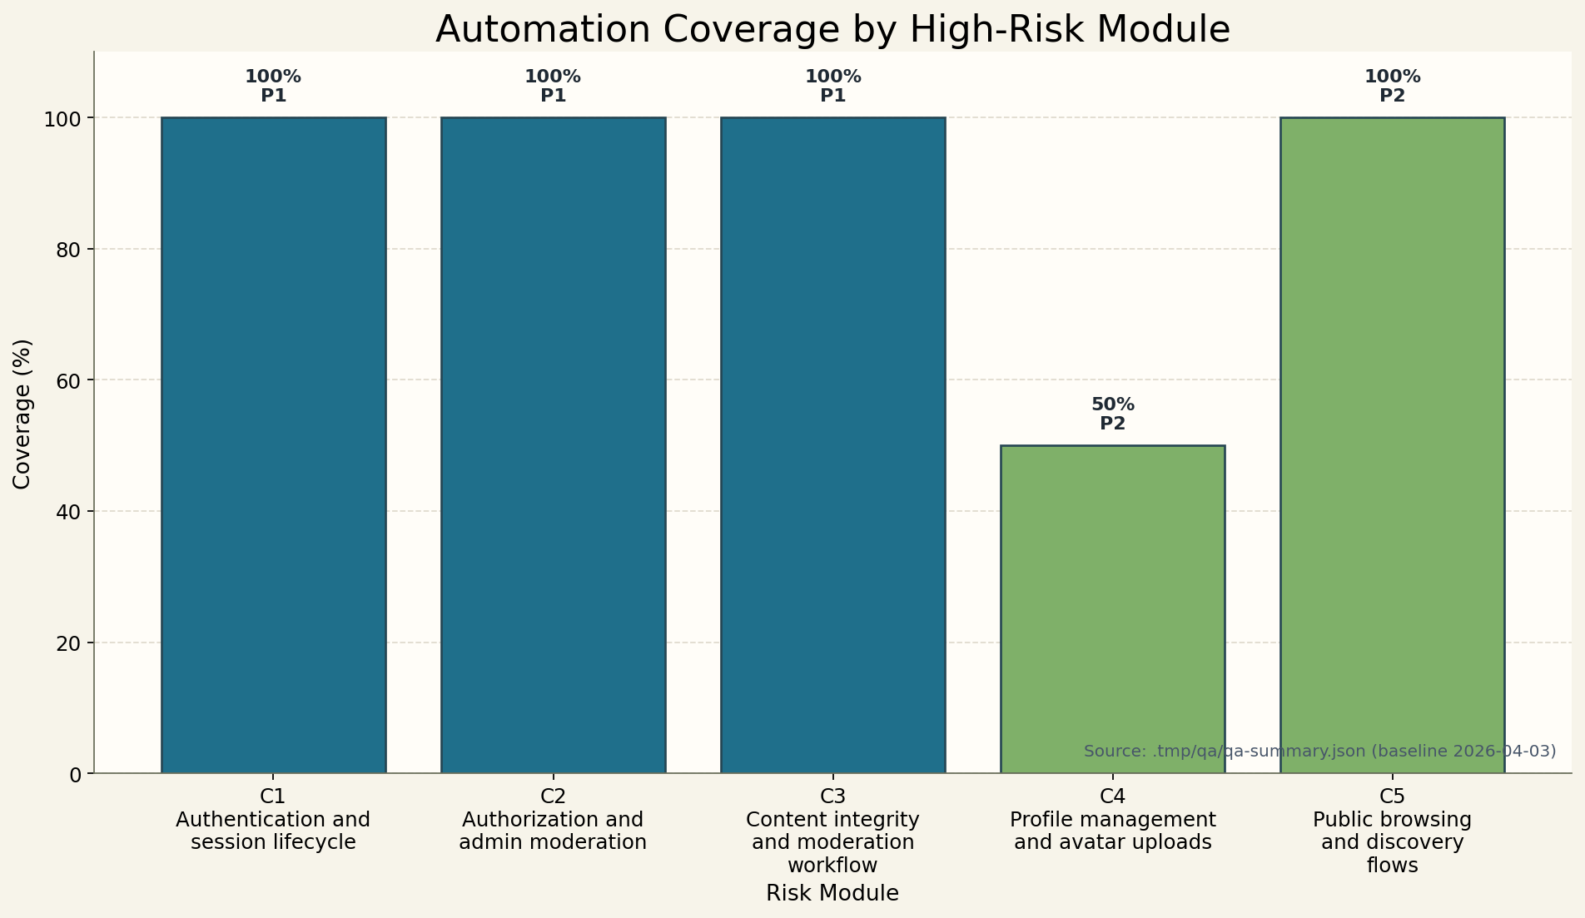
Figure 7. Execution Time Trend Chart
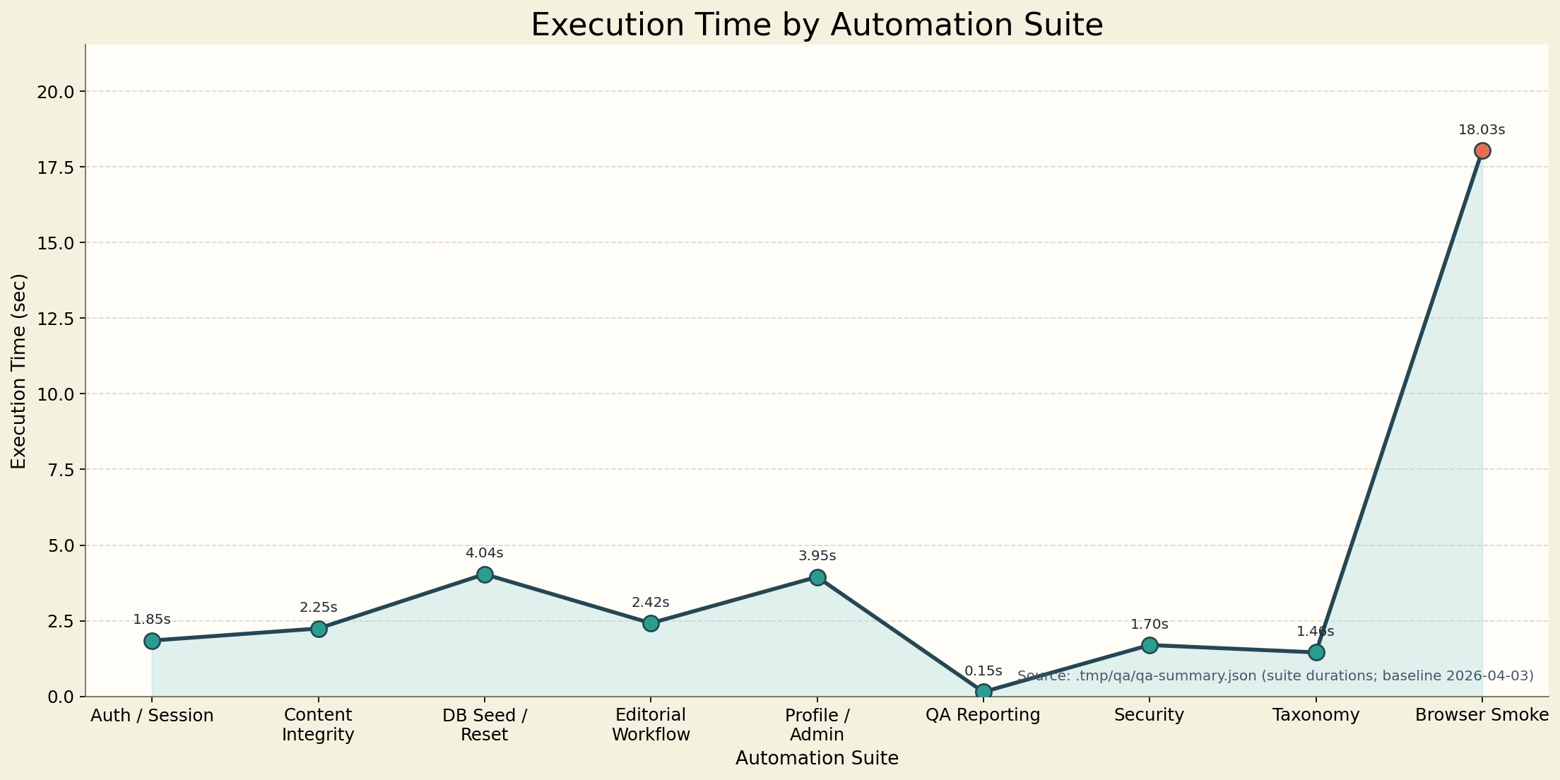
5. Documentation and Reproducibility Evidence
Assignment 2 requires the technical work to be documented in a form that can be reused directly in the final research paper. This section therefore converts the implementation, quality gates, and metrics into a documented QA strategy update. The present report serves as the primary Assignment 2 document, while repository artifacts provide the executable and visual evidence needed for reproducibility.
5.1 Automation Approach and Tool Selection
The automation approach remained explicitly risk-based. Following the Assignment 1 risk register, implementation began with the three P1 modules (C1-C3) because they represent the highest security, authorization, and content-integrity risk. API automation was prioritized first because most critical business rules live in the backend service layer. After that foundation was stable, a controlled browser smoke layer was added to prove that the frontend, backend, authentication, and persistence layers work together on the most important user journeys. Coverage for P2 modules was then expanded selectively where it improved evidence quality without creating disproportionate maintenance cost.
The selected toolchain is documented below.
Table 5.1. Automation Approach and Tool Selection
Area | Selected Tool / Framework | Why This Choice Fits the Project | Evidence / Location
API automation | Vitest + Supertest | TypeScript-native, low setup cost, fast feedback, and strong request/response validation | server/src/test/*.integration.test.ts
Browser automation | Playwright | reliable end-to-end execution, deterministic web-server orchestration, and exportable reports | tests/e2e/smoke.spec.ts, playwright.config.ts
Coverage collection | @vitest/coverage-v8 | integrates directly with the existing Vitest stack and produces machine-readable coverage output | server/coverage/coverage-summary.json
QA summary and gate logic | custom QA scripts | converts raw test and coverage artifacts into measurable quality-gate results | server/src/qa/reporting.ts, server/src/qa/check-quality-gates.ts
CI/CD orchestration | GitHub Actions | keeps automated verification visible on push and pull_request and stores artifacts centrally | .github/workflows/qa.yml
Supporting manual QC | Swagger UI and Postman | supports contract inspection, demo replay, and reviewer-friendly evidence capture | docs/qa/postman/inkwell-qa.postman_collection.json

Maintainability and reusability were treated as documentation concerns, not only coding concerns. The current implementation supports reruns through:
- shared API helpers for registration, login, auth headers, and common entity creation in server/src/test/helpers.ts
- centralized integration-test environment reset in server/src/test/setup.ts
- explicit database reset protection for test-only environments in server/src/test/reset-db.ts
- controlled Playwright server orchestration and artifact reporters in playwright.config.ts
This structure satisfies the Assignment 2 requirement to document not only what tools were selected, but also how the automation remains modular and reproducible over repeated runs.
5.2 Quality Gate Documentation
Unlike Section 3.1, which defines the operational pass/fail criteria, and Section 3.4, which records the latest execution results, this subsection documents the traceability of each gate for the report and the later research paper. Its purpose is to show where each gate is defined, where it is enforced, and which artifact preserves the latest measured result.
The quality gates are therefore documented in three layers:
- definition in the report, where the thresholds and rationale are explained
- enforcement in the repository, where the thresholds are encoded and executed during qa:gates
- evidence in generated artifacts, where the latest measured result is preserved for review and reuse
The documentation traceability for the current gate set is shown below.
Table 5.2. Quality Gate Documentation
Quality Gate ID | Metric / Criterion | Threshold / Requirement | Latest Documented Result (2026-04-03) | Report Reference | Enforcement / Evidence Source | Documentation Note
QG01 | backend statement coverage | >= 80% | 83.73% | Sections 3.1, 3.4 | server/src/qa/reporting.ts, server/src/qa/check-quality-gates.ts, server/coverage/coverage-summary.json | documents breadth of backend execution
QG02 | backend line coverage | >= 80% | 83.33% | Sections 3.1, 3.4 | server/src/qa/reporting.ts, server/src/qa/check-quality-gates.ts, server/coverage/coverage-summary.json | documents depth of backend execution
QG03 | api failed tests | 0 allowed | 0 | Sections 3.1, 3.4 | server/src/qa/reporting.ts, server/src/qa/check-quality-gates.ts, .tmp/qa/vitest-report.json, .tmp/qa/qa-summary.json | documents backend execution reliability
QG04 | e2e failed or flaky tests | 0 allowed | 0 | Sections 3.1, 3.4 | server/src/qa/reporting.ts, server/src/qa/check-quality-gates.ts, .tmp/qa/playwright-report.json, .tmp/qa/qa-summary.json | documents smoke-suite stability
QG05 | P1 automation coverage | 100% of P1 modules must be covered | 100% | Sections 3.1, 3.4 | server/src/qa/reporting.ts, server/src/qa/check-quality-gates.ts, .tmp/qa/qa-summary.json | documents enforcement of the Assignment 1 risk strategy

This documentation is important for the research paper because it shows that the thresholds are not rhetorical. Each gate has a defined rule, a version-controlled enforcement point, and a preserved evidence source for the latest measured outcome.
5.3 CI/CD Integration Overview
The CI/CD documentation records both the execution order and the evidence produced by the pipeline. The repository uses one GitHub Actions workflow triggered on push and pull_request, with the quality-gate decision delayed until raw artifacts from API and browser execution have been restored and summarized centrally.
Table 5.3. CI/CD Integration Overview
Pipeline Step | Tool / Framework | Trigger | Description | Documentation Evidence
1. lint | Prettier, ESLint, GitHub Actions | push, pull_request | checks formatting, lint rules, and whether autofix leaves file changes | .github/workflows/qa.yml
2. build | TypeScript | push, pull_request | verifies that frontend and backend workspaces build successfully | .github/workflows/qa.yml
3. api-tests | Vitest, Supertest, PostgreSQL, GitHub Actions | push, pull_request | runs backend coverage suite and uploads API QA artifacts | .github/workflows/qa.yml, .tmp/qa/vitest-report.json
4. e2e | Playwright | push, pull_request | runs smoke tests and uploads Playwright reports and failure artifacts | .github/workflows/qa.yml, playwright-report/
5. qa-gates | custom qa:summary and qa:gates scripts | push, pull_request | restores artifacts, generates QA summary, and evaluates formal gates | .tmp/qa/qa-summary.json
6. docker-build | Docker | push, pull_request | verifies that the backend image can still be packaged after QA succeeds | .github/workflows/qa.yml

The visual documentation already prepared for this report is:
- docs/qa/screenshots/pipeline-overview.png for the logical pipeline diagram
- docs/qa/screenshots/workflow-pass.png for the latest successful workflow run
Together, these assets satisfy the Assignment 2 requirement to document triggers, stages, integration flow, and observable execution status.
5.4 Initial Results and Coverage Metrics for Documentation
Section 4 contains the detailed metrics tables required by the assignment. For documentation purposes, the baseline values that should be carried forward into the research paper are summarized below.
Table 5.4. Initial Results and Coverage Metrics for Documentation
Result Area | Current Baseline (2026-04-03) | Interpretation | Supporting Evidence
High-risk module automation coverage | 100% (5/5) | every high-risk module from Assignment 1 now has automated coverage | .tmp/qa/qa-summary.json
P1 automation coverage | 100% (3/3) | all critical-risk modules are covered as required | .tmp/qa/qa-summary.json
API execution result | 38/38 passed | backend integration layer is stable in the final baseline | .tmp/qa/vitest-report.json
Browser smoke execution result | 4/4 passed | integrated critical user journeys remain operational | .tmp/qa/playwright-report.json, playwright-report/
Backend statement coverage | 83.73% | exceeds the formal quality-gate threshold | server/coverage/coverage-summary.json
Backend line coverage | 83.33% | exceeds the formal quality-gate threshold | server/coverage/coverage-summary.json
Combined automated wall-clock duration | 65.08 seconds | practical for repeated CI/CD execution | .tmp/qa/qa-summary.json
Visible defects in final measured baseline | 0 | no open failures remained in the final evidence capture | .tmp/qa/qa-summary.json, .tmp/qa/vitest-report.json, .tmp/qa/playwright-report.json

This summary is suitable for the methodology and results chapters of the final research paper because it links the risk-based strategy, measured execution outcomes, and formal QA gates in one documented baseline.
5.5 Evidence for Reproducibility
Reproducibility requires more than pass/fail claims. It requires version-controlled scripts, deterministic environment handling, machine-readable reports, and visual artifacts that can be checked independently. The table below records the most important reproducibility assets for the current baseline.
Table 5.5. Evidence for Reproducibility
Evidence ID | Module / Feature | Type | Description | File Location / Link
R01 | Automation strategy | Document | repository-level QA strategy and rationale for risk-based automation | docs/qa/test-strategy.md
R02 | CI/CD pipeline definition | Code | version-controlled workflow that executes lint, build, tests, gates, and Docker verification | .github/workflows/qa.yml
R03 | Integration rerun support | Code | helpers and setup scripts that reset database, uploads, and auth-related test state | server/src/test/helpers.ts, server/src/test/setup.ts, server/src/test/reset-db.ts
R04 | Browser rerun support | Code | Playwright configuration that provisions servers, reporters, traces, and screenshots | playwright.config.ts, tests/e2e/smoke.spec.ts
R05 | API execution evidence | Log | machine-readable backend test results for the final baseline | .tmp/qa/vitest-report.json
R06 | Browser execution evidence | Log | machine-readable smoke execution results for the final baseline | .tmp/qa/playwright-report.json
R07 | Unified QA evidence | Log | aggregated summary combining coverage, execution, risk coverage, and gate results | .tmp/qa/qa-summary.json
R08 | Coverage evidence | Report | backend statement, line, function, and branch coverage summary | server/coverage/coverage-summary.json
R09 | Pipeline visual evidence | Screenshot | diagram and successful workflow run for report packaging | docs/qa/screenshots/pipeline-overview.png, docs/qa/screenshots/workflow-pass.png
R10 | QA result visual evidence | Screenshot | coverage, Playwright, and QA-gate screenshots prepared for final report insertion | docs/qa/screenshots/coverage-summary.png, docs/qa/screenshots/playwright-report.png, docs/qa/screenshots/qa-summary.png
R11 | Metrics chart evidence | Screenshot | chart assets for automation coverage and execution-time reporting | docs/qa/screenshots/automation-coverage-chart.png, docs/qa/screenshots/execution-time-chart.png

Taken together, these artifacts demonstrate that the Assignment 2 automation can be rerun, inspected, and defended as a reproducible QA baseline rather than as a one-time execution claim.
5.6 Documentation Deliverables and Best-Practice Alignment
The Documentation part of Assignment 2 requires both specific deliverables and evidence that documentation best practices were followed. The current report resolves those requirements as follows.
Table 5.6. Documentation Deliverables and Best-Practice Alignment
Documentation Requirement | Current Resolution in the Report | Status | Notes
Updated QA Test Strategy Document | Sections 2-5 plus supporting strategy file docs/qa/test-strategy.md | Complete | Markdown source is complete; final PDF export can be produced during submission packaging
Quality gate definitions and thresholds | Sections 3.1, 3.4, and 5.2 | Complete | definitions, measured results, and traceability are documented separately
CI/CD overview with screenshots and diagrams | Sections 3.2, 5.3, and screenshots in docs/qa/screenshots/ | Complete | pipeline diagram and successful workflow screenshot are already present
Initial metrics from automation runs | Section 4 and Section 5.4 | Complete | coverage, execution time, defects, and logs are recorded
Reproducibility evidence | Section 5.5 and artifacts under .tmp/qa/, playwright-report/, and docs/qa/screenshots/ | Complete | logs, screenshots, reports, and code references are all tracked

The documentation best practices listed in Assignment 2 are also resolved explicitly:
- tables and metrics were updated to the verified 2026-04-03 baseline
- screenshots and logs are stored in dedicated evidence locations rather than scattered through the repository
- failure handling and alerting are documented in Section 3.3
- the report is now structured so it can be reused directly as the main reference for the research paper chapter on automation strategy and implementation
- the requested automation-coverage and execution-time chart assets are now available in docs/qa/screenshots/automation-coverage-chart.png and docs/qa/screenshots/execution-time-chart.png
6. Deliverables Checklist
Assignment 2 ends with a deliverables checklist and additional notes for submission readiness. The table below resolves those requirements against the current repository state and this report.
Table. 6. Deliverables Checklist
Deliverable | Description | File / Location | Status | Notes / Evidence
Automated Test Scripts | automated scripts for high-risk modules, including positive and negative flows | server/src/test/, tests/e2e/, repository: https://github.com/a169n/aqa_1 | Complete | high-risk API and browser smoke coverage is documented in Section 2; commit history is listed in Section 2.4
Version Control Evidence | repository history showing implementation progress and organization of scripts | repository: https://github.com/a169n/aqa_1, Section 2.4 | Complete | commit milestones are recorded in the report and the workspace is linked to a remote GitHub repository
Filled Scope / Case / Evidence Tables | scope, test cases, scripts, version control, metrics, and reproducibility tables | Sections 2-5 | Complete | the report now contains the required structured tables for all major Assignment 2 components
Updated QA Test Strategy Document | document containing automation approach, tool selection, quality gates, CI/CD overview, and initial results | docs/qa/assignment-2-report.md, docs/qa/test-strategy.md | Complete | content is present in source form and can be exported to PDF/DOCX during final submission packaging
Quality Gate Report | definitions, thresholds, results, and failure-handling documentation | Sections 3.1-3.4, 5.2 | Complete | quality-gate logic and evidence sources are fully documented
Metrics Report | tables/charts/logs for coverage, execution time, and defects | Section 4, .tmp/qa/, server/coverage/, docs/qa/screenshots/ | Complete | tables, logs, and the chart assets for the automation-coverage and execution-time figures are now present
CI/CD Pipeline Evidence | screenshots and diagrams showing pipeline integration and execution | docs/qa/screenshots/pipeline-overview.png, docs/qa/screenshots/workflow-pass.png | Complete | pipeline flow and successful workflow run are already captured
Reproducibility Evidence | logs, screenshots, and code references showing the tests can be rerun | Section 5.5, .tmp/qa/, playwright-report/, docs/qa/screenshots/ | Complete | rerun evidence is centralized and traceable

6.1 Notes Resolution
The final notes in Assignment 2 are resolved in the current report and repository as follows:
- the checklist above can now be used directly to track submission readiness
- version-controlled evidence is available through the configured GitHub remote: https://github.com/a169n/aqa_1
- screenshots, logs, and diagrams are already organized into dedicated folders such as docs/qa/screenshots/, .tmp/qa/, and playwright-report/
- the checklist is written as part of the reproducibility record, not as a separate administrative note, so it supports the research paper requirement for traceable and verifiable evidence

