Assignment 3 Experimental Engineering Report
Course: AQA
Student: Asqar, Aibyn, Zhansaya

Objective and Scope
This report documents performance, mutation, and chaos testing for Assignment 3. It provides reproducible metrics, comparative analysis, identified gaps, and actionable recommendations.
High-risk focus modules: authentication/session flow, authorization/admin moderation, and content/editorial workflows.
Experimental Setup
- Node.js version: v25.9.0
- Platform: win32
- CPU model: AMD Ryzen 9 5900HX with Radeon Graphics
- Total memory (bytes): 16541556736
- Infrastructure: local Docker Compose stack (backend + PostgreSQL) for controlled runs.
- Artifacts root: .tmp/qa/experimental and server/reports/mutation.
1. Performance Testing
Execution thresholds from the test harness: p95 <= 0.00 ms, error rate <= 0.00%.
Scenario | Avg Latency (ms) | Max p95 (ms) | Avg Throughput (req/s) | Avg Error Rate (%) | Threshold Fails | Comment
endurance | 182.27 | 1086.00 | 435.16 | 0.000 | 0 | Within threshold
normal | 130.11 | 760.00 | 563.62 | 0.000 | 0 | Within threshold
peak | 325.85 | 2387.00 | 544.86 | 0.000 | 0 | Within threshold
spike | 888.47 | 5112.00 | 344.92 | 0.000 | 1 | Requires follow-up
Performance analysis:
- Highest p95 latency observed on auth_login (spike) = 5112.00 ms.
- Highest error rate observed on auth_login (normal) = 0.000%.
- Threshold violations found in 1 of 20 endpoint-scenario combinations.
- Observation: auth_login shows low latency but very high error rate, indicating functional rejection under load rather than latency saturation. Root cause requires status-code level drill-down in raw logs.
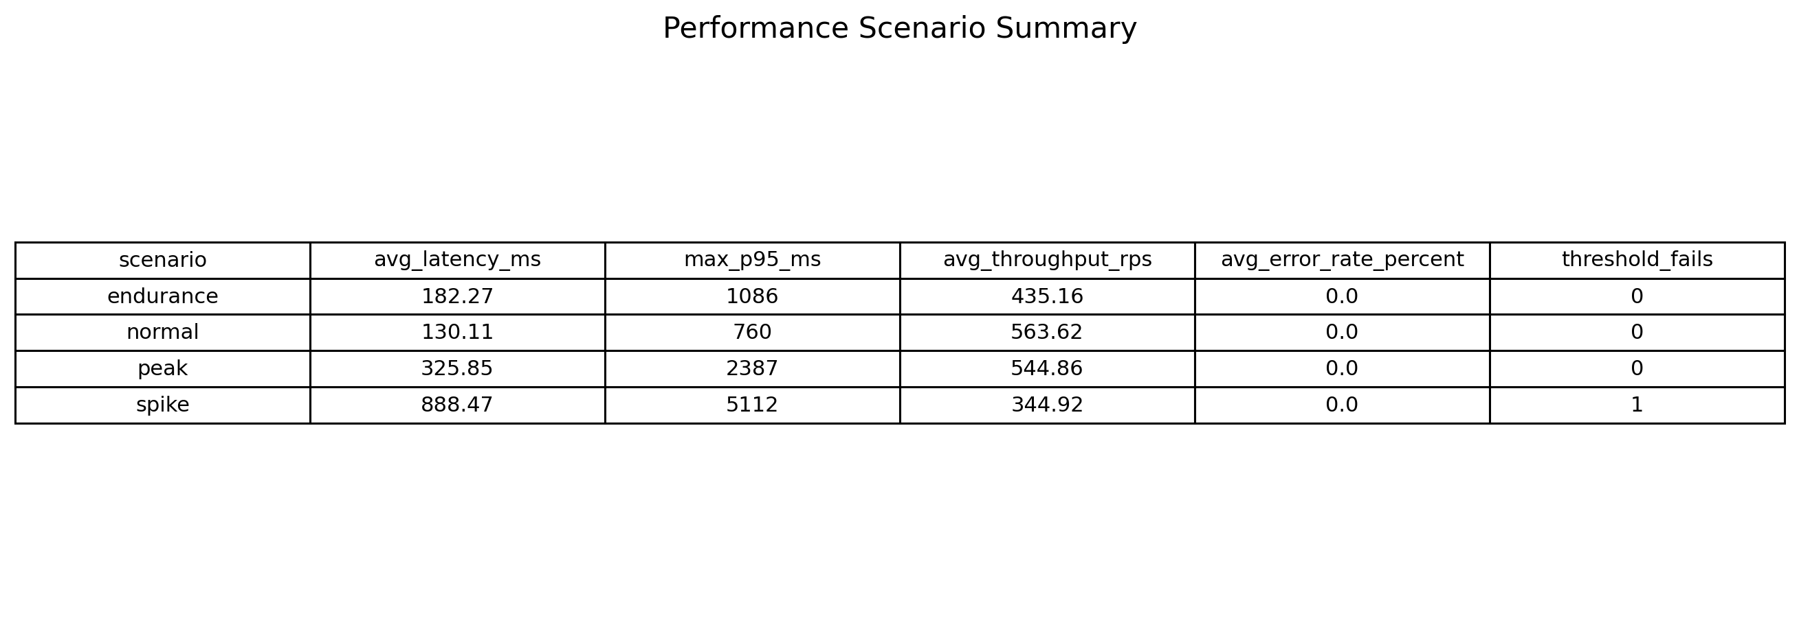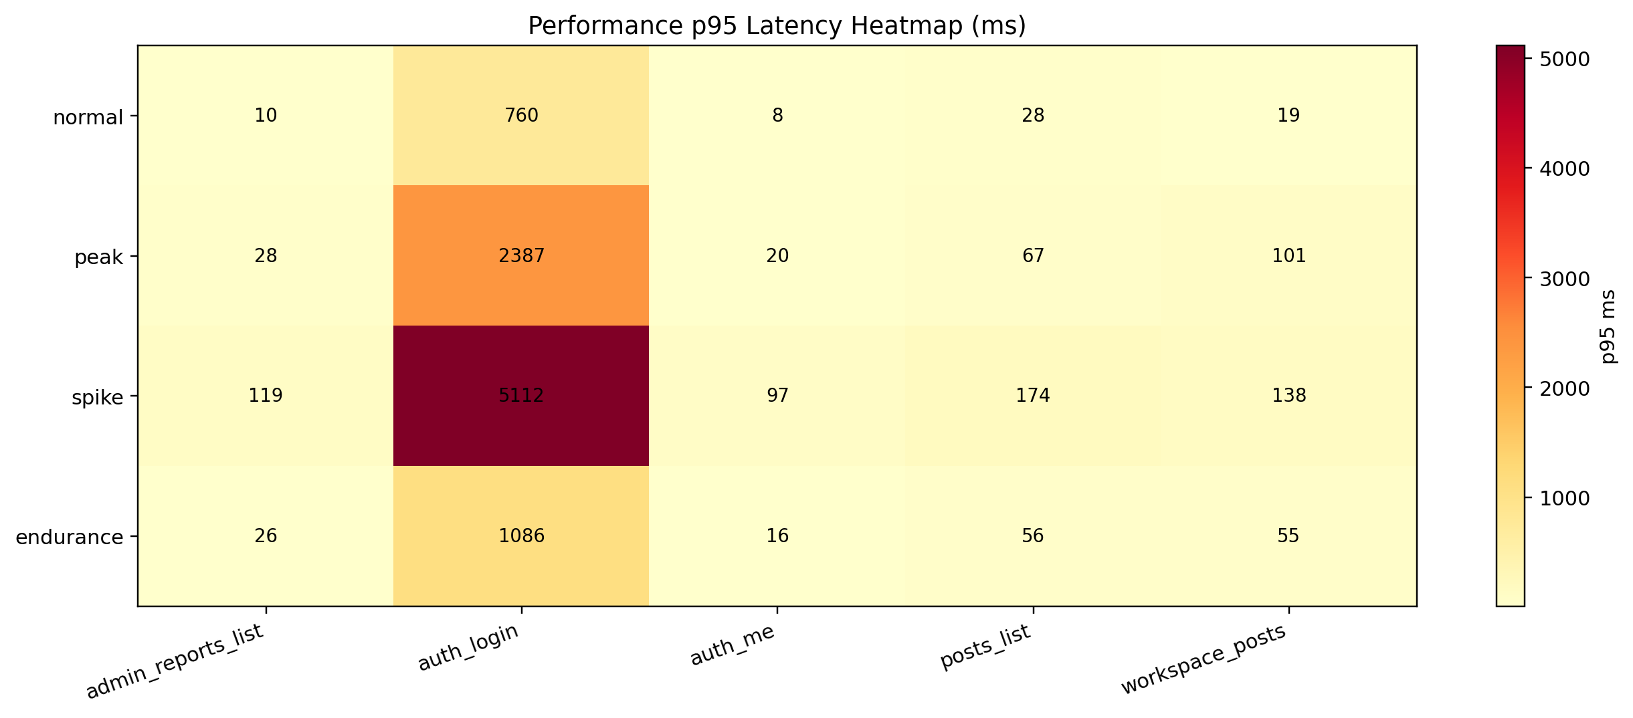
Figure P1. Performance scenario summary table. | Figure P2. p95 latency heatmap by scenario and endpoint.
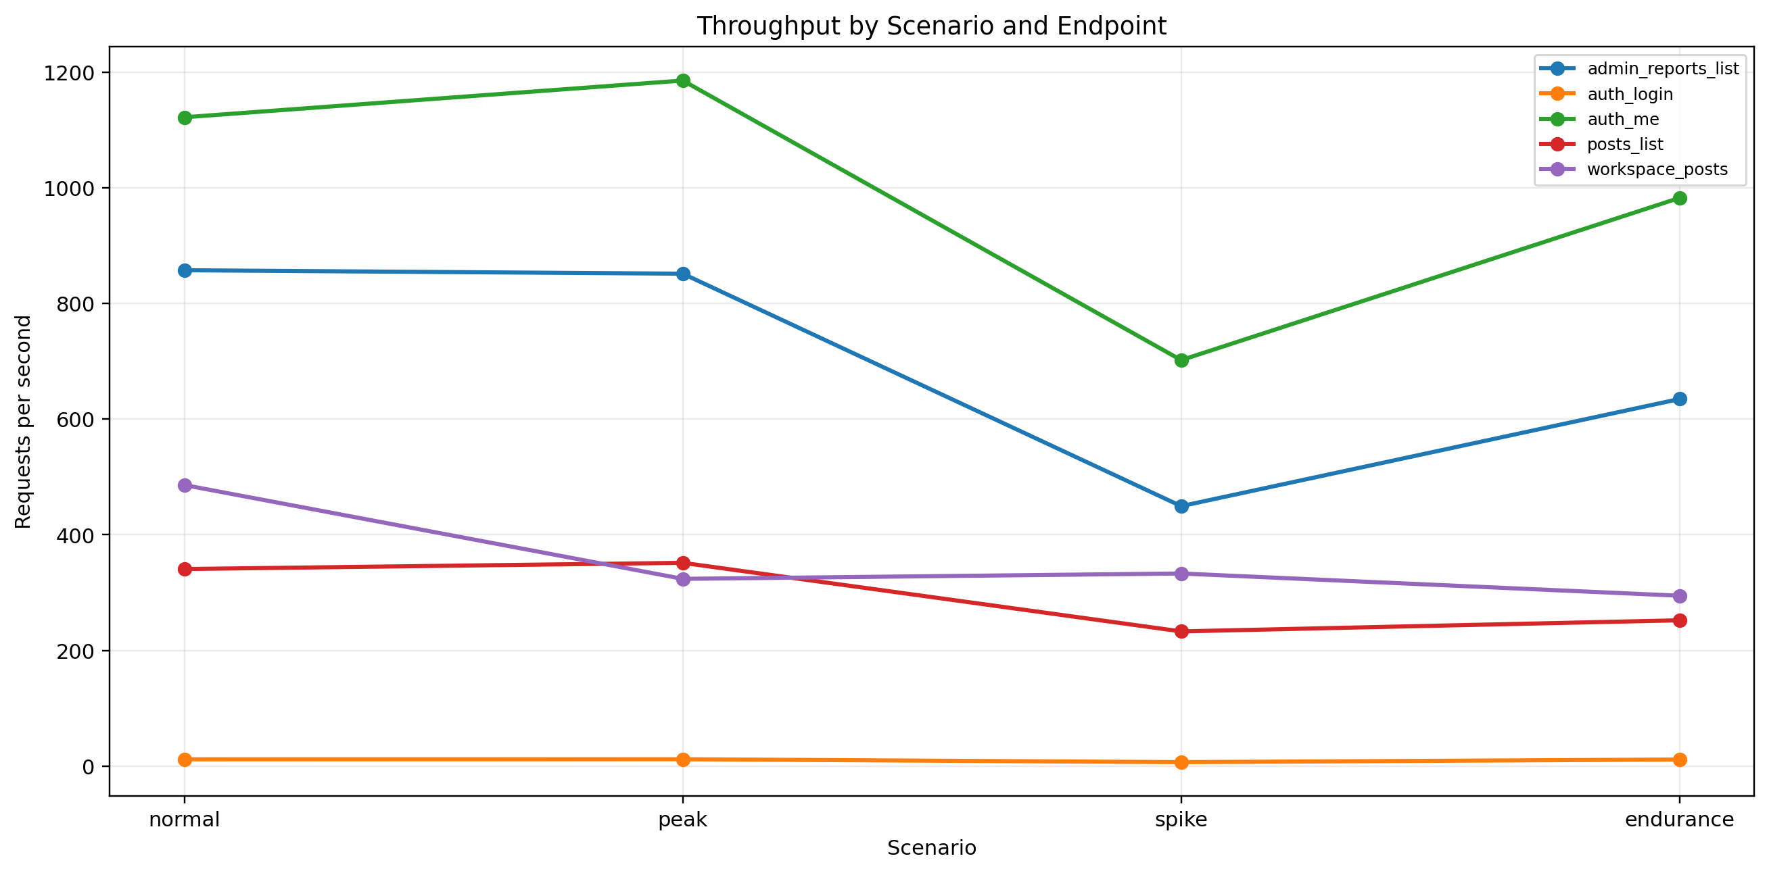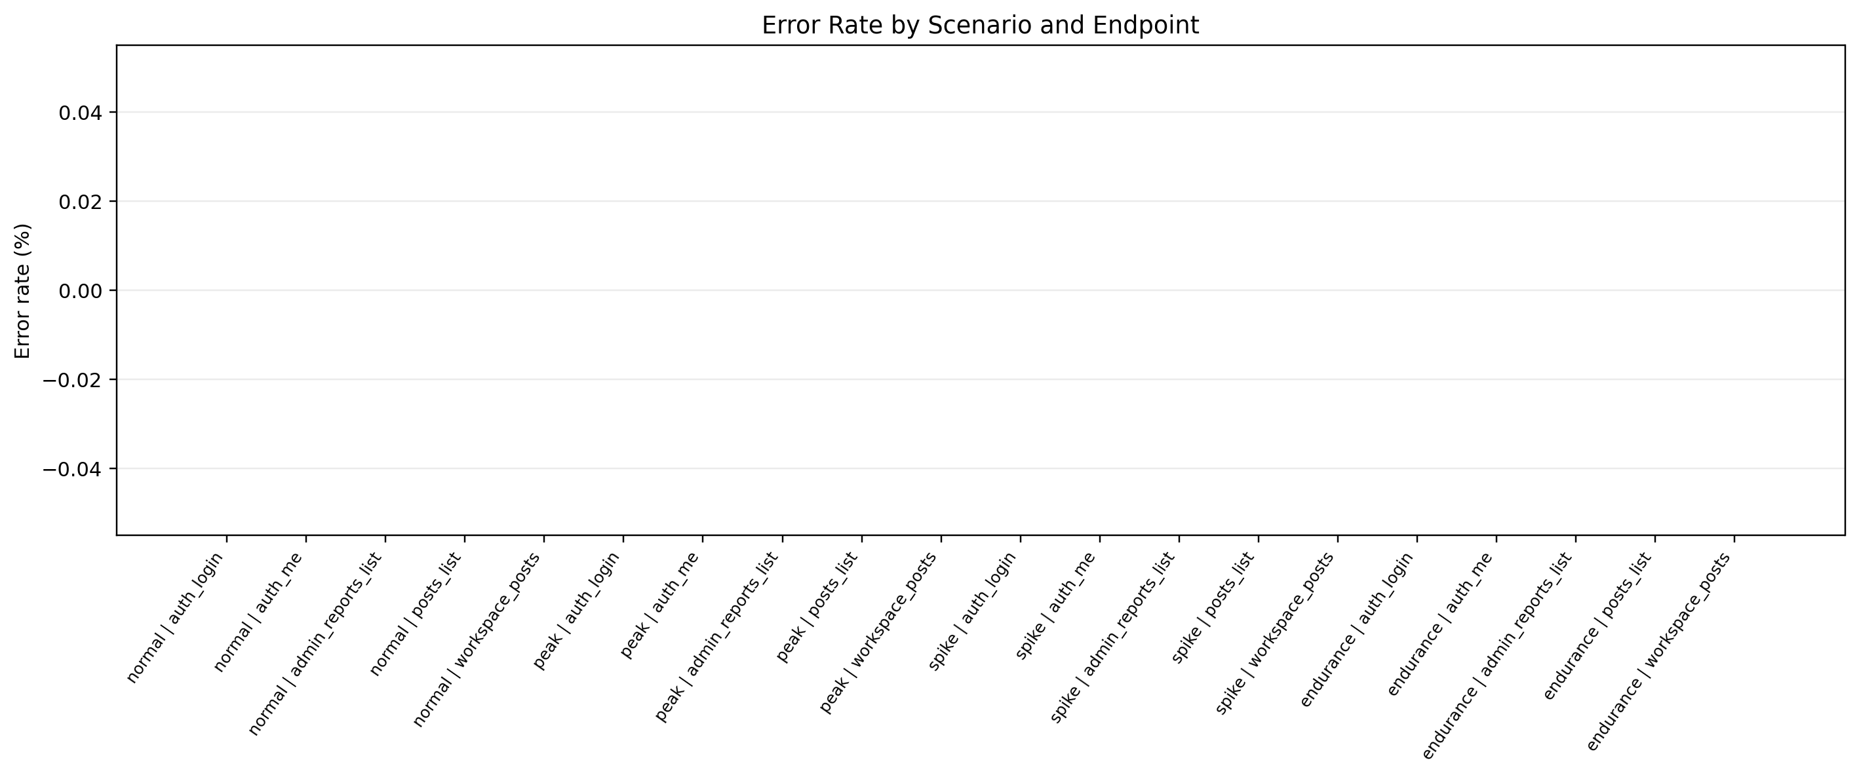
Figure P3. Throughput trend by scenario and endpoint. | Figure P4. Error-rate distribution by scenario and endpoint.
2. Mutation Testing
Mutation score: 80.00% (4 killed / 5 created, 1 survived).
Module | Mutants Created | Killed | Survived | Mutation Score (%) | Assessment
auth | 2 | 2 | 0 | 100.00 | Strong
authorization | 1 | 1 | 0 | 100.00 | Strong
content | 2 | 1 | 1 | 50.00 | Needs more tests
Mutation analysis:
- Survived mutant: content-visibility-status in server/src/services/blog.service.ts. Description: Treat non-published status as published in visibility guard.
- The surviving content-visibility mutant indicates missing assertions around status-based access rules for unpublished content paths.
- Recommended action: add negative tests that explicitly validate visibility gating when status != PUBLISHED.
- Assumption for comparative analysis: acceptable baseline mutation score >= 75.00%. Current status: PASS.
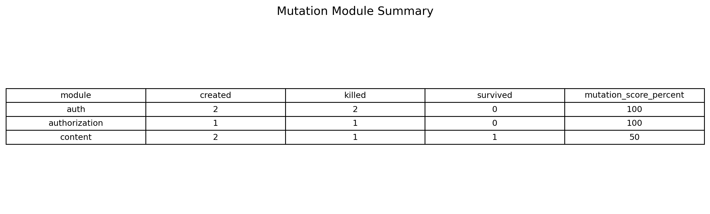
Figure M1. Mutation module summary table.
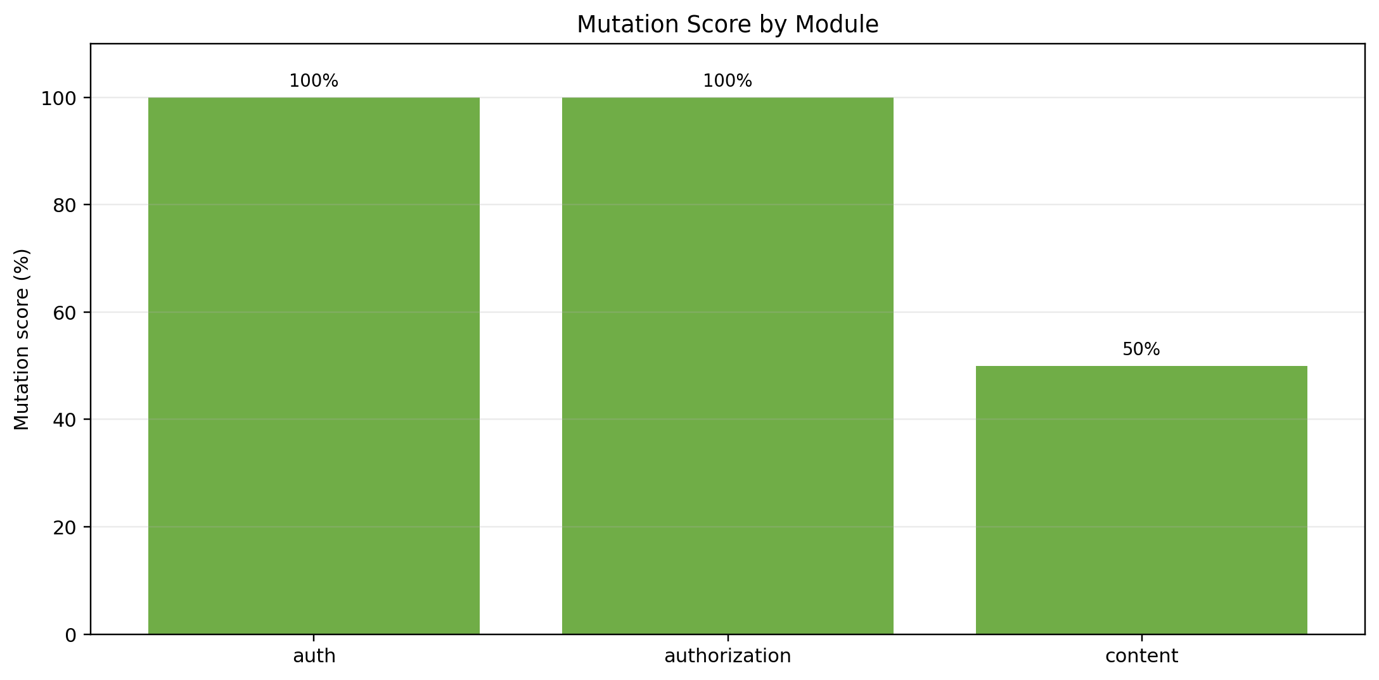
Figure M2. Mutation score by module.
3. Chaos / Fault Injection Testing
Assumption for comparative analysis: expected availability >= 95.00% and recovery <= 5000 ms for controlled short fault windows.
Scenario | Injected | Availability (%) | Failed / Total Probes | Recovery (ms) | Degradation Mode | Restore | Assessment
api-downtime | yes | 88.89 | 1 / 9 | 211 | user-visible-errors | yes | PARTIAL
db-unavailable | yes | 100.00 | 0 / 28 | 520 | graceful | yes | PASS
network-latency | yes | 100.00 | 0 / 22 | 158 | graceful | yes | PASS
Chaos analysis:
- api-downtime: availability dropped below assumed target.
- db-unavailable: behavior within assumed experimental expectations.
- network-latency: behavior within assumed experimental expectations.
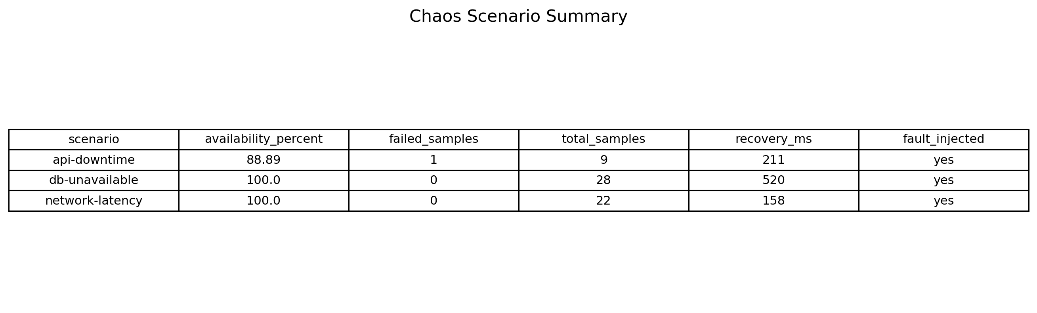
Figure C1. Chaos scenario summary table.
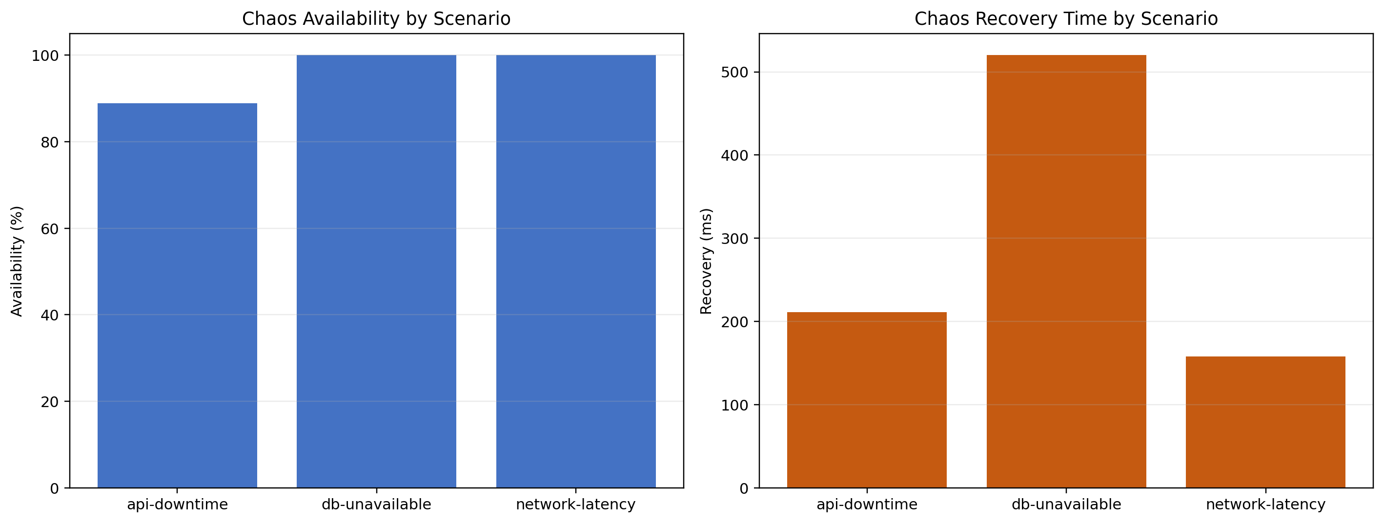
Figure C2. Availability and recovery metrics by chaos scenario.
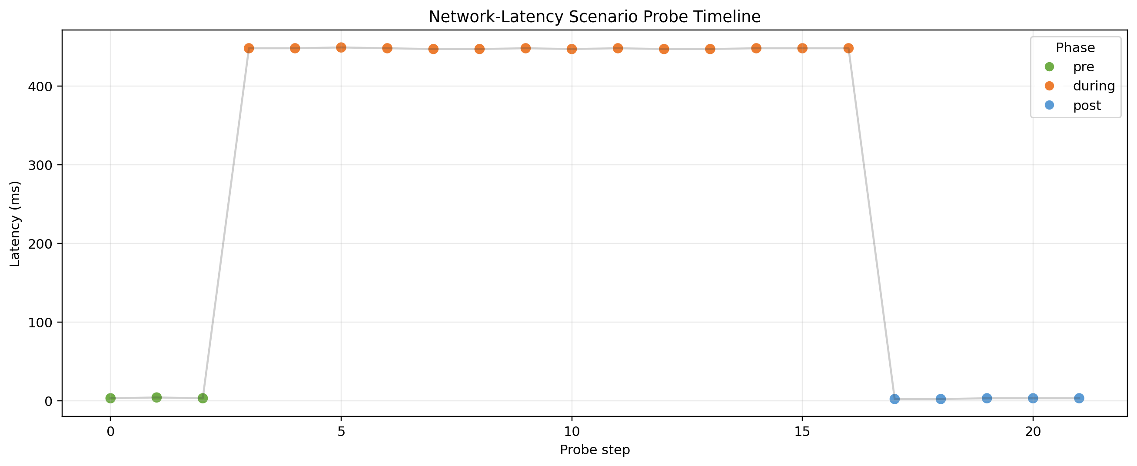
Figure C3. Probe timeline in network-latency scenario.
4. Comparative Analysis and Additional Interpretation
Test Area | Expected | Observed | Status
Performance | All endpoints within p95 and error thresholds | 1 threshold violations out of 20 combinations | PARTIAL
Mutation | Mutation score >= 75.00% | Score 80.00%, survived mutants: 1 | PASS
Chaos | Each planned scenario injected successfully, availability >= 95.00%, recovery <= 5000 ms | Partial: api-downtime | PARTIAL
Comparative interpretation: performance and chaos results show specific resilience gaps under selected fault/load modes. Mutation results are generally strong, but one surviving mutant identifies a concrete coverage gap.
Partial means the experiment was completed and reproducible, but at least one result did not meet the target threshold. It is a quality gap, not a missing task.
Performance (Partial)
- Most endpoint-scenario combinations met thresholds, with 1 follow-up case(s).
- This indicates a load-related bottleneck in a specific scenario rather than a broad functional failure.
- Action: profile the login path under spike load and optimize the most expensive step.
Chaos (Partial)
- Fault injection worked, but target thresholds were not fully met in: api-downtime.
- Action: improve graceful degradation/fallback behavior during hard service outage windows.
Mutation
- Mutation score is 80.00%, with 1 surviving mutant(s).
- Action: add targeted negative tests around content visibility and publication-status rules.
Conclusion: the assignment is complete in execution, artifacts, and analysis. Partial statuses document specific, measurable improvement points with a clear follow-up plan.
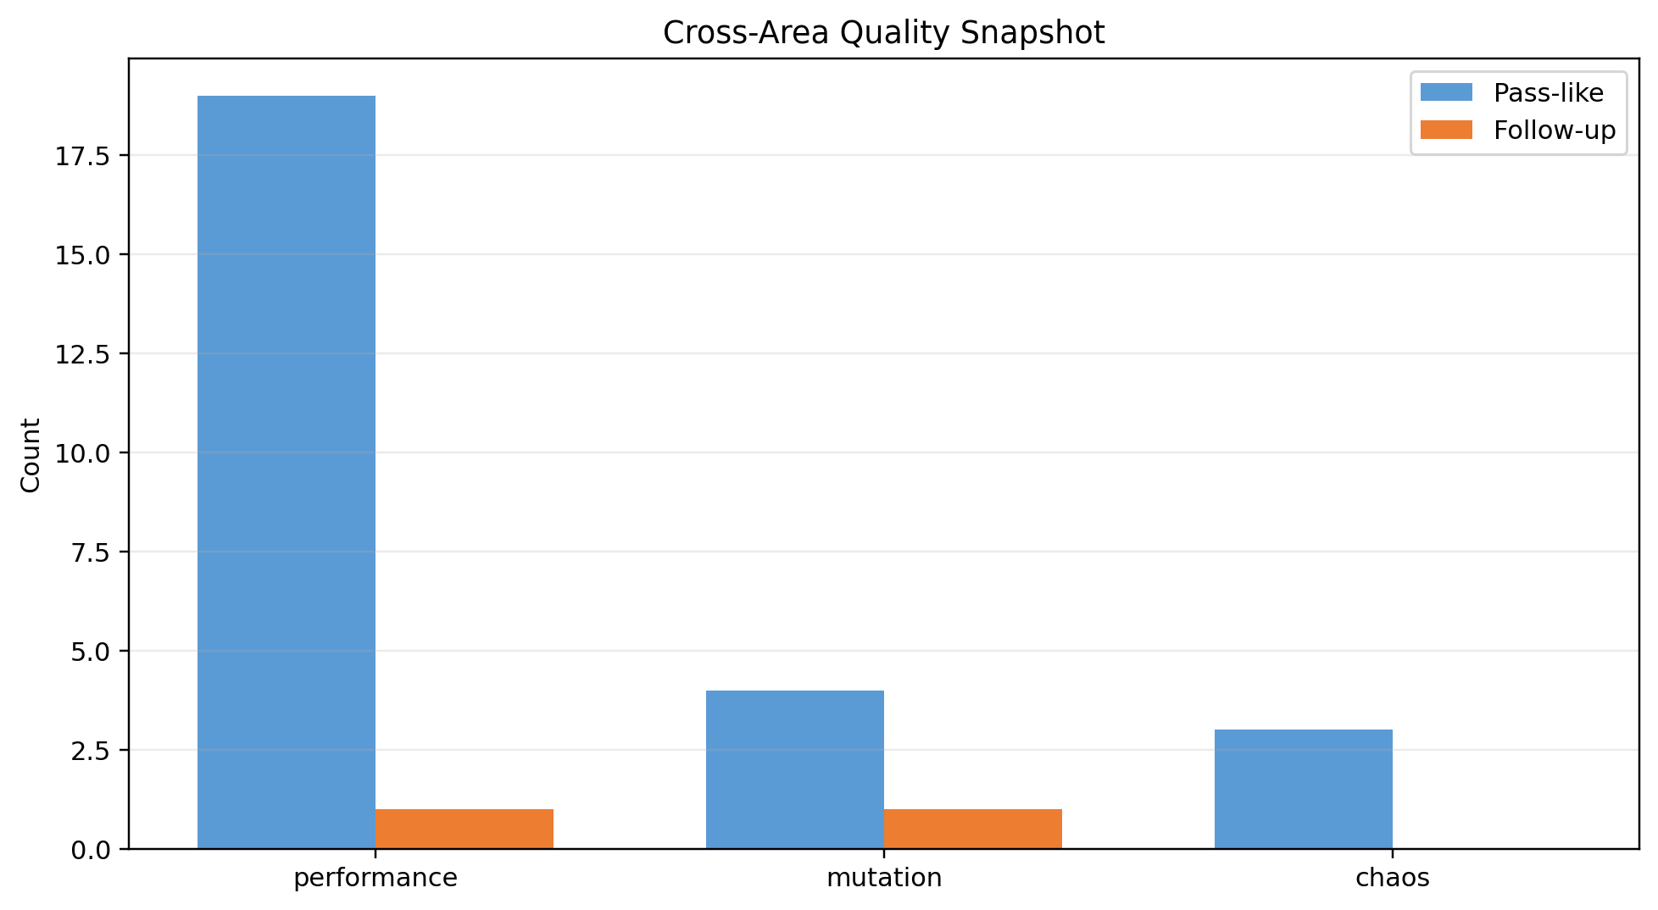
Figure X1. Cross-area quality snapshot.
5. Recommendations
- Performance: isolate auth_login failure modes by recording HTTP status distribution and response body categories for error responses under load.
- Performance: separate functional authentication checks from throughput stress by adding read-heavy authenticated workloads and token reuse scenarios.
- Mutation: add focused tests for content visibility state transitions and unauthorized publication-state access.
- Reporting: capture dashboard screenshots during each scenario and map each image to scenario IDs for reproducible evidence in the final submission.

