Explanation Stability and Feature Richness in a Teacher-Facing Student Digital Twin
A. S. Talgatov  Master degree student  School of Software Engineering  Astana IT University  Astana, Kazakhstan  ORCID: 0009-0006-3463-4644  a1byn.talgat05@gmail.com | S. A. Nurgaliyeva*  PhD in computer science  School of Software Engineering  Astana IT University  Astana, Kazakhstan  ORCID: 0009-0009-5880-6166  symbat.nurgaliyeva@astanait.edu.kz

Abstract—Learning management systems (LMS) record large volumes of educational activity, but their built-in analytics are mostly descriptive rather than predictive or explanatory. This paper presents a teacher-facing Student Digital Twin — a lean, time-aware weekly student-state representation — coupled with an Explainable AI (XAI) layer and an end-to-end interface that turns raw public learning-analytics data into per-student grade predictions, pass-risk flags, and model-behaviour explanations. Rather than reporting a single best configuration, we run a dependency-driven sequence of frozen experiments and ask a falsifiable question: do engineered Digital-Twin features improve prediction over a competent LMS baseline, and are the explanations stable? On the Open University Learning Analytics Dataset (OULAD) module DDD 2013J (1,938 students, 67,830 weekly snapshots) the full Twin ablation is mixed-to-null — no Twin block beats the LMS baseline by more than 1.0 RMSE — while on a second cohort (BBB 2013J) a mastery block improves the temporal-forward split by −1.026 RMSE but nothing else, a direction confirmed by student-clustered bootstrap. A second institution (KU Leuven, 1,495 students) cannot even support the mastery ablation. Across three real cohorts and two institutions, adding feature richness does not robustly help, and the XAI importance rankings are regime-sensitive (Kendall τ 0.55–0.79 within a course, 0.32–0.61 across courses). The contribution is a reproducible, leakage-aware prototype with a teacher UI and an honest, multi-cohort evaluation — including a documented synthetic-target circularity failure mode — rather than an accuracy record.
Keywords: learning analytics; explainable AI; explanation stability; student performance prediction; OULAD; digital twin; gradient boosting; permutation importance; teacher-facing dashboards; reproducibility; honest negative result
I. INTRODUCTION
Learning management systems capture attendance, submissions, marks, and clickstream activity, yet teachers still lack an integrated, forward-looking view of a student’s evolving academic state, the likely end-of-course outcome, and the factors behind that estimate. Most published learning-analytics work optimises a classifier for accuracy on a held-out split and appends post-hoc explanations, reporting only the best configuration on a single cohort. This leaves three practical questions unanswered: whether a Digital-Twin representation of student state adds defensible value over a plain LMS feature set, whether the resulting explanations are stable enough to show a teacher, and whether the whole cycle can be implemented and reproduced on real public data.
This paper addresses those questions with a working prototype and an explicitly honest evaluation. The central object is the student modelled as a dynamic digital twin: weekly state snapshots at the grain 1 row = 1 student × 1 week. The term “Digital Twin” here denotes a lean, time-aware state representation, not a full counterfactual simulation engine. We retain the term deliberately but scope it narrowly: the twin maintains a descriptive weekly state and includes a lightweight SHAP-based what-if layer — estimating the predicted-grade change if a flagged factor reached its cohort median — rather than a mechanistic simulation. Full simulation and causal counterfactual reasoning are treated as explicit design boundaries (Section VII) rather than implicit promises. Around this representation we build a gradient-boosting predictor, a perturbation-based XAI layer, and a Next.js teacher interface that reads frozen prediction artifacts.
The novelty is not a new algorithm or a higher accuracy number. It is the combination of (1) an end-to-end, open, leakage-aware pipeline from raw OULAD data to teacher-facing weekly explanations; (2) a dependency-driven ablation that tests the Twin representation instead of assuming it; (3) an explanation-stability analysis across splits, courses, and institutions; and (4) an honest multi-cohort finding — including a documented synthetic-data circularity failure mode — of a kind systematically underrepresented in the literature.
II. RELATED WORK
SHAP + gradient boosting on OULAD. Training gradient boosting or random forests on OULAD and adding SHAP explanations post-hoc is now standard practice [4]–[7]. Published benchmarks reach ROC-AUC 0.993 and F1 0.911 on dropout prediction [4]. Adding explainability is therefore no longer a contribution by itself, and continuous-grade regression — used here alongside classification — is comparatively less common but not sufficient on its own.
Explanation stability. Tiukhova et al. [2] showed that XAI-derived feature importance for student-success models can be unstable across configurations. We extend this stability lens from the single-model setting to a transfer setting, measuring rank agreement across evaluation splits, across two OULAD courses, and across institutions.
Digital Twin in education. Digital twins in education appear mostly as conceptual or review work [8]; working implementations of a student digital twin on real data are essentially absent. Teacher-facing interfaces in peer-reviewed work publish model metrics, not systems; commercial platforms (EAB Navigate, Civitas Learning, Brightspace Insights) have dashboards but are closed and undocumented. Papers that add SHAP rarely address how teachers may misinterpret explanations or the difference between model-behaviour description and causal claim.
Research gap. No published work implements and honestly evaluates a full-cycle prototype — raw data → weekly twin snapshots → predictions → per-student explanations → teacher UI — on real public data, with explicit documentation of where the added components fail to beat a simpler baseline. This paper targets that gap.
III. SYSTEM ARCHITECTURE
The prototype is a monorepo with two independently runnable services and a strict read-only boundary between computation and presentation.
ML service (services/ml/, Python). Contains the OULAD data adapter, the weekly snapshot builder, the feature-engineering pipeline, the experiment runner, the model-training code, and the perturbation-based XAI module. All experiment outputs are versioned JSON/CSV artifacts under data/artifacts/experiments/.
Web service (apps/web/, Next.js). A server-side-rendered frontend that reads the frozen artifacts at request time and serves teacher-facing views. It performs no ML computation, so results are reproducible independently of the UI and the UI is testable without retraining.
Data flow. Raw OULAD CSV → OULAD adapter → weekly snapshot table (one row per student per week) → feature engineering → trained Gradient Boosting model → prediction + perturbation-based explanation artifacts → JSON consumed by the web app.
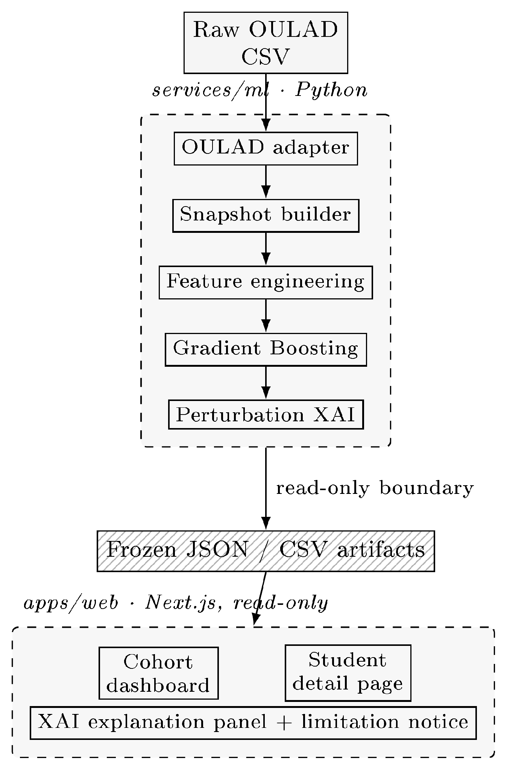
Fig. 1. Fig. 1. End-to-end architecture: a Python ML service turns raw OULAD CSV into frozen JSON/CSV artifacts, consumed by a read-only Next.js teacher interface.
Teacher interface. A cohort dashboard presents a sortable, filterable table of all students with predicted grade, pass-risk badge, current week, and key LMS signals (Fig. 2). A student detail page shows summary cards (predicted vs. actual grade, risk, mastery, activity, attendance, assignment/quiz averages, 3-week trend), a weekly trajectory chart, a raw weekly-snapshot table, an explanation panel listing which signals raise or lower the current-week prediction, and a what-if panel showing the estimated predicted-grade gain if each flagged below-median factor reached its cohort median (Fig. 3). The explanation panel carries an explicit XAI limitation notice: the factors describe model behaviour, not causes; the score is not a sole basis for intervention; and rankings can shift across time periods and cohorts. The what-if estimates are labelled as perturbation-based approximations, not causal or simulation-derived claims. This framing directly operationalises the research gap of Section II. We present the interface as a design demonstrator whose presentation of XAI output is derived from the explanation-stability result (Section V-C), not as an evaluated intervention; no user study is claimed here.
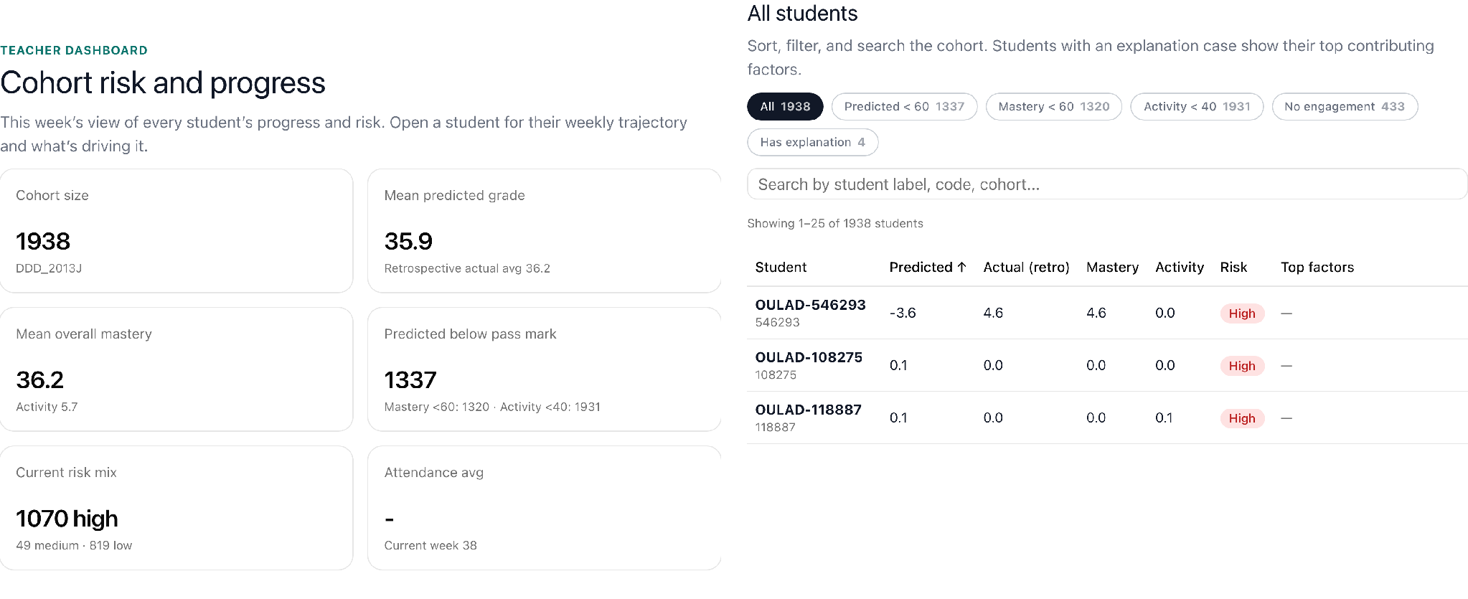
Fig. 2. Fig. 2. Teacher cohort dashboard (live Next.js UI, OULAD DDD 2013J): summary cards (left) and the sortable student table with grade, mastery, activity, risk badge, and top factors (right).
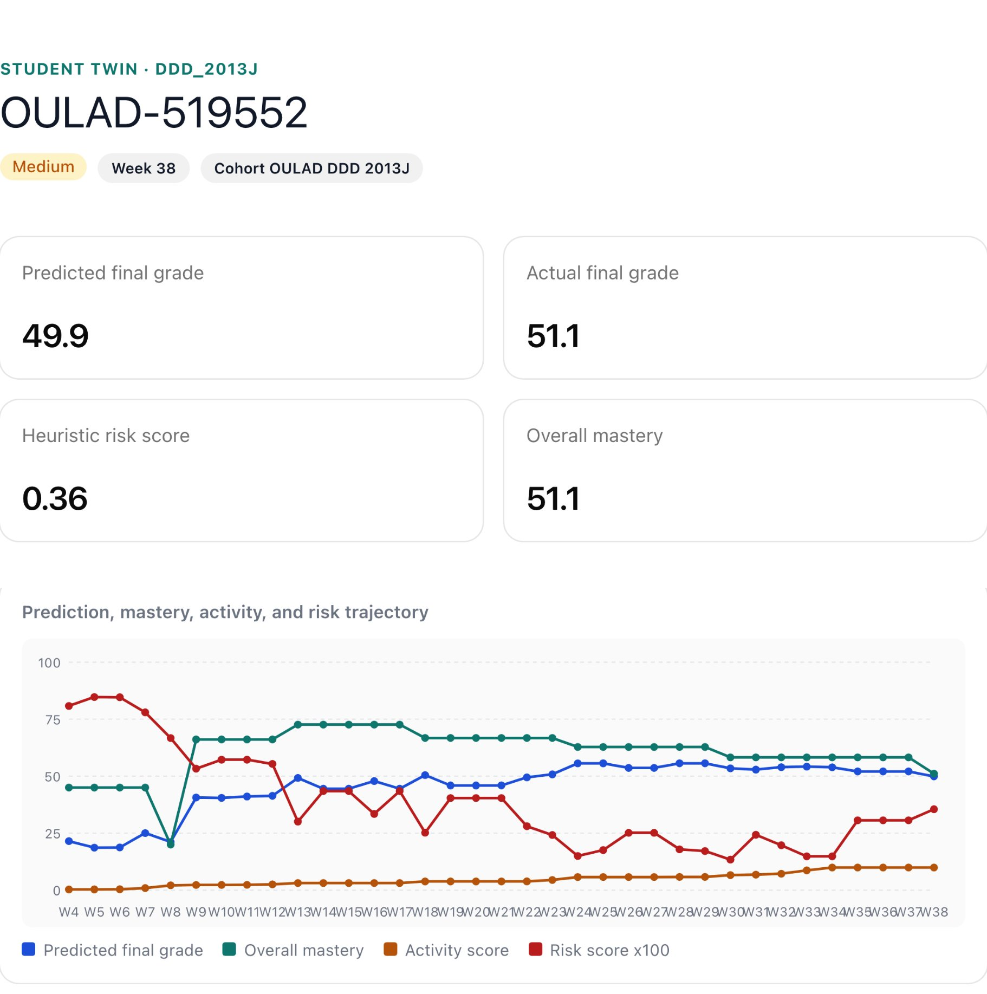
Fig. 3. Per-student Twin view (live system): current-state summary cards and the weekly trajectory of predicted grade, mastery, activity, and risk (×100), weeks 4–38 (student OULAD-519552).
IV. DATA AND EXPERIMENTAL DESIGN
A. Datasets
We evaluate on real, public, non-circular data from two institutions.
OULAD DDD 2013J [1]: 1,938 students, 67,830 weekly snapshots, weeks 4–38.
OULAD BBB 2013J [1]: 2,237 students, 80,532 weekly snapshots; richer dated assessment structure than DDD.
KU Leuven 1819 [3]: 1,495 students, two courses pooled, weeks 2–15.
A separate synthetic dataset is used only for controlled methodological checks; its limitations are stated in Section VII.
B. Feature sets (nested ablation)
The Digital-Twin representation is tested by decomposition, not assumed: A_simple (minimal baseline); B_lms (LMS behavioural features, the proxy for “what the literature uses”); B_lms+mastery (LMS plus a lean mastery-proxy block derived from the dated assessment structure); and C_twin (full engineered Twin representation: trends, mastery, indices, temporal context). Because each set is a strict superset of the previous one (Fig. 4), the Twin is tested by decomposition rather than assumed.
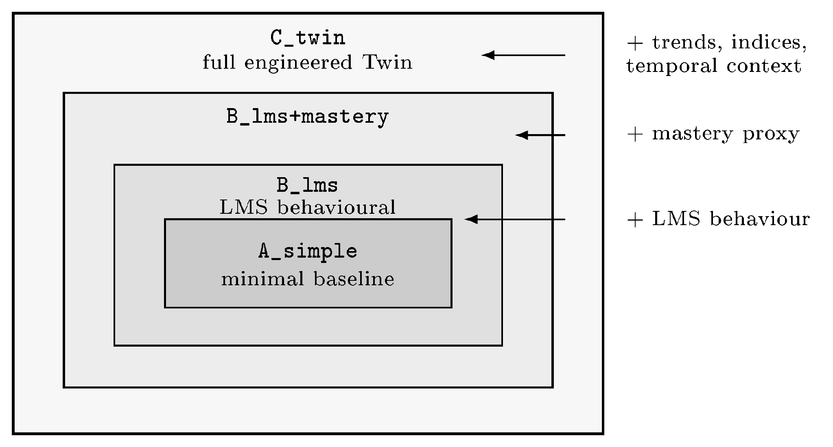
Fig. 4. Nested feature-set ablation shown as concentric regions to test the Twin by decomposition, not assumption.
C. Models and protocol
Model families are deliberately simple and defensible: Ridge regression, Logistic Regression, Random Forest, and Gradient Boosting. Two splits are used: a student-grouped split (primary; test_size = 0.25, seed = 42; for DDD: 1,454 train vs. 484 test students) and a temporal-forward split (train on early weeks, predict later weeks). The pipeline is leakage-aware: train-only preprocessing, explicit forbidden-column enforcement, and fixed-model reporting (Gradient Boosting held fixed across splits) to neutralise best-model-per-cell selection artifacts. Targets: final_weighted_score (regression, 0–100) and passed_observed (binary classification).
V. RESULTS
A. This work vs. standard baselines
All rows use OULAD DDD 2013J, the B_lms feature set, and the student-grouped split, except the last “ours” row which adds the mastery block. RMSE is on the 0–100 score scale; F1/ROC-AUC are for passed_observed.
TABLE I THIS WORK VS. STANDARD BASELINES
Approach | RMSE | F1 | AUC | XAI | UI | Open
Logistic Regression (ours) | – | 0.854 | 0.951 | No | No | Yes
Random Forest (ours) | 13.633 | 0.861 | 0.947 | No | No | Yes
GB LMS-only (ours) | 12.658 | 0.863 | 0.953 | No | No | Yes
GB + Twin + XAI (this work) | 12.724 | 0.861 | 0.953 | Yes | Yes | Yes
GB + SHAP (literature) [4] | – | 0.911 | 0.993 | Yes | No | Part.
Commercial (EAB Navigate) | unk. | unk. | unk. | Part. | Yes | No

Gradient Boosting on B_lms is the strongest baseline (RMSE 12.658, F1 0.863, ROC-AUC 0.953); Ridge regression is the weakest (RMSE 14.318). Logistic Regression is already competitive (F1 0.854, ROC-AUC 0.951), reflecting that the dominant predictor — assessment submission rate — is approximately linear in the log-odds of passing. Adding the mastery (Twin) block changes RMSE by +0.066 (worse) and F1 by −0.002: no improvement on this cohort and split. This is the honest negative result, stated rather than hidden.
B. When does the Twin help, and when not?
The full nested ablation under fixed-model reporting gives a course- and split-dependent answer (Table II).
TABLE II NESTED ABLATION BY COHORT AND SPLIT
Cohort | Student-grouped | Temporal-forward
DDD 2013J | null (mastery +0.061) | weak: mastery −0.381
BBB 2013J | null (all within 0.087) | largest gain: mastery −1.026

On DDD, no Twin block beats B_lms by more than 1.0 RMSE on either split, the full C_twin stays within ±0.025 RMSE (non-inferior, not better), and the minimal A_simple is clearly worse (+1.207 grouped, +4.105 temporal-forward) — confirming the LMS layer already carries the signal. On BBB, which has a richer assessment structure, the mastery block improves the temporal-forward split by −1.026 RMSE (6.311 → 5.284) and the full C_twin by −0.765, but the student-grouped split stays null and the trend/index blocks are null on both courses.
Reading. Engineered Twin value is heterogeneous: it appears only under forward-time prediction on a course with rich assessment structure, and disappears under the student-grouped regime (Fig. 5). It is not a robust improvement. We verified that the direction of the single positive cell is robust under resampling, not an artefact of the test split: a student-clustered bootstrap (5,000 resamples of the 559 held-out test students, seed = 42) was re-run on the frozen BBB 2013J pipeline in the current environment (Python 3.14.3, scikit-learn 1.9.0). Gradient Boosting point estimates proved environment-sensitive — the reproduced temporal-forward baseline RMSE drifted 21.6% from the originally stored value (7.675 vs. 6.311), against only 1.7% drift on the student-grouped split, consistent with out-of-time extrapolation amplifying small cross-version differences in tree-splitting behaviour. The bootstrap therefore reports reproduced-environment estimates throughout. On temporal-forward, the 95% CI of the mastery RMSE reduction lies entirely below zero ([−2.54, −1.80]; one-sided P(Δ ≥ 0) = 0.000), confirming the direction is not noise even though the point estimate shifted with the environment. On the student-grouped split, the 95% CI ([−0.17, +0.03]) crosses zero (P(Δ ≥ 0) = 0.082) — statistically corroborating, not merely describing, the null reading reported above. We therefore treat the BBB temporal-forward cell as the one place Twin features robustly help in direction, while withholding any claim about a stable effect size given its environment sensitivity. Crucially, the OULAD classification target is genuinely predictive throughout (best-model F1 0.83–0.93, never 1.000), which is what makes this negative finding trustworthy.
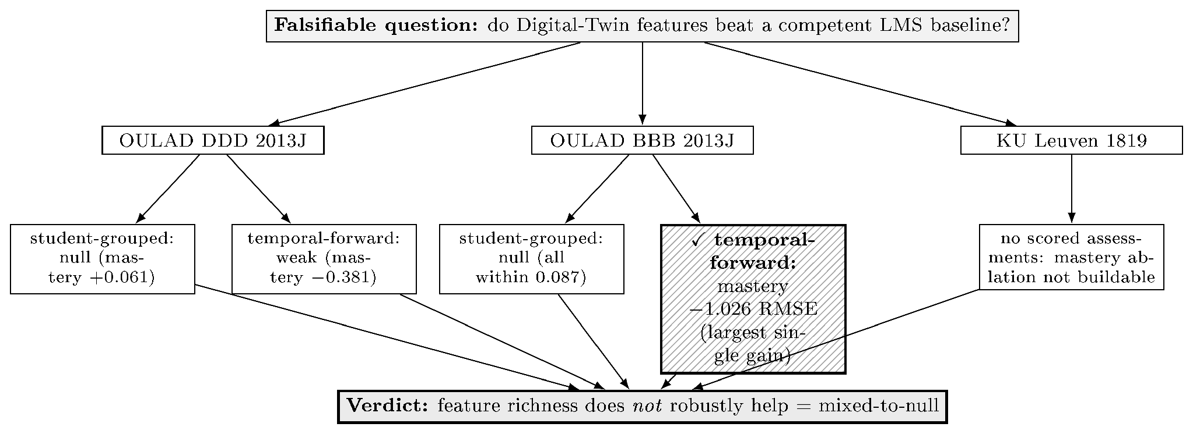
Fig. 5. Dependency-driven evaluation arc and verdict. Only the BBB temporal-forward cell shows a real mastery gain (−1.026 RMSE); everything else is null or weak.
C. XAI and explanation stability
Explanations use held-out permutation importance, model-native importance, and one-feature local median-replacement perturbation. We deliberately avoid SHAP: Shapley-value attributions rest on a background / conditional-expectation estimate that is fragile on the small per-student samples surfaced in the teacher UI, and have documented conceptual and robustness problems as feature-importance measures [12], [13]; the perturbation method instead operates directly on the single prediction row shown to the teacher, with no background-set assumption. On DDD, the dominant factor is assessment_submission_rate_due_to_date (importance share 0.28–0.38; 0.381 in the headline model) and, once mastery is included, the co-circular overall_mastery_proxy (0.23–0.43). The genuinely exogenous signals — is_unregistered_by_week (0.13–0.20) and VLE clickstream (0.02–0.06) — are interpretable but carry modest weight (Fig. 6).
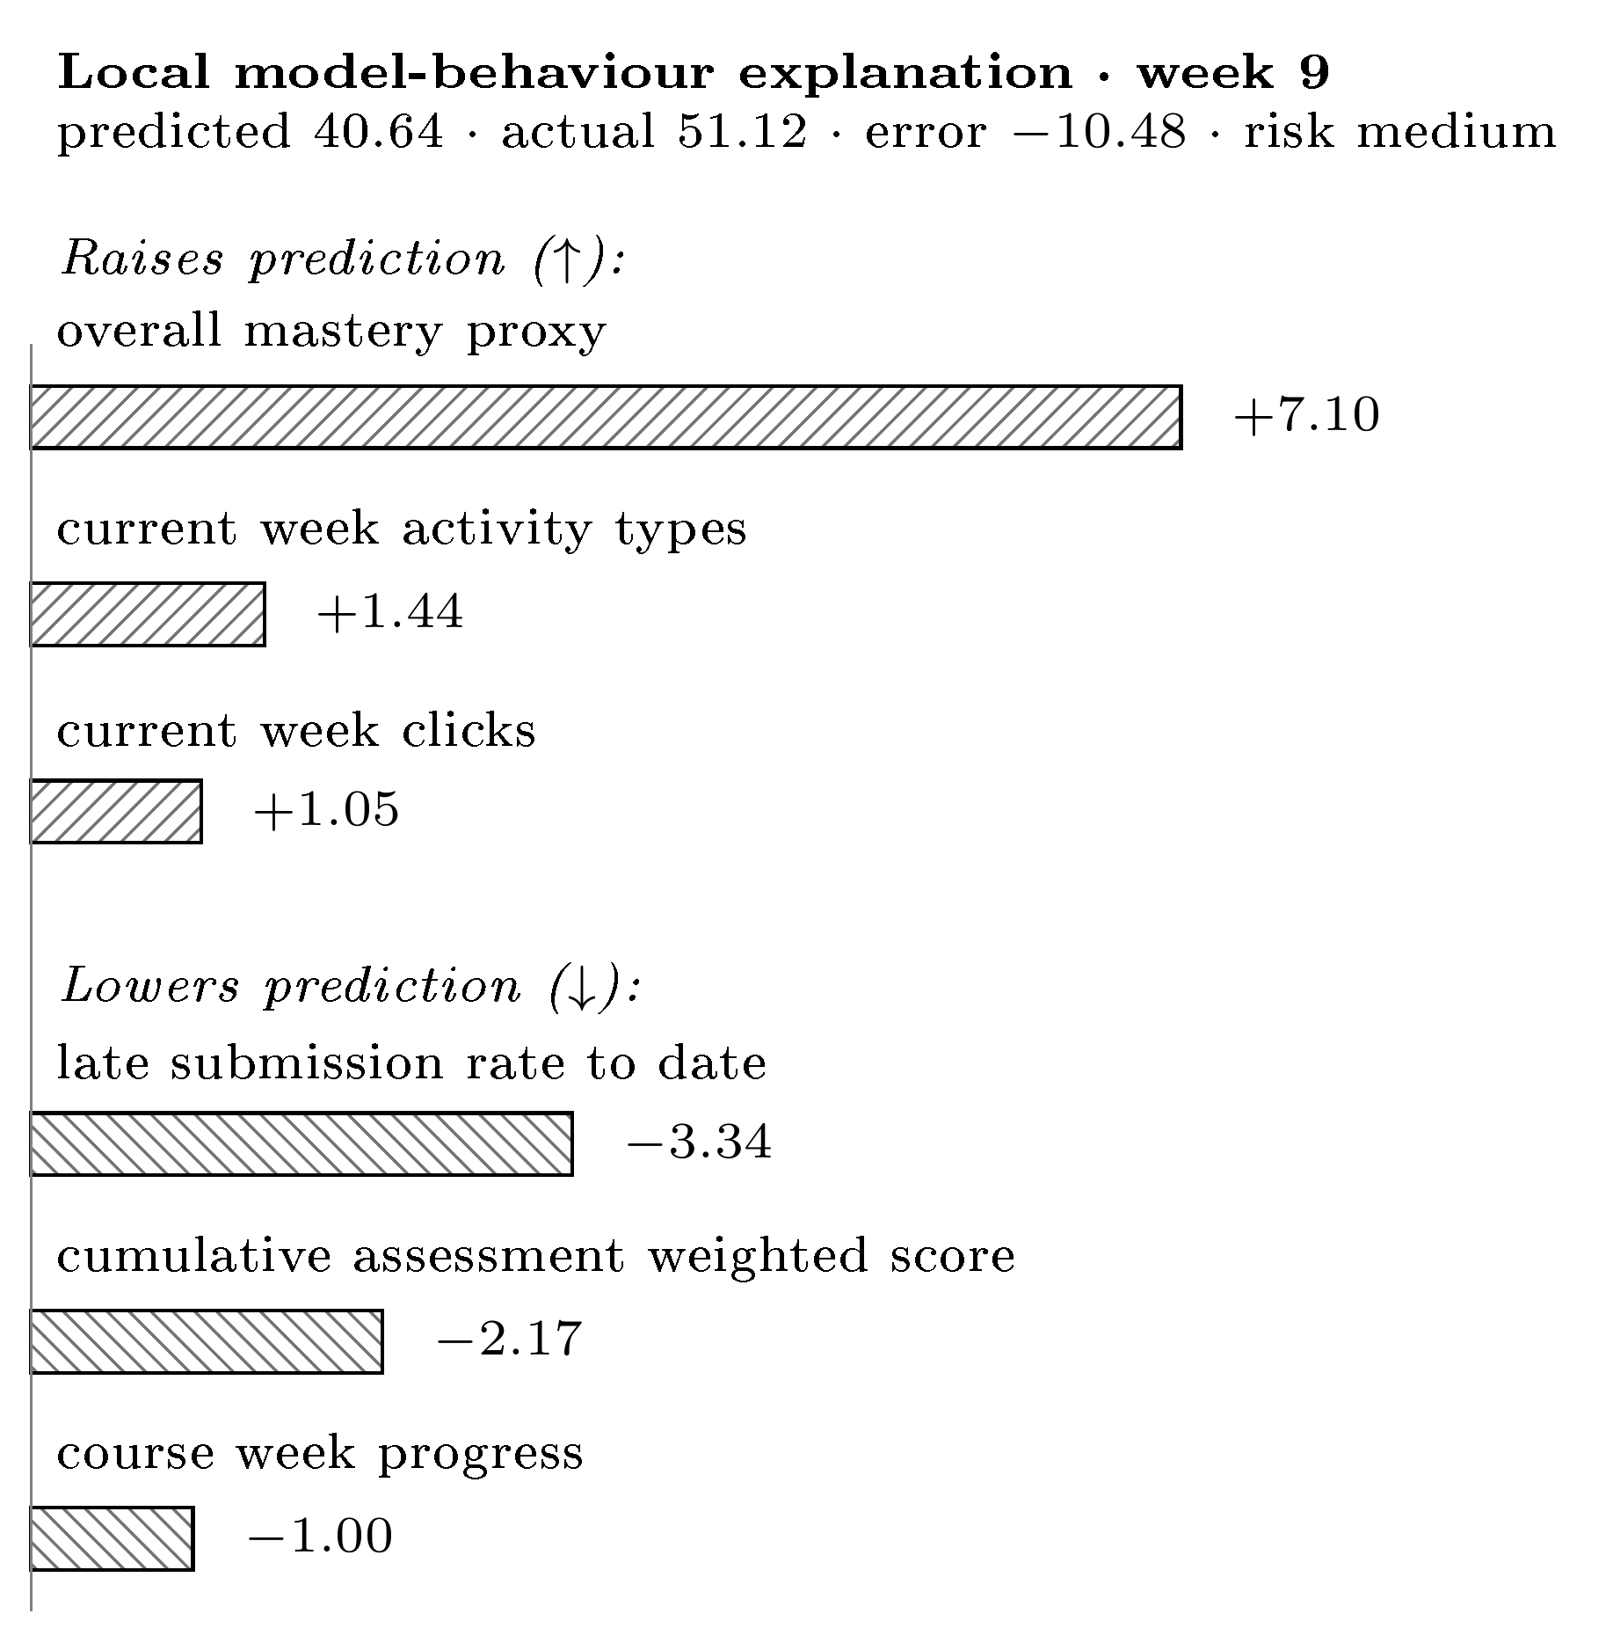
Fig. 6. Per-student explanation: signals raising vs. lowering the predicted grade (RMSE-scale points), dual-coded by sign and hatch for greyscale; shown with an XAI limitation notice.
The rankings are not invariant. Within a course, across splits: Kendall τ = 0.79/0.68/0.55 for B_lms / +mastery / C_twin (mean 0.67); none reach 0.90. Across courses (DDD vs. BBB): τ = 0.32–0.61 (mean 0.52) — even less stable. Across three institutions (engagement-only): mean τ ≈ 0.56; clicks and active-days recur as top drivers, but the mid/lower ordering is institution-specific (Fig. 7).
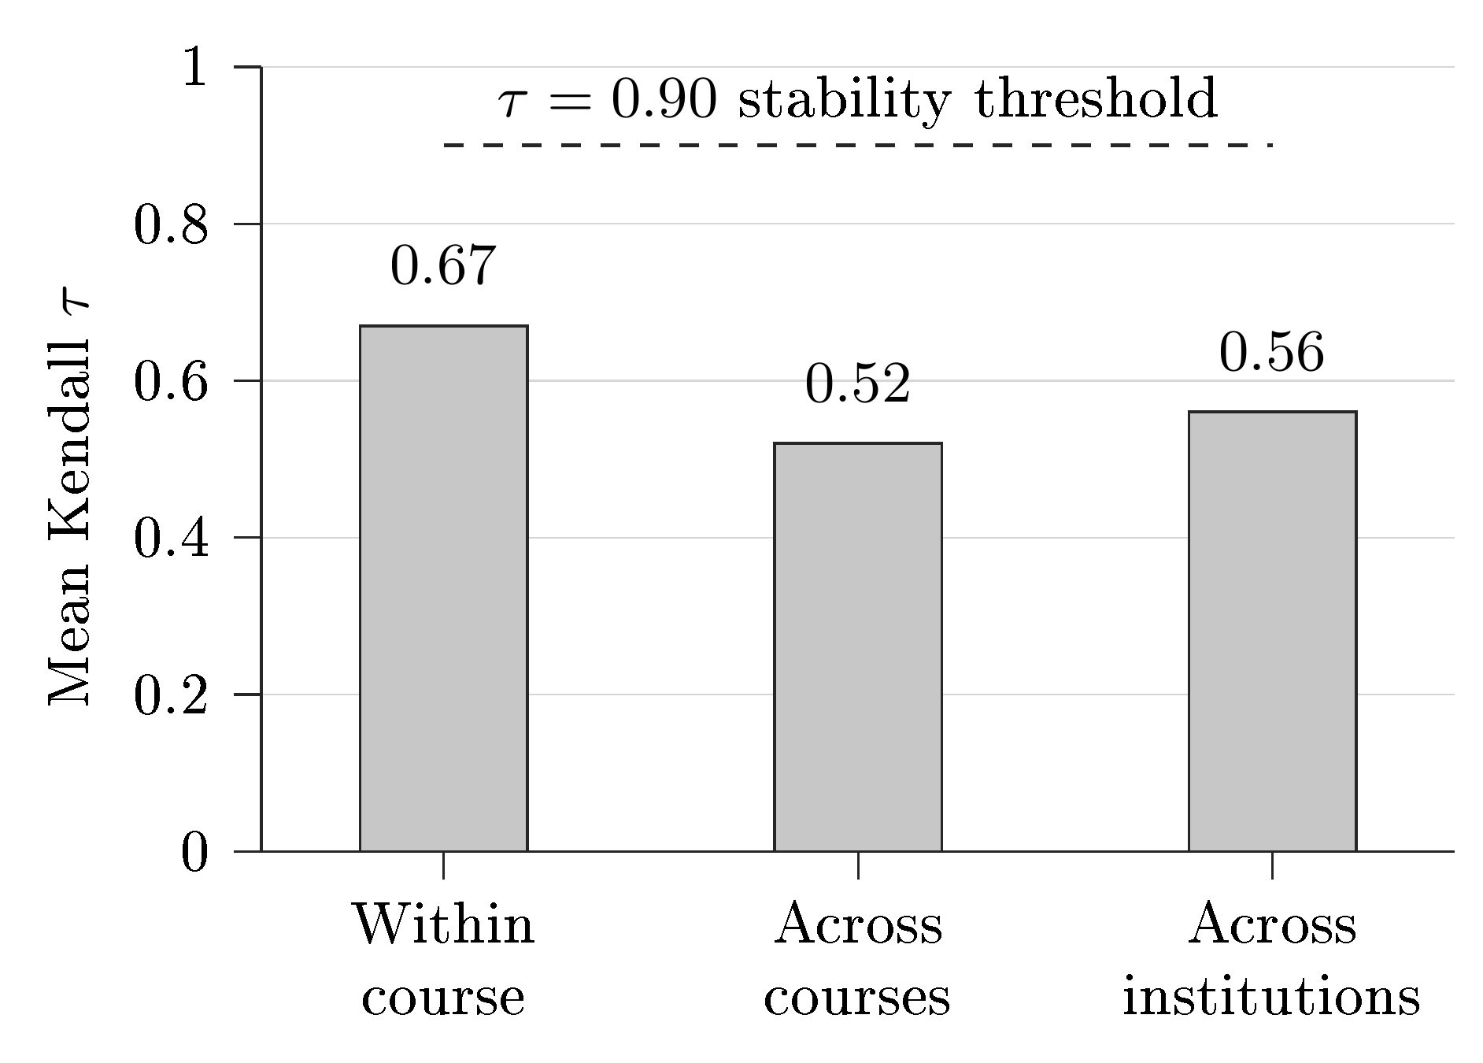
Fig. 7. Explanation-stability summary: mean Kendall τ never reaches the 0.90 stability threshold, dropping from 0.67 within-course to 0.52–0.56 across courses/institutions.
A controlled synthetic faithfulness probe confirms the method is faithful when ground truth is known: at the final course week, permutation importance recovers the generator’s weight ordering exactly (Kendall τ = 1.0). The same few features dominate across regimes, but their relative priority reorders — so explanations must be framed as model-behaviour under a particular evaluation scenario, not as stable causal rankings.
D. Second institution
KU Leuven exposes clickstream and course structure but no intermediate scored assessments and no continuous grade — only a binary PASSED outcome. The mastery/Twin ablation therefore cannot be built there at all (itself a cross-institution heterogeneity result). On its engagement-only task, under fixed-model reporting, prediction is modest (F1 0.74–0.76, ROC-AUC 0.66–0.70) and a richer engagement set does not beat a minimal two-feature one (fixed-model F1 delta −0.015 / +0.000). A matched three-institution synthesis, restricted to the temporal-forward split, shows a two-feature engagement baseline (clicks + active-days) is hard to beat (F1 delta spread −0.016 to +0.026); on the student-grouped split richer engagement helps more, particularly on OULAD (delta up to +0.072), so this baseline-sufficiency finding is split-specific rather than universal.
VI. DISCUSSION
Three points follow. First, on the central question — do Twin features beat a competent LMS baseline? — the honest answer across three real cohorts and two institutions is not robustly. The benefit is real but narrow (BBB, temporal-forward, mastery) and vanishes under the stricter student-grouped regime, on other courses, and on other blocks. Reporting only the favourable cell, as is common, would have manufactured a false “Twin wins” narrative.
Second, explanations are regime-dependent. Importance rankings reorder across splits, courses, and institutions, which has a direct product consequence: a teacher UI must present XAI output as “how the model weights each signal for this prediction”, not “why this student is at risk”. Our interface encodes exactly this caveat.
Third, the contribution is best read on three axes, not accuracy alone. On accuracy this work is comparable to standard baselines and below the published best (ROC-AUC 0.953 vs. 0.993 [4]) — expected and not a weakness. On explainability it provides per-student, background-free perturbation explanations with documented stability limits. On teacher-facing completeness — weekly trajectory, per-student XAI panel, cohort filtering, explicit limitation notice on real OULAD data — it is, to our knowledge, the most complete openly-documented artifact of its kind; we offer it as a design demonstrator whose presentation of XAI output follows from our stability finding (Section V-C), not as an intervention with demonstrated efficacy.
VII. LIMITATIONS AND THREATS TO VALIDITY
Synthetic circularity (documented failure mode). During development, a synthetic target manufactured an apparent “mastery win”. The synthetic final_grade is a deterministic, noise-free closed-form weighted mean of the same behaviours the features re-aggregate (week-10 reconstruction error 0.008, correlation 1.000000); the resulting R² ≈ 0.99 and saturated passed F1 = 1.000 are algebraic artifacts, not learnable signal. We report this explicitly as a cautionary methodological result: a circular target can fabricate a feature-group advantage that disappears on genuine data.
Partial target circularity on OULAD. final_weighted_score is partly fed by assessment scores, so the regression results lean somewhat on within-system accounting; the classification target and VLE clickstream are the cleaner, exogenous evidence.
Mastery redundancy. overall_mastery is close to cumulative LMS performance (|r| = 0.993 with avg_assignment_score), so it must not be presented as an independent construct.
No user evaluation of the interface. The teacher interface is a design demonstrator: its presentation of XAI output as model-behaviour-under-a-scenario follows directly from the explanation-stability result (Section V-C), but we make no claim about its effect on teacher understanding or decisions. A qualitative or controlled study with instructors is left to future work.
External validity. Evidence spans two OULAD courses (one institution) and a second institution that cannot test the mastery ablation; this supports the narrower claim that feature-richness does not robustly help, not a like-for-like institutional replication. Explanations are not causal and not SHAP.
Scope of counterfactual reasoning. The teacher interface includes a lightweight what-if layer: for each factor depressing the predicted grade below cohort median, it estimates the grade gain achievable if that factor reached median, using the local SHAP contribution as a first-order approximation. This is a descriptive, perturbation-based counterfactual estimate — not a mechanistic simulation or causal claim — and is framed explicitly as such in the UI. Full causal intervention modelling and simulation engines are out of scope.
Reproducibility across environments. Gradient Boosting point estimates on the BBB 2013J temporal-forward split shifted materially when re-executed under a different Python/scikit-learn environment (21.6% RMSE drift; Section V-B), versus only 1.7% drift on the student-grouped split. The direction of the mastery effect on temporal-forward was confirmed stable by student-clustered bootstrap under the reproduced environment, but the magnitude should not be treated as environment-invariant; this is itself an instance of the heterogeneity this paper argues for taking seriously rather than averaging away.
VIII. CONCLUSION
We presented an explainable, teacher-facing Student Digital Twin and evaluated it honestly across two institutions. On real, non-circular OULAD data the engineered Twin features do not deliver a consistent advantage over a competent LMS baseline: the result is mixed-to-null on DDD 2013J and heterogeneous on BBB 2013J (mastery −1.026 RMSE on temporal-forward only, direction confirmed by student-clustered bootstrap), and a second institution cannot even build the ablation. The accompanying XAI explanations are regime-sensitive within a course (Kendall τ 0.55–0.79) and partly course-specific across courses (0.32–0.61). The contribution is therefore methodological and system-level — a reproducible, leakage-aware pipeline with a teacher interface, an explanation-stability analysis, a documented synthetic-circularity failure mode, and an honest multi-cohort finding — rather than an accuracy record. Future work includes external validation across more institutions and validated intervention/counterfactual reasoning.
Data and Code Availability
All datasets used are public and openly licensed. OULAD is distributed under CC-BY 4.0 [1]; the KU Leuven activity/performance dataset is distributed under CC-BY 4.0 via Zenodo [3]. The authors are not affiliated with, and report no competing interest in, the dataset providers; both datasets were obtained from their public releases. All experiment code, configuration, and frozen result artifacts (versioned JSON/CSV per experiment) are available in the project repository at https://github.com/a169n/student-digital-twin-xai to support independent reproduction.
References
[1] J. Kuzilek, M. Hlosta, and Z. Zdrahal, “Open University Learning Analytics dataset,” Scientific Data, vol. 4, art. 170171, 2017, doi: 10.1038/sdata.2017.171.
[2] E. Tiukhova, P. Vemuri, N. López Flores, A. S. Islind, M. Óskarsdóttir, S. Poelmans, B. Baesens, and M. Snoeck, “Explainable Learning Analytics: Assessing the stability of student success prediction models by means of explainable AI,” Decision Support Systems, vol. 182, art. 114229, 2024, doi: 10.1016/j.dss.2024.114229.
[3] E. Tiukhova, D. Van Landuyt, B. Baesens, and M. Snoeck, “Open data, private learners: a de-identified student activity and performance dataset for learning analytics,” Scientific Data, vol. 13, art. 548, 2026, doi: 10.1038/s41597-026-06821-3.
[4] J. López de la Rosa et al., “A Modular and Explainable Machine Learning Pipeline for Student Dropout Prediction in Higher Education,” Algorithms, vol. 18, no. 10, art. 662, 2025, doi: 10.3390/a18100662.
[5] S. Boujmiraz, H. Darhmaoui, and A. Drissi el Maliani, “Predicting student performance: A comprehensive review of machine learning, deep learning, and explainable AI approaches,” Computers and Education: Artificial Intelligence, vol. 10, art. 100548, 2026, doi: 10.1016/j.caeai.2026.100548.
[6] F. T. Johora, M. N. Hasan, A. Rajbongshi, M. Ashrafuzzaman, and F. Akter, “An explainable AI-based approach for predicting undergraduate students’ academic performance,” Computers and Education Open, 2025.
[7] W. Villegas-Ch et al., “Machine learning models for academic performance prediction: interpretability and application in educational decision-making,” Frontiers in Education, vol. 10, art. 1632315, 2025, doi: 10.3389/feduc.2025.1632315.
[8] M. Furini, O. Gaggi, S. Mirri, M. Montangero, E. Pelle, F. Poggi, and C. Prandi, “Digital twins and artificial intelligence as pillars of personalized learning models,” Communications of the ACM, vol. 65, no. 4, pp. 98–104, Apr. 2022, doi: 10.1145/3478281.
[9] S. M. Lundberg and S.-I. Lee, “A unified approach to interpreting model predictions,” in Advances in Neural Information Processing Systems (NeurIPS), vol. 30, 2017, pp. 4765–4774.
[10] L. Breiman, “Random forests,” Machine Learning, vol. 45, no. 1, pp. 5–32, 2001, doi: 10.1023/A:1010933404324.
[11] J. H. Friedman, “Greedy function approximation: a gradient boosting machine,” Annals of Statistics, vol. 29, no. 5, pp. 1189–1232, 2001, doi: 10.1214/aos/1013203451.
[12] I. E. Kumar, S. Venkatasubramanian, C. Scheidegger, and S. Friedler, “Problems with Shapley-value-based explanations as feature importance measures,” in Proc. 37th Int. Conf. Machine Learning (ICML), 2020, pp. 5491–5500.
[13] D. Slack, S. Hilgard, E. Jia, S. Singh, and H. Lakkaraju, “Fooling LIME and SHAP: Adversarial attacks on post hoc explanation methods,” in Proc. AAAI/ACM Conf. AI, Ethics, and Society (AIES), 2020, pp. 180–186.

