Reference Points for Explanation-Stability Claims: A Five-Institution Student-Risk Benchmark
Aibyn Talgatov  School of Software Engineering  Astana IT University  Astana, Kazakhstan  ORCID: 0009-0006-3463-4644  255308@astanait.edu.kz | Symbat Nurgaliyeva  School of Software Engineering  Astana IT University  Astana, Kazakhstan  ORCID: 0009-0009-5880-6166  symbat.nurgaliyeva@astanait.edu.kz | Zhuldyz Basheyeva  School of Software Engineering  Astana IT University  Astana, Kazakhstan  ORCID: 0000-0001-9605-2101  zhuldyz.basheyeva@astanait.edu.kz
Aivar Sakhipov  School of Software Engineering  Astana IT University  Astana, Kazakhstan  ORCID: 0000-0003-1045-4199  aivar.sakhipov@astanait.edu.kz | Nazym Turysbek  School of Cybersecurity  Astana IT University  Astana, Kazakhstan  ORCID: 0009-0000-0932-3525  n.turysbek@astanait.edu.kz | Marzhan Kali  School of Cybersecurity  Astana IT University  Astana, Kazakhstan  ORCID: 0000-0001-5588-8164  marzhan.kali@astanait.edu.kz

Abstract—Studies of student-risk models are almost always run on one dataset, and studies of their explanations on one importance estimator. We release a benchmark that removes the first restriction and use it to show why the second one matters. The benchmark covers 63 cohorts from five universities on three learning-management platforms in five countries, 35,529 distinct students, harmonised to one seven-feature schema, with adapters and frozen results released. Three findings follow. First, predictability varies far more than any single-dataset study can see, and most of that variation tracks the institution rather than the task: within-cohort ROC-AUC spans 0.384 to 0.953 across the 63 cohorts and 0.527 to 0.845 across institution means, and 18 cohorts have bootstrap intervals covering chance, so a single-dataset result describes its dataset. Second, we test on this population the reported finding that the choice of explainer matters more than the sample a model is trained on, and find the comparison has no estimator-free answer. Permutation importance and SHAP agree with each other at Kendall τ 0.410, which is above permutation's own within-cohort reference of 0.345 and below SHAP's of 0.592: the reported ordering holds under one estimator and reverses under the other. Third, a single-estimator stability study reports a conclusion conditional on an undeclared choice: measuring how much a year of retraining costs a feature ranking gives τ 0.256 under permutation importance and 0.508 under SHAP, a gap of 0.252 (95 % interval 0.204–0.298), while the cost itself, 0.173 and 0.129, differs by an amount whose interval covers zero, so the estimator moves the reported level by more than the effect under study. We also report two measurement hazards found by auditing our own pipeline, and a zero-training baseline that gradient boosting fails to beat in 38 of 63 cohorts.
Index Terms—benchmark, learning analytics, explainable AI, feature importance, replication, trustworthy AI
I. INTRODUCTION
Two habits shape the empirical literature on student-risk prediction. Models are developed and evaluated on a single dataset, usually one institution's. Explanations are computed with a single importance estimator, usually whichever library the authors reached for. Neither habit is examined, because examining either needs what most studies lack: many institutions, or many estimators applied to the same models.
This paper supplies both. It is a resource paper with a measurement result attached, not a methods paper: we propose no new model, explainer or transfer technique.
Contributions:
1) A public five-institution benchmark: 63 cohorts, 35,529 distinct students, three platforms, five countries, one harmonised schema, with adapters, cohort definitions and frozen results released (Section III).
2) The spread of predictability across institutions, which a single-dataset study cannot observe (Section V-A).
3) An attempted replication of the finding that explainer choice matters more than the training sample [8], on a population five times larger and structurally different, which turns out to depend on which estimator supplies the reference (Section V-B).
4) A consequence: single-estimator stability studies report conclusions conditional on an undeclared choice; we quantify how much (Section V-C).
5) Two measurement hazards and a baseline audit that changed our own conclusions mid-project (Section V-D).
II. RELATED WORK
Prediction on public LMS data. Gradient boosting or random forests over weekly activity features, with post-hoc explanations attached, is the standard configuration, and reviews catalogue hundreds of such systems [4, 5, 6]. The reporting unit is one configuration on one cohort.
Cross-institution work. Transfer of student models is well studied: across 24 Moodle courses [9, 10], four US universities on private data [11], two universities [12], 532 courses at one institution [13], and between partner institutions as early as 2014 [14]. What is missing is a harmonised, multi-platform corpus others can run against, the gap this benchmark fills.
Explanation stability. Tiukhova et al. showed with SHAP that importance rankings of student-success models shift across cohorts and years of one programme [7]. Swamy et al. compared five explainers on bidirectional LSTM models over five MOOCs and concluded that “the choice of explainer is an important decision and is in fact paramount to the interpretation of the predictive results, even more so than the course the model is trained on” [8]. Theirs is the conclusion we set out to replicate. We claim no priority for it, and where we fail to reproduce it we report that as a result about measurement rather than as a refutation of their setting, which differs from ours in model family, features and population. Their design established the ordering structurally — principal-component scatter and per-course heatmaps — but could not put the two sources of variation on a common numeric scale, because their importance vectors have course-specific lengths. A harmonised schema removes that obstacle, which is the extension we contribute. Outside education, Hooker et al. show permutation importance evaluates a model off its own data manifold and argue a defensible estimate requires refitting [15]; Krishna et al. document disagreement between explanation methods generally [16]; and Verdinelli and Wasserman prove that SHAP and leave-one-covariate-out target genuinely different estimands [17], which we treat as the correct interpretation of part of our result rather than as a competing explanation of it.
III. THE BENCHMARK

A. Five institutions, three platforms, five countries
Table I summarises the corpus and Fig. 1 the pipeline that produces it. A cohort is one course, one academic period, one institution, admitted with at least 50 students and at least 15 in the rarer outcome class. Cohort sizes sum to 45,158, but only 35,529 students are distinct: 7,995 of them, 22.5 %, appear in more than one cohort, which Section V-D shows is not a bookkeeping detail. Within a cohort a student contributes exactly one row, so the folds of the within-cohort cross-validation never share a student; repetition is a cross-cohort matter, and Section V-D reports it per pair. Outcome definitions differ across institutions and are perfectly collinear with institution, so no analysis here separates a label effect from an institution effect; OULAD in particular counts withdrawal as failure, which a clickstream predicts almost by construction. Every cross-institution number in this paper — the per-institution means of Table I, the variance share in Section V-A, the bottom rung of Fig. 3 — is therefore reported as describing the corpus, not as an effect of institution, and the measurement result of Sections V-B and V-C rests only on comparisons within one cohort or one course, where the outcome definition is fixed.
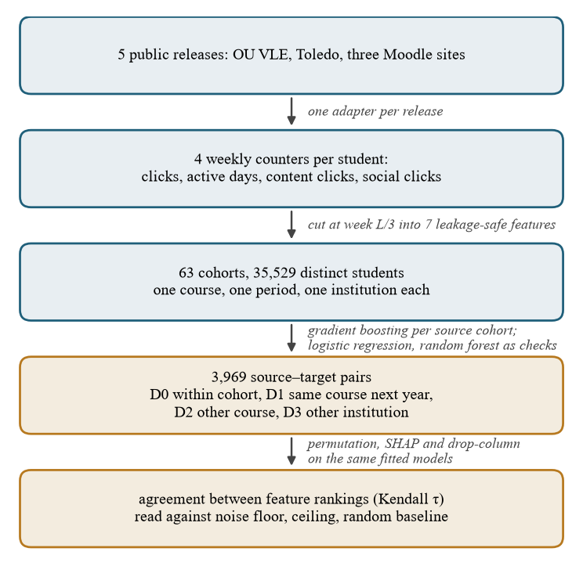
Fig. 1. The pipeline, from five public releases to the reference points. Blue stages build the benchmark; ochre stages evaluate on it.
TABLE I
The benchmark. Pass rate is the range over the institution's cohorts; within-cohort ROC-AUC is the mean of 5-fold cross-validated gradient boosting over them, descriptive only because outcome definitions differ by institution.
Institution | Platform | Country | Cohorts | Students | Pass rate | Within-cohort AUC
Open University [1] | OU VLE | UK | 19 | 30,059 | 0.34–0.73 | 0.845
Univ. of KwaZulu-Natal [3] | Moodle | South Africa | 16 | 7,254 | 0.60–0.95 | 0.667
KU Leuven [2] | Toledo | Belgium | 6 | 3,939 | 0.51–0.75 | 0.608
Univ. de Oviedo [13] | Moodle | Spain | 20 | 3,789 | 0.26–0.84 | 0.606
Univ. of Zambia [18, 19] | Moodle | Zambia | 2 | 117 | 0.25–0.38 | 0.527
Total | 3 platforms | 5 countries | 63 | 35,529 distinct | 0.25–0.95 | —

B. Schema, calendars and corrections
Each adapter emits four weekly counters per student — clicks, active days, content clicks, social clicks — from which seven leakage-safe features are derived identically: four cumulative counters, current-week clicks, active weeks so far, and weeks since last activity. No demographic or assessment feature enters the models; three institutions publish none. Courses run 14 to 46 weeks, so the prediction point is relative: one row per student at week ⌈ 1/3 × length ⌉, repeated at 1/4 and 1/2.
Terminology. This per-student weekly state is often called a digital twin of the learner, but the term is graded by data flow: a digital shadow carries an automated one-way flow from the object to its representation, and a digital twin closes the loop with a flow back [23, 24]. Our schema is one-way by construction, so it is a digital shadow, and we claim no simulation, counterfactual or intervention capability; systems that do close the loop keep a teacher who can inspect and override model-scored output before it reaches the student [25]. The distinction is load-bearing: closing the loop means reading feature attributions causally, which Section V-B argues against, since the attributions move more between estimators than the effect under study.
The three Moodle institutions publish no course calendar, so an active span is inferred from the log as the first to the last week in which at least 10 % of enrolled students were active. Building the benchmark surfaced two data defects worth recording for reusers: one release stores its academic years under identical filenames, so a naive loader silently returns the same year three times; and another records a single final examination mark per student with no sitting year, so assigning it to every year in which a student appears leaks a later outcome backwards. Fixing the second cost one cohort, and we report the smaller benchmark, not the leaked one.
IV. METHOD
Models. A fixed gradient-boosting classifier [20] (200 trees, depth 3, learning rate 0.05) is the primary model, with logistic regression and a random forest as robustness checks (Table II). Nothing is tuned per cohort: the object of study is what an ordinary model does. The explanation analyses use gradient boosting alone, since TreeSHAP needs a tree ensemble and those analyses hold the model fixed while the estimator varies.
Explainers. Three importance estimators are applied to the same fitted model on the same held-out students: permutation importance (three repeats, AUC scoring); SHAP, the mean absolute TreeSHAP value per feature [21]; and drop-column, refitting without each feature and measuring the AUC lost, which is what [15] argues a defensible estimate requires.
Agreement. Kendall τ over the seven features and Jaccard overlap of the top three. Because such numbers are meaningless without bounds, we measure three: a noise floor (one fitted model, two permutation seeds), an attainable ceiling (two models fitted to disjoint halves of one cohort, both ranked on the same students), and an analytic random baseline (expected τ 0.000, expected top-3 Jaccard 0.303). Floor and ceiling are computed under permutation importance and so carry that estimator's scale, not a universal one; Table III therefore gives a within-cohort reference for each estimator, from a second two-thirds split ranked on its own held-out third.
Cohort separations. Cohort pairs are labelled by what differs: the same course in another year, another course at the same institution, or another institution. All 3,969 ordered source–target combinations are evaluated, including the 63 in which source and target are the same cohort.
V. RESULTS
A. How far predictability varies, and with what

The last column of Table I gives within-cohort discrimination per institution, but those are means; the claim is about spread. Fig. 2 gives one row per cohort. Within-cohort ROC-AUC runs from 0.384 to 0.953, each interval a 400-resample bootstrap over that cohort's students. Eighteen of the 63 intervals cover 0.5, and one Oviedo course sits entirely below it at 0.384. A study reporting 0.85 and one reporting 0.55 may be equally competent and correct about their data.
Institution — and with it platform, outcome definition and scale, which are collinear here — accounts for 57.3 % of the variance in cohort AUC, as the between-group share of the total sum of squares in a one-way analysis of variance over the five institutions; the figure describes the corpus and is not an estimate of an institution effect. The remainder is not noise: OULAD's 19 cohorts occupy a narrow band from 0.709 to 0.897, while Oviedo's 20 span almost the entire axis, so within one institution the variation can be as large as between institutions. Nor is the institution effect clean. Cohort AUC correlates 0.669 with cohort size, and the median OULAD cohort holds 1,614 students, twelve times the median Oviedo cohort; institution, platform, outcome definition and scale are collinear here, and this benchmark cannot separate them. What it does establish is the size of the target a single-cohort result is estimating, which a single-dataset design cannot observe.
The spread is not a property of gradient boosting. Table II repeats the within-cohort measurement with logistic regression and a random forest: the ordering of institutions is the same under all three, the three models sit within 0.05 of one another at every institution but Zambia, whose two cohorts hold 117 students between them, and logistic regression is the best of the three overall, 0.717 against 0.691 and 0.692. Transferred to another institution, all three lose most of what they had.
TABLE II
Mean within-cohort ROC-AUC per institution for the three model families and the zero-training rule; the last row is cross-institution transfer on pairs that share no student.
 | Gradient | Logistic | Random | Rule: active
 | boosting | regression | forest | days
Open University | 0.845 | 0.858 | 0.848 | 0.830
KwaZulu-Natal | 0.667 | 0.716 | 0.673 | 0.717
KU Leuven | 0.608 | 0.652 | 0.614 | 0.655
Oviedo | 0.606 | 0.630 | 0.611 | 0.631
Zambia | 0.527 | 0.449 | 0.418 | 0.565
All 63 cohorts | 0.691 | 0.717 | 0.692 | 0.713
Another institution | 0.596 | 0.598 | 0.630 | —

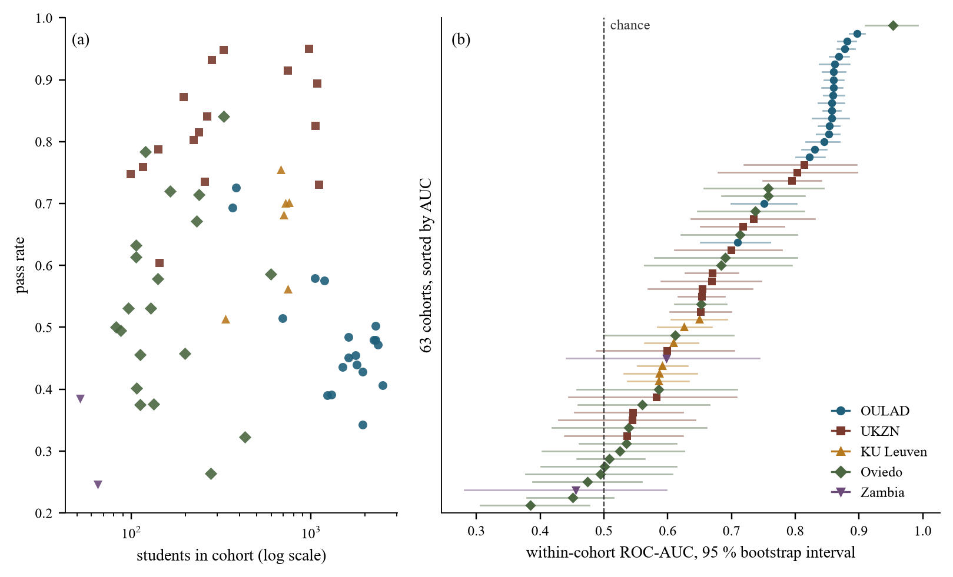
Fig. 2. The 63 cohorts. (a) Size and pass rate; colour and marker identify the institution. (b) Within-cohort ROC-AUC, sorted, with 400-resample bootstrap intervals over students.
B. Reference points, and a replication with no estimator-free answer

Fig. 3 places every comparison in this paper on one axis, and the grey bars are what the others are read against. The noise floor is what one fitted model scores against itself when only the permutation seed changes, so no bar can be read as stable above it; the random baseline, τ 0.000, is the axis origin. Two models differing only in which half of one cohort they saw agree at τ 0.338 (0.279–0.398) under permutation importance: that ceiling is the most such a comparison attains under it, and every bar measured under permutation importance (blue and brown) is read against it, while the two cross-estimator bars (orange) have no single estimator's scale and are read against each estimator's own reference in Table III. The noise floor of 0.706 (0.669–0.742) rules out estimator variance.
Against those bounds, the estimator comparison. Applied to one fitted model on one set of students, permutation importance and SHAP agree at τ 0.410 (0.355–0.464), permutation and drop-column at 0.259 (0.213–0.303), SHAP and drop-column at 0.127 (0.074–0.179). Taken bare, the two low numbers look like the conclusion of Swamy et al. [8] — that the explainer is a first-order determinant of the resulting factor list — now on 63 cohorts across five institutions, on one gradient-boosting model rather than one recurrent network over five MOOCs. Taken against the bounds, neither is a like-for-like arm: one estimator is degenerate here, and the remaining pair has no single scale.
One arm requires a caveat we report rather than hide. Four of the seven features are cumulative counters of the same behaviour, and removing one leaves near-duplicates behind, so drop-column importance is zero or negative for 3.2 of 7 features on average, against 2.0 for permutation and 0.1 for SHAP. Its agreement with itself across resamples of one cohort is 0.173 (0.120–0.227) — lower than its agreement with permutation on identical data, and against 0.592 (0.540–0.641) for SHAP. On collinear behavioural features, drop-column is not a reliable estimator, and 0.127 should be read as evidence about that estimator in this setting rather than as a headline. The defensible figure is the permutation-versus-SHAP agreement of 0.410, and it does not settle the question, because a cross-estimator quantity has no single estimator's scale. Against permutation importance's own within-cohort reference of 0.345 (0.287–0.401) it is high, and the explainer matters less than the training sample; against SHAP's 0.592 it is low, and the explainer matters more, which is the ordering Swamy et al. report. The permutation-only ceiling of 0.338 is the strictest reference we have and supports the first reading, but it too is one estimator's. The comparison has no estimator-free answer here, and Section V-C measures why.
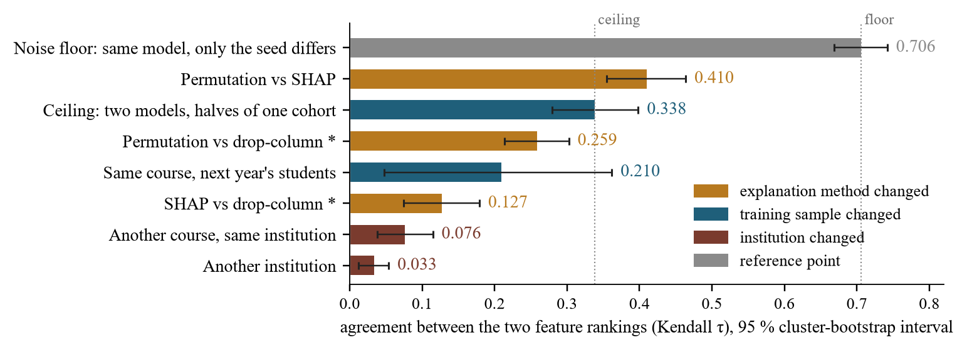
Fig. 3. Every agreement comparison in this paper on one scale. Colour marks what differed between the two rankings; whiskers are 95 % cluster-bootstrap intervals over cohorts, or over target cohorts for the three transfer bars; dotted lines mark the floor and the ceiling, and the axis origin, τ = 0, is the expected agreement of two independent rankings. Starred bars involve drop-column, degenerate here (Section V-B).
C. A single-estimator study measures its own estimator

The practical consequence is sharper than the comparison above. Take a question the literature does ask — how much does retraining on the next year's students change a model's feature ranking? — and answer it three times, changing only the estimator, on the same 78 course-year pairs, the same fitted models and the same held-out thirds (Table III).
Each estimator needs its own reference, because they disagree on the level even when nothing is retrained. Applied twice to the cohorts in those pairs under two different splits, SHAP reproduces itself at τ 0.638 (0.595–0.678) and permutation importance at 0.429 (0.383–0.472). Against those references, a year of retraining costs 0.129 (0.091–0.167) under SHAP and 0.173 (0.123–0.224) under permutation; the paired difference, -0.043, has an interval of -0.095 to 0.009 (Wilcoxon signed-rank p = 0.15), so as far as these pairs can tell the two estimators see an effect of one size. The level at which that effect is reported differs by 0.252 (0.204–0.298; p < 0.001), 1.7 times the mean effect of 0.151. Fig. 3 shows the ladder's D1 rung at 0.210, not 0.256, because the ladder scores the whole target cohort, not a held-out third; the gap between protocols is small beside that between estimators.
TABLE III
One question, three estimators, on identical models and evaluation sets: 78 course-year pairs, three splits each; brackets are 95 % bootstrap intervals over the pairs. ^{*}Degenerate here (Section V-B).
Estimator | Same cohort, another split | Next year's students | Cost of one year
SHAP | 0.638 [0.595, 0.678] | 0.508 [0.471, 0.545] | 0.129 [0.091, 0.167]
Permutation importance | 0.429 [0.383, 0.472] | 0.256 [0.214, 0.298] | 0.173 [0.123, 0.224]
Drop-column^{*} | 0.199 [0.146, 0.253] | 0.055 [0.021, 0.089] | 0.144 [0.077, 0.212]
Spread of the level, SHAP - permutation (paired bootstrap; Wilcoxon p < 0.001) |  |  | 0.252 [0.204, 0.298]
Mean cost of one year, SHAP and permutation |  |  | 0.151
Cost difference, SHAP - permutation (paired bootstrap; Wilcoxon p = 0.15) |  |  | -0.043 [-0.095, 0.009]

A stability study that fixes one estimator therefore reports a number that is as much a property of that choice as of the data, and none we know of declares which estimator produced it. The recommendation is cheap: report agreement under at least two estimators, and what each scores when nothing has changed, since without that reference a τ has no scale.
D. Three controls that changed our own conclusions

A zero-training baseline. Ranking students by cumulative active days — no model, no training, no labels — reaches AUC 0.713 against 0.691 for a locally trained gradient-boosting model, beating it in 38 of 63 cohorts; logistic regression reaches 0.717. At the Open University, on the twelve cohorts where intermediate assessment scores exist, the rule reaches 0.834 and the shared seven-feature model 0.858; adding the assessment features takes the model to 0.902. Behavioural counters carry roughly what a single attendance counter already carries; the value of a model here scales with what it knows beyond attendance.
A majority-class metric. Our first implementation computed F1 with the default positive label, passing. Every configuration looked healthy while losing, on the class an alerting system acts on, to a rule that alerts everyone. The check costs one line: print the trivial rule beside every score [22].
Contamination. 72 of 78 same-course pairs and 324 of 916 other-course pairs share students between training and evaluation, up to 94 % of the target cohort; cross-institution pairs are clean at under 1.5 %. Uncorrected, same-course transfer appears to beat within-cohort performance. Any evaluation of this shape must report per-pair overlap.
VI. DISCUSSION AND LIMITATIONS
The benchmark makes one thing cheap: anyone can run a new model, representation or explainer against 63 cohorts from three platforms in five countries and report our reference points.
The measurement result is a caution rather than a discovery. Swamy et al. established that the explainer dominates the training sample [8]; on this population that ordering holds against SHAP's reference and reverses against permutation importance's. We read that not as a refutation — their models, features and population all differ from ours — but as evidence that a claim of this form cannot be evaluated until the reference is named, and that naming it can decide the answer.
Limitations. Seven behavioural features are strongly correlated, exactly the setting where importance is least identifiable and in which drop-column degenerates; richer feature sets may behave differently and we cannot test that where assessment data is unpublished. Outcome semantics differ across institutions and are collinear with institution. Three institutions' course calendars are inferred, not published. The 1/3 cutoff is not load-bearing: at 1/4 and 1/2 every level moves and no ordering does, with cross-institution explanation agreement 0.038, 0.034 and 0.029 at the three cutoffs and accuracy rising with the later one. The intervals on agreement figures resample cohorts, or target cohorts, and so price the sampling of cohorts, not of students within them; the estimator spread in Section V-C rests on 78 course-year pairs, three splits each, from 16 course families at four institutions, and pairs from one family are not independent, so its interval is narrower than a family-clustered one would be. Cross-institution comparisons are descriptive throughout, for the reason given in Section III. Everything here is correlational, and Section V-B is an argument against reading any of these rankings causally.
VII. CONCLUSION
We release a benchmark of 63 student cohorts from five universities, three platforms and five countries, harmonised to one schema, with adapters and frozen results. Within-cohort ROC-AUC spans 0.384 to 0.953, so a single-dataset result is a statement about its dataset. We supply the floor, ceiling and random baseline an explanation-agreement number needs to be read at all, and find the reported dominance of the explainer over the training sample holds or reverses according to which estimator supplies the reference. The consequence we most want read is narrow: a stability number reported with one estimator and no same-data reference has a level that moves, when the estimator changes, by more than the effect under study. Reporting two, and what each scores when nothing has changed, costs one run and makes the answer mean something.
REPRODUCIBILITY
We release the five institution adapters, the cohort definitions, the experiment code and the frozen result files, together with a script that recomputes every number in this paper from those files. We redistribute none of the student data. All five releases are published openly by their originating institutions, four under a DOI; the repository records each source, licence and expected path, and the adapters read a copy the reuser downloads. Everything named here is at https://github.com/a169n/student-risk-benchmark.
ETHICS
All five datasets are published in de-identified form by their originating institutions, and this is a secondary analysis of those releases: no student was contacted and no re-identification was attempted. No demographic attribute enters any model. One release ships a name column beside its hashed student identifier; our adapter never reads it and joins on the hash alone, and we note it so other reusers choose deliberately.
REFERENCES
[1] J. Kuzilek, M. Hlosta, and Z. Zdrahal, “Open University Learning Analytics dataset,” Sci. Data, vol. 4, art. 170171, 2017.
[2] E. Tiukhova, D. Van Landuyt, B. Baesens, and M. Snoeck, “Open data, private learners: a de-identified student activity and performance dataset for learning analytics,” Sci. Data, vol. 13, art. 548, 2026.
[3] R. Raghavjee, P. R. Subramaniam, and I. Govender, “Anonymized dataset of Information Systems and Technology students at a South African university for learning analytics,” Data, vol. 11, no. 1, art. 1, 2026.
[4] A. Bettahi, F.-Z. Belouadha, and H. Harroud, “A modular and explainable machine learning pipeline for student dropout prediction in higher education,” Algorithms, vol. 18, no. 10, art. 662, 2025.
[5] S. Boujmiraz, H. Darhmaoui, and A. Drissi el Maliani, “Predicting student performance: a comprehensive review of machine learning, deep learning, and explainable AI approaches,” Comput. Educ.: Artif. Intell., vol. 10, art. 100548, 2026.
[6] R. Guevara-Reyes, I. Ortiz-Garcés, R. Andrade, F. Cox-Riquetti, and W. Villegas-Ch, “Machine learning models for academic performance prediction: interpretability and application in educational decision-making,” Front. Educ., vol. 10, art. 1632315, 2025.
[7] E. Tiukhova et al., “Explainable learning analytics: assessing the stability of student success prediction models by means of explainable AI,” Decis. Support Syst., vol. 182, art. 114229, 2024.
[8] V. Swamy, B. Radmehr, N. Krco, M. Marras, and T. Käser, “Evaluating the explainers: black-box explainable machine learning for student success prediction in MOOCs,” in Proc. 15th Int. Conf. Educational Data Mining (EDM), 2022.
[9] J. López-Zambrano, J. A. Lara, and C. Romero, “Towards portability of models for predicting students' final performance in university courses starting from Moodle logs,” Appl. Sci., vol. 10, no. 1, art. 354, 2020.
[10] J. López-Zambrano, J. A. Lara, and C. Romero, “Improving the portability of predicting students' performance models by using ontologies,” J. Comput. High. Educ., vol. 34, pp. 1–19, 2022.
[11] J. Gardner, R. Yu, Q. Nguyen, C. Brooks, and R. Kizilcec, “Cross-institutional transfer learning for educational models: implications for model performance, fairness, and equity,” in Proc. ACM Conf. Fairness, Accountability, and Transparency (FAccT), 2023.
[12] J. Schwerter et al., “Cross-course generalizability of SRL-aligned predictive models using digital learning traces,” arXiv:2604.22812, 2026.
[13] M. Riestra-González, M. del P. Paule-Ruíz, and F. Ortin, “Massive LMS log data analysis for the early prediction of course-agnostic student performance,” Comput. Educ., vol. 163, art. 104108, 2021.
[14] S. M. Jayaprakash, E. W. Moody, E. J. M. Lauría, J. R. Regan, and J. D. Baron, “Early alert of academically at-risk students: an open source analytics initiative,” J. Learn. Anal., vol. 1, no. 1, pp. 6–47, 2014.
[15] G. Hooker, L. Mentch, and S. Zhou, “Unrestricted permutation forces extrapolation: variable importance requires at least one more model, or there is no free variable importance,” Stat. Comput., vol. 31, art. 82, 2021.
[16] S. Krishna et al., “The disagreement problem in explainable machine learning: a practitioner's perspective,” arXiv:2202.01602, 2022.
[17] I. Verdinelli and L. Wasserman, “Feature importance: a closer look at Shapley values and LOCO,” Stat. Sci., vol. 39, no. 4, 2024.
[18] L. Phiri, “A multi-source dataset for CS1 failure prediction in a sub-Saharan African context,” Zenodo, 2026, doi:10.5281/zenodo.21292883.
[19] L. Phiri, M. Chaibela, I. Chisha, D. Pungwa, D. Siabbaba, and B. Simukoko, “Which CS1 students will fail? Identifying digital markers from learning analytics in computer systems and architecture using weighted academic momentum and interaction logs,” arXiv:2608.16914, 2026.
[20] J. H. Friedman, “Greedy function approximation: a gradient boosting machine,” Ann. Stat., vol. 29, no. 5, pp. 1189–1232, 2001.
[21] S. M. Lundberg and S.-I. Lee, “A unified approach to interpreting model predictions,” in Adv. Neural Inf. Process. Syst. (NeurIPS), 2017.
[22] N. Bosch and L. Paquette, “Metrics for discrete student models: chance levels, comparisons, and use cases,” J. Learn. Anal., vol. 5, no. 2, pp. 86–104, 2018.
[23] W. Kritzinger, M. Karner, G. Traar, J. Henjes, and W. Sihn, “Digital Twin in manufacturing: a categorical literature review and classification,” IFAC-PapersOnLine, vol. 51, no. 11, pp. 1016–1022, 2018.
[24] K. Addanki and L. Corrin, “Unveiling the potential of Digital Twin technology for Higher Education,” in Proc. ASCILITE 2023: People, Partnerships and Pedagogies, ASCILITE Publications, 2023.
[25] A. Yerniyazov, B. Bakayeva, Z. Iztayev, P. Kozhabekova, and S. Nurgaliyeva, “A mobile system for formative assessment and teacher-reviewed feedback,” Int. J. Interact. Mobile Technol., vol. 20, no. 15, pp. 37–50, 2026.

