选择器属性说明

前言
- 如对本文内容有疑问，请联系本文作者
- 该文章适用于组件的初中级入门学习，若希望了解组件高级配置，可阅读代码工程文档进行学习 [点击跳转Picker(选择器)文档](https://xft-demo.cmburl.cn/XFTPRO-DOCS/mobile/form/picker#%E5%B1%9E%E6%80%A7%E8%A1%A8)。

选择器属性面板
本章节针对选择器的属性、数据、样式面板的可视化配置进行说明解释，如需了解组件高级配置，可跳转代码工程文档进行学习 [选择器](https://xft-demo.cmburl.cn/XFTPRO-DOCS/mobile/form/picker#%E5%9F%BA%E6%9C%AC%E7%94%A8%E6%B3%95)。
<table>
<tr>
<th width="89" verticalAlign="middle" colwidth="89" style="vertical-align:middle; vertical-align:middle; vertical-align:middle; vertical-align:middle; vertical-align:middle; vertical-align:middle; vertical-align:middle; vertical-align:middle; vertical-align:middle; vertical-align:middle; vertical-align:middle; vertical-align:middle; vertical-align:middle; vertical-align:middle; vertical-align:middle; vertical-align:middle; vertical-align:middle; vertical-align:middle; vertical-align:middle; vertical-align:middle; vertical-align:middle; vertical-align:middle; vertical-align:middle; vertical-align:middle; vertical-align:middle; vertical-align:middle; vertical-align:middle; vertical-align:middle; vertical-align:middle; vertical-align:middle; vertical-align:middle; vertical-align:middle; vertical-align:middle; vertical-align:middle; vertical-align:middle; vertical-align:middle; vertical-align:middle; vertical-align:middle; vertical-align:middle; vertical-align:middle; vertical-align:middle; vertical-align:middle; vertical-align:middle; vertical-align:middle; vertical-align:middle; vertical-align:middle; vertical-align:middle; vertical-align:middle; vertical-align:middle; vertical-align:middle; vertical-align:middle; vertical-align:middle; vertical-align:middle; vertical-align:middle;">分类</th>
<th width="136" verticalAlign="middle" colwidth="136" style="vertical-align:middle; vertical-align:middle; vertical-align:middle; vertical-align:middle; vertical-align:middle; vertical-align:middle; vertical-align:middle; vertical-align:middle; vertical-align:middle; vertical-align:middle; vertical-align:middle; vertical-align:middle; vertical-align:middle; vertical-align:middle; vertical-align:middle; vertical-align:middle; vertical-align:middle; vertical-align:middle; vertical-align:middle; vertical-align:middle; vertical-align:middle; vertical-align:middle; vertical-align:middle; vertical-align:middle; vertical-align:middle; vertical-align:middle; vertical-align:middle; vertical-align:middle; vertical-align:middle; vertical-align:middle; vertical-align:middle; vertical-align:middle; vertical-align:middle; vertical-align:middle; vertical-align:middle; vertical-align:middle; vertical-align:middle; vertical-align:middle; vertical-align:middle; vertical-align:middle; vertical-align:middle; vertical-align:middle; vertical-align:middle; vertical-align:middle; vertical-align:middle; vertical-align:middle; vertical-align:middle; vertical-align:middle; vertical-align:middle; vertical-align:middle; vertical-align:middle; vertical-align:middle; vertical-align:middle; vertical-align:middle; margin:0px; padding:0.5rem 1rem; font-weight:600;">
**显示名称**
</th>
<th width="150" verticalAlign="middle" colwidth="150" style="vertical-align:middle; vertical-align:middle; vertical-align:middle; vertical-align:middle; vertical-align:middle; vertical-align:middle; vertical-align:middle; vertical-align:middle; vertical-align:middle; vertical-align:middle; vertical-align:middle; vertical-align:middle; vertical-align:middle; vertical-align:middle; vertical-align:middle; vertical-align:middle; vertical-align:middle; vertical-align:middle; vertical-align:middle; vertical-align:middle; vertical-align:middle; vertical-align:middle; vertical-align:middle; vertical-align:middle; vertical-align:middle; vertical-align:middle; vertical-align:middle; vertical-align:middle; vertical-align:middle; vertical-align:middle; vertical-align:middle; vertical-align:middle; vertical-align:middle; vertical-align:middle; vertical-align:middle; vertical-align:middle; vertical-align:middle; vertical-align:middle; vertical-align:middle; vertical-align:middle; vertical-align:middle; vertical-align:middle; vertical-align:middle; vertical-align:middle; vertical-align:middle; vertical-align:middle; vertical-align:middle; vertical-align:middle; vertical-align:middle; vertical-align:middle; vertical-align:middle; vertical-align:middle; vertical-align:middle; vertical-align:middle; margin:0px; padding:0.5rem 1rem; font-weight:600;">
**属性**
</th>
<th width="106" verticalAlign="middle" colwidth="106" style="vertical-align:middle; vertical-align:middle; vertical-align:middle; vertical-align:middle; vertical-align:middle; vertical-align:middle; vertical-align:middle; vertical-align:middle; vertical-align:middle; vertical-align:middle; vertical-align:middle; vertical-align:middle; vertical-align:middle; vertical-align:middle; vertical-align:middle; vertical-align:middle; vertical-align:middle; vertical-align:middle; vertical-align:middle; vertical-align:middle; vertical-align:middle; vertical-align:middle; vertical-align:middle; vertical-align:middle; vertical-align:middle; vertical-align:middle; vertical-align:middle; vertical-align:middle; vertical-align:middle; vertical-align:middle; vertical-align:middle; vertical-align:middle; vertical-align:middle; vertical-align:middle; vertical-align:middle; vertical-align:middle; vertical-align:middle; vertical-align:middle; vertical-align:middle; vertical-align:middle; vertical-align:middle; vertical-align:middle; vertical-align:middle; vertical-align:middle; vertical-align:middle; vertical-align:middle; vertical-align:middle; vertical-align:middle; vertical-align:middle; vertical-align:middle; vertical-align:middle; vertical-align:middle; vertical-align:middle; vertical-align:middle;margin:0px; padding:0.5rem 1rem; font-weight:600;">
**默认值**
</th>
<th width="424" verticalAlign="middle" colwidth="424" style="vertical-align:middle; vertical-align:middle; vertical-align:middle; vertical-align:middle; vertical-align:middle; vertical-align:middle; vertical-align:middle; vertical-align:middle; vertical-align:middle; vertical-align:middle; vertical-align:middle; vertical-align:middle; vertical-align:middle; vertical-align:middle; vertical-align:middle; vertical-align:middle; vertical-align:middle; vertical-align:middle; vertical-align:middle; vertical-align:middle; vertical-align:middle; vertical-align:middle; vertical-align:middle; vertical-align:middle; vertical-align:middle; vertical-align:middle; vertical-align:middle; vertical-align:middle; vertical-align:middle; vertical-align:middle; vertical-align:middle; vertical-align:middle; vertical-align:middle; vertical-align:middle; vertical-align:middle; vertical-align:middle; vertical-align:middle; vertical-align:middle; vertical-align:middle; vertical-align:middle; vertical-align:middle; vertical-align:middle; vertical-align:middle; vertical-align:middle; vertical-align:middle; vertical-align:middle; vertical-align:middle; vertical-align:middle; vertical-align:middle; vertical-align:middle; vertical-align:middle; vertical-align:middle; vertical-align:middle; vertical-align:middle; margin:0px; padding:0.5rem 1rem; font-weight:600;">
**描述**
</th>
<th width="195" verticalAlign="top" colwidth="195" style="">图片示例</th>
</tr>
<tr>
<td width="89" verticalAlign="middle" rowspan="3" colwidth="89" style="vertical-align:middle; vertical-align:middle; vertical-align:middle; vertical-align:middle; vertical-align:middle; vertical-align:middle; vertical-align:middle; vertical-align:middle; vertical-align:middle; vertical-align:middle; vertical-align:middle; vertical-align:middle; vertical-align:middle; vertical-align:middle; vertical-align:middle; vertical-align:middle; vertical-align:middle; vertical-align:middle; vertical-align:middle; vertical-align:middle; vertical-align:middle; vertical-align:middle; vertical-align:middle; vertical-align:middle; vertical-align:middle; vertical-align:middle; vertical-align:middle; vertical-align:middle; vertical-align:middle; vertical-align:middle; vertical-align:middle; vertical-align:middle; vertical-align:middle; vertical-align:middle; vertical-align:middle; vertical-align:middle; vertical-align:middle; vertical-align:middle; vertical-align:middle; vertical-align:middle; vertical-align:middle; vertical-align:middle; vertical-align:middle; vertical-align:middle; vertical-align:middle; vertical-align:middle; vertical-align:middle; vertical-align:middle; vertical-align:middle; vertical-align:middle; vertical-align:middle; vertical-align:middle; vertical-align:middle; vertical-align:middle;">基础配置</td>
<td width="136" verticalAlign="middle" colwidth="136" style="vertical-align:middle; vertical-align:middle; vertical-align:middle; vertical-align:middle; vertical-align:middle; vertical-align:middle; vertical-align:middle; vertical-align:middle; vertical-align:middle; vertical-align:middle; vertical-align:middle; vertical-align:middle; vertical-align:middle; vertical-align:middle; vertical-align:middle; vertical-align:middle; vertical-align:middle; vertical-align:middle; vertical-align:middle; vertical-align:middle; vertical-align:middle; vertical-align:middle; vertical-align:middle; vertical-align:middle; vertical-align:middle; vertical-align:middle; vertical-align:middle; vertical-align:middle; vertical-align:middle; vertical-align:middle; vertical-align:middle; vertical-align:middle; vertical-align:middle; vertical-align:middle; vertical-align:middle; vertical-align:middle; vertical-align:middle; vertical-align:middle; vertical-align:middle; vertical-align:middle; vertical-align:middle; vertical-align:middle; vertical-align:middle; vertical-align:middle; vertical-align:middle; vertical-align:middle; vertical-align:middle; vertical-align:middle; vertical-align:middle; vertical-align:middle; vertical-align:middle; vertical-align:middle; vertical-align:middle; vertical-align:middle; margin:0px; padding:0.5rem 1rem;">标题</td>
<td width="150" verticalAlign="middle" colwidth="150" style="vertical-align:middle; vertical-align:middle; vertical-align:middle; vertical-align:middle; vertical-align:middle; vertical-align:middle; vertical-align:middle; vertical-align:middle; vertical-align:middle; vertical-align:middle; vertical-align:middle; vertical-align:middle; vertical-align:middle; vertical-align:middle; vertical-align:middle; vertical-align:middle; vertical-align:middle; vertical-align:middle; vertical-align:middle; vertical-align:middle; vertical-align:middle; vertical-align:middle; vertical-align:middle; vertical-align:middle; vertical-align:middle; vertical-align:middle; vertical-align:middle; vertical-align:middle; vertical-align:middle; vertical-align:middle; vertical-align:middle; vertical-align:middle; vertical-align:middle; vertical-align:middle; vertical-align:middle; vertical-align:middle; vertical-align:middle; vertical-align:middle; vertical-align:middle; vertical-align:middle; vertical-align:middle; vertical-align:middle; vertical-align:middle; vertical-align:middle; vertical-align:middle; vertical-align:middle; vertical-align:middle; vertical-align:middle; vertical-align:middle; vertical-align:middle; vertical-align:middle; vertical-align:middle; vertical-align:middle; vertical-align:middle; margin:0px; padding:0.5rem 1rem;">label</td>
<td width="106" verticalAlign="middle" colwidth="106" style="vertical-align:middle; vertical-align:middle; vertical-align:middle; vertical-align:middle; vertical-align:middle; vertical-align:middle; vertical-align:middle; vertical-align:middle; vertical-align:middle; vertical-align:middle; vertical-align:middle; vertical-align:middle; vertical-align:middle; vertical-align:middle; vertical-align:middle; vertical-align:middle; vertical-align:middle; vertical-align:middle; vertical-align:middle; vertical-align:middle; vertical-align:middle; vertical-align:middle; vertical-align:middle; vertical-align:middle; vertical-align:middle; vertical-align:middle; vertical-align:middle; vertical-align:middle; vertical-align:middle; vertical-align:middle; vertical-align:middle; vertical-align:middle; vertical-align:middle; vertical-align:middle; vertical-align:middle; vertical-align:middle; vertical-align:middle; vertical-align:middle; vertical-align:middle; vertical-align:middle; vertical-align:middle; vertical-align:middle; vertical-align:middle; vertical-align:middle; vertical-align:middle; vertical-align:middle; vertical-align:middle; vertical-align:middle; vertical-align:middle; vertical-align:middle; vertical-align:middle; vertical-align:middle; vertical-align:middle; vertical-align:middle; margin:0px; padding:0.5rem 1rem;">
</td>
<td width="424" verticalAlign="middle" colwidth="424" style="vertical-align:middle; vertical-align:middle; vertical-align:middle; vertical-align:middle; vertical-align:middle; vertical-align:middle; vertical-align:middle; vertical-align:middle; vertical-align:middle; vertical-align:middle; vertical-align:middle; vertical-align:middle; vertical-align:middle; vertical-align:middle; vertical-align:middle; vertical-align:middle; vertical-align:middle; vertical-align:middle; vertical-align:middle; vertical-align:middle; vertical-align:middle; vertical-align:middle; vertical-align:middle; vertical-align:middle; vertical-align:middle; vertical-align:middle; vertical-align:middle; vertical-align:middle; vertical-align:middle; vertical-align:middle; vertical-align:middle; vertical-align:middle; vertical-align:middle; vertical-align:middle; vertical-align:middle; vertical-align:middle; vertical-align:middle; vertical-align:middle; vertical-align:middle; vertical-align:middle; vertical-align:middle; vertical-align:middle; vertical-align:middle; vertical-align:middle; vertical-align:middle; vertical-align:middle; vertical-align:middle; vertical-align:middle; vertical-align:middle; vertical-align:middle; vertical-align:middle; vertical-align:middle; vertical-align:middle; vertical-align:middle; margin:0px; padding:0.5rem 1rem;">字段标题</td>
<td width="195" verticalAlign="middle" rowspan="3" colwidth="195" style="vertical-align:middle; vertical-align:middle; vertical-align:middle; vertical-align:middle; vertical-align:middle; vertical-align:middle; vertical-align:middle; vertical-align:middle; vertical-align:middle; vertical-align:middle; vertical-align:middle; vertical-align:middle; vertical-align:middle; vertical-align:middle; vertical-align:middle; vertical-align:middle; vertical-align:middle; vertical-align:middle; vertical-align:middle; vertical-align:middle; vertical-align:middle; vertical-align:middle; vertical-align:middle; vertical-align:middle;">
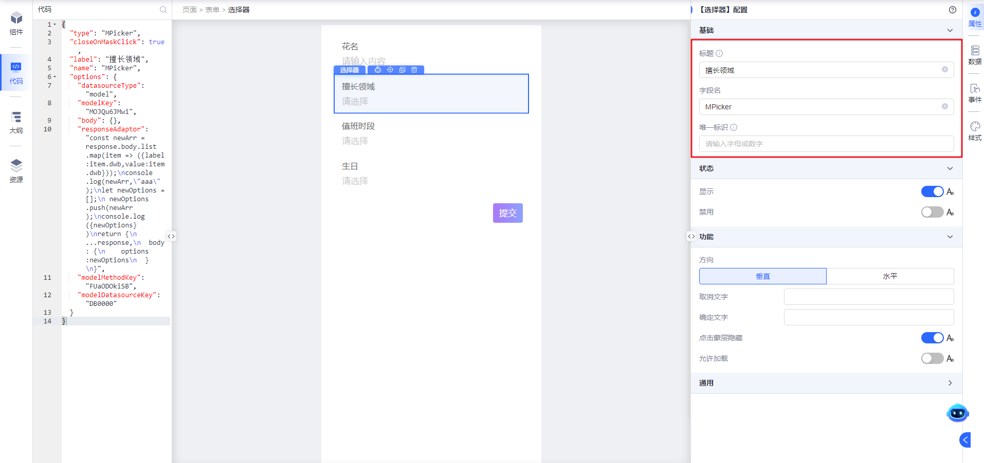
</td>
</tr>
<tr>
<td width="136" verticalAlign="middle" colwidth="136" style="vertical-align:middle; vertical-align:middle; vertical-align:middle; vertical-align:middle; vertical-align:middle; vertical-align:middle; vertical-align:middle; vertical-align:middle; vertical-align:middle; vertical-align:middle; vertical-align:middle; vertical-align:middle; vertical-align:middle; vertical-align:middle; vertical-align:middle; vertical-align:middle; vertical-align:middle; vertical-align:middle; vertical-align:middle; vertical-align:middle; vertical-align:middle; vertical-align:middle; vertical-align:middle; vertical-align:middle; vertical-align:middle; vertical-align:middle; vertical-align:middle; vertical-align:middle; vertical-align:middle; vertical-align:middle; vertical-align:middle; vertical-align:middle; vertical-align:middle; vertical-align:middle; vertical-align:middle; vertical-align:middle; vertical-align:middle; vertical-align:middle; vertical-align:middle; vertical-align:middle; vertical-align:middle; vertical-align:middle; vertical-align:middle; vertical-align:middle; vertical-align:middle; vertical-align:middle; vertical-align:middle; vertical-align:middle; vertical-align:middle; vertical-align:middle; vertical-align:middle; vertical-align:middle; vertical-align:middle; vertical-align:middle; margin:0px; padding:0.5rem 1rem;">字段名</td>
<td width="150" verticalAlign="middle" colwidth="150" style="vertical-align:middle; vertical-align:middle; vertical-align:middle; vertical-align:middle; vertical-align:middle; vertical-align:middle; vertical-align:middle; vertical-align:middle; vertical-align:middle; vertical-align:middle; vertical-align:middle; vertical-align:middle; vertical-align:middle; vertical-align:middle; vertical-align:middle; vertical-align:middle; vertical-align:middle; vertical-align:middle; vertical-align:middle; vertical-align:middle; vertical-align:middle; vertical-align:middle; vertical-align:middle; vertical-align:middle; vertical-align:middle; vertical-align:middle; vertical-align:middle; vertical-align:middle; vertical-align:middle; vertical-align:middle; vertical-align:middle; vertical-align:middle; vertical-align:middle; vertical-align:middle; vertical-align:middle; vertical-align:middle; vertical-align:middle; vertical-align:middle; vertical-align:middle; vertical-align:middle; vertical-align:middle; vertical-align:middle; vertical-align:middle; vertical-align:middle; vertical-align:middle; vertical-align:middle; vertical-align:middle; vertical-align:middle; vertical-align:middle; vertical-align:middle; vertical-align:middle; vertical-align:middle; vertical-align:middle; vertical-align:middle; margin:0px; padding:0.5rem 1rem;">name</td>
<td width="106" verticalAlign="middle" colwidth="106" style="vertical-align:middle; vertical-align:middle; vertical-align:middle; vertical-align:middle; vertical-align:middle; vertical-align:middle; vertical-align:middle; vertical-align:middle; vertical-align:middle; vertical-align:middle; vertical-align:middle; vertical-align:middle; vertical-align:middle; vertical-align:middle; vertical-align:middle; vertical-align:middle; vertical-align:middle; vertical-align:middle; vertical-align:middle; vertical-align:middle; vertical-align:middle; vertical-align:middle; vertical-align:middle; vertical-align:middle; vertical-align:middle; vertical-align:middle; vertical-align:middle; vertical-align:middle; vertical-align:middle; vertical-align:middle; vertical-align:middle; vertical-align:middle; vertical-align:middle; vertical-align:middle; vertical-align:middle; vertical-align:middle; vertical-align:middle; vertical-align:middle; vertical-align:middle; vertical-align:middle; vertical-align:middle; vertical-align:middle; vertical-align:middle; vertical-align:middle; vertical-align:middle; vertical-align:middle; vertical-align:middle; vertical-align:middle; vertical-align:middle; vertical-align:middle; vertical-align:middle; vertical-align:middle; vertical-align:middle; vertical-align:middle; margin:0px; padding:0.5rem 1rem;">
</td>
<td width="424" verticalAlign="middle" colwidth="424" style="vertical-align:middle; vertical-align:middle; vertical-align:middle; vertical-align:middle; vertical-align:middle; vertical-align:middle; vertical-align:middle; vertical-align:middle; vertical-align:middle; vertical-align:middle; vertical-align:middle; vertical-align:middle; vertical-align:middle; vertical-align:middle; vertical-align:middle; vertical-align:middle; vertical-align:middle; vertical-align:middle; vertical-align:middle; vertical-align:middle; vertical-align:middle; vertical-align:middle; vertical-align:middle; vertical-align:middle; vertical-align:middle; vertical-align:middle; vertical-align:middle; vertical-align:middle; vertical-align:middle; vertical-align:middle; vertical-align:middle; vertical-align:middle; vertical-align:middle; vertical-align:middle; vertical-align:middle; vertical-align:middle; vertical-align:middle; vertical-align:middle; vertical-align:middle; vertical-align:middle; vertical-align:middle; vertical-align:middle; vertical-align:middle; vertical-align:middle; vertical-align:middle; vertical-align:middle; vertical-align:middle; vertical-align:middle; vertical-align:middle; vertical-align:middle; vertical-align:middle; vertical-align:middle; vertical-align:middle; vertical-align:middle; margin:0px; padding:0.5rem 1rem;">字段名</td>
</tr>
<tr>
<td width="136" verticalAlign="middle" colwidth="136" style="vertical-align:middle; vertical-align:middle; vertical-align:middle; vertical-align:middle; vertical-align:middle; vertical-align:middle; vertical-align:middle; vertical-align:middle; vertical-align:middle; vertical-align:middle; vertical-align:middle; vertical-align:middle; vertical-align:middle; vertical-align:middle; vertical-align:middle; vertical-align:middle; vertical-align:middle; vertical-align:middle; vertical-align:middle; vertical-align:middle; vertical-align:middle; vertical-align:middle; vertical-align:middle; vertical-align:middle; vertical-align:middle; vertical-align:middle; vertical-align:middle; vertical-align:middle; vertical-align:middle; vertical-align:middle; vertical-align:middle; vertical-align:middle; vertical-align:middle; vertical-align:middle; vertical-align:middle; vertical-align:middle; vertical-align:middle; vertical-align:middle; vertical-align:middle; vertical-align:middle; vertical-align:middle; vertical-align:middle; vertical-align:middle; vertical-align:middle; vertical-align:middle; vertical-align:middle; vertical-align:middle; vertical-align:middle; vertical-align:middle; vertical-align:middle; vertical-align:middle; vertical-align:middle; vertical-align:middle; vertical-align:middle; margin:0px; padding:0.5rem 1rem;">唯一标识</td>
<td width="150" verticalAlign="middle" colwidth="150" style="vertical-align:middle; vertical-align:middle; vertical-align:middle; vertical-align:middle; vertical-align:middle; vertical-align:middle; vertical-align:middle; vertical-align:middle; vertical-align:middle; vertical-align:middle; vertical-align:middle; vertical-align:middle; vertical-align:middle; vertical-align:middle; vertical-align:middle; vertical-align:middle; vertical-align:middle; vertical-align:middle; vertical-align:middle; vertical-align:middle; vertical-align:middle; vertical-align:middle; vertical-align:middle; vertical-align:middle; vertical-align:middle; vertical-align:middle; vertical-align:middle; vertical-align:middle; vertical-align:middle; vertical-align:middle; vertical-align:middle; vertical-align:middle; vertical-align:middle; vertical-align:middle; vertical-align:middle; vertical-align:middle; vertical-align:middle; vertical-align:middle; vertical-align:middle; vertical-align:middle; vertical-align:middle; vertical-align:middle; vertical-align:middle; vertical-align:middle; vertical-align:middle; vertical-align:middle; vertical-align:middle; vertical-align:middle; vertical-align:middle; vertical-align:middle; vertical-align:middle; vertical-align:middle; vertical-align:middle; vertical-align:middle; margin:0px; padding:0.5rem 1rem;">storeName、nodeName</td>
<td width="106" verticalAlign="middle" colwidth="106" style="vertical-align:middle; vertical-align:middle; vertical-align:middle; vertical-align:middle; vertical-align:middle; vertical-align:middle; vertical-align:middle; vertical-align:middle; vertical-align:middle; vertical-align:middle; vertical-align:middle; vertical-align:middle; vertical-align:middle; vertical-align:middle; vertical-align:middle; vertical-align:middle; vertical-align:middle; vertical-align:middle; vertical-align:middle; vertical-align:middle; vertical-align:middle; vertical-align:middle; vertical-align:middle; vertical-align:middle; vertical-align:middle; vertical-align:middle; vertical-align:middle; vertical-align:middle; vertical-align:middle; vertical-align:middle; vertical-align:middle; vertical-align:middle; vertical-align:middle; vertical-align:middle; vertical-align:middle; vertical-align:middle; vertical-align:middle; vertical-align:middle; vertical-align:middle; vertical-align:middle; vertical-align:middle; vertical-align:middle; vertical-align:middle; vertical-align:middle; vertical-align:middle; vertical-align:middle; vertical-align:middle; vertical-align:middle; vertical-align:middle; vertical-align:middle; vertical-align:middle; vertical-align:middle; vertical-align:middle; vertical-align:middle; margin:0px; padding:0.5rem 1rem;">
</td>
<td width="424" verticalAlign="middle" colwidth="424" style="vertical-align:middle; vertical-align:middle; vertical-align:middle; vertical-align:middle; vertical-align:middle; vertical-align:middle; vertical-align:middle; vertical-align:middle; vertical-align:middle; vertical-align:middle; vertical-align:middle; vertical-align:middle; vertical-align:middle; vertical-align:middle; vertical-align:middle; vertical-align:middle; vertical-align:middle; vertical-align:middle; vertical-align:middle; vertical-align:middle; vertical-align:middle; vertical-align:middle; vertical-align:middle; vertical-align:middle; vertical-align:middle; vertical-align:middle; vertical-align:middle; vertical-align:middle; vertical-align:middle; vertical-align:middle; vertical-align:middle; vertical-align:middle; vertical-align:middle; vertical-align:middle; vertical-align:middle; vertical-align:middle; vertical-align:middle; vertical-align:middle; vertical-align:middle; vertical-align:middle; vertical-align:middle; vertical-align:middle; vertical-align:middle; vertical-align:middle; vertical-align:middle; vertical-align:middle; vertical-align:middle; vertical-align:middle; vertical-align:middle; vertical-align:middle; vertical-align:middle; vertical-align:middle; vertical-align:middle; vertical-align:middle; margin:0px; padding:0.5rem 1rem;">
storeName：组件数据域名称，通常结合基座方法env.updateStore()使用，将键值对类型的数据传递给其他组件的数据域。
nodeName：组件节点名称，通常结合组件的各种动作方法使用
</td>
</tr>
<tr>
<td width="89" verticalAlign="middle" rowspan="2" colwidth="89" style="vertical-align:middle; vertical-align:middle; vertical-align:middle; vertical-align:middle; vertical-align:middle; vertical-align:middle; vertical-align:middle; vertical-align:middle; vertical-align:middle; vertical-align:middle; vertical-align:middle; vertical-align:middle; vertical-align:middle; vertical-align:middle; vertical-align:middle; vertical-align:middle; vertical-align:middle; vertical-align:middle; vertical-align:middle; vertical-align:middle; vertical-align:middle; vertical-align:middle; vertical-align:middle; vertical-align:middle; vertical-align:middle; vertical-align:middle; vertical-align:middle; vertical-align:middle; vertical-align:middle; vertical-align:middle; vertical-align:middle; vertical-align:middle; vertical-align:middle; vertical-align:middle; vertical-align:middle; vertical-align:middle; vertical-align:middle; vertical-align:middle; vertical-align:middle; vertical-align:middle; vertical-align:middle; vertical-align:middle; vertical-align:middle; vertical-align:middle; vertical-align:middle; vertical-align:middle; vertical-align:middle; vertical-align:middle; vertical-align:middle; vertical-align:middle; vertical-align:middle; vertical-align:middle; vertical-align:middle; vertical-align:middle;">状态</td>
<td width="136" verticalAlign="middle" colwidth="136" style="vertical-align:middle; vertical-align:middle; vertical-align:middle; vertical-align:middle; vertical-align:middle; vertical-align:middle; vertical-align:middle; vertical-align:middle; vertical-align:middle; vertical-align:middle; vertical-align:middle; vertical-align:middle; vertical-align:middle; vertical-align:middle; vertical-align:middle; vertical-align:middle; vertical-align:middle; vertical-align:middle; vertical-align:middle; vertical-align:middle; vertical-align:middle; vertical-align:middle; vertical-align:middle; vertical-align:middle; vertical-align:middle; vertical-align:middle; vertical-align:middle; vertical-align:middle; vertical-align:middle; vertical-align:middle; vertical-align:middle; vertical-align:middle; vertical-align:middle; vertical-align:middle; vertical-align:middle; vertical-align:middle; vertical-align:middle; vertical-align:middle; vertical-align:middle; vertical-align:middle; vertical-align:middle; vertical-align:middle; vertical-align:middle; vertical-align:middle; vertical-align:middle; vertical-align:middle; vertical-align:middle; vertical-align:middle; vertical-align:middle; vertical-align:middle; vertical-align:middle; vertical-align:middle; vertical-align:middle; vertical-align:middle; margin:0px; padding:0.5rem 1rem;">显示</td>
<td width="150" verticalAlign="middle" colwidth="150" style="vertical-align:middle; vertical-align:middle; vertical-align:middle; vertical-align:middle; vertical-align:middle; vertical-align:middle; vertical-align:middle; vertical-align:middle; vertical-align:middle; vertical-align:middle; vertical-align:middle; vertical-align:middle; vertical-align:middle; vertical-align:middle; vertical-align:middle; vertical-align:middle; vertical-align:middle; vertical-align:middle; vertical-align:middle; vertical-align:middle; vertical-align:middle; vertical-align:middle; vertical-align:middle; vertical-align:middle; vertical-align:middle; vertical-align:middle; vertical-align:middle; vertical-align:middle; vertical-align:middle; vertical-align:middle; vertical-align:middle; vertical-align:middle; vertical-align:middle; vertical-align:middle; vertical-align:middle; vertical-align:middle; vertical-align:middle; vertical-align:middle; vertical-align:middle; vertical-align:middle; vertical-align:middle; vertical-align:middle; vertical-align:middle; vertical-align:middle; vertical-align:middle; vertical-align:middle; vertical-align:middle; vertical-align:middle; vertical-align:middle; vertical-align:middle; vertical-align:middle; vertical-align:middle; vertical-align:middle; vertical-align:middle; margin:0px; padding:0.5rem 1rem;">visible</td>
<td width="106" verticalAlign="middle" colwidth="106" style="vertical-align:middle; vertical-align:middle; vertical-align:middle; vertical-align:middle; vertical-align:middle; vertical-align:middle; vertical-align:middle; vertical-align:middle; vertical-align:middle; vertical-align:middle; vertical-align:middle; vertical-align:middle; vertical-align:middle; vertical-align:middle; vertical-align:middle; vertical-align:middle; vertical-align:middle; vertical-align:middle; vertical-align:middle; vertical-align:middle; vertical-align:middle; vertical-align:middle; vertical-align:middle; vertical-align:middle; vertical-align:middle; vertical-align:middle; vertical-align:middle; vertical-align:middle; vertical-align:middle; vertical-align:middle; vertical-align:middle; vertical-align:middle; vertical-align:middle; vertical-align:middle; vertical-align:middle; vertical-align:middle; vertical-align:middle; vertical-align:middle; vertical-align:middle; vertical-align:middle; vertical-align:middle; vertical-align:middle; vertical-align:middle; vertical-align:middle; vertical-align:middle; vertical-align:middle; vertical-align:middle; vertical-align:middle; vertical-align:middle; vertical-align:middle; vertical-align:middle; vertical-align:middle; vertical-align:middle; vertical-align:middle; margin:0px; padding:0.5rem 1rem;">TRUE</td>
<td width="424" verticalAlign="middle" colwidth="424" style="vertical-align:middle; vertical-align:middle; vertical-align:middle; vertical-align:middle; vertical-align:middle; vertical-align:middle; vertical-align:middle; vertical-align:middle; vertical-align:middle; vertical-align:middle; vertical-align:middle; vertical-align:middle; vertical-align:middle; vertical-align:middle; vertical-align:middle; vertical-align:middle; vertical-align:middle; vertical-align:middle; vertical-align:middle; vertical-align:middle; vertical-align:middle; vertical-align:middle; vertical-align:middle; vertical-align:middle; vertical-align:middle; vertical-align:middle; vertical-align:middle; vertical-align:middle; vertical-align:middle; vertical-align:middle; vertical-align:middle; vertical-align:middle; vertical-align:middle; vertical-align:middle; vertical-align:middle; vertical-align:middle; vertical-align:middle; vertical-align:middle; vertical-align:middle; vertical-align:middle; vertical-align:middle; vertical-align:middle; vertical-align:middle; vertical-align:middle; vertical-align:middle; vertical-align:middle; vertical-align:middle; vertical-align:middle; vertical-align:middle; vertical-align:middle; vertical-align:middle; vertical-align:middle; vertical-align:middle; vertical-align:middle; margin:0px; padding:0.5rem 1rem;">
显隐配置，支持静态、表达式以及资源点配置；
默认是显示状态
</td>
<td width="195" verticalAlign="middle" rowspan="2" colwidth="195" style="vertical-align:middle; vertical-align:middle; vertical-align:middle; vertical-align:middle; vertical-align:middle; vertical-align:middle; vertical-align:middle; vertical-align:middle; vertical-align:middle; vertical-align:middle; vertical-align:middle; vertical-align:middle; vertical-align:middle; vertical-align:middle; vertical-align:middle; vertical-align:middle; vertical-align:middle; vertical-align:middle; vertical-align:middle; vertical-align:middle; vertical-align:middle; vertical-align:middle; vertical-align:middle; vertical-align:middle;">
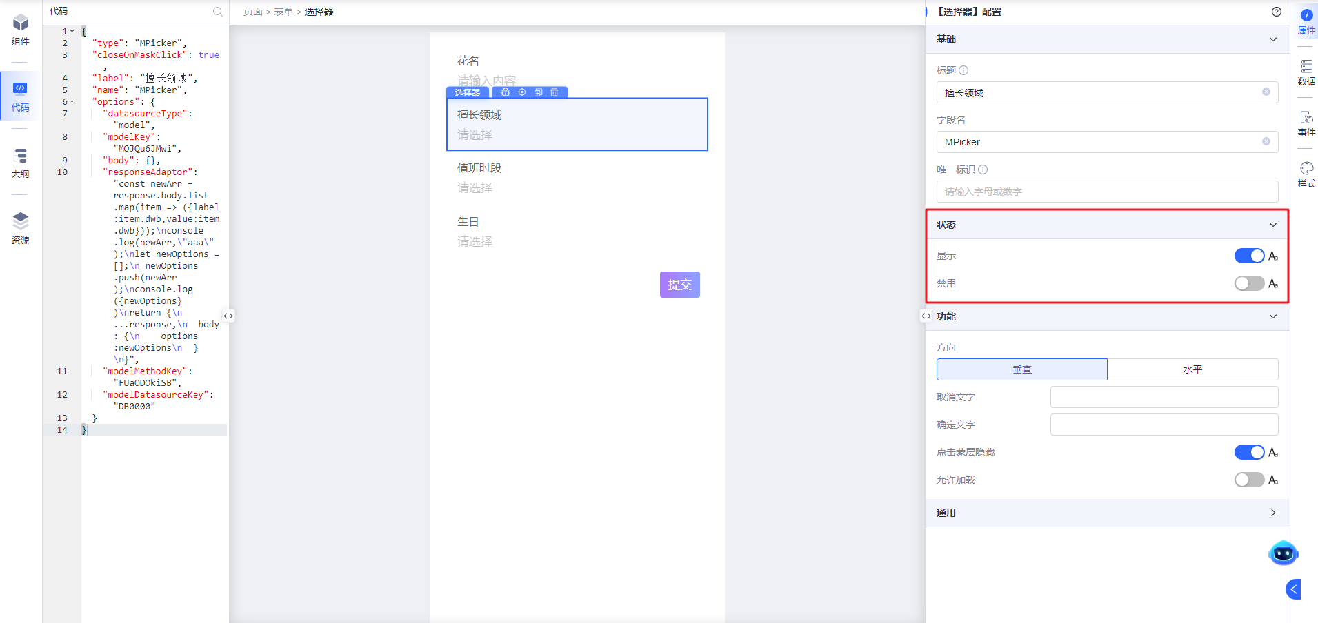
</td>
</tr>
<tr>
<td width="136" verticalAlign="middle" colwidth="136" style="vertical-align:middle; vertical-align:middle; vertical-align:middle; vertical-align:middle; vertical-align:middle; vertical-align:middle; vertical-align:middle; vertical-align:middle; vertical-align:middle; vertical-align:middle; vertical-align:middle; vertical-align:middle; vertical-align:middle; vertical-align:middle; vertical-align:middle; vertical-align:middle; vertical-align:middle; vertical-align:middle; vertical-align:middle; vertical-align:middle; vertical-align:middle; vertical-align:middle; vertical-align:middle; vertical-align:middle; vertical-align:middle; vertical-align:middle; vertical-align:middle; vertical-align:middle; vertical-align:middle; vertical-align:middle; vertical-align:middle; vertical-align:middle; vertical-align:middle; vertical-align:middle; vertical-align:middle; vertical-align:middle; vertical-align:middle; vertical-align:middle; vertical-align:middle; vertical-align:middle; vertical-align:middle; vertical-align:middle; vertical-align:middle; vertical-align:middle; vertical-align:middle; vertical-align:middle; vertical-align:middle; vertical-align:middle; vertical-align:middle; vertical-align:middle; vertical-align:middle; vertical-align:middle; vertical-align:middle; vertical-align:middle; margin:0px; padding:0.5rem 1rem;">禁用</td>
<td width="150" verticalAlign="middle" colwidth="150" style="vertical-align:middle; vertical-align:middle; vertical-align:middle; vertical-align:middle; vertical-align:middle; vertical-align:middle; vertical-align:middle; vertical-align:middle; vertical-align:middle; vertical-align:middle; vertical-align:middle; vertical-align:middle; vertical-align:middle; vertical-align:middle; vertical-align:middle; vertical-align:middle; vertical-align:middle; vertical-align:middle; vertical-align:middle; vertical-align:middle; vertical-align:middle; vertical-align:middle; vertical-align:middle; vertical-align:middle; vertical-align:middle; vertical-align:middle; vertical-align:middle; vertical-align:middle; vertical-align:middle; vertical-align:middle; vertical-align:middle; vertical-align:middle; vertical-align:middle; vertical-align:middle; vertical-align:middle; vertical-align:middle; vertical-align:middle; vertical-align:middle; vertical-align:middle; vertical-align:middle; vertical-align:middle; vertical-align:middle; vertical-align:middle; vertical-align:middle; vertical-align:middle; vertical-align:middle; vertical-align:middle; vertical-align:middle; vertical-align:middle; vertical-align:middle; vertical-align:middle; vertical-align:middle; vertical-align:middle; vertical-align:middle; margin:0px; padding:0.5rem 1rem;">disabled</td>
<td width="106" verticalAlign="middle" colwidth="106" style="vertical-align:middle; vertical-align:middle; vertical-align:middle; vertical-align:middle; vertical-align:middle; vertical-align:middle; vertical-align:middle; vertical-align:middle; vertical-align:middle; vertical-align:middle; vertical-align:middle; vertical-align:middle; vertical-align:middle; vertical-align:middle; vertical-align:middle; vertical-align:middle; vertical-align:middle; vertical-align:middle; vertical-align:middle; vertical-align:middle; vertical-align:middle; vertical-align:middle; vertical-align:middle; vertical-align:middle; vertical-align:middle; vertical-align:middle; vertical-align:middle; vertical-align:middle; vertical-align:middle; vertical-align:middle; vertical-align:middle; vertical-align:middle; vertical-align:middle; vertical-align:middle; vertical-align:middle; vertical-align:middle; vertical-align:middle; vertical-align:middle; vertical-align:middle; vertical-align:middle; vertical-align:middle; vertical-align:middle; vertical-align:middle; vertical-align:middle; vertical-align:middle; vertical-align:middle; vertical-align:middle; vertical-align:middle; vertical-align:middle; vertical-align:middle; vertical-align:middle; vertical-align:middle; vertical-align:middle; vertical-align:middle; margin:0px; padding:0.5rem 1rem;">FALSE</td>
<td width="424" verticalAlign="middle" colwidth="424" style="vertical-align:middle; vertical-align:middle; vertical-align:middle; vertical-align:middle; vertical-align:middle; vertical-align:middle; vertical-align:middle; vertical-align:middle; vertical-align:middle; vertical-align:middle; vertical-align:middle; vertical-align:middle; vertical-align:middle; vertical-align:middle; vertical-align:middle; vertical-align:middle; vertical-align:middle; vertical-align:middle; vertical-align:middle; vertical-align:middle; vertical-align:middle; vertical-align:middle; vertical-align:middle; vertical-align:middle; vertical-align:middle; vertical-align:middle; vertical-align:middle; vertical-align:middle; vertical-align:middle; vertical-align:middle; vertical-align:middle; vertical-align:middle; vertical-align:middle; vertical-align:middle; vertical-align:middle; vertical-align:middle; vertical-align:middle; vertical-align:middle; vertical-align:middle; vertical-align:middle; vertical-align:middle; vertical-align:middle; vertical-align:middle; vertical-align:middle; vertical-align:middle; vertical-align:middle; vertical-align:middle; vertical-align:middle; vertical-align:middle; vertical-align:middle; vertical-align:middle; vertical-align:middle; vertical-align:middle; vertical-align:middle; margin:0px; padding:0.5rem 1rem;">
禁用配置，支持静态、表达式以及资源点配置；
默认是未禁用状态
</td>
</tr>
<tr>
<td width="89" verticalAlign="top" rowspan="5" colwidth="89" style="">功能</td>
<td width="136" verticalAlign="top" colwidth="136" style="">方向</td>
<td width="150" verticalAlign="top" colwidth="150" style="">layout</td>
<td width="106" verticalAlign="top" colwidth="106" style="">vertical</td>
<td width="424" verticalAlign="top" colwidth="424" style="">默认是垂直方向展示</td>
<td width="195" verticalAlign="top" rowspan="5" colwidth="195" style="">
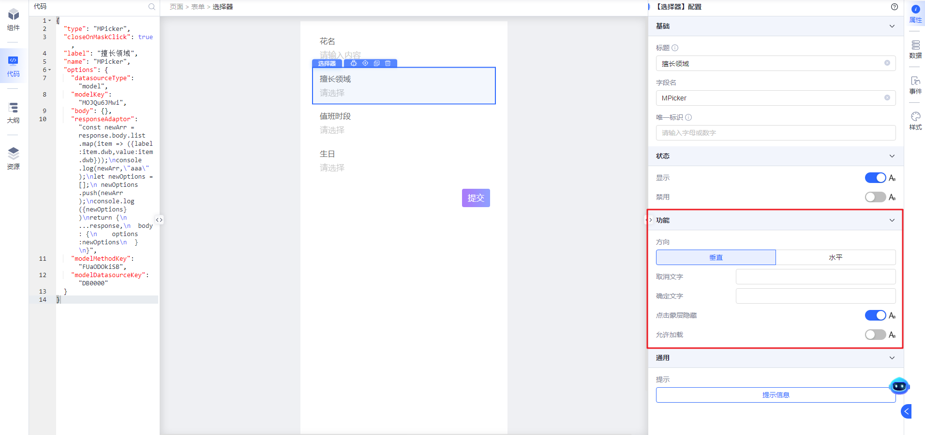
</td>
</tr>
<tr>
<td width="136" verticalAlign="top" colwidth="136" style="">取消文字</td>
<td width="150" verticalAlign="top" colwidth="150" style="">cancelText</td>
<td width="106" verticalAlign="top" colwidth="106" style="">
</td>
<td width="424" verticalAlign="top" colwidth="424" style="">默认展示取消</td>
</tr>
<tr>
<td width="136" verticalAlign="top" colwidth="136" style="">确定文字</td>
<td width="150" verticalAlign="top" colwidth="150" style="">confirmText</td>
<td width="106" verticalAlign="top" colwidth="106" style="">
</td>
<td width="424" verticalAlign="top" colwidth="424" style="">默认展示确定</td>
</tr>
<tr>
<td width="136" verticalAlign="top" colwidth="136" style="">点击蒙层隐藏</td>
<td width="150" verticalAlign="top" colwidth="150" style="">closeOnMaskClick</td>
<td width="106" verticalAlign="top" colwidth="106" style="">true</td>
<td width="424" verticalAlign="top" colwidth="424" style="">默认点击蒙层后隐藏选择框</td>
</tr>
<tr>
<td width="136" verticalAlign="top" colwidth="136" style="">允许加载</td>
<td width="150" verticalAlign="top" colwidth="150" style="">loading</td>
<td width="106" verticalAlign="top" colwidth="106" style="">false</td>
<td width="424" verticalAlign="top" colwidth="424" style="">默认不允许加载</td>
</tr>
<tr>
<td width="89" verticalAlign="top" colwidth="89" style="">通用</td>
<td width="136" verticalAlign="top" colwidth="136" style="">提示</td>
<td width="150" verticalAlign="top" colwidth="150" style="">tips</td>
<td width="106" verticalAlign="top" colwidth="106" style="">
</td>
<td width="424" verticalAlign="top" colwidth="424" style="">
1、标题提示是出现在标题或控件的右侧；
2、控件提示是出现在标题或控件的下方
</td>
<td width="195" verticalAlign="top" colwidth="195" style="">
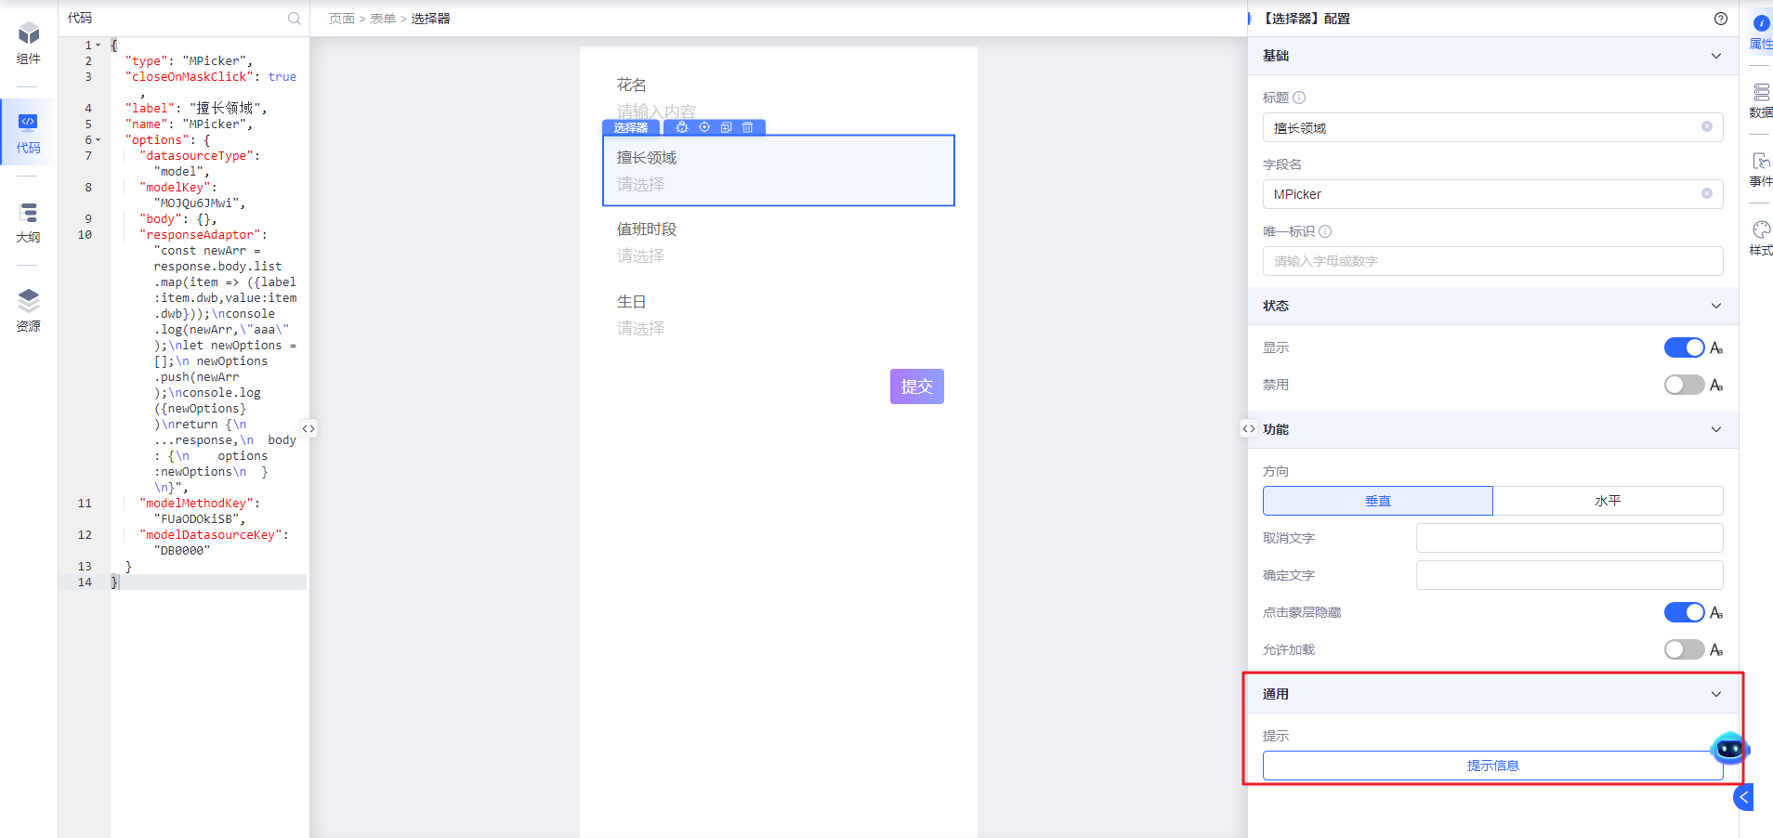
</td>
</tr>
</table>

属性和功能配置演示

**基础配置**

**标题**
控制选择器的标题展示。
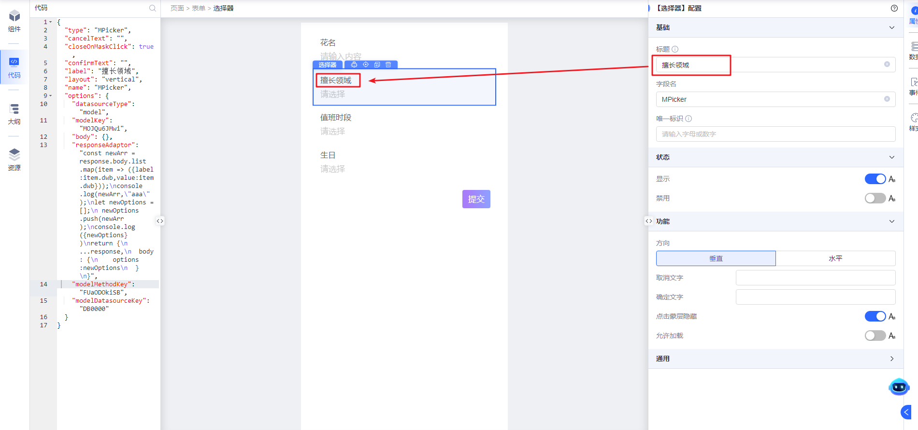

**字段名**
字段名是表单提交时该表单项的字段名。
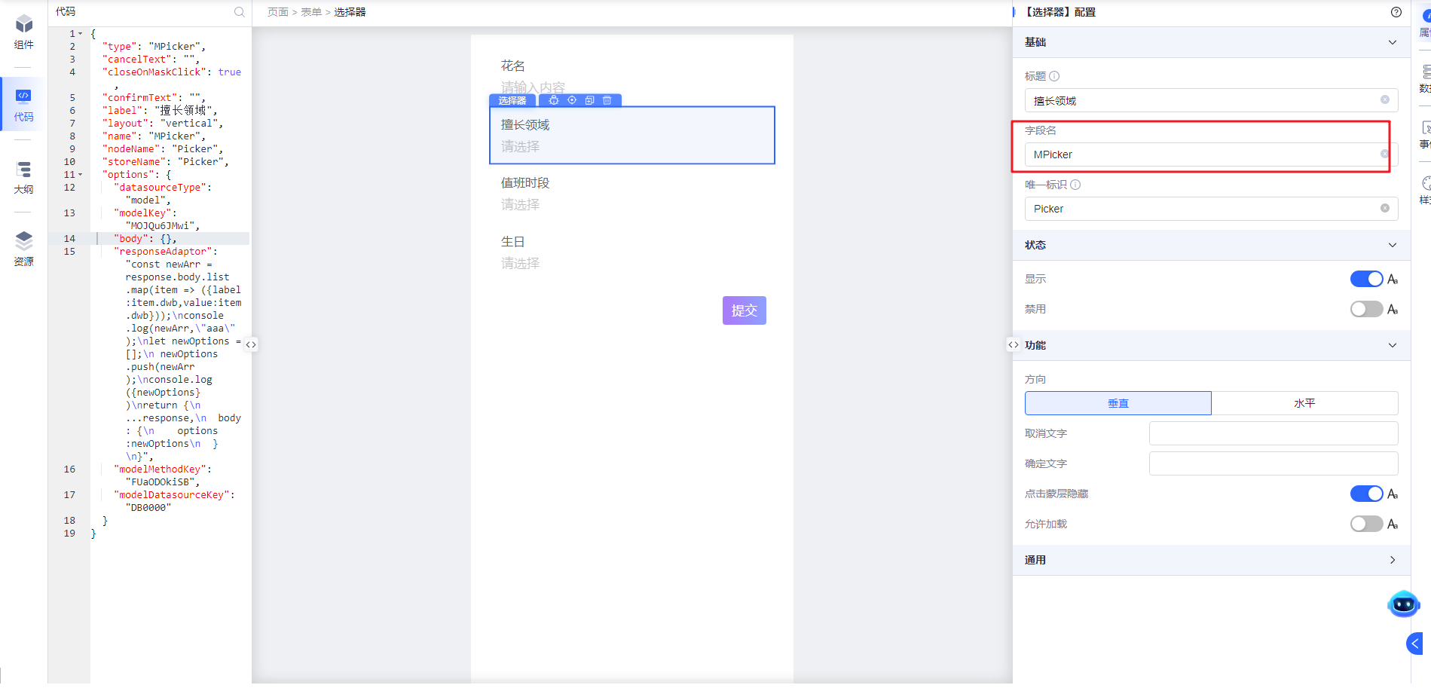

**唯一标识**
组件唯一标识，用于和其它组件做数据联动和动作交互。输入唯一标识会生成storeName，nodeName两个属性。
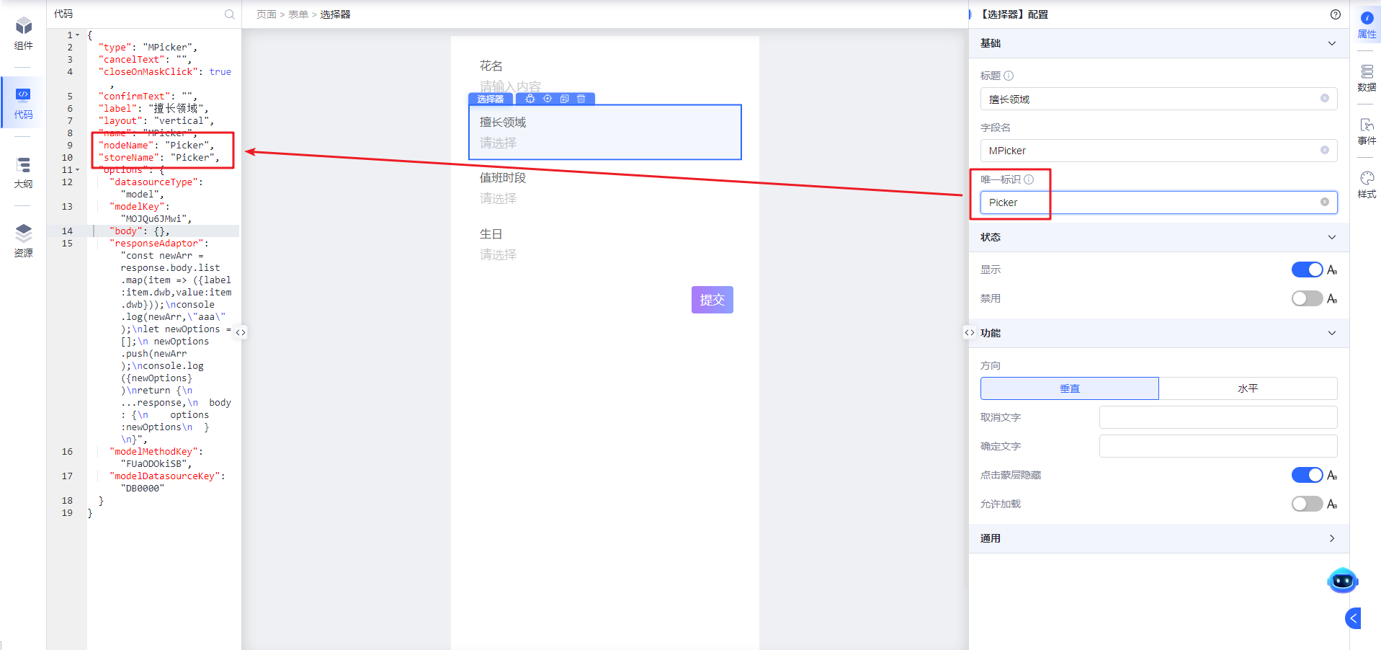

**状态**

**显示**
控制选择器组件的显隐，默认是显示状态。显隐状态可通过常量、表达式、资源点进行控制。
显示状态
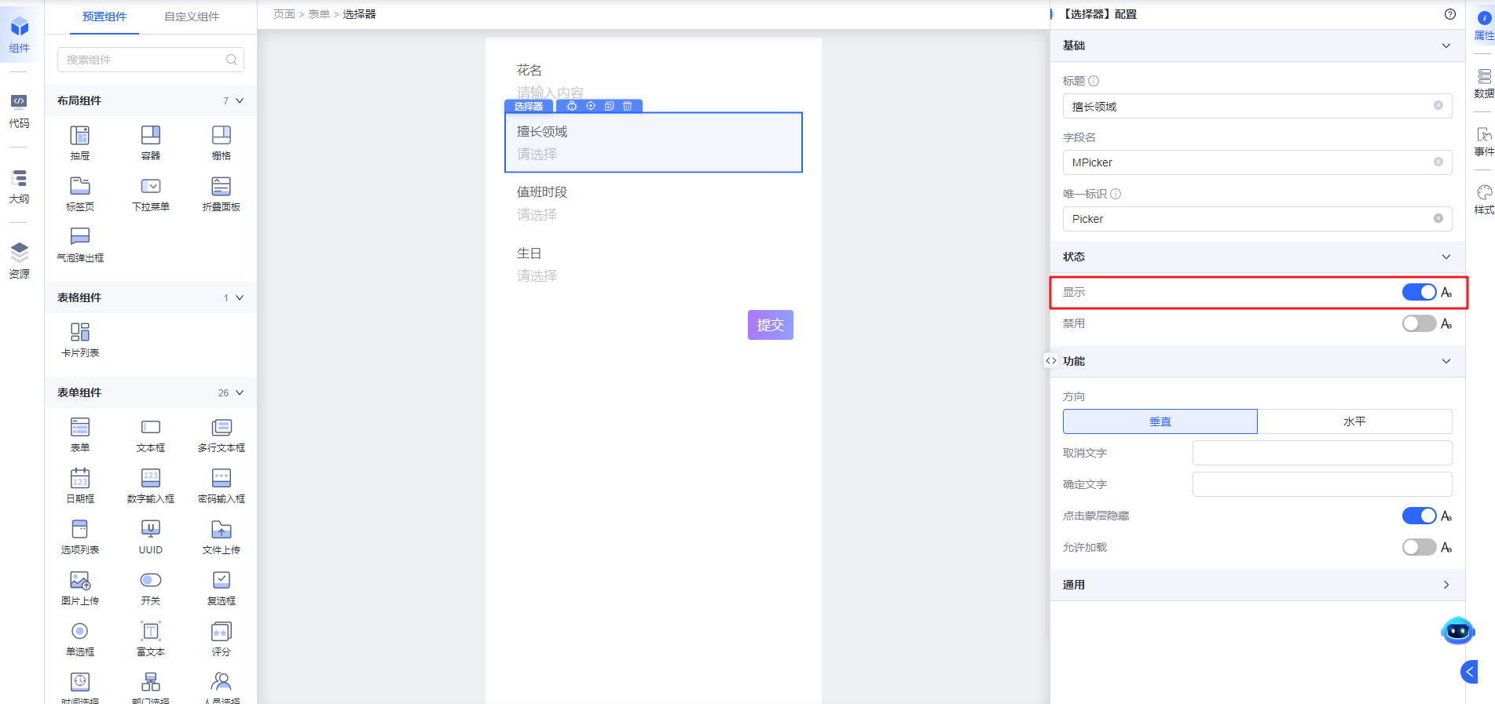
隐藏状态
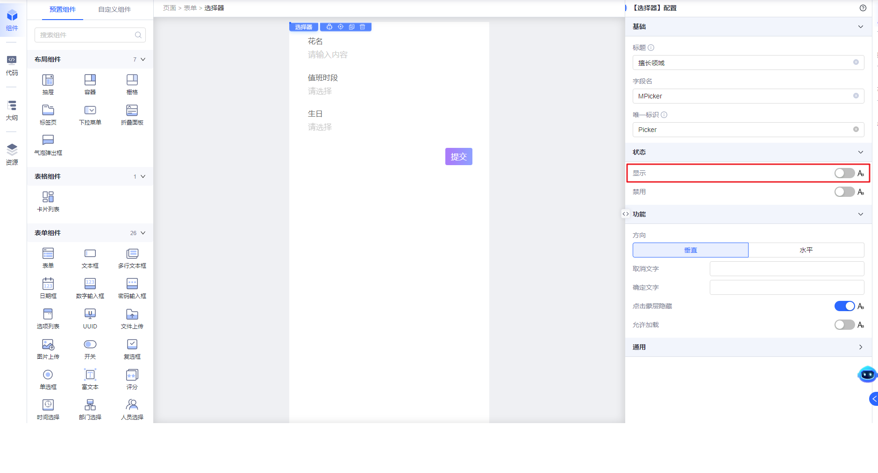

**禁用**
控制选择器组件是否可编辑，可支持常量值，表达式，资源点。
可编辑（非禁用）状态
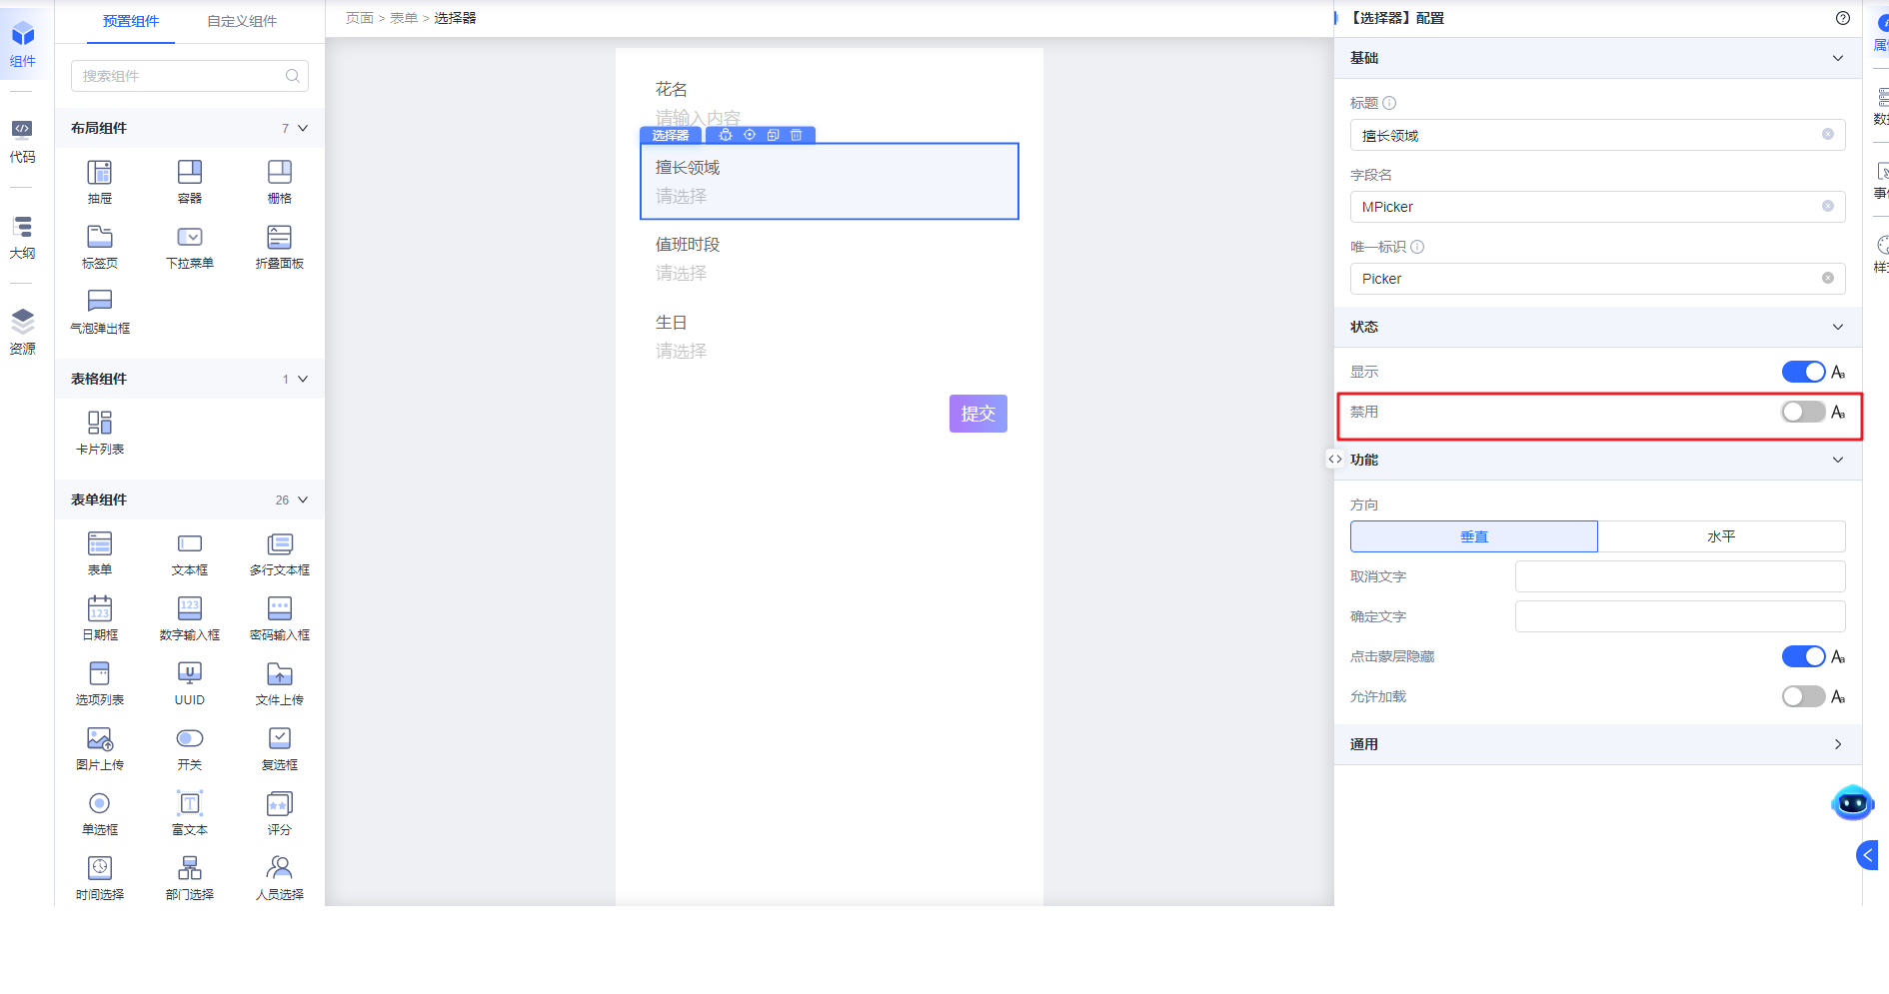
预览时点击可唤起选择器
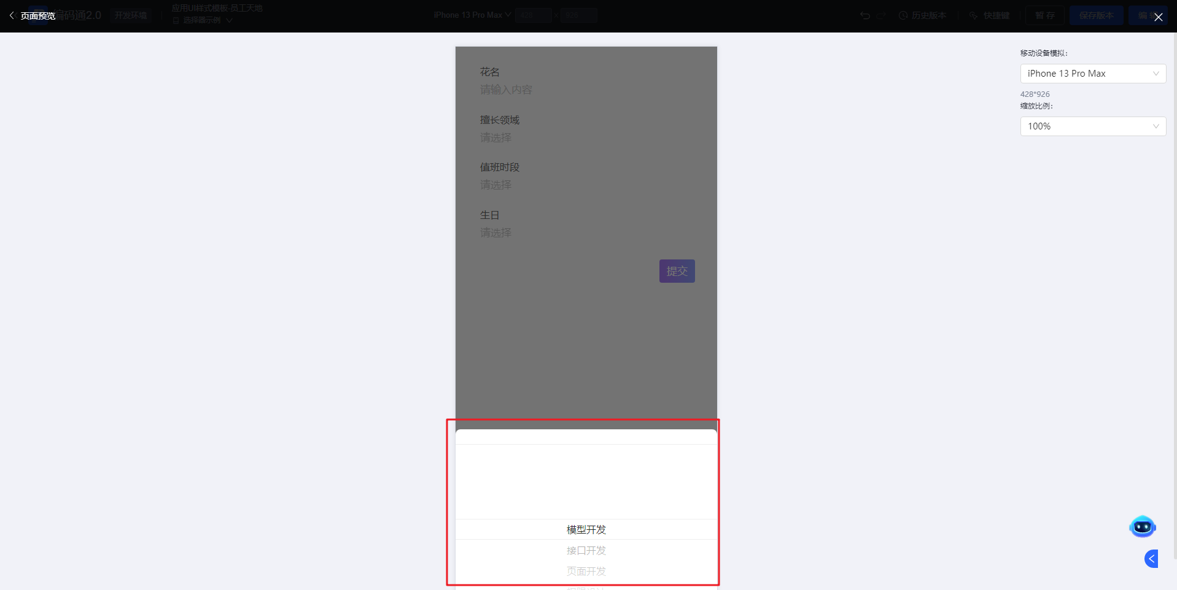
不可编辑（禁用）状态，开发态看起来和可编辑（非禁用）状态一样
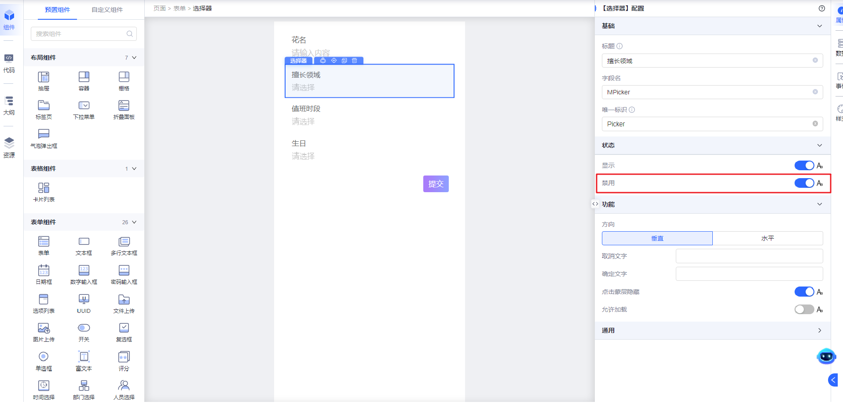
预览时点击无反应。
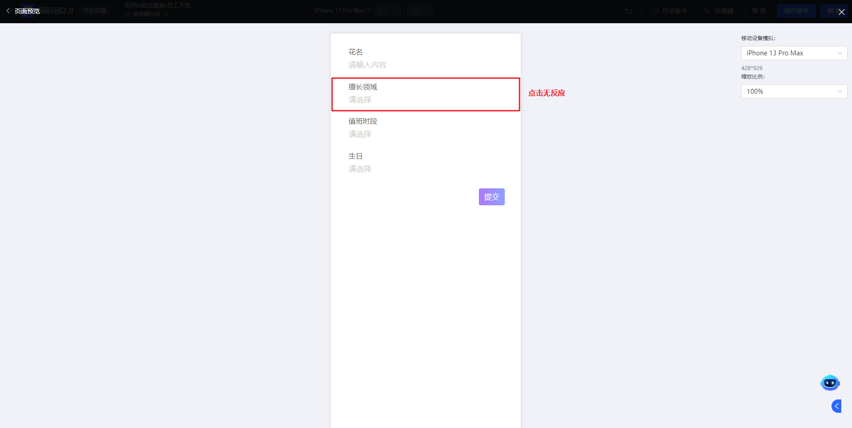

**功能**

**方向**
控制选择器的标题和输入框的布局方式。
垂直布局
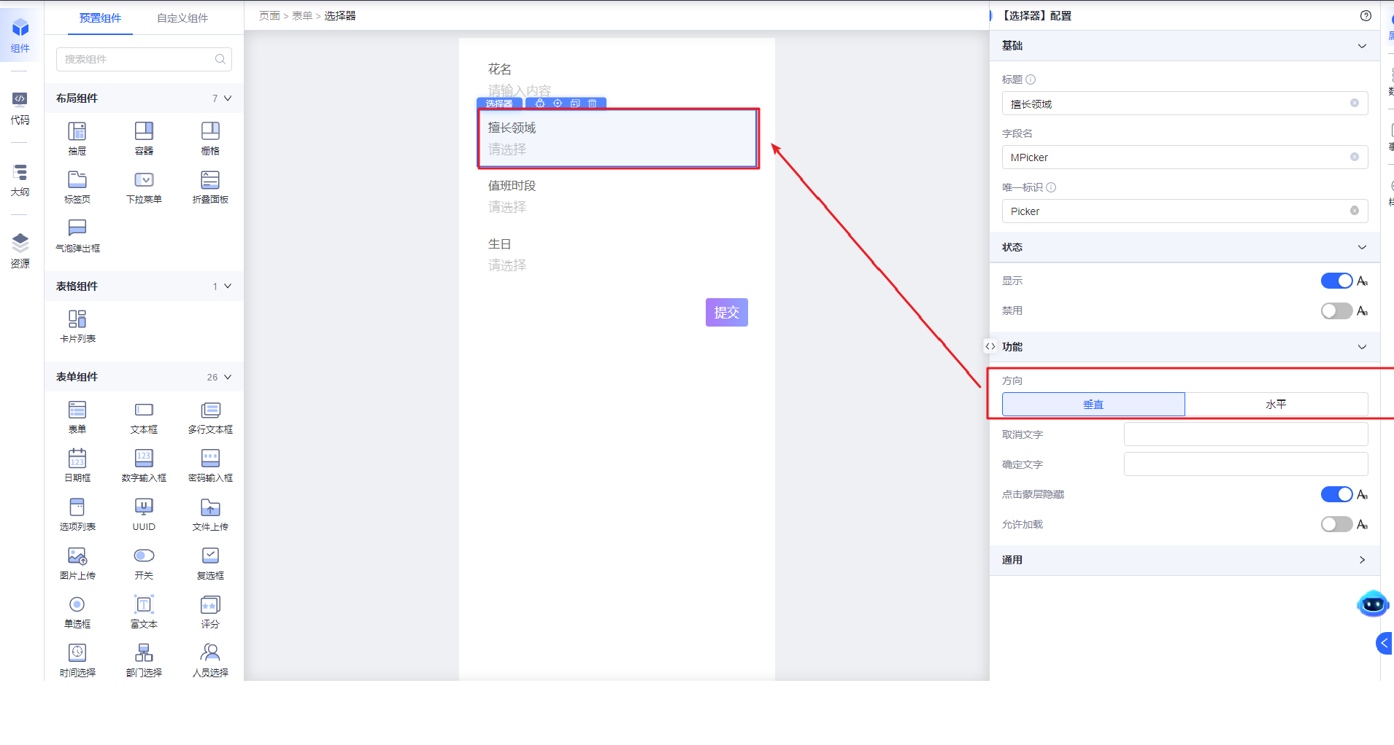
水平布局
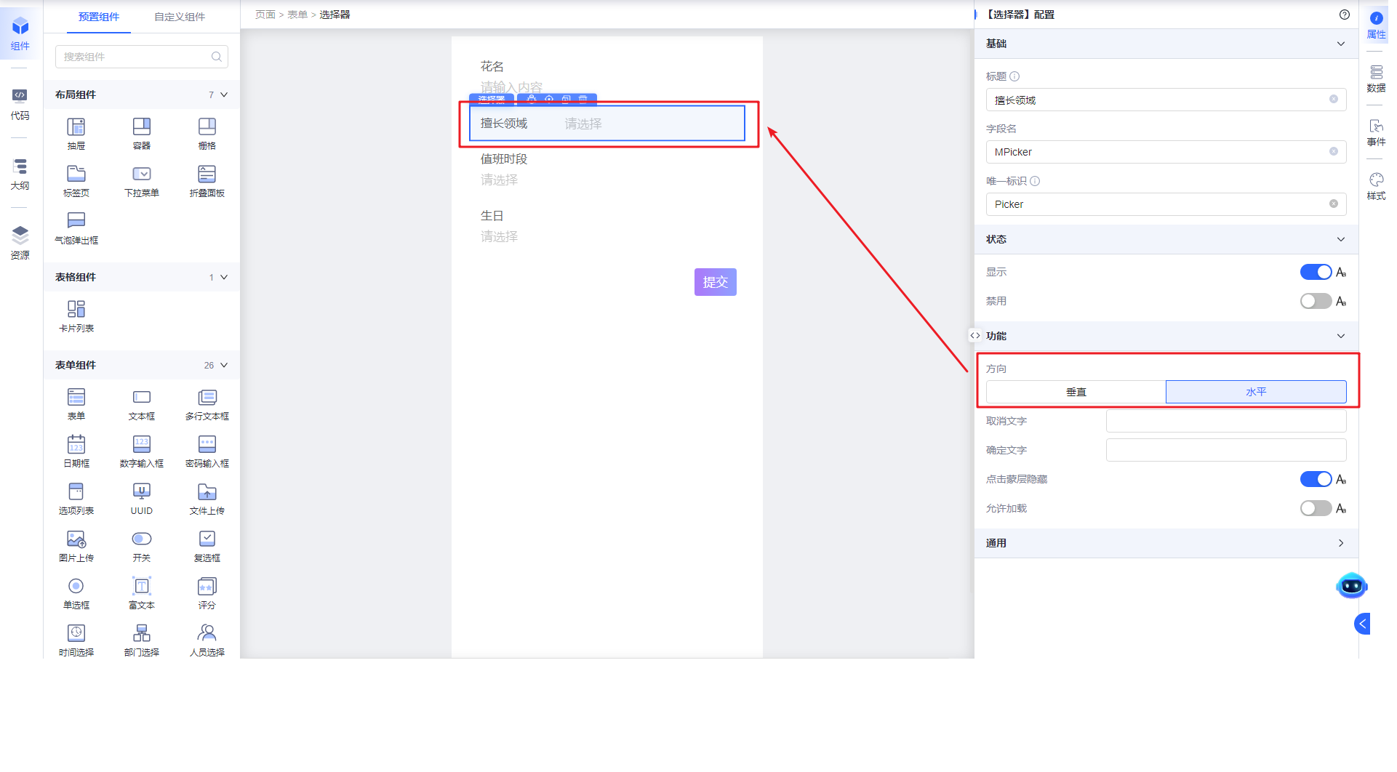

**取消文字**
配置选项选择器的取消功能文案。如未配置过，默认文案是“取消”。
配置
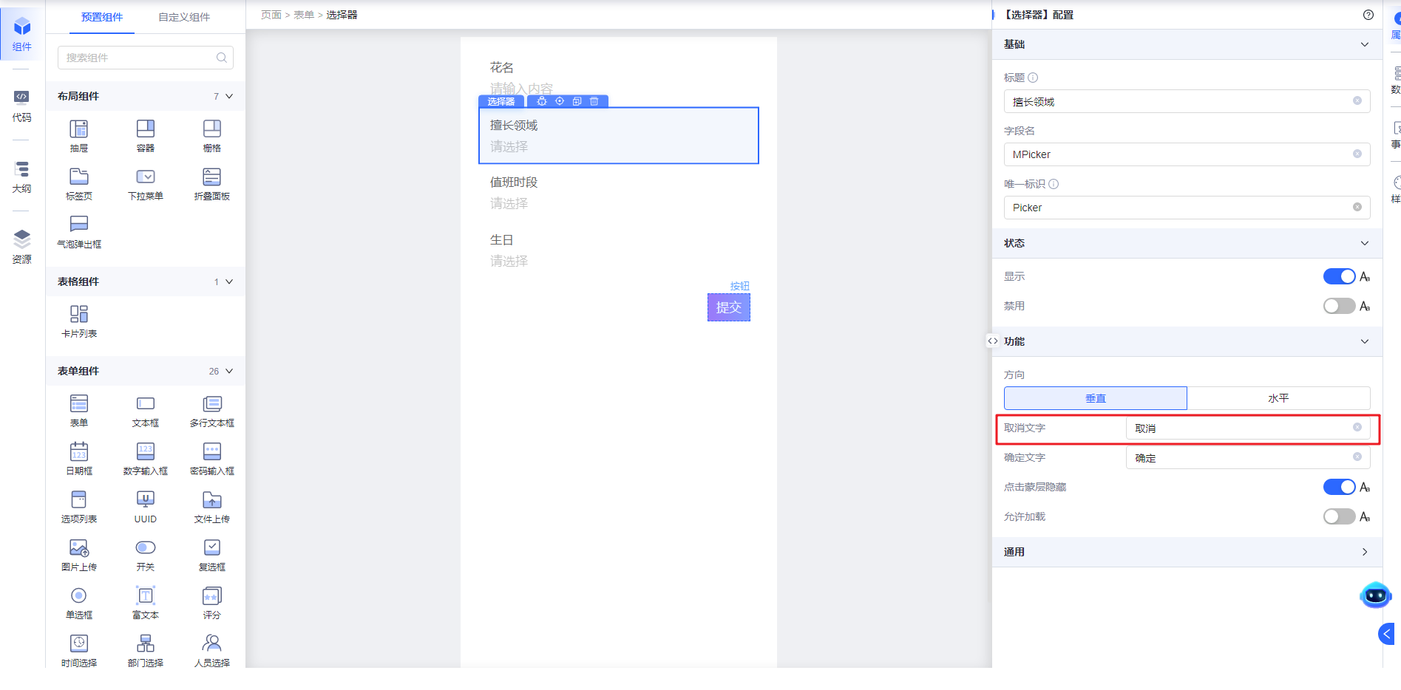
运行态展示效果
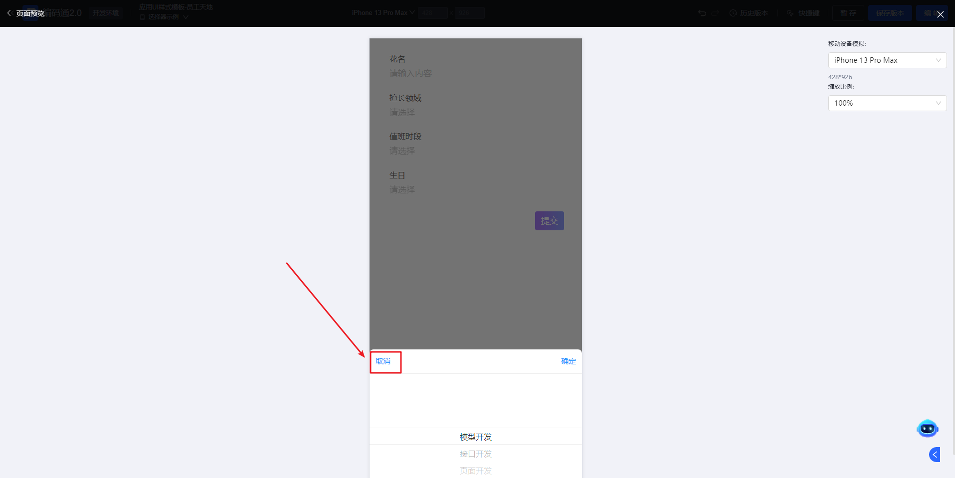

**确认文字**
配置选项选择器的确定功能文案。如未配置过，默认文案是“确定”。
配置
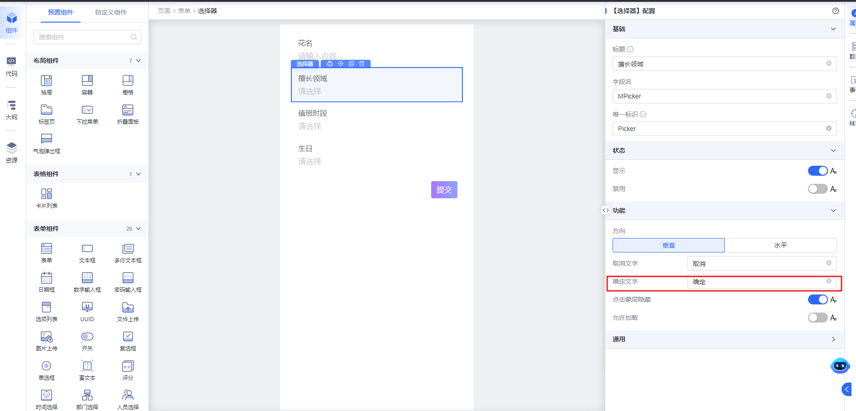
预览态展示效果
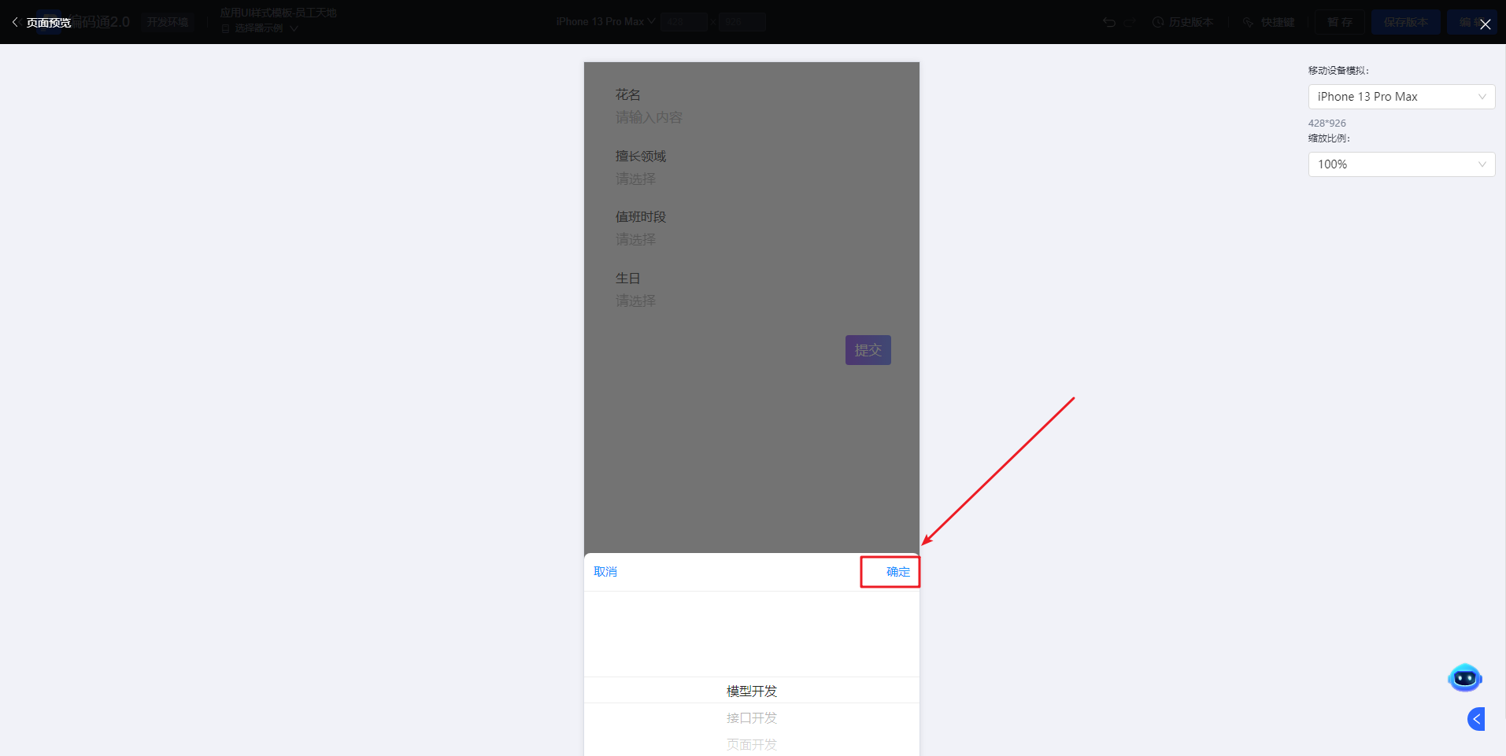

**点击蒙层隐藏**
控制选择器点击蒙层是否隐藏功能，默认是开启状态。
开启状态，点击蒙层隐藏选择框
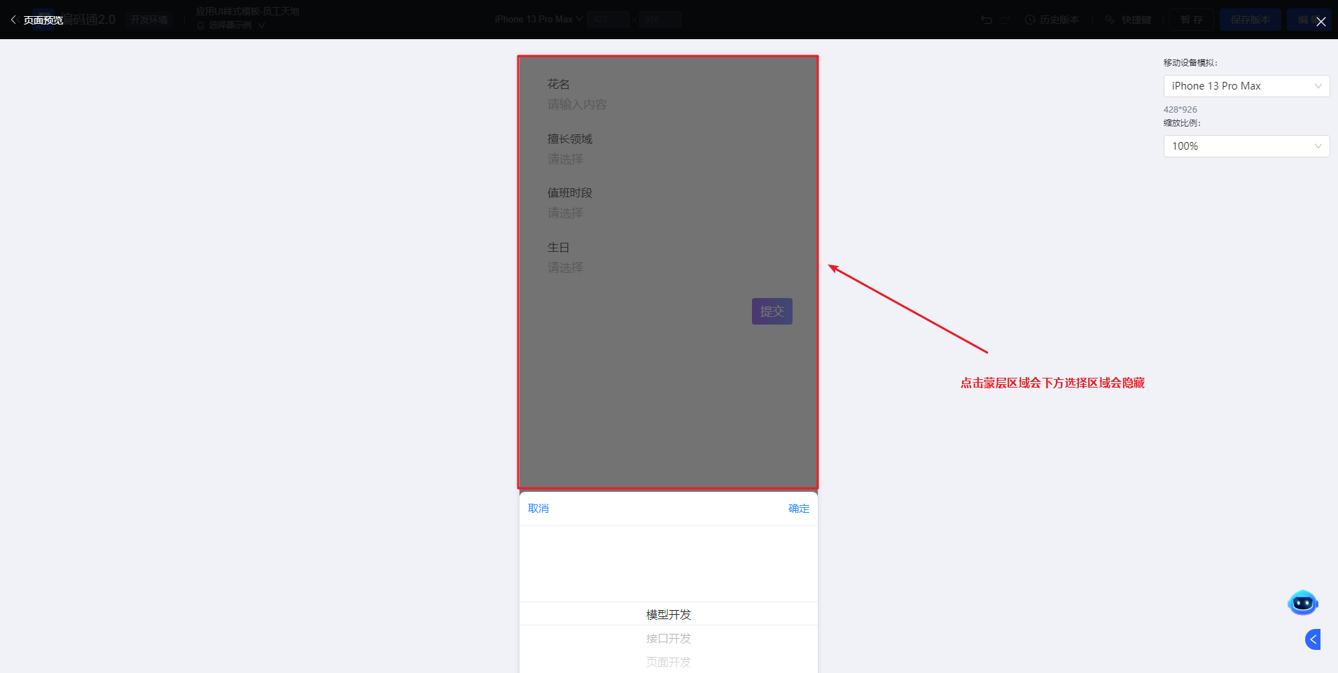
关闭状态，点击蒙层不隐藏选择框
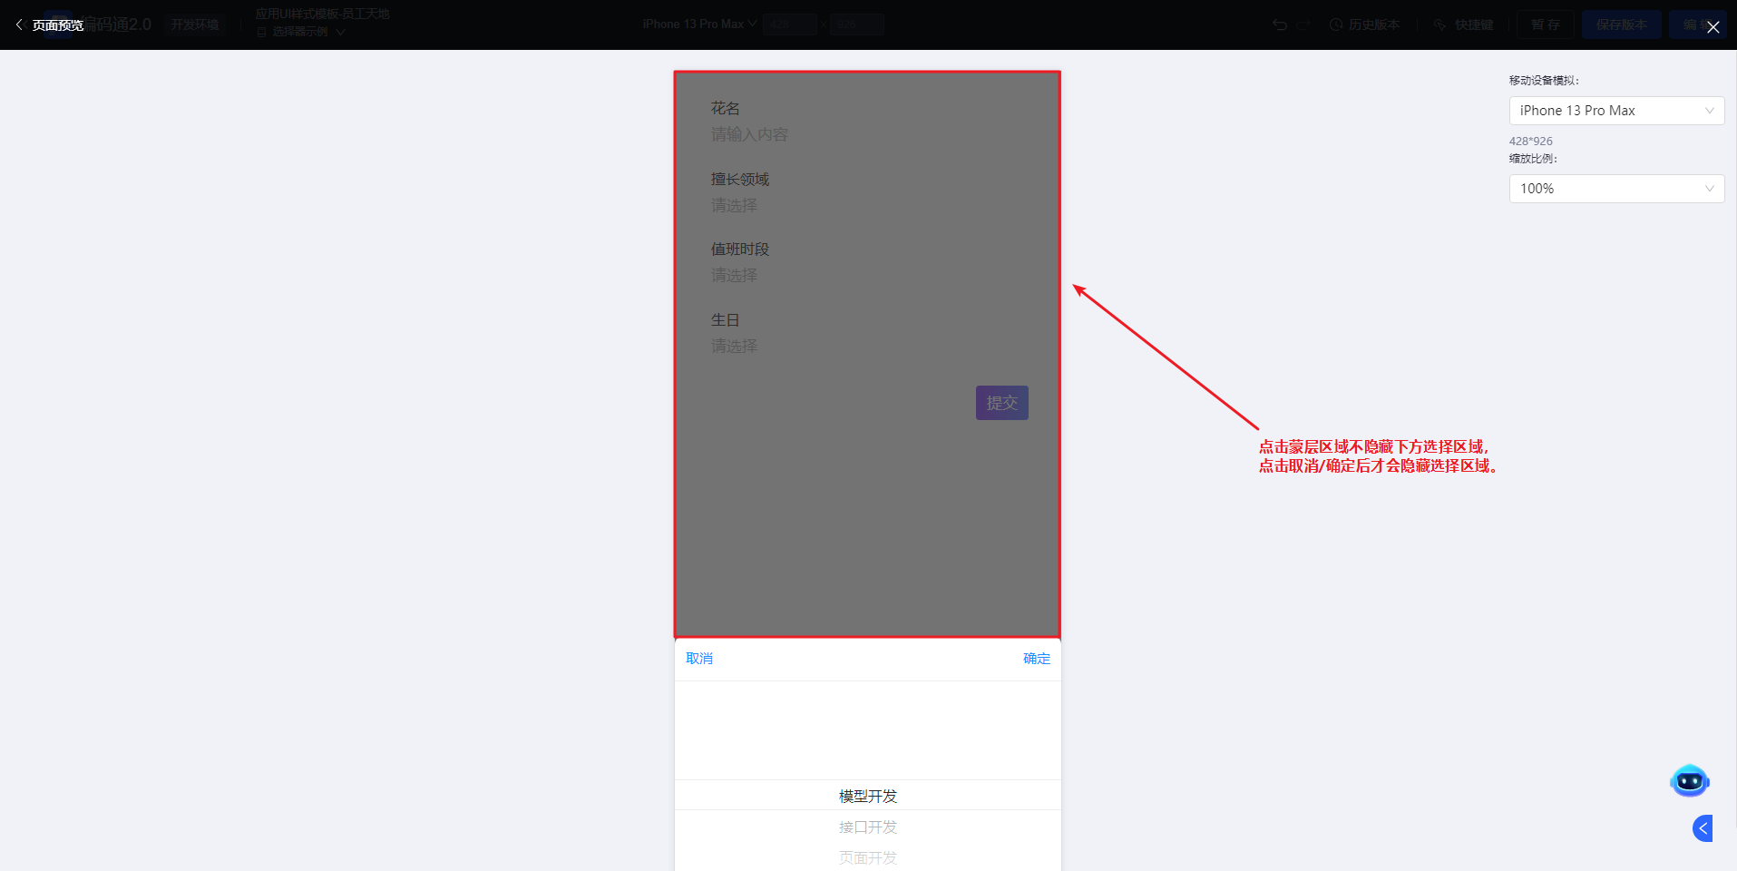

**允许加载**
控制下方选择区域是否有加载过程。
不允许加载，直接展示下方选择区域，没有加载过程。
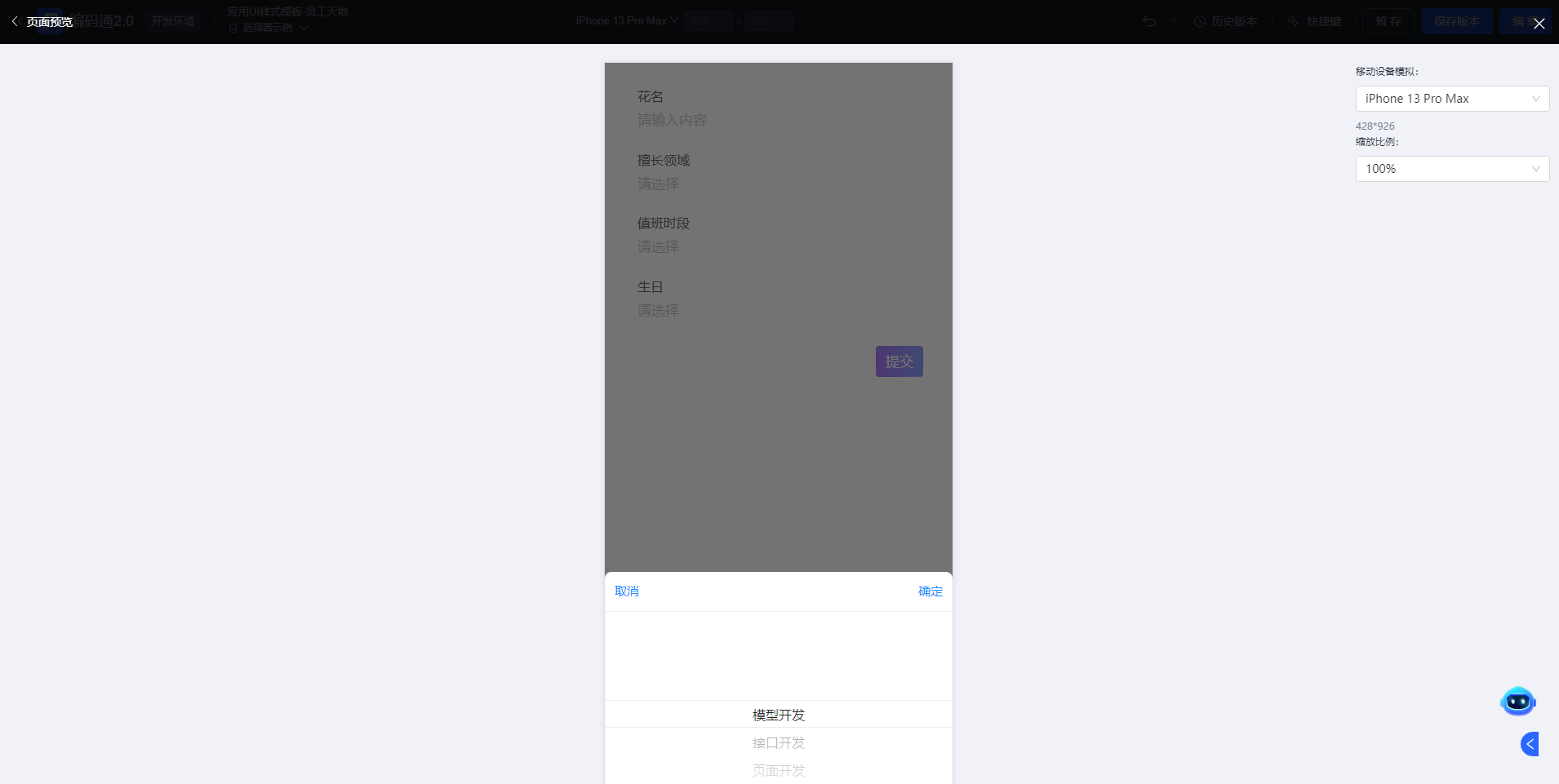
允许加载，有加载过程，适用数选择项数据量大或者接口反应慢。
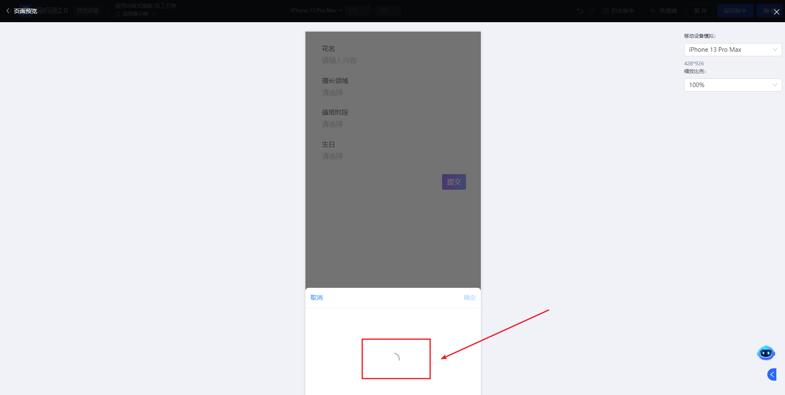

**通用**

**提示**
提示信息主要用于对选择器的一些填写说明。

**标题提示**
标题提示是出现在标题或控件的右侧。
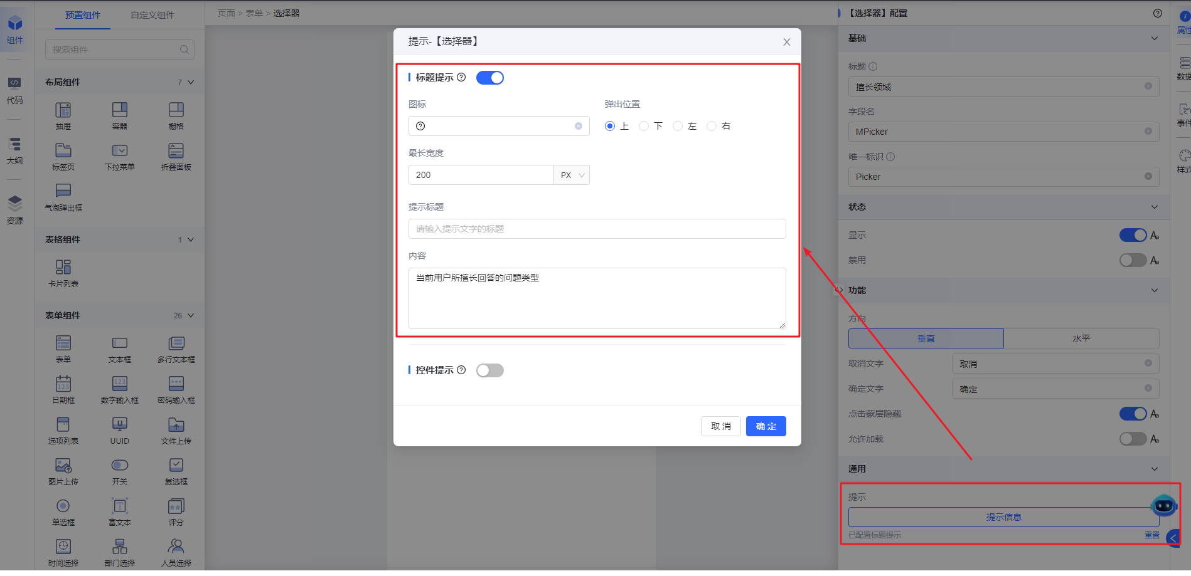
- 图标：主要提示图标的展示
- 弹出位置：设置提示在图标的相对位置
- 最长宽度：设置提示信息的宽度
- 提示标题：设置提示信息的标题
- 内容：提示信息的主要内容
展示效果
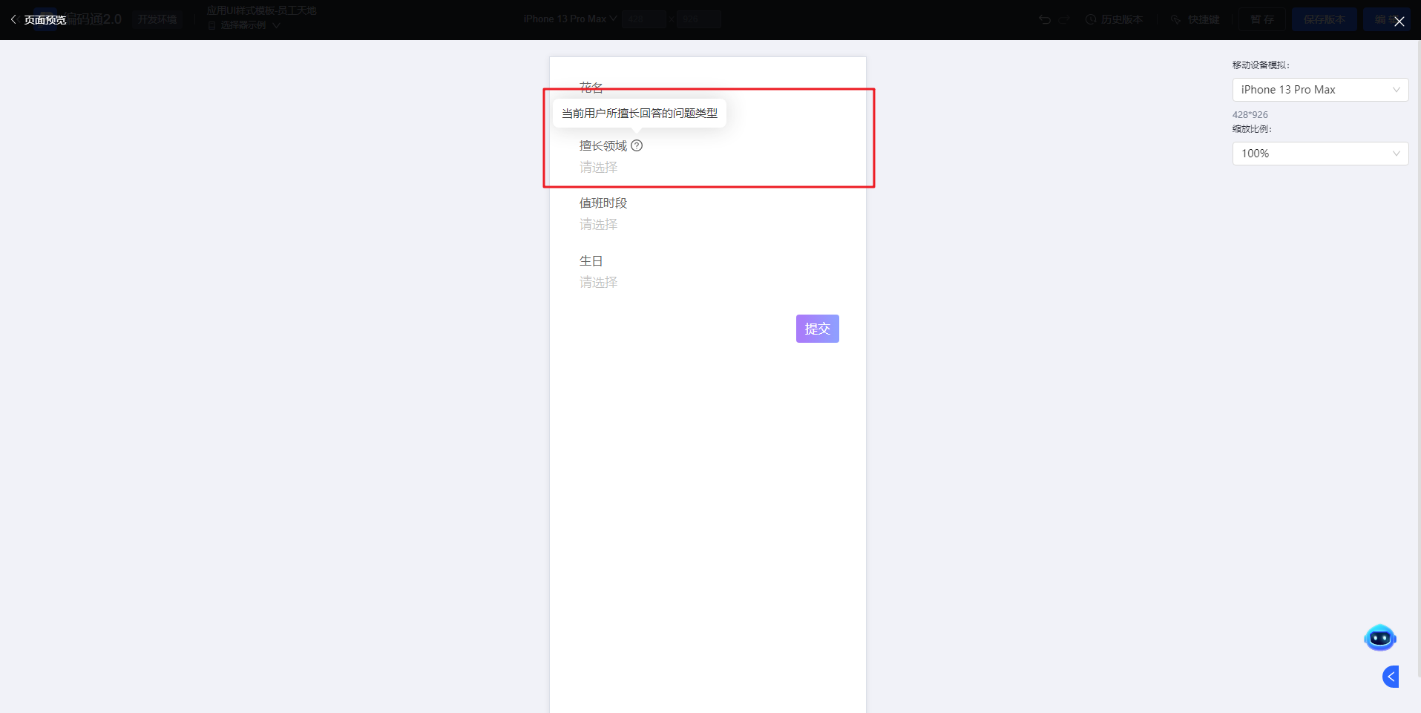

**控件提示**
控件提示是出现在标题或控件的下方
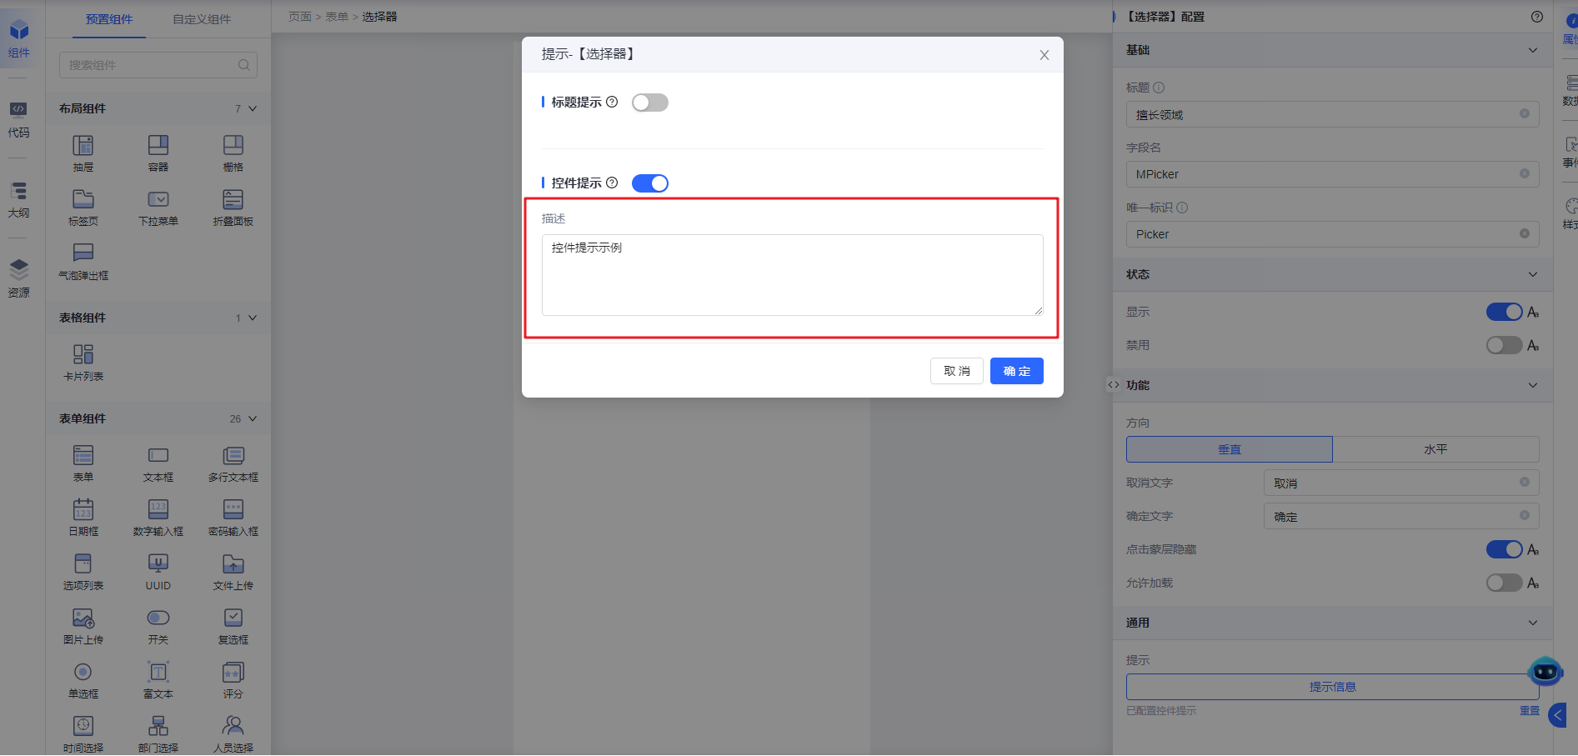
展示效果
