选项列表属性说明

前言
- 阅读本文前需要您对[数据域和数据链](https://xft-demo.cmburl.cn/XFTPRO-DOCS/concept/datafield)、[数据联动](./images/img_5192007448165685350.png)、[组件联动](./images/img_8202284858495357379.png)有最基本的了解。
- 该文章适用于组件的初中级入门学习，若希望了解组件高级配置，可阅读代码工程文档进行学习，前往[代码工程文档](https://xft-demo.cmburl.cn/XFTPRO-DOCS/mobile/form/select)。

选项列表属性面板
本章节针对选项列表的属性、数据、样式面板的可视化配置进行说明解释，如需了解组件高级配置，可跳转代码工程文档进行学习 [选项列表](https://xft-demo.cmburl.cn/XFTPRO-DOCS/mobile/form/select#%E6%95%B0%E6%8D%AEt)。
<table>
<tr>
<th width="89" verticalAlign="middle" colwidth="89" style="vertical-align:middle; vertical-align:middle; vertical-align:middle; vertical-align:middle; vertical-align:middle; vertical-align:middle; vertical-align:middle; vertical-align:middle; vertical-align:middle; vertical-align:middle; vertical-align:middle; vertical-align:middle; vertical-align:middle; vertical-align:middle; vertical-align:middle; vertical-align:middle; vertical-align:middle; vertical-align:middle; vertical-align:middle; vertical-align:middle; vertical-align:middle; vertical-align:middle; vertical-align:middle; vertical-align:middle; vertical-align:middle; vertical-align:middle; vertical-align:middle; vertical-align:middle; vertical-align:middle; vertical-align:middle; vertical-align:middle; vertical-align:middle; vertical-align:middle; vertical-align:middle; vertical-align:middle; vertical-align:middle; vertical-align:middle; vertical-align:middle; vertical-align:middle; vertical-align:middle; vertical-align:middle; vertical-align:middle; vertical-align:middle; vertical-align:middle; vertical-align:middle; vertical-align:middle; vertical-align:middle; vertical-align:middle; vertical-align:middle; vertical-align:middle; vertical-align:middle; vertical-align:middle; vertical-align:middle; vertical-align:middle; vertical-align:middle; vertical-align:middle; vertical-align:middle; vertical-align:middle; vertical-align:middle; vertical-align:middle; vertical-align:middle; vertical-align:middle; vertical-align:middle;">分类</th>
<th width="136" verticalAlign="middle" colwidth="136" style="vertical-align:middle; vertical-align:middle; vertical-align:middle; vertical-align:middle; vertical-align:middle; vertical-align:middle; vertical-align:middle; vertical-align:middle; vertical-align:middle; vertical-align:middle; vertical-align:middle; vertical-align:middle; vertical-align:middle; vertical-align:middle; vertical-align:middle; vertical-align:middle; vertical-align:middle; vertical-align:middle; vertical-align:middle; vertical-align:middle; vertical-align:middle; vertical-align:middle; vertical-align:middle; vertical-align:middle; vertical-align:middle; vertical-align:middle; vertical-align:middle; vertical-align:middle; vertical-align:middle; vertical-align:middle; vertical-align:middle; vertical-align:middle; vertical-align:middle; vertical-align:middle; vertical-align:middle; vertical-align:middle; vertical-align:middle; vertical-align:middle; vertical-align:middle; vertical-align:middle; vertical-align:middle; vertical-align:middle; vertical-align:middle; vertical-align:middle; vertical-align:middle; vertical-align:middle; vertical-align:middle; vertical-align:middle; vertical-align:middle; vertical-align:middle; vertical-align:middle; vertical-align:middle; vertical-align:middle; vertical-align:middle; vertical-align:middle; vertical-align:middle; vertical-align:middle; vertical-align:middle; vertical-align:middle; vertical-align:middle; vertical-align:middle; vertical-align:middle; vertical-align:middle; margin:0px; padding:0.5rem 1rem; font-weight:600;">
**显示名称**
</th>
<th width="150" verticalAlign="middle" colwidth="150" style="vertical-align:middle; vertical-align:middle; vertical-align:middle; vertical-align:middle; vertical-align:middle; vertical-align:middle; vertical-align:middle; vertical-align:middle; vertical-align:middle; vertical-align:middle; vertical-align:middle; vertical-align:middle; vertical-align:middle; vertical-align:middle; vertical-align:middle; vertical-align:middle; vertical-align:middle; vertical-align:middle; vertical-align:middle; vertical-align:middle; vertical-align:middle; vertical-align:middle; vertical-align:middle; vertical-align:middle; vertical-align:middle; vertical-align:middle; vertical-align:middle; vertical-align:middle; vertical-align:middle; vertical-align:middle; vertical-align:middle; vertical-align:middle; vertical-align:middle; vertical-align:middle; vertical-align:middle; vertical-align:middle; vertical-align:middle; vertical-align:middle; vertical-align:middle; vertical-align:middle; vertical-align:middle; vertical-align:middle; vertical-align:middle; vertical-align:middle; vertical-align:middle; vertical-align:middle; vertical-align:middle; vertical-align:middle; vertical-align:middle; vertical-align:middle; vertical-align:middle; vertical-align:middle; vertical-align:middle; vertical-align:middle; vertical-align:middle; vertical-align:middle; vertical-align:middle; vertical-align:middle; vertical-align:middle; vertical-align:middle; vertical-align:middle; vertical-align:middle; vertical-align:middle; margin:0px; padding:0.5rem 1rem; font-weight:600;">
**属性**
</th>
<th width="106" verticalAlign="middle" colwidth="106" style="vertical-align:middle; vertical-align:middle; vertical-align:middle; vertical-align:middle; vertical-align:middle; vertical-align:middle; vertical-align:middle; vertical-align:middle; vertical-align:middle; vertical-align:middle; vertical-align:middle; vertical-align:middle; vertical-align:middle; vertical-align:middle; vertical-align:middle; vertical-align:middle; vertical-align:middle; vertical-align:middle; vertical-align:middle; vertical-align:middle; vertical-align:middle; vertical-align:middle; vertical-align:middle; vertical-align:middle; vertical-align:middle; vertical-align:middle; vertical-align:middle; vertical-align:middle; vertical-align:middle; vertical-align:middle; vertical-align:middle; vertical-align:middle; vertical-align:middle; vertical-align:middle; vertical-align:middle; vertical-align:middle; vertical-align:middle; vertical-align:middle; vertical-align:middle; vertical-align:middle; vertical-align:middle; vertical-align:middle; vertical-align:middle; vertical-align:middle; vertical-align:middle; vertical-align:middle; vertical-align:middle; vertical-align:middle; vertical-align:middle; vertical-align:middle; vertical-align:middle; vertical-align:middle; vertical-align:middle; vertical-align:middle; vertical-align:middle; vertical-align:middle; vertical-align:middle; vertical-align:middle; vertical-align:middle; vertical-align:middle; vertical-align:middle; vertical-align:middle; vertical-align:middle; margin:0px; padding:0.5rem 1rem; font-weight:600;">
**默认值**
</th>
<th width="424" verticalAlign="middle" colwidth="424" style="vertical-align:middle; vertical-align:middle; vertical-align:middle; vertical-align:middle; vertical-align:middle; vertical-align:middle; vertical-align:middle; vertical-align:middle; vertical-align:middle; vertical-align:middle; vertical-align:middle; vertical-align:middle; vertical-align:middle; vertical-align:middle; vertical-align:middle; vertical-align:middle; vertical-align:middle; vertical-align:middle; vertical-align:middle; vertical-align:middle; vertical-align:middle; vertical-align:middle; vertical-align:middle; vertical-align:middle; vertical-align:middle; vertical-align:middle; vertical-align:middle; vertical-align:middle; vertical-align:middle; vertical-align:middle; vertical-align:middle; vertical-align:middle; vertical-align:middle; vertical-align:middle; vertical-align:middle; vertical-align:middle; vertical-align:middle; vertical-align:middle; vertical-align:middle; vertical-align:middle; vertical-align:middle; vertical-align:middle; vertical-align:middle; vertical-align:middle; vertical-align:middle; vertical-align:middle; vertical-align:middle; vertical-align:middle; vertical-align:middle; vertical-align:middle; vertical-align:middle; vertical-align:middle; vertical-align:middle; vertical-align:middle; vertical-align:middle; vertical-align:middle; vertical-align:middle; vertical-align:middle; vertical-align:middle; vertical-align:middle; vertical-align:middle; vertical-align:middle; vertical-align:middle; margin:0px; padding:0.5rem 1rem; font-weight:600;">
**描述**
</th>
<th width="195" verticalAlign="top" colwidth="195" style="">图片示例</th>
</tr>
<tr>
<td width="89" verticalAlign="middle" rowspan="4" colwidth="89" style="vertical-align:middle; vertical-align:middle; vertical-align:middle; vertical-align:middle; vertical-align:middle; vertical-align:middle; vertical-align:middle; vertical-align:middle; vertical-align:middle; vertical-align:middle; vertical-align:middle; vertical-align:middle; vertical-align:middle; vertical-align:middle; vertical-align:middle; vertical-align:middle; vertical-align:middle; vertical-align:middle; vertical-align:middle; vertical-align:middle; vertical-align:middle; vertical-align:middle; vertical-align:middle; vertical-align:middle; vertical-align:middle; vertical-align:middle; vertical-align:middle; vertical-align:middle; vertical-align:middle; vertical-align:middle; vertical-align:middle; vertical-align:middle; vertical-align:middle; vertical-align:middle; vertical-align:middle; vertical-align:middle; vertical-align:middle; vertical-align:middle; vertical-align:middle; vertical-align:middle; vertical-align:middle; vertical-align:middle; vertical-align:middle; vertical-align:middle; vertical-align:middle; vertical-align:middle; vertical-align:middle; vertical-align:middle; vertical-align:middle; vertical-align:middle; vertical-align:middle; vertical-align:middle; vertical-align:middle; vertical-align:middle; vertical-align:middle; vertical-align:middle; vertical-align:middle; vertical-align:middle; vertical-align:middle; vertical-align:middle; vertical-align:middle; vertical-align:middle; vertical-align:middle;">基础配置</td>
<td width="136" verticalAlign="middle" colwidth="136" style="vertical-align:middle; vertical-align:middle; vertical-align:middle; vertical-align:middle; vertical-align:middle; vertical-align:middle; vertical-align:middle; vertical-align:middle; vertical-align:middle; vertical-align:middle; vertical-align:middle; vertical-align:middle; vertical-align:middle; vertical-align:middle; vertical-align:middle; vertical-align:middle; vertical-align:middle; vertical-align:middle; vertical-align:middle; vertical-align:middle; vertical-align:middle; vertical-align:middle; vertical-align:middle; vertical-align:middle; vertical-align:middle; vertical-align:middle; vertical-align:middle; vertical-align:middle; vertical-align:middle; vertical-align:middle; vertical-align:middle; vertical-align:middle; vertical-align:middle; vertical-align:middle; vertical-align:middle; vertical-align:middle; vertical-align:middle; vertical-align:middle; vertical-align:middle; vertical-align:middle; vertical-align:middle; vertical-align:middle; vertical-align:middle; vertical-align:middle; vertical-align:middle; vertical-align:middle; vertical-align:middle; vertical-align:middle; vertical-align:middle; vertical-align:middle; vertical-align:middle; vertical-align:middle; vertical-align:middle; vertical-align:middle; vertical-align:middle; vertical-align:middle; vertical-align:middle; vertical-align:middle; vertical-align:middle; vertical-align:middle; vertical-align:middle; vertical-align:middle; vertical-align:middle; margin:0px; padding:0.5rem 1rem;">标题</td>
<td width="150" verticalAlign="middle" colwidth="150" style="vertical-align:middle; vertical-align:middle; vertical-align:middle; vertical-align:middle; vertical-align:middle; vertical-align:middle; vertical-align:middle; vertical-align:middle; vertical-align:middle; vertical-align:middle; vertical-align:middle; vertical-align:middle; vertical-align:middle; vertical-align:middle; vertical-align:middle; vertical-align:middle; vertical-align:middle; vertical-align:middle; vertical-align:middle; vertical-align:middle; vertical-align:middle; vertical-align:middle; vertical-align:middle; vertical-align:middle; vertical-align:middle; vertical-align:middle; vertical-align:middle; vertical-align:middle; vertical-align:middle; vertical-align:middle; vertical-align:middle; vertical-align:middle; vertical-align:middle; vertical-align:middle; vertical-align:middle; vertical-align:middle; vertical-align:middle; vertical-align:middle; vertical-align:middle; vertical-align:middle; vertical-align:middle; vertical-align:middle; vertical-align:middle; vertical-align:middle; vertical-align:middle; vertical-align:middle; vertical-align:middle; vertical-align:middle; vertical-align:middle; vertical-align:middle; vertical-align:middle; vertical-align:middle; vertical-align:middle; vertical-align:middle; vertical-align:middle; vertical-align:middle; vertical-align:middle; vertical-align:middle; vertical-align:middle; vertical-align:middle; vertical-align:middle; vertical-align:middle; vertical-align:middle; margin:0px; padding:0.5rem 1rem;">label</td>
<td width="106" verticalAlign="middle" colwidth="106" style="vertical-align:middle; vertical-align:middle; vertical-align:middle; vertical-align:middle; vertical-align:middle; vertical-align:middle; vertical-align:middle; vertical-align:middle; vertical-align:middle; vertical-align:middle; vertical-align:middle; vertical-align:middle; vertical-align:middle; vertical-align:middle; vertical-align:middle; vertical-align:middle; vertical-align:middle; vertical-align:middle; vertical-align:middle; vertical-align:middle; vertical-align:middle; vertical-align:middle; vertical-align:middle; vertical-align:middle; vertical-align:middle; vertical-align:middle; vertical-align:middle; vertical-align:middle; vertical-align:middle; vertical-align:middle; vertical-align:middle; vertical-align:middle; vertical-align:middle; vertical-align:middle; vertical-align:middle; vertical-align:middle; vertical-align:middle; vertical-align:middle; vertical-align:middle; vertical-align:middle; vertical-align:middle; vertical-align:middle; vertical-align:middle; vertical-align:middle; vertical-align:middle; vertical-align:middle; vertical-align:middle; vertical-align:middle; vertical-align:middle; vertical-align:middle; vertical-align:middle; vertical-align:middle; vertical-align:middle; vertical-align:middle; vertical-align:middle; vertical-align:middle; vertical-align:middle; vertical-align:middle; vertical-align:middle; vertical-align:middle; vertical-align:middle; vertical-align:middle; vertical-align:middle;
margin:0px; padding:0.5rem 1rem;">
</td>
<td width="424" verticalAlign="middle" colwidth="424" style="vertical-align:middle; vertical-align:middle; vertical-align:middle; vertical-align:middle; vertical-align:middle; vertical-align:middle; vertical-align:middle; vertical-align:middle; vertical-align:middle; vertical-align:middle; vertical-align:middle; vertical-align:middle; vertical-align:middle; vertical-align:middle; vertical-align:middle; vertical-align:middle; vertical-align:middle; vertical-align:middle; vertical-align:middle; vertical-align:middle; vertical-align:middle; vertical-align:middle; vertical-align:middle; vertical-align:middle; vertical-align:middle; vertical-align:middle; vertical-align:middle; vertical-align:middle; vertical-align:middle; vertical-align:middle; vertical-align:middle; vertical-align:middle; vertical-align:middle; vertical-align:middle; vertical-align:middle; vertical-align:middle; vertical-align:middle; vertical-align:middle; vertical-align:middle; vertical-align:middle; vertical-align:middle; vertical-align:middle; vertical-align:middle; vertical-align:middle; vertical-align:middle; vertical-align:middle; vertical-align:middle; vertical-align:middle; vertical-align:middle; vertical-align:middle; vertical-align:middle; vertical-align:middle; vertical-align:middle; vertical-align:middle; vertical-align:middle; vertical-align:middle; vertical-align:middle; vertical-align:middle; vertical-align:middle; vertical-align:middle; vertical-align:middle; vertical-align:middle; vertical-align:middle; margin:0px; padding:0.5rem 1rem;">字段标题</td>
<td width="195" verticalAlign="middle" rowspan="4" colwidth="195" style="vertical-align:middle; vertical-align:middle; vertical-align:middle; vertical-align:middle; vertical-align:middle; vertical-align:middle; vertical-align:middle; vertical-align:middle; vertical-align:middle; vertical-align:middle; vertical-align:middle; vertical-align:middle; vertical-align:middle; vertical-align:middle; vertical-align:middle; vertical-align:middle; vertical-align:middle; vertical-align:middle; vertical-align:middle; vertical-align:middle; vertical-align:middle; vertical-align:middle; vertical-align:middle; vertical-align:middle; vertical-align:middle; vertical-align:middle; vertical-align:middle; vertical-align:middle; vertical-align:middle; vertical-align:middle; vertical-align:middle; vertical-align:middle; vertical-align:middle;">
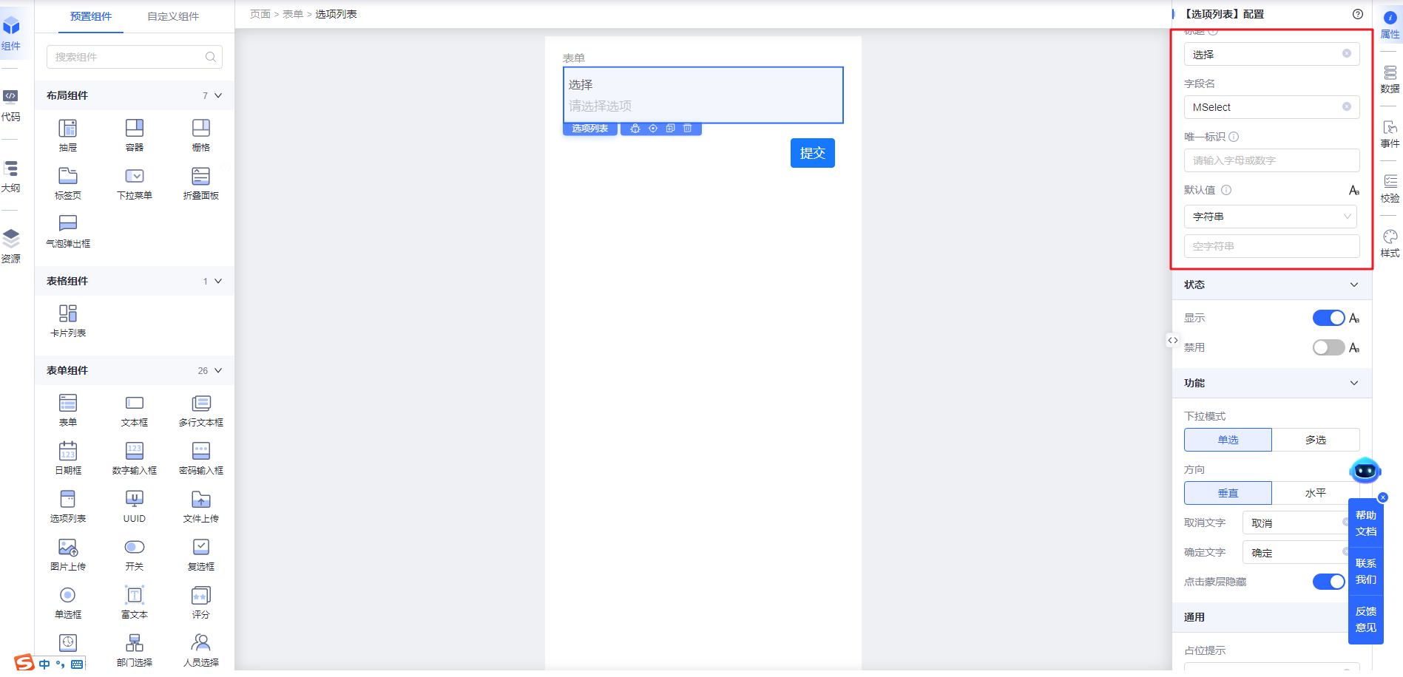
</td>
</tr>
<tr>
<td width="136" verticalAlign="middle" colwidth="136" style="vertical-align:middle; vertical-align:middle; vertical-align:middle; vertical-align:middle; vertical-align:middle; vertical-align:middle; vertical-align:middle; vertical-align:middle; vertical-align:middle; vertical-align:middle; vertical-align:middle; vertical-align:middle; vertical-align:middle; vertical-align:middle; vertical-align:middle; vertical-align:middle; vertical-align:middle; vertical-align:middle; vertical-align:middle; vertical-align:middle; vertical-align:middle; vertical-align:middle; vertical-align:middle; vertical-align:middle; vertical-align:middle; vertical-align:middle; vertical-align:middle; vertical-align:middle; vertical-align:middle; vertical-align:middle; vertical-align:middle; vertical-align:middle; vertical-align:middle; vertical-align:middle; vertical-align:middle; vertical-align:middle; vertical-align:middle; vertical-align:middle; vertical-align:middle; vertical-align:middle; vertical-align:middle; vertical-align:middle; vertical-align:middle; vertical-align:middle; vertical-align:middle; vertical-align:middle; vertical-align:middle; vertical-align:middle; vertical-align:middle; vertical-align:middle; vertical-align:middle; vertical-align:middle; vertical-align:middle; vertical-align:middle; vertical-align:middle; vertical-align:middle; vertical-align:middle; vertical-align:middle; vertical-align:middle; vertical-align:middle; vertical-align:middle; vertical-align:middle; vertical-align:middle; margin:0px; padding:0.5rem 1rem;">字段名</td>
<td width="150" verticalAlign="middle" colwidth="150" style="vertical-align:middle; vertical-align:middle; vertical-align:middle; vertical-align:middle; vertical-align:middle; vertical-align:middle; vertical-align:middle; vertical-align:middle; vertical-align:middle; vertical-align:middle; vertical-align:middle; vertical-align:middle; vertical-align:middle; vertical-align:middle; vertical-align:middle; vertical-align:middle; vertical-align:middle; vertical-align:middle; vertical-align:middle; vertical-align:middle; vertical-align:middle; vertical-align:middle; vertical-align:middle; vertical-align:middle; vertical-align:middle; vertical-align:middle; vertical-align:middle; vertical-align:middle; vertical-align:middle; vertical-align:middle; vertical-align:middle; vertical-align:middle; vertical-align:middle; vertical-align:middle; vertical-align:middle; vertical-align:middle; vertical-align:middle; vertical-align:middle; vertical-align:middle; vertical-align:middle; vertical-align:middle; vertical-align:middle; vertical-align:middle; vertical-align:middle; vertical-align:middle; vertical-align:middle; vertical-align:middle; vertical-align:middle; vertical-align:middle; vertical-align:middle; vertical-align:middle; vertical-align:middle; vertical-align:middle; vertical-align:middle; vertical-align:middle; vertical-align:middle; vertical-align:middle; vertical-align:middle; vertical-align:middle; vertical-align:middle; vertical-align:middle; vertical-align:middle; vertical-align:middle; margin:0px; padding:0.5rem 1rem;">name</td>
<td width="106" verticalAlign="middle" colwidth="106" style="vertical-align:middle; vertical-align:middle; vertical-align:middle; vertical-align:middle; vertical-align:middle; vertical-align:middle; vertical-align:middle; vertical-align:middle; vertical-align:middle; vertical-align:middle; vertical-align:middle; vertical-align:middle; vertical-align:middle; vertical-align:middle; vertical-align:middle; vertical-align:middle; vertical-align:middle; vertical-align:middle; vertical-align:middle; vertical-align:middle; vertical-align:middle; vertical-align:middle; vertical-align:middle; vertical-align:middle; vertical-align:middle; vertical-align:middle; vertical-align:middle; vertical-align:middle; vertical-align:middle; vertical-align:middle; vertical-align:middle; vertical-align:middle; vertical-align:middle; vertical-align:middle; vertical-align:middle; vertical-align:middle; vertical-align:middle; vertical-align:middle; vertical-align:middle; vertical-align:middle; vertical-align:middle; vertical-align:middle; vertical-align:middle; vertical-align:middle; vertical-align:middle; vertical-align:middle; vertical-align:middle; vertical-align:middle; vertical-align:middle; vertical-align:middle; vertical-align:middle; vertical-align:middle; vertical-align:middle; vertical-align:middle; vertical-align:middle; vertical-align:middle; vertical-align:middle; vertical-align:middle; vertical-align:middle; vertical-align:middle; vertical-align:middle; vertical-align:middle; vertical-align:middle; margin:0px; padding:0.5rem 1rem;">
</td>
<td width="424" verticalAlign="middle" colwidth="424" style="vertical-align:middle; vertical-align:middle; vertical-align:middle; vertical-align:middle; vertical-align:middle; vertical-align:middle; vertical-align:middle; vertical-align:middle; vertical-align:middle; vertical-align:middle; vertical-align:middle; vertical-align:middle; vertical-align:middle; vertical-align:middle; vertical-align:middle; vertical-align:middle; vertical-align:middle; vertical-align:middle; vertical-align:middle; vertical-align:middle; vertical-align:middle; vertical-align:middle; vertical-align:middle; vertical-align:middle; vertical-align:middle; vertical-align:middle; vertical-align:middle; vertical-align:middle; vertical-align:middle; vertical-align:middle; vertical-align:middle; vertical-align:middle; vertical-align:middle; vertical-align:middle; vertical-align:middle; vertical-align:middle; vertical-align:middle; vertical-align:middle; vertical-align:middle; vertical-align:middle; vertical-align:middle; vertical-align:middle; vertical-align:middle; vertical-align:middle; vertical-align:middle; vertical-align:middle; vertical-align:middle; vertical-align:middle; vertical-align:middle; vertical-align:middle; vertical-align:middle; vertical-align:middle; vertical-align:middle; vertical-align:middle; vertical-align:middle; vertical-align:middle; vertical-align:middle; vertical-align:middle; vertical-align:middle; vertical-align:middle; vertical-align:middle; vertical-align:middle; vertical-align:middle; margin:0px; padding:0.5rem 1rem;">字段名</td>
</tr>
<tr>
<td width="136" verticalAlign="middle" colwidth="136" style="vertical-align:middle; vertical-align:middle; vertical-align:middle; vertical-align:middle; vertical-align:middle; vertical-align:middle; vertical-align:middle; vertical-align:middle; vertical-align:middle; vertical-align:middle; vertical-align:middle; vertical-align:middle; vertical-align:middle; vertical-align:middle; vertical-align:middle; vertical-align:middle; vertical-align:middle; vertical-align:middle; vertical-align:middle; vertical-align:middle; vertical-align:middle; vertical-align:middle; vertical-align:middle; vertical-align:middle; vertical-align:middle; vertical-align:middle; vertical-align:middle; vertical-align:middle; vertical-align:middle; vertical-align:middle; vertical-align:middle; vertical-align:middle; vertical-align:middle; vertical-align:middle; vertical-align:middle; vertical-align:middle; vertical-align:middle; vertical-align:middle; vertical-align:middle; vertical-align:middle; vertical-align:middle; vertical-align:middle; vertical-align:middle; vertical-align:middle; vertical-align:middle; vertical-align:middle; vertical-align:middle; vertical-align:middle; vertical-align:middle; vertical-align:middle; vertical-align:middle; vertical-align:middle; vertical-align:middle; vertical-align:middle; vertical-align:middle; vertical-align:middle; vertical-align:middle; vertical-align:middle; vertical-align:middle; vertical-align:middle; vertical-align:middle; vertical-align:middle; vertical-align:middle; margin:0px; padding:0.5rem 1rem;">唯一标识</td>
<td width="150" verticalAlign="middle" colwidth="150" style="vertical-align:middle; vertical-align:middle; vertical-align:middle; vertical-align:middle; vertical-align:middle; vertical-align:middle; vertical-align:middle; vertical-align:middle; vertical-align:middle; vertical-align:middle; vertical-align:middle; vertical-align:middle; vertical-align:middle; vertical-align:middle; vertical-align:middle; vertical-align:middle; vertical-align:middle; vertical-align:middle; vertical-align:middle; vertical-align:middle; vertical-align:middle; vertical-align:middle; vertical-align:middle; vertical-align:middle; vertical-align:middle; vertical-align:middle; vertical-align:middle; vertical-align:middle; vertical-align:middle; vertical-align:middle; vertical-align:middle; vertical-align:middle; vertical-align:middle; vertical-align:middle; vertical-align:middle; vertical-align:middle; vertical-align:middle; vertical-align:middle; vertical-align:middle; vertical-align:middle; vertical-align:middle; vertical-align:middle; vertical-align:middle; vertical-align:middle; vertical-align:middle; vertical-align:middle; vertical-align:middle; vertical-align:middle; vertical-align:middle; vertical-align:middle; vertical-align:middle; vertical-align:middle; vertical-align:middle; vertical-align:middle; vertical-align:middle; vertical-align:middle; vertical-align:middle; vertical-align:middle; vertical-align:middle; vertical-align:middle; vertical-align:middle; vertical-align:middle; vertical-align:middle; margin:0px; padding:0.5rem 1rem;">storeName、nodeName</td>
<td width="106" verticalAlign="middle" colwidth="106" style="vertical-align:middle; vertical-align:middle; vertical-align:middle; vertical-align:middle; vertical-align:middle; vertical-align:middle; vertical-align:middle; vertical-align:middle; vertical-align:middle; vertical-align:middle; vertical-align:middle; vertical-align:middle; vertical-align:middle; vertical-align:middle; vertical-align:middle; vertical-align:middle; vertical-align:middle; vertical-align:middle; vertical-align:middle; vertical-align:middle; vertical-align:middle; vertical-align:middle; vertical-align:middle; vertical-align:middle; vertical-align:middle; vertical-align:middle; vertical-align:middle; vertical-align:middle; vertical-align:middle; vertical-align:middle; vertical-align:middle; vertical-align:middle; vertical-align:middle; vertical-align:middle; vertical-align:middle; vertical-align:middle; vertical-align:middle; vertical-align:middle; vertical-align:middle; vertical-align:middle; vertical-align:middle; vertical-align:middle; vertical-align:middle; vertical-align:middle; vertical-align:middle; vertical-align:middle; vertical-align:middle; vertical-align:middle; vertical-align:middle; vertical-align:middle; vertical-align:middle; vertical-align:middle; vertical-align:middle; vertical-align:middle; vertical-align:middle; vertical-align:middle; vertical-align:middle; vertical-align:middle; vertical-align:middle; vertical-align:middle; vertical-align:middle; vertical-align:middle; vertical-align:middle; margin:0px; padding:0.5rem 1rem;">
</td>
<td width="424" verticalAlign="middle" colwidth="424" style="vertical-align:middle; vertical-align:middle; vertical-align:middle; vertical-align:middle; vertical-align:middle; vertical-align:middle; vertical-align:middle; vertical-align:middle; vertical-align:middle; vertical-align:middle; vertical-align:middle; vertical-align:middle; vertical-align:middle; vertical-align:middle; vertical-align:middle; vertical-align:middle; vertical-align:middle; vertical-align:middle; vertical-align:middle; vertical-align:middle; vertical-align:middle; vertical-align:middle; vertical-align:middle; vertical-align:middle; vertical-align:middle; vertical-align:middle; vertical-align:middle; vertical-align:middle; vertical-align:middle; vertical-align:middle; vertical-align:middle; vertical-align:middle; vertical-align:middle; vertical-align:middle; vertical-align:middle; vertical-align:middle; vertical-align:middle; vertical-align:middle; vertical-align:middle; vertical-align:middle; vertical-align:middle; vertical-align:middle; vertical-align:middle; vertical-align:middle; vertical-align:middle; vertical-align:middle; vertical-align:middle; vertical-align:middle; vertical-align:middle; vertical-align:middle; vertical-align:middle; vertical-align:middle; vertical-align:middle; vertical-align:middle; vertical-align:middle; vertical-align:middle; vertical-align:middle; vertical-align:middle; vertical-align:middle; vertical-align:middle; vertical-align:middle; vertical-align:middle; vertical-align:middle; margin:0px; padding:0.5rem 1rem;">
storeName：组件数据域名称，通常结合基座方法env.updateStore()使用，将键值对类型的数据传递给其他组件的数据域。
nodeName：组件节点名称，通常结合组件的各种动作方法使用
</td>
</tr>
<tr>
<td width="136" verticalAlign="top" colwidth="136" style="">默认值</td>
<td width="150" verticalAlign="top" colwidth="150" style="">initialValue</td>
<td width="106" verticalAlign="top" colwidth="106" style="">
</td>
<td width="424" verticalAlign="top" colwidth="424" style="">
表单项组件的默认值。若表单组件已配置默认值，则以表单组件默认值为准。
</td>
</tr>
<tr>
<td width="89" verticalAlign="middle" rowspan="2" colwidth="89" style="vertical-align:middle; vertical-align:middle; vertical-align:middle; vertical-align:middle; vertical-align:middle; vertical-align:middle; vertical-align:middle; vertical-align:middle; vertical-align:middle; vertical-align:middle; vertical-align:middle; vertical-align:middle; vertical-align:middle; vertical-align:middle; vertical-align:middle; vertical-align:middle; vertical-align:middle; vertical-align:middle; vertical-align:middle; vertical-align:middle; vertical-align:middle; vertical-align:middle; vertical-align:middle; vertical-align:middle; vertical-align:middle; vertical-align:middle; vertical-align:middle; vertical-align:middle; vertical-align:middle; vertical-align:middle; vertical-align:middle; vertical-align:middle; vertical-align:middle; vertical-align:middle; vertical-align:middle; vertical-align:middle; vertical-align:middle; vertical-align:middle; vertical-align:middle; vertical-align:middle; vertical-align:middle; vertical-align:middle; vertical-align:middle; vertical-align:middle; vertical-align:middle; vertical-align:middle; vertical-align:middle; vertical-align:middle; vertical-align:middle; vertical-align:middle; vertical-align:middle; vertical-align:middle; vertical-align:middle; vertical-align:middle; vertical-align:middle; vertical-align:middle; vertical-align:middle; vertical-align:middle; vertical-align:middle; vertical-align:middle; vertical-align:middle; vertical-align:middle; vertical-align:middle;">状态</td>
<td width="136" verticalAlign="middle" colwidth="136" style="vertical-align:middle; vertical-align:middle; vertical-align:middle; vertical-align:middle; vertical-align:middle; vertical-align:middle; vertical-align:middle; vertical-align:middle; vertical-align:middle; vertical-align:middle; vertical-align:middle; vertical-align:middle; vertical-align:middle; vertical-align:middle; vertical-align:middle; vertical-align:middle; vertical-align:middle; vertical-align:middle; vertical-align:middle; vertical-align:middle; vertical-align:middle; vertical-align:middle; vertical-align:middle; vertical-align:middle; vertical-align:middle; vertical-align:middle; vertical-align:middle; vertical-align:middle; vertical-align:middle; vertical-align:middle; vertical-align:middle; vertical-align:middle; vertical-align:middle; vertical-align:middle; vertical-align:middle; vertical-align:middle; vertical-align:middle; vertical-align:middle; vertical-align:middle; vertical-align:middle; vertical-align:middle; vertical-align:middle; vertical-align:middle; vertical-align:middle; vertical-align:middle; vertical-align:middle; vertical-align:middle; vertical-align:middle; vertical-align:middle; vertical-align:middle; vertical-align:middle; vertical-align:middle; vertical-align:middle; vertical-align:middle; vertical-align:middle; vertical-align:middle; vertical-align:middle; vertical-align:middle; vertical-align:middle; vertical-align:middle; vertical-align:middle; vertical-align:middle; vertical-align:middle; margin:0px; padding:0.5rem 1rem;">显示</td>
<td width="150" verticalAlign="middle" colwidth="150" style="vertical-align:middle; vertical-align:middle; vertical-align:middle; vertical-align:middle; vertical-align:middle; vertical-align:middle; vertical-align:middle; vertical-align:middle; vertical-align:middle; vertical-align:middle; vertical-align:middle; vertical-align:middle; vertical-align:middle; vertical-align:middle; vertical-align:middle; vertical-align:middle; vertical-align:middle; vertical-align:middle; vertical-align:middle; vertical-align:middle; vertical-align:middle; vertical-align:middle; vertical-align:middle; vertical-align:middle; vertical-align:middle; vertical-align:middle; vertical-align:middle; vertical-align:middle; vertical-align:middle; vertical-align:middle; vertical-align:middle; vertical-align:middle; vertical-align:middle; vertical-align:middle; vertical-align:middle; vertical-align:middle; vertical-align:middle; vertical-align:middle; vertical-align:middle; vertical-align:middle; vertical-align:middle; vertical-align:middle; vertical-align:middle; vertical-align:middle; vertical-align:middle; vertical-align:middle; vertical-align:middle; vertical-align:middle; vertical-align:middle; vertical-align:middle; vertical-align:middle; vertical-align:middle; vertical-align:middle; vertical-align:middle; vertical-align:middle; vertical-align:middle; vertical-align:middle; vertical-align:middle; vertical-align:middle; vertical-align:middle; vertical-align:middle; vertical-align:middle; vertical-align:middle; margin:0px; padding:0.5rem 1rem;">visible</td>
<td width="106" verticalAlign="middle" colwidth="106" style="vertical-align:middle; vertical-align:middle; vertical-align:middle; vertical-align:middle; vertical-align:middle; vertical-align:middle; vertical-align:middle; vertical-align:middle; vertical-align:middle; vertical-align:middle; vertical-align:middle; vertical-align:middle; vertical-align:middle; vertical-align:middle; vertical-align:middle; vertical-align:middle; vertical-align:middle; vertical-align:middle; vertical-align:middle; vertical-align:middle; vertical-align:middle; vertical-align:middle; vertical-align:middle; vertical-align:middle; vertical-align:middle; vertical-align:middle; vertical-align:middle; vertical-align:middle; vertical-align:middle; vertical-align:middle; vertical-align:middle; vertical-align:middle; vertical-align:middle; vertical-align:middle; vertical-align:middle; vertical-align:middle; vertical-align:middle; vertical-align:middle; vertical-align:middle; vertical-align:middle; vertical-align:middle; vertical-align:middle; vertical-align:middle; vertical-align:middle; vertical-align:middle; vertical-align:middle; vertical-align:middle; vertical-align:middle; vertical-align:middle; vertical-align:middle; vertical-align:middle; vertical-align:middle; vertical-align:middle; vertical-align:middle; vertical-align:middle; vertical-align:middle; vertical-align:middle; vertical-align:middle; vertical-align:middle; vertical-align:middle; vertical-align:middle; vertical-align:middle; vertical-align:middle; margin:0px; padding:0.5rem 1rem;">TRUE</td>
<td width="424" verticalAlign="middle" colwidth="424" style="vertical-align:middle; vertical-align:middle; vertical-align:middle; vertical-align:middle; vertical-align:middle; vertical-align:middle; vertical-align:middle; vertical-align:middle; vertical-align:middle; vertical-align:middle; vertical-align:middle; vertical-align:middle; vertical-align:middle; vertical-align:middle; vertical-align:middle; vertical-align:middle; vertical-align:middle; vertical-align:middle; vertical-align:middle; vertical-align:middle; vertical-align:middle; vertical-align:middle; vertical-align:middle; vertical-align:middle; vertical-align:middle; vertical-align:middle; vertical-align:middle; vertical-align:middle; vertical-align:middle; vertical-align:middle; vertical-align:middle; vertical-align:middle; vertical-align:middle; vertical-align:middle; vertical-align:middle; vertical-align:middle; vertical-align:middle; vertical-align:middle; vertical-align:middle; vertical-align:middle; vertical-align:middle; vertical-align:middle; vertical-align:middle; vertical-align:middle; vertical-align:middle; vertical-align:middle; vertical-align:middle; vertical-align:middle; vertical-align:middle; vertical-align:middle; vertical-align:middle; vertical-align:middle; vertical-align:middle; vertical-align:middle; vertical-align:middle; vertical-align:middle; vertical-align:middle; vertical-align:middle; vertical-align:middle; vertical-align:middle; vertical-align:middle; vertical-align:middle; vertical-align:middle; margin:0px; padding:0.5rem 1rem;">
显隐配置，支持静态、表达式以及资源点配置；
默认是显示状态
</td>
<td width="195" verticalAlign="middle" rowspan="2" colwidth="195" style="vertical-align:middle; vertical-align:middle; vertical-align:middle; vertical-align:middle; vertical-align:middle; vertical-align:middle; vertical-align:middle; vertical-align:middle; vertical-align:middle; vertical-align:middle; vertical-align:middle; vertical-align:middle; vertical-align:middle; vertical-align:middle; vertical-align:middle; vertical-align:middle; vertical-align:middle; vertical-align:middle; vertical-align:middle; vertical-align:middle; vertical-align:middle; vertical-align:middle; vertical-align:middle; vertical-align:middle; vertical-align:middle; vertical-align:middle; vertical-align:middle; vertical-align:middle; vertical-align:middle; vertical-align:middle; vertical-align:middle; vertical-align:middle; vertical-align:middle;">
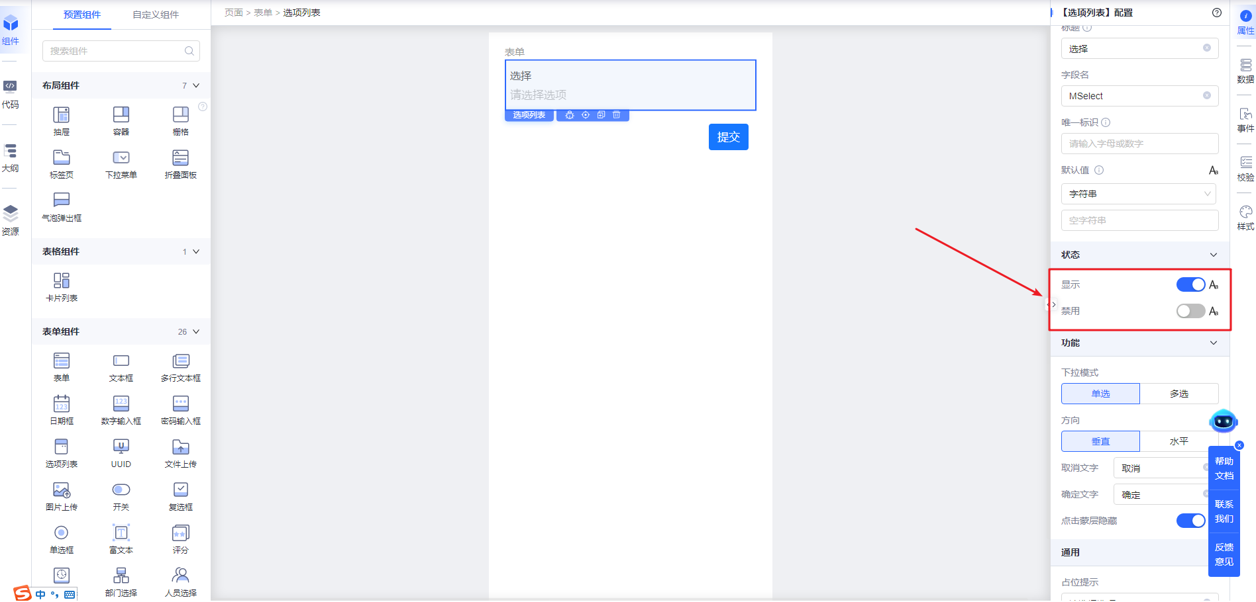
</td>
</tr>
<tr>
<td width="136" verticalAlign="middle" colwidth="136" style="vertical-align:middle; vertical-align:middle; vertical-align:middle; vertical-align:middle; vertical-align:middle; vertical-align:middle; vertical-align:middle; vertical-align:middle; vertical-align:middle; vertical-align:middle; vertical-align:middle; vertical-align:middle; vertical-align:middle; vertical-align:middle; vertical-align:middle; vertical-align:middle; vertical-align:middle; vertical-align:middle; vertical-align:middle; vertical-align:middle; vertical-align:middle; vertical-align:middle; vertical-align:middle; vertical-align:middle; vertical-align:middle; vertical-align:middle; vertical-align:middle; vertical-align:middle; vertical-align:middle; vertical-align:middle; vertical-align:middle; vertical-align:middle; vertical-align:middle; vertical-align:middle; vertical-align:middle; vertical-align:middle; vertical-align:middle; vertical-align:middle; vertical-align:middle; vertical-align:middle; vertical-align:middle; vertical-align:middle; vertical-align:middle; vertical-align:middle; vertical-align:middle; vertical-align:middle; vertical-align:middle; vertical-align:middle; vertical-align:middle; vertical-align:middle; vertical-align:middle; vertical-align:middle; vertical-align:middle; vertical-align:middle; vertical-align:middle; vertical-align:middle; vertical-align:middle; vertical-align:middle; vertical-align:middle; vertical-align:middle; vertical-align:middle; vertical-align:middle; vertical-align:middle; margin:0px; padding:0.5rem 1rem;">禁用</td>
<td width="150" verticalAlign="middle" colwidth="150" style="vertical-align:middle; vertical-align:middle; vertical-align:middle; vertical-align:middle; vertical-align:middle; vertical-align:middle; vertical-align:middle; vertical-align:middle; vertical-align:middle; vertical-align:middle; vertical-align:middle; vertical-align:middle; vertical-align:middle; vertical-align:middle; vertical-align:middle; vertical-align:middle; vertical-align:middle; vertical-align:middle; vertical-align:middle; vertical-align:middle; vertical-align:middle; vertical-align:middle; vertical-align:middle; vertical-align:middle; vertical-align:middle; vertical-align:middle; vertical-align:middle; vertical-align:middle; vertical-align:middle; vertical-align:middle; vertical-align:middle; vertical-align:middle; vertical-align:middle; vertical-align:middle; vertical-align:middle; vertical-align:middle; vertical-align:middle; vertical-align:middle; vertical-align:middle; vertical-align:middle; vertical-align:middle; vertical-align:middle; vertical-align:middle; vertical-align:middle; vertical-align:middle; vertical-align:middle; vertical-align:middle; vertical-align:middle; vertical-align:middle; vertical-align:middle; vertical-align:middle; vertical-align:middle; vertical-align:middle; vertical-align:middle; vertical-align:middle; vertical-align:middle; vertical-align:middle; vertical-align:middle; vertical-align:middle; vertical-align:middle; vertical-align:middle; vertical-align:middle; vertical-align:middle; margin:0px; padding:0.5rem 1rem;">disabled</td>
<td width="106" verticalAlign="middle" colwidth="106" style="vertical-align:middle; vertical-align:middle; vertical-align:middle; vertical-align:middle; vertical-align:middle; vertical-align:middle; vertical-align:middle; vertical-align:middle; vertical-align:middle; vertical-align:middle; vertical-align:middle; vertical-align:middle; vertical-align:middle; vertical-align:middle; vertical-align:middle; vertical-align:middle; vertical-align:middle; vertical-align:middle; vertical-align:middle; vertical-align:middle; vertical-align:middle; vertical-align:middle; vertical-align:middle; vertical-align:middle; vertical-align:middle; vertical-align:middle; vertical-align:middle; vertical-align:middle; vertical-align:middle; vertical-align:middle; vertical-align:middle; vertical-align:middle; vertical-align:middle; vertical-align:middle; vertical-align:middle; vertical-align:middle; vertical-align:middle; vertical-align:middle; vertical-align:middle; vertical-align:middle; vertical-align:middle; vertical-align:middle; vertical-align:middle; vertical-align:middle; vertical-align:middle; vertical-align:middle; vertical-align:middle; vertical-align:middle; vertical-align:middle; vertical-align:middle; vertical-align:middle; vertical-align:middle; vertical-align:middle; vertical-align:middle; vertical-align:middle; vertical-align:middle; vertical-align:middle; vertical-align:middle; vertical-align:middle; vertical-align:middle; vertical-align:middle; vertical-align:middle; vertical-align:middle; margin:0px; padding:0.5rem 1rem;">FALSE</td>
<td width="424" verticalAlign="middle" colwidth="424" style="vertical-align:middle; vertical-align:middle; vertical-align:middle; vertical-align:middle; vertical-align:middle; vertical-align:middle; vertical-align:middle; vertical-align:middle; vertical-align:middle; vertical-align:middle; vertical-align:middle; vertical-align:middle; vertical-align:middle; vertical-align:middle; vertical-align:middle; vertical-align:middle; vertical-align:middle; vertical-align:middle; vertical-align:middle; vertical-align:middle; vertical-align:middle; vertical-align:middle; vertical-align:middle; vertical-align:middle; vertical-align:middle; vertical-align:middle; vertical-align:middle; vertical-align:middle; vertical-align:middle; vertical-align:middle; vertical-align:middle; vertical-align:middle; vertical-align:middle; vertical-align:middle; vertical-align:middle; vertical-align:middle; vertical-align:middle; vertical-align:middle; vertical-align:middle; vertical-align:middle; vertical-align:middle; vertical-align:middle; vertical-align:middle; vertical-align:middle; vertical-align:middle; vertical-align:middle; vertical-align:middle; vertical-align:middle; vertical-align:middle; vertical-align:middle; vertical-align:middle; vertical-align:middle; vertical-align:middle; vertical-align:middle; vertical-align:middle; vertical-align:middle; vertical-align:middle; vertical-align:middle; vertical-align:middle; vertical-align:middle; vertical-align:middle; vertical-align:middle; vertical-align:middle; margin:0px; padding:0.5rem 1rem;">
禁用配置，支持静态、表达式以及资源点配置；
默认是未禁用状态
</td>
</tr>
<tr>
<td width="89" verticalAlign="top" rowspan="5" colwidth="89" style="">功能</td>
<td width="136" verticalAlign="top" colwidth="136" style="">下拉模式</td>
<td width="150" verticalAlign="top" colwidth="150" style="">mode</td>
<td width="106" verticalAlign="top" colwidth="106" style="">single</td>
<td width="424" verticalAlign="top" colwidth="424" style="">控制下拉选择模式是单选还是多选</td>
<td width="195" verticalAlign="top" rowspan="5" colwidth="195" style="">
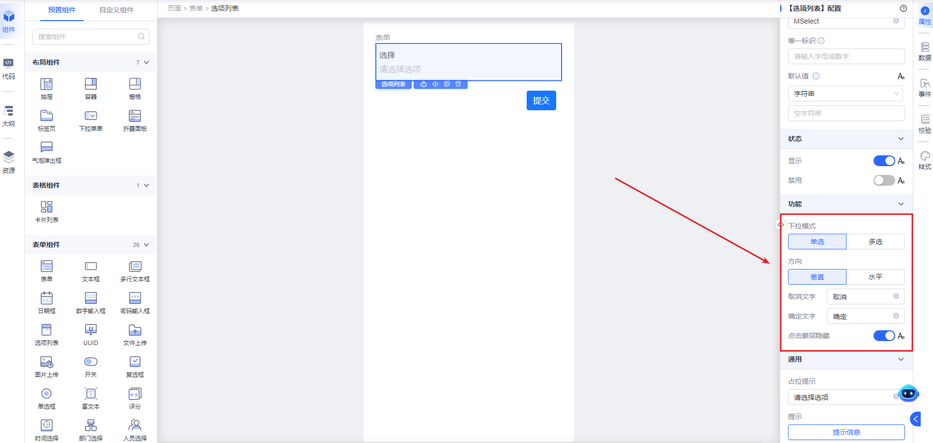
</td>
</tr>
<tr>
<td width="136" verticalAlign="top" colwidth="136" style="">方向</td>
<td width="150" verticalAlign="top" colwidth="150" style="">layout</td>
<td width="106" verticalAlign="top" colwidth="106" style="">vertical</td>
<td width="424" verticalAlign="top" colwidth="424" style="">控制布局是</td>
</tr>
<tr>
<td width="136" verticalAlign="top" colwidth="136" style="">取消文字</td>
<td width="150" verticalAlign="top" colwidth="150" style="">cancelText</td>
<td width="106" verticalAlign="top" colwidth="106" style="">取消</td>
<td width="424" verticalAlign="top" colwidth="424" style="">下拉选择框的取消操作文案展示</td>
</tr>
<tr>
<td width="136" verticalAlign="top" colwidth="136" style="">确定文字</td>
<td width="150" verticalAlign="top" colwidth="150" style="">confirmText</td>
<td width="106" verticalAlign="top" colwidth="106" style="">确定</td>
<td width="424" verticalAlign="top" colwidth="424" style="">下拉选择框的确定操作文案展示</td>
</tr>
<tr>
<td width="136" verticalAlign="top" colwidth="136" style="">点击蒙层隐藏</td>
<td width="150" verticalAlign="top" colwidth="150" style="">closeOnMaskClick</td>
<td width="106" verticalAlign="top" colwidth="106" style="">true</td>
<td width="424" verticalAlign="top" colwidth="424" style="">控制下拉选择框展示的，点击蒙层是否隐藏下拉选择框</td>
</tr>
<tr>
<td width="89" verticalAlign="top" rowspan="2" colwidth="89" style="">通用</td>
<td width="136" verticalAlign="top" colwidth="136" style="">占位提示</td>
<td width="150" verticalAlign="top" colwidth="150" style="">placeholder</td>
<td width="106" verticalAlign="top" colwidth="106" style="">请选择选项</td>
<td width="424" verticalAlign="top" colwidth="424" style="">初始未选择任一选项时的提示文案</td>
<td width="195" verticalAlign="top" rowspan="2" colwidth="195" style="">
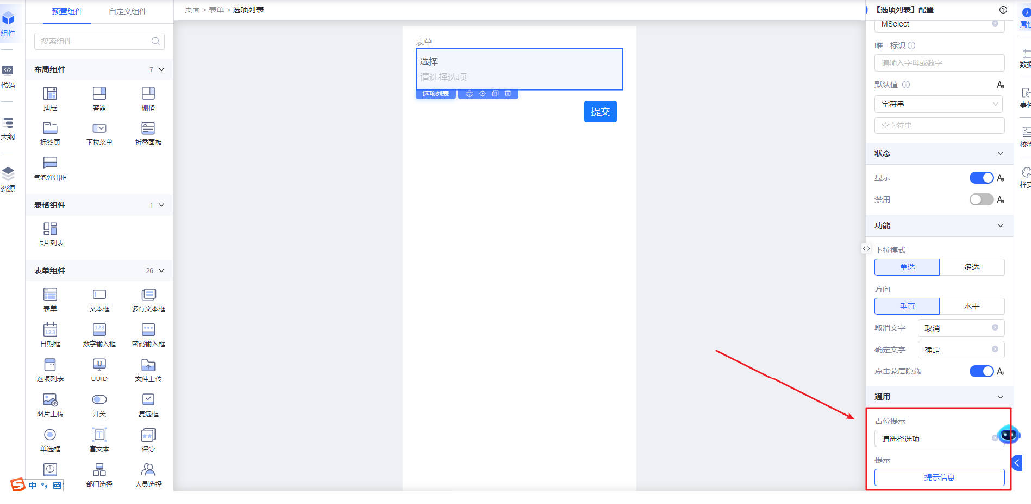
</td>
</tr>
<tr>
<td width="136" verticalAlign="top" colwidth="136" style="">提示</td>
<td width="150" verticalAlign="top" colwidth="150" style="">tips</td>
<td width="106" verticalAlign="top" colwidth="106" style="">
</td>
<td width="424" verticalAlign="top" colwidth="424" style="">
1、标题提示是出现在标题或控件的右侧；
2、控件提示是出现在标题或控件的下方
</td>
</tr>
</table>

属性和功能配置演示

基础配置

标题
控制选项列表的标题展示。
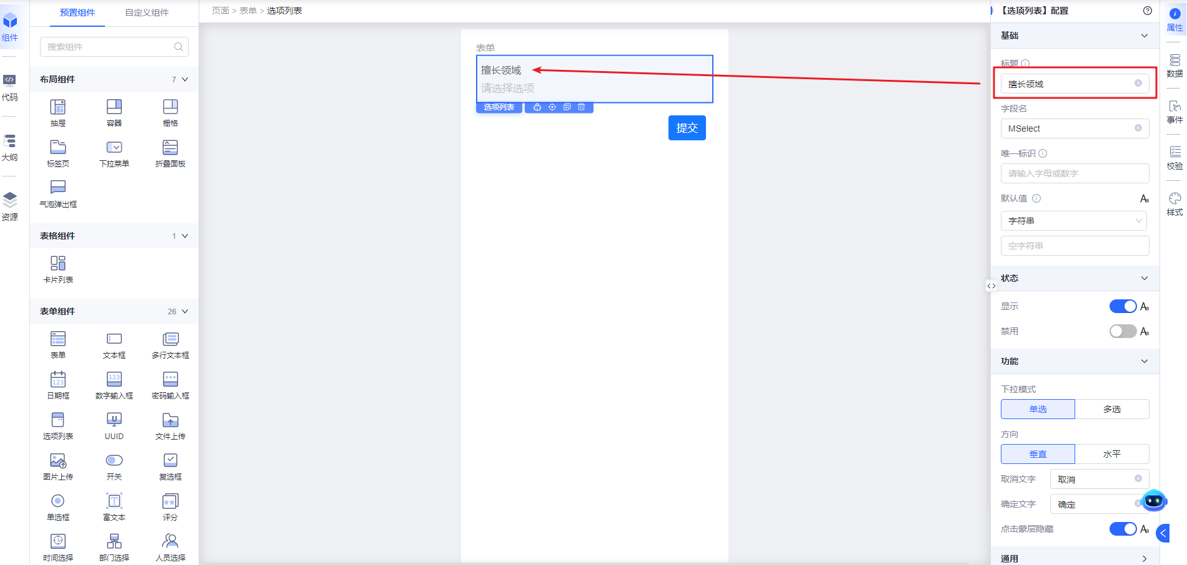

字段名
字段名是表单提交时该表单项的字段名。
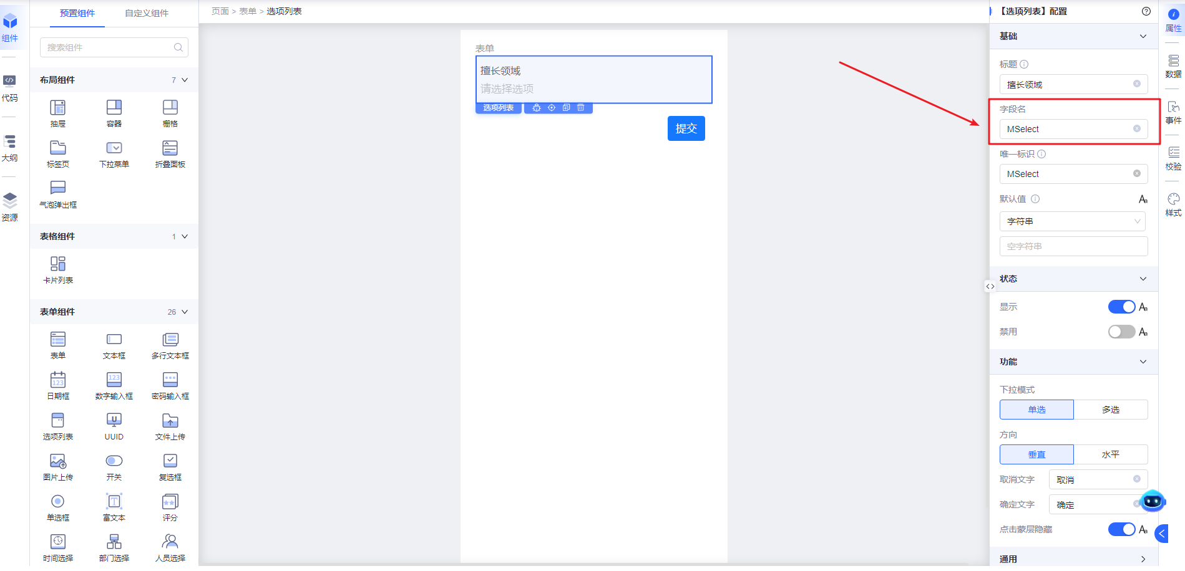

唯一标识
组件唯一标识，用于和其它组件做数据联动和动作交互。输入唯一标识会生成storeName，nodeName两个属性。
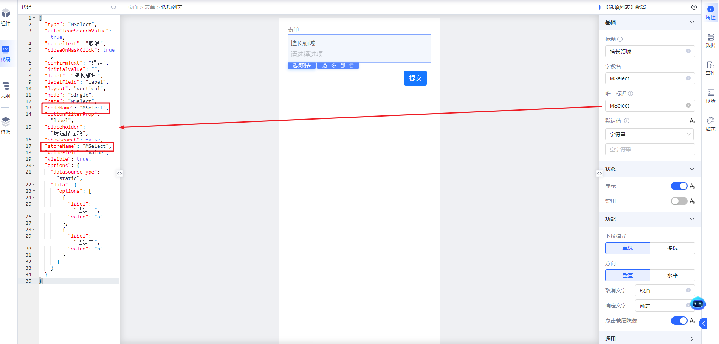

默认值
控制选择列表的默认展示，需要配置为数据源选项的value。
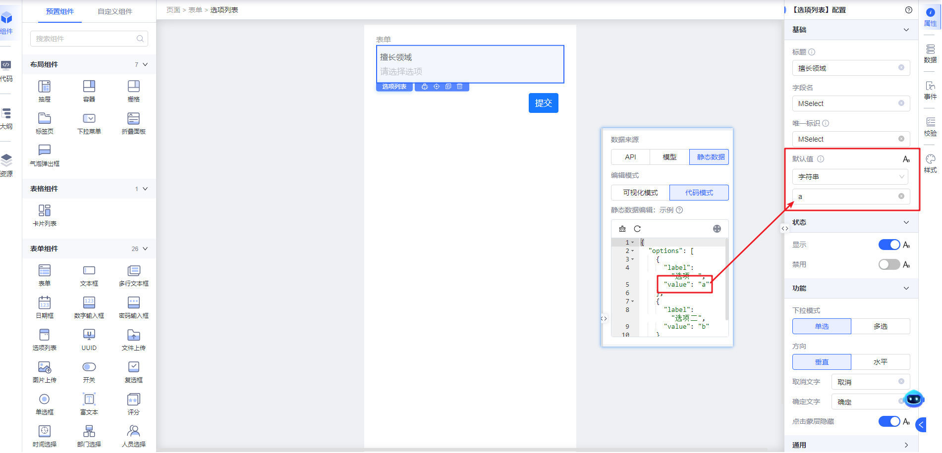

状态

显示
控制选项列表组件的显隐，默认是显示状态。显隐状态可通过常量、表达式、资源点进行控制。
显示状态
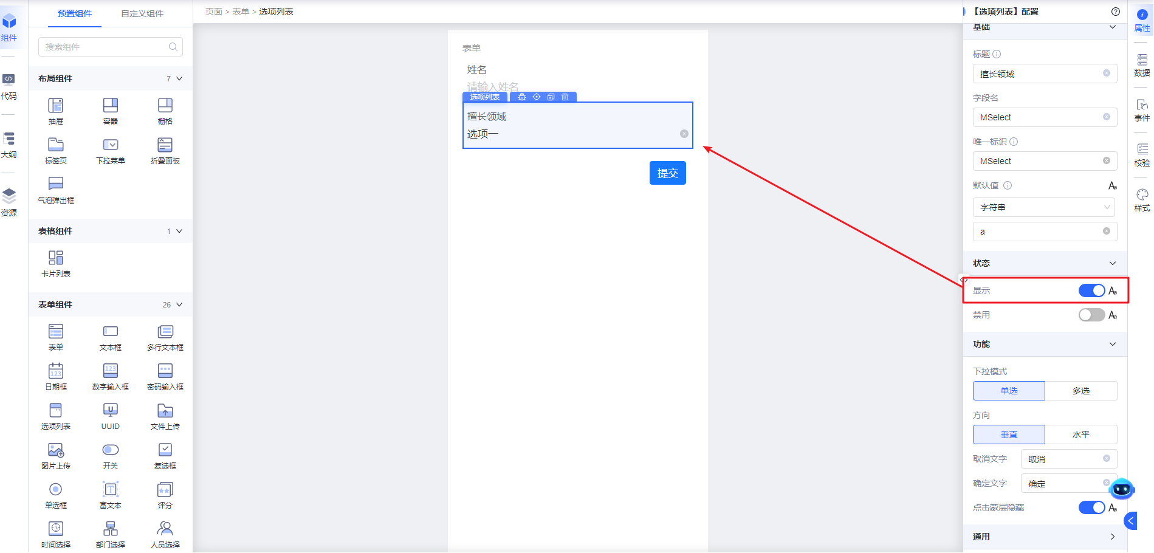
隐藏状态
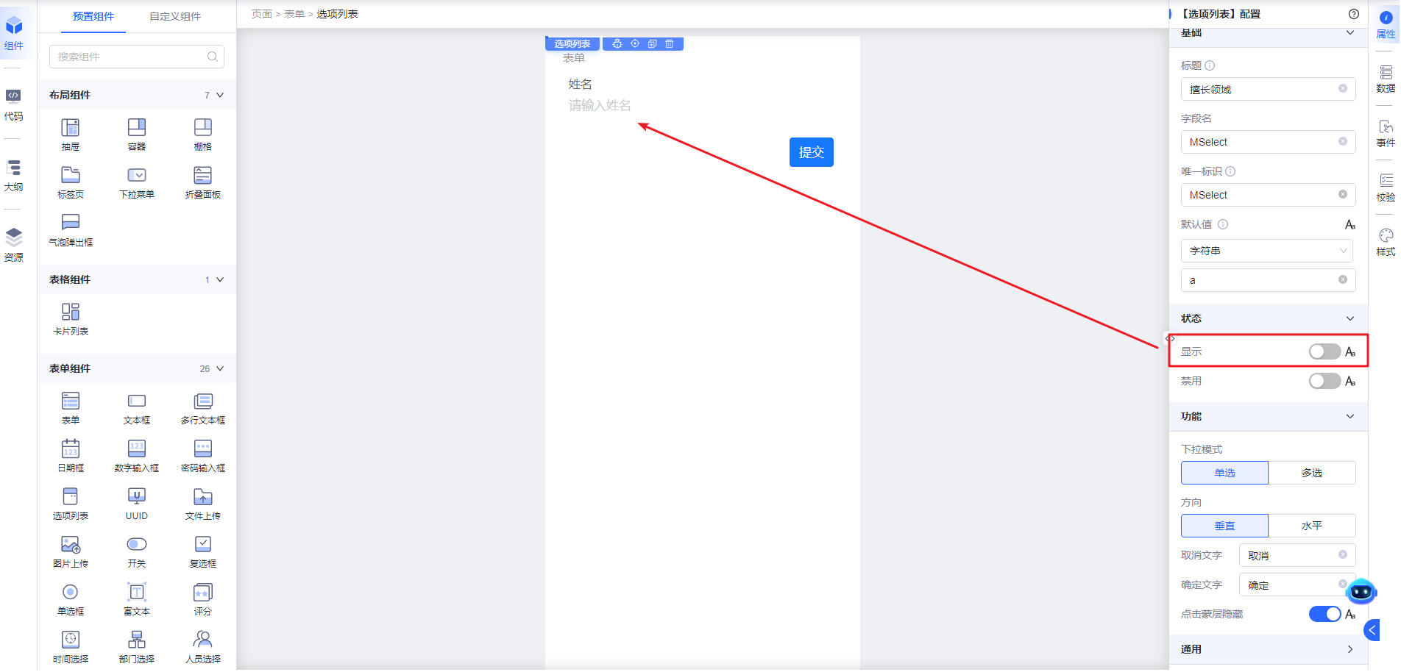

禁用
控制选项列表组件是否可编辑，可支持常量值，表达式，资源点。
可编辑（非禁用）状态
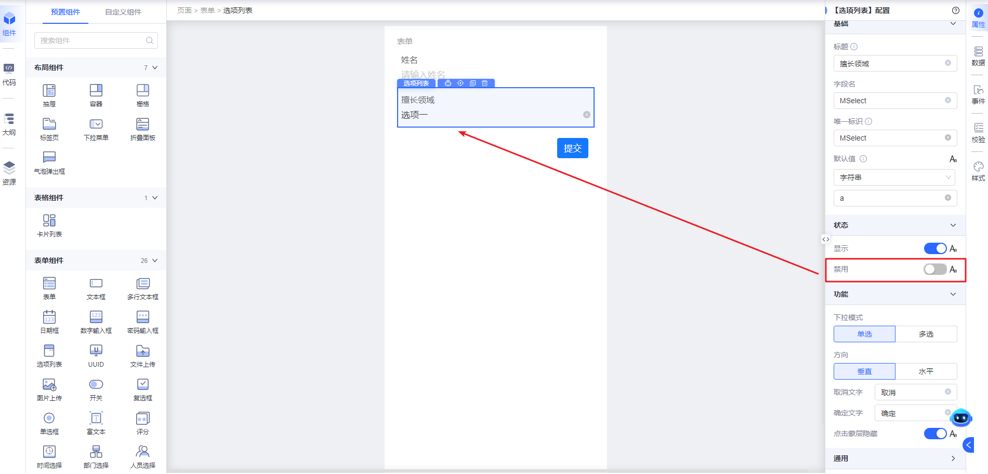
不可编辑（禁用）状态，开发态看起来和可编辑（非禁用）状态一样
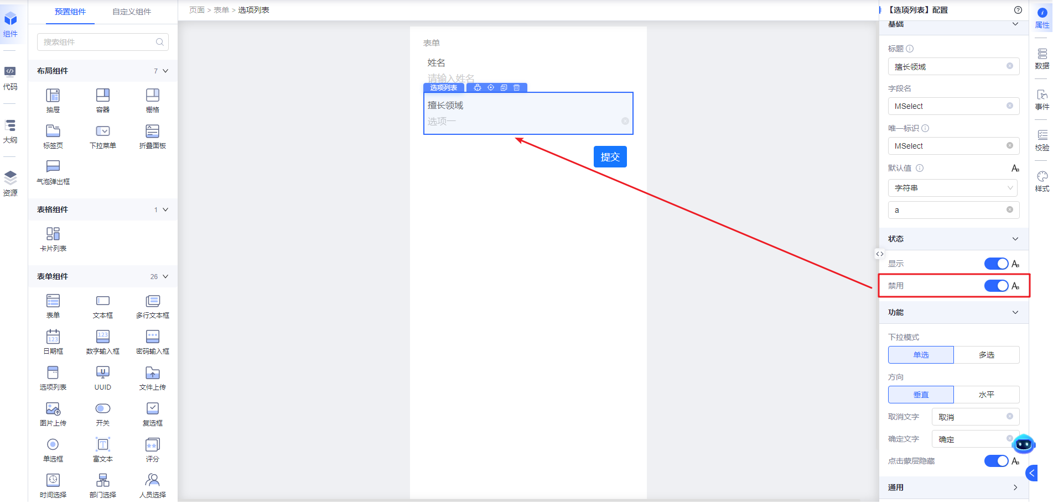

功能

下拉模式
控制选项是单选还是多选。
单选
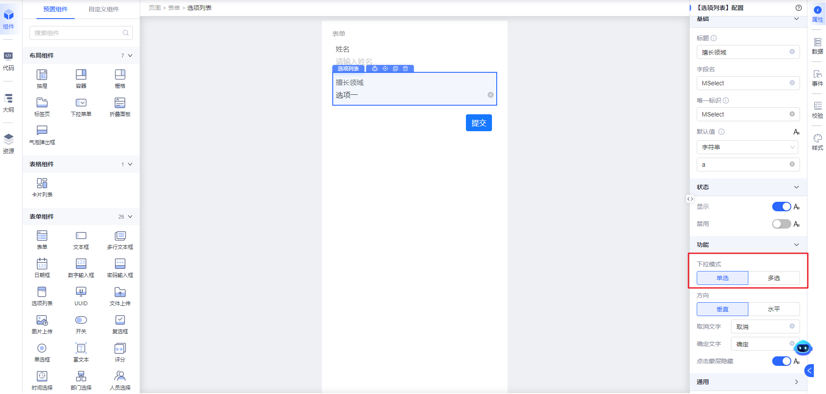
配置效果
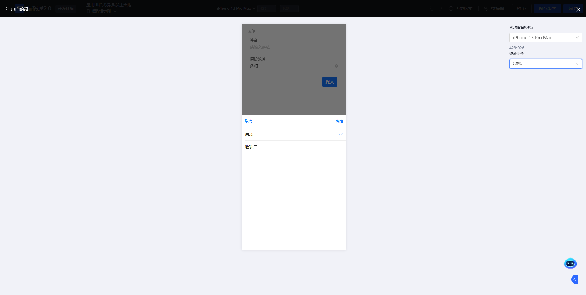
多选配置
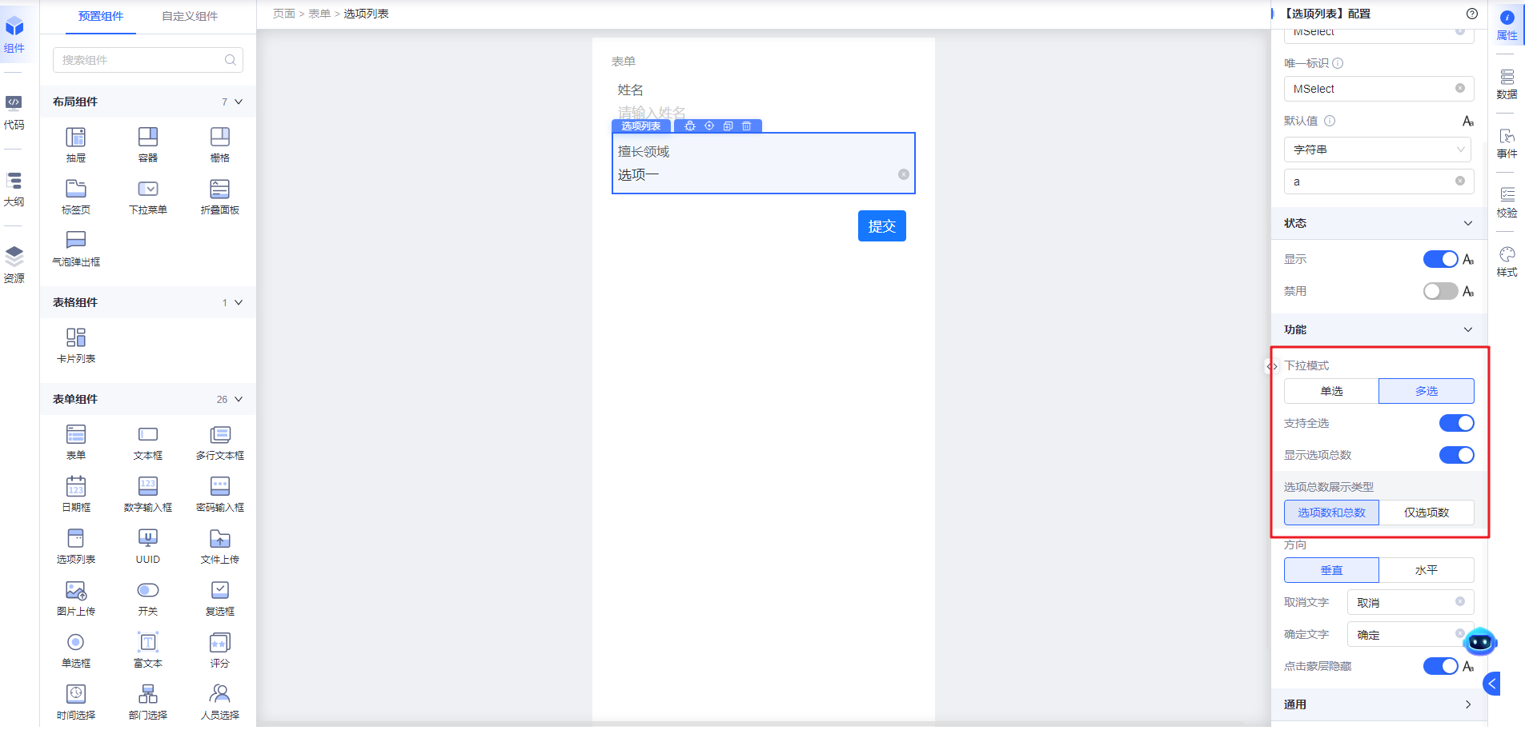
配置效果
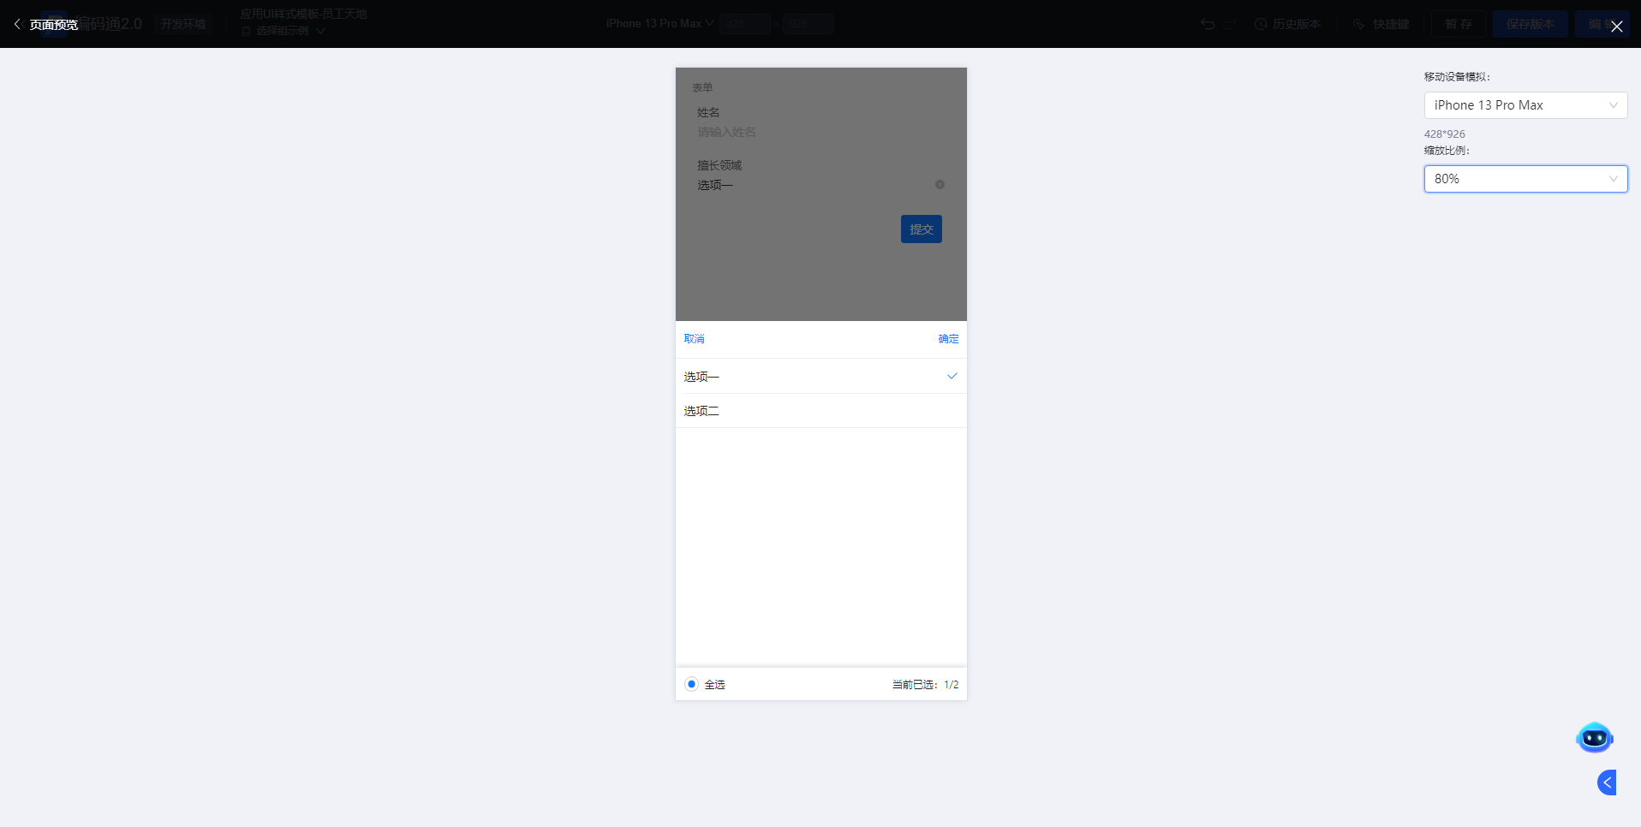

方向
控制选项列表的标题和输入框的布局方式。
垂直布局
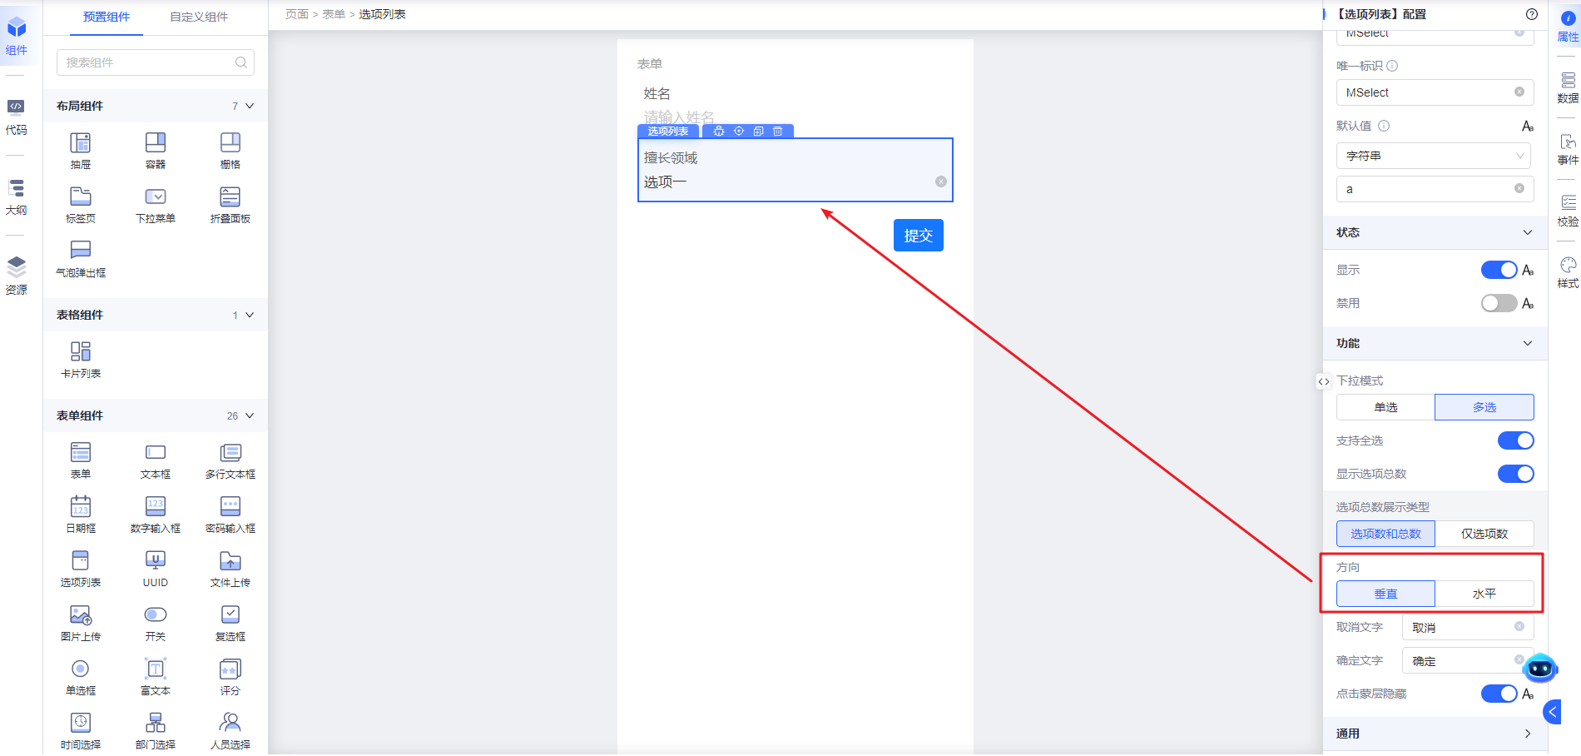
水平布局
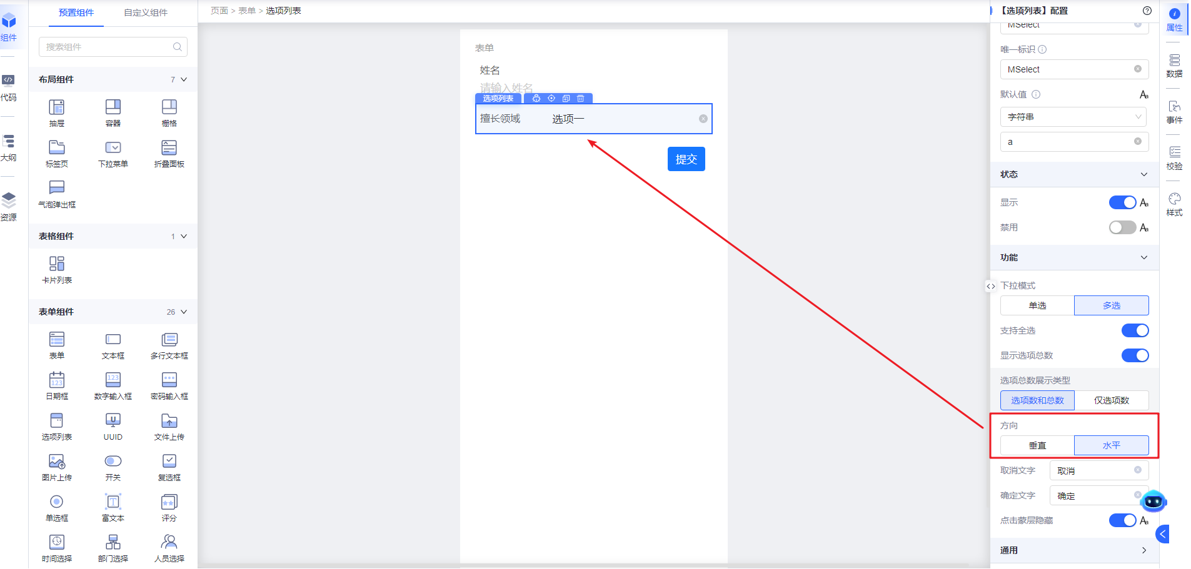

取消文字
配置选项选择器的取消功能文案。如未配置过，默认文案是“取消”。
配置
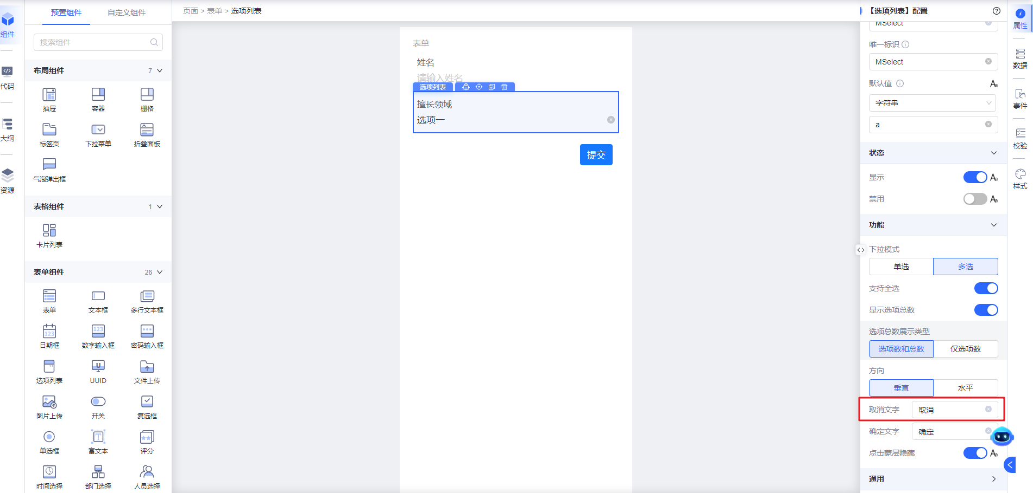
运行态展示效果
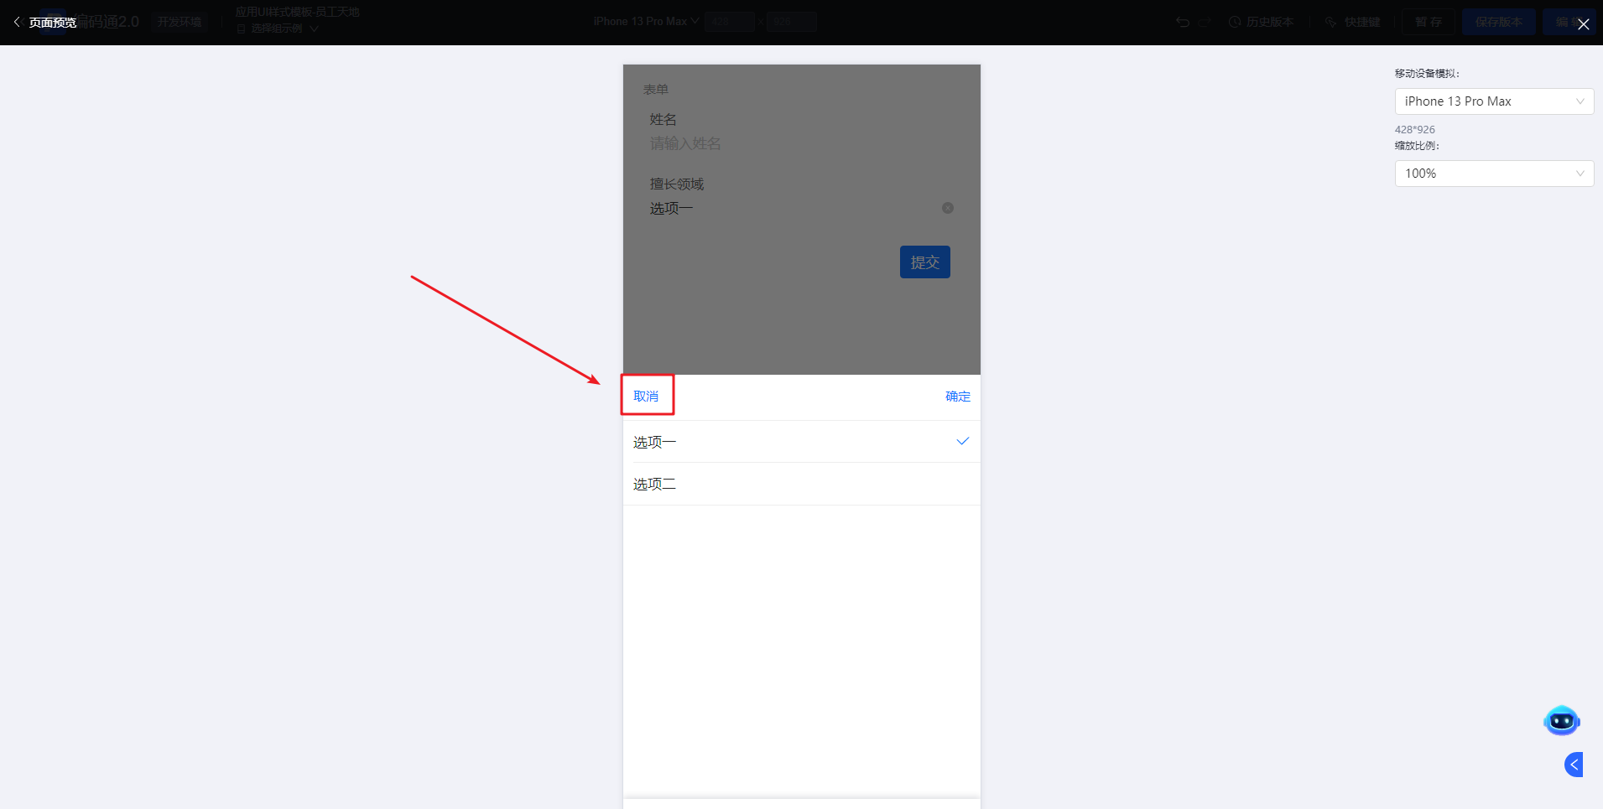

确认文字
配置选项选择器的确定功能文案。如未配置过，默认文案是“确定”。
配置
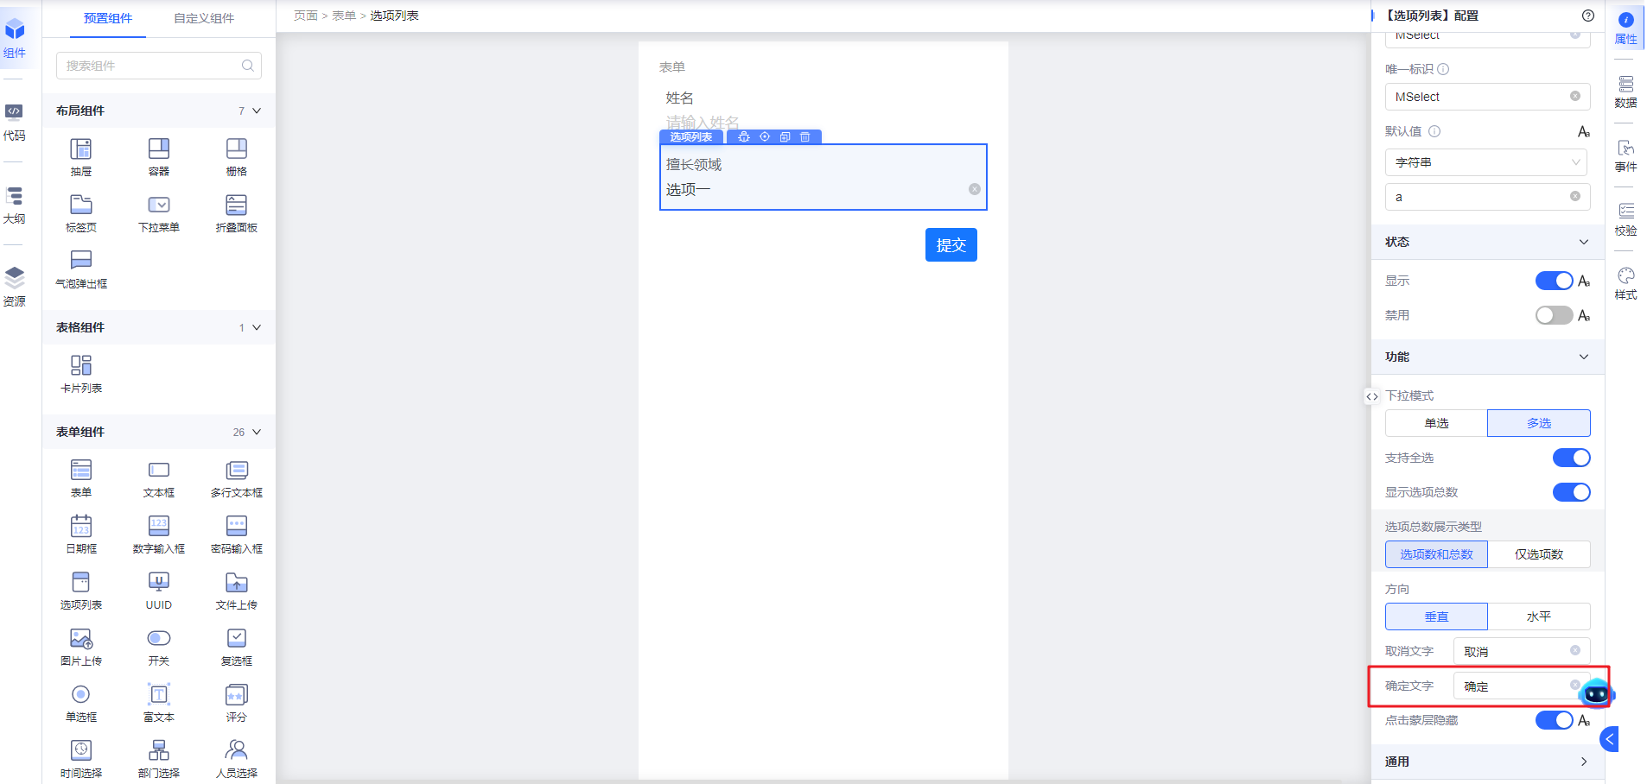
预览态展示效果
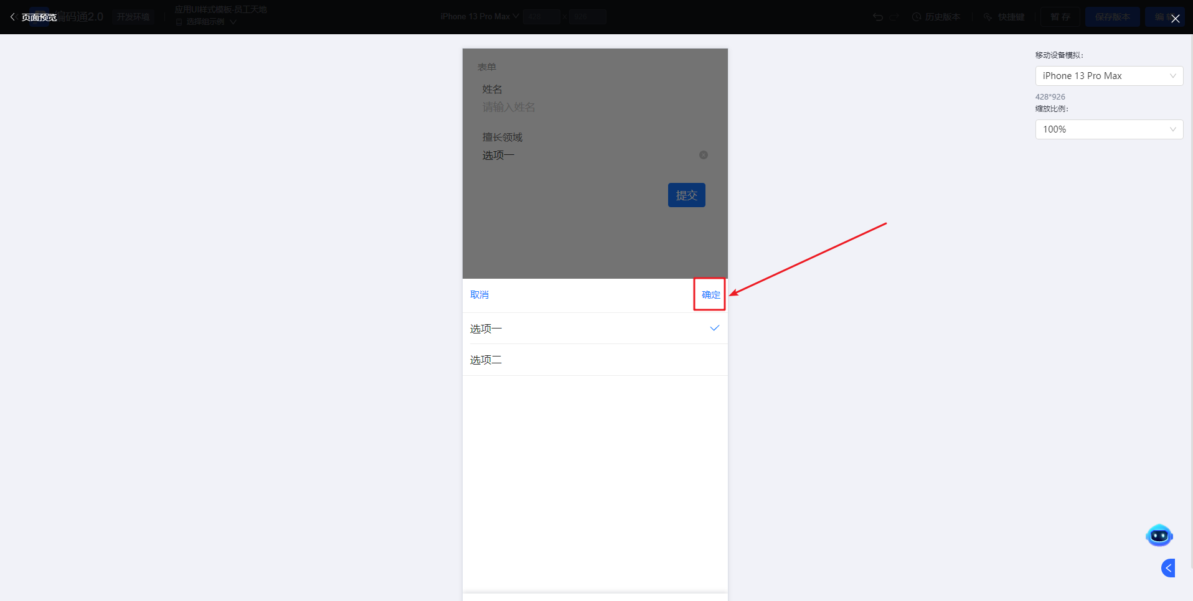

点击蒙层隐藏
控制选项列表点击蒙层是否隐藏功能，默认是开启状态。
开启状态，点击蒙层隐藏选择框
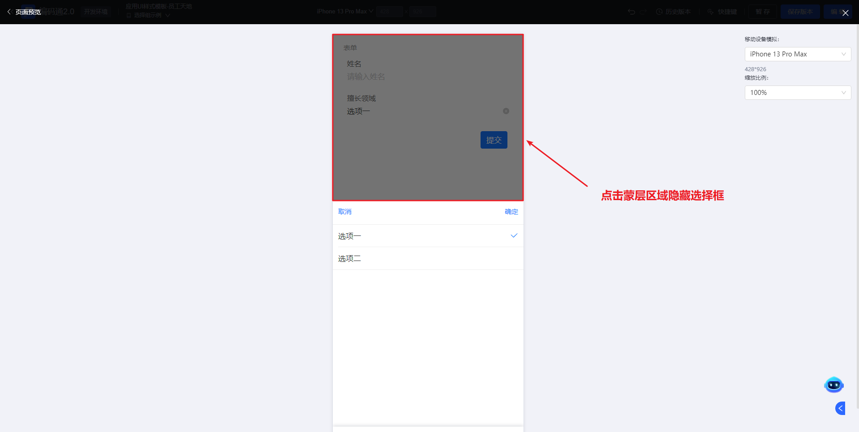
关闭状态，点击蒙层不隐藏选择框
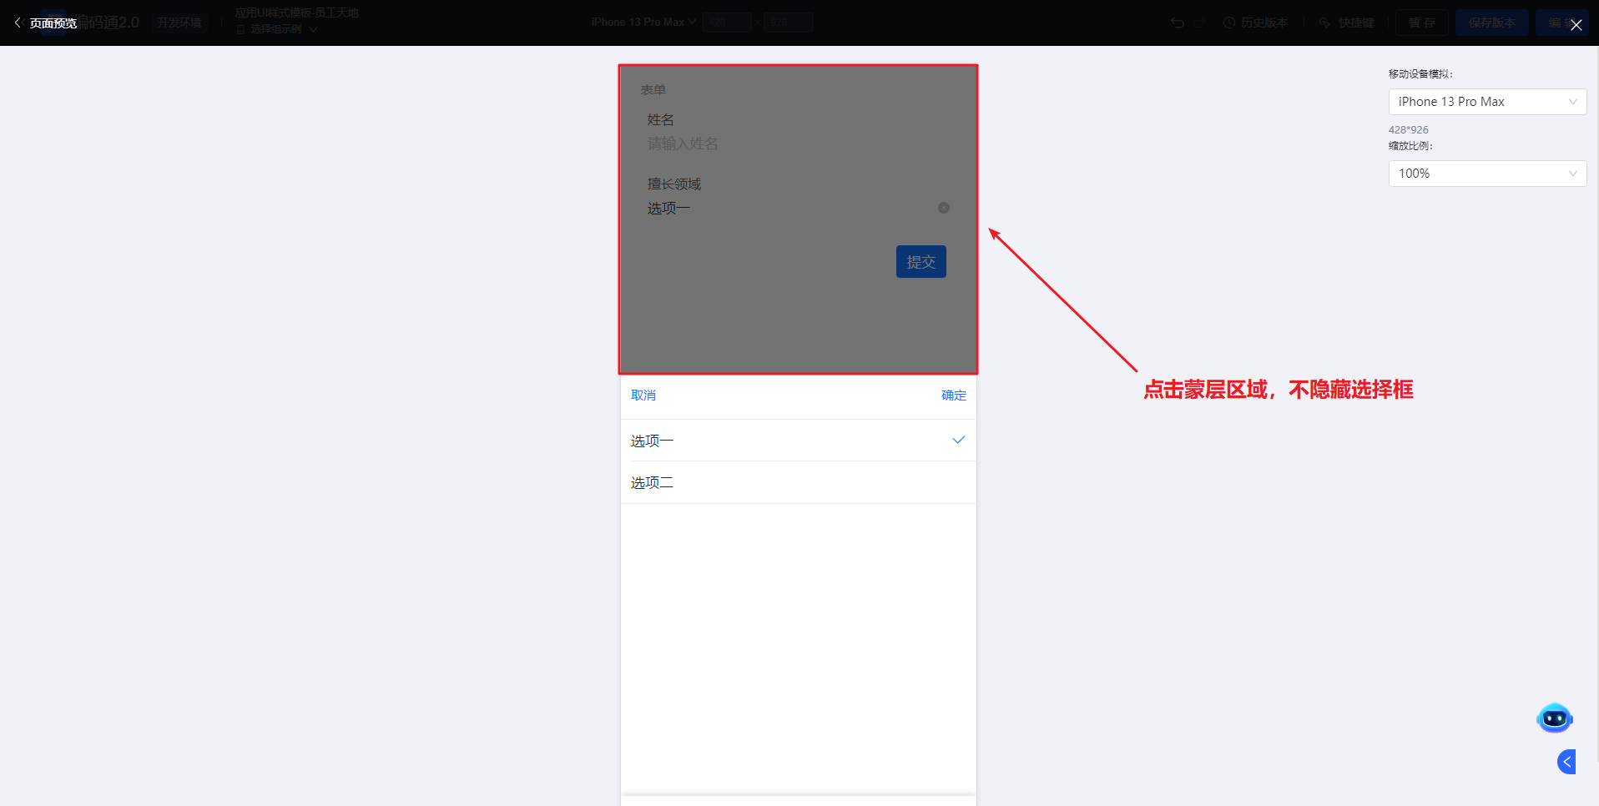

通用

占位提示
当选项列表未选中任一选项时的文案展示。
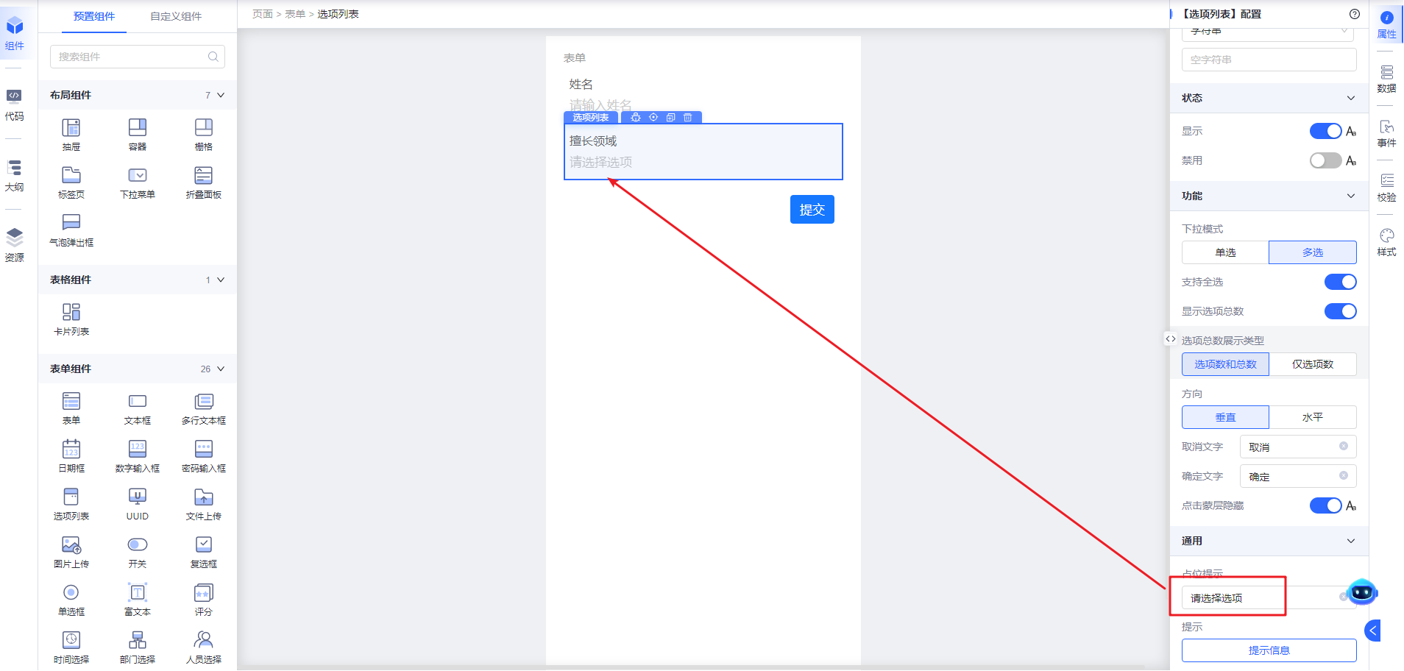

提示
提示信息主要用于对选项的一些填写说明。

标题提示
标题提示是出现在标题或控件的右侧。
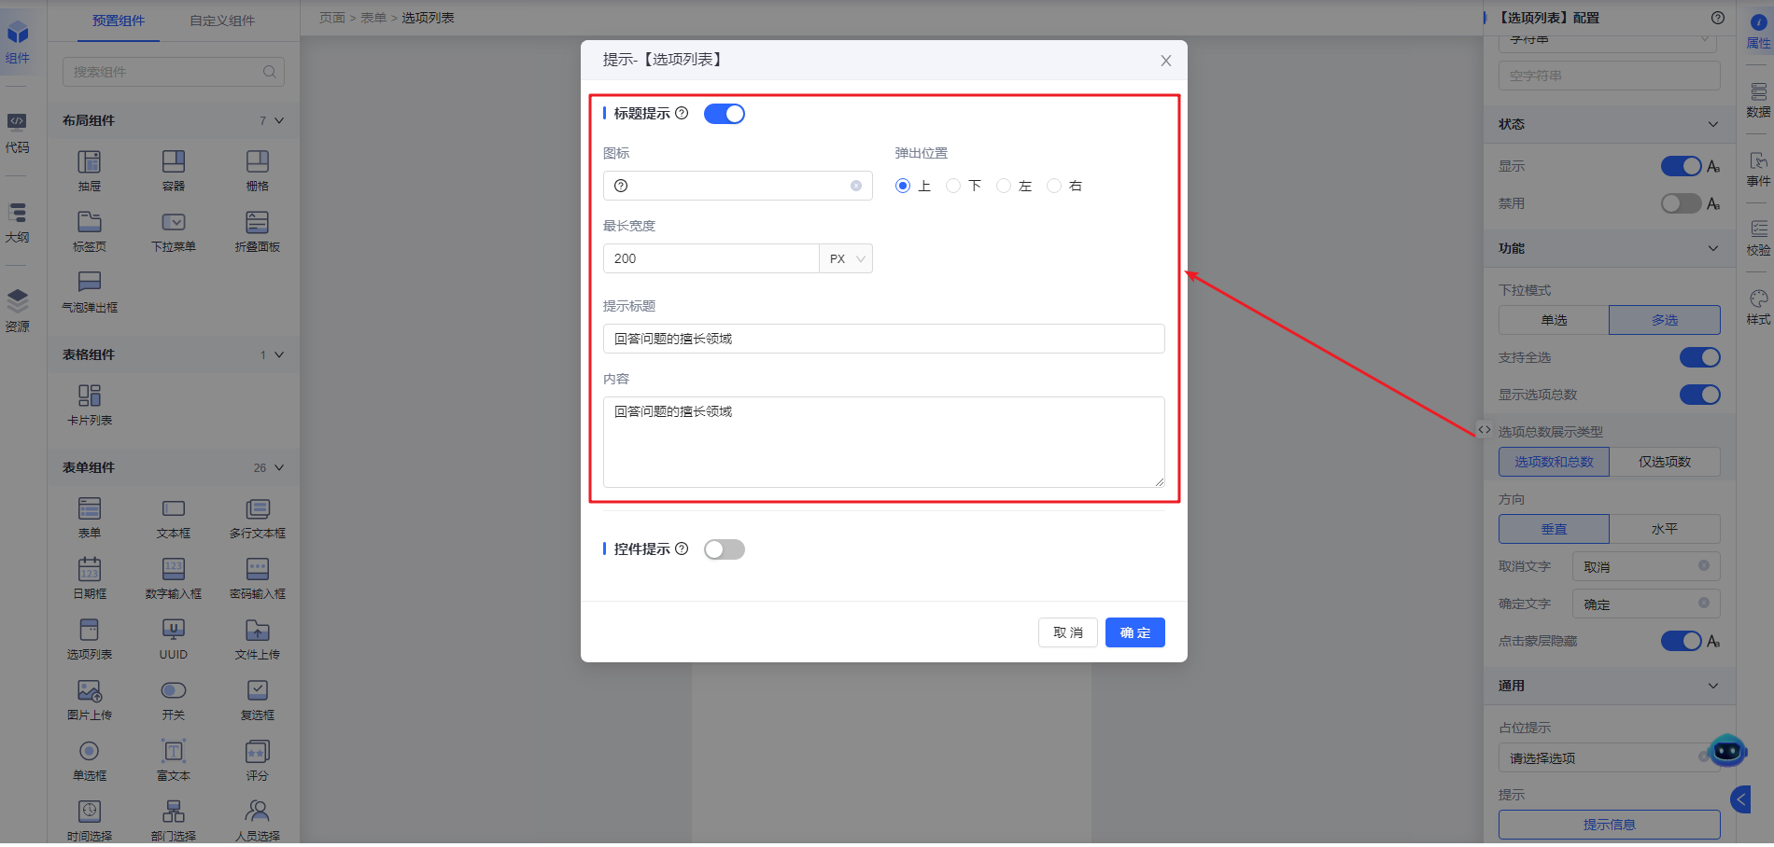
- 图标：主要提示图标的展示
- 弹出位置：设置提示在图标的相对位置
- 最长宽度：设置提示信息的宽度
- 提示标题：设置提示信息的标题
- 内容：提示信息的主要内容
展示效果
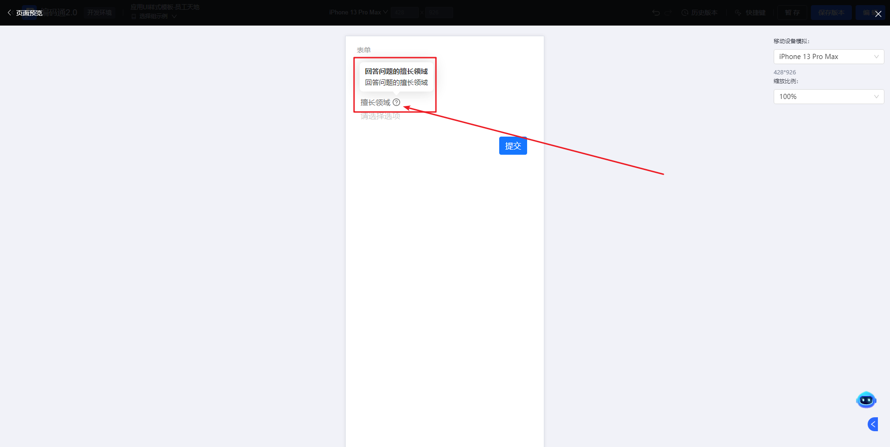

控件提示
控件提示是出现在标题或控件的下方
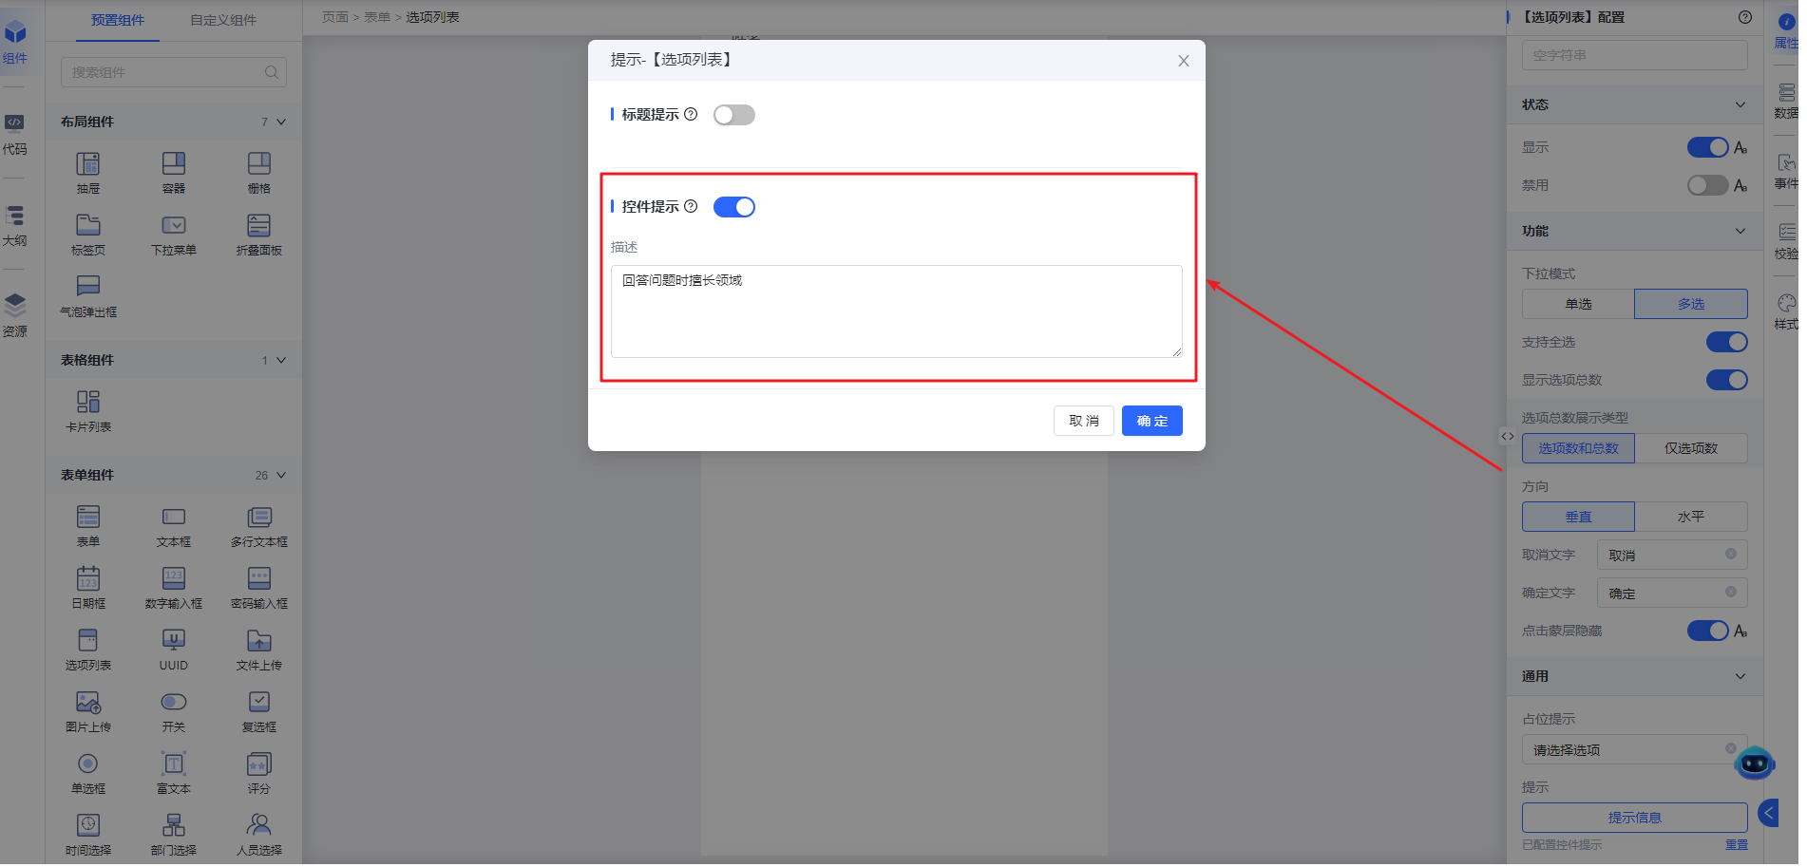
展示效果
