Garment Shop Billing Platform
Technical product specification and implementation architecture
This document defines the first release of a subscription controlled billing platform for small garment shops in tier 2 and tier 3 Indian cities. It gives the delivery team a shared product scope, system boundaries, technical architecture, data model and delivery sequence. The recommended approach is a Flutter shop application with a Spring Boot platform and a separate web based admin portal.
Document item | Value
Primary users | Shop owners, shop staff, platform operations team
Client applications | Flutter shop app and web based admin portal
Backend | Spring Boot microservices with MongoDB
Release focus | Fast billing, inventory, customer credit, invoices, offline sync and subscription enforcement
Version | Draft 1.0

1 Product Direction
The product replaces handwritten billing and basic notebooks without forcing small retailers to learn enterprise software. The shop app must make a sale possible in seconds: choose a category, tap a product, use double tap to add repeat quantity, apply a discount, choose payment and issue a receipt. Barcode scanning is intentionally out of scope.

Goals
- Reduce time at the billing counter through large category and product tiles, minimal data entry and a double tap add interaction.
- Give the owner one reliable view of sales, inventory, staff activity and customer credit.
- Allow staff to bill safely with password plus a 3 digit PIN and audited permissions.
- Enable the platform team to onboard shops, manage plans and enforce subscription status centrally.
- Operate gracefully through intermittent connectivity, with secure local data and reliable sync.

Non goals for the first release
- Barcode scanning and hardware inventory scanners.
- Full accounting, supplier purchase orders, GST filing and e commerce storefronts.
- Complex garment matrices such as colour size style variants; products can be added as separate stock keeping units initially.
- Automated WhatsApp marketing campaigns without customer consent controls.

2 Users and Permissions
Role | Primary actions | Key limits
Shop owner | Manage catalog, prices, stock, staff, discounts, reports, credit and customer offers | Can view all shop data and configure print and WhatsApp settings
Shop staff | Create bills, take payments, issue receipts and view allowed products | Password plus 3 digit PIN; discount ceiling, returns and customer data access are owner configured
Platform admin | Onboard shops, issue plans, record renewals, suspend or reactivate shops and support users | No shop data editing unless explicitly granted support access with audit logging
Platform support | Help with setup, printers and account recovery | Scoped access and all support actions recorded

3 Functional Scope

3.1 Shop application
Module | Must have behaviour
Billing | Category first catalog; tap to inspect; double tap to add one more item; cart quantity adjustment; percentage or fixed amount discount; Cash, UPI and Credit payments; hold and resume bill; GST inclusive price breakdown; bill number and sale audit trail.
Catalog and inventory | Categories, products, GST inclusive selling price, GST rate, purchase price optional, available quantity, low stock threshold, stock adjustment reason and opening stock import.
Customers and credit | Customer name and mobile; credit sale requires a customer; outstanding balance, payment collection, transaction ledger and WhatsApp payment reminder.
Staff | Owner creates staff member, assigns PIN and permissions; every bill, discount, return and stock adjustment has an actor.
Receipts | Print thermal receipt over Bluetooth from the Flutter app; generate and share invoice through the WhatsApp Business API; reprint and resend historical receipt.
Offers | Customer consent flag, audience selection and reusable message templates. Start with manual, owner initiated sends and delivery logs.
Reports | Today sales, payment breakup, top products, low stock, credit outstanding, staff sales and daily closing summary.
Offline mode | Catalog, current sales and permitted writes are stored locally; a queue syncs safely when network returns; visible sync state and conflict guidance.

3.2 Admin portal
Module | Must have behaviour
Shop onboarding | Create tenant, shop profile, owner account, plan, billing cycle, optional trial and initial subscription state.
Subscriptions | Plans, start and end dates, payments, invoice reference, grace period, renewal reminders, suspension and reactivation.
Access enforcement | See shop status as trial, active, grace, expired or suspended. Backend rejects protected writes for inactive shops.
Operations | Search shops, reset owner access, view basic usage and device/sync health, manage support tickets or notes.
Audit and reporting | Admin action history, subscription changes, shop activation history and consolidated active shop metrics.

4 Subscription and Access Policy
Subscription must be enforced by the backend, not only by Flutter screens. Every authenticated shop request carries a tenant identity. A Spring Boot subscription gate checks the shop status before protected commands are executed.
Status | Shop app access | Backend policy
Trial or Active | Full access to entitled features | Allow reads and writes within plan entitlements
Grace 7 days | Full access with clear renewal banner | Allow protected writes for seven calendar days after expiry; queue renewal reminders
Expired | Read only: historic bills, reports and outstanding credit can be viewed/exported | Reject new bills, stock edits, staff changes, offer sends and other mutations with subscription expired error
Suspended | Read only or fully blocked according to admin reason | Reject protected writes immediately; log status and reason
Reactivated | Access restored after fresh subscription check | Allow writes and process queued actions only after explicit revalidation

Offline rule: the app stores a signed entitlement with expiry and seven day grace end. It may work offline only while that entitlement is valid. On reconnect, the server is authoritative. The client must not create fresh billing actions after local entitlement expiry.

5 Microservices Architecture
The platform will use independently deployable Spring Boot microservices behind an API gateway. Every domain business service is paired with a private data service. Business services contain rules, orchestration, authorization decisions and events; data services are the only components permitted to access MongoDB. This enforces a clean business logic and persistence boundary while retaining domain ownership and tenant isolation.
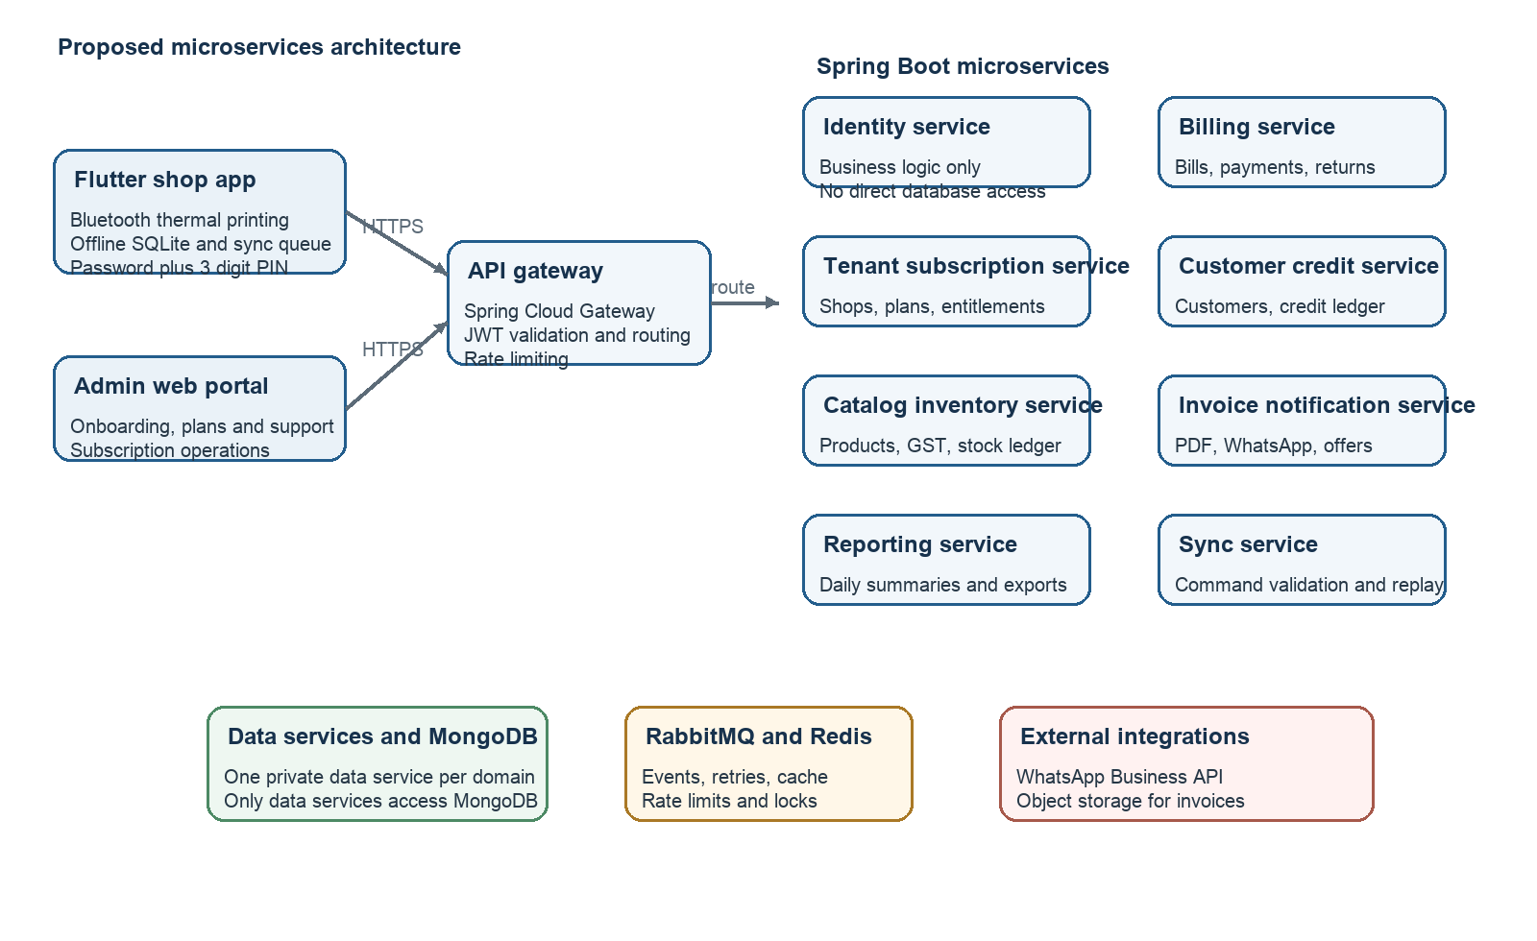
Figure 1 Logical architecture and integration boundaries

Technology decisions
Layer | Recommendation | Notes
Shop app | Flutter with Riverpod or BLoC, encrypted SQLite local store and background sync queue | Android first; Bluetooth integration prints thermal receipts locally; design large touch targets and local language support.
Admin portal | Flutter Web or React | Use the team preferred web stack. It consumes the same secure administrative APIs.
API platform | Java 21, Spring Boot 3, Spring Cloud Gateway, Spring Security, Bean Validation and OpenAPI | Versioned REST APIs at the edge; service to service calls use REST for queries and RabbitMQ events for state changes.
Data | MongoDB replica set, MongoDB transactions where needed and Redis | Each service owns its collections. Redis supports rate limiting, cached reads, locks and short lived tokens.
Async work | RabbitMQ plus retry and dead letter queues | Use events for invoice generation, WhatsApp sends, stock alerts, subscription reminders and reporting projections.
Files and documents | Object storage with short lived signed links | Store generated invoices and exports, not primary business records.
Observability | Structured logs, metrics, error tracking and audit log | Track each tenant separately while protecting PII.

6 Microservices and Responsibilities
All services are Spring Boot applications. Each domain consists of a business service and a matching data service. The data service owns its MongoDB collections and exposes an internal contract only to its paired business service; no business service connects directly to MongoDB and no service writes another domain’s collections. The API gateway is the only public entry point for shop and admin clients.
Service | Responsibilities | Owned data and integration
API gateway | Routes requests, validates access token, applies rate limits, correlates request IDs and exposes versioned external APIs. | No business data. Spring Cloud Gateway; forwards tenant and actor context only after validation.
Identity and access service | Business logic: owner and staff login, PIN and password validation, JWT issuance, roles, lockout and session replacement. | Calls Identity data service only. Publishes user and role change events.
Identity data service | Persistence logic: credential hash lookup, session storage and revocation, user and role persistence. Internal service only. | Owns Identity MongoDB collections. Never applies login or authorization policy.
Tenant subscription service | Onboards shops, maintains plans, payments, status, entitlements and seven day grace period. Provides the authoritative subscription decision. | Tenants, shops, plans, subscriptions and entitlements. Emits activated, expired, suspended and reactivated events.
Catalog inventory service | Categories, products, GST inclusive price, embedded GST rate, stock ledger, opening stock, adjustments and low stock thresholds. | Categories, products, stock ledger and price history. Consumes completed sale and return events.
Billing service | Creates held and completed bills, validates discounts and permissions, records Cash UPI Credit payments, returns and invoice number allocation. | Bills, lines, payments, returns and idempotency keys. Emits bill completed and bill reversed events.
Customer credit service | Customer profile, credit eligibility, credit ledger, collections, outstanding balance and payment reminders. | Customers, credit ledger and collections. Consumes bill and payment events.
Invoice notification service | Creates GST inclusive invoice PDF, sends the invoice through WhatsApp Business API, manages offers, consent, templates, delivery status and retries. | Invoice records, message jobs, consent and delivery logs. Uses object storage and WhatsApp adapter.
Offline sync service | Accepts ordered offline commands, validates signed entitlement, performs idempotency checks, returns reconciliation results and reports conflicts. | Device sync cursor, command receipt, conflict and retry records. Calls billing and inventory through service APIs or command events.
Reporting service | Builds daily sales, GST, payment, product, staff, stock and credit projections; creates export files and daily closing views. | Read models and export jobs only. Consumes events; it never becomes billing source of truth.
Admin operations service | Supports portal workflows: shop lookup, subscription actions, access recovery, audit search, operational health and support notes. | Admin audit, support notes and health summaries. Calls tenant subscription and identity services.

Service communication and data ownership
Data service rule: every business service that needs persisted data has a paired internal data service: Identity data, Tenant subscription data, Catalog inventory data, Billing data, Customer credit data, Invoice notification data, Offline sync data, Reporting data and Admin operations data. Each data service owns a separate MongoDB database or collection namespace and credentials. A business service calls only its own data service through an internal authenticated REST or gRPC interface; it may never query MongoDB directly. Data services do not expose public APIs, do not make business decisions and do not call other domains.
Interaction | Design rule
Synchronous request | Gateway to a service; service to service REST is used only for immediate query or approval needs, such as subscription validation before bill completion.
Asynchronous event | RabbitMQ event is used for bill completion, inventory update, invoice generation, WhatsApp delivery, reporting and low stock updates. Consumers must be idempotent.
MongoDB ownership | Separate database or collection namespace per data service with service credentials. Cross domain views are built from events, not database joins.
Failure handling | Use an outbox record with every business transaction, retry queues and dead letter queues. A failed notification must not roll back a completed bill.

All mutation APIs must be idempotent. Flutter generates a UUID for a bill, payment or stock adjustment; the server stores the idempotency key so a retry cannot create duplicate sales. API responses include server revision and sync outcome.

7 Service Interaction Use Cases
These diagrams turn the architecture into implementation flows. They show which Spring Boot microservices participate, what a successful path produces and how the app behaves when validation fails. Each service must log the correlation ID, tenant ID and actor ID for its part of the flow.
Use case | Primary services | Negative path
Owner or staff login | API gateway, Identity and access service | Invalid credentials or lockout; no session is issued.
Complete a bill | Tenant subscription, Billing, Inventory, Customer credit, Invoice notification, Reporting | Expired or suspended tenant; new bill is rejected and app becomes read only.
Sync offline sale | Offline sync, Billing, Inventory and Tenant subscription | Expired local entitlement, duplicate command or stock conflict; reconcile without duplicate sale.
Send invoice and print | Invoice notification, Object storage, WhatsApp provider; Bluetooth stays in Flutter app | Retry WhatsApp delivery or reprint locally; never reverse a completed sale.
Onboard shop | Admin operations, Tenant subscription and Identity | Reject invalid plan or unauthorised admin; do not expose a partial tenant.
Renew subscription | Tenant subscription and payment provider | Payment decline or verification failure; retain grace or read only status.
Complete credit sale | Billing and Customer credit | Missing customer or credit rule violation; use cash or get owner approval.
Send due reminder | Customer credit, Invoice notification and WhatsApp provider | No consent or delivery failure; record reason and retry eligible messages.

7.1 Login flow
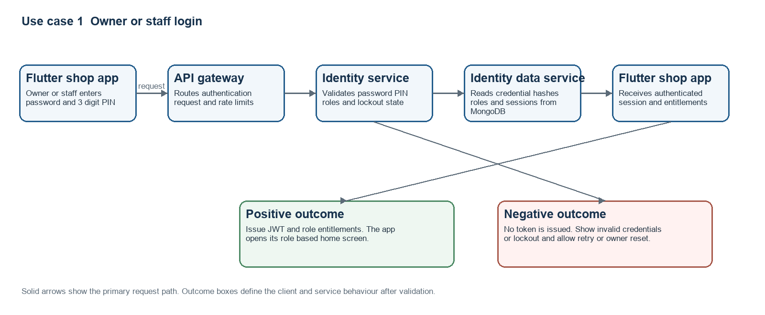
Figure 2 Login interaction with positive and negative response paths

7.2 Bill completion flow
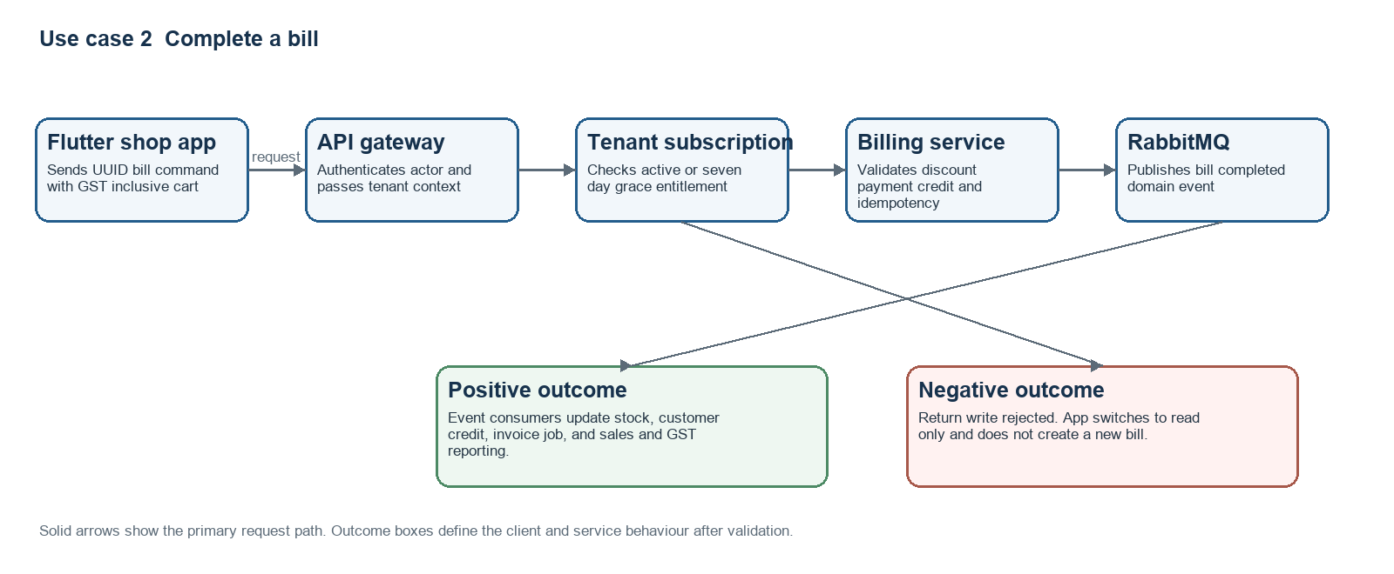
Figure 3 Bill completion across subscription billing and event consumers

7.3 Offline sync flow
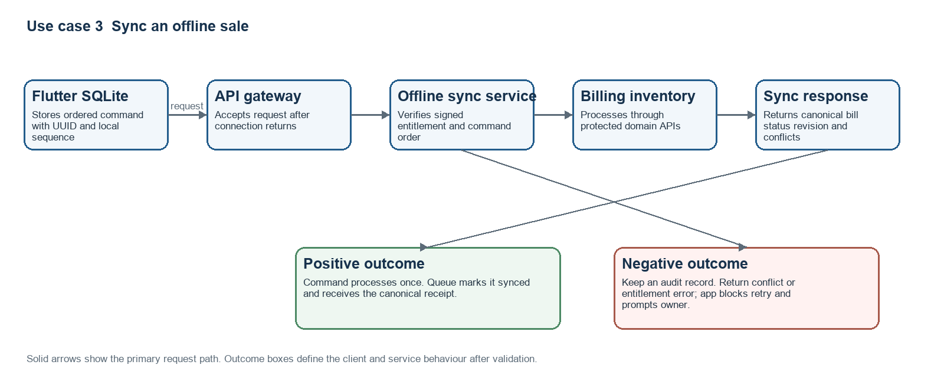
Figure 4 Offline command replay and reconciliation flow

7.4 Invoice and thermal receipt flow
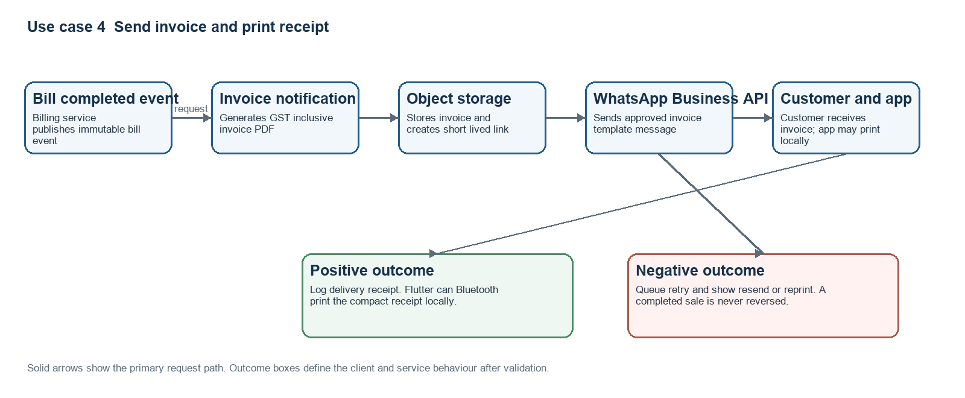
Figure 5 WhatsApp invoice delivery and Bluetooth thermal receipt flow

7.5 Shop onboarding flow
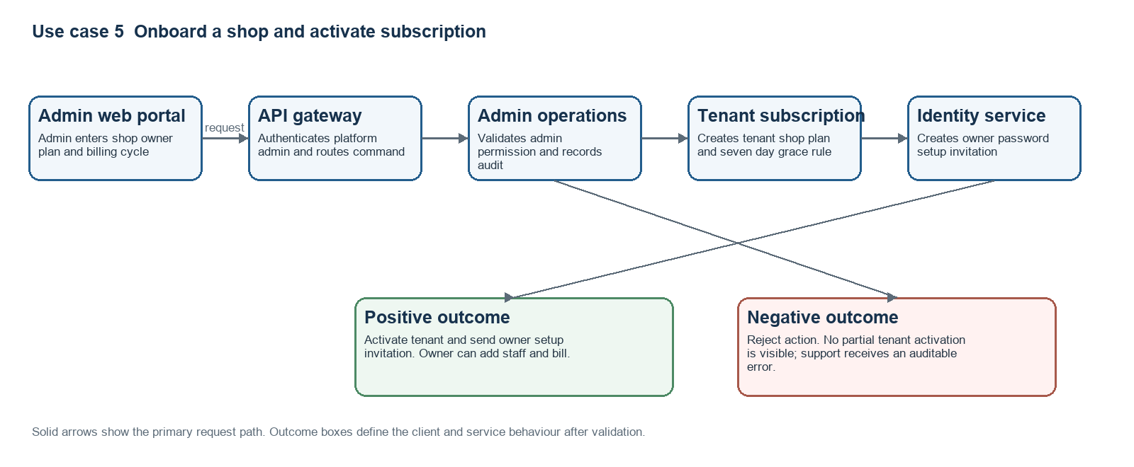
Figure 6 Admin shop onboarding and subscription activation flow

7.6 Subscription renewal flow
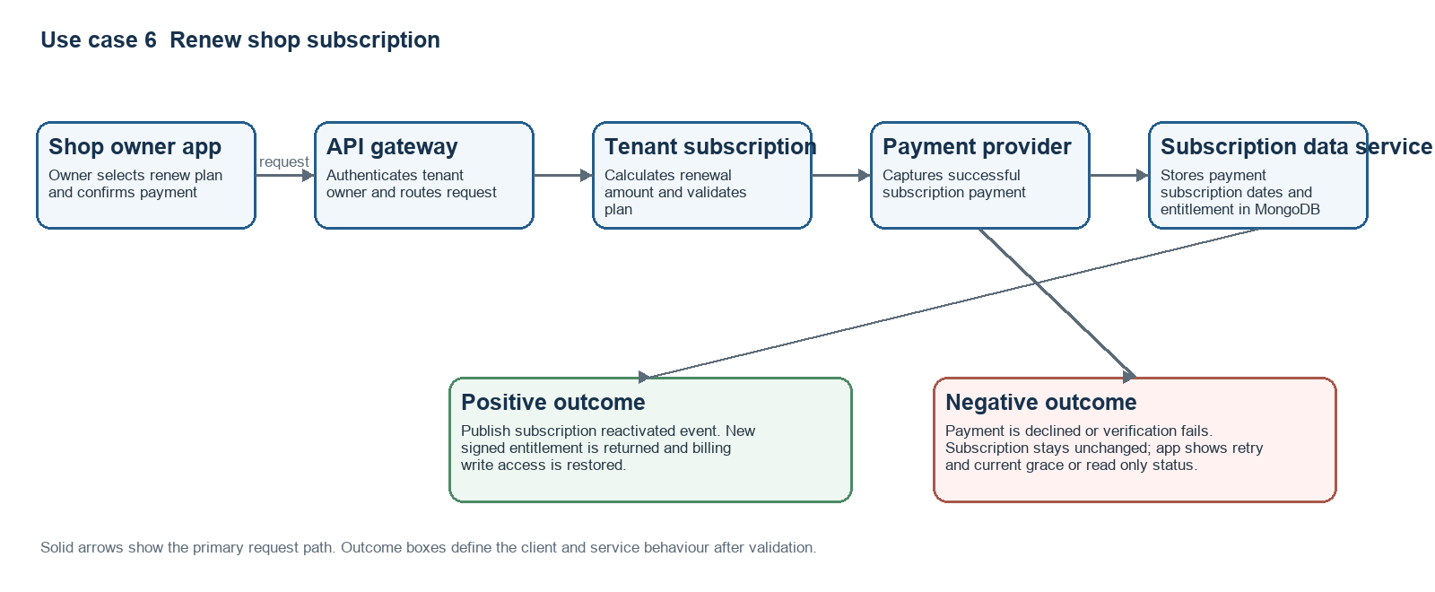
Figure 7 Shop subscription renewal and restored entitlement flow

7.7 Customer credit sale flow
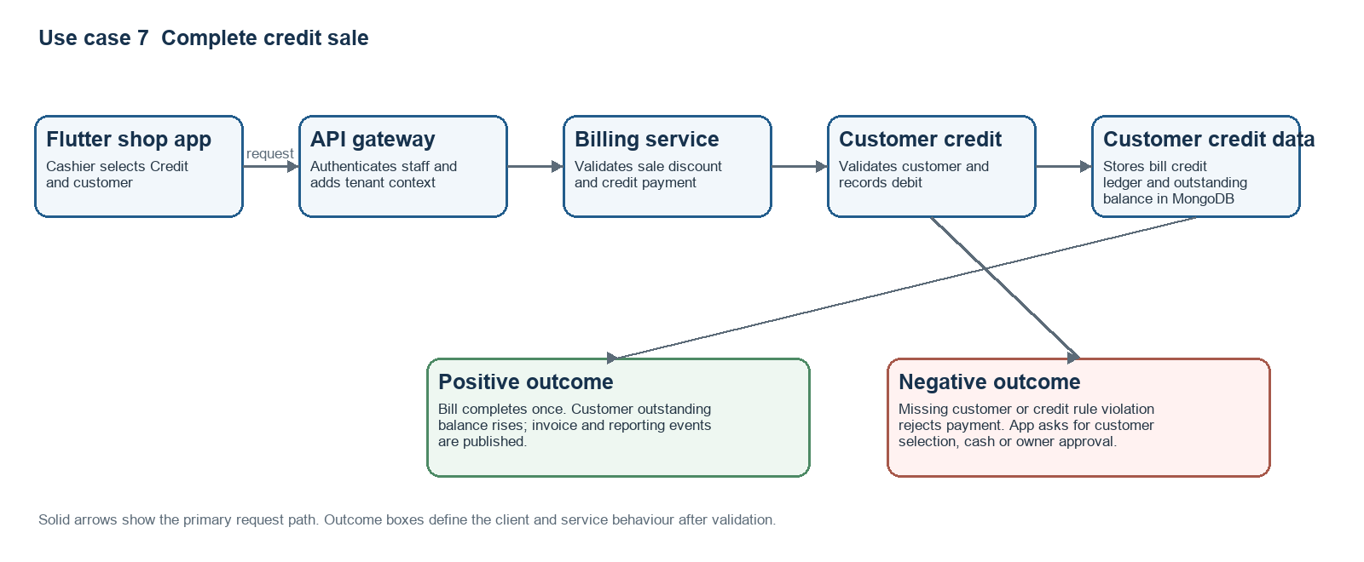
Figure 8 Credit sale and outstanding balance creation flow

7.8 Pending payment reminder flow
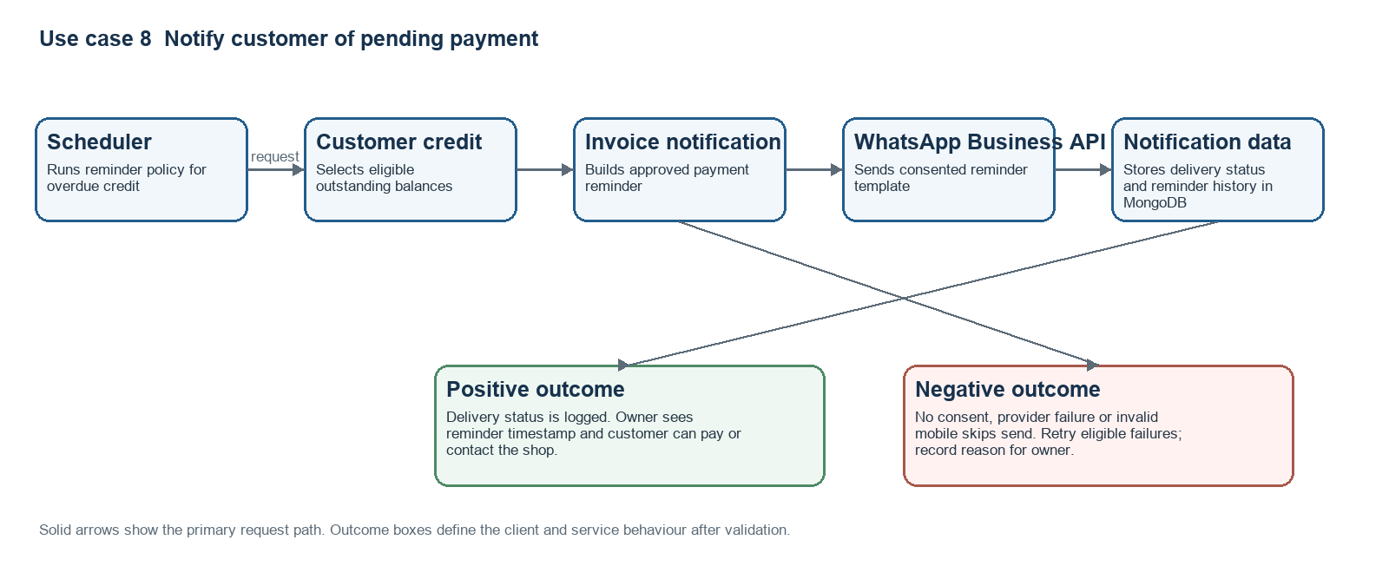
Figure 9 Pending payment reminder flow

8 Core Data Model
Entity | Key fields and relationships
Tenant and Shop | tenantId, shop profile, timezone, currency, settings. Every operational entity is tenant scoped.
User and StaffProfile | userId, tenantId, role, password hash, 3 digit PIN hash for staff, permissions, active status and failed login counters.
Subscription | tenantId, plan, status, start date, end date, seven day grace end, entitlement snapshot, payment references.
Product and Category | productId, categoryId, name, SKU optional, GST inclusive selling price, embedded GST rate and active status.
InventoryLedger | productId, quantity delta, reason, related sale or adjustment, actor, timestamp. Quantity on hand is derived or maintained transactionally.
Bill and BillLine | bill number, tenant, customer optional, staff actor, status, discount, GST inclusive payment totals; each line stores product name, inclusive price and GST snapshot.
Payment and CreditLedger | bill relation, method, amount, collection reference; credit debit and settlement entries are immutable.
Customer and Consent | name, mobile, outstanding balance projection, WhatsApp marketing consent and communication history.
AuditLog and SyncEvent | actor, action, target, timestamp, before after summary; device, entitlement and retry context where applicable.

9 Critical Workflows and Rules

Sale completion
- The cashier adds products by double tapping a product tile. The cart validates active product and available stock before completion.
- Discount may be percentage or fixed amount. Server checks owner configured staff limit and ensures discount does not exceed bill subtotal. Product price is GST inclusive; bill lines snapshot the inclusive price and embedded GST rate.
- Credit payment requires a customer. Completing the bill writes the bill, payment/credit ledger, inventory ledger and audit event in one database transaction.
- Invoice number is allocated by the server or preallocated safe ranges for offline use. Successful sync returns the canonical receipt.
- Flutter pairs with a supported Bluetooth thermal printer and renders a compact receipt locally. Print failure never reverses the sale; cashier can reprint or send the invoice through WhatsApp.

Offline sync
- Local database holds encrypted session data, current catalog, product stock snapshot and pending command queue.
- Queued commands have UUID, device timestamp, local sequence and retry count. Upload in order per device; server idempotency ensures safe retries.
- A stock conflict is surfaced when an offline sale exceeds server quantity. The sale remains auditable; owner receives a reconciliation task rather than silent data loss.
- Subscription and staff permissions are cached only for their signed validity window. The server always evaluates current status once online.

10 Security and Reliability
- Use TLS for all traffic, short lived JWT access tokens, refresh token rotation and password plus 3 digit PIN hashes using a password hashing algorithm such as Argon2 or BCrypt. Apply rate limits and lockout after repeated failures.
- Enforce tenant scoping in the service and repository layer; never trust a tenant identifier supplied by the client.
- Record immutable audit events for sales, voids, returns, discounts, stock changes, credit collections, subscription updates and admin support actions.
- Encrypt backups and object storage, apply role based access control, limit admin support impersonation and mask customer mobile numbers in routine logs.
- Perform automated database backups, test restores, monitor failed syncs and outbound message retries, and use error alerts with tenant safe context.
- Use feature flags for staged rollout of WhatsApp, credit and offer capabilities; do not expose unfinished features through plan entitlements.

11 Recommended Missing Features
The following additions provide high value without changing the core direction. They should be prioritized deliberately rather than all added to the first release.
Priority | Feature | Why it matters
P0 | Bill hold and resume | Counter staff can park one customer bill while serving another.
P0 | Returns, exchange and void policy | Garment shops need a controlled way to reverse or exchange a sale; require owner approval or configured staff permission.
P0 | Daily closing and cash reconciliation | Owner compares expected cash with counted cash and records variance.
P0 | Data export and migration | CSV export for bills, products, customers and credit protects shop trust and helps onboarding.
P1 | Product variants | Size, colour and design can be implemented after the simple SKU workflow is stable.
P1 | Purchase and supplier ledger | Supports stock receiving, cost history and payables when inventory discipline improves.
P1 | Local languages | Hindi plus a region selected language; retain simple labels and icon assisted navigation.
P1 | Price override approval | Owner PIN confirmation for staff price changes, high discounts and negative stock.
P2 | Customer loyalty | Points or visit based offers, only after consent and the credit ledger are reliable.
P2 | Multi shop owner view | Useful when the product expands from single stores to local chains.

12 Delivery Plan
Release | Scope | Exit criteria
Foundation | Tenant, authentication, shop onboarding, plans and subscription gate; Flutter project setup, local store and sync protocol | An active tenant can sign in; expired tenant mutations are rejected by API and app shows read only state.
MVP billing | Catalog, stock ledger, billing, discounts, Cash UPI Credit, staff PIN, customer credit, reports and thermal WhatsApp receipt integrations | A small shop can complete and reprint a bill online or offline; synced sale does not duplicate.
Operations | Admin dashboard, renewal workflows, audit, support tooling, daily closing, returns and exports | Platform team can onboard, renew, suspend and diagnose a shop without database access.
Growth | Offers with consent, variants, suppliers, languages, loyalty and multi shop reporting | Features are measured, entitlements are robust and support load is controlled.

13 Confirmed Decisions and Remaining Open Items
- Confirmed: MongoDB is the operational database, deployed as a replica set. Each microservice owns its collections and uses MongoDB transactions only within its own boundary.
- Confirmed: Flutter supports offline work through encrypted SQLite and a signed entitlement; the authoritative platform is Spring Boot microservices.
- Confirmed: Product prices include GST. Bills display the inclusive total and retain the embedded GST breakdown required by the configured invoice format.
- Confirmed: Staff sign in with a password plus a 3 digit PIN. Apply lockout and owner controlled resets because the PIN has low entropy.
- Confirmed: Thermal receipts print through Bluetooth from the Flutter device. Invoices are generated by the Invoice notification service and sent through WhatsApp Business API.
- Confirmed: Subscription expiry provides a 7 day grace period. After grace, the shop is read only and protected backend writes are rejected.
- Select the initial WhatsApp Business provider and agree on template approval, opt in and per message cost ownership.
- Confirm the supported Bluetooth thermal printer models and Flutter plugin compatibility. Provide a device compatibility matrix before committing to a plugin.
- Confirm GST invoice fields, invoice numbering and whether an owner can choose inclusive tax rate by product or category.
- Choose the password reset flow for owner and staff accounts: owner assisted, mobile OTP, or both.
- Decide the initial offline stock policy: block completion when locally known stock is zero, or permit sale and flag reconciliation.

14 Definition of Done for MVP
- A shop owner can be onboarded by an admin, activate a subscription and invite staff.
- A staff member can add products using the tile and double tap workflow, apply allowed discount, collect payment and issue an invoice.
- Every completed bill updates inventory, payments, customer credit and reporting exactly once, including after network retries.
- An expired subscription cannot create a bill or modify data through either the UI or direct API request.
- Owner can view daily sales, cash UPI Credit totals, low stock, staff sales and outstanding credit.
- Admin can search the shop, renew or suspend it, reset access and review the relevant audit history.

