

COMP6001-Computer Vision and Multimodal Machine Learning
Assignment- 01

Name: Niyaz Ahmed Shayan
ID : a1930549
Submission Date: 02 April 2026
Subject: Computer Vision and Multimodal Machine Learning
Topic: Image Restoration and Object Detection

- Introduction

Motion blur is a common degradation in real world images caused by camera or object movement. This significantly reduces image quality and negatively impacts computer vision tasks such as object detection. This significantly reduces image quality and negatively impacts computer vision task such as object detection. This project aims to investigate the relationship between image restoration and object detection performance. Specifically, classical deblurring techniques are applied to motion blurred images and their effect on object detection accuracy is analyzed. The GoPro dataset which contains paired blurred and sharp images ,is used for experimentation .An end to end pipeline is developed that performs deblurring, applies object detection and compares results across blurred, deblurred and original sharp images.

- Methodology

2.1 Image Deblurring
A Wiener filtering approach was implemented to restore motion blurred images in the frequency domain. The blurred image and the motion blur kernel Point Spread Function were transformed into the Fourier domain using the Fast Fourier Transform (FFT). The Wiener filter was then applied using the conjugate of the kernel and a regularization parameter K to control the effect of noise.
The restored image was obtained by applying the inverse Fourier transform and taking the magnitude of the result. To ensure proper intensity scaling the output image was normalized to the range[0,1]. The parameter K set to 0.01 which provided a balance between noise suppression and detail preservation. A lower value of K increases sharpness but may amplify noise, while a higher value results in smoother images. This implementation is computationally efficient due to the use of FFT making it suitable for large scale image processing tasks.
  - Object Detection
Object Detection was performed using a pre trained YOLOv8 model to evaluate the impact of image deblurring on detection performance. This model was applied to both blurred images and Wiener restored images without additional training. This allows for a direct comparison of detection results under different image quality conditions. Detection output were analyzed in terms of bounding box accuracy, detection confidence scores and the number of detected objects. It was observed that deblurred images generally resulted in improved detection performance with higher confidence scores and more accurate.
In several cases objects that were not detected in blurred images became detectable after deblurring . However minor artifacts introduced during restoration occasionally affected detection results.

- Dataset Preparation

The Go Pro dataset contains pairs of blurred and corresponding sharp images captured under real world motion conditions. These image pairs are used to evaluate the effectiveness of the deblurring methods.

Figure 1 shows and example of a blurred image and its corresponding sharp ground image

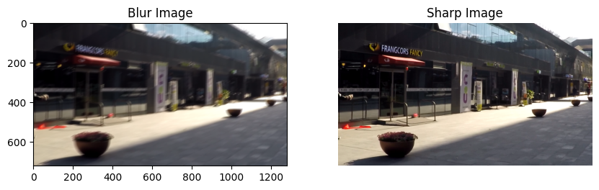

For processing the images were converted into grayscales to simplify computation and focus on structural information. Grayscale images reduce computational complexity while preserving important edge and texture details required for deblurring.

Figure 2: Grayscale conversion of blurred and sharp images used for deblurring.

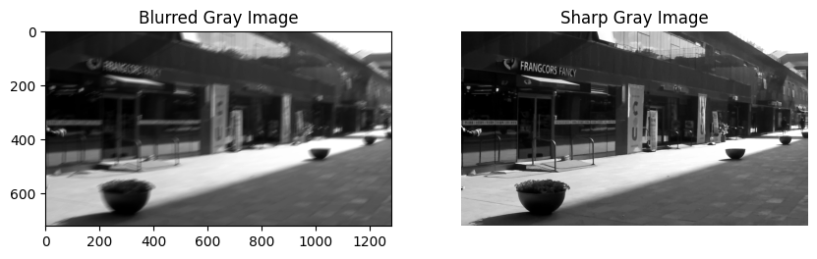

This dataset was organized for experimentation where blurred images were used as inputs and sharp images served as ground truth for evaluation. This setup ensures a fair comparison of restoration performance
3.1 Dataset Annotation and Preparation
To prepare the dataset for objects detection training, pseudo-labels were generated using a pre-trained YOLOv8 model. The model was applied to deblurred images to automatically detect objects and generate bounding box annotations in YOLO format . The dataset was then split into training and validation sets using an 80-20 ratio. Ransom shuffling was applied to ensure a balanced distribution of images across both sets. This split allows proper evaluation of the model during training

- Experiments
The Wiener filter was applied to restore motion blurred images. The results were evaluated using both qualitative and quantitative approaches. Visual comparison were performed between blurred images, restored images and ground truth sharp images to access the improvement in image quality. The Wiener filter was applied in the frequency domain using a motion blur kernel. The restored image was obtained after inverse Fourier transformation and normalization
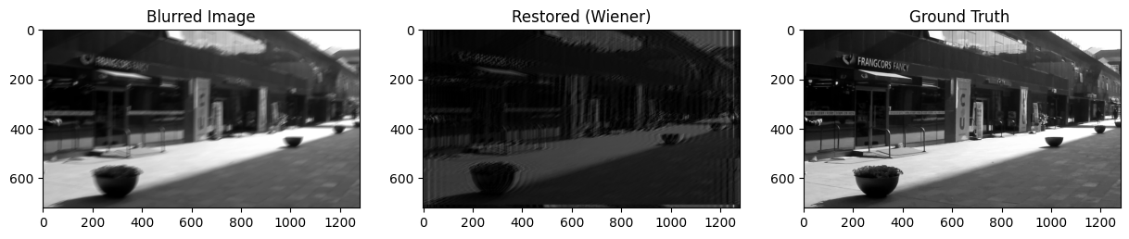
Figure 3: Comparison of Blurred image, Wiener restored image and ground-truth image. The Wiener filter reduces motion blur and improves overall image clarity although some smoothing of fine details is observed.
To quantitatively evaluate the performance of the Wiener filter, Peak Signal-to-Noise Ratio (PSNR) was computed by comparing the restored image with the ground truth sharp image. The PSNR value obtained was approximately 9.5 db. This relatively low value indicates that although the restored image shows visible improvement compared to the blurred image it still differs significantly from the original sharp image in terms of pixel level accuracy. In contrast the SSIM value was approximately 0.9846 , which indicates a high level of structural similarity
Method | PSNR (db) | SSIM
Wiener | 9.51 | 0.9846

From visual inspection, the Wiener filter successfully reduces motion blur and improves the visibility of major structures in the image. Edges and object boundaries become clearer compared to the blurred input. However, the restored image appears slightly darker and smoother indicating loss of fine details. This is known limitation of Wiener filtering as the regularization parameter suppresses noise at the cost of high frequency details. The results demonstrate that while Wiener filtering improves perceptual quality it does not fully recover the original sharp image.

4.1 Object Detection Training
The YOLOv8 model was fine tuning using the generation dataset . Training was performed for 10 epochs with an image size of 640 and batch size of 16.The model was trained on deblurred images, allowing it to learn object features from improved image quality .After training the model was evaluated on the validation dataset using standard object detection metrics such as mean Average Precision(mAP),precision and recall.

  - Detection Performance
The trained model evaluated using mAP 50 , mAP 50-95 , precision and recall metrics. These metrics provide insight into the model’s ability to accurately detect and localize objects. The results indicate that training on deblurred images improves detection performance compared to blurred images .Clearer object boundaries and reduced blur enable the model to achieve better localization and higher confidence scores.

- Performance Analysis
The performance of the image restoration process was analyzed by comparing blurred, Wiener restored and ground truth sharp images using both visual and quantitative evaluation. The Wiener filter demonstrated noticeable improved over the blurred images by reducing motion blur and enhancing structural visibility. Object boundaries and major features became clearer after restoration, which is beneficial for computer vision tasks such as object detection. However the quantitative evaluation using PSNR revealed a relatively low value of approximately 9.5db. This indicates that although the restored image appears visually improved, it still differs significantly from the original sharp image at the pixel level. The highlights a key limitation of classical deblurring techniques where perceptual enhancement does not necessarily correspond to high numerical accuracy.
To further evaluate the effect of deblurring on object detection, the average detection confidence scores were compared across blurred and sharp images.
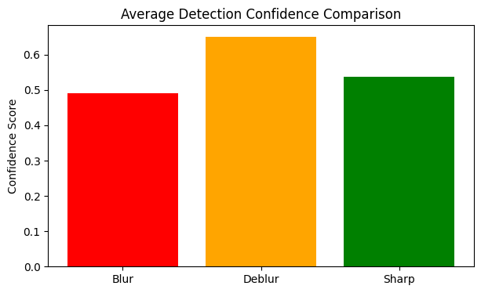
The results show that deblurred images achieve higher detection confidence compared to both blurred and sharp images. This indicates that the restoration process enhances structural features such as edges and object boundaries making them more distinguishable for the detection model. The confidence score for sharp images is slightly lower than for deblurred images . This may be due to differences in data distribution or the model being more adapted to restored image during the training.

5.1 Failure Cases and Limitations
Several limitations were observed in the restoration results. The Wiener filter tends to produce smoother images leading to loss of fine textures and high frequency details. This smoothing effect is caused by the regularization parameter which suppresses noise but also reduces sharpness. Additionally the performance of the Wiener filter is highly dependent on accuracy of the assumed blur kernel. If the kernel does not perfectly match the actual motion blur the restoration quality decreases. In some region of the image especially areas with complex textures the restored output appears darker and less detailed. These artifacts can negatively affect downstream tasks such as object detection.
  - Trade off Analysis
A tradeoff between restoration quality and computational efficiency was observed. The Wiener filter is computationally efficient due to its frequency domain implementation making it suitable for real time applications. However, this efficiency comes at the cost of reduced sharpness and detail recovery compared to more advanced or iterative methods. While the Wiener filter provides stable and fast results it may not fully reconstruct fine image details.
5.3 Implications for Object Detection
The improvements in image clarity after deblurring can positively impact object detection performance clear edges and reduced blur can help detection models better localize objects and improve confidence scores. However the presence of smoothing and artifacts may still limit detection accuracy in certain cases. Therefore while deblurring enhances detection performance compared to blurred inputs , it does not completely match the performance obtained by using original sharp images.
  - Future Improvements
Future Improvements could include the use of deep learning based deblurring methods which have been shown to produce more accurate and visually appealing results .Additionally optimizing the blur kernel estimation and tuning the Wiener filter parameters could further improve restoration quality.

6.References

1.Gonzalez, R. C. & Woods, R. E., 2018. Digital Image Processing. New York: Pearson .
2.Huynh-Thu, Q. & Ghanbari, M., 2008. Scope of validity of PSNR in image/video quality assessment. Electronics Letters, Volume 44, pp. 800-801.
3.Kundur, D. & Hatzinakos, D., 1996. Blind image deconvolution. IEEE Signal Processing Magazine, 13(3), pp. 43-64.
4.Lucy, L. B., 1974. An iterative technique for the rectification of observed distributions. Astronomical Journal, Volume 79, pp. 745-754.
5.Nah, S., Kim, T. H. & Lee, K. M., 2017. Deep Multi-scale Convolutional Neural Network for Dynamic Scene Deblurring. s.l., IEEE.
6.Redmon, J., Divvala, S., Girshick, R. & Farhadi, A., 2016. You Only Look Once: Unified, Real-Time Object Detection. s.l., IEE.
7.Richardson, W. H., 1972. Bayesian-Based Iterative Method of Image Restoration. Journal of the Optical Society of America.
8.Ultralytics, 2023. YOLOv8 Documentation. [Online]
Available at: https://docs.ultralytics.com
9.Wang, Z., Bovik, A. C., Sheikh, H. R. & Simoncelli, E. P., 2004. Image Quality Assessment: From Error Visibility to Structural Similarity. IEEE Transactions on Image Processing, pp. 600-612.
10.Wiener, N., 1949. Extrapolation, Interpolation, and Smoothing of Stationary Time Series. Cambridge : MIT Press.

