Run the program
- Place sodium.jar, swidgets.jar, org.hamcrest_3.0.0.jar and org.junit_4.13.2.v20240929-1000.jar in the root folder
- Place a src/ folder in the root folder
- Place all the .java into the src/ folder
- Execute commnd
javac -d bin -cp ".;org.hamcrest_3.0.0.jar;sodium-1.2.0.jar;swidgets.jar;org.junit_4.13.2.v20240929-1000.jar" src\*.java
in the root folder in the terminal
- A bin folder will be created in the root folder
- Execute command
java -cp ".;org.hamcrest_3.0.0.jar;bin;sodium-1.2.0.jar;swidgets.jar;org.junit_4.13.2.v20240929-1000.jar" Main
to run the application in the root folder in the terminal
- Execute command
- java -cp ".;org.hamcrest_3.0.0.jar;bin;sodium-1.2.0.jar;swidgets.jar;org.junit_4.13.2.v20240929-1000.jar" org.junit.runner.JUnitCore FrameManager_Test
to run the unit test in the root folder in the terminal

Testing

There are some logical function tests to validate the computational and reactive parts of the program. Some components, such as real-time display updates or GUI responsiveness, cannot be fully tested through Junit as the application includes a GUI built with Swing and Sodium FRP. Therefore, those features needed to be tested manually by using screen capture in this report.

Junit
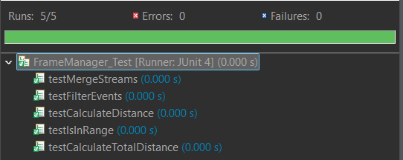

testMergeStreams

This test verifies that the mergeStreams function can combine multiple Sodium Stream<GpsEvent> objects into a single stream. It can ensure that updates from all sources propagate correctly.

testFilterEvents

Ensure the filterEvents function can successfully filter a list of GPS events and return only the event if they are in range (within the given latitude and longitude boundaries)

testCalculateDistance

To confirm the calculateDistance function correctly computes the distance between two GPS coordinates with three values (latitude, longitude and altitude).

testIsInRange

Verifies that the isInRange function determines whether a GPS event’s latitude and longitude fall within a specified range correctly.

testCalculateTotalDistance
Check if the calculateTotalDistance function calculates the sum of total travel distance between a list of consecutive GPS events.

Manually Test with Screen Capture

Ten Tracker Simplified Display
The application GUI displays ten trackers, and their latitude and longitude are updated in real time when new data is received. The altitude value is removed from display.

Most Recent Event Display
The latest event panel shows the most recently received data from gps.dat using the merged stream. It keeps updating when new data is received, and only displays the latest event.
If there is no new data received after 3 seconds, the label will change to “Waiting for tracker events…”.

Filter Display by Latitude and Longitude
There are four input fields for the user to enter the distance range. Once they enter the values, they can click the “Set Range” button to apply the range. The default range is latitude -90 to 90 and longitude -180 to 180.
The current range panel value will change based on the input field.

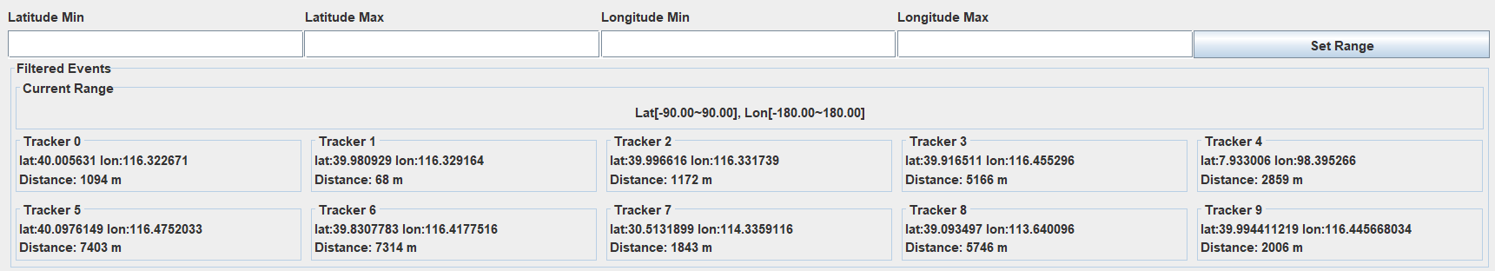
Under the current panel, there is ten tracker displayed, it is as same as the “Ten Tracker Simplified Display”, but an extra “Distance” value. By default latitude and longitude, the panel display all the trackers.
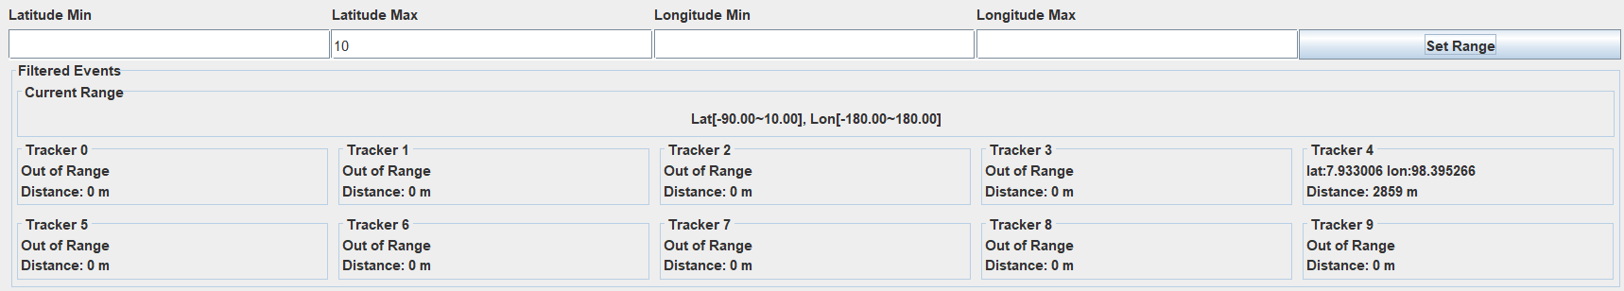
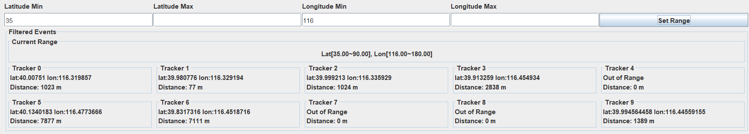
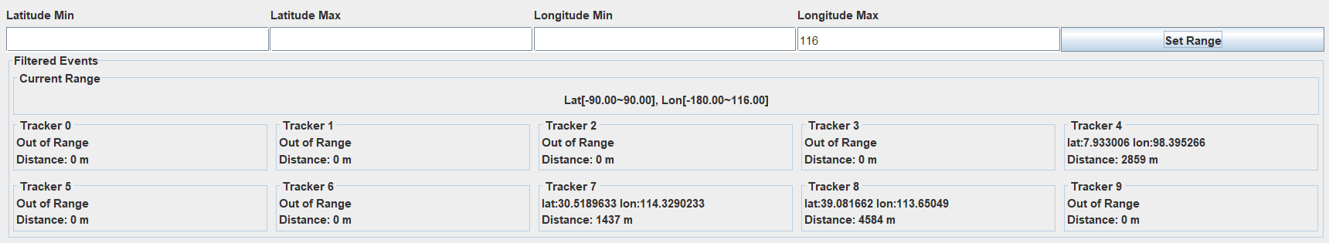
The filtered ten tracker panel will show the information only if they are in range. Otherwise, their label will be marked as out of range.

Distance Calculation
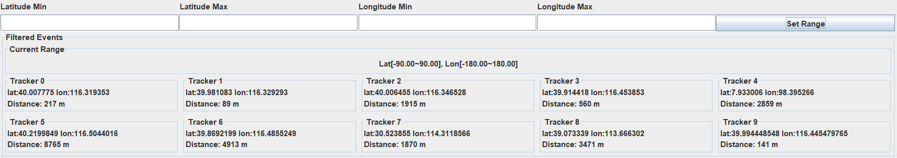
There is a total distance value display under the latitude and longitude value in each tracker. It will calculate the total distance with all the event within the range.
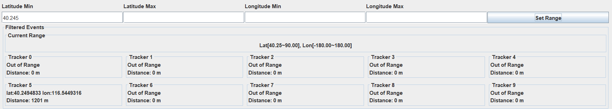
Take Tracker 5 as an example. It only calculates the events where the latitude and longitude are within the specified range. The distance has reduced from around 8765 m to 1201 m.
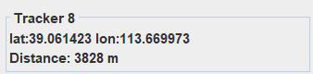
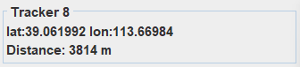
Also, take Tracker 8 as an example. Tracker 8’s distance keeps decreasing because the distance is calculated only based on events within the last 5 minutes. Tracker 8 may either have not received new data or its new movement is smaller than the data recorded earlier within that 5-minute window.

Filtered Most Recent Event Display
There is a latest filtered event panel that works the same way as the “Latest Event” panel. The only difference is that it displays only the received data that are within the specified range.
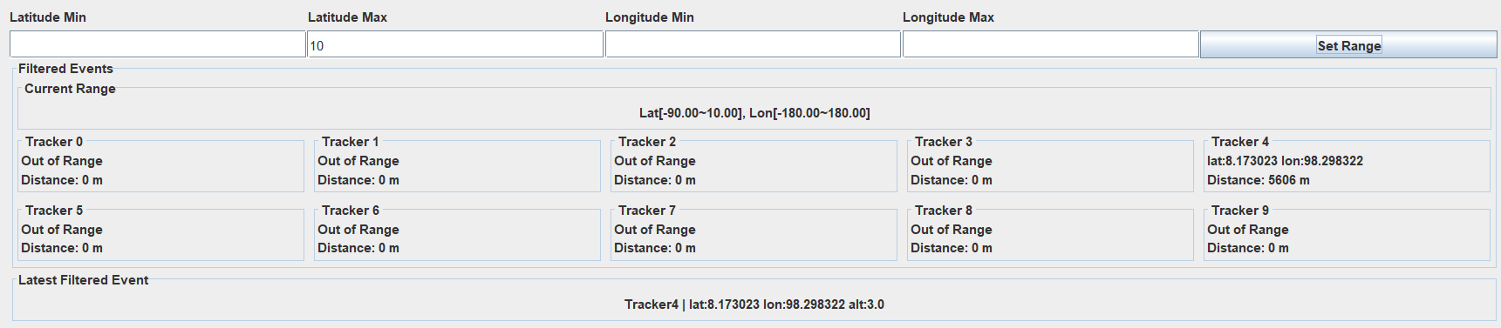
For example, it will display Tracker 4 only if the other trackers are out of range.

