Enterprise Risk Management Analytics:
A Comprehensive Assessment of Microsoft’s
Cybersecurity Platform Acquisition

Prepared by:
Honglin Wang, Chuanli Yang, Raymond Twumasi Opoku

ALY 6130: Risk Management for Analytics
Northeastern University
March 2026

Background
This report presents a comprehensive enterprise risk management (ERM) analytics assessment for Microsoft Corporation’s proposed acquisition of a mid-sized cybersecurity-as-a-service (CaaS) platform company specializing in AI-driven threat detection and zero-trust architecture solutions. The acquisition represents a significant strategic initiative that would expand Microsoft’s presence in the rapidly growing cybersecurity market, placing the company in direct competition with specialized vendors such as CrowdStrike, Palo Alto Networks, and Fortinet—a competitive environment Microsoft has not yet fully experienced at this scale (Fraser & Simkins, 2016). As Hopkin (2018) emphasizes, ERM provides a structured framework for identifying, assessing, and managing risks across an organization in a holistic manner, and this assessment applies that framework to evaluate the multidimensional risk profile of the proposed acquisition.
The assessment builds upon several phases of analytical work conducted throughout the course. The initial phase involved a S.W.O.T. analysis with an ERM focus that identified internal strengths and weaknesses alongside external opportunities and threats, with particular attention to technical risk and information security risk (Bromiley et al., 2015). The second phase established a structured risk register identifying three primary competitive risks—two negative and one positive—each articulated through formal risk statements following Hillson’s (2009) recommended format. Subsequent phases incorporated qualitative assessment using Scenario Analytics and Industry Fusion Analytics, followed by quantitative analysis employing Indicators and Warning (I&W) techniques, Monte Carlo simulation, and machine learning validation (Grabo et al., 2004; Vose, 2008). The final phase developed Key Risk Indicators (KRIs) with threshold-based escalation protocols aligned with the COSO (2017) ERM framework.
Microsoft’s existing security division already generates over $20 billion in annual revenue, and the proposed acquisition of a dedicated cybersecurity platform would further consolidate the company’s position as a full-spectrum enterprise technology provider (IT Daily, 2025). However, the cybersecurity market’s complexity, the elevated threat landscape during integration, and the intense competitive dynamics require a rigorous, evidence-based risk evaluation that goes beyond descriptive analysis. This report aggregates all prior work into an integrated assessment designed to inform executive decision-makers by providing quantifiable risk metrics, probabilistic modeling outputs, and actionable risk response strategies grounded in industry-standard methodologies.

Identification of Risks
Three competitive risks were identified through a systematic process that integrated SWOT findings, competitive intelligence analysis, and ERM principles. The risk identification process followed the COSO (2017) framework, which emphasizes evaluating risks in terms of both potential losses and upside opportunities. Each risk was articulated using Hillson’s (2009) structured format of “The risk of… caused by… resulting in…” to ensure clarity regarding cause, event, and consequence. A total of 40 sub-risks were developed across the three areas (15 for Market Share Loss, 15 for Data Breach, and 10 for Enterprise Acquisition), each scored on Likelihood (7–12) and Impact (4–9) dimensions. The risk heatmap in Figure 1 displays the concentration of these sub-risks across the Likelihood-Impact scoring space.
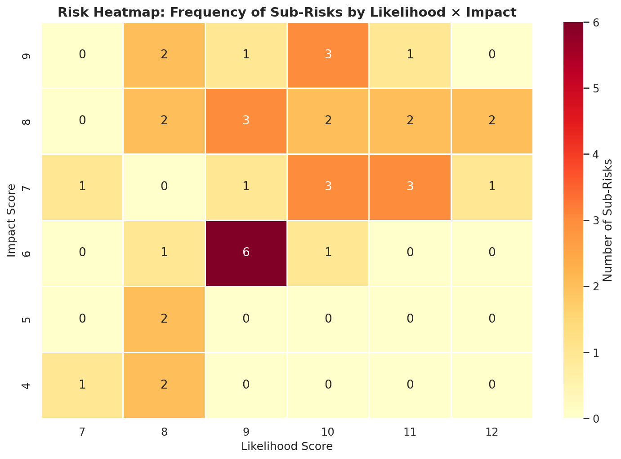
Figure 1. Risk Heatmap Displaying Frequency of Sub-Risks by Likelihood and Impact Score.
The heatmap reveals that the majority of risks cluster in the medium-to-high quadrant, with the densest concentration at Likelihood 9–10 and Impact 6–7 representing competitive market share risks. The upper-right quadrant (Likelihood 10–12, Impact 8–9) contains the most critical risks—primarily data breach sub-risks—confirming their classification as the highest-priority threats. No risks appear in the low-likelihood, low-impact region, consistent with the high-stakes nature of cybersecurity acquisitions (Cybersecurity HQ, 2024).

Risk 1 (Negative): Loss of Cybersecurity Market Share to Specialized Competitors
The risk of losing cybersecurity market share to specialized competitors is caused by entering the dedicated cybersecurity market where agile, focused competitors such as CrowdStrike and Palo Alto Networks have established brand loyalty, deeper domain expertise, and faster product release cycles. This could result in failure to achieve projected acquisition synergies, reduced return on investment, customer attrition to competitors offering more specialized solutions, and diminished credibility as a cybersecurity provider (Bromiley et al., 2015). CrowdStrike and Palo Alto Networks are reporting annual revenue growth rates exceeding 25%, and the first 12 to 18 months post-acquisition represent a critical window during which enterprise customers will evaluate Microsoft’s competitive viability (Fraser & Simkins, 2016). The likelihood was assessed at 4 (Likely) and impact at 4 (Major), producing a risk score of 16 in the High priority category.

Risk 2 (Negative): Critical Data Breach During Platform Integration
The risk of a critical data breach or security incident during platform integration is caused by merging disparate technology architectures and security frameworks that create temporary vulnerabilities, expanded attack surfaces, and potential misconfigurations in access controls during the transition period. This could result in exposure of sensitive threat intelligence data or customer information, regulatory penalties under GDPR and CCPA, loss of customer trust, class-action litigation, and reputational damage that undermines the core value proposition of the cybersecurity acquisition (COSO, 2017). Nation-state actors and advanced persistent threats (APTs) actively target organizations undergoing major technology transitions because security controls are often temporarily relaxed or inconsistently applied (NIST, 2018). The likelihood was assessed at 3 (Possible) and impact at 5 (Catastrophic), producing a risk score of 15 in the High priority category.

Risk 3 (Positive): Accelerated Enterprise Customer Acquisition Through Bundled Security Offerings
The opportunity for accelerated enterprise customer acquisition through bundled security-compliance offerings is caused by growing regulatory pressure under GDPR, CCPA, and emerging AI governance frameworks compelling enterprises to seek unified compliance-security platforms, combined with the fact that no single competitor currently offers an integrated solution at Microsoft’s scale. This could result in capturing market share from competitors who offer point solutions, increasing average revenue per enterprise customer, establishing Microsoft as the de facto standard for enterprise security compliance, and creating significant switching costs that strengthen long-term customer retention (Hopkin, 2018). The likelihood was assessed at 4 (Likely) and positive impact at 4 (Major), producing a risk score of 16 representing significant upside potential.

Qualitative Risk Assessment
The qualitative assessment phase employed two primary analytical frameworks: Scenario Analytics and Industry Fusion Analytics, as outlined in Fleisher and Bensoussan (2015). These techniques provided structured methods for evaluating risk characteristics before committing to resource-intensive quantitative modeling, and their findings directly informed the design of subsequent quantitative assessments.

Scenario Analytics
Scenario Analytics was applied to each risk area by developing best-case, most-likely, and worst-case narratives across five measurable dimensions per risk. Figure 2 presents the normalized scenario comparison across all three risk areas. For Risk 1 (Market Share Loss), the worst-case scenario envisioned Microsoft losing more than 75% of contested enterprise deals with a competitive win rate dropping to 25%, customer churn reaching 15%, and revenue impact of $400 million, while the best case projected a 55% win rate with minimal churn and only $50 million in competitive losses. For Risk 2 (Data Breach), the worst case involved 25 unresolved vulnerabilities, a 60% breach probability, potential regulatory fines exceeding $800 million, and 18 months of recovery time. The most-likely scenario projected 8 unresolved vulnerabilities with containable incidents. For Risk 3 (Enterprise Acquisition), the worst case anticipated pipeline growth of only 4% monthly with an extended 24-month time to market, while the best case projected 20% monthly growth with market entry in 8 months (Fleisher & Bensoussan, 2015).
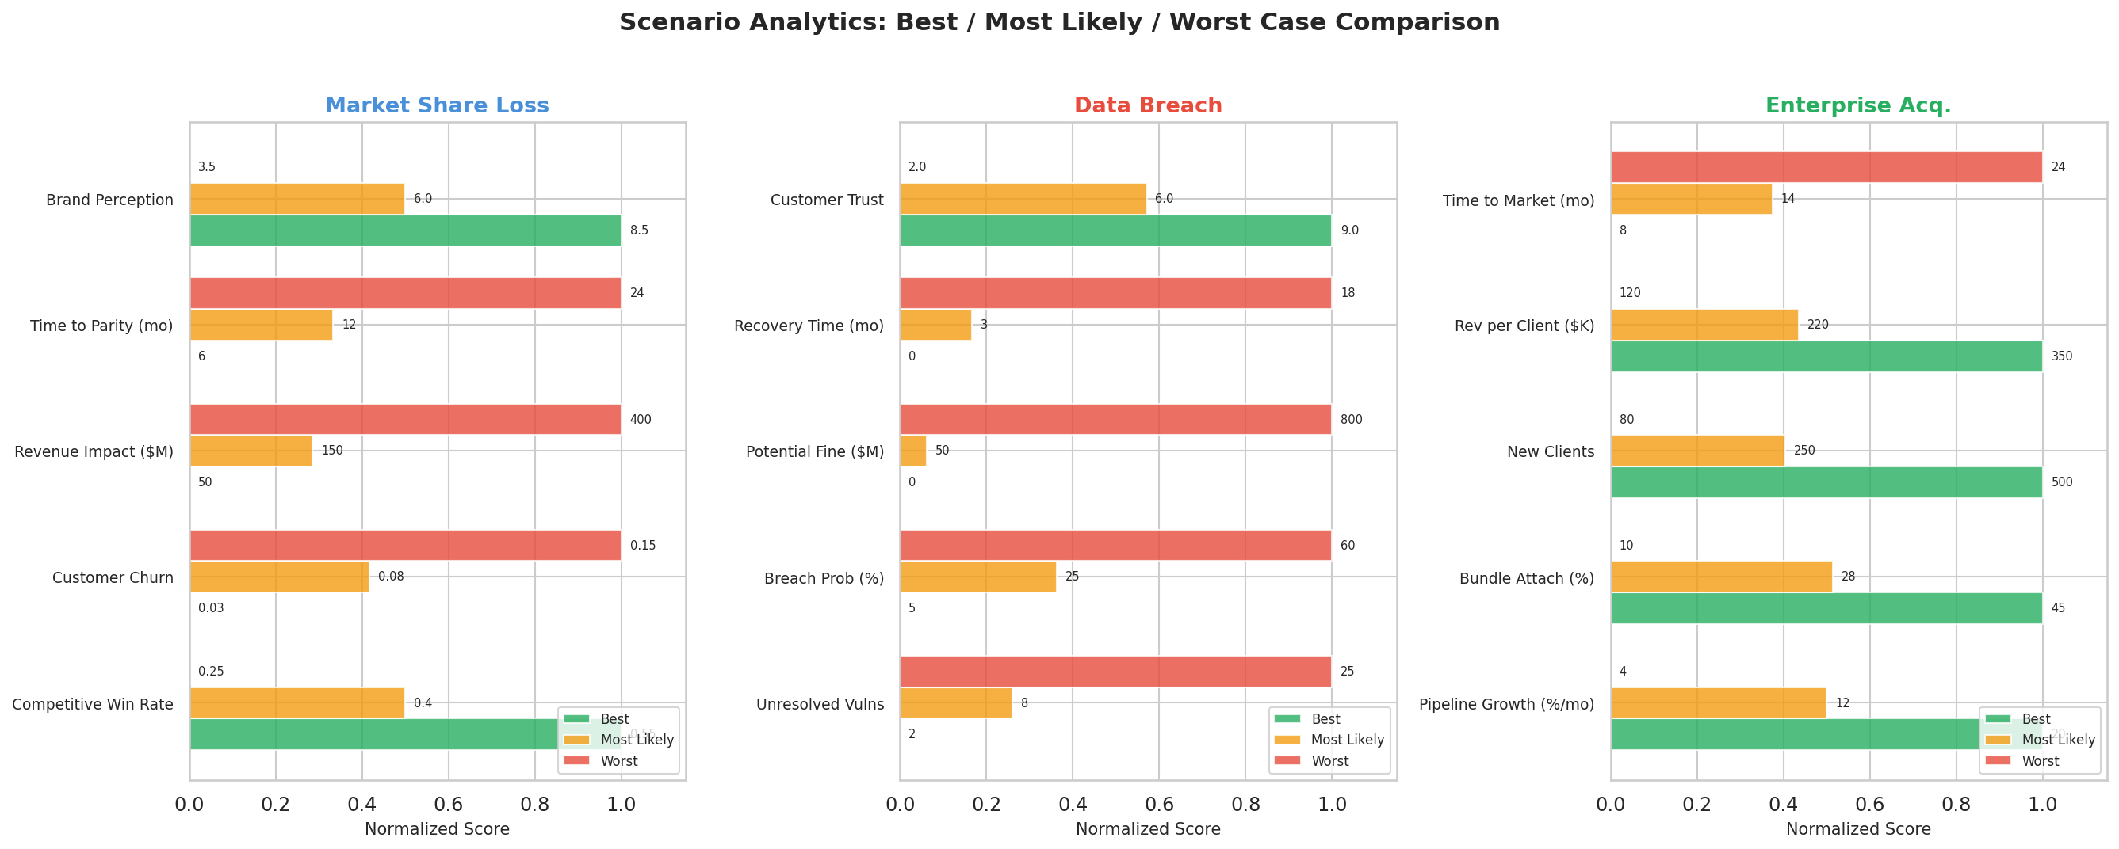
Figure 2. Scenario Analytics: Best-Case, Most-Likely, and Worst-Case Comparison Across Risk Areas.

Industry Fusion Analytics
Industry Fusion Analytics assessed how converging forces across five industries—cybersecurity, cloud computing, regulatory compliance, enterprise software, and artificial intelligence—influence each risk area. Figure 3 presents the fusion influence matrix. The analysis revealed that the convergence of cybersecurity and compliance services is creating a new market category that favors platform providers over point-solution vendors, directly supporting the viability of Risk 3 as a positive opportunity. However, this same convergence intensifies Risk 1, as specialized competitors are also pursuing integration strategies through partnerships and acquisitions. The fusion of AI and cybersecurity creates both technical risk (Risk 2) through increased integration complexity and strategic opportunity (Risk 3) through differentiated capabilities. Regulatory compliance convergence most strongly influences the Enterprise Acquisition opportunity, as GDPR, CCPA, and AI governance frameworks drive demand for integrated solutions. Cloud computing convergence equally impacts Data Breach and Enterprise Acquisition, as both depend on Azure integration success (Fleisher & Bensoussan, 2015).
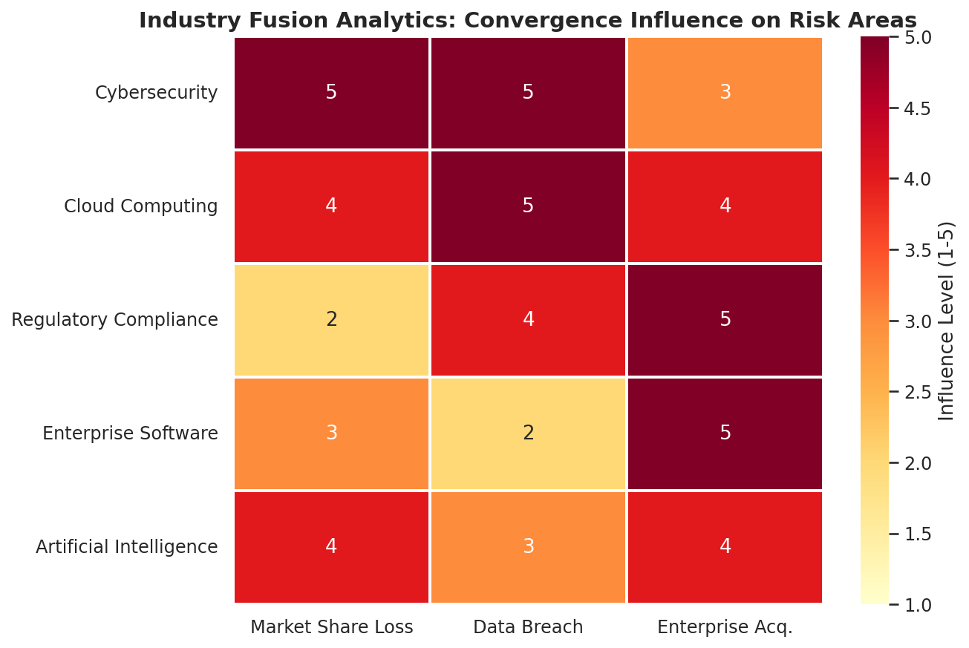
Figure 3. Industry Fusion Analytics: Convergence Influence Matrix (1 = Minimal, 5 = Dominant).

Qualitative Conclusion and Candidacy for Quantitative Analysis
The qualitative assessment concluded that all three risks warranted further quantitative analysis. Risk 2 (Data Breach) was identified as the most critical candidate due to its catastrophic worst-case impact ($800M+) and the availability of real-time measurable security indicators. Risk 1 (Market Share Loss) was prioritized due to the availability of competitive win/loss data and the wide scenario spread indicating high outcome uncertainty. Risk 3 (Enterprise Acquisition) was recommended for quantitative modeling to validate the magnitude of the upside opportunity and ensure resource allocation proportional to realistic capture probability (COSO, 2017).

Quantitative Risk Assessment
The quantitative risk assessment represents the core analytical contribution of this report, moving beyond qualitative characterization to deliver rigorous, evidence-based risk evaluation. The assessment integrates four complementary methodologies: standardized quantitative risk modeling, machine learning-based risk prediction, Monte Carlo simulation, and an integrated situation assessment that connects business and non-business environmental factors to model inputs and risk distributions.

Standardized Quantitative Risk Modeling
A detailed risk register containing 40 sub-risks across the three main risk areas was developed to provide the foundational dataset for quantitative analysis. Each sub-risk was scored on two dimensions: Likelihood (scaled 7–12) and Impact (scaled 4–9), reflecting the realistic range of scores identified through research. The total Risk Score was computed as the product of Likelihood and Impact, consistent with PMI (2021) risk quantification standards. Under the severity classification schema (High ≥ 40, Medium 15–39, Low < 15), 37 of 40 sub-risks were classified as High and 3 as Medium, reflecting the elevated threat environment inherent in a major cybersecurity acquisition.

Statistical Estimation of Probability Distributions
For each risk area, truncated normal distributions were fitted to the observed Likelihood and Impact scores. The Market Share Loss area exhibited a Likelihood mean of approximately 10.1 (SD = 1.3) and Impact mean of 6.5 (SD = 0.9). The Data Breach area showed higher values: Likelihood mean of 10.5 (SD = 1.2) and Impact mean of 7.1 (SD = 1.1). The Enterprise Acquisition area showed moderate scores: Likelihood mean of 9.4 (SD = 1.5) and Impact mean of 6.1 (SD = 1.4). These distributions informed the Monte Carlo simulation inputs (Vose, 2008).

Scenario-Based Numerical Modeling: Indicators and Warning Analysis
The I&W analysis technique served as the primary scenario-based numerical framework. Five quantitative indicators were selected per risk area based on observability and predictive relevance. Market Share Loss indicators included customer churn rate, competitor launch frequency, NPS trends, market share changes, and R&D investment ratios versus competitors. Data Breach indicators comprised unresolved vulnerability counts, failed penetration test findings, mean time to detect anomalies (MTTD), unauthorized access attempt frequency, and integration milestone completion rates. Enterprise Acquisition indicators included pipeline conversion rates, onboarding capacity utilization, bundle attach rates, client satisfaction scores, and revenue-per-client trends. Each indicator was scored on a 1–5 scale and composite I&W scores were computed as the arithmetic mean per risk area (Grabo et al., 2004).
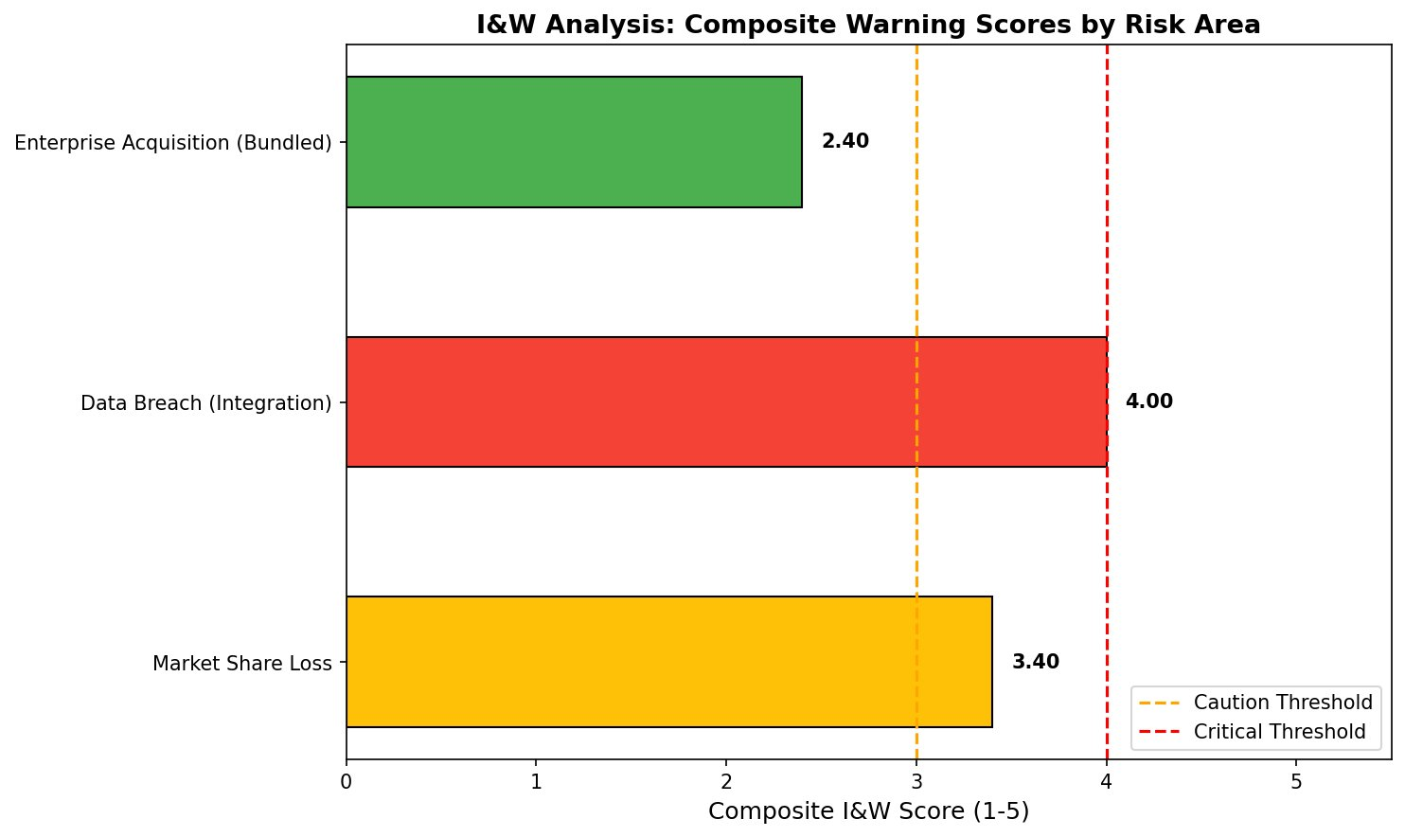
Figure 4. I&W Composite Warning Scores by Risk Area.
Warning thresholds were calibrated at: Green (All Clear) for composite scores below 3.0, Yellow (Caution) for scores of 3.0–3.99, and Red (Critical) for scores at 4.0 or above. Data Breach received a Red warning (composite score = 4.00), driven by 18 unresolved vulnerabilities and critical penetration test failures. Market Share Loss received a Yellow warning (composite score = 3.40), reflecting elevated churn signals and competitive pressure. Enterprise Acquisition achieved a Green status (composite score = 2.40), indicating favorable current conditions (Grabo et al., 2004; NIST, 2018).
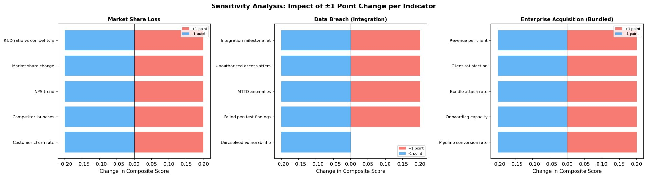
Figure 5. Sensitivity Analysis: Impact of ±1 Point Change per Indicator (Tornado Chart).
A sensitivity analysis (Figure 5) identified the most influential indicators for each risk area. For Market Share Loss, the R&D ratio versus competitors had the greatest impact on the composite score. For Data Breach, the integration milestone completion rate was the most sensitive driver. For Enterprise Acquisition, revenue per client showed the largest influence. These findings inform management prioritization of monitoring resources and mitigation investments.

ML-Based Risk Prediction
A Random Forest classifier was applied to validate the manual risk categorization. The initial model used Likelihood Score and Impact Score as input features with the severity label (High/Medium) as the target. Configuration included 50 estimators, maximum tree depth of 3, minimum leaf size of 5, and balanced class weights. The model was enhanced by incorporating Monte Carlo-derived features: area-level mean risk score (MC_Mean), standard deviation (MC_Std), and probability of exceeding the High threshold (MC_Prob_High). The enhanced model achieved 88% accuracy with a weighted F1-score of 0.89 under stratified 3-fold cross-validation (Breiman, 2001; Hastie et al., 2009).
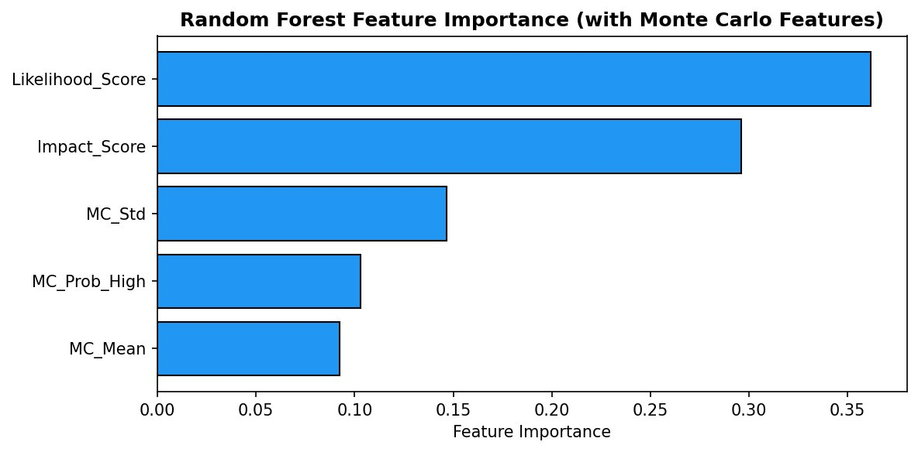
Figure 6. Random Forest Feature Importance (with Monte Carlo Features).
Figure 6 displays the feature importance ranking. Likelihood Score (0.36) and Impact Score (0.30) remain the dominant predictors. Among the Monte Carlo features, MC_Std (0.15) provides the greatest marginal information, suggesting that the variability of risk outcomes is an important differentiator between risk levels. The confusion matrix revealed that 32 of 37 actual High-risk items were correctly predicted, with the 5 misclassified items falling near the High/Medium boundary (scores 35–40), a known characteristic of tree-based classifiers at linear decision surfaces (Hastie et al., 2009).

Monte Carlo Simulation
Monte Carlo simulation modeled uncertainty across all three risk areas using 10,000 iterations. For each area, Likelihood and Impact values were sampled from truncated normal distributions fitted to observed data, yielding simulated risk score distributions with Value-at-Risk (VaR) estimates at the 95th percentile (Vose, 2008).
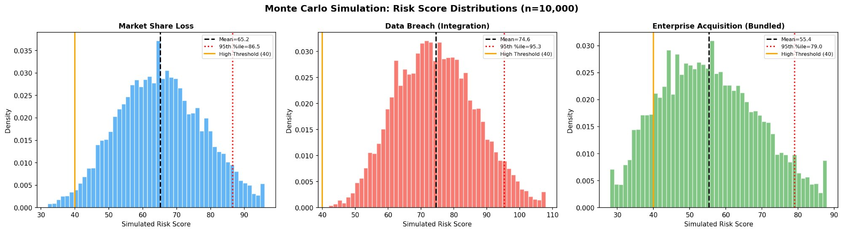
Figure 7. Monte Carlo Simulation: Risk Score Distributions (n = 10,000).
Figure 7 presents the simulated distributions. Data Breach exhibited the highest mean (74.6) and 95th-percentile VaR (95.3), with 100% of simulations exceeding the High threshold. Market Share Loss showed a mean of 65.2, VaR of 86.5, and 98.4% High probability. Enterprise Acquisition had the lowest mean (55.4) and VaR (79.0), but still showed 86.5% High probability, indicating substantial tail-risk exposure even in the most favorable area (Vose, 2008).
Table 1
Quantitative Risk Assessment Summary
Risk Area | Avg Score | MC Mean | MC VaR(95%) | P(High) | I&W Score | Warning
Market Share Loss | 66.5 | 65.2 | 86.5 | 98.4% | 3.40 | YELLOW
Data Breach (Integration) | 75.8 | 74.6 | 95.3 | 100% | 4.00 | RED
Enterprise Acq. (Bundled) | 57.2 | 55.4 | 79.0 | 86.5% | 2.40 | GREEN

Integrated Situation Assessment
The quantitative models are grounded in an integrated assessment of both business and non-business environmental factors. Market competition directly informed Likelihood parameters for Risk 1: CrowdStrike’s and Palo Alto Networks’ 25%+ annual growth rates justify elevated likelihood scores (10–12) for competitive sub-risks. Supply chain considerations influenced Risk 2: the acquisition target’s third-party vendor dependencies create integration touchpoints where vulnerabilities propagate. Financial conditions shaped Risk 3: Microsoft’s $20B+ security revenue provides capacity for bundled offerings, but opportunity cost of delayed integration was modeled through pipeline sensitivity (Fraser & Simkins, 2016). Regulatory factors drive distributions across all areas: GDPR penalties of up to 4% of global turnover inform the catastrophic Impact scores for breach risks. Geopolitical factors influence Risk 2 through nation-state targeting. Technological disruption compresses competitive windows and increases integration complexity across all risks (COSO, 2017; NIST, 2018).

Risk Response Strategy
Risk response strategies were developed for each identified risk following COSO’s (2017) four-category framework: avoid, reduce, share, and accept. The strategies are calibrated to the quantitative findings, with mitigation investment proportional to Monte Carlo VaR estimates and I&W warning levels.

Risk 1: Market Share Loss — Reduce and Share
The primary response is risk reduction through competitive differentiation. Microsoft should establish a dedicated cybersecurity business unit with autonomous product development authority, retain the acquired company’s leadership team, and institutionalize competitive intelligence monitoring. Risk sharing is achieved through strategic partnerships with managed security service providers (MSSPs). Differentiated pricing for bundled Microsoft-security offerings leverages the company’s unique integration capabilities (Hopkin, 2018). The Yellow I&W warning level indicates heightened vigilance and monthly executive review.

Risk 2: Data Breach During Integration — Reduce and Avoid
Given the Red I&W warning and 100% Monte Carlo High probability, this risk demands the most aggressive response. The primary strategy is risk reduction through phased integration with isolated sandbox testing, zero-trust verification across all integration touchpoints, continuous penetration testing, and a dedicated 24/7 SOC monitoring integration-specific telemetry. Third-party security auditors provide independent validation. Risk avoidance is incorporated by pausing non-critical integration activities when the I&W composite reaches 4.0. The CISO has authority to halt integration workstreams unilaterally if the vulnerability index exceeds the Red threshold (NIST, 2018).

Risk 3: Enterprise Customer Acquisition — Exploit and Enhance
As a positive risk, the response focuses on exploitation and enhancement. Microsoft should develop the integrated compliance-security product suite within 12 months, create enterprise customer migration incentive programs, establish regulatory consulting partnerships, and launch targeted go-to-market campaigns in regulated industries. The Green I&W status indicates favorable conditions, but the 86.5% Monte Carlo High probability underscores that active pursuit is required to realize the upside (Hillson, 2009).

Key Risk Indicators (KRIs) and Trigger Points for Action
Key Risk Indicators were developed following the COSO (2017) framework by selecting metrics with demonstrated predictive validity as leading indicators. Each KRI was designed using the CRISP-DM methodology to ensure clear understanding of business context, data sources, modeling approach, and deployment strategy (Hopkin, 2018).
Table 2
Key Risk Indicators, Thresholds, and Escalation Actions
Risk Area | KRI Metric | Green | Amber | Red / Escalation
Market Share Loss | Monthly Competitive Win/Loss Rate | > 45% win rate | 35–45% | < 35%; Executive review of integration strategy
Data Breach | Integration Vulnerability Index | < 5 unresolved | 5–15 unresolved | > 15 or exploited; Pause integration, invoke IR protocol
Enterprise Acq. | Qualified Pipeline Growth Rate (MoM) | ≥ 15% MoM | 8–15% MoM | < 8%; Evaluate GTM repositioning, additional partnerships
Each KRI operates as a leading indicator: competitive win rates signal erosion before revenue declines; vulnerability counts predict exploitation before breaches occur; pipeline growth predicts revenue conversion 3–6 months ahead. Monitoring frequency is monthly for Risk 1 and Risk 3, and weekly for Risk 2 during active integration phases, reflecting the Red I&W warning urgency (COSO, 2017; Grabo et al., 2004).

CRISP-DM Alignment
The KRI development followed the six phases of CRISP-DM. Business Understanding defined each KRI’s purpose and the management decision it informs. Data Understanding identified sources (CRM systems, vulnerability scanners, SIEM platforms, marketing automation). Data Preparation established automated pipelines for indicator extraction. Modeling defined scoring algorithms and threshold calibration. Evaluation validated KRI sensitivity through the tornado chart analysis (Figure 5). Deployment established dashboards, reporting cadences, and escalation protocols integrated into Microsoft’s ERM governance structure (Hopkin, 2018).

Conclusion
This enterprise risk management analytics assessment demonstrates that Microsoft’s proposed cybersecurity platform acquisition presents a complex, multidimensional risk profile requiring rigorous quantitative evaluation and systematic management oversight. The integrated analytical framework—combining SWOT analysis, structured risk identification, qualitative scenario and industry fusion analytics, I&W analysis, Monte Carlo simulation, and Random Forest machine learning validation—provides decision-makers with a comprehensive, evidence-based foundation for evaluating the acquisition’s risk-reward profile.
The quantitative findings are clear and actionable. Data Breach During Platform Integration demands immediate intervention with a Red I&W warning (4.00), 100% Monte Carlo High probability, and 95th-percentile VaR of 95.3. Market Share Loss requires heightened vigilance at Yellow (3.40) with 98.4% High probability and VaR of 86.5. Enterprise Customer Acquisition shows favorable Green indicators (2.40) but carries 86.5% High probability, underscoring that active pursuit is required to capture the upside.
The ML validation (88% accuracy, weighted F1 = 0.89) confirms reliable risk classifications, while feature importance analysis reveals that risk outcome variability (MC_Std) provides meaningful predictive information beyond traditional scoring. The sensitivity analysis identifies priority indicators for monitoring. The risk response strategies and KRI threshold structures translate these analytical findings into a practical governance framework, enabling data-driven decisions at each integration stage with mitigation resources allocated proportional to quantified tail-risk exposure. This assessment demonstrates that enterprise risk management analytics, properly executed, transforms risk from an abstract concern into a measurable, manageable, and monitorable dimension of organizational performance (COSO, 2017; Hopkin, 2018).

References
Breiman, L. (2001). Random forests. Machine Learning, 45(1), 5–32. https://doi.org/10.1023/A:1010933404324
Bromiley, P., McShane, M., Nair, A., & Rustambekov, E. (2015). Enterprise risk management: Review, critique, and research directions. Long Range Planning, 48(4), 265–276. https://doi.org/10.1016/j.lrp.2014.07.005
Committee of Sponsoring Organizations of the Treadway Commission. (2017). Enterprise risk management—Integrating with strategy and performance. COSO. https://www.coso.org/guidance-on-ic
Cybersecurity HQ. (2024). Cybersecurity mergers & acquisitions in 2024. https://newsletter.cybersecurityhq.com/p/cybersecurity-mergers-acquisitions-in-2024
Fleisher, C. S., & Bensoussan, B. E. (2015). Business and competitive analysis: Effective application of new and classic methods (2nd ed.). FT Press.
Fraser, J. R. S., & Simkins, B. J. (2016). The challenges of and solutions for implementing enterprise risk management. Business Horizons, 59(6), 689–698. https://doi.org/10.1016/j.bushor.2016.06.007
Grabo, C. M., Goldman, J., & Wasik, J. M. (2004). Anticipating surprise: Analysis for strategic warning. Center for Strategic Intelligence Research.
Hastie, T., Tibshirani, R., & Friedman, J. (2009). The elements of statistical learning: Data mining, inference, and prediction (2nd ed.). Springer.
Helms, M. M., & Nixon, J. (2010). Exploring SWOT analysis—Where are we now? A review of academic research from the last decade. Journal of Strategy and Management, 3(3), 215–251. https://doi.org/10.1108/17554251011064837
Hillson, D. (2009). Managing risk in projects. Gower Publishing. https://doi.org/10.4324/9781315237572
Hillson, D., & Simon, P. (2020). Practical project risk management: The ATOM methodology (3rd ed.). Berrett-Koehler Publishers.
Hopkin, P. (2018). Fundamentals of risk management: Understanding, evaluating, and implementing effective risk management (5th ed.). Kogan Page.
IT Daily. (2025). Microsoft’s rise to cybersecurity giant. https://www.it-daily.net/it-security-en/cloud-security-en/microsofts-rise-to-cybersecurity-giant
National Institute of Standards and Technology. (2018). Framework for improving critical infrastructure cybersecurity (Version 1.1). U.S. Department of Commerce. https://doi.org/10.6028/NIST.CSWP.04162018
Project Management Institute. (2021). A guide to the project management body of knowledge (PMBOK guide) (7th ed.). PMI.
Vose, D. (2008). Risk analysis: A quantitative guide (3rd ed.). Wiley.

Appendix 1: Complete Risk Treatment and Response Plan
The complete Risk Treatment and Response Plan (RT&RP) is maintained in the accompanying Excel workbook (risk_register_updated.xlsx). The RT&RP contains the following components:
Risk Register: 40 sub-risks across three main risk areas with Likelihood Score, Impact Score, Risk Score, severity classification, Monte Carlo results (MC Mean, MC VaR 95th percentile, P(High)), I&W Composite Score, and Warning Level.
Risk Calculation Matrix: A 5×5 risk scoring matrix mapping Likelihood and Impact to priority levels.
KRI Worksheet: Detailed documentation of Problem Statement, KRI Metric, Data Source, CRISP-DM alignment, threshold levels, and escalation actions for each risk area.
Table A1
Risk Treatment and Response Plan Summary (3 Main Risks)
# | Risk | L | I | Score | Mitigation Strategy
1 | Market Share Loss to Specialized Competitors | 4 | 4 | 16 (H) | Dedicated cybersecurity BU; retain acquired leadership; competitive intelligence monitoring; differentiated bundled pricing
2 | Critical Data Breach During Integration | 3 | 5 | 15 (H) | Phased integration with sandbox; zero-trust across touchpoints; continuous pen testing; 24/7 SOC; third-party audit
3 | Accelerated Enterprise Acquisition (Positive) | 4 | 4 | 16 (H) | Integrated compliance-security suite in 12 months; migration incentives; regulatory consulting partnerships; targeted GTM campaigns
Note. L = Likelihood; I = Impact; H = High priority. The full 40-item risk register with all sub-risks and Monte Carlo/I&W annotations is available in the accompanying Excel workbook.

