Risk Assessment and Classification Analysis:
Microsoft Cybersecurity Acquisition Case Study

Honglin Wang, Chuanli Yang, Raymond Twumasi Opoku
ALY 6130
March 2026

Introduction
This report presents a comprehensive risk assessment for Microsoft’s acquisition and integration of a cybersecurity firm. As organizations pursue mergers and acquisitions in the technology sector, identifying, quantifying, and prioritizing risks becomes essential to safeguarding stakeholder interests and ensuring operational continuity (Hillson & Simon, 2020). The cybersecurity industry, in particular, presents unique challenges during integration phases, as system vulnerabilities may be temporarily amplified while platforms are being consolidated (NIST, 2018).
Microsoft’s cybersecurity revenue reached $20 billion annually by 2023, reflecting a growth strategy driven by targeted acquisitions (IT Daily, 2025). However, high-profile breaches affecting acquiring firms during post-merger integration have underscored the need for rigorous risk management (Cybersecurity HQ, 2024). This report leverages a structured risk register containing 40 sub-risks across three main risk areas, scored by likelihood and impact. A Random Forest machine learning classifier is applied to validate the risk categorization, and the results are visualized through a risk heatmap and confusion matrix.

Methodology

Risk Identification and Scoring
The risk register was developed by examining external news sources, industry reports, and internal organizational factors related to Microsoft’s cybersecurity acquisition. Each risk was scored on two dimensions: Likelihood (scaled 7–12) and Impact (scaled 4–9), reflecting the realistic range of scores identified through our research rather than a default 1–10 scale. The total Risk Score for each entry was computed as the product of Likelihood and Impact (PMI, 2021).
The 40 identified sub-risks were organized under three main risk areas: (a) Loss of Cybersecurity Market Share, encompassing 15 competitive and market-positioning risks; (b) Critical Data Breach During Platform Integration, containing 15 security and technical risks; and (c) Accelerated Enterprise Customer Acquisition Through Bundled Security Offerings, comprising 10 opportunity-related risks that include both positive outcomes and associated operational strains.

Risk Categorization Thresholds
Risk scores were classified into severity tiers using the following thresholds: High risk was assigned to any score at or above 40, Medium risk for scores between 15 and 39, and Low risk for scores below 15. These thresholds were selected based on the distribution of computed scores and aligned with standard risk matrix practices in enterprise risk management (COSO, 2017). Under this schema, the dataset yielded 37 High-risk items and 3 Medium-risk items, reflecting the elevated threat environment inherent in a major cybersecurity acquisition.

Machine Learning Classification
To validate the manually assigned risk levels and explore automated classification, a Random Forest classifier was trained using Likelihood Score and Impact Score as input features and the severity label as the target variable. Random Forest is an ensemble learning method that constructs multiple decision trees and aggregates their predictions through majority voting, thereby reducing variance and mitigating overfitting (Breiman, 2001). The model was configured with 50 estimators, a maximum tree depth of 3, a minimum leaf size of 5, and balanced class weights to address the class imbalance between High and Medium categories. Stratified 3-fold cross-validation was employed to ensure each fold preserved the original class distribution (Hastie et al., 2009).

Results

Risk Heatmap Analysis
The risk heatmap in Figure 1 displays the concentration of risks across different Likelihood and Impact score combinations. The axes reflect the actual data ranges observed in the risk register: Likelihood scores range from 7 to 12, and Impact scores range from 4 to 9. The color intensity corresponds to the count of risks at each coordinate pair, with darker cells indicating higher concentrations.
The most prominent cluster appears at Likelihood 9 and Impact 6, where six risks converge. This cluster primarily represents competitive market share risks and operational integration concerns that carry moderate impact but relatively high probability. Another notable area of concentration is at higher Impact scores (7–9) with Likelihood values of 10–12, representing the most critical risks—particularly those related to data breaches during platform integration. These risks populate the upper-right quadrant of the heatmap, confirming their classification as High severity.

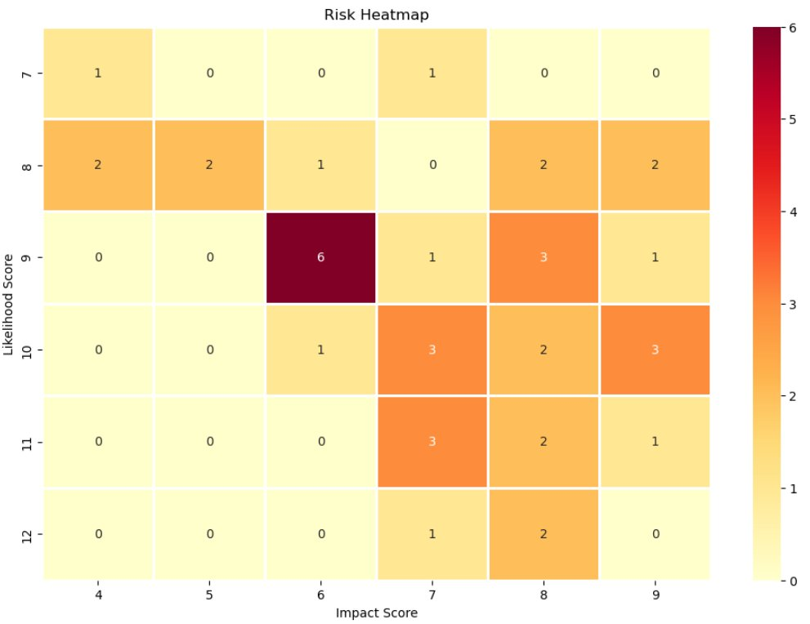
Figure 1. Risk Heatmap Displaying Frequency of Risks by Likelihood and Impact Score.
The heatmap reveals that the majority of risks fall in the medium-to-high quadrant, with no risks appearing in the extreme low-likelihood and low-impact region. This distribution is consistent with the high-stakes nature of cybersecurity acquisitions, where even moderate threats carry significant consequences (Cybersecurity HQ, 2024). The three risks classified as Medium (scores between 28 and 40) correspond to bundled offering risks where the Impact scores are lower (4–5), resulting in total scores below the High threshold.

Classification Model Performance
The Random Forest classifier achieved a mean accuracy of 0.87 under stratified cross-validation, demonstrating strong predictive capability given the small and imbalanced dataset. Figure 2 presents the detailed classification report, and Figure 3 shows the confusion matrix.

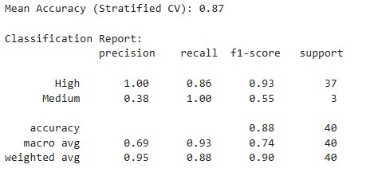
Figure 2. Classification Report Showing Precision, Recall, and F1-Score by Risk Level.
For the High-risk class, the model achieved perfect precision (1.00), meaning every item it predicted as High was indeed High. Recall for the High class was 0.86, indicating that 32 out of 37 actual High-risk items were correctly identified, while 5 were misclassified as Medium. The F1-score for High risk was 0.93, reflecting an excellent balance between precision and recall. For the Medium class, precision was lower at 0.38, with perfect recall of 1.00—all 3 Medium-risk items were correctly identified, but 5 High-risk items were also incorrectly assigned to this category. The weighted average F1-score across both classes was 0.90, and overall accuracy stood at 0.88.

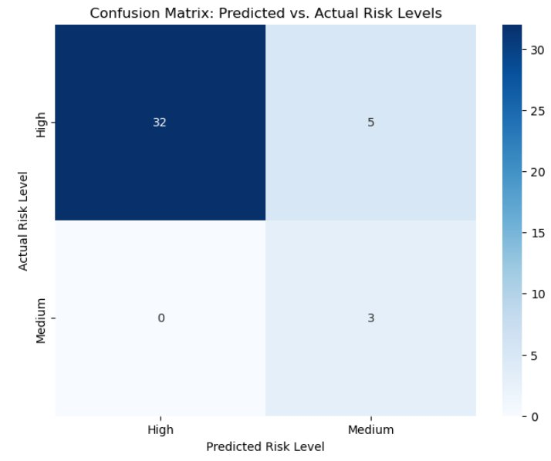
Figure 3. Confusion Matrix of Predicted vs. Actual Risk Levels.
The confusion matrix in Figure 3 provides a granular view of model performance. Of the 37 actual High-risk entries, 32 were correctly predicted as High, and 5 were misclassified as Medium. All 3 Medium-risk entries were correctly predicted. The absence of any Low-risk items in the dataset reflects the inherent severity of risks associated with a cybersecurity merger, where even lower-probability events tend to carry substantial impact. The 5 misclassified High items had risk scores near the High/Medium boundary, suggesting that the model appropriately struggles at threshold boundaries—a known characteristic of tree-based classifiers when classes are separated by linear thresholds (Hastie et al., 2009).

Discussion

Key Risk Area: Vulnerability to Hacking During System Integration
Among the identified risks, vulnerability to hacking during system integration represents one of the most consequential threats. As Microsoft integrates the acquired cybersecurity firm into its infrastructure, a transitional period of 12 to 18 months creates an extended window where systems are only partially synchronized and security measures are not fully robust. Experienced threat actors are known to monitor such transitions, recognizing that organizations often face distractions and heightened vulnerability during significant technological changes (NIST, 2018).
The implications of a breach during this phase are particularly severe for a cybersecurity firm. While any organization suffering a data breach faces regulatory fines and litigation, a cybersecurity firm that is itself breached confronts an existential trust crisis: customers would reasonably question the company’s ability to protect their data. Regulatory penalties from authorities in Europe and the United States could reach hundreds of millions of dollars, and rebuilding brand reputation could take years (Cybersecurity HQ, 2024). This risk has been classified as High due to its potentially disastrous impact, even though it may not be the most probable event.
To manage this risk proactively, the team monitors the number of unresolved security vulnerabilities within the integrating systems on a weekly basis. A green status indicates fewer than 5 unresolved issues, yellow (caution) is triggered by 5–15 unresolved issues or a single significant issue outstanding for over a week, and red (critical) is signaled by more than 15 unresolved issues or evidence of active hacking attempts. At the critical level, all non-essential merger activities are halted, external security professionals are engaged, and the board is informed.

Interpretation of Model Results
The Random Forest model’s 87% mean accuracy validates the manual risk categorization process and demonstrates that the Likelihood and Impact scores contain sufficient signal to distinguish between risk severity levels. The strong performance on the High class (F1 = 0.93) is particularly important from a risk management perspective, as failure to identify High-risk items could lead to inadequate mitigation measures. The lower precision on the Medium class (0.38) reflects the class imbalance inherent in the dataset; with only 3 Medium-risk items out of 40 total, the model has limited training examples for this category (Breiman, 2001).
The use of balanced class weights and constrained tree depth helped prevent the model from simply predicting all items as High. The stratified cross-validation approach ensured that both classes were represented in each fold, providing a more reliable estimate of generalization performance than a simple train-test split would on such a small dataset (Hastie et al., 2009).

Practical Implications
The concentration of risks in the High category suggests that Microsoft’s cybersecurity acquisition carries significant overall exposure. The data breach risks during platform integration (Risk Area 2) consistently scored highest, with many items receiving Impact scores of 8–9 and Likelihood scores of 9–12. These risks demand immediate and sustained attention, including penetration testing, strict access management, and incident response readiness (NIST, 2018). The market share risks (Risk Area 1) also scored highly, reflecting the competitive pressures Microsoft faces from specialized cybersecurity vendors who may offer more innovative or tailored solutions. The opportunity risks related to bundled offerings (Risk Area 3) present a more mixed profile, with some items scoring in the Medium range, indicating that while the upside potential is significant, the associated operational risks are comparatively manageable with proper planning (PMI, 2021).

Conclusion
This analysis demonstrates the value of combining structured risk scoring with machine learning validation in the context of a high-stakes cybersecurity acquisition. The risk register identified 40 sub-risks across three domains, with the overwhelming majority classified as High severity. The Random Forest classifier confirmed these classifications with 87% accuracy and a weighted F1-score of 0.90, providing an additional layer of confidence in the risk assessment. The risk heatmap effectively visualizes the distribution of threats, highlighting concentration areas that require prioritized management attention. Organizations undertaking similar acquisitions should adopt comparable multi-method approaches—integrating quantitative scoring, machine learning validation, and visual analytics—to ensure comprehensive and defensible risk management (COSO, 2017; Hillson & Simon, 2020).

References
Breiman, L. (2001). Random forests. Machine Learning, 45(1), 5–32. https://doi.org/10.1023/A:1010933404324
Committee of Sponsoring Organizations of the Treadway Commission. (2017). Enterprise risk management—Integrating with strategy and performance. COSO.
Cybersecurity HQ. (2024). Cybersecurity mergers & acquisitions in 2024. https://newsletter.cybersecurityhq.com/p/cybersecurity-mergers-acquisitions-in-2024
Hastie, T., Tibshirani, R., & Friedman, J. (2009). The elements of statistical learning: Data mining, inference, and prediction (2nd ed.). Springer.
Hillson, D., & Simon, P. (2020). Practical project risk management: The ATOM methodology (3rd ed.). Berrett-Koehler Publishers.
IT Daily. (2025). Microsoft’s rise to cybersecurity giant. https://www.it-daily.net/it-security-en/cloud-security-en/microsofts-rise-to-cybersecurity-giant
National Institute of Standards and Technology. (2018). Framework for improving critical infrastructure cybersecurity (Version 1.1). U.S. Department of Commerce. https://doi.org/10.6028/NIST.CSWP.04162018
Project Management Institute. (2021). A guide to the project management body of knowledge (PMBOK guide) (7th ed.). PMI.

