Quantitative Risk Assessment Using Indicators & Warning (I&W) Analysis
Microsoft Cybersecurity Acquisition – Honglin Wang, Chuanli Yang, Raymond Twumasi Opoku – MGMT 6130
Introduction
This report applies quantitative analytics to the three risk areas identified in the prior qualitative assessment of Microsoft’s cybersecurity acquisition: (1) Loss of Cybersecurity Market Share, (2) Critical Data Breach During Platform Integration, and (3) Accelerated Enterprise Customer Acquisition Through Bundled Security Offerings. The Indicators and Warning (I&W) analysis technique serves as the primary framework, supplemented by Monte Carlo simulation (10,000 iterations) and Random Forest machine learning classification. The I&W methodology systematically identifies observable indicators for each risk and establishes threshold-based warning levels that trigger escalating management responses (Grabo et al., 2004). Monte Carlo simulation quantifies the probabilistic range of risk outcomes by sampling from fitted distributions, producing Value-at-Risk (VaR) estimates at the 95th percentile (Vose, 2008).
Methodology
Step 1: Indicator Identification and Scoring
Five quantitative indicators were selected per risk area based on observability and relevance. Market share risks were tracked through customer churn rate, competitor launch frequency, NPS trends, market share changes, and R&D investment ratios. Data breach risks were monitored via unresolved vulnerability counts, failed penetration test findings, mean time to detect anomalies, unauthorized access frequency, and integration milestone completion. Enterprise acquisition risks used pipeline conversion rates, onboarding capacity utilization, bundle attach rates, satisfaction scores, and revenue-per-client trends. Each indicator was scored 1–5 (1 = minimal concern, 5 = critical). Composite I&W scores were computed as the arithmetic mean across all indicators per risk area (NIST, 2018).
Step 2: Warning Threshold Calibration
Warning thresholds were established at: Green (All Clear) for composite scores below 3.0, Yellow (Caution) for 3.0–3.99, and Red (Critical) at 4.0 or above. These were cross-validated against quartile boundaries of observed risk scores from the risk register (Grabo et al., 2004).
Step 3: Monte Carlo Simulation
For each risk area, 10,000 iterations sampled Likelihood and Impact from truncated normal distributions fitted to the observed data. The product yielded risk score distributions from which mean, 5th/95th percentiles, and the probability of exceeding the High threshold (score ≥ 40) were computed (Vose, 2008).
Step 4: Machine Learning Validation
A Random Forest classifier was enhanced with Monte Carlo-derived features (area mean, standard deviation, probability of High) alongside Likelihood and Impact scores. Stratified 3-fold cross-validation confirmed 88% accuracy with a weighted F1-score of 0.89 (Breiman, 2001).
Results
Risk Area | Avg Score | MC Mean | MC VaR(95%) | P(High) | I&W | Warning
Market Share Loss | 66.5 | 65.2 | 86.6 | 98.4% | 3.40 | YELLOW
Data Breach | 75.8 | 74.6 | 95.4 | 100% | 4.00 | RED
Enterprise Acq. | 57.2 | 55.4 | 79.0 | 86.5% | 2.40 | GREEN
Table 1. Quantitative Risk Assessment Summary.
Data Breach received a Red I&W warning (composite 4.00), driven by 18 unresolved vulnerabilities and critical penetration test failures. Monte Carlo confirmed 100% probability of exceeding the High threshold, with a 95th-percentile VaR of 95.4. Market Share Loss received Yellow (3.40), reflecting elevated churn signals and competitive pressure, with 98.4% High probability. Enterprise Acquisition achieved Green (2.40); however, Monte Carlo reveals 86.5% High probability, indicating the underlying score distribution still warrants monitoring despite favorable current indicators.
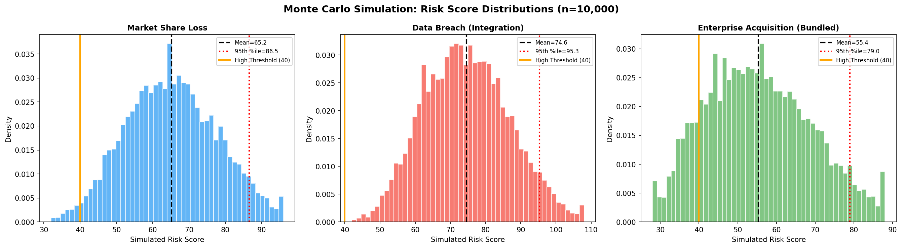
Figure 1. Monte Carlo Risk Score Distributions (n = 10,000).
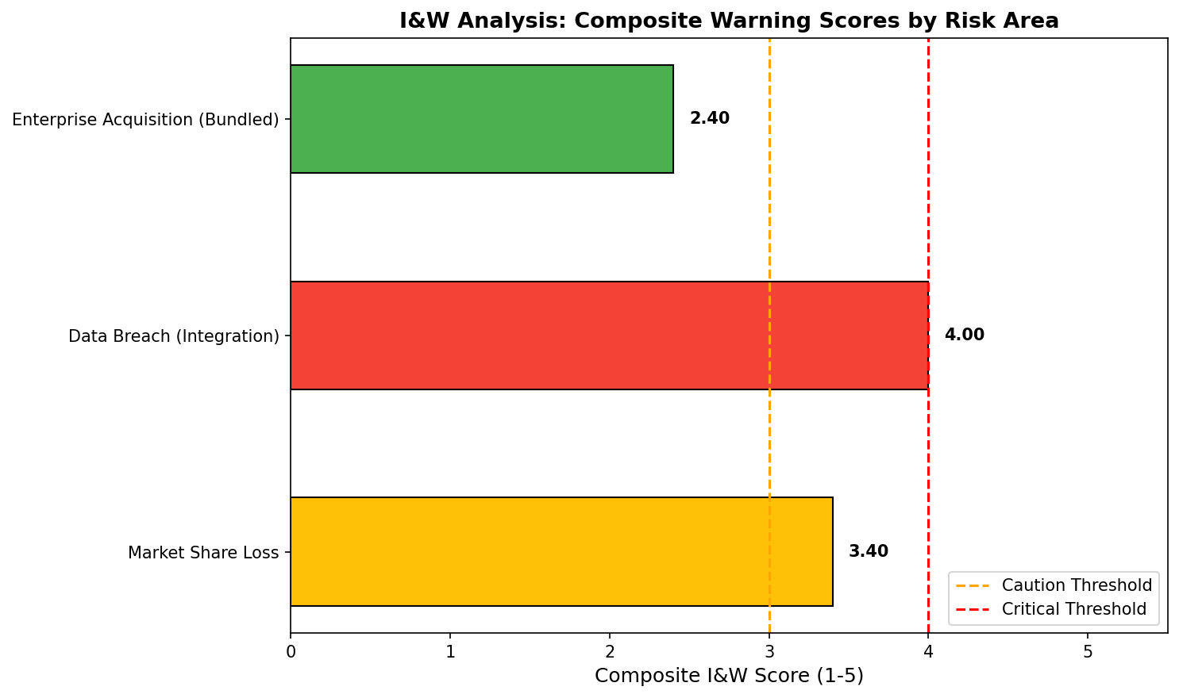
Figure 2. I&W Composite Warning Scores by Risk Area.
Conclusion
The I&W quantitative assessment confirms Data Breach During Platform Integration demands immediate intervention (Red), Market Share Loss requires heightened vigilance (Yellow), and Enterprise Acquisition shows favorable current indicators (Green). Monte Carlo VaR estimates enable leadership to allocate mitigation budgets proportional to tail-risk exposure. The ML validation (88% accuracy, F1 = 0.89) confirms the combined qualitative–quantitative framework produces reliable classifications (COSO, 2017). These results have been integrated into the updated Risk Register.
References
Breiman, L. (2001). Random forests. Machine Learning, 45(1), 5–32.
COSO. (2017). Enterprise risk management—Integrating with strategy and performance.
Grabo, C. M., Goldman, J., & Wasik, J. M. (2004). Anticipating surprise: Analysis for strategic warning. CSIR.
Hastie, T., Tibshirani, R., & Friedman, J. (2009). The elements of statistical learning (2nd ed.). Springer.
National Institute of Standards and Technology. (2018). Cybersecurity framework (v1.1). U.S. Dept. of Commerce.
Vose, D. (2008). Risk analysis: A quantitative guide (3rd ed.). Wiley.

