



Express Software Comparison Report

Discrete Manufacturing ERP Evaluation Express Software Comparison for E-Business Suite by Oracle, NetSuite by Oracle NetSuite, Epicor Kinetic by Epicor
The graphs below were developed for an express software comparison of E-Business Suite by Oracle, NetSuite by Oracle NetSuite, Epicor Kinetic by Epicor. They display the standard scores of the vendor solutions, as determined through TEC's default Discrete Manufacturing ERP Evaluation Model. The graphs reflect 3370 functional, technical, and business criteria. This comparison is based on average weights and priorities.

Overall Performance
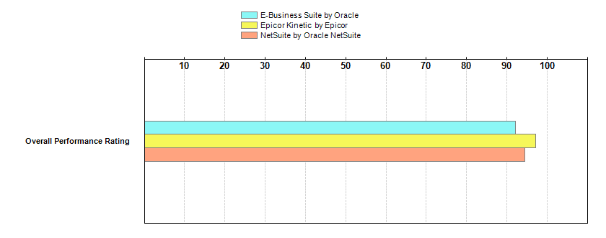
  Discrete Manufacturing ERP Evaluation
  Financials
  Human Resources
  Manufacturing Management
  Inventory Management
  Purchasing Management
  Quality Management
  Sales Management
  Product Technology

  Discrete Manufacturing ERP Evaluation
  Module | Total Criteria | E-Business Suite | Epicor Kinetic | NetSuite
  Module | Total Criteria | by Oracle | by Epicor | by Oracle NetSuite
  Module | Total Criteria | Module Rating | Module Rating | Module Rating
  Financials | 958 | 95.03 | 98.55 | 99.90
  Includes: Accounts Payable (A/P),Accounts Receivable,Budgeting,Cash Management,Cost Accounting,Financial Reporting,Fixed Assets,General Ledger,Project Accounting
  Human Resources | 434 | 92.41 | 98.90 | 90.04
  Includes: Benefits,Employee Metrics,Employee Self-Service,Health and Safety,Payroll,Personnel Management,Training,Workforce Management
  Manufacturing Management | 1047 | 96.68 | 97.66 | 90.34
  Includes: Field Service and Repairs,Product Costing,Product Data Management (PDM),Product/Item Configurator,Production Planning,Project Management,Shop Floor Control
  Inventory Management | 184 | 95.61 | 98.80 | 97.65
  Includes: Adjusting Inventory,Data Requirements,Forecasting,Inventory Management--Online Requirements,Locations and Lot Control,Processing Requirements,Reporting and Interfacing Requirements (Inventory Management),Reservations and Allocations
  Purchasing Management | 260 | 97.26 | 100.00 | 97.73
  Includes: Management of POs,Online Requirements for Purchasing Management,Pricing,Procurement Reporting and Online Reporting,Profile of Suppliers,Purchase Orders (POs),Rating of Suppliers,Receipts for Procurement,Repeat Procurement,Reporting and Interfacing Requirements for Purchasing Management,Requisitions and Quotations,Vendor Contracts and Agreements
  Quality Management | 78 | 98.13 | 96.94 | 97.48
  Includes: Inventory Quality Management,Non Production Quality Management,Production Quality Management
  Sales Management | 248 | 86.55 | 98.67 | 93.59
  Includes: Available-to-Promise (ATP),Customer Relationship Management (CRM),Customer Service and Returned Goods Handling,Online Requirements (Sales Management),Order Entry,Pricing and Discounting,Reporting and Interfacing Requirements (Sales Management)
  Product Technology | 161 | 75.51 | 88.00 | 88.79
  Includes: Cloud, SaaS and Hosting Options,Platforms,Security,Server Administration,Technical Architecture
  Discrete Manufacturing ERP Evaluation
  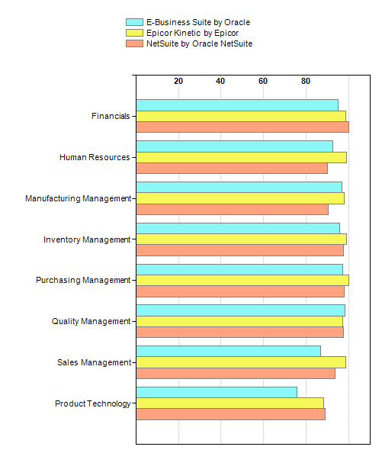

Financials
The Financials module provides features and functions that allow accountants and financial managers to ensure financial transactions are tracked and properly recorded, and that this information is available via reports and other data retrieval tools. Traditionally, this module includes the general ledger, accounts payable, fixed assets, cost accounting, cash management, accounts receivable, and financial reporting submodules
Financials Module Ratings

  Financials
  Module | Total Criteria | E-Business Suite | Epicor Kinetic | NetSuite
  Module | Total Criteria | by Oracle | by Epicor | by Oracle NetSuite
  Module | Total Criteria | Module Rating | Module Rating | Module Rating
  General Ledger | 313 | 95.47 | 98.93 | 99.83
  Includes: Chart of Accounts Structure,Controls for Ledgers,Enterprise Reporting Structure,Journal Entry and Reporting,Journal Vouchers,Ledger Development and Management,Multicurrency Capabilities,Online Inquiry Reporting,Parameters and Structuring,Report Writing Capabilities,Variable Analysis
  Accounts Payable (A/P) | 235 | 94.63 | 97.66 | 99.23
  Includes: A/P Ledger Posting,A/P Transactions and Controls,Control of Payments,Invoice Process and Aging,Journal Invoice Process,Policies and Procedures,Processing of Checks,Processing of Payments,Reporting,Supplier Master Data
  Fixed Assets | 89 | 97.50 | 94.25 | 100.00
  Includes: Asset Transactions,Depreciation Books,Depreciation of Assets,Records for Fixed Assets,Tax Reports
  Cost Accounting | 49 | 98.56 | 98.27 | 100.00
  Includes: Cost Allocation Processing,Cost Allocations,Cost Data,Management of Costs
  Cash Management | 16 | 88.75 | 98.13 | 100.00
  Includes: "Miscellaneous" category for charges and deposits,Automatically records bank cash receipts,Cash projects by currency,Checks committed funds against cash reserves or availability,Entity, bank, expected date, terms, and customer payment history are used to create cash projections,Notifies and reports on statement discrepancies,Prints account statements,Processes cancelled A/P checks,Projects cash resources from sales, A/R, field services, and miscellaneous cash,Projects cash utilization from purchasing, A/P, and miscellaneous cash,Records cash payments and receipts via electronic banking functions,Records journal entries to the G/L cash accounts,Reports cash projections,Updates and maintains pay date schedule,Up-to-date cash balance report,Views of inflows and outflows from cash book by bank, year, or statement
  Budgeting | 65 | 96.77 | 100.00 | 100.00
  Includes: Allocation of Budgets,Budget Accounting,Budget Control,Budget Development,Budgets
  Accounts Receivable | 105 | 96.29 | 99.68 | 100.00
  Includes: Credit and Collections Management,Data Requirements,Interfacing Requirements,On-line Requirements,Processing Requirements,Reporting Requirements
  Financial Reporting | 35 | 87.31 | 100.00 | 100.00
  Includes: Miscellaneous,Online Requirements
  Project Accounting | 51 | 100.00 | 100.00 | 100.00
  Includes: Cost Coding Structure Creation or Maintenance,Line Item Data Capture,Project and Cost Coding Structure,Project Creation,Reporting Format and Tools,Transaction Processing
  Financials
  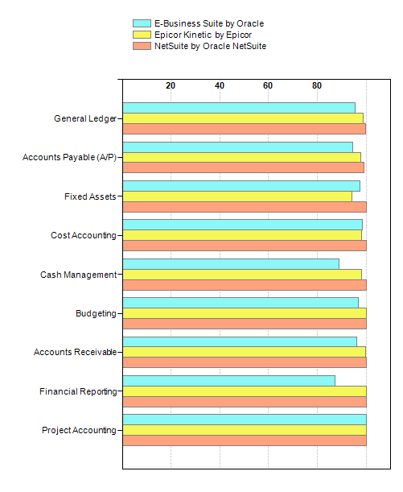

Human Resources
Human Resources encompasses all the applications necessary for handling personnel-related tasks for corporate managers and individual employees. Modules will include Personnel Management, Benefit Management, Payroll Management, Employee Self Service, Data Warehousing, Health and Safety, Workforce Management, Training, and Product Technology
Human Resources Module Ratings

  Human Resources
  Module | Total Criteria | E-Business Suite | Epicor Kinetic | NetSuite
  Module | Total Criteria | by Oracle | by Epicor | by Oracle NetSuite
  Module | Total Criteria | Module Rating | Module Rating | Module Rating
  Personnel Management | 122 | 83.62 | 98.27 | 95.45
  Includes: Budgeting and Cost Control,Career Development and Training,Competency Management,Employment History and Personnel Reporting,Government and Compliance Reporting,Job Position and Wage Profiles,Management of Rewards,Organizational Structures,Profile of Personnel,Recruitment Management,Track Discipline Actions
  Benefits | 23 | 90.77 | 100.00 | 80.00
  Includes: Administering Benefits,Profile for Employee Benefit Plan,Standard Benefits
  Payroll | 70 | 100.00 | 98.33 | 96.67
  Includes: Automated Time Sheet,Earnings and Deductions,Eligibility Parameters,Profile for Employee Payroll,Security and Audit,User Balances
  Employee Self-Service | 22 | 95.91 | 100.00 | 92.73
  Includes: Account for time based on type of absence or attendance,Allocate time to multiple projects and assignments,Change benefits related to a life event,Choose and maintain personal passwords,Enroll in or cancel participation in courses,Internal and external application for a job and view the status of the application,Maintain dependents and beneficiaries related to life event,Maintain emergency contacts,Posting and updating resumes,Pre-book for courses not yet scheduled,Review and enter or submit expenses,Review and maintain a knowledge sharing diary,Review and maintain bank info for direct deposit and reimbursements,Review and maintain deduction information for automatic bill payment service,Review and maintain name, address, telephone number, etc., associated with life events,Review or enroll in benefits for open enrollment period,Review vacation and sick day balances and submit leave requests,Search for available courses based on topic, text, language, and location,Update W4 information such as tax filling status, number of exemptions, and withholding information,View course calendars and details,View pay stub info: gross pay, taxes, other deductions, net pay, pay period, and year-to-date totals,View personal training history
  Employee Metrics | 13 | 83.85 | 100.00 | 100.00
  Includes: Absence and leave accrual reporting,Alert supervisor when an employee is out of compliance in training or certification,Budgeting versus actual comparisons by position or business unit,Competency profile of the workforce, with breakdowns per departments, positions, etc.,EEO/affirmative action/disabled employee reporting,External and internal training requirements reports, with detailed breakdowns per departments, positions, etc.,HR budgeting reports (dollars, hours, FTE, and headcount),Report on vacation usage and alert supervisors when allocation is exhausted,Reports on training history, success rate, course attendance, inability to accommodate all interested candidates, etc.,Reports on vacancies and the effectiveness of filling them such as time to fill, cost per applicant, and average time of retaining the position,Staff headcount, movement, and turnover trends analyses and reports,Wage and salary costs data, with detailed breakdowns across, for example, earnings, deductions, and disbursements,Workforce planning reporting
  Health and Safety | 11 | 97.27 | 100.00 | 80.00
  Includes: Detect and monitor hazardous conditions (areas) and materials, and exporting them via an interface for further processing,Initiation of corrective actions related to an incident,Integration with supply chain and HR modules,Logging of first aid records and reports,Maintain database of all MSDS sheets for all materials used,Maintenance of agent composition and information in a central database,Manage occupational injury and illness claims,Perform accident investigations, identifications, and recording,Report and investigate incidents of injury and illness for employees and contractors,Report incidents involving vehicles and equipment,Support OSHA, BG, and safety regulatory reports
  Workforce Management | 147 | 93.75 | 94.63 | 95.47
  Includes: Administration,Contract Management,Expense Tracking,Proactive Information Delivery,Project Identification,Project Management and Tracking,Resource Allocation and Analysis,Resource Identification and Classification,Security,Time Tracking,Workforce Forecasting and Planning (Supply and Demand),Workforce Gap Analysis
  Training | 26 | 94.12 | 100.00 | 80.00
  Includes: Administration,Planning
  Human Resources
  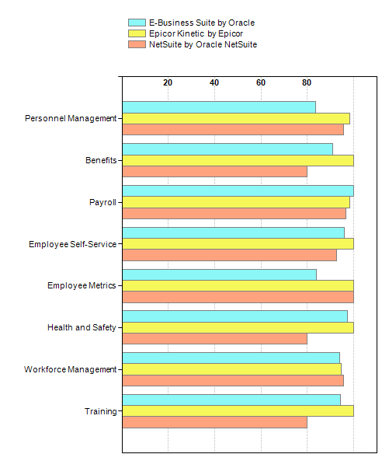

Manufacturing Management
Manufacturing Management covers discrete manufacturing and provides the ability to plan production at various scales, rolling high-level plans down into daily schedules of individual machines and workers, and tracing real-time situations on the production shop floor and in planning to control manufacturing, and thus ensuring manufacturing facilities follow production plans in an accurate and timely manner, as well as providing the ability to alter manufacturing schedules and current operations as required. It involves product configuring, work centers and machines dispatching, all aspects of work-in-progress management, and comprehensive product costing functionality. It also provides a consolidated view of the production situation using extensive multi-level reporting capabilities.
Manufacturing Management Module Ratings

  Manufacturing Management
  Module | Total Criteria | E-Business Suite | Epicor Kinetic | NetSuite
  Module | Total Criteria | by Oracle | by Epicor | by Oracle NetSuite
  Module | Total Criteria | Module Rating | Module Rating | Module Rating
  Product Costing | 105 | 96.26 | 100.00 | 100.00
  Includes: Actual Costing,Cost Accounting Variance and Analysis,Cost Report and Inventory Accounting,Costing Activity,Costing Calculations,Item Costing,Purchase Costing
  Shop Floor Control | 385 | 94.02 | 99.69 | 95.86
  Includes: Company Calendar,Flow Manufacturing,Material Picking and Kits Management,Orders Dispatching,Production Inventory Control,Production Orders Control and Reporting,Quality Control and Hazmat Reporting,WIP Management,Work Centers and Machines
  Field Service and Repairs | 119 | 97.54 | 96.69 | 91.39
  Includes: Call Management,Field Service Management,Processing and Statusing,Service Contracts Management,Service Order Management,Service Training Management
  Production Planning | 297 | 91.57 | 98.84 | 94.23
  Includes: Capacity Requirements Planning (CRP) and Work Center Scheduling,Master Production Scheduling (MPS),Material Requirements Planning (MRP),Rough-Cut Capacity Planning (RCCP)
  Product Data Management (PDM) | 68 | 98.24 | 98.82 | 81.76
  Includes: Automatic effectivity dating on production revisions,Automatic notification when configuration changes,Bills and item masters are automatically updated when changes are approved,BOMs structured in a tree chart can be edited and modified,Change request escalation process, including approvals and sign-offs,Controls effectivity dates for revision levels,Copied bills can also include same as-except rules,Customizable reason and impact codes can be created to indicate changes and their affects on inventory,Dynamic and graphical parts lists,ECNs can be approved online by authorized personnel,Engineering bills can be changed online,Engineering change activities tied to work, customer, and purchase orders,Engineering change data can be viewed online,Existing bills can be copied and used for new products or orders,Flags BOM loops,Generates reports for prior, present, and planned revision levels,Generates snapshots of as-built revision levels by part,Global add, change, and delete online function for BOM items,Global updating of BOM item numbers,History file for item numbers,Identifies part substitutions and tracks materialand labor costs for temporary configuration changes,Implements a design freeze so manufacturing can remain responsive to production scheduling,Inputs cost target data,Inputs where item classification,Integrates with a CAD or PDM system so part numbers can be added directly into a BOM,Item version control,Links engineering change activity log to all associated documents and annotations,Logs engineering changes and authorized engineering change activities for revision control,Maintains log of ECOs, ECNs, notices, and requests,Material requirements are scheduled contingent on specific assembly configurations,Modifications at part revision level can be tracked to change date or serial number,Multiple description fields for product definition,Online and print inquiries to engineering change data,Online display of higher-level items affected by engineering change activities,Online display of items by engineering change activity,Open order engineering changes data inquiries,PDM manages AutoCAD files and their relationships, such as xrefs,PDM manages Microsoft Office files such as Word and Excel,PDM manages miscellaneous files from various programs, such as test data files, finite element analysis files, etc.,PDM manages ProEngineer files and their ProE relationships, such as parts to assemblies, drawings to parts, and family table,PDM workflow,Queries and reports by revision effectivity date,Reference designators are included with BOMs,Reports engineering change activity data by project,Reports implementation status of an engineering change,Revision-level views for work orders, rework orders, purchasing, and inventory,Rules to ensure that only available parts are added to a BOM,Sends notification for phantom BOMs and assemblies must be kitted,Sequence numbering is used to update BOMs,Simultaneous maintenance and scheduling of revisions for multiple items,Standard interface to CAD systems for direct data access,Suspends engineering changes to BOMs used for customized items,The number of components can be changed on a bill,Tracks and generates reports on forthcoming engineering changes,Tracks and links order revisions in MPS and MRP,Tracks and manages engineering change effectivity dates by order or serial number,Tracks and reports engineering change activity data,Tracks BOM effectivity by engineering change number and the dates the changes will be in effect,Tracks changes by engineering change number,Tracks engineering change activities by effectivity,Tracks reasons for engineering change activities and traces higher-level accommodation of changes,Updates manufacturing revision levels and most recent engineering revision levels,Updates to BOM are triggered by release status of parent,Users can make and modify approved changes,Uses effective dates to exclude or include items from MRP calculations,Uses effectivity logic by date, lot, order number, or must-be-used-by date,Validates data before it is added to a file or database,Where-used reporting feature explodes BOMs of ECNs
  Project Management | 36 | 99.17 | 93.89 | 86.94
  Includes: Assigns an ID when an order for material is received,Associates different costs to different elements in the WBS,Automatically provides full multilevel pegging,Calculates net requirements for projects and contracts (netting logic),Checks inventory availability of standard required components,Consolidates POs within specified project groupings,Contract-specific requirements,Documents and provides an audit trail of inventory movement, by project,Documents residual material,Firm planned orders,Issues alterts to reassign surplus or reassign, reclaim, or recycle residual material,Material demand rule that allows material to be issued to a project only if that material is in supply,Material is only issued if assigned to that project,Material plan identifies cost collection points,Material planning for process by-products and co-products,Multilevel pegging for materials, inventory, and manufacturing activities,Netting is based on time-phasing logic that incorporates project requirements and their due dates,Optimal order quantity calculations,Optional control number for materials, inventory, and manufacturing activities,Project group codes separating non-sales orders and groups,Project-specific order planning,Reassigns material to other operations or projects,Reports project material plan status by project components,Rules include sending an alert when a receipt is overdue,Sends rescheduling notification to planner,Supply-demand relationship table that defines control IDs,Time-phasing is used to create and compare project plans with master planning schedule,Tracks and dates borrowed material and charges it to the borrowing contract,Tracks orders by project,Transaction tracking by project with online audit trail,Uses a supply-demand relationship table to issue more than one ID to material,Uses control IDs to identify transactions such as receipts, issues, adjustments (including physical count adjustments), material assignments,Uses control numbers to link materials, inventory, manufacturing activities, etc. to customer orders,Uses planning algorithms in project management,What-if modeling for bottleneck resolution,When material is moved from one project to another, the cost of the material is also transferred
  Product/Item Configurator | 37 | 100.00 | 95.68 | 82.16
  Includes: Auto planning BOM,Automatically loads common prior data for real time selection,BOM creation,BOM linking,Cell coding,Conditions,Configuration history,Configurator error reports,Configurator simulation,Design change control,Design development temporary configuration,Error reporting,Formatted quoting,Graphic display of selection trees,GUI,Item master creation,Master model tree types,Menu selections,Multiple modeling,Native language text,Option planning percentages,Option types,Order entry-driven and item master-driven,Pegging to BOM and utilize effectivity dates,Pricing and target cost,Product variability,Provide ability to block series of numbers,Quote history,Reopens existing configuration to allow changes,Routing creation,Routing steps,Rule and condition statements,Selection constraints,Selection types,Selections for generating sequential part numbers based on part attributes,Sub-configurations,User-defined fields
  Manufacturing Management
  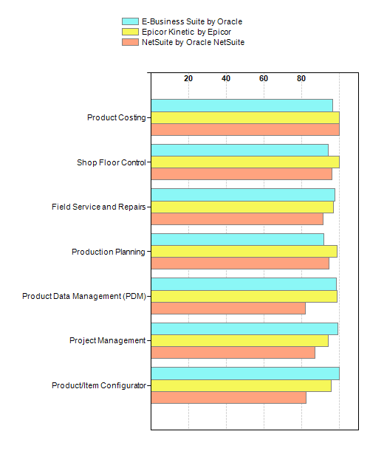

Inventory Management
Solutions for inventory management are used for the record-keeping of goods that are warehoused, and managing the movement of these goods to, from, and through warehouses.
Inventory Management Module Ratings

  Inventory Management
  Module | Total Criteria | E-Business Suite | Epicor Kinetic | NetSuite
  Module | Total Criteria | by Oracle | by Epicor | by Oracle NetSuite
  Module | Total Criteria | Module Rating | Module Rating | Module Rating
  Inventory Management--Online Requirements | 30 | 92.67 | 100.00 | 96.00
  Includes: Ability to label and track country of origin on parts and in operating system.,Ability to maintain files "up selling" parts based on certain other parts purchased.,Ability to structure material to a buy item, supporting ECN control capabilities,Analyzes performance by comparing forecasted demand to actual demand by period or product aggregate specified by user,Automated pick system sorted by grid location.,Bar coding of individual parts as received prior to warehousing, real time scanning, and inventory updates at picking, and real time scanning at shipping.,Creates reserve allocations for items,Electronic "drop ship" capability between buyer/planner and vendors. Buyer/planner should have access to vendors' "on hand" information, launch order with "ship to" information,Estimates percentage of future demand based on existing data for item-level components,Flags allocated items when quantities fall below reorder levels,Generates demand forecasts,Identify the source of demand,Identify type of transaction,Internal cross-reference to vendor part numbers,Inventory fields that accept part numbers and product configuration codes. Product configuration codes would allow logic behind randomly generated part numbers.,Maintain item number history of usage, both planned and unplanned, and purged upon a specific date criteria,Management of leasing and rotable spares,Measures accuracy of forecasts (adjusted or unadjusted),Multi-currency capability,On-line request for requisition generation and approval.,Part text files with forced viewing on screen,Pricing (selling prices) must have ability to price given various conditions (i.e. export pricing multipliers, subsidiary pricing multipliers, domestic pricing multipliers).,Provide capability to track items by lot or serial number,Reports actual or impending shortages,Selling prices may be controlled based on different commodity tables (for example, hydraulics carry different multipliers than "make parts" or other commercial parts).,System must be capable of managing harmonized part number information and integrating or maintaining harmonized information with third party (e.g.. freight forwarder),Ten year look at usage history by year and source of demand,Users can manually reserve inventory or place it on hard hold for a specific order,Vendor cross reference (infinite number of vendor pt. numbers) with wild-card search capability,Visibility and management of remote site or distributed inventories and rotable spares
  Processing Requirements | 28 | 97.86 | 100.00 | 98.93
  Includes: Ability to track inventory by business unit,Automatic generation of recommended parts tied to BOM,Capability to drive spares distribution demand from forecast,Flexible assignment of inventory processing by product and part (kanban and point-of-use),Kanban inventory management,Planning and controlling inventory in independent work cells,Provide adjustment or update for unit of measure differences or conversions,Provide allocation of raw material and component inventory to firm planned or open work order locations,Provide audit trail of all transactions by document number and part number,Provide capability to cycle count including on-line display and reporting of transactions,Provide capability to cycle count including printing a trigger report based on negative balances,Provide capability to cycle count including printing a trigger report based on ABC classification,Provide capability to cycle count including printing a trigger report based on zero inventory balance,Provide capability to cycle count including printing supporting worksheets,Provide capability to cycle count including printing various reports-- quantity and value ($),Provide capability to cycle count including recount support,Provide capability to establish cycle count control groups (of item numbers),Provide capability to identify preferred stocking quantities (to facilitate storage and issuance),Provide capability to perform physical inventories, capability to include generation of inventory tags, tag reports, and variance reports.,Provide capability to receive, stock, disburse, and report on inventory by part number and location utilizing bar code,Provide flexible unit of measure conversion capabilities,Provide for ABC classification of parts, based on order activity, historic usage/cost, or projected usage/cost,Provide for cycle count correction made by entering a recount or providing recount report,Provide for cycle count percentage and cost tolerances based on ABC classification,Provide for multiple facilities, warehouses, stockrooms, and inventory locations,Provide for non-nettable inventory locations,Provide mechanized cycle count adjustment process with user-defined various thresholds,Track and control vendor consigned inventory
  Data Requirements | 12 | 100.00 | 100.00 | 100.00
  Includes: Provide commodity code assigned by purchasing to logical groups of parts information on the inventory master file,Provide effectivity information on the inventory master file (absolute date effectivity may be assigned via item number),Provide effectivity information on the inventory master file regardless of its total product structure usage,Provide extensive user-defined-field capability in inventory master file.,Provide for item coding of inventory and item master records to identify floor stock,Provide item description information on the inventory master file,Provide item number information on the inventory master file,Provide lead time information on the inventory master file,Provide product line code information on the inventory master file,Provide scrap or shrinkage code/modifiers information on the inventory master file (codes and modifiers to adjust MPS planned requirements/orders must be available in the BOM file),Provide source of supply information on the inventory master file,Provide unit of measure information on the inventory master file
  Locations and Lot Control | 20 | 97.00 | 100.00 | 100.00
  Includes: A given finished item can be listed simultaneously in multiple stocking places in one site,Assigns unique descriptions, cost information, and automatic expiration dates to each lot,Calculates available volume and dimensions in a given storage location,Discrete rules for stockage and allocation between production and support operations.,Establish a cross-reference of a stored item's lot or serial number and its physical location,Generates location reports by specific material, by item, or by location to control inventory,Handles multiple companies, multiple divisions in a company, multiple plants, and multiple warehouses,Indicates if item is stored in a temporary or permanent location,Locate items,Lot control maintained by location,Option to use lots and sub-lots, or subdivisions of lots,Prioritizes consumption or allocation of lots by creation date, receipt date, expiry date, or lot number.,Set stocking locations for each item as fixed, assigned, manual or assigned by the system,Standard locations for stocking items,Standard ten-position convention to identify location of items in inventory,Traces an item by its lot or serial number,Use random locations for storing items,Users create methods for issuing and receiving items,Users define types to classify storage locations, such as warehouse, store, branch, truck, consigned, return, repair, inspection, department, bulk, or category,Uses tables to assign lot numbers
  Reporting and Interfacing Requirements (Inventory Management) | 16 | 88.75 | 100.00 | 100.00
  Includes: Interface with the general ledger to calculate the cost using the item's average cost,Interface with the general ledger to calculate the cost using the item's standard cost,Interface with the general ledger to forward a journal for all inventory adjustments,Interface with the general ledger to use general ledger account numbers that create a different general ledger entity and department for each unique inventory site and location,Produce system-generated documents for material issues to production runs,Provide inquiry and reporting capability for inventory status by item number and serial number,Provide inquiry and reporting capability for inventory transaction summary by from and to dates,Provide inquiry and reporting capability for inventory transactions by item number, location, and transaction type.,Provide inquiry and reporting capability for negative balance inventory and flagging upon this condition occurring,Provide inquiry and reporting capability for shortages and backorders,Provide inquiry and reporting capability for slow moving and obsolete inventory,Provide inventory valuation reporting by item number, product code, warehouse, production facility, distribution center, or stockroom,Provide reporting capability by item number (all transactions since last cycle count),Provide reporting of inactive, excess, or obsolete inventory,Provide the ability for a distribution center to run reports or inquiries on inventory status, open order status (sales and production), costs, sales, and quotes for items that only pertain to their specific facility,Reports of inventory by team, planner code, and buyer code
  Adjusting Inventory | 8 | 92.50 | 100.00 | 100.00
  Includes: Authorization on individual transaction level,Displays inventory balance information before and after adjustments,Generates automatic reorders,Inventory adjustments tracked for reporting purposes,Manual adjustments to inventory values,Secure access via control number to modify inventory transactions,User specifies reason codes for adjusting inventory, such as cycle count or poor quality,Users define rules for overstock and understock exceptions
  Forecasting | 48 | 97.50 | 90.42 | 86.25
  Includes: Accumulation of old forecasts into future periods,Adjusts forecasts according to fluctuating demand using adaptive or exponential smoothing, moving average, and weighted moving average,Aggregate forecasts break down into specific forecasts at unit level,Classifies and orders demand structure from product family level to product unit detail,Compares actual service levels to service levels specified in policies,Compares forecast demand performance to historical sales data,Conducts simulation to test policies,Confidence factors incorporated into forecasting model,Creates "what-if" scenarios for a product to test alternate scenarios or models,Creates demand forecasting units for a product line or a group of product lines that may not correspond to physical stocking locations,Customizable forecast periods, ranges of tolerance, data points, and data presentation,Demand forecast breaks down according to discrete profiles,Displays actual and forecast demand by customizable period,Evaluates forecast models for accuracy based on historical data,Flags violations of demand thresholds at product unit level,Forecast is adjusted automatically according to information on selling patterns, which is received by electronic transmissions,Forecast percentage included in forecast calculation,Generates consolidated forecasts by part number and covering all facilities,Generates detailed forecasts by item number or SKU, that can be aggregated,Generates different forecasts according to various demand hypotheses,Generates initialization and control reports to create and evaluate forecasts,Generates initialization or simulation reports for safety stock,Generates product family forecasts by rolling up detailed forecasts for items that are related,Generates statistical or focus forecasts automatically to update inventory,Imports forecast data from spreadsheet,Matches forecast model to selected historical data,Model takes demand anomalies into consideration,Monitors high quantity demand signals,Multilevel aggregating or disaggregating,Overwrites or consolidates forecasts at item level,Permits variable length periods for demand data,Provides details of items in product group forecasts to create more detailed forecasts,Provides mean absolute deviation (MAD) to use when calculating safety stock,Sends signals to users when forecast has errors or an activity is not within threshold levels,Tracks accuracy of forecasted quantities by comparing planned and actual data,Tracks demand fluctuations caused by extraneous events,User-defined analysis periods,User-defined component level forecast,User-defined data aggregation, grouping by sales region, product line, or customer,User-defined normal, seasonal, and promotional demand,Users can create forecasts by demand class, by item, by customer, by product family, by model, and by option classes,Users can create forecasts for each item included in a multi-level bill of materials,Users specify stock-keeping units (SKU) and demand forecasting units (DFU) to use in demand forecasting,Uses beta factor to resolve forecasting errors,Uses forecasting algorithms to generate several forecasts for an item, to generate the ideal forecast according to historical data,Uses sales history or demand pattern data of existing products to create forecast for new similar items,Uses statistics to forecast trended demand, seasonal demand changes, and increase in demand during promotions,Various algorithms are available for generating forecast summaries at aggregate level, as well as forecasts at the product family or item level
  Reservations and Allocations | 22 | 98.64 | 100.00 | 100.00
  Includes: Allocates back-ordered items by location according to customizable criteria,Allocates material and capacity to orders,Assigns and displays available back-ordered products by location,Available inventory reduced at time of sales order entry,Capacity allocation by individual requirement source,Customizable rules for reallocating inventory across open orders,Displays online and in real time resources and inventory that are available in a specific location,Displays online detailed information about allocations, pegging it to other data,Displays storage limits by warehouse, lot number, or inventory allocation,Finds alternative inventory sources if default sourcing link does not satisfy need,Immediate allocation of inventory quantities to backorders,Inventory allocation as order is released for ALL orders,Item balances maintained by grade specifications and lot number,Picking methods will determine the quantities reserved,Reservation days--time fence between soft and hard allocations,Reserved inventory allocation by order account,Reserves product and confirms shipping date upon receipt of order,Reverses back-order status of inventory upon order rejection,Specifies accounts for which no backorders are to be carried,User determines how lots will be reserved; oldest lot is automatically reserved first by default,Users assign define criteria for creating reservations and a hierarchy for sequencing them,Users can manually override back-ordered items that have been allocated
  Inventory Management
  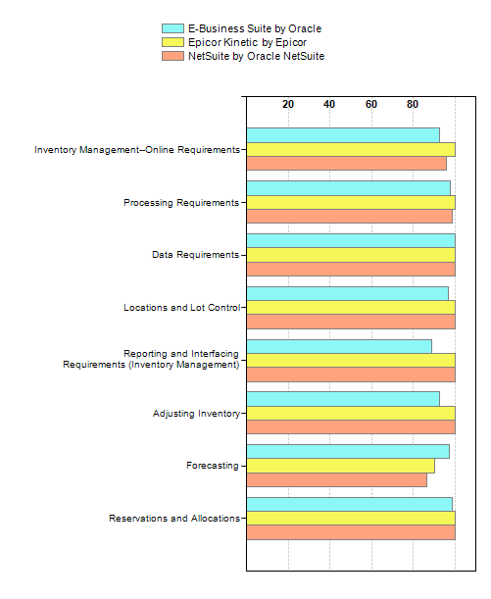

Purchasing Management
Purchasing management encompasses a group of applications that controls purchasing of raw materials needed to build products and that manages inventory stocks. It also involves creating purchase orders/contracts, supplier tracking, goods receipt and payment, and regulatory compliance analysis and reporting.
Purchasing Management Module Ratings

  Purchasing Management
  Module | Total Criteria | E-Business Suite | Epicor Kinetic | NetSuite
  Module | Total Criteria | by Oracle | by Epicor | by Oracle NetSuite
  Module | Total Criteria | Module Rating | Module Rating | Module Rating
  Profile of Suppliers | 12 | 100.00 | 100.00 | 100.00
  Includes: A primary vendor can be set as the default for each class,Associate items with vendors' descriptions,Bill-to-entity information including currency, bank, account number, and mode of payment,Code different vendor production lead times, taking into account both supplier lead time and transport time,Commentary about suppliers,Data related to bank, accounts, payment methods, currency, etc., are included in the payment profile,Fields for supplier data such as shipping methods, item references, and conditions,Identifier for approved vendors,Store e-mail addresses, web sites, and fax numbers in vendor profiles,Suppliers may have more than one address,Vendor group for miscellaneous purposes,Vendor shipment process with terms and acceptance requirements for reception
  Rating of Suppliers | 13 | 88.46 | 100.00 | 100.00
  Includes: Analyzes suppliers' PO fulfillment performance based on significant data points such as cost or price and quality,Average of early days and late days delivery,Goods delivery times are maintained as statistics for each supplier,Historical tracking of supplier performance criteria, including crucial data on fulfillment satisfaction, delivery commitments, and quality.,Include measurement unit on product stocking and invoicing,Maintains quality ratings of supplier products and performance,Maximum quantity (based on size, volume, or weight criteria) of products that can be shipped in a container,Multiple search criteria for vendor data,Profile products,Rejected salvaged in number and dollar value,Twenty-four month statistical performance data,Vendor rating statistics are automatically updated and reported,Year-to-date description of purchases in dollar value, by supplier
  Requisitions and Quotations | 13 | 100.00 | 100.00 | 100.00
  Includes: Displays planned purchase orders,Manage and update supplier's quotes for particular items,Manages supplier quotation file by item or product with purging based on user-defined criteria (for example, date),Processes requests for quotation (RFQ),Procurement system allows multiple line items and delivery schedules,Purchase requisition reference to project, account, program, contract, and sales order,Quality codes included on purchase requisitions,Quotation copies maintained for suppliers,Requisitions can be approved in real time,Retain requisition history,Returned/awarded quote information (quote effectivity range, lead item, and minimum lots),Support competitive quoting,Users can manually enter requisitions, which update along with automatic entries
  Purchase Orders (POs) | 63 | 98.57 | 100.00 | 100.00
  Includes: Allow multiple buyers to procure same item for separate business units,Assigns sequential PO numbers automatically,Automatic system messages to follow up POs may be triggered by user-specified criteria,Automatically calculates delivery times and dates,Automatically flags past due deliveries and supports inquiries on future deliveries,Automatically generate a PO number and assign it for each PO sequence,Blanket PO release control options,Blanket POs may be issued, up to a specified quantity or dollar amount,Categorizes POs by single; recurring; maintenance, repair, and operations supplies; specific project; or job-triggered orders,Codes for multiple deliveries of a specific item in a PO (may accommodate more than one date or location),Confirms POs by product numbers or PO number,Contract and project number line item,Control of default order type, order series, and warehouse code,Conversion of a planned purchase order to a PO electronically forwarded to vendor automatically,Cost tables and codes may be parameterized by supplier groups, individual suppliers, or companies,Drop-ship, direct shipments, special order transit options traceable by serial number,Features to track foreign trade zone orders,Flow down of project or part notes to PO,Individual components may be divided for multiple lead times, including categories such as dock-to-stock and preparation lead times,Individual POs can handle more than one item,Line-item-specific delivery dates,Maintains purchasing conditions for specific order items (e.g., seasonal or promotional items),Manually enter and send purchase order,Matrix of vendors, by item, approved as alternate suppliers,MRP requisition converts to a purchase order,Multiple line items per purchase order to accommodate blanket POs and subcontractor relationships,Multiple order types including return and subcontract,Non-receivable items; No receipt expected,Notes for internal purposes may be excluded from printing, or printed when they're intended for external display.,Option to automatically close a sub-contracted work order upon receipt of associated sub-contracted PO,Option to automatically create and maintain sub-contracted POs upon creation of sub-contracted work order operations,Order line and customer order line split for multiple deliveries,Order link to financial company for vendor selection,Orders and suppliers link to the financial company, which links to the warehouse for transactions,Overrides default data with user-defined data by order,Parts, supplies, and services purchases,PO line item comments may be entered in a user-defined or standard predefined format,POs include the vendor's quotation number,POs may be associated with contracts that require lot traceability,POs may be coded by their status as communicated by the MRP system. Codes should include planned, firm planned, and requisitioned,Provision to track non-recurring charges associated with a line item of a purchase order, such as tooling or setup charges. Should be connected to the line item, but separately identifiable and reportable,Purchase history is accessible in real time by supplier or part,Purchase order line status includes released and closed indications,Purchase order status and confirmation notes on the product and supplier,Purchase order types including standard PO, blanket/contract, subcontract order/operation, purchase request, and return-from-stock,Purchase orders for miscellaneous (non-inventoried) items "Fast Path",Purchase quantity includes the measurement unit and conversion (for example, "meter" or "piece"),Quality codes included on purchase orders,Quotation entry includes data fields for effectivity dates, and pricing discounts and percentages,Receive partial shipments,Remote PO access and printing of associated documentation,Rules based automatic on-line notification of engineering change number (ECN) activity,Selected items in an order may be flagged for defect checking,Separate purchase order sequence for each business unit,Subcontracted purchase orders tied to work order operation; material supplied by either vendor or internal operation,Supplier and item data may set as defaults upon placing POs,Supports purchase card activity,System-generated POs may be routed for online review and approval,System's item file correlates vendor part numbers to internal part numbers,System's item file maintains preferred vendors for specific parts as indicated by vendor number,Users control text entry and display formats,Vendor selection algorithm based on lowest price quote, strong delivery time, or preferred source status,Workflow management: on-line approvals
  Pricing | 13 | 100.00 | 100.00 | 95.38
  Includes: Automatic update of an item's record based on the item's most recent purchase price,Automatically updates prices and discounts based on a percentage or fixed amount,Calculates PO price by searching price tables,Orders may be discounted manually or automatically based on the order line,POs may be generated in any currency,Price adjustments such as quantity discounts are determined from a grade table,Price and discount table corresponds to individual suppliers and items,Price rounding determined by established rates,Pricing and discounting tables include effectivity dates,Suppliers are chosen automatically on the basis of best pricing or discounting,Suppliers may be chosen manually on the basis of best pricing or discounting,Vendor price may be changed for a product class in multiple vendor agreements,View "hedge" contracts and adjust exchange rates on an order basis
  Vendor Contracts and Agreements | 16 | 100.00 | 100.00 | 100.00
  Includes: Agreement number designating common terms,Agreements with suppliers may be discounted at different levels including the product level, product class level, and a level for general terms,Assesses shipping and handling charges as a percentage of the order's value,Assigns contract data (automatically) to a purchase order line based on a link to MPS/MRP purchase requirements,Batch mode price changes effective by product or purchase class,Contract effectivity dates (start and end),Contract terms may specify ranges for delivery dates and quantities,Defines normal contract and special contract types,Discounts may be entered on the screen (bracketed discount),Provides (based on agreement) the date that a second discount issuance becomes available,Purchase contract histories may be archived,Schedule for delivery of each line item,Standard documentation types for contracts, which can determine the contract status,The price and discounts may be applied to the order total of the vendor agreement,Users may choose to print an acknowledgement of the contract,Users may enter agreement start dates (a signal date)
  Management of POs | 25 | 95.20 | 100.00 | 92.80
  Includes: Additional orders may be generated to designate special order characteristics,Analyzes purchase statistics based on user-defined criteria,Calculates ABC classification (items categorized based on usage per year),Compares budgets,Consolidates enterprise-wide purchasing as a central unit,Determines product availability by subtracting outgoing orders from incoming receipts,Determines, measures, and reports statistics for purchase budgets,Entities within a company link to a common legal entity (for example, business units, plants, sites, etc.),Forecasts the product reorder date (determined by stock estimates),History of POs,Identification codes for purchasing agents sorted by warehouse or other method,In-depth reports on purchasing statistics defined by specific parameters,Interface provides buyers with important purchasing criteria factors,Internal processing lead times provided based on products and warehouses,Maintains PO history information by item,Online tracking of PO maintenance history,Products classified within a purchase class default to a main vendor,Purchase suggestion field contains products identified from available stock or reorder points,Reports shortages and schedule information to suppliers in real time,Retain PO data for audit purposes (PO with electronic approval),Tracks consigned inventory, in real time, to include inventory segregation and payment control,Users may authorize supplier invoices on the basis of packaging slips or line level,Users may issue stock replenishment orders based on predefined terms,Users may maintain purchasing files from any terminal, PC, or workstation,Verifies (and holds if necessary) receiving transactions on the basis of controls defined during purchasing
  Procurement Reporting and Online Reporting | 24 | 92.50 | 100.00 | 100.00
  Includes: Alerts users with a list of stock actions (such as replenishment) or product actions that need to be resolved,Automatic reminder (closed-loop system) for corrective actions,Committed POs may be reported or queried based on contracts,Committed POs may be reported or queried based on formal supplier transactions,Generates a list of the demand forecast for stock orders (may be based on seasonal activities, consumption, etc.),Identifies unfilled order backlog by reporting or querying on PO buyer status (includes planned, firm planned, and released),Inputs or updates data upon product purchase or upon verification at warehouse arrival,Online views for history and related notes,PO commitments may be traced by accounting time period (30, 60, and 90 days),Purchase order report and query for planned POs and released POs,Purchase order status and follow-up reporting or querying,Purchasing action recommended according to material requirements,Released purchase orders traced by part number,Reminds suppliers about orders that have not been confirmed or delivered,Reports or queries POs by buyer performance (a comparison of price quoted to price paid as well as delivery time promised to actual date of receipt).,Reports or queries quotes sorted by supplier name or number, or item name or number,Reports or queries transaction data history for purchased items,Requisition report and query,Runs reports or queries on purchase orders based on parameters determined by users such as alphabetical supplier, due date, PO number, or part number,Turnover frequency is tracked by product number and product group,User-defined parameters for PO and receipt exception reporting,User-defined reporting to aid contract renegotiation,Users may determine the summary information that should be provided regarding warehouse and inventory,Users may query available balances and product consumption by warehouse
  Repeat Procurement | 19 | 100.00 | 100.00 | 96.84
  Includes: Creates blanket POs where the system issues automatic releases to production and notifies A/P (user-definable),Delivery schedule may be sent electronically to suppliers (for example, via a file),Delivery schedule updates may be sent electronically to suppliers (for example, via a file),Includes established effective dates in contract orders and line items,PO line items maintain information pertaining to allocation, delivery, and purchase,PO receipts may be generated for EDI transactions as determined by users,POs may require authorization upon release by suppliers,POs released by a supplier may be changed,Predefined user parameters match EDI invoices with PO receipts,Purchasing agent may establish special conditions for delivery by the vendor,Queries on POs collected to the present date, and display according to user-selected parameters,Real-time matching of transactions with material shortage log,Reconciles and reports on POs automatically released to suppliers,Records and maintains supplier release transaction histories,Reports an item's pricing history by supplier,Shipping and delivery schedules for the vendor reported in physical or electronic formats,Tracks quantity or dollar value ranges for contracts,Users (with proper authorization) may chart activity in the receiving calendar,Users (with proper authorization) may issue blanket POs for specified items, quantities, and time periods
  Receipts for Procurement | 30 | 94.00 | 100.00 | 92.00
  Includes: Accept-with-rework category for received materials,Automatically numbers receipts in sequence,Calls up PO receipts in real time and updates inventory data,Calls up PO receipts, in real time, for items received or services rendered, and updates inventory data,Computes and posts price variances for standard cost accounting,Correlates quantities of the PO with the received invoice,Creates receipts based on the contract or project,Flags and updates using conversion factors when received unit of measure is different from ordered unit of measure,Handles obsolescence data for material under shelf life control,Issues a claim note when the packing slip differs in quantity from the receipt,Issues reports in real time, comparing material received against production material shortages,Issues shipping and credit documents to suppliers for returns, or to obtain replacements for rejected materials,Logs receiving and releasing vendor transactions during shipment, component manufacturing, and material authorization,Maintains changes to the pricing of materials,Maintains data on purchases for analyzing, project accounting, and reporting,Material receipt information may be noted,Multiple POs may be grouped as a single receipt for one shipment,Provides receipts for materials requiring inspection upon reception,Provides receipts, in real time, for materials that do not require incoming inspection (goods that go to stores without intervention),Real time orders may be issued to rework,Receipt order or receipt number,Receives and processes drop-ship orders by line item on a PO,Records and issues claims upon receiving materials that violate standards,Records invoice to financial system as materials are received,Reports information on goods reception,Reports on material rejections (as for material tests and specification differences),Reports on material rejections based on contract or project parameters,Tracks and report on errors in batch processing on receiving materials,Transactions for receipts include vendor certification and lot numbers as well as the results of quality tests,Users may log and report on scrap or reject goods in real time based on a choice of PO, supplier, and item parameters
  Online Requirements for Purchasing Management | 14 | 100.00 | 100.00 | 95.71
  Includes: Create a purchase order from an existing requisition,Create and use blanket purchase orders,Create multiple releases, each relieving a committed amount,Creates a new requisition similar to an existing requisition using a copy function,Enters and amends quote responses for requisitions while online,Extracts and transmits PDF drawing files and other files to vendors,Manual instigation of purchase requisitions,Multiple release capability at the line item level,Multiple vendors for the same part are stored in a file; all vendors can be accessed for the same part with pricing visibility,Online reporting to all vendors, which includes providing a PO,Provides a reference to a contract or master agreement,Provides a reference to the blanket purchase order that yielded a particular PO,Search the vendor record via a short description of the vendor's name,Stores "vendor qualification level" (e.g. qualified, non-qualified, and under evaluation)
  Reporting and Interfacing Requirements for Purchasing Management | 18 | 98.33 | 100.00 | 100.00
  Includes: Automatic reminder for overdue shipments sent to vendors via fax or e-mail,Automatically faxes a purchase order to vendor,Electronically transmits POs to suppliers,General ledger interface increases the raw materials account upon reception and credits A/P using the PO cost maintained for the item number,General ledger interface increases the raw materials account upon reception, and credits A/P using the standard cost setup for the inventory item number,Generate past due reports by vendor or item number in due date sequence,Inventory system interface increments on-hand quantity when a PO is received,Inventory system interface increments on-order quantity when a PO is opened,Inventory system interface updates the average unit cost of the item received,Print a vendor performance report based on dollar volumes,Print a vendor performance report based on orders placed,Print a vendor performance report based on price variances,Print a vendor performance report based on rejects (number and percent),Print a vendor performance report based on shipment and purchasing history,Print a vendor performance report based on showing late deliveries (days late),Print open PO detail information by vendor, item number, due date, or dollar value,Print selected ship-to locations on a purchase order,Vendor profile fax numbers and e-mail addresses to be used for point-and-click transmissions of data to vendors
  Purchasing Management
  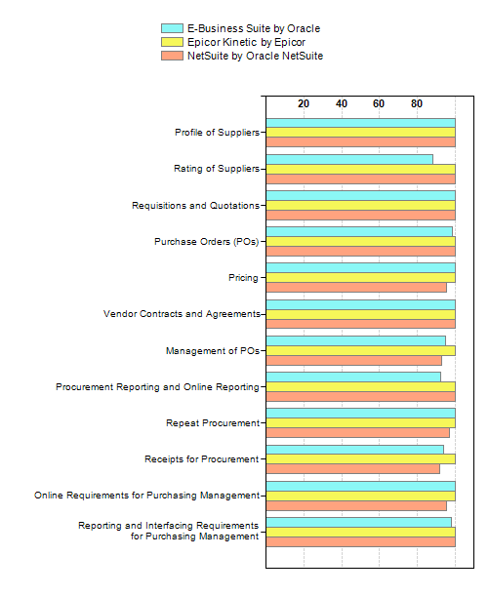

Quality Management
Quality management refers to the set of actions taken by an organization to ensure that it creates and delivers high-quality products. In order to do so, organizations must comply to national and international rules and regulations related to product quality, but they often also create and use internal requirements for quality control. Specific procedures need to be set up in order to ensure that the end products comply to internal or external quality standards. All these activities need to be well documented in order to provide the information needed when customers are not satisfied with the quality of the products received. Government agencies may also require this information for control and verification.
Quality Management Module Ratings

  Quality Management
  Module | Total Criteria | E-Business Suite | Epicor Kinetic | NetSuite
  Module | Total Criteria | by Oracle | by Epicor | by Oracle NetSuite
  Module | Total Criteria | Module Rating | Module Rating | Module Rating
  Production Quality Management | 29 | 96.90 | 100.00 | 98.28
  Includes: Assigns codes to reject descriptions,Automatically updates schedule information for items returned to suppliers,Corrective actions can be initiated, and processed, and tracked,Damaged material--corrective action and failure analysis available to vendor on-line,Defective or excess material return processing must update on-hand,Flags need to perform inspection of a specific item or a supplier's items,Identifies items awaiting or in process of inspection through an online query,Lists authorized alternatives for substitution-approved items,Lists authorized vendors for each item,Prints debit memo as part of return-to-supplier process,Prints document identifying point of return and justification,Processes material receipts which have failed inspection,Provides aggregate supplier quality data,Quality data on-line,Quality document linkage with product master within PDM,Recalculates average item cost,Receives items and records as “inventory on hold” when quality inspection is pending,Requirements grouping using collection plans,Tracks and reports on non-dispositioned rejects,Tracks customer-rejected items awaiting disposition from original supplier,Tracks items awaiting return shipment to vendor,Tracks items awaiting rework order,Tracks items for which there is no disposition, or which are rejected pending vendor approval,Tracks items for which use is conditional on QA statement of acceptable variance,Tracks material inspection dispositions,Tracks quantity rejected at inspection,Tracks unresolved rejections,Transactions related to material returns to vendors can be performed online,Validates inspection disposition using criteria that specify inspection process
  Non Production Quality Management | 24 | 97.50 | 90.83 | 94.17
  Includes: Built in Control Plan, management and reporting,Contract Review for having a documented record to which both parties have agreed assures both parties of no future misunderstandings.,Control of Customer Supplied Product - by assigning a part number,Control of Inspection, Measuring and Test Equipment for any type of equipment must be calibrated on a regular basis and records maintained,Control of Nonconforming Product to identify products which do not pass an inspection or test so they won't inadvertently be delivered to a customer.,Control of Quality Records - To retain records that demonstrate that activities were satisfactorily carried out in accordance with the requirements quality system,Corrective Actions linked to Return Authorizations,Corrective and Preventive Action to identify the root cause of the problem and take action to prevent it from happening again,Design Control to meet the requirements of our customers and get it right the first time.,Document and Data Control for If a change is made in a process, procedure, instruction, etc..., one must update the documents and inform all who are affected,Document control,Documented procedures and work instructions that defines and documents quality system.,Engineering Change Orders linked to part numbers and bills of materials,Inspection and Test Status to identify whether the product has passed or failed the inspection/test and indicates the proper corrective actions,Inspection and Testing of the product throughout the manufacturing process,Internal Quality Audits - Review our processes and procedures on regular basis to make sure that they are being followed,Management Responsibility and Quality Policy - for defining the quality policy and conducting ongoing reviews to ensure proper implementation,Process Control to catch and fix problems early, before they affect our customers,Product Identification and Traceability - allows to follow the product from inception to delivery,Purchasing - Quality maintained with the parts/components that are supplied by outside vendors.,Quick Inspections for fast, easy, accurate data entry,Servicing post-sales and follow-up requirements for the product are also documented,Training for all personnel in their tasks and training records are maintained,Web-based routing and approval, including support for personnel outside your organization
  Inventory Quality Management | 25 | 100.00 | 100.00 | 100.00
  Includes: Alphanumeric stock code,Consigned inventory location tracking,Excisable items - Definition and Chapter allocation,Finished goods issues and accounting,Forward and backward traceability,Gate pass - returnable/non returnable,Handling Material Rejections,Handling of non-stock low value items like stationery,Inbound and outbound serial number tracking,Inter and intra-site transfer management,Item lead time management,Lot and expiration date management,Lot number linked production inward entry,Material Requisition from different requirement areas,Material returns and adjustments (with value and without value),Multiple levels of classification of items - up to 2 levels,Multiple packaging configurations per item,Multiple quality status levels - accepted, rejected, scrap, return,Multiple units of measurement,Quality Control based on QC checks,Receiving material against material requirement, gate pass and production requisition Landed Rate of Items,Rejected material dispatch to vendor,Stock Valuation - LIFO/FIFO/weighted average,Tracking of item qty on various parameters viz., on-hand, available, reserved, ordered, to order, rejected, rework able, defective,User-defined quality control technical sheets
  Quality Management
  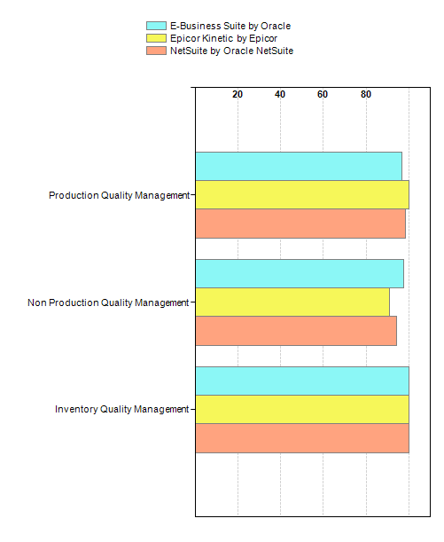

Sales Management
Sales Management encompasses a group of applications that automates the data entry process of customer orders and keeps track of the status of orders. It involves order entry, order tracing and status reporting, pricing, invoicing, etc. It also provides a basic functionality for lead tracking, customer information, quote processing, pricing & rebates, etc.
Sales Management Module Ratings

  Sales Management
  Module | Total Criteria | E-Business Suite | Epicor Kinetic | NetSuite
  Module | Total Criteria | by Oracle | by Epicor | by Oracle NetSuite
  Module | Total Criteria | Module Rating | Module Rating | Module Rating
  Online Requirements (Sales Management) | 42 | 88.57 | 100.00 | 98.10
  Includes: 1) Invoice,2) Sales order or quote,3) Bill of lading,Accommodate an order type for a new order or quote,Accommodate multiple ship-to addresses for each bill-to address,Accommodate, primarily for the sales order, a customer requested ship date, a due date, and a company expected ship date,Allow for customer account and sales order status on-line by customer name or number or by sales order number,Allow for customer master file inquiry that displays the billing address for a customer,Allow for customer master file inquiry that displays the billing and shipping terms for a customer,Allow for customer master file inquiry that displays the credit standing for a customer,Allow for customer master file inquiry that displays the shipping address (multiple) for a customer,Allow for customer master file inquiry that displays the special instructions for a customer,Allow for on-line production status inquiry by customer purchase order number and customer code,Allow sorting and printing each of the booking, billing, backlog, and backorder reports by company,Allow sorting and printing each of the booking, billing, backlog, and backorder reports by customer code,Allow sorting and printing each of the booking, billing, backlog, and backorder reports by customer name,Allow sorting and printing each of the booking, billing, backlog, and backorder reports by distribution center,Allow sorting and printing each of the booking, billing, backlog, and backorder reports by part number,Allow sorting and printing each of the booking, billing, backlog, and backorder reports by product category,Allow sorting and printing each of the booking, billing, backlog, and backorder reports by region,Allow sorting and printing each of the booking, billing, backlog, and backorder reports by representative/sales person,Allow sorting and printing each of the booking, billing, backlog, and backorder reports by sales order number,Apply sales tax automatically,Automatic pricing may be overridden,Automatically change all the prices by a certain percent or dollar amount,Calculate split commissions automatically,Change prices easily, including limiting price override capability so that only the sales manager can use it beyond a certain percent of list price,Create a backorder for under shipped or unshipped lines,Create an order from only selected lines of the quote,Creates order from quote and retains quote reference identification (for all new orders or quotes),Decrease the amount quoted,Link each sales order to the appropriate shipping facility (i.e. production facility, etc.),Process and print a special message or memo (at least 300 characters) on the following:,Process change orders easily, "pegging" these change orders to the original sales order,Provide a management summary report showing on-time shipments,Provide on-line invoice history file displaying past customer invoices,Provide on-line order history file displaying past orders for the customer,Provide the ability to allocate inventory to customers based on a customer priority code in the customer master record,Quotes and sales orders are viewable by salespersons (direct or agent) that are involved (commission structure),Status field for new quotes or orders (specifies whether it's a new order or quote),Support a competitive information system whereby competitive quotes are entered from the field and reported centrally,Validate order dates/MRP dates
  Reporting and Interfacing Requirements (Sales Management) | 49 | 77.35 | 99.39 | 80.41
  Includes: Accommodate processing and printing of invoices, reports, and shipping,Allow for price/cost on-line inquiry ability based on price, average cost, standard cost, and margin, both by product and by customer,Automatically update order entry option costs based on changes in part content, purchased/make part costs, assembly standard labor hours, or run-off procedures,Generate statements and notices of "no charge" sales,Interface with the general ledger to forward a sales and accounts receivable journal,Interface with the general ledger to optionally summarize this journal to reflect totals by customer,Limit access to quotes and orders for which the salesman is either the "sold-to" or "ship-to" designee,List open quotes by customer for a given date range,On-line interface with shippers prior to and after shipment for shipping arrangements, tracking, and feedback after ship,Print a master price list,Print bill of lading/packing list documents including quality affidavit,Print billing reports by product, invoice number, and customer,Print credit memos,Print customer number, name, and address labels for file folders,Print customer profile analysis showing customer detail activity for the past two years,Print detail and summary sales reports showing current month, same month last year, YTD and YTD last year for each division with various sorts available by customer,Print detail and summary sales reports showing current month, same month last year, YTD and YTD last year for each division with various sorts available by product category,Print detail and summary sales reports showing current month, same month last year, YTD and YTD last year for each division with various sorts available by products and services,Print detail and summary sales reports showing current month, same month last year, YTD and YTD last year for each division with various sorts available by salesperson,Print invoice register detailed and summary,Print invoices for goods,Print invoices for services,Print master price list (to drive all pricing within the system),Print sales journals showing general ledger accounts and amounts posted,Print sales order changes,Print sales orders,Report billing and shipment history (units) by month, displaying each of the twelve months with a total,Report booking history (units) by month, displaying each of the twelve months with a total,Report comparative unit and dollar bookings for this month versus the same month last year,Report comparative unit and dollar bookings for YTD versus YTD last year,Report comparative unit and dollar bookings/shipments for this month versus the same month last year,Report comparative unit and dollar bookings/shipments for variance for each of the above,Report comparative unit and dollar bookings/shipments for YTD versus YTD last year,Report consigned inventory (equipment and parts) by location, by agent, and by product category,Report daily unit and dollar billing/shipments, by item number and by customer with MTD totals and sort by product group,Report daily unit and dollar bookings, by item number, by customer and customer type, with month to date (MTD) totals.,Report price variances (sales price less list price) by sales order,Report sales by customer or agent, MTD, and YTD,Report statistics on the customer order status by code for credit hold,Report statistics on the customer order status by code for rescheduled by customer,Report statistics on the customer order status by code for rescheduled due to the item shortage,Report statistics on the number of credit memos processed each month,Report statistics on the number of invoices processed each month,Report statistics on the number of open sales orders at the beginning and end of the month, new sales orders, sales orders closed and cancelled, and adjustments, as well as service level (on-time delivery) by customer,Report unit and dollar backlog (bookings for future delivery),Report unit and dollar backorder (bookings for past requested ship dates),Reports statistics on customer order status, by code, for customer-created hold,Track and provide access to requests for engineering,Variance for each of the above (month to month and YTD)
  Available-to-Promise (ATP) | 10 | 91.00 | 100.00 | 91.00
  Includes: Allocation reports specify total demand, and on-hand stock, as well as sales order sequencing,Available-to-promise items are specified according to capacity,Available-to-promise items are specified automatically by the system,Available-to-promise scheduling can be viewed by time period and by allocation,Calculates quantity that can be supplied by due date,Imports available-to-promise quantities and dates into sales order,Models available-to-promise production in the context of existing orders,Models lead times and limits for available-to-promise items,Schedule views for available-to-promise items,Supply chain limits and real-time ERP data are processed simultaneously to generate order quotations online
  Pricing and Discounting | 77 | 96.49 | 99.22 | 95.32
  Includes: Access to historical data for basis of estimate,Allows zero-cost items,Applies established sales order discounts to back orders,Assigns begin-by and end-by dates for promotional discounts,Associates free goods with order lines,Associates multiple prices and costs with each item,Associates price ranges with each item,Automates procedures for establishing prices for demo orders, counter orders, credits, invoices, and returns,Automates procedures for establishing prices for standard orders,Automatic order discounting by buying agreement,Automatic routing of quoting/pricing activity--activity and approvals, and transmissions back to requestors,Automatically calculate and track discounts at the total bill level or individual line level,Billing terms applied to entire order or to individual line items,Builds pricing tables according to product characteristics,Calculates net price after discounts on a customer-by-customer basis,Calculates price breaks according to item order quantity,Calculates price breaks per item, according to item's year-to-date dollar amount ordered,Calculates price for new products according to gross profit requirements and projected discounts,Combines and coordinates pricing lists,Create scenarios and perform “what-if” analysis to decide pricing of items,Creates price list reports that contain information such as discount brackets, special agreements promotional prices, and special prices that have an expiration date,Current and new pricing displays that are used for “what-if” analysis,Customizable correlation between price and cost,Discount cascade rules,Discount templates by product family,Discounting specified by customer or product group, or by geographic location,Discounts and price list updates and copies are applied to the whole system,Discounts and prices can be assigned during order entry or during invoicing,Discounts are based on amount, applied by header, or associated with contract lines,Displays item cost on invoices and customer orders,Displays net profit margin for sales orders and sales order lines,Entry fields for product options,Establishes price adjustment categories,Establishes pricing in multiple currencies,Flags instances of below-cost price overrides,Generates discounts according to order or customer profile,Generates new price lists with user-defined effectivity date,Generates price list reports of orders that have been invoiced, by product, by customer, or by state,Item pricing can be done by currency, unit of measure, formula, and percentage of current price or cost,Items can be priced using multiple scenarios, such as manual, set, item, and quantity breaks,Lists items suitable for substitution of out-of-stocks,Maintain discount history with effective dates,Maintain history of option cost and price changes,Manage combined discount programs,Management review necessary where price is less than cost,Manual adjustments to prices that are associated to predefined G/L accounts,Manual discount entry for single items or for invoice as a whole,Manual override for unit selling prices,Manual overrides of calculated unit cost,Manual pricing overrides,Multilevel pricing structures,Multiple service price list categories, including standard, custom, single factor, internal, and customer,Online addition of new inventory items and customers to system,On-line display of discount on invoices and on customer orders or requests,Override automated discount with appropriate controls,Price list additions,Prices are adjusted online when a configured product in a sales order or a group of sales orders undergoes any type of adjustment,Prices can originate from sources such as a price list, a price created manually, a promotion price, a special price, an advanced promotion price, a total price, or a price adjustment,Prices specified in each order line item may be manually adjusted more than once,Pricing calculation algorithms,Pricing can be done using the price of the original or a substitute item,Pricing choices down to customer add-to, ship-to, or parent level,Pricing effectivity dates,Pricing hierarchies based on item and customer parameters,Promotion discounts can be associated with products or product groupings,Provides standard list prices,Quantity discounts can be defined according to item category, weight, order quantity, or total price,Specifies pricing and invoice variables online,Specifies type of order discount,Standard discounts associated with specific customers and items,Tracks all price adjustments for purposes of gross-to-net price reconciliations,Tracks date of last cost adjustment,Tracks gross margin value for each item,Unique quote requirements,Unit price adjustments according to volume purchased over a customizable period,User-defined limits for item and customer profile types,Variable margin pricing system allows users to include multiple categories for pricing
  Customer Relationship Management (CRM) | 23 | 73.04 | 93.48 | 95.65
  Includes: Associate expense reports to customer profile accounts,Automatically generate a call or mail list based on a selection of any combination of database elements in the list database,Competitor scenario analysis,Identification of a customer's end markets, end products, and end customers,Maintain a base of product information about company products and services by hierarchically arranging this information under specific headings,Maintain a base of product information about company products and services that can be searched by the entire text or by related keywords,Maintain a base of product information about company products and services that records product-to-product relationships or product-to-customer relationships for cross-selling,Provide a base of information, which logs date and source for information about competitors including pricing information,Provide a base of information, which logs date and source for information about competitors including specific product strengths and weaknesses,Provide a period by period trend report of historical sales and salesperson activity based on past performance,Provide a report of the forecast error based on past forecasts compared with past actual sales results,Provide a telephony interface including a scripted interactive voice response dialogue that loads into the computer telephony system,Provide a telephony interface including caller ID lookup against contact record to fetch the correct contact record based on the in-bound caller ID,Provide a telephony interface including in-bound call queue management putting the incoming calls to the next available operator,Provide a telephony interface including the ability for the caller to identify himself using his normal telephone number,Provide call history for the customer,Provide hot key access to customer account information,Provide teleconferencing abilities that include computer to computer connections over the Internet to achieve a sales conference,Provide the ability to display content that is unique to any visitor's personal profile,Provide the ability to e-mail any product information upon request,Provide the ability to store and report forecasted sales based by salesperson and territory as well as based on the probability and projected closing date for each sale,Receive updates from the mobile device and synchronize those updates with the main database,Support the extract and load of contact and call information into a mobile device
  Order Entry | 18 | 86.67 | 100.00 | 97.78
  Includes: Electronic Order Entry Methods,Manual Order Entry Methods,Order Validation Process
  Customer Service and Returned Goods Handling | 29 | 92.76 | 98.62 | 96.90
  Includes: Access of customer and customer order information through a single screen, including open orders; order details, status, and history; invoicing, credit details, and payment application,Algorithms for calculation of service levels,Automatically send out credit memos and create RMA notices for receiving when material is returned,Customizable enquiry procedures,Determine disposition of goods before moving items to stock, repair, inspection, or an outside vendor,Gathering of labor to repairs order and issuance of materials to repairs order,Generates reports that consider customers' activities to determine the quality of customer service,Generates returned material authorization (RMA) based on shipment history,Generates work orders based on sales orders,Handles returned material authorization (RMA) in any format,Invoices can be recreated at any moment, even after closing out an order,Invoices can be viewed or modified online,Link to sales order or invoice with automatic issuance of credit,Material can be returned for replacement,Order inquiry link to manufacturing status, capacity, ATP yield, and inventory status,Partial shipment against purchase order,Product return authorization for rework,Provides real-time product inventory and delivery status,Reports and analyzes customer service performance data,Reports shipment via line item, order, or pick slip numbers,Return authorization or credit memos can automatically search the original sales order to use that information,Return Material Authorization (RMA) coordinates with shop floor schedule,Re-usable routings to support repetitive activity such as overhauls,Serial number tracks to customer location,The system can recreate invoices for customers that did not receive their bills,Tracking of item through repairs process and gathering of repairs-specific information such as a teardown report,Tracks returned goods by lot or serial number,Users can define procedures to calculate service levels,Work order status can be viewed and changed online
  Sales Management
  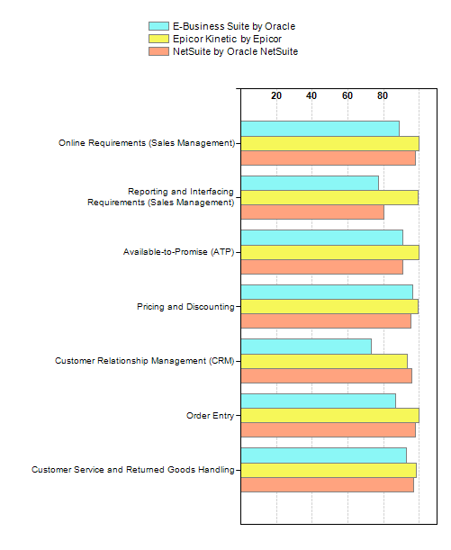

Product Technology
This group of criteria defines the technical architecture of the product as well as the technological environment in which the product can run successfully. Criteria include product and application architecture, software usability and administration, platform and database support, application standards support, communications and protocol support and integration capabilities. Relative to the other evaluation criteria, best practice selections place a lower relative importance on the product technology criterion. This apparently lower importance is deceptive because the product technology usually houses the majority of the selecting organization's mandatory criteria, which generally include server, client, protocol and database support, application scalability, and other architectural capabilities. The definition of mandatory criteria within this set often allows the client to quickly narrow the long list of potential vendors to a short list of applicable solutions that pass muster relative to the most basic mandatory selection criteria.
Product Technology Module Ratings

  Product Technology
  Module | Total Criteria | E-Business Suite | Epicor Kinetic | NetSuite
  Module | Total Criteria | by Oracle | by Epicor | by Oracle NetSuite
  Module | Total Criteria | Module Rating | Module Rating | Module Rating
  Technical Architecture | 34 | 83.68 | 100.00 | 86.56
  Includes: Application Integration,Technical Specifics
  Platforms | 34 | 62.35 | 51.02 | 76.93
  Includes: Database,Mobile OS,Servers,Web Browser,Workstation OS
  Security | 54 | 73.52 | 88.98 | 96.30
  Includes: Encryption,Permissions and Access Control,Security Protocols
  Server Administration | 24 | 100.00 | 100.00 | 90.83
  Includes: Administration services console also provides wizards, editors, dynamic menus, and tools,Authentication services for name and password,Authorization security,Automatically notifies end users by e-mail when reports or other content is updated,Caching,Caching of frequently run reports to ensure speed of execution and reduced database resource usage,Centralized control of servers, applications, security, libraries, and metadata, across multiple platforms,Centralized web-based administration of users' and groups' profiles and privileges,Centrally managed document and file template,Centrally managed process and project template,Data dictionary (consistent data and report definitions eliminate confusing discrepancies and disagreements),Enables horizontal scaling to thousands of users,Logon security,Maintains data integrity and information systems by keeping control on users' access to data,Maintains relational router, enabling users to move between multidimensional cube and the relational data,National language support (NLS),Provides 24x7 availability and reliability,Relational data warehouse and OLAP data marts on the same platform,Remote server administration,Report repository for saving, viewing, and distributing reports and other documents,Security administration,Self-tuning architecture,Server clustering,Users can modify their personal settings
  Cloud, SaaS and Hosting Options | 15 | 58.00 | 100.00 | 93.33
  Includes: All data is maintained in a relational database, which allows third party BI tools to access the data,Application can be hosted within customer's secured environment,Audit trail,Automatic system deployment and maintenance,Hosted single-tenent ASP delivery,Hosting environment is SSAE 16 Type II compliant,Multitenant SaaS application to allow all users to receive application updates at the same time,Runs with any browser on any platform and over slow connections (like dial-up),Scripting language lets administrators write and maintain advanced or complex calculations through a point and click UI without knowing programming,Secure application and data access via management tools,Secure application and data access via vendor's provisioning,The same application is used when the user is is working both on-line and off-line and has an identical look and feel,User side is pure HTML, does not require any applets, Active X controls, or any other plug-ins,Users can work off-line, disconnected from the Internet, and replicate afterwards,Vendor addresses customization requirements for business functionality, data security, user interface, etc.
  Product Technology
  