



High-level Requirements Report

Report Prepared for: Егор Коротков
Area of Interest: Discrete Manufacturing (ERP)

The following table displays your answers to the questionnaire, and illustrates the functionalities of your selected products.

 | Your Responses |  | ABW |  | BilTAY Tekonoloji SCIENTA |  | BizITS
 |  |  | By InfoPower International Inc |  | By BilTAY Teknoloji Telekomünikasyon San |  | By GMA Infosys
1 | Annual Revenue
1.1 | Less than $10 million
  Yes or Extensive Support
2 | Budget
2.1 | $0 to $25,000
  Yes or Extensive Support
3 | Food and Beverage Products
3.1 | Transportation
  No, Not a Competence
4 | Functionality
4.1 | Logistics and distribution management
  Yes or Extensive Support
5 | Local Support
5.1 | Europe (east and south)
  Yes or Extensive Support
  Yes or Extensive Support
  Potential to Support
6 | Number of Employees
6.1 | 1 to 25 employees
  Yes or Extensive Support
  Yes or Extensive Support
  Yes or Extensive Support

 | TEC Certified product. |  | Product does not meet requirement that you indicated was mandatory.

TEC Certified products have met the stringent requirements set forth by our analysts. The graph below provides an overview of the relative strengths and weaknesses of the selected products, based on your answers to the questionnaire. The numbers along the outside of the graph correspond to the question numbers. The numbers down the middle (0, 20, 40, 60, 80, 100) represent the product's ability to meet your needs, expressed as a percentage.

Discrete Manufacturing (ERP)

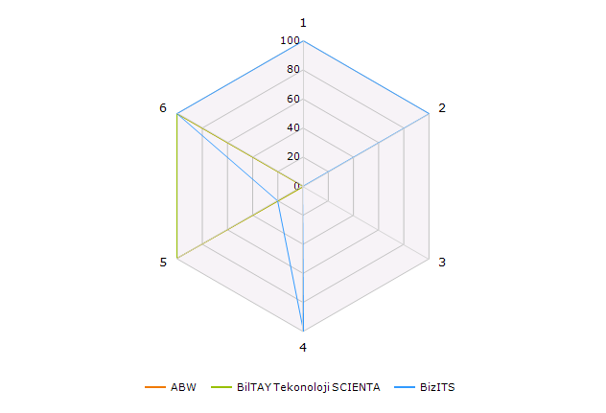

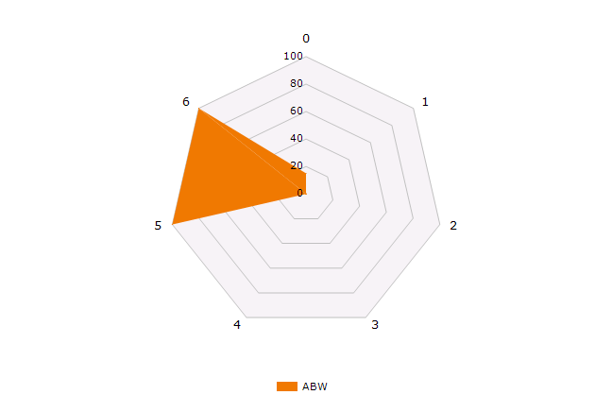

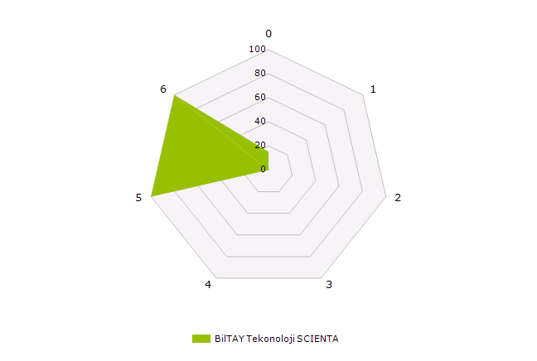

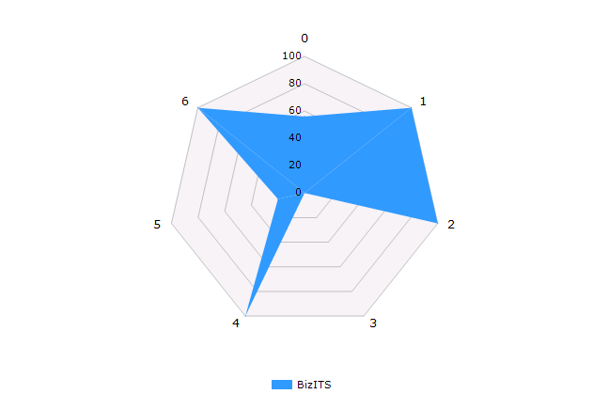

The chart below is based on a comparison of the answers you provided against your selected products' functionalities, and shows the overall ratings.

