Qatar University  College of Engineering  Dept. of Computer Science & Eng. | Software Engineering  CMPS 310 - Lab
Lab 9 Quick Revision on JavaFX
Supporting tools - Eclipse and SceneBuilder | 2 hours 30 minutes
Learning objectives
- Explain how the model, view (FXML) and controller of an MVC-based JavaFX application are separated.
- Build and run simple JavaFX interfaces with FXML and SceneBuilder: a login window and a menu bar.
- Handle the ActionEvents raised by buttons and menu items in a controller.
- Design mockup screens for All Phones Shop (APS) use cases: a toolbar and input forms.
Course learning outcome: CLO 6 - Design, implement, test and present a software system in a group.
JavaFX and MVC
This lab is a quick revision of JavaFX; it assumes that you already know the basics. It prepares the mockup screens for the APS system that you will refine in the course project. Each sample separates the application into the components below, so one component can change without significantly disturbing the others.
Component | Where it lives | Role
Model | Package model | Domain data and services, such as DateModel or UserAccountContainer. It knows nothing about the screen.
View | FXML file, drawn with SceneBuilder | The layout of the screen. Each control that the controller uses has an fx:id; each event names a handler, such as onAction="#login".
Controller | Package controller | Handles the ActionEvents from the view with @FXML methods, calls the model and updates the view.
Application | Package app | Loads the FXML with FXMLLoader, creates the Scene and shows the Stage.
Set up the project - 10 minutes
- Start Eclipse and create a new Java project with JavaFX enabled.
- In the src folder, create four packages: model, view, controller and app.
- Keep SceneBuilder available for editing the FXML files. The sample code is at the end of this document.
Part A JavaFX samples - Guided practice
Work through A.1 to A.3 with the instructor. The instructor first briefly explains the objectives of the lab and the quick revision of building a simple GUI with JavaFX (25 minutes). Copy the code of each sample from the Sample code section into the correct packages, then compile and run it.
A.1 Practise an MVC-based application - 15 minutes
- Copy the code of Sample 1 to the correct packages. Compile it and run the program.
- Notice how the view, controller and model classes are separate components. This allows each component to be modified without significantly disturbing the others.
A.2 Write a simple login window - 15 minutes
- Copy the code of Sample 2 to the correct packages. Compile and run the program.
- Note the use of the MVC architecture.
- Explore the UserAccountContainer class and see how it provides UserAccount services such as find(), login() and logout().
- Understand the use of the "Login" button and how its ActionEvent is handled.
A.3 Create a simple menu bar - 15 minutes
- Copy the code of Sample 3 to the correct packages, then compile and run the program.
- See how the menu items and sub-menu items have been created and how their action events are handled.
Part B All Phones Shop - Individual mockup screens
Individual assessment. You may discuss ideas, but build and explain your own screens. You can reuse any code from the samples. Keep the menu names consistent with the APS use cases from Labs 5 to 8, such as Register Client, Sell Item and Buy on Auction.
B.1 Design a toolbar for the major APS use cases - 20 minutes
- Make a copy of MenuView.fxml, then use SceneBuilder to add a toolbar below the menu bar, as shown in Figure 1.
- The icons on the buttons are not graphics but MS-Office fonts (hint: the font name is Segoe UI Symbol).
- Update the controller to handle the ActionEvents generated by the toolbar buttons.
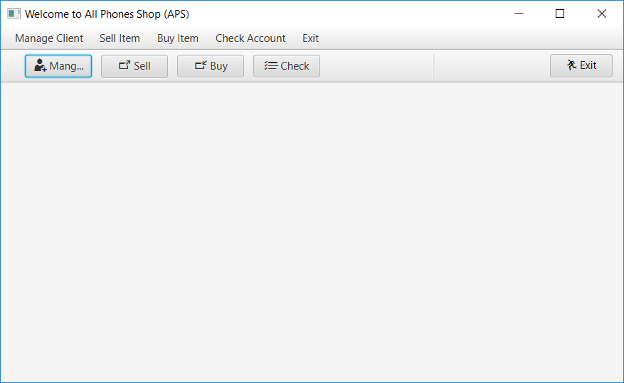
Figure 1 APS toolbar below the menu bar
B.2 Design forms for the Sell Item and Buy on Fixed use cases - 40 minutes
- Each form must have at least four text fields and one "Enter" button.
- The client (actor) can enter input data in the four fields, such as the item model, make, capacity and color.
- Create one FXML file for each form: the Sell Item FXML and the Buy Item FXML.
B.3 Save your work
Save your work. Copy the new code into your Word document: the updated Menu FXML, the Sell Item FXML, the Buy Item FXML, the updated controller and screenshots of the running screens.
Submission requirements
10 minutes. Open the CMPS310 GitHub repositories and select your own repository. Submit the file below inside a folder named Lab 9 JavaFX, using the individual repository workflow from Lab 4. Part A is not submitted. Commit and push the file, then check that it opens from your repository.
File | Required contents
lab09-solution.docx | Name and student ID; the updated Menu FXML, Sell Item FXML and Buy Item FXML; the updated controller; readable screenshots of the toolbar and both forms running.
Assessment criteria (10 points)
Criterion | Points
Toolbar covers the major APS use cases, is consistent with the menu bar, and its ActionEvents are handled in the controller | 3
Sell Item and Buy on Fixed forms have at least four suitable text fields and an Enter button | 3
MVC separation is respected; the code is in the correct packages, compiles and runs | 2.5
Readable code, screenshots and complete submission | 1.5
Further reading: OpenJFX documentation; Scene Builder
Sample code
Copy the code of each sample to the matching package of your Eclipse project: model, view (FXML), controller and app.
Sample 1: Designing an MVC-based Application
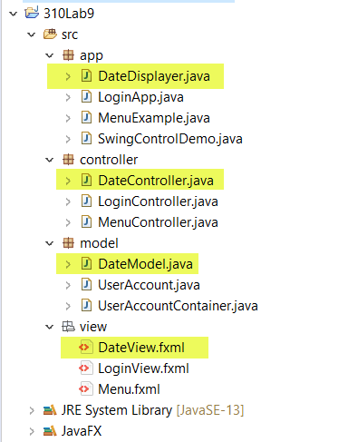
Model
package model;
import java.text.DateFormat;
import java.text.SimpleDateFormat;
import java.util.Calendar;
import java.util.GregorianCalendar;

public class DateModel {
public String getCurrentDate() {
Calendar calendar = new GregorianCalendar();
DateFormat dateFormat = new SimpleDateFormat("dd/MM/yyyy");
return dateFormat.format(calendar.getTime());
}
}
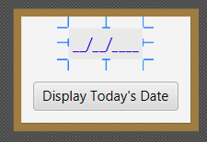
View (based on FXML)
<?xml version="1.0" encoding="UTF-8"?>

<?import javafx.geometry.Insets?>
<?import javafx.scene.control.Button?>
<?import javafx.scene.control.Label?>
<?import javafx.scene.layout.VBox?>
<?import javafx.scene.text.Font?>

<VBox alignment="CENTER" spacing="20.0" xmlns="http://javafx.com/javafx/11.0.1" xmlns:fx="http://javafx.com/fxml/1" fx:controller="controller.DateController">
<children>
<Label fx:id="dateView" text="__/__/____" textFill="#2406ea">
<font>
<Font size="14.0" />
</font>
<padding>
<Insets bottom="3.0" left="3.0" right="3.0" top="3.0" />
</padding>
</Label>
<Button fx:id="displayDateButton" mnemonicParsing="false" onAction="#displayDate"
text="Display Today's Date" textAlignment="CENTER" textFill="#090909" />
</children>
<padding>
<Insets bottom="10.0" left="10.0" right="10.0" top="10.0" />
</padding>
</VBox>
Controller
package controller;

import javafx.event.ActionEvent;
import javafx.fxml.FXML;
import javafx.scene.control.Button;
import javafx.scene.control.Label;
import model.DateModel;

public class DateController {

private DateModel model=new DateModel();
@FXML
private Label dateView;

@FXML
private Button displayDateButton;

@FXML
void displayDate(ActionEvent event) {
dateView.setText(model.getCurrentDate());
}

}
Sample MVC-based Main Application
package app;

import javafx.application.Application;
import javafx.fxml.FXMLLoader;
import javafx.scene.Scene;
import javafx.scene.layout.Pane;
import javafx.stage.Stage;

public class DateDisplayer extends Application {

@Override
public void start(Stage stage) throws Exception{
Pane root = FXMLLoader.load(getClass().getResource("/view/DateView.fxml"));
stage.setScene(new Scene(root, 300, 100));
stage.setTitle("Date Displayer App");
stage.show();
}

public static void main(String[] args) {
launch(args);
}
}
Sample 2: Developing a simple MVC-based Login Window in JavaFX
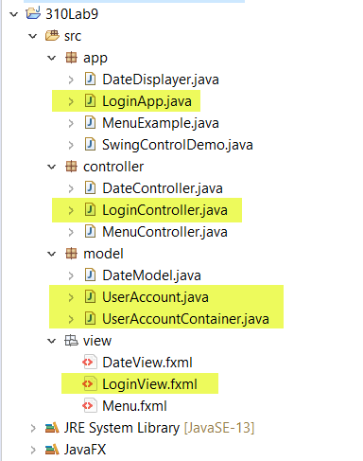
Model
package model;
public class UserAccount {
private String username="", password="";
private boolean isLogged=false;

public UserAccount(String username, String password) {
if (UserAccountContainer.find(username)==null) {//check if Account exists
this.username = username;
this.password = password;
UserAccountContainer.addUser(this);//automatically added to container
}
else
System.err.println("Error: Username already exists.");
}

public String getUsername() {
return username;
}

public boolean isLogged() {
return isLogged;
}

public void logout() {
final StackTraceElement[] elements = new Throwable().getStackTrace();
if (elements[1].getClassName().equals("model.UserAccountContainer"))//only the
container is allowed to set isLogged
this.isLogged = false;
}

public void login() {
final StackTraceElement[] elements = new Throwable().getStackTrace();
if (elements[1].getClassName().equals("model.UserAccountContainer"))//only the
container is allowed to set isLogged
this.isLogged = true;
}

public void changePassword(String oldPassword, String newPassword) {
if (this.password.equals(oldPassword))
this.password = newPassword;
}
public boolean isValid(String username, String password) {
return this.username.equalsIgnoreCase(username) && this.password.equals(password);
}
}

package model;

import java.util.ArrayList;
import java.util.List;

public class UserAccountContainer {
private static List<UserAccount> userAccounts = new ArrayList<UserAccount>();

public static void addUser(UserAccount user) {
if (user!=null)
userAccounts.add(user);
}

public static UserAccount find(String username) {
for (UserAccount user : userAccounts)
if(user.getUsername().equals(username))
return user;

return null;
}

public static UserAccount login(String username, String password) {
UserAccount temp = find(username);
if (temp!=null && temp.isValid(username, password))
{
temp.login();
return temp;
}
return null;
}
public static void logout(UserAccount user) {
if(user.isLogged())
user.logout();
}
}
View (based on FXML)
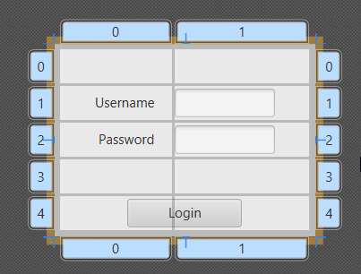
<?xml version="1.0" encoding="UTF-8"?>

<?import javafx.geometry.Insets?>
<?import javafx.scene.control.Button?>
<?import javafx.scene.control.Label?>
<?import javafx.scene.control.PasswordField?>
<?import javafx.scene.control.TextField?>
<?import javafx.scene.layout.ColumnConstraints?>
<?import javafx.scene.layout.GridPane?>
<?import javafx.scene.layout.RowConstraints?>
<?import javafx.scene.layout.VBox?>

<VBox xmlns="http://javafx.com/javafx/11.0.1" xmlns:fx="http://javafx.com/fxml/1" fx:controller="controller.LoginController">
<children>
<GridPane hgap="2.0" vgap="2.0">
<columnConstraints>
<ColumnConstraints hgrow="SOMETIMES" minWidth="10.0" prefWidth="100.0" />
<ColumnConstraints hgrow="SOMETIMES" minWidth="10.0" prefWidth="120.0" />
</columnConstraints>
<rowConstraints>
<RowConstraints minHeight="10.0" prefHeight="30.0" vgrow="SOMETIMES" />
<RowConstraints minHeight="10.0" prefHeight="30.0" vgrow="SOMETIMES" />
<RowConstraints minHeight="10.0" prefHeight="30.0" vgrow="SOMETIMES" />
<RowConstraints fillHeight="false" minHeight="10.0" prefHeight="30.0" valignment="CENTER" vgrow="NEVER" />
<RowConstraints fillHeight="false" minHeight="10.0" prefHeight="30.0" valignment="CENTER" vgrow="NEVER" />
</rowConstraints>
<children>
<Label text="Username" textAlignment="RIGHT" GridPane.halignment="RIGHT" GridPane.rowIndex="1">
<GridPane.margin>
<Insets right="15.0" />
</GridPane.margin>
</Label>
<Label text="Password" textAlignment="RIGHT" GridPane.halignment="RIGHT" GridPane.rowIndex="2">
<GridPane.margin>
<Insets right="15.0" />
</GridPane.margin>
</Label>
<TextField fx:id="username" GridPane.columnIndex="1" GridPane.rowIndex="1">
<GridPane.margin>
<Insets right="30.0" />
</GridPane.margin>
</TextField>
<PasswordField fx:id="password" GridPane.columnIndex="1" GridPane.rowIndex="2">
<GridPane.margin>
<Insets right="30.0" />
</GridPane.margin>
</PasswordField>
<Button fx:id="loginButton" alignment="CENTER" contentDisplay="CENTER" maxHeight="1.7976931348623157E308" mnemonicParsing="false" onAction="#login" prefHeight="30.0" prefWidth="102.0" text="Login" GridPane.columnSpan="2" GridPane.halignment="CENTER" GridPane.rowIndex="4" GridPane.vgrow="NEVER">
<opaqueInsets>
<Insets />
</opaqueInsets>
<GridPane.margin>
<Insets bottom="5.0" left="5.0" right="5.0" top="5.0" />
</GridPane.margin>
</Button>
</children>
<opaqueInsets>
<Insets bottom="5.0" left="5.0" right="5.0" top="5.0" />
</opaqueInsets>
<padding>
<Insets bottom="5.0" left="5.0" right="5.0" top="5.0" />
</padding>
</GridPane>
</children>
</VBox>
Controller
package controller;

import javafx.event.ActionEvent;
import javafx.fxml.FXML;
import javafx.scene.control.Alert;
import javafx.scene.control.Alert.AlertType;
import javafx.scene.control.Button;
import javafx.scene.control.PasswordField;
import javafx.scene.control.TextField;
import javafx.stage.Window;
import model.UserAccount;
import model.UserAccountContainer;

public class LoginController {
@FXML
private PasswordField password;

@FXML
private TextField username;

@FXML
private Button loginButton;

@FXML
void login(ActionEvent event) {
UserAccount user = UserAccountContainer.login( username.getText(), password.getText());
if (user != null && user.isLogged()) {
displayMessage("Welcome " + user.getUsername() + ". You have successfully logged in.",
AlertType.CONFIRMATION);
username.clear();
password.clear();

((Window) loginButton.getScene().getWindow()).hide();
} else
displayMessage("Unsuccessfull login. Try again.", AlertType.ERROR);
}

public void displayMessage(String message, AlertType type) {
Alert alert = new Alert(type);
alert.setTitle("System Message");
alert.setHeaderText(null);
alert.setContentText(message);
alert.showAndWait();
}
}
Sample MVC-based Main Application
package app;
import javafx.application.Application;
import javafx.fxml.FXMLLoader;
import javafx.scene.Scene;
import javafx.scene.layout.Pane;
import javafx.stage.Stage;
import model.UserAccount;

public class LoginApp extends Application {
@Override
public void start(Stage stage) throws Exception{
Pane root = FXMLLoader.load(getClass().getResource("/view/LoginView.fxml"));
stage.setScene(new Scene(root, 300, 200));
stage.setTitle("Login Dialog");
stage.show();
}

public static void main(String[] args) {
//Create sample UserAccounts:
new UserAccount("sayed", "password123");
new UserAccount("ahmed", "ahmed123");
launch(args);
}
}
Sample 3: Developing a Menu-based GUI in JavaFX
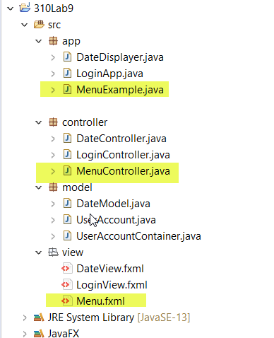
Model
This is just a mockup – no model is used. The menubar is not functional.
View (based on FXML)
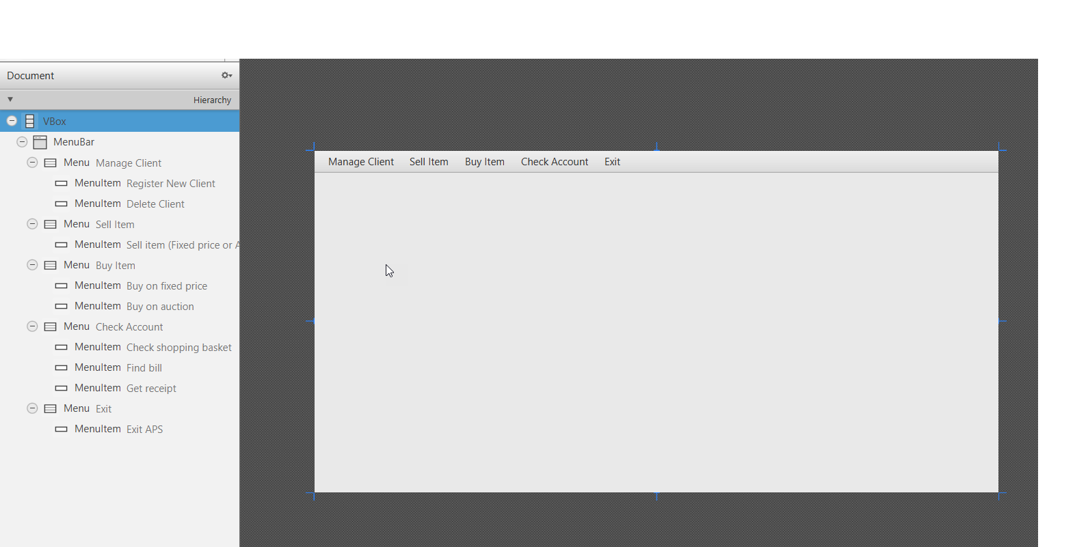
<?xml version="1.0" encoding="UTF-8"?>

<?import javafx.scene.control.Menu?>
<?import javafx.scene.control.MenuBar?>
<?import javafx.scene.control.MenuItem?>
<?import javafx.scene.layout.VBox?>

<VBox id="vbox" prefHeight="400" prefWidth="800" xmlns:fx="http://javafx.com/fxml/1" xmlns="http://javafx.com/javafx/11.0.1" fx:controller="controller.MenuController">
<MenuBar fx:id="menuBar">
<menus>
<Menu text="Manage Client">
<items>
<MenuItem onAction="#registerNewClient" text="Register New Client" />
<MenuItem onAction="#deleteClient" text="Delete Client" />
</items>
</Menu>
<Menu text="Sell Item">
<items>
<MenuItem mnemonicParsing="false" onAction="#sellItem" text="Sell item (Fixed price or Auction)" />
</items>
</Menu>
<Menu text="Buy Item">
<items>
<MenuItem onAction="#buyOnFixed" text="Buy on fixed price" />
<MenuItem onAction="#buyOnAuction" text="Buy on auction" />
</items>
</Menu>
<Menu mnemonicParsing="false" text="Check Account">
<items>
<MenuItem mnemonicParsing="false" onAction="#checkShoppingBasket" text="Check shopping basket" />
<MenuItem mnemonicParsing="false" onAction="#findBill" text="Find bill" />
<MenuItem mnemonicParsing="false" onAction="#getReceipt" text="Get receipt" />
</items>
</Menu>
<Menu mnemonicParsing="false" text="Exit">
<items>
<MenuItem mnemonicParsing="false" onAction="#exit" text="Exit APS" />
</items>
</Menu>
</menus>
</MenuBar>
</VBox>
Controller
package controller;

import javafx.event.ActionEvent;
import javafx.fxml.FXML;
import javafx.scene.control.Alert;
import javafx.scene.control.Alert.AlertType;
import javafx.scene.control.MenuBar;

public class MenuController {
@FXML
private MenuBar menuBar;

@FXML
void buyOnAuction(ActionEvent event) {
displayMessage("Buy on Auction is waiting to be implemented", AlertType.CONFIRMATION);
}

@FXML
void buyOnFixed(ActionEvent event) {
displayMessage("Buy on Fixed Price is waiting to be implemented", AlertType.CONFIRMATION);
}

@FXML
void checkShoppingBasket(ActionEvent event) {
displayMessage("Checking the shopping basket is waiting to be implemented", AlertType.CONFIRMATION);
}

@FXML
void deleteClient(ActionEvent event) {
displayMessage("Delete a client (by corporate clients only) is waiting\nto be implemented", AlertType.CONFIRMATION);
}

@FXML
void exit(ActionEvent event) {
System.exit(0);
}

@FXML
void findBill(ActionEvent event) {
displayMessage("Finding a bill is waiting to be implemented", AlertType.CONFIRMATION);
}

@FXML
void getReceipt(ActionEvent event) {
displayMessage("Getting a receipt is waiting to be implemented", AlertType.CONFIRMATION);
}

@FXML
void registerNewClient(ActionEvent event) {
displayMessage("Registering a new client is waiting to be implemented", AlertType.CONFIRMATION);
}

@FXML
void sellItem(ActionEvent event) {
displayMessage("Selling an item (both on fixed price or on auction) is waiting\nto be implemented", AlertType.CONFIRMATION);
}

public void displayMessage(String message, AlertType type) {
Alert alert = new Alert(type);
alert.setTitle("APS Message");
alert.setHeaderText(null);
alert.setContentText(message);

alert.showAndWait();
}

}
Sample MVC-based Main Application
package app;

import javafx.application.Application;
import javafx.fxml.FXMLLoader;
import javafx.scene.Scene;
import javafx.scene.layout.Pane;
import javafx.stage.Stage;

public class MenuExample extends Application {

@Override
public void start(final Stage stage) throws Exception {
Pane root = FXMLLoader.load(getClass().getResource("/view/Menu.fxml"));
stage.setScene(new Scene(root, 600, 400));
stage.setTitle("Welcome to All Phones Shop (APS)");
stage.show();
}

public static void main(String[] arguments) {
Application.launch(MenuExample.class, arguments);
}
}

