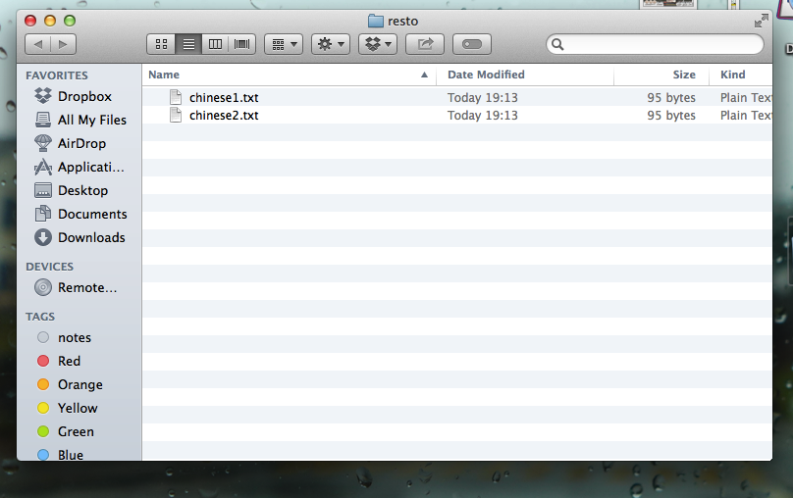

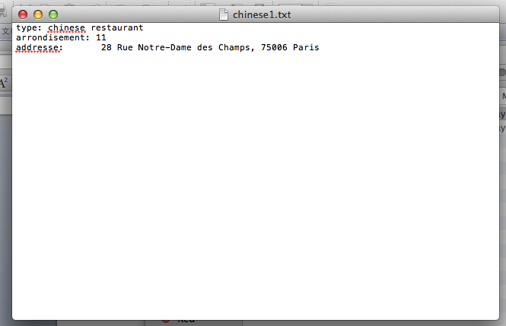





The red part is the result.

Command:

**grep –l arrondisement * | xargs grep –l type**

**grep –l means list out the file name which contains the aimed string.**

**xargs is for safety and not to have errors**