- Explain Transformers

Transformers are neural network architectures that use self-attention mechanisms to process sequential data in parallel, replacing the need for recurrence.They are specifically designed to comprehend context and meaning by analyzing the relationship between different elements, and they rely almost entirely on a mathematical technique called attention to do so.
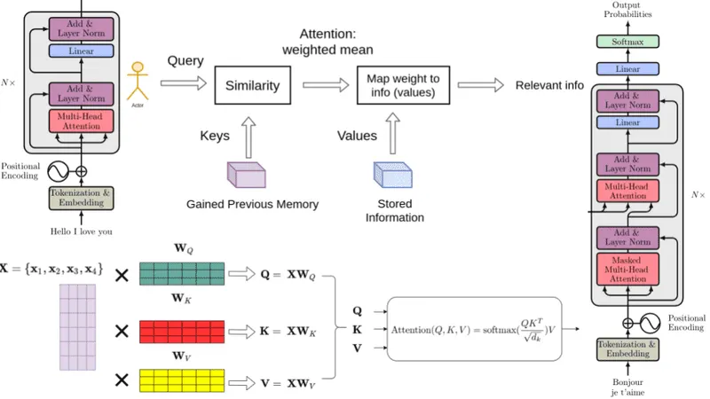
Transformer models such as relational databases generate query, key and value vectors for each part of a data sequence, and use them to compute attention weights through a series of matrix multiplications.
Relational databases are designed to simplify the storage and retrieval of relevant data: they assign a unique identifier (“key”) to each piece of data, and each key is associated with a corresponding value. The “Attention is All You Need” paper applied that conceptual framework to processing the relationships between each token in a sequence of text.
- The query vector represents the information a specific token is “seeking.” In other words, a token’s query vector is used to compute how other tokens might influence its meaning, conjugation or connotations in context.
- The key vectors represent the information that each token contains. Alignment between query and key is used to compute attention weights that reflect how relevant they are in the context of that text sequence.
- The value (or value vector) “returns” the information from each key vector, scaled by its respective attention weight. Contributions from keys that are strongly aligned with a query are weighted more heavily; contributions from keys that are not relevant to a query will be weighted closer to zero.
For an LLM, the model’s “database” is the vocabulary of tokens it has learned from the text samples in its training data. Its attention mechanism uses information from this “database” to understand the context of language.
The transformer has 4 main parts:
- Tokenization
- Embedding
- Positional encoding
- Transformer block (several of these)
- Softmax
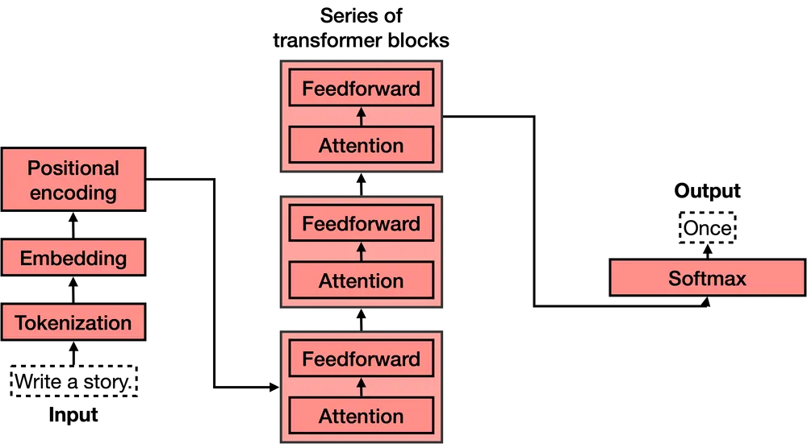
The fourth one, the transformer block, is the most complex of all. Many of these can be concatenated, and each one contains two main parts: The attention and the feedforward components.

- Explain Pre-training and Fine tuning

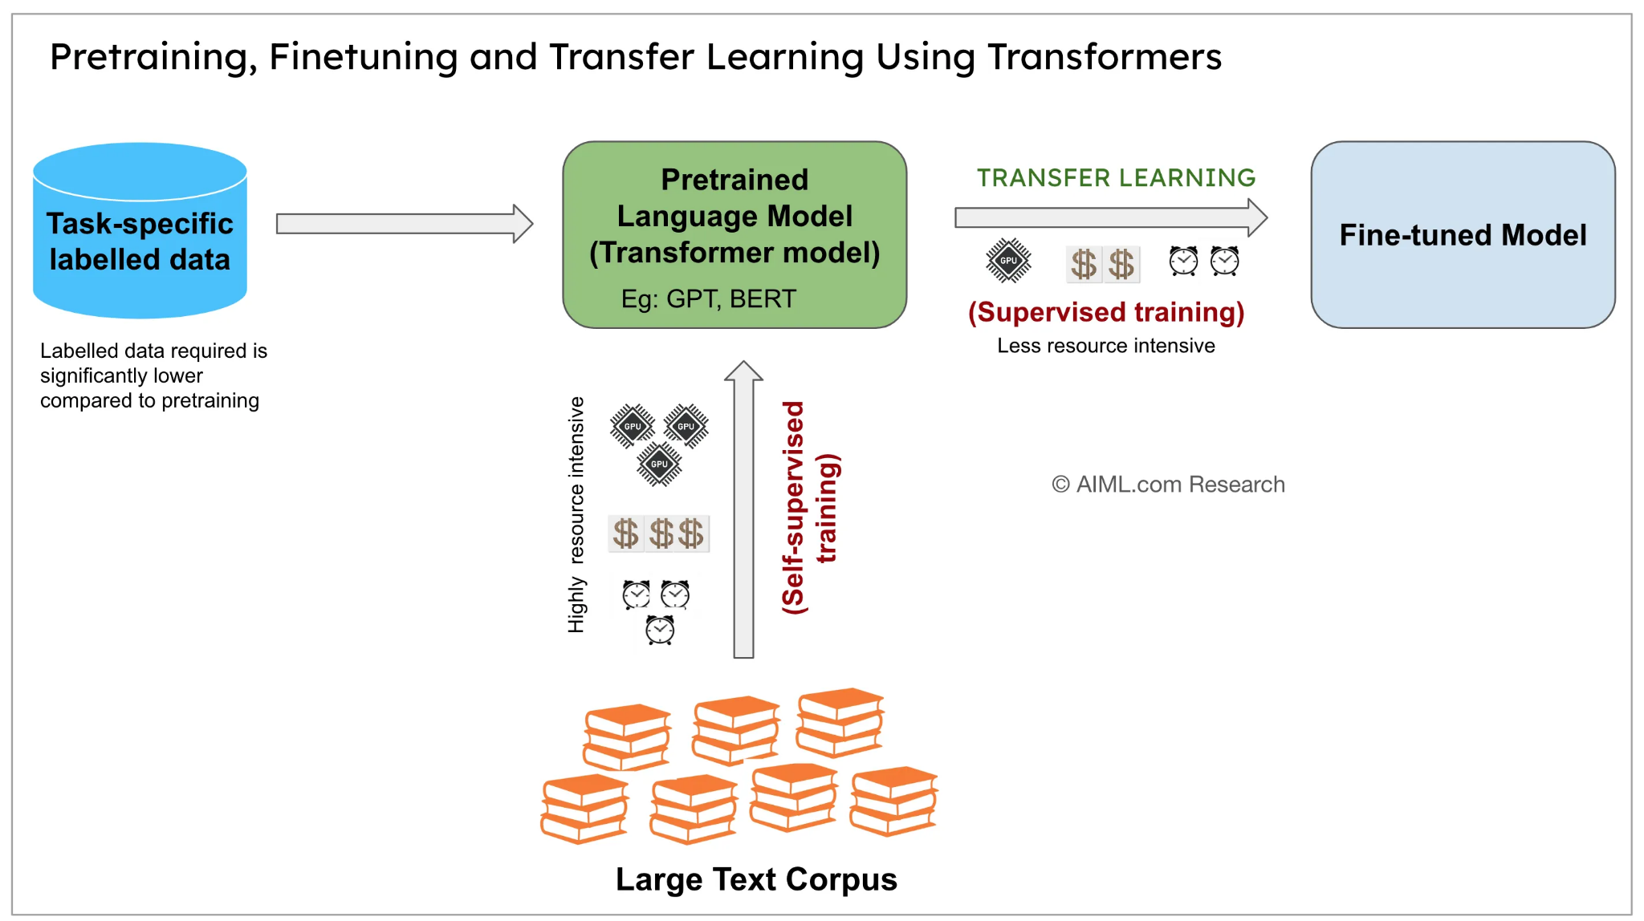

- Pre-training
The primary goal of pre-training is to expose a Transformer model to a massive dataset of unlabeled text, allowing it to learn the fundamental patterns and structures inherent in language. This vast data often comes from the internet, encompassing books, articles, websites, and more. By processing this diverse information, the model develops a broad understanding of grammar, semantics, and common-sense knowledge.
Several key tasks are employed during pre-training to facilitate this learning:
- Masked Language Modeling (MLM): In this technique, a certain percentage of the tokens (words or subwords) in the input text are randomly masked. The model’s objective is then to predict these masked tokens based on the surrounding context. This forces the model to understand the relationships between words and capture contextual meaning. For example, in the sentence “The cat sat on the [MASK],” the model would learn to predict “mat.”
- Next Sentence Prediction (NSP) : While its effectiveness is debated in more recent research, NSP was an early pre-training task. The model was presented with pairs of sentences and had to predict whether the second sentence was the subsequent sentence in the original document. This aimed to help the model understand the relationships and coherence between sentences.
- Causal Language Modeling (CLM): This task is the core of generative models like GPT. The model is trained to predict the next token in a sequence, given all the preceding tokens. By repeatedly predicting the next word, the model learns the statistical patterns of language generation. For instance, given “Once upon a,” the model learns to predict likely next words like “time” or “day.”
The benefits of pre-training are substantial. The model learns rich and generalizable language representations, capturing both semantic (meaning) and syntactic (structure) information. This pre-trained knowledge provides a strong foundation, enabling the model to perform well on a variety of downstream tasks even with limited task-specific data.

Fine-tuning: Adapting to Specific Tasks
Once a Transformer model has been pre-trained on a massive dataset, the next crucial step is fine-tuning. The goal of fine-tuning is to adapt the pre-trained model to perform a specific NLP task using a smaller, labeled dataset relevant to that task.
The fine-tuning process typically involves taking the pre-trained model and adding a small task-specific layer on top (e.g., a classification layer). The entire model, or a significant portion of it, is then trained on the labeled task-specific data. Because the model has already learned general language representations during pre-training, it requires significantly less labeled data and training time to achieve high performance on the target task compared to training a model from scratch.
Common fine-tuning tasks and approaches include:
- Text Classification: Adding a classification layer to the encoder and training it to assign a category label to the input text (e.g., sentiment analysis, topic classification).
- Named Entity Recognition (NER): Adding a token classification layer to the encoder, where the model predicts a label (e.g., Person, Organization, Location) for each token in the input sequence.
- Question Answering: Modifying the architecture to predict the start and end spans of the answer within a given context passage based on a question.
- Machine Translation: Fine-tuning a pre-trained encoder-decoder Transformer on parallel text data (sentences in two languages and their corresponding translations).
- Text Generation: Fine-tuning a pre-trained causal language model on task-specific data or providing specific prompts to guide the generation process.
The benefits of fine-tuning are significant. It allows us to achieve high performance on specific tasks with considerably less labeled data, which can be expensive and time-consuming to acquire. Fine-tuning also results in faster training times, as the model starts with a strong prior knowledge of language learned during pre-training.

- Explain Post-embedding and Tokenization

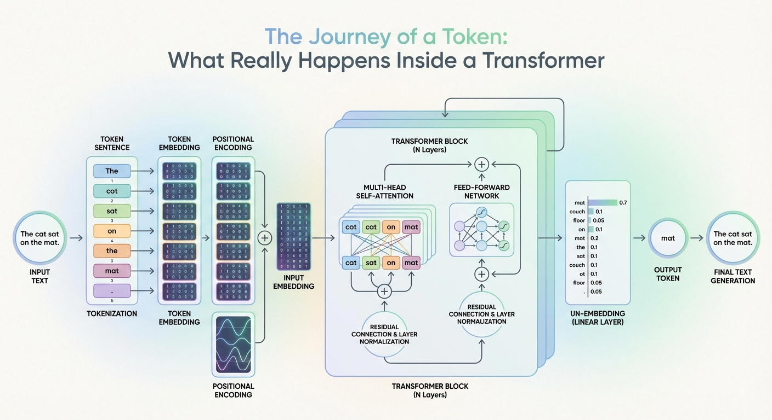

Post-embedding
It accepts tensors and ragged tensors, and assumes that the final dimension represents the features, while the second-to-last dimension represents the sequence.
- Permutation Invariance: Transformers process all input tokens in parallel rather than sequentially. On its own, self-attention does not know the order of words.
- Injecting Position: To fix this, positional encodings (or learned positional embeddings) are added element-wise to the token embeddings (X = Token Embedding + Positional Encoding). This gives the model a sense of sequence, distinguishing “dog bites man” from “man bites dog”.
How It Works
- Token Embedding: Raw text tokens are mapped into semantic vectors.
- Positional Encoding Injection: A position vector of the exact same dimension is element-wise added (or integrated) to the token embedding:
$Final Input=Token Embedding+Positional Embedding$
Main Types of Positional Embeddings
- Absolute Positional Embeddings (Sinusoidal):
  - Uses alternating sine and cosine functions of varying frequencies across the embedding dimensions.
  - Creates a unique wave-like pattern for every position index pos.
  - Example: The original "Attention Is All You Need" paper.

- Learned Absolute Embeddings:
  - Treats positions like a lookup table of trainable parameters learned during training (used in models like BERT and GPT-2/3).
- Relative Positional Embeddings:
  - Focuses on how far apart two tokens are rather than their fixed spot in the sequence, adding bias matrices directly into the attention scores (used in Transformer-XL, T5).
- Rotary Positional Embeddings:
  - Rotates the query and key vectors in the self-attention mechanism using rotation matrices. This allows the model to naturally capture relative distances and scale to longer context windows (used in modern LLMs like Llama and Mistral).

