- What is Agentic AI? How it differs from traditional AI?

Agentic AI is an artificial intelligence system that can independently plan, reason, make decisions, and execute multi-step tasks to achieve a broad goal with minimal human supervision.

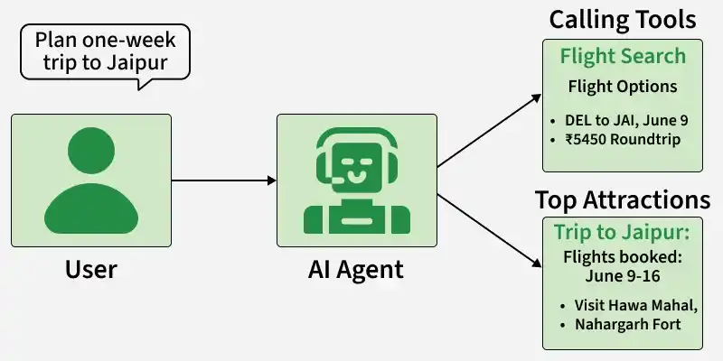

Agentic AI is a type of AI system that can autonomously make decisions, plan actions and execute tasks to achieve specific goals with minimal human intervention. It focuses on goal-driven behavior, reasoning and interaction with tools and environments.

- Specialised mastery: It’s trained and fine-tuned to handle a particular type of problem with great accuracy.
- Tool usage: It can connect with and use specific tools like software, APIs, databases, etc to achieve its goal.
- Goal-oriented actions: Instead of just giving information, it actively takes steps toward completing the task.
- Efficient problem-solving: Because it can plan, adapt and take actions autonomously, it can handle tasks more efficiently in dynamic environments.
- Traditional vs. Agentic AI: Unlike traditional AI systems that primarily respond to inputs, Agentic AI focuses on autonomous decision-making and goal-driven actions. It is defined by behavior (how it acts), not by the breadth of knowledge like General AI.
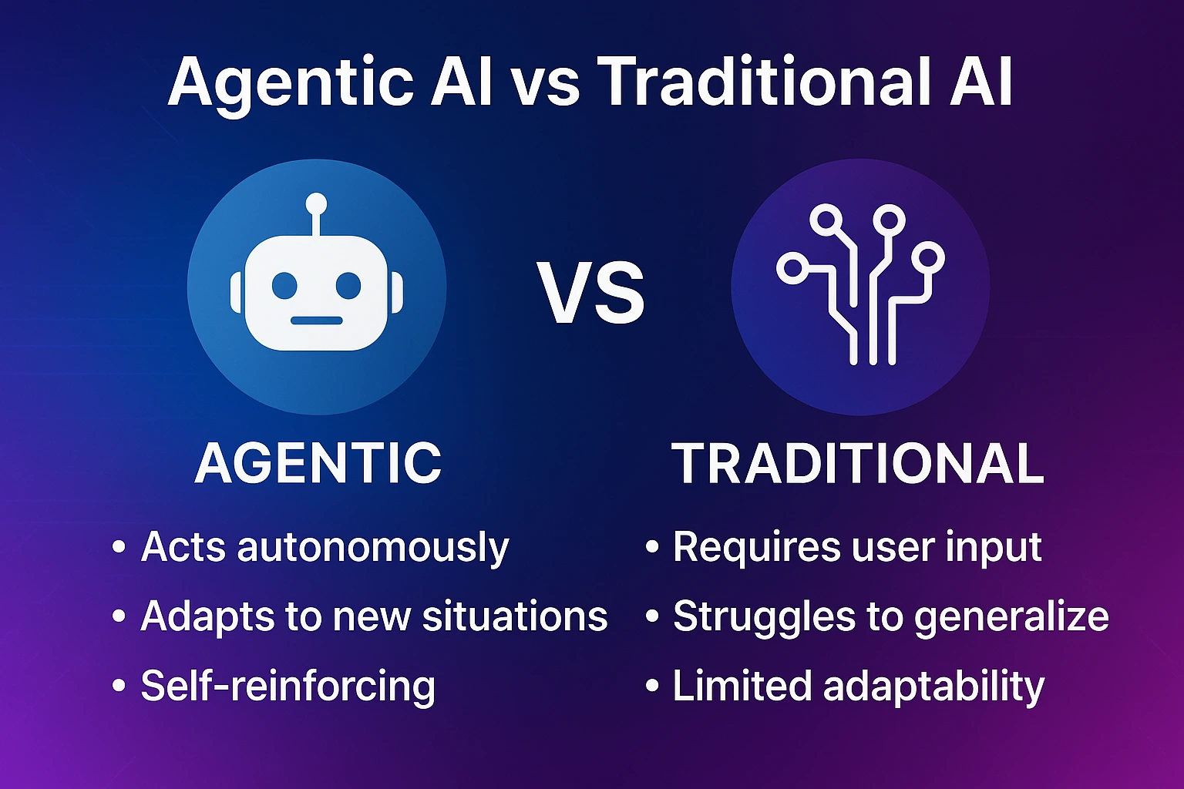

Feature | Traditional AI | Agentic AI
Primary Goal | Execute a specific rules-based or predictive task | Achieve a broad, multi-step objective autonomously
Decision-Making | Static, rule-based, or single-model inference | Contextual, dynamic reasoning with planning modules
Tool Use | Limited or none; primarily processes input-output | High; actively invokes APIs, browsers, and external software
Learning & Feedback | Relies on batch data updates or retraining | Adapts via real-time feedback and loop evaluations
- Core capabilities of Agentic AI

Agentic AI operates through a continuous, goal-driven cycle of Perceive, Reason, Act, and Learn (often expanded with reflection or evaluation). Unlike standard generative AI—which simply answers a prompt and stops—agentic systems autonomously pursue complex objectives with minimal human oversight

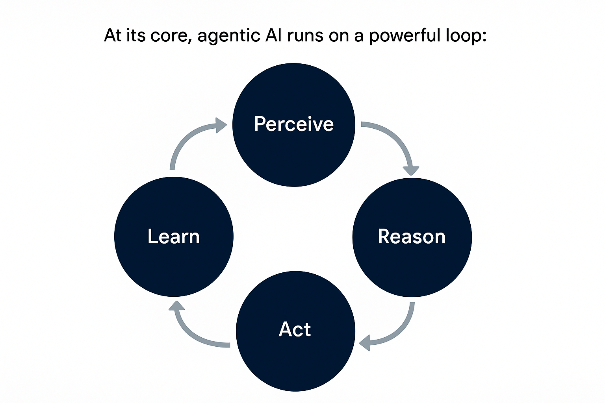

Perceive (Sensing the Environment)
- What it does: The agent gathers and ingests data from its surroundings, user inputs, APIs, databases, files, or real-time sensor streams.
- How it works: It processes multimodality (text, images, audio, video) and uses context windows or Retrieval-Augmented Generation (RAG) to understand the current state of the task.

Reason (Planning and Decision-Making)
- What it does: Using a large language model (LLM) or a specialized planning module as its "brain," the agent interprets the data, defines sub-goals, and maps out a step-by-step strategy.
- How it works: It applies techniques like chain-of-thought reasoning, ReAct (Reason + Act), or multi-agent orchestration to weigh alternatives and decide what to do next rather than just guessing a single output token.
Act (Executing via Tools)
- What it does: The agent translates thought into execution by interacting with external digital or physical systems.
- How it works: It calls APIs, writes code, queries databases, sends messages, or delegates sub-tasks to other agents using tool-use protocols like the Model Context Protocol (MCP)
Learn (Reflecting and Adapting)
- What it does: The agent evaluates the outcome of its action, checking whether it succeeded or failed.
- How it works: If an action fails or hits a roadblock, the feedback loops back into the perception and reasoning stages. It updates its memory, adjusts its plan, and tries a different approach until the main goal is reached

- Single Agent vs Multi Agent

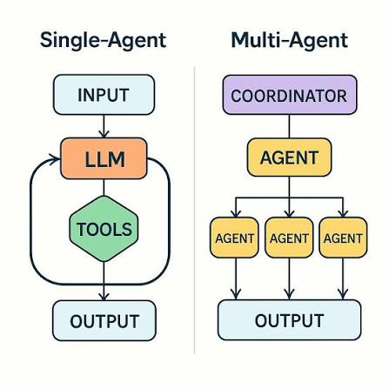

Dimension | Single-agent system | Multi-agent system
Architecture | One LLM-driven agent, with or without tools, executing a task end to end | Two or more agents that communicate, hand off, or work in parallel toward a shared goal
Cost | Low. One reasoning chain, minimal redundant calls | High. Coordination messages, context duplication, and role overhead multiply LLM calls
Latency | Low to moderate. Sequential but direct | Higher. Agents wait on each other, verify each other, and sometimes loop
Reliability | One point of failure, but that point is easy to isolate | Errors from one agent can propagate to others before anyone catches them
Debuggability | Simple. One trace, one decision path | Hard. Failures hide inside inter-agent handoffs and shared state
Control | High. Deterministic, easy to constrain | Lower. Behavior emerges from agent interaction, harder to predict
Scalability | Scales by running more parallel instances of the same agent | Scales by adding roles, but each addition adds coordination surface
Best fit | Linear workflows, single-domain tasks, tool-augmented automation | Genuinely parallel work, distinct expert roles, tasks exceeding one context window

- Use Cases of Agenti AI
Agentic AI moves beyond passive chatbots by using autonomous planning, reasoning, memory, and external tool/API execution to complete multi-step workflows.

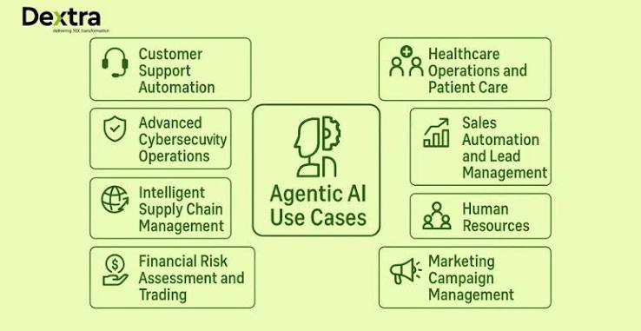
Key Enterprise & Industry Use Cases
- Customer Support & Self-Service: Autonomous agents query CRMs, pull past support ticket histories, use tools to fetch API data, and resolve customer queries directly without human intervention.
- Software Development & Coding: AI coding agents and copilots inspect files, write multi-step code, test applications, handle deployments, and execute spec-driven development workflows.
- Sales & Outbound Prospecting: AI-powered Sales Development Representatives (SDRs) handle meeting preparation, pipeline research, lead qualification, and multi-channel outreach.
- IT Operations & Self-Healing Systems: Agents monitor live infrastructure telemetry, detect system anomalies, triage alerts, and execute fixes or isolate security threats in real time.
- Finance & Compliance: Agents automate accounts payable/receivable, invoice processing, ledger entries, banking compliance checks, and Know Your Customer (KYC) workflows.
- HR & Internal Operations: Agents manage employee inquiries regarding company policies, process leave requests, pull context for reviews, and sort or screen incoming resumes.
- Supply Chain & Logistics: Multi-agent systems coordinate inventory management, route optimization, smart warehouse tracking, and multi-step supplier operations.
- Data Integration & Business Intelligence: Platforms like Boomi or ThoughtSpot connect fragmented enterprise data sources, govern RAG knowledge pipelines, and deliver autonomous business analytics.

