- LangChain

LangChain is one of the most widely used frameworks for building Retrieval-Augmented Generation (RAG) systems. While RAG is the architecture used to ground an LLM with external knowledge, LangChain provides the modular plumbing—such as document loaders, text splitters, vector store integrators, and prompt chains—to build and connect that system together seamlessly.

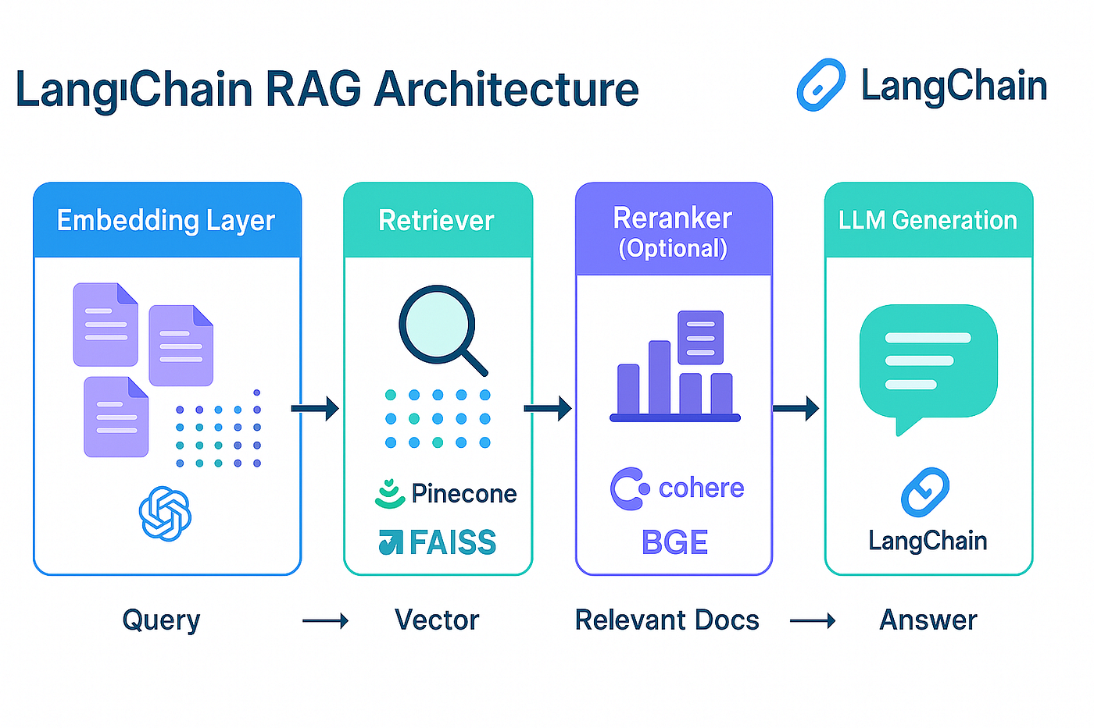
Ingestion Phase (The Knowledge Base)
Before an LLM can search your data, the information must be prepared and stored:
- Document Loaders (document_loaders): Standardise data import from over hundreds of sources, including PDFs, Markdown files, Slack channels, Notion workspaces, or web pages via LangChain Document Loaders.
- Text Splitters (text_splitter): Break large documents into smaller, coherent units (chunks). This ensures the text fits within the LLM's context window and retains semantic value.
- Embedding Models (embeddings): Transform text chunks into mathematical vectors that represent their contextual meaning. LangChain provides native wrappers for providers like OpenAI, Hugging Face, or Cohere.
- Vector Stores (vectorstores): Specialized databases that index and store these embeddings for rapid similarity searching. LangChain integrates directly with popular options like FAISS, Chroma, Pinecone, and Weaviate
Retrieval & Generation Phase (The Chain)
When a user asks a question, the runtime architecture kicks in:
- Retrievers (retrievers): Interfaces that take a user's natural language query, convert it into an embedding, and query the vector database to pull the most relevant text chunks.
- Prompt Templates (prompts): Structure instructions for the LLM. A standard RAG prompt combines the user's raw question with the dynamically retrieved text fragments as context, instructing the model to only answer based on the provided material.
- Chat Models / LLMs (chat_models): The engine that generates the final human-readable answer.
- LCEL (LangChain Expression Language): The syntax (| operator) used to chain the retriever, prompt template, and LLM together into a declarative execution flow.
USE CASES:
- Enterprise Document Q&A & Compliance: Companies use LangChain's document loaders (PDFs, Word docs, spreadsheets) and RecursiveCharacterTextSplitter to index thousands of pages of internal policy manuals, annual reports, or compliance guidelines. Users can query this text in natural language to extract precise answers backed by exact source citations.
- Customer Support & Conversational Chatbots: Integrating LangChain’s vector store retrievers with memory modules (e.g., ConversationBufferMemory) allows chatbots to maintain context across multi-turn user conversations. The bot answers technical issues using product documentation while remembering user preferences from previous messages.
- Intelligent Enterprise Search Engines: Standard keyword search often misses intent. LangChain enables semantic search engines by generating text embeddings that map the true conceptual meaning of enterprise data (across platforms like Confluence, Slack, and Google Drive), serving contextually relevant results.
- Research Assistance & Summarization: Academic, legal, and financial researchers leverage LangChain to ingest extensive literature databases. The RAG pipeline isolates relevant sections across hundreds of papers, compiles them, and summarizes the findings to answer specific research hypotheses

- Llamaindex

LlamaIndex is an open-source data framework designed to connect custom data sources to large language models (LLMs) through Retrieval-Augmented Generation (RAG) | Developer Documentation.
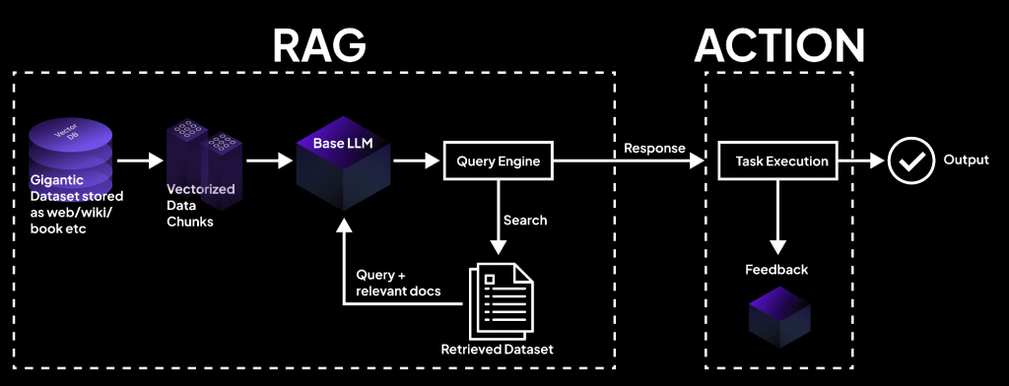

How LlamaIndex RAG Works
A standard RAG workflow in LlamaIndex moves through five key stages:
- Loading: Ingests raw data (PDFs, SQL databases, APIs, or local files) using data connectors into Documents and Nodes.
- Indexing: Splits text into smaller chunks and creates vector embeddings to store in a searchable index or vector database.
- Storing: Saves the index, metadata, and embeddings for quick retrieval.
- Querying: Uses retrievers, node postprocessors, and response synthesizers to find relevant context when a user asks a question.
- Evaluation: Measures the accuracy and speed of the generated output.
Core Components in Python
- SimpleDirectoryReader: Loads files from a local directory.
- VectorStoreIndex: Converts document nodes into vector representations for semantic search.
- Query Engine: Orchestrates the retrieval of context and passes it to the LLM to generate a grounded response

USE CASES
1. Data Ingestion & Loading
LLMs cannot natively access your enterprise data. LlamaIndex uses LlamaHub to provide hundreds of data connectors (called Readers).
- Use Case: Instantly ingest unstructured text, PDFs, Notion pages, Slack channels, SQL databases, and APIs into standard Document objects using a simple line of code (like SimpleDirectoryReader).
- Advanced Parsing: It powers tools like LlamaParse to extract complex layouts, embedded tables, and images from dense financial or technical documents.

2. Chunking & Transformation
Large documents exceed LLM context limits and dilute search accuracy. LlamaIndex transforms raw data into manageable snippets called Nodes.
- Use Case: It applies smart text-splitting strategies (e.g., SentenceSplitter) to slice data by a specific token size while maintaining overlapping context windows so sentences aren't cut in half.
- Metadata Augmentation: It automatically attaches helpful tags to data chunks—such as page numbers, file names, or even AI-generated summary questions—to optimize downstream search relevance.
3. Indexing & Storing
To search text mathematically, it must be converted into numerical vectors.
- Use Case: LlamaIndex acts as the orchestrator that passes text chunks to an embedding model (like OpenAI or Hugging Face) and builds a VectorStoreIndex.
- Storage Integration: It seamlessly interfaces with external vector databases like Elasticsearch, Chroma, Pinecone, or SingleStore to save these index structures for long-term production use.

4. Advanced Query Routing & Retrieval
Standard vector search (semantic top-k) frequently fails if a user asks a complex question. LlamaIndex excels at advanced query strategies:
- Query Decomposition: It can break a complex user question down into multiple sub-questions, execute them independently against different indices, and combine the results.
- Router Engines: It acts as a traffic controller, dynamically deciding whether a user’s prompt requires a semantic vector search or a broad text summarization.
- GraphRAG: It structures your documents into knowledge graphs (using entities and relations), allowing the LLM to traverse complex, connected concepts that traditional keyword matching misses.
5. Response Synthesis (Generation)
Once the correct facts are retrieved, LlamaIndex formats them into a final package for the LLM.
- Use Case: It acts as the prompt packager, passing both the original user query and the retrieved text context to the LLM (like GPT-4 or Mistral) to generate a highly accurate, grounded answer.
- Agentic RAG: It can orchestrate stateful AI agents that can chat, remember conversation history, utilize multiple retrieval tools, and even double-check their own answers before outputting them to the user.

- HAYSTACK

Haystack is an open-source AI orchestration and natural language processing (NLP) framework developed by Deepset for building production-ready Large Language Model (LLM) applications, semantic search, and Retrieval-Augmented Generation (RAG) systems
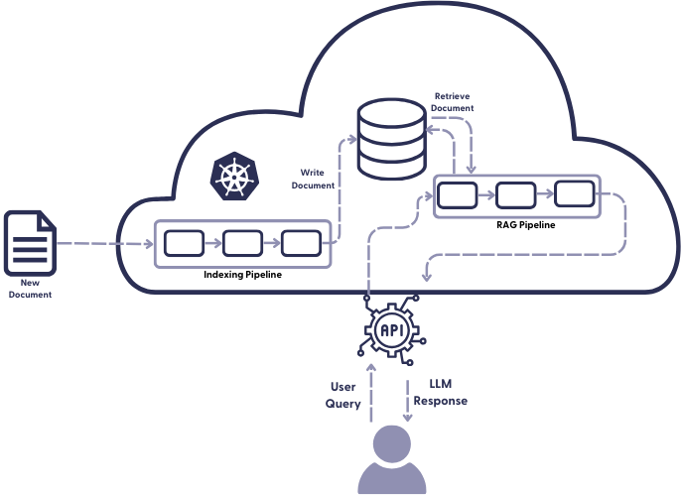
The Core Building Blocks of Haystack RAG
- Document Stores: Databases that hold your source data. Haystack decouples storage from the pipeline logic, offering native integrations with third-party vector databases like Milvus, Pinecone, Qdrant, and Weaviate.
- Components: Self-contained blocks of code that perform distinct tasks (e.g., parsing a PDF via Docling, embedding text, or fetching documents). You can naturally write custom blocks using the @component decorator.
- Pipelines: The connective infrastructure that binds components together. You connect the outputs of one component to the inputs of another, ensuring strict data type validation at runtime.
Main Use Cases of Haystack
- Retrieval-Augmented Generation (RAG): Connects external data sources and vector databases to LLMs so applications can answer questions accurately using proprietary or real-time documents.
- AI Agents: Builds modular agents capable of tool-calling, branching logic, decision-making, and self-correction loops.
- Semantic Search: Retrieves documents based on the actual meaning and context of a user's query rather than basic keyword matching
- Question Answering & Chatbots: Extracts granular, specific answers from large document collections or customer support data.
- Multimodal & Document Processing: Processes various data types, including text, images, and audio transcriptions.

