Santa Clara University
FINAL REPORT
COEN 493 Directed Reasearch
On
Big Data Analysis

(Prof. Dr. Rani Mikkilineni)

Submitted by
Aarthi Nagarajan
Student Id: 00001286259
TABLE OF CONTENTS
1. INTRODUCTION 3
2. GOAL 3
3. DATASET DESCRIPTION 3
3.1 Variable descriptions 4
4. APACHE SPARK 5
4.1 Resilient Distributed Datasets (RDD) 6
4.2 DataFrames 7
4.3 GraphFrames 7
4.3.1 PageRank 8
4.3.2 BFS 8
4.2 Seaborn 8
5. IMPLEMENTATION 8
5.1 Configuration 8
5.2 Details 8
5.3 Output -1 Screenshot 9
5.3.1 Description 10
5.3.1.1 Graph 1 – Arrival Delay East Coast 10
5.3.1.2 Graph 2 – Departure Delay East Coast 11
5.3.1.3 Graph 3 – SFO Arrival Delay 11
5.3.1.4 Graph 4 – Arrival Delay of Carriers 11
5.3.1.5 Graph 5 – SFO weekly Arrival Delay 11
5.3.1.6 Graph 6 – Chicago- Monthly Departure Delay 11
5.4 Output - 2 Screenshot 12
5.4.1 Description 12
5.4.1.1 Graph 1: Finding the top 20 most connected airports using Page Rank algorithm 12
5.4.1.2 Graph 2: Which flights departing from SFO are most likely to have significant delays 12
6. APPENDIX 13
7. REFERENCES 17

- INTRODUCTION
Big Data is the science of processing large amount of data for analyzing, predicting trends out of them. This is one of the most critical emerging technologies. The traditional data architectures are good in processing organized data. But in today’s world we have huge volumes of different data sets getting generated every single day. This required a new paradigm of computing strategies and technologies to handle these large data sets. The 4V's of big data - volume, velocity, variety and veracity makes the data management and analytics challenging for the traditional data warehouses. It is important to think of big data and analytics together. Analytics is about examining data to derive interesting and relevant trends and patterns, which can be used to inform decisions, optimize processes, and even drive new business models.
- GOAL
The goal of this project is to identify some interesting patterns from the Airline dataset. The Airline dataset contains information about each flight flown in the period 1987 – 2008 between various USA cities. Some of the interesting information, patterns from this dataset include but not limited to:
- most connected airports,
- best day of the week to travel with minimal delay from SFO airport.
For this project, I used the following technologies: Apache Spark, Python, Seaborn. Also, I used Microsoft Azure for computing needs.
- DATASET DESCRIPTION
The dataset is an airlines' data collection from the Research and Innovative Technology Administration (RITA). The data consists of flight arrival and departure details for all commercial flights within the USA, from October 1987 to April 2008. This is a large dataset: there are nearly 120 million records in total, and takes up 1.6 gigabytes of space when compressed and 12 gigabytes when uncompressed. It includes 29 attributes for each trip like Destination, Origin, Arrival time, Departure time and so on. Here is a descriptive list of useful variables.

3.1 Variable descriptions
 | Name | Description
1 | Year | 1987-2008
2 | Month | 1-12
3 | DayofMonth | 1-31
4 | DayOfWeek | 1 (Monday) - 7 (Sunday)
5 | DepTime | actual departure time
6 | CRSDepTime | scheduled departure time
7 | ArrTime | actual arrival time
8 | CRSArrTime | scheduled arrival time
9 | UniqueCarrier | unique carrier code
10 | FlightNum | flight number
11 | TailNum | plane tail number
12 | ActualElapsedTime | in minutes
13 | CRSElapsedTime | in minutes
14 | AirTime | in minutes
15 | ArrDelay | arrival delay, in minutes
16 | DepDelay | departure delay, in minutes
17 | Origin | origin IATA airport code
18 | Dest | destination IATA airport code
19 | Distance | in miles
20 | TaxiIn | taxi in time, in minutes
21 | TaxiOut | taxi out time in minutes
22 | Cancelled | was the flight cancelled?
23 | CancellationCode | reason for cancellation (A = carrier, B = weather, C = NAS, D = security)
24 | Diverted | 1 = yes, 0 = no
25 | CarrierDelay | in minutes
26 | WeatherDelay | in minutes
27 | NASDelay | in minutes
28 | SecurityDelay | in minutes
29 | LateAircraftDelay | in minutes

- APACHE SPARK
Apache Spark is an open-source distributed general-purpose cluster computing framework with (mostly) in-memory data processing engine that can do ETL, analytics, machine learning and graph processing on large volumes of data at rest (batch processing) or in motion (stream processing). It provides rich concise high-level APIs in these programming languages: Scala, Python, Java, R, and SQL. Spark aims at speed, ease of use, extensibility and interactive analytics. The following diagram shows the architecture of spark.

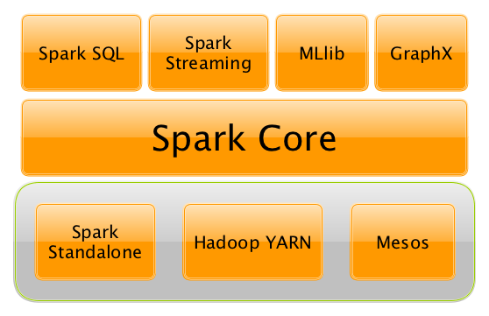
Figure : The Spark Platform
Spark Core is the foundation of the overall spark infrastructure. It provides distributed task dispatching, scheduling, and basic I/O functionalities, exposed through an application programming interface (for Java, Python, Scala, and R).

Spark SQL is a component on top of Spark Core that introduced a data abstraction called Data Frames, which provides support for structured and semi-structured data. Spark SQL provides a domain-specific language (DSL) to manipulate DataFrames in Scala, Java, or Python.
Spark streaming and MLlib are used for streaming and machine learning applications respectively.
GraphX is a distributed graph processing framework on top of Apache Spark Core.

4.1 Resilient Distributed Datasets (RDD)
RDD is the base abstraction of Apache Spark, it's the Resilient Distributed Dataset. RDDs are a programming abstraction that represents an immutable partitioned collection of objects, allowing for distributed operations to be performed upon them. RDDs are fault-tolerant (the resilient part) and, most importantly, can be stored in memory on worker nodes for immediate reuse. In memory storage provides for faster and more easily expressed iterative algorithms as well as enabling real-time interactive analyses.

4.2 DataFrames
Like an RDD, a DataFrame is an immutable distributed collection of data. Unlike an RDD, data is organized into named columns, like a table in a relational database. Designed to make large data sets processing even easier, DataFrame allows developers to impose a structure onto a distributed collection of data, allowing higher-level abstraction; it provides a domain specific language API to manipulate your distributed data.
We can create DataFrames by loading data from structured files (JSON, Parquet, CSV), RDDs, tables in Hive, or external databases (JDBC). We can also create DataFrames from scratch and build upon them. We can read any format provided there is an appropriate Spark SQL extension of DataFrameReader to format the dataset appropriately.

4.3 GraphFrames
GraphFrames support general graph processing, similar to GraphX library, built on top of Spark DataFrames. In GraphFrames, vertices and edges are represented as DataFrames, allowing us to store arbitrary data with each vertex and edge.
GraphFrames support the full set of algorithms available in GraphX, in all 3 language APIs. Results from graph algorithms are either DataFrames or GraphFrames.
Some of the algorithms implemented by GraphFrames include
- Breadth-first search (BFS): Find shortest paths from one set of vertices to another
- PageRank: Identify important vertices in a graph
- Shortest paths: Find shortest paths from each vertex to landmark vertices
- Label Propagation Algorithm (LPA): Detect communities in a graph
In this project, the flight data can be modeled as a graph with airports as vertices and connecting flights as edges. I have used PageRank and BFS algorithms provided by GraphFrames in this project.
4.3.1 PageRank
Using the PageRank algorithm, Spark iteratively traverses the graph and determines a rough estimate of how important the airport is.
4.3.2 BFS
I used BFS algorithm for our airline dataset to find the shortest number of connections between cities based on the dataset i.e. the hops between cities.

4.2 Seaborn
Seaborn is a library for making attractive and informative statistical graphics in Python. It is built on top of matplotlib and tightly integrated with the PyData stack, including support for numpy and pandas data structures and statistical routines from scipy and statsmodels.
- IMPLEMENTATION

5.1 Configuration
I used a spark cluster with one master and two worker nodes. Each node contains 2 cores, 7 GB RAM. Versions of various installed components

Java | 7
Spark | 2.1.1
Scala | 2.2.2
Python | 2.7.6

5.2 Details
I used PySpark to implement the application that would be submitted as a job in the spark cluster. The implementation includes the following steps
- Load the airline data from CSV files into spark cluster as DataFrames
- Join the airline data with airport, city information from a different csv file
- Filter, aggregate, group, sort data as required using DataFrames
- Run Spark SQL queries to get analyzed information
- Use graph algorithms to analyze on the dataset
- Convert the result to panda dataframes
- Plot the data using seaborn library

5.3 Challenges
These are some of the challenges that I faced in this project.
- Choosing the right library for visualization was a challenging one. I started with matplotlib, evaluated zeppelin, seaborn. Also, to easily add views to dashboards tried pushing the data to Elasticsearch and visualized using Kibana. Each library, tool had its own advantages. Finally, I used seaborn because of its simplicity and a lot of flexibility.
- Setting up the cluster in the cloud was much more challenging than setting up a local development setup in the local box. I used Microsoft azure and started with two nodes initially, but later added one more node to reduce the time taken for execution of some of the graph algorithms. But this required repeated installs and setups. To reduce the cost, I had to stop the servers and start them only when needed.

5.3 Output -1 Screenshot
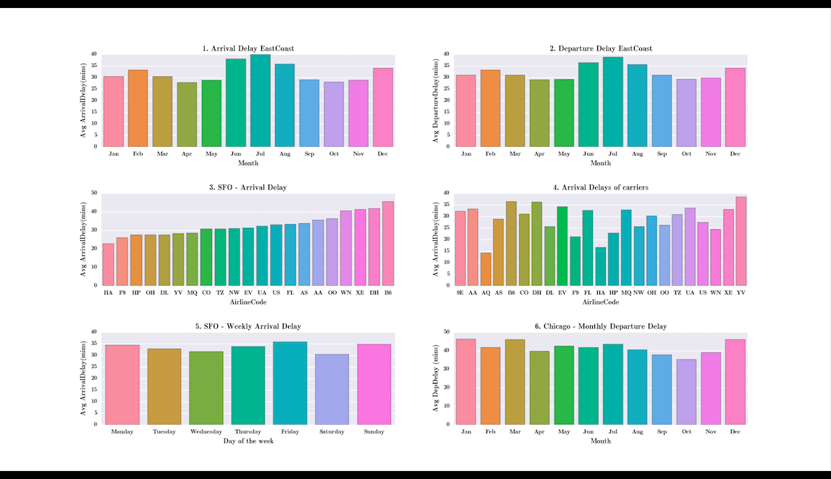

5.3.1 Description
5.3.1.1 Graph 1 – Arrival Delay East Coast
This graph shows the monthly analysis of Average arrival delay in East Coast Airports [Washington Dulles International Airport (IAD), Hartsfield–Jackson Atlanta International Airport, Baltimore/Washington International Thurgood Marshall Airport, Logan International Airport - Boston), John F. Kennedy International Airport – New York]. From the plot, we could see that the month of July has the highest average arrival delay and the months of April and October has minimal delays.
5.3.1.2 Graph 2 – Departure Delay East Coast
This graph shows the monthly analysis of Average arrival delay in East Coast Airports. From the plot, we could see that the month of July has the highest average Departure delay and the months of April, May and October has minimal delays.

5.3.1.3 Graph 3 – SFO Arrival Delay
This graph shows the Arrival delay analysis of various carriers in San Francisco International Airport. Hawaiian Airlines, Inc. (HA) has the lowest Arrival delay in SFO airport and JetBlue (B6) has the highest delay.
5.3.1.4 Graph 4 – Arrival Delay of Carriers
This graph shows the arrival delay analysis of various carriers across all airports to find the overall best performing airline. This shows that Aloha Airlines(AQ) has minimal delay and Mesa Airlines, Inc. (YV)
5.3.1.5 Graph 5 – SFO weekly Arrival Delay
This graph analyzes the arrival delay of each day of the week in SFO airport. Friday has highest delay, Wednesday and Saturday have lower delay.
5.3.1.6 Graph 6 – Chicago- Monthly Departure Delay
This graph analyzes the departure delay of each month of the year in Chicago O'Hare International Airport. The months of January, March and December has higher delays. April, September and October has lower delays.

5.4 Output - 2 Screenshot
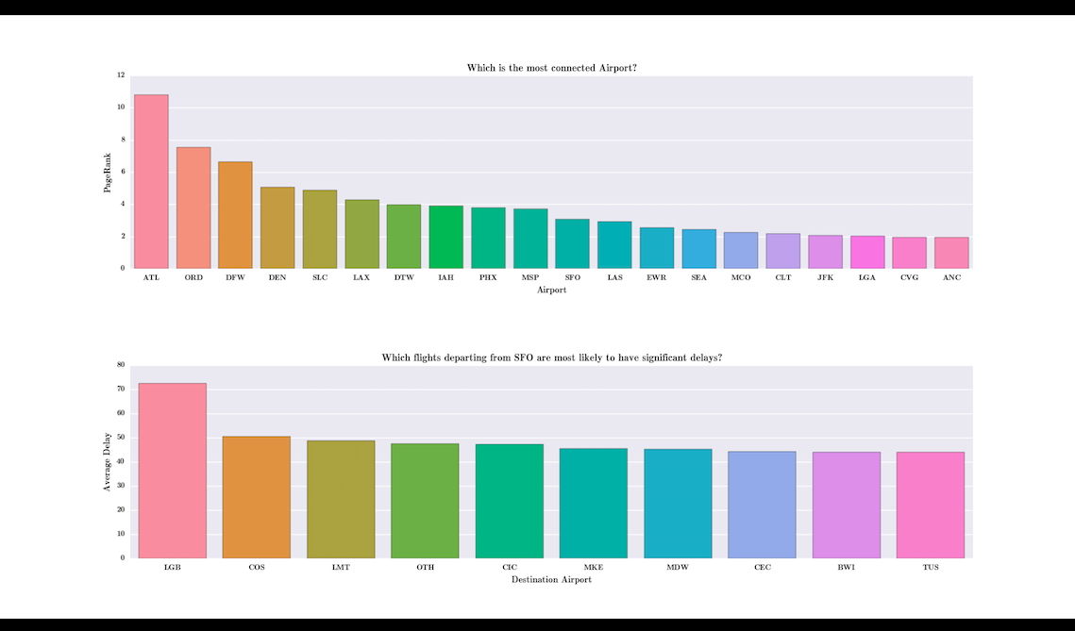

5.4.1 Description
5.4.1.1 Graph 1: Finding the top 20 most connected airports using Page Rank algorithm
We found that Hartsfield–Jackson Atlanta International Airport(ATL) is the most connected airport and Ted Stevens Anchorage International Airport – Alaska (ANC) is the least connected one among top 20 airports.

5.4.1.2 Graph 2: Which flights departing from SFO are most likely to have significant delays
For analysis among several flights, we have limited it to top 10 flights in descending order of departure delay. Long Beach Airport – Los Angeles (LGB) has the most significant departure delay with over 70 mins in average. Tucson International Airport (TUS)(Arizona) has the least delay.

- APPENDIX
SPARK INSTALLATION, SETUP IN CLOUD (MICROSOFT AZURE)
- Created an Ubuntu (Version 14.4) Linux virtual machine in Microsoft Azure cloud service
- ssh username@<public ip address>
- hostname –I --- 10.0.0.4 – to get private ip address of that Linux machine
- sudo apt-get -y update # updates package source
- Install java using “sudo apt-get install openjdk-7-jre-headless” command
- sudo apt-get install scala
- wget http://apache.mirrors.tds.net/spark/spark-2.1.1/spark-2.1.1-bin-hadoop2.7.tgz -P ~/Downloads
- sudo tar zxvf ~/Downloads/spark-* -C /usr/local
- To create VM in Microsoft Azure:
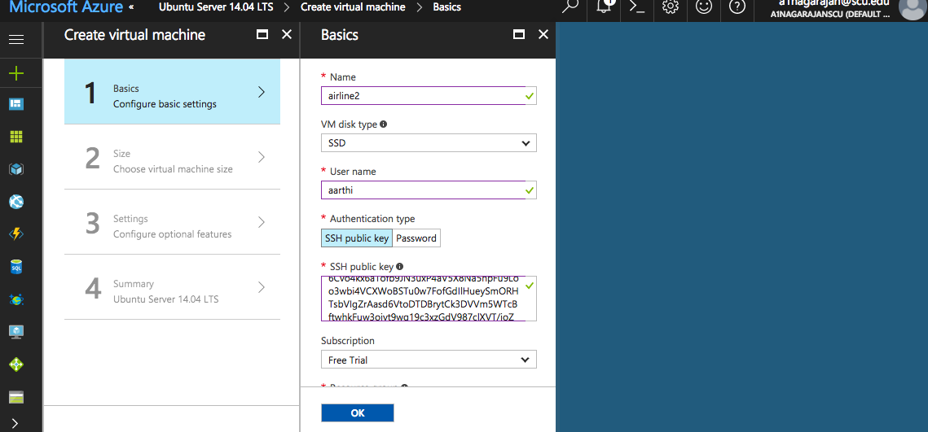
Size:
Standard DS2 v2 Promo (2 cores, 7 GB memory)
Resource group: airlineAnalysisGrp
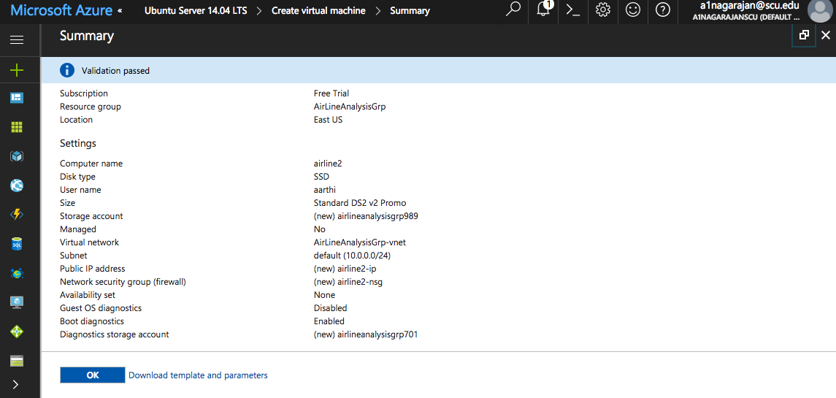
- Add these lines in $SPARK_HOME/conf/spark-env.sh
export JAVA_HOME=/usr
export SPARK_PUBLIC_DNS="current_node_public_dns"
export SPARK_WORKER_CORES=6
- Run this in one node, to make it master
touch $SPARK_HOME/conf/slaves
vi $SPARK_HOME/conf/slaves and added the other node ip address which will be the worker node (this should contain all the worker node ip addresses if there are more worker nodes)
- Run ‘ssh-keygen -t rsa’ in master node
- Copy the content of file ‘~/.ssh/id_rsa.pub’ in master to the worker node ~/.ssh/authorized_keys file
- Run ‘ssh-keygen –t rsa’ in worker node
- Copy the content of ‘~/.ssh/id_rsa.pub’ in master to the worker node ~/.ssh/authorized_keys file
- Run ‘$SPARK_HOME/sbin/start-all.sh’ in master node
- Run the below command to get public ip of that node from azure compute
curl -s checkip.dyndns.org | sed -e 's/.*Current IP Address: //' -e 's/<.*$//'
- open AirLineAnalysisGrp security group in Azure and select ‘airline1-nsg’ Network security group
- Click on Inbound security rule, press Add button, add new rule to allow port 8080 for viewing spark console as below

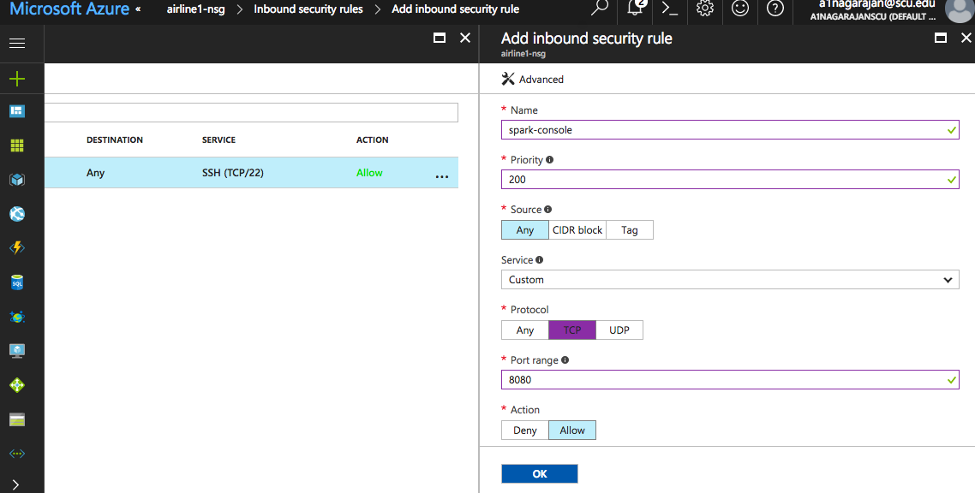

- Open master virtual machine in azure, open Network Interfaces

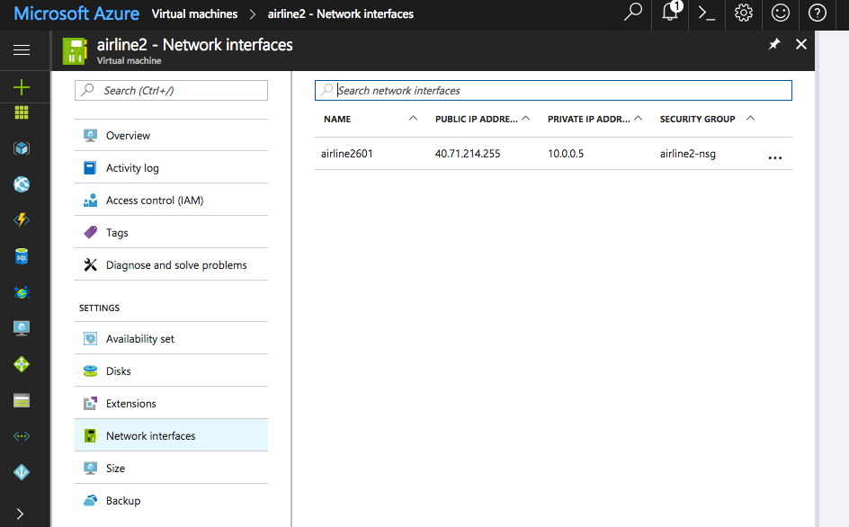

- Click on the network interface shown in the right tab
- Select the Network Security group option from left pane in this window
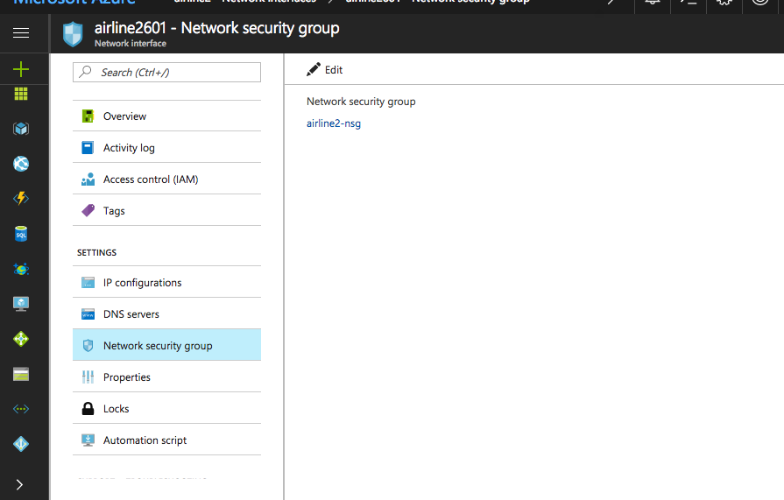
- Select the network security group shown in the center panel
- Add inbound security rule as shown above
- Change user as root using ‘sudo su’
- Do these to change owner to different user for /mnt folder
chown username:username /mnt
cd /mnt
wget <data csv file>
exit
- bzip2 -d filename.csv.bz2 to unzip the file
- $SPARK_HOME/bin/spark-shell --packages com.databricks:spark-csv_2.11:1.5.0
- Install Python Matplotlib: sudo apt-get install python-matplotlib
- pip install pandas matplotlib seaborn
- sudo apt-get install python-scipy
The installations are required in all the nodes of a cluster.
Commands to Run:
- spark-submit --master spark://10.0.0.5:7077 AirlineDataAnalysis1.py >/tmp/out1.txt
- spark-submit --master spark://10.0.0.5:7077 --packages graphframes:graphframes:0.5.0-spark2.1-s_2.11 AirlineDataAnalysis2.py >/tmp/out2.txt
- REFERENCES
[1] Learning Spark Lightning-Fast Big Data Analysis by Holden Karau, Andy Konwinski, Patrick Wendell, Matei Zaharia
[2] Learning Python by David Ascher and Mark Lutz

[3] Starting Out with Python by Tony Gaddis 2nd edition
[4] http://stat-computing.org/dataexpo/2009/the-data.html
[5] https://cwiki.apache.org/confluence/display/SPARK/PySpark+Internals
[6] http://blog.insightdatalabs.com/spark-cluster-step-by-step/
[7] http://blog.insightdatalabs.com/spark-cluster-step-by-step/
[8] https://spark-packages.org/package/databricks/spark-csv
[9]https://jaceklaskowski.gitbooks.io/mastering-apache-spark/content/spark-overview.html
[10] https://matplotlib.org/faq/installing_faq.html#install-osx-binaries
[11] https://hortonworks.com/
[12] https://databricks.com/

