1. Prove the following assertion: For every game tree, the utility obtained by MAX using minimax decisions against a suboptimal MIN will be never be lower than the utility obtained playing against an optimal MIN.

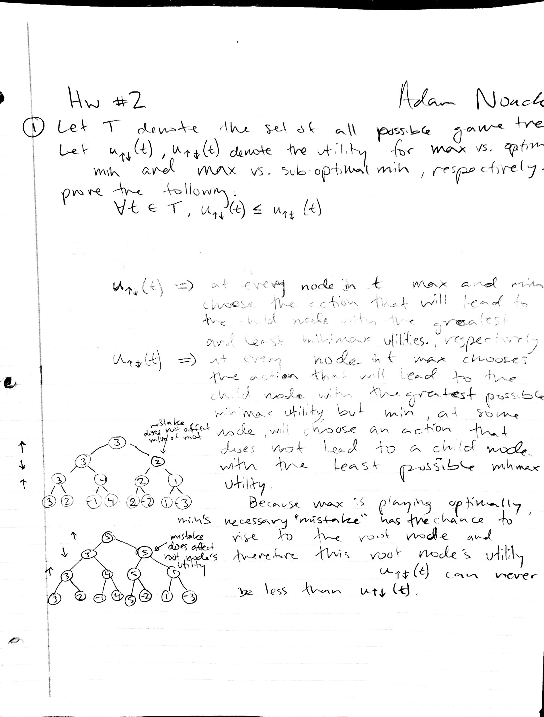

2. Prove that alpha-beta pruning takes time O(b^(m/2)) with optimal move ordering, where m is the maximum depth of the game tree and b is the branch factor.

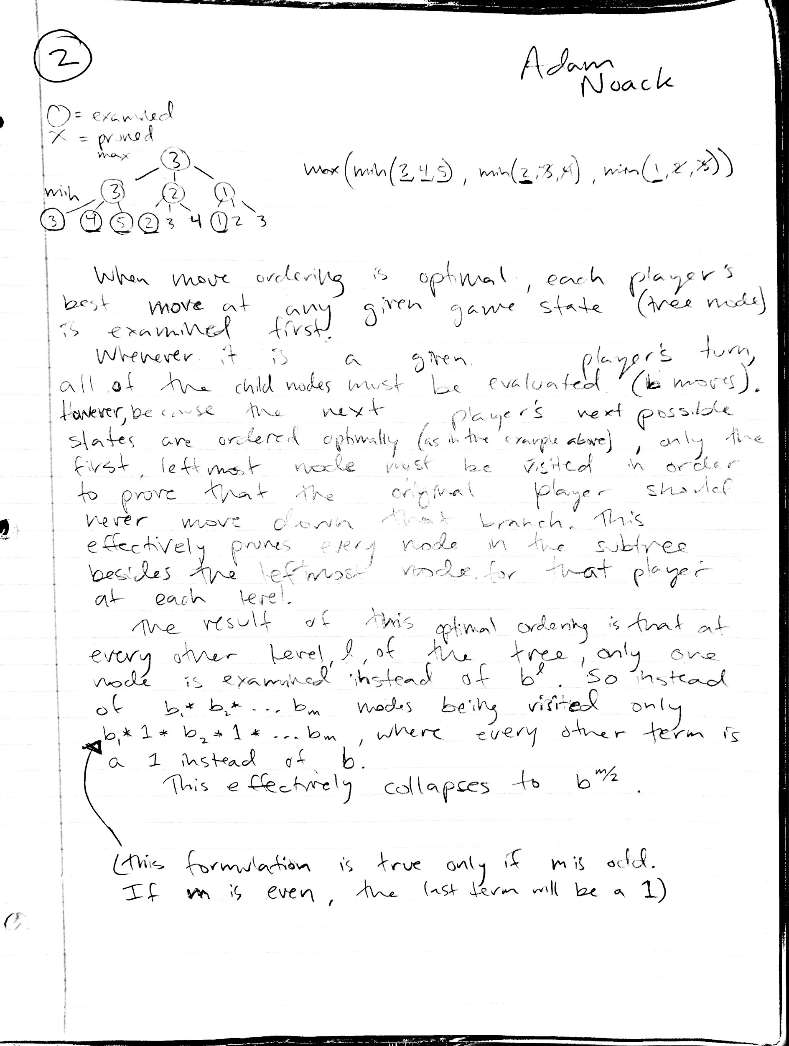

3. Programming assignment:

I did not end up implementing arc consistency or forward checking.

Total assignments to find all 32 solutions: 758.

OUTPUT FROM PROGRAM:

Enter the minuend (5 letters): eight

Enter the subtrahend (4 letters): four

Enter the difference (4 letters): four

EIGHT

-FOUR

------

FOUR

IMPLIES THAT...

FOUR

+FOUR

------

EIGHT

Solution #1

Cumulative assignments: 99

Variable assignments: {'F': 7, 'I': 4, 'O': 2, 'R': 9, 'c2': 1, 'T': 8, 'c3': 0, 'G': 5, 'H': 3, 'c1': 1, 'E': 1, 'c4': 1, 'U': 6}

Solution #2

Cumulative assignments: 131

Variable assignments: {'F': 6, 'I': 2, 'O': 4, 'R': 5, 'c2': 1, 'T': 0, 'c3': 0, 'G': 9, 'H': 7, 'c1': 1, 'E': 1, 'c4': 1, 'U': 8}

Solution #3

Cumulative assignments: 156

Variable assignments: {'F': 9, 'I': 8, 'O': 2, 'R': 7, 'c2': 1, 'T': 4, 'c3': 0, 'G': 5, 'H': 3, 'c1': 1, 'E': 1, 'c4': 1, 'U': 6}

Solution #4

Cumulative assignments: 187

Variable assignments: {'F': 5, 'I': 0, 'O': 4, 'R': 6, 'c2': 1, 'T': 2, 'c3': 0, 'G': 9, 'H': 7, 'c1': 1, 'E': 1, 'c4': 1, 'U': 8}

Solution #5

Cumulative assignments: 210

Variable assignments: {'F': 8, 'I': 7, 'O': 6, 'R': 5, 'c2': 0, 'T': 0, 'c3': 1, 'G': 2, 'H': 9, 'c1': 1, 'E': 1, 'c4': 1, 'U': 4}

Solution #6

Cumulative assignments: 222

Variable assignments: {'F': 8, 'I': 7, 'O': 5, 'R': 6, 'c2': 0, 'T': 2, 'c3': 1, 'G': 0, 'H': 9, 'c1': 1, 'E': 1, 'c4': 1, 'U': 4}

Solution #7

Cumulative assignments: 276

Variable assignments: {'F': 6, 'I': 3, 'O': 9, 'R': 7, 'c2': 0, 'T': 4, 'c3': 1, 'G': 8, 'H': 5, 'c1': 1, 'E': 1, 'c4': 1, 'U': 2}

Solution #8

Cumulative assignments: 288

Variable assignments: {'F': 6, 'I': 3, 'O': 7, 'R': 9, 'c2': 0, 'T': 8, 'c3': 1, 'G': 4, 'H': 5, 'c1': 1, 'E': 1, 'c4': 1, 'U': 2}

Solution #9

Cumulative assignments: 323

Variable assignments: {'F': 8, 'I': 6, 'O': 2, 'R': 5, 'c2': 0, 'T': 0, 'c3': 0, 'G': 4, 'H': 7, 'c1': 1, 'E': 1, 'c4': 1, 'U': 3}

Solution #10

Cumulative assignments: 343

Variable assignments: {'F': 7, 'I': 4, 'O': 3, 'R': 9, 'c2': 0, 'T': 8, 'c3': 0, 'G': 6, 'H': 5, 'c1': 1, 'E': 1, 'c4': 1, 'U': 2}

Solution #11

Cumulative assignments: 363

Variable assignments: {'F': 6, 'I': 2, 'O': 4, 'R': 5, 'c2': 0, 'T': 0, 'c3': 0, 'G': 8, 'H': 7, 'c1': 1, 'E': 1, 'c4': 1, 'U': 3}

Solution #12

Cumulative assignments: 383

Variable assignments: {'F': 9, 'I': 8, 'O': 3, 'R': 7, 'c2': 0, 'T': 4, 'c3': 0, 'G': 6, 'H': 5, 'c1': 1, 'E': 1, 'c4': 1, 'U': 2}

Solution #13

Cumulative assignments: 395

Variable assignments: {'F': 9, 'I': 8, 'O': 2, 'R': 5, 'c2': 0, 'T': 0, 'c3': 0, 'G': 4, 'H': 7, 'c1': 1, 'E': 1, 'c4': 1, 'U': 3}

Solution #14

Cumulative assignments: 425

Variable assignments: {'F': 5, 'I': 0, 'O': 4, 'R': 6, 'c2': 0, 'T': 2, 'c3': 0, 'G': 8, 'H': 7, 'c1': 1, 'E': 1, 'c4': 1, 'U': 3}

Solution #15

Cumulative assignments: 437

Variable assignments: {'F': 5, 'I': 0, 'O': 2, 'R': 8, 'c2': 0, 'T': 6, 'c3': 0, 'G': 4, 'H': 7, 'c1': 1, 'E': 1, 'c4': 1, 'U': 3}

Solution #16

Cumulative assignments: 439

Variable assignments: {'F': 5, 'I': 0, 'O': 2, 'R': 9, 'c2': 0, 'T': 8, 'c3': 0, 'G': 4, 'H': 7, 'c1': 1, 'E': 1, 'c4': 1, 'U': 3}

Solution #17

Cumulative assignments: 462

Variable assignments: {'F': 8, 'I': 7, 'O': 6, 'R': 2, 'c2': 1, 'T': 4, 'c3': 1, 'G': 3, 'H': 0, 'c1': 0, 'E': 1, 'c4': 1, 'U': 5}

Solution #18

Cumulative assignments: 482

Variable assignments: {'F': 7, 'I': 5, 'O': 6, 'R': 2, 'c2': 1, 'T': 4, 'c3': 1, 'G': 3, 'H': 8, 'c1': 0, 'E': 1, 'c4': 1, 'U': 9}

Solution #19

Cumulative assignments: 502

Variable assignments: {'F': 6, 'I': 3, 'O': 7, 'R': 2, 'c2': 1, 'T': 4, 'c3': 1, 'G': 5, 'H': 8, 'c1': 0, 'E': 1, 'c4': 1, 'U': 9}

Solution #20

Cumulative assignments: 514

Variable assignments: {'F': 6, 'I': 3, 'O': 8, 'R': 2, 'c2': 1, 'T': 4, 'c3': 1, 'G': 7, 'H': 0, 'c1': 0, 'E': 1, 'c4': 1, 'U': 5}

Solution #21

Cumulative assignments: 539

Variable assignments: {'F': 8, 'I': 6, 'O': 3, 'R': 2, 'c2': 1, 'T': 4, 'c3': 0, 'G': 7, 'H': 0, 'c1': 0, 'E': 1, 'c4': 1, 'U': 5}

Solution #22

Cumulative assignments: 579

Variable assignments: {'F': 7, 'I': 4, 'O': 2, 'R': 3, 'c2': 1, 'T': 6, 'c3': 0, 'G': 5, 'H': 8, 'c1': 0, 'E': 1, 'c4': 1, 'U': 9}

Solution #23

Cumulative assignments: 608

Variable assignments: {'F': 6, 'I': 2, 'O': 3, 'R': 4, 'c2': 1, 'T': 8, 'c3': 0, 'G': 7, 'H': 0, 'c1': 0, 'E': 1, 'c4': 1, 'U': 5}

Solution #24

Cumulative assignments: 642

Variable assignments: {'F': 9, 'I': 8, 'O': 3, 'R': 2, 'c2': 1, 'T': 4, 'c3': 0, 'G': 7, 'H': 0, 'c1': 0, 'E': 1, 'c4': 1, 'U': 5}

Solution #25

Cumulative assignments: 653

Variable assignments: {'F': 9, 'I': 8, 'O': 2, 'R': 3, 'c2': 1, 'T': 6, 'c3': 0, 'G': 5, 'H': 4, 'c1': 0, 'E': 1, 'c4': 1, 'U': 7}

Solution #26

Cumulative assignments: 672

Variable assignments: {'F': 5, 'I': 0, 'O': 3, 'R': 2, 'c2': 1, 'T': 4, 'c3': 0, 'G': 7, 'H': 8, 'c1': 0, 'E': 1, 'c4': 1, 'U': 9}

Solution #27

Cumulative assignments: 678

Variable assignments: {'F': 5, 'I': 0, 'O': 3, 'R': 4, 'c2': 1, 'T': 8, 'c3': 0, 'G': 7, 'H': 2, 'c1': 0, 'E': 1, 'c4': 1, 'U': 6}

Solution #28

Cumulative assignments: 684

Variable assignments: {'F': 5, 'I': 0, 'O': 3, 'R': 2, 'c2': 1, 'T': 4, 'c3': 0, 'G': 7, 'H': 6, 'c1': 0, 'E': 1, 'c4': 1, 'U': 8}

Solution #29

Cumulative assignments: 728

Variable assignments: {'F': 8, 'I': 7, 'O': 5, 'R': 2, 'c2': 0, 'T': 4, 'c3': 1, 'G': 0, 'H': 6, 'c1': 0, 'E': 1, 'c4': 1, 'U': 3}

Solution #30

Cumulative assignments: 734

Variable assignments: {'F': 8, 'I': 7, 'O': 5, 'R': 3, 'c2': 0, 'T': 6, 'c3': 1, 'G': 0, 'H': 4, 'c1': 0, 'E': 1, 'c4': 1, 'U': 2}

Solution #31

Cumulative assignments: 752

Variable assignments: {'F': 7, 'I': 5, 'O': 9, 'R': 2, 'c2': 0, 'T': 4, 'c3': 1, 'G': 8, 'H': 6, 'c1': 0, 'E': 1, 'c4': 1, 'U': 3}

Solution #32

Cumulative assignments: 758

Variable assignments: {'F': 7, 'I': 5, 'O': 9, 'R': 3, 'c2': 0, 'T': 6, 'c3': 1, 'G': 8, 'H': 4, 'c1': 0, 'E': 1, 'c4': 1, 'U': 2}