Adding a pdf brochure to the website

Now that you have made some really fantastic and appealing brochures for A1 Professional Designs and you want the user to be able to download the brochure when he/she clicks the ‘download brochure’ button, as shown in the picture below, you need to follow the following steps.

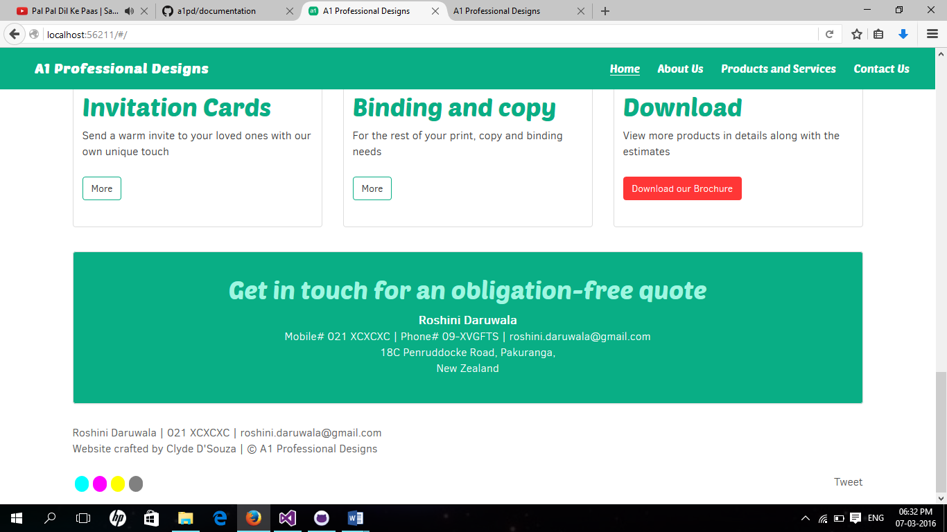

**Step 1:** You would need to add your brochures to the solution itself (of course, you can it elsewhere as well, but for now, let’s keep it within a given context). To add a brochure, we will right click on the ‘assets’ folder and then click on ‘add’ -> ‘existing item’ as shown in the picture below.

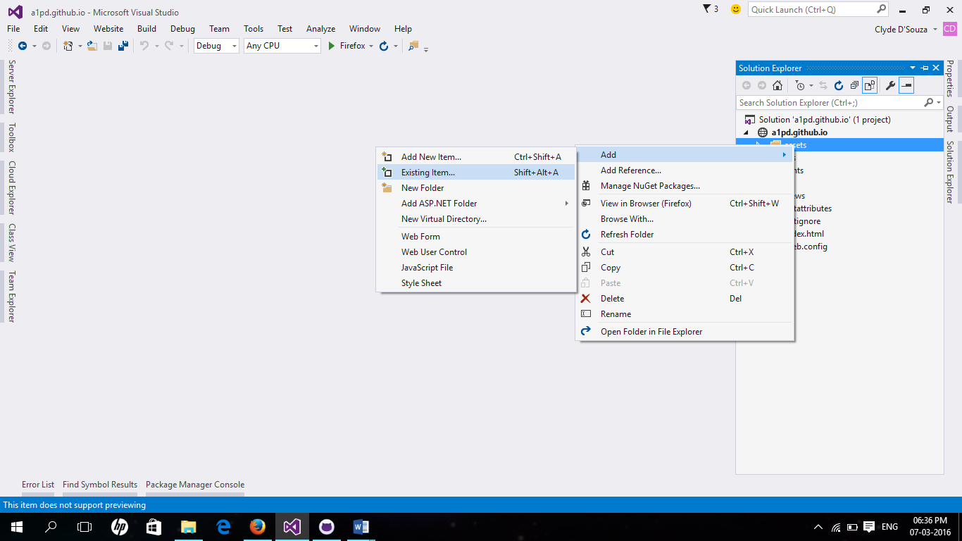

**Step 2:** Browse the system and locate your brochure and click on ‘add’. This will add the brochure that you selected from the file explorer window into the ‘assets’ folder.

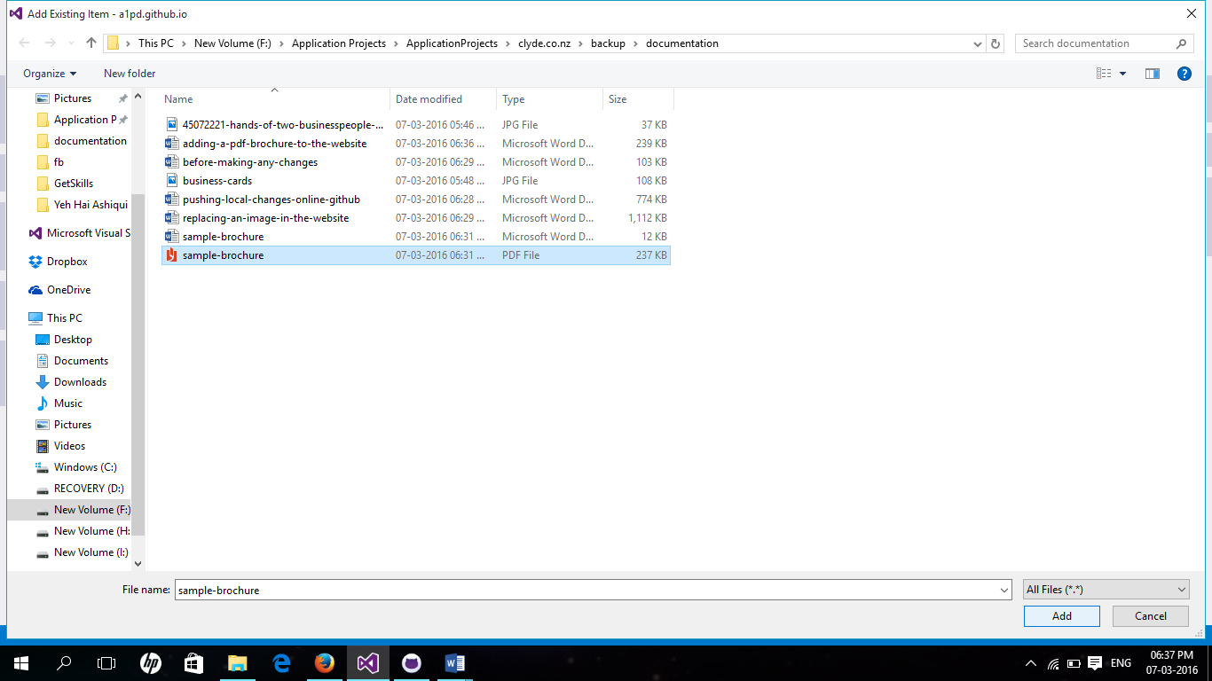

**Step 3:** Since, the ‘download the brochure’ button is on the home page and we want that button to work, we would have to change the code pertaining to that page only. So, we navigate to the ‘views’ folder and then double click the ‘home.html’.

Below is the image showing you the contents before editing.

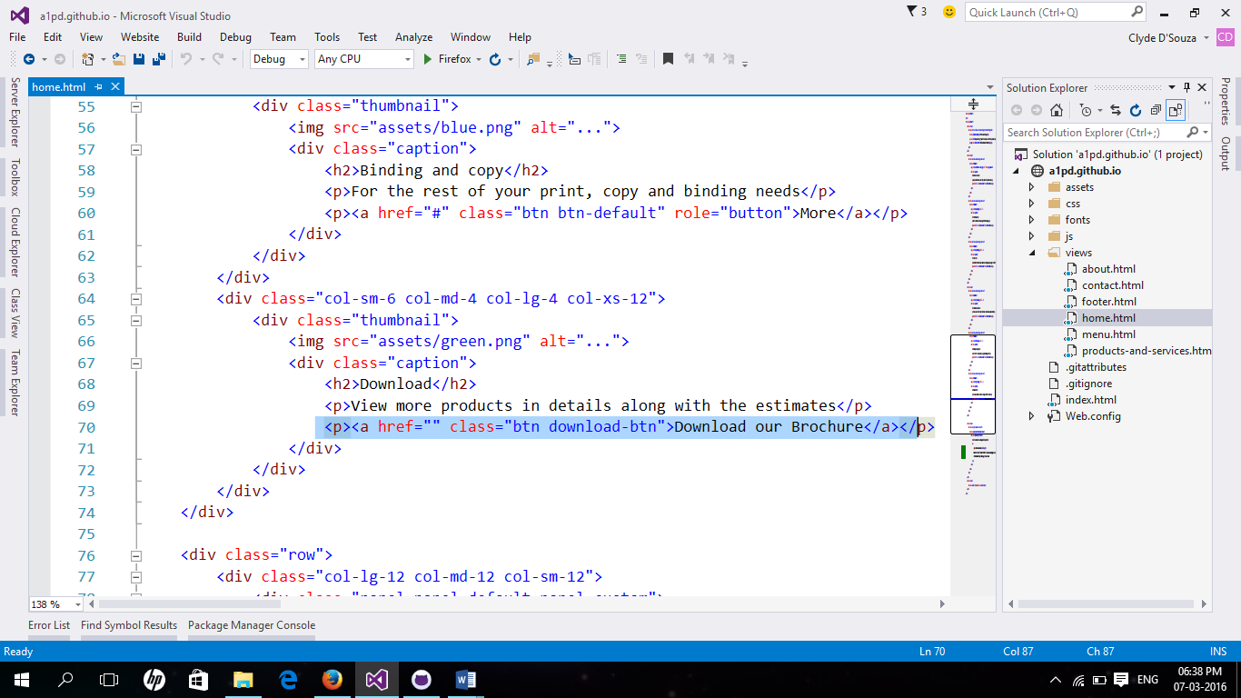

Below is the picture after editing i.e. after adding the path of the newly added pdf brochure.

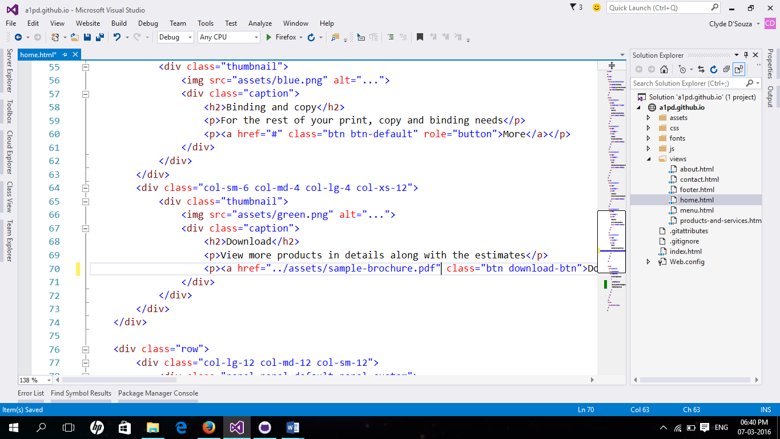

**Step 4:** Don’t forget to save. And once that’s done, run the application to see your changes have worked correctly.

The image below shows that the brochure has been loaded in another tab after clicking the download brochure button from the home page.

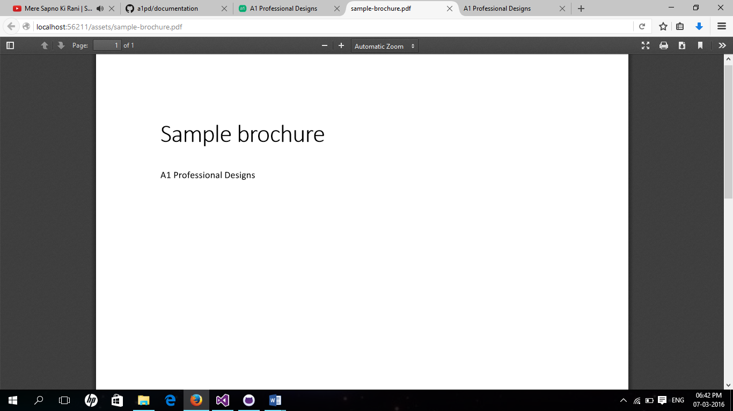

Voila!

You have now made changes to your website locally. You would now upload (push) these changes to the online version of the website that sits at [www.github.com](http://www.github.com). To upload your local changes to the online version refer to the documentation – “pushing-local-changes-online-github”

Read the entire collection of documentation files put up in the [a1pd/documentation](https://github.com/a1pd/documentation) repository.