Before making any changes

Before you head over to make any changes on your local repository, remember to ‘sync’ the repository in the GitHub software as shown in the image below.

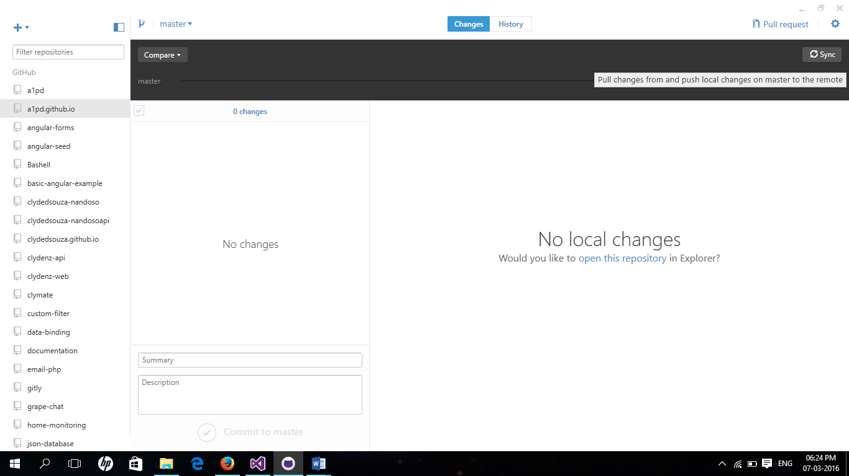

By doing this you would ensure that your local and online repository is in sync so that before you make your changes locally, you get the latest version of the repository, just in case any other contributor has been making changes silently.

Voila!

Read the entire collection of documentation files put up in the [a1pd/documentation](https://github.com/a1pd/documentation) repository.