Pushing local changes online

Assuming you have just made some local changes (like the one in the document –“replacing-an-image-in-the-website”), you would now need to push these changes online so your future website visitors see the changes.

**Step 1:** Make sure you have saved all your changes in Visual Studio and have finished editing and ready to deploy.

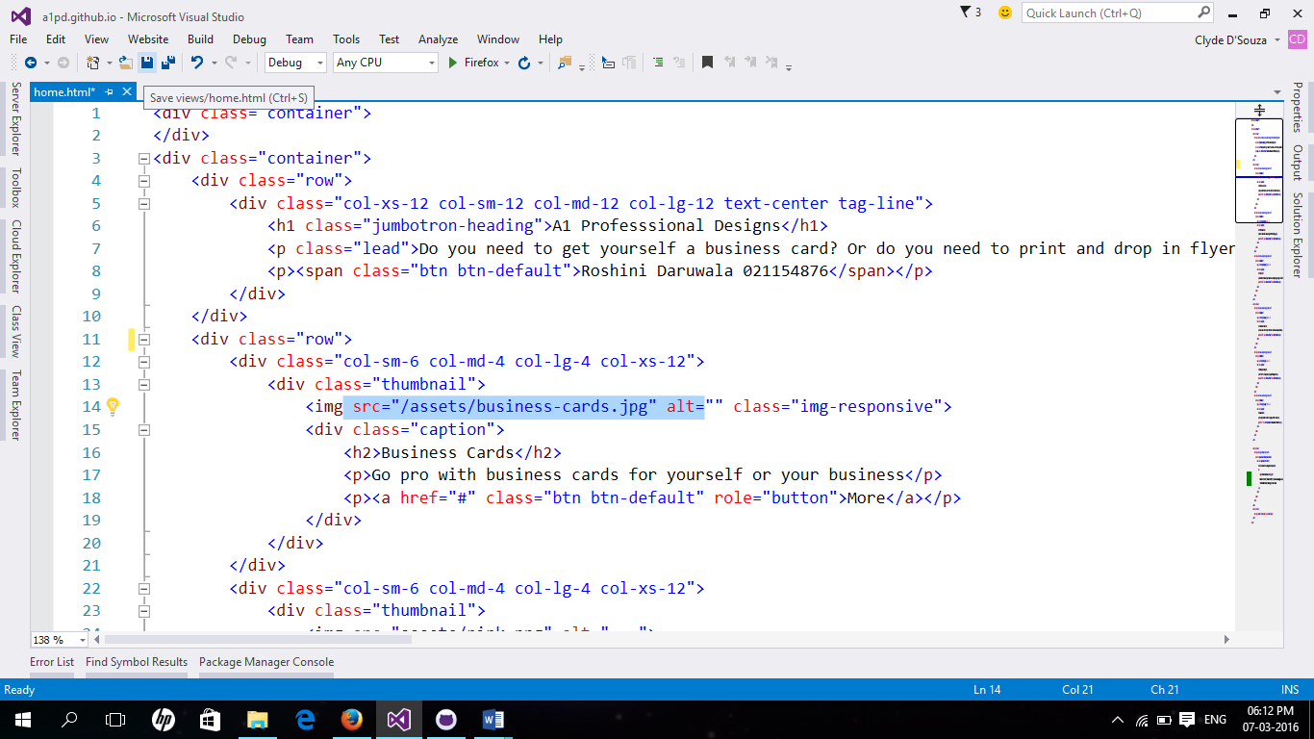

**Step 2:** You now need to open GitHub for Windows software that you would have downloaded ([available here](https://desktop.github.com/), if you don’t have it yet) and locate the local repository that you just edited. Notice that it has detected that you have made some changes.

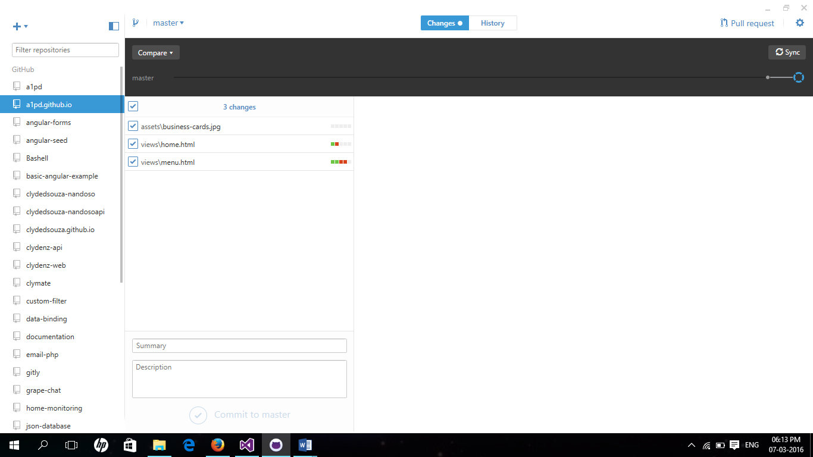

**Step 3:** Enter a meaningful commit message and optionally a commit description. You then click the ‘Commit to master’ button located at the bottom.

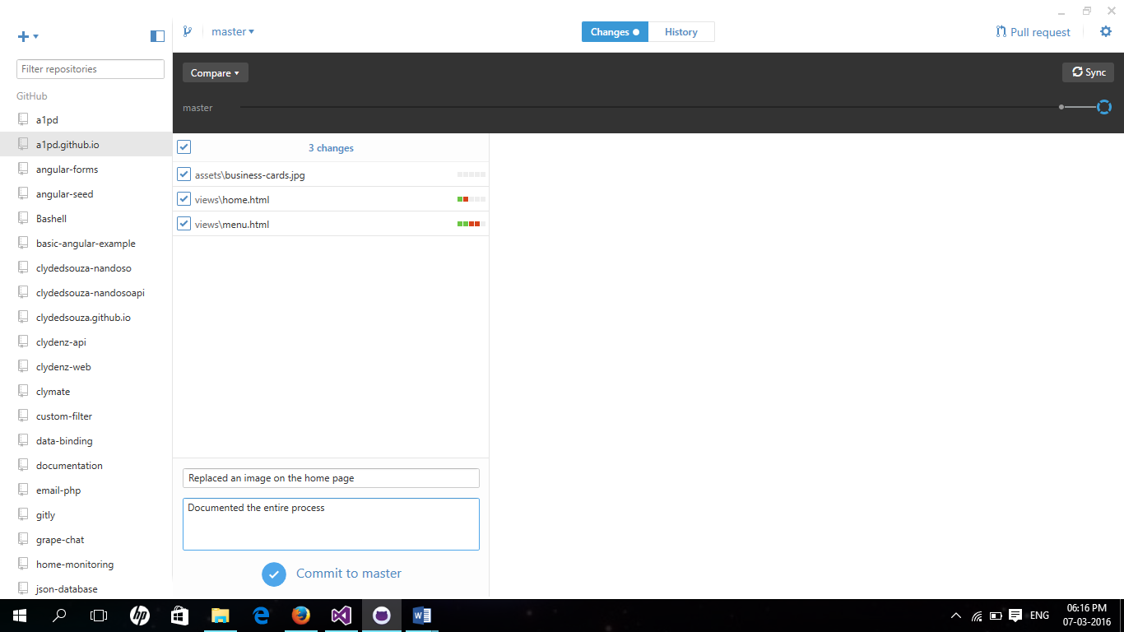

**Step 4:** Remember to ‘sync’ the changes which pushes the locally committed files online.

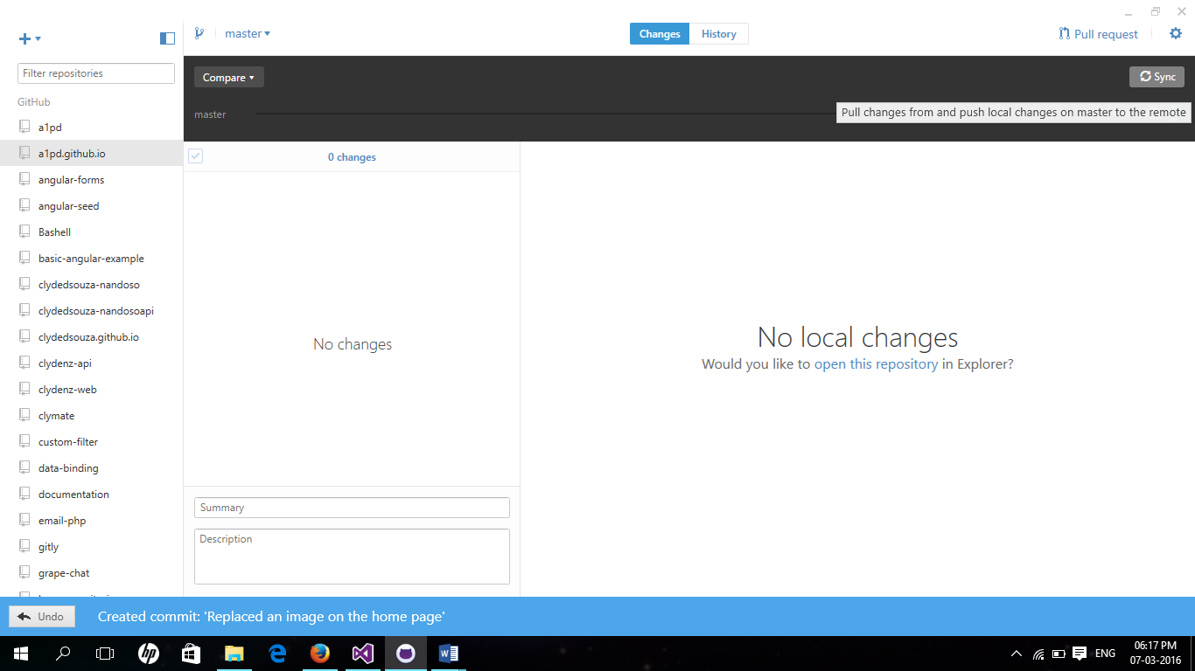

**Step 5:** If you visit the online repository, you would see that the changes have been reflected.

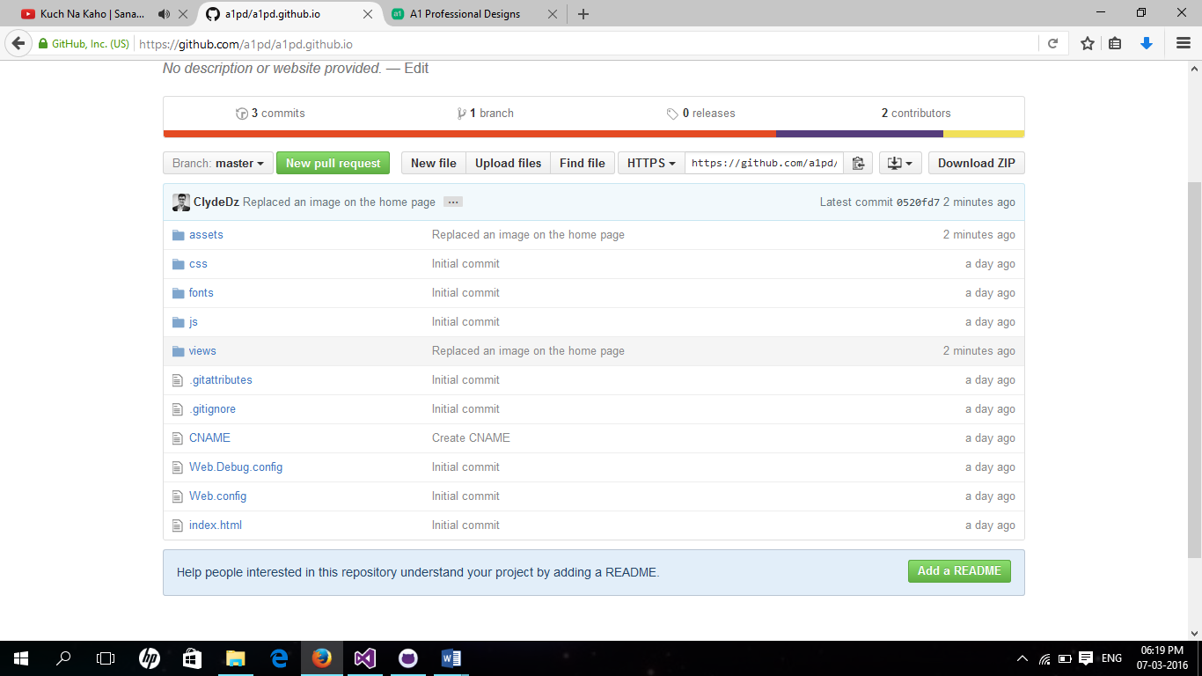

**Step 6:** And since the online GitHub repository has been updated, if you head over to the website, you should see that our changes have been reflected on the website as well.



Voila!

Read the entire collection of documentation files put up in the [a1pd/documentation](https://github.com/a1pd/documentation) repository.