Replacing an image in the website

Let’s say you want to replace the business cards image (the gray box) with a custom image that you create.

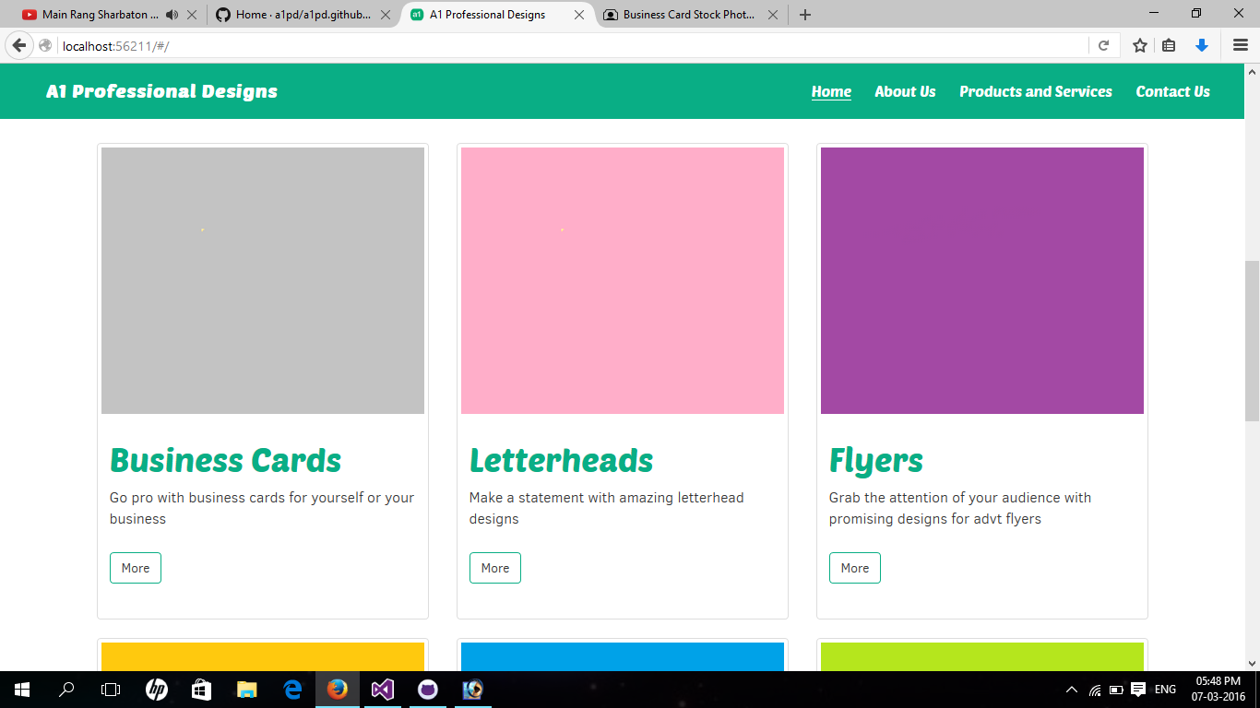

To get started, you would need to open the website contents in Visual Studio. Of course, you can do without Visual Studio, but for now, let’s keep things familiar.

**Step 1:** Right click the ‘assets’ folder and click ‘Add existing item’ as shown in the picture below.

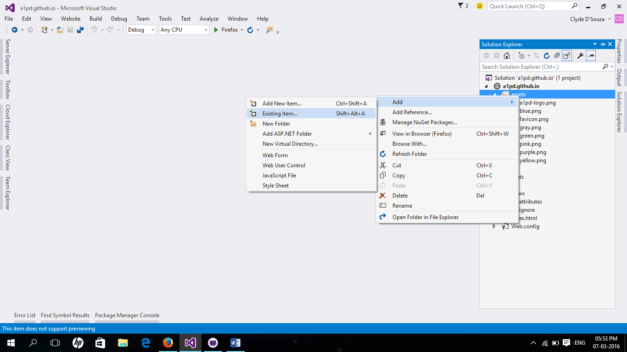

**Step 2:** Browse for the image you want to add using the file explorer window that pops up in front of you and click ‘Add’ after selecting the photo as shown in the picture below.

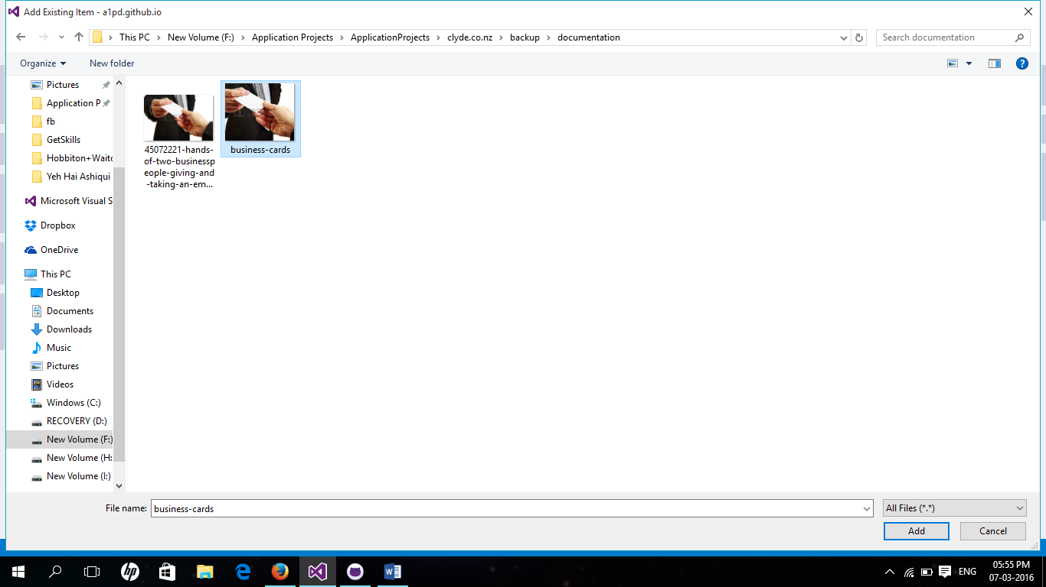

**Step 3:** The picture is now added in our solution and you can confirm that by having a look at the ‘assets’ folder.

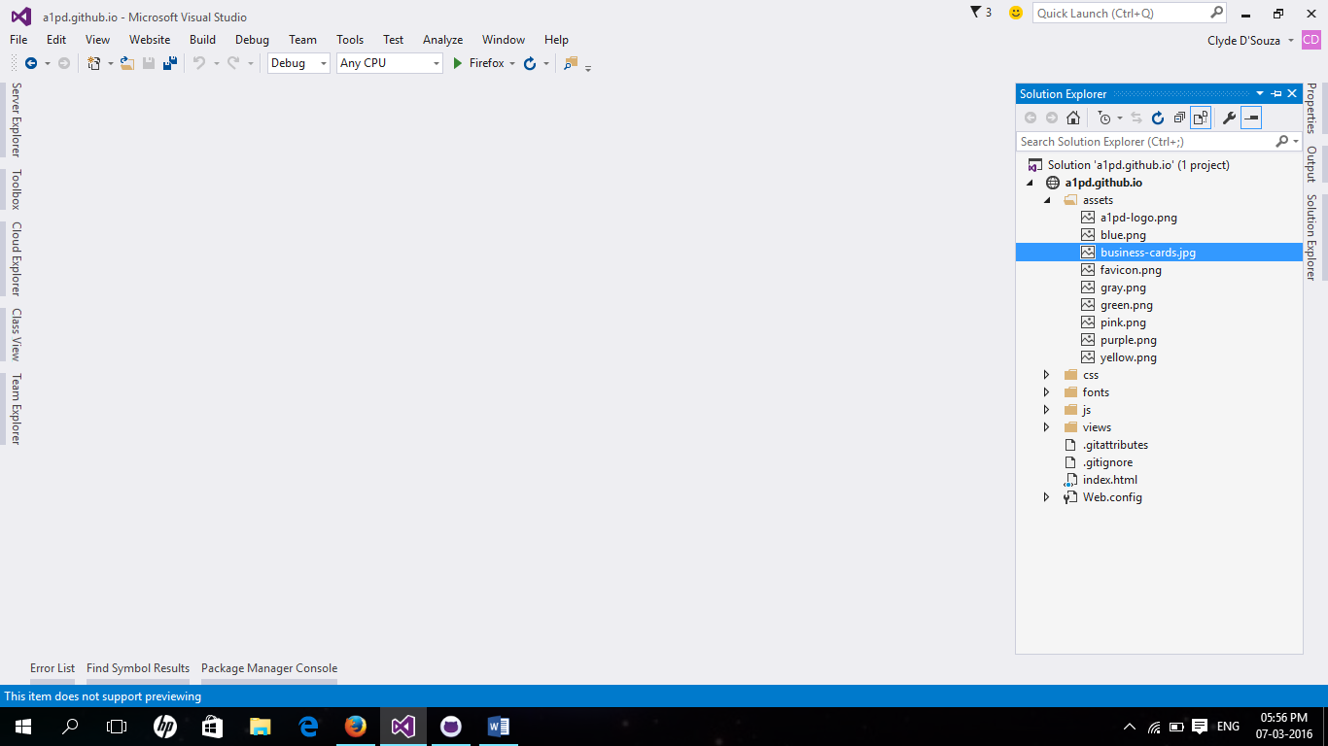

**Step 4:** Since you want to replace the image on the home page for the business cards block, you would navigate to the ‘views’ folder in the Visual Studio project opened up and in the folder you would double click on ‘home.html’.

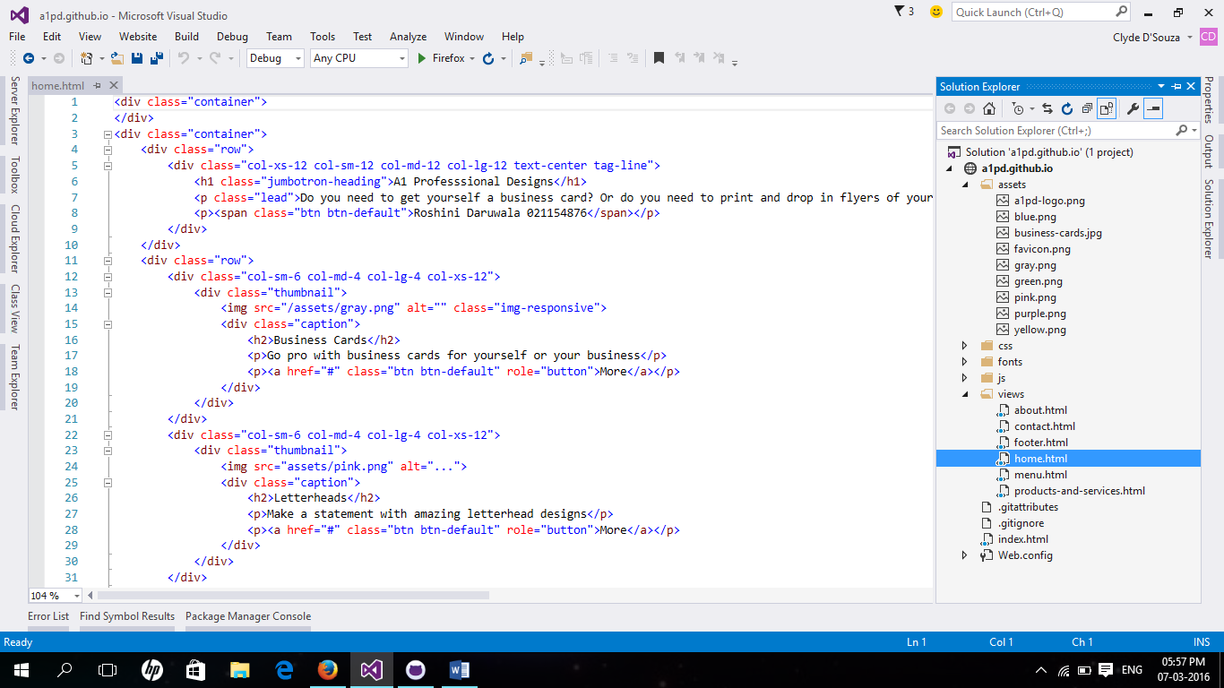

**Step 5:** Replace the path to the old image with the new image path.

Old code snippet highlighting the old image path

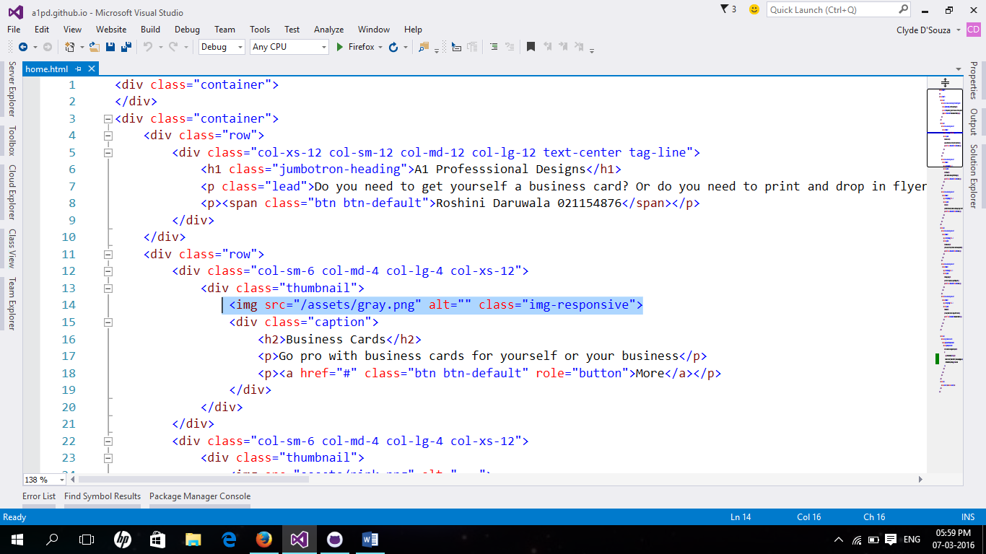

New code snippet highlighting the new image path

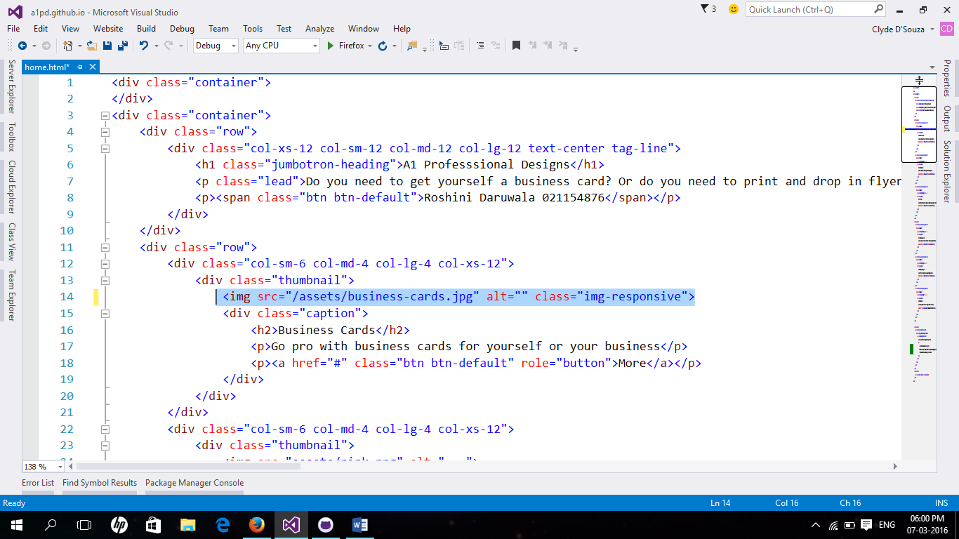

**Step 6:** Run the web application to ensure that the new image has been loaded correctly.

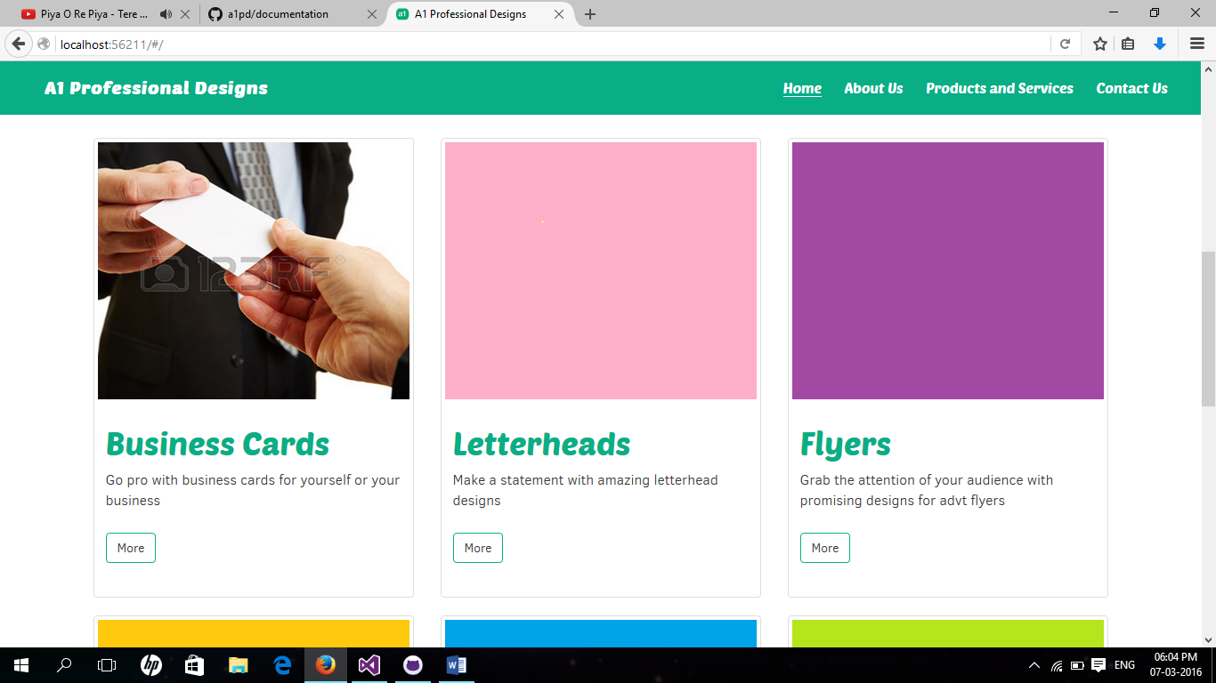

Voila!

You have now made changes to your website locally. You would now upload (push) these changes to the online version of the website that sits at [www.github.com](http://www.github.com). To upload your local changes to the online version refer to the documentation – “pushing-local-changes-online-github”

Read the entire collection of documentation files put up in the [a1pd/documentation](https://github.com/a1pd/documentation) repository.