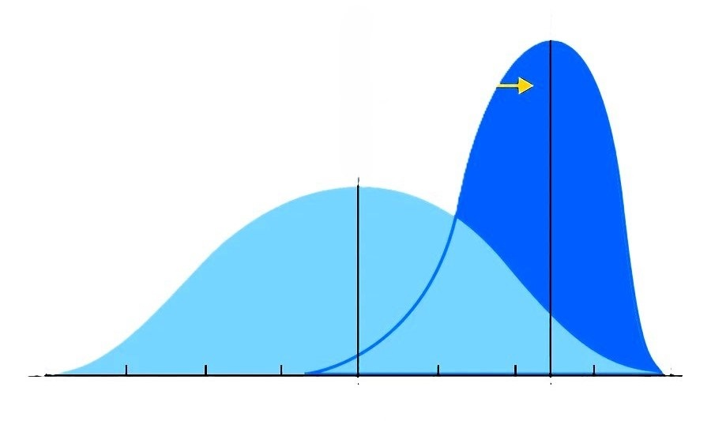
Power of 1:1 Tutoring
1:1 Tutoring
1:30 Traditional
2 Sigma
Performance

