Name :VELVIZHI S
Reg No : 411625149054
Department : CSE(CYBER SECURITY)
Subject : PYTHON
Batch : 4

Mini Project 1:NUMBER GUESSING GAME

1. Project Title
Number Guessing Game Using Loop in Python

2. Problem Statement
Design and implement a Number Guessing Game in Python where the computer generates a random number within a specified range. The user is required to guess the number within a limited number of attempts using a loop.
3. Objective
• To understand and implement loop control structures in Python.
• To generate random numbers using the random module.
• To develop logical thinking by comparing user input with system-generated values.
• To create an interactive console-based game.
• To provide hints (Too High / Too Low) to guide the user toward the correct answer.
• To limit the number of attempts using a loop.

4. Tools Used
- Python 3
- VS Code / IDLE

5. Description
The Number Guessing Game is a simple interactive Python application developed using loop control structures. In this game, the computer randomly generates a number within a specified range (for example, 1 to 50).

6. Algorithm
• Start the program.
• Import the random module.
• Generate a random number between a specified range (e.g., 1 to 50).
• Set the maximum number of attempts.
• Display instructions to the user.
• Use a loop to allow multiple guessing attempts.
• For each attempt:
a. Ask the user to enter a guess.
b. Compare the guess with the generated number.
c. If the guess is lower, display “Too Low”.
d. If the guess is higher, display “Too High”.
e. If the guess is correct, display a success message and exit the loop.
• If all attempts are exhausted, display the correct number.
• End the program.

7. Program (Python Code)
import random
import sys

secret_number = random.randint(1, 50)
max_attempts = 10

inputs = sys.stdin.read().split() # Read all inputs at once
print("🎯 Welcome to the Number Guessing Game!")
print(f"You have {max_attempts} attempts to guess the number between 1 and 50.\n")

for attempt in range(1, max_attempts + 1):
if attempt-1 < len(inputs):
guess = int(inputs[attempt-1])
else:
print("😢 No more input available. Exiting.")
break

if guess < secret_number:
print("Too low! 🔻\n")
elif guess > secret_number:
print("Too high! 🔺\n")
else:
print(f"🎉 Correct! You guessed it in {attempt} attempts.\n")
break
else:
print(f"😢 Sorry! You've used all {max_attempts} attempts. The number was {secret_number}.\n")

8. Sample Output
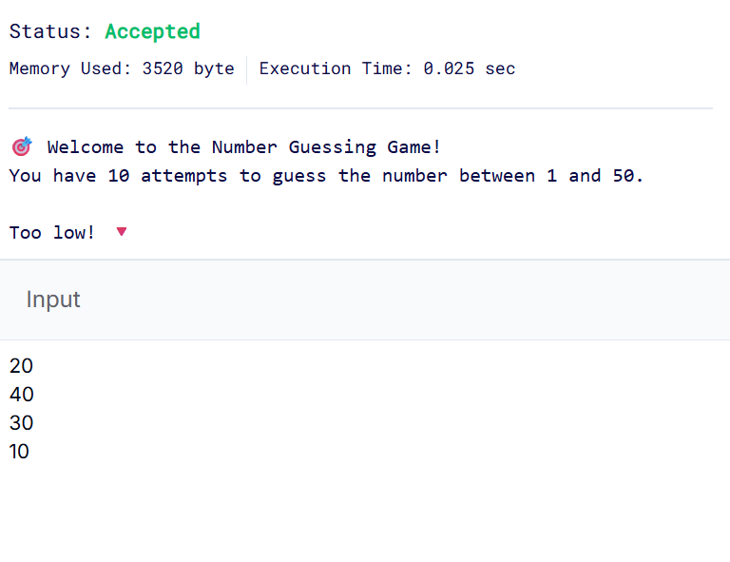
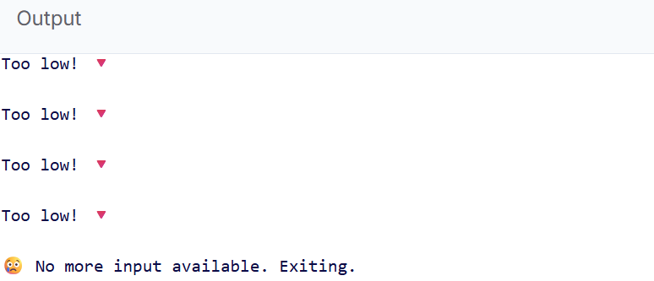

9. Result
The Number Guessing Game was successfully implemented using Python loops.
The program generated a random number and allowed the user to guess it within a limited number of attempts. Appropriate hints such as “Too High” and “Too Low” were displayed after each guess.
10. Conclusion
The Number Guessing Game was developed successfully using Python. This application helped in understanding the practical use of loop control structures, conditional statements, and random number generation. It also improved logical thinking and user interaction handling..

