An Explainable Stacking Framework for Multiclass Sleep-Disorder Risk Stratification
Rifat Bin Reza^{1,*}, Md Ahadul Haque Suvo², Atair Rahman Alvi¹
¹ BSRM School of Engineering, Department of Electrical and Electronics Engineering, Brac University, Dhaka, Bangladesh
² Aviation and Aerospace University, Department of Avionics Engineering, Dhaka, Bangladesh
* Corresponding author: rifat.bin.reza1@g.bracu.ac.bd

Abstract
Small tabular sleep-health benchmarks are susceptible to outcome ambiguity and optimistic evaluation. This study describes an explainable stacking framework using the publicly available Sleep Health and Lifestyle Dataset (374 records, 11 candidate predictors, three outcome categories: no recorded disorder, insomnia, sleep apnea). The protocol removes administrative identifiers, separates systolic and diastolic blood pressure, and confines learned preprocessing to training partitions. The primary specification combines Random Forest and XGBoost probabilities with encoded predictor pass-through in a logistic-regression meta-learner. A source-file audit shows that only 132 of the 374 records are unique (242 exact duplicates) and that 22 predictor vectors carry conflicting labels, capping attainable accuracy at 93.3%; evaluation is therefore grouped by predictor vector. On the stratified 75-record hold-out set the stack classified 72 records correctly (96.00%, macro-F1 0.94), identical to soft voting, and 68 of the 75 test records repeated a training record. Under 10$×$5 repeated grouped cross-validation the stack reached 89.6% accuracy (95% CI 86.1–92.7; macro-F1 0.87), statistically indistinguishable from soft voting ($−0.2$ pp, 95% CI $−1.8$ to $+1.1$), from its base learners, from logistic regression (89.7%), and from a transformer for tabular data (FT-Transformer, 89.7%); accuracy fell to 73.0% on unique rows only. SHAP rankings were stable within a model (rank correlation 0.97–0.98) but differed between the stack and soft voting (0.18), and the two blood-pressure predictors are strongly collinear (VIF 35–38). The results constitute a computational benchmark, not evidence of diagnostic validity.
Keywords: sleep disorder; insomnia; sleep apnea; stacking ensemble; XGBoost; explainable machine learning; clinical decision support

Introduction
Sleep disorders represent a heterogeneous group of conditions that differ in clinical definition, underlying mechanisms, and management requirements. The International Classification of Sleep Disorders distinguishes insomnia disorders from sleep-related breathing disorders, including obstructive sleep apnea, and therefore a computational model that groups such conditions into a small number of benchmark categories should not be interpreted as reproducing the clinical taxonomy [1]. Nevertheless, automated risk-stratification approaches are increasingly investigated as tools for identifying individuals who may warrant further assessment. In particular, artificial-intelligence methods have been explored for sleep-apnea screening using electrocardiography, oximetry, respiratory signals, wearable sensors, and multimodal physiological measurements [3, 4, 11, 12]. These studies demonstrate the potential of machine learning to support scalable screening, while also highlighting the distinction between computational discrimination and clinically established diagnosis.
Alongside signal-based approaches, structured tabular sleep-health datasets provide a simpler environment for studying machine-learning methodology. Demographic characteristics, sleep duration and quality, physical activity, perceived stress, body-mass-index category, heart rate, blood pressure, and occupation can be combined to construct predictive models without requiring continuous physiological waveforms. Such datasets are attractive because they are inexpensive to analyse and readily accessible for methodological benchmarking. However, their simplicity can conceal important limitations. Outcome categories may not correspond to clinician-adjudicated diagnoses, predictor variables can be strongly correlated, class frequencies may be unequal, and administrative or preprocessing operations can unintentionally introduce information leakage. Consequently, apparently strong performance on a small tabular benchmark should be interpreted primarily as evidence of predictive behaviour within that dataset rather than as evidence of clinical validity.
Recent work has applied both conventional machine-learning ensembles and neural architectures to structured prediction problems. For tabular data, comparative evidence indicates that tree-based ensembles and deep neural networks can exhibit different strengths depending on the dataset characteristics and learning task [13]. Of particular relevance to the present study, Alom et al. evaluated ensemble neural-network methods on the same Sleep Health and Lifestyle Dataset considered here and reported accuracy values for bagging, boosting, and weighted-averaging configurations [14]. These findings provide a direct literature context for the present benchmark, although the two studies do not necessarily share identical preprocessing, data partitioning, validation, or model-selection procedures. The reported numerical results are therefore used as descriptive reference points rather than as evidence from a matched experimental comparison.
A further methodological concern arises when several predictive models are combined through stacking. Stacked generalization can exploit complementary errors and probability estimates from heterogeneous base learners, but its validity depends critically on how the second-level training data are constructed [28]. If a meta-learner is trained using in-sample predictions from base learners, information from observations used to fit those learners can propagate into the second stage and produce optimistic performance estimates. Similar concerns apply to preprocessing: scaling, categorical encoding, feature construction, and other learned transformations must be isolated from the evaluation data and, in an out-of-fold stacking procedure, must also be refitted within each training fold [5–7]. These considerations are especially important for small datasets, for which a modest number of observations can produce large changes in estimated performance.
The interpretation of tabular machine-learning models also requires caution. Explainable artificial-intelligence methods such as SHAP and LIME can describe which variables are influential for a fitted prediction function and how individual predictions are locally represented [21–23]. Accumulated Local Effects provide an additional way of visualising model behaviour while accounting for the empirical distribution of predictors [24]. However, attribution magnitude does not establish causality, and an explanation of a fitted model does not demonstrate that the underlying association is clinically meaningful. Recent reviews and reporting frameworks therefore emphasise explanation fidelity, stability, uncertainty, data provenance, calibration, external validation, and intended use when interpreting healthcare-oriented artificial intelligence systems [8, 9, 16, 17]. This distinction is particularly important for benchmark datasets whose outcome categories are not independently clinically adjudicated.
Against this background, there remains a methodological gap in carefully evaluating heterogeneous stacking on the Sleep Health and Lifestyle Dataset under an explicitly leakage-controlled protocol while maintaining a clear separation between benchmark prediction and clinical interpretation. The present study addresses this gap through a two-learner Random Forest–XGBoost stacking framework with a multinomial logistic meta-learner. The proposed configuration combines out-of-fold class-probability estimates from the two base learners with encoded predictors through a pass-through connection, thereby allowing the meta-learner to exploit both model-level and feature-level information. The evaluation isolates a stratified hold-out test set before learned preprocessing, uses fold-specific transformations when generating out-of-fold probabilities, and compares the resulting stack with RF–XGBoost soft voting. Published ANN results on the same benchmark are included as contextual reference values rather than as a matched experimental baseline.
In addition to predictive discrimination, the study examines model behaviour using post-hoc explanation methods, principal-component visualisation, rank-based feature association analysis, and a two-dimensional Accumulated Local Effects surface. These analyses are intended to characterise the fitted models rather than to infer biological mechanisms or establish diagnostic relationships. Paired uncertainty analysis is also used to examine the difference between stacking and soft voting on the common hold-out sample. Particular attention is given to the provenance of the outcome labels and to the distinction between benchmark categories and clinically adjudicated disease status.
The contributions of this study are therefore fourfold. First, it provides a leakage-controlled formulation of heterogeneous RF–XGBoost stacking for a small mixed-type sleep-health benchmark. Second, it evaluates whether probability-level stacking provides a measurable difference from soft voting under a common hold-out partition. Third, it provides complementary global and local explanation analyses while explicitly limiting causal interpretation. Fourth, it provides an explicit account of evaluation design, outcome-label provenance, and benchmark constraints when interpreting predictive results from this dataset. The resulting framework is intended as a reproducible computational benchmark for tabular sleep-disorder risk stratification rather than as a diagnostic model.
The evaluation comprises a source-file audit of the benchmark, a re-execution of the single hold-out split, repeated grouped and nested cross-validation against a broad set of baselines (including a transformer for tabular data), calibration, paired tests, and stability and fidelity audits of the SHAP and LIME analyses (Sections 3.3, 4.1, 5.2, and 6). Stacking itself is an established technique; the contribution of this work is the audited evaluation of this configuration, not a new algorithm, and inference rests on the grouped cross-validation rather than on the single split.

Related work and study rationale
Table 1 summarises the related studies and their relevance to the present benchmark.
Recent sleep-AI research has concentrated primarily on apnea detection from physiological signals and wearable devices. Contemporary reviews cover electrocardiographic, oximetric, respiratory, and multimodal signal pipelines, and consistently distinguish automated screening from clinically adjudicated diagnosis [3, 4, 11, 12]. This evidence base is informative for clinical framing but is not directly comparable with the present low-dimensional lifestyle dataset, which contains neither raw physiological waveforms nor polysomnographic severity indices. For tabular prediction, recent evidence continues to treat tree ensembles and neural architectures as complementary rather than universally interchangeable model families [13]. Alom et al. applied ANN bagging, boosting, and weighted averaging to the same sleep-health benchmark used here [14]; their reported accuracies provide the principal literature-derived numerical comparator in this manuscript. In a different clinical setting, Alabi et al. demonstrated that heterogeneous stacking can be paired with SHAP and LIME, but their cancer-survival task, sample construction, and validation design preclude direct performance comparison [15].
Beyond single-model approaches, ensemble learning provides a practical means of combining models with different inductive biases on structured data. Bagging-based methods reduce variance through aggregation across decision trees, whereas boosting iteratively focuses model capacity on residual errors and can capture complementary nonlinear decision boundaries. Simple probability averaging combines model outputs but applies a fixed aggregation rule. Stacked generalisation instead learns a second-level mapping from base-model predictions, allowing the final predictor to adapt to complementary predictive patterns among the constituent learners [28]. For small structured datasets, however, the construction of the second-level training set is critical: using in-sample base-model predictions can expose the meta-learner to overly optimistic signals. Out-of-fold prediction generation provides a means of training the meta-learner on predictions produced for observations that were not used to fit the corresponding base learner. This methodological consideration motivates the leakage-controlled RF–XGBoost stacking design adopted in the present study. The unresolved methodological question is therefore whether an out-of-fold heterogeneous stack can improve discrimination on this specific benchmark while maintaining strict evaluation separation and transparent uncertainty. The present study addresses this question by comparing RF–XGBoost stacking with RF–XGBoost soft voting on the same hold-out observations, while retaining complementary analyses of model structure and explanation. The comparison is descriptive because the studies do not share an identical evaluation protocol.
The accuracies of the cited ANN study, obtained under a different partitioning protocol, serve as literature context for the present benchmark. Learned feature-fusion and causal-graph models have also been developed for traffic forecasting, image segmentation and remote-sensing detection [42–44]; these settings exploit spatial or temporal structure that the present tabular records do not have, so the comparison here is confined to tabular learners.
Table 1. Summary of related studies and their relevance to this work.
Study | Data/task | Methods | Relevance
Alom et al. [14] | Sleep-health tabular data | ANN Ensembles | Literature context
Alabi et al. [15] | Cancer survival | Stacking, SHAP, LIME | Supports explainable stacking
Bazoukis et al. [4] | Physiological sleep data | ML/DL methods | Clinical screening context
Tyagi et al. [11] | Sleep signals | ML/DL pipelines | Signal-based comparison
Borisov et al. [13] | Tabular datasets | Tree and neural models | Supports heterogeneous models
This study | Sleep-Health Tabular Data | Heterogeneous stack | OOF stacking, XAI, uncertainty

Materials and Methods

Methodological overview
The documented analytical pathway is summarised in Fig. 1. Deterministic preparation removes the identifier, harmonises predefined BMI labels, and splits blood pressure into numerical components. A stratified test partition is isolated before fitting numerical scaling or categorical vocabularies. The stacking protocol then combines out-of-fold base-learner probabilities with encoded predictors in a logistic meta-learner. Test evaluation follows pipeline fitting, with no test-driven transformation updates. These steps specify the intended leakage controls; the available manuscript and figures alone do not establish that every transformation and model-selection decision followed them in the implementation.
These steps specify the leakage controls, which were re-implemented and executed end to end in the released code (Section 4.4). Duplicate records, which fold-wise preprocessing cannot control, are handled by the grouped evaluation described in Section 4.1.
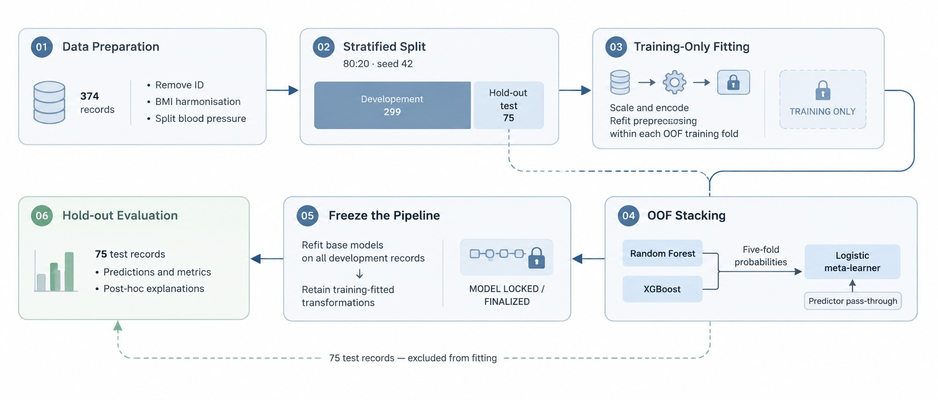
Figure 1. Main architecture and analytical workflow of the RF–XGBoost stacking framework. The six stages show deterministic data preparation, the stratified development/test split, training-only preprocessing, out-of-fold stacking with predictor pass-through, pipeline finalisation, and hold-out evaluation. The dashed route denotes test records excluded from fitting. The stacking architecture and training protocol are detailed in Fig. 4 and Algorithm 2. This schematic describes the documented protocol.

Problem formulation and notation
Let the benchmark sample be $D=\{\left(x_{i},y_{i}\right)\}_{i=1}^{N}$, where $N=374$, $x_{i}∈R^{d_{n}}×A^{d_{c}}$ contains numerical and categorical predictors, and $y_{i}∈C=\{0,1,2\}$ denotes insomnia, no recorded disorder, or sleep apnea. The analytical objective is to estimate a probabilistic mapping
$$F:X→Δ^{C−1}, {\hat{y}}_{i}=arg\max_{c∈C}F_{c}\left(x_{i}\right),$$
where $C=3$ and $Δ^{C−1}$ is the probability simplex. The stratified partition satisfies
$$D_{tr}∩D_{te}=⌀, \left|D_{tr}\right|=299, \left|D_{te}\right|=75,$$
and every estimated parameter is a function of $D_{tr}$ only. For numerical predictor $j$, development-set standardisation is
xij=xij−μjtrσjtr, μjtr=1ntri∈Dtr​xij,
where $σ_{j}^{\left(tr\right)}$ is the standard deviation estimated from $D_{tr}$. A categorical level $a_{q}$ is represented by $o_{iq}=I\left(x_{ij}=a_{q}\right)$. Consequently, the fitted transformer $T_{{\hat{θ}}_{tr}}$ maps each observation to the fixed-schema vector $x′_{i}=T_{{\hat{θ}}_{tr}}\left(x_{i}\right)$, with neither the scale parameters nor the categorical vocabulary re-estimated on the test partition.

Data source and outcome definition
Table 2 summarises the reported dataset characteristics; Table 3 groups the predictors and specifies their computational treatment.
The analysis used the publicly available Sleep Health and Lifestyle Dataset hosted on Kaggle [18]. The dataset comprises 374 participant-level observations and 13 variables: one administrative identifier, 11 candidate predictors, and the Sleep Disorder outcome. The predictors represent demographic characteristics, sleep behaviour, physical activity, perceived stress, body-mass category, heart rate, and blood pressure. Because the data were not collected as a prospectively recruited clinical cohort and the outcome was not independently adjudicated, the dataset is treated as a methodological benchmark for risk stratification rather than as a source of prevalence estimates or diagnostic ground truth.
The outcome column contains 374 labels: None (219), Insomnia (77), and Sleep Apnea (78). “None” is a literal category label meaning that no sleep disorder is recorded; it is read as a category and not as a missing value (text parsers convert the string to a missing value by default, so this conversion is disabled). The label is a dataset-supplied category: neither its presence nor its absence establishes clinician-confirmed absence of disease.
The audit also examined repetition within the file. Excluding Person ID, 242 of the 374 records are exact duplicates of another record, leaving 132 unique rows (None 73, Insomnia 29, Sleep Apnea 30) that span 109 distinct predictor vectors. Twenty-two predictor vectors, covering 128 records, carry more than one outcome label (Fig. 2a). A classifier that assigns the majority label to every distinct predictor vector therefore attains at most 349/374 = 93.3% accuracy on this file, and the in-sample accuracy of a Random Forest (93.0%) lies at that ceiling. The dataset has no documented provenance, and its repetition structure is consistent with a synthetic or templated generating process; it is treated strictly as a methodological benchmark. Under any random split, identical predictor vectors fall into both training and test partitions, so a record-level split rewards memorisation. Evaluation is therefore grouped by predictor vector (Section 4.1), and a unique-rows analysis is reported as a sensitivity check (Fig. 2b).
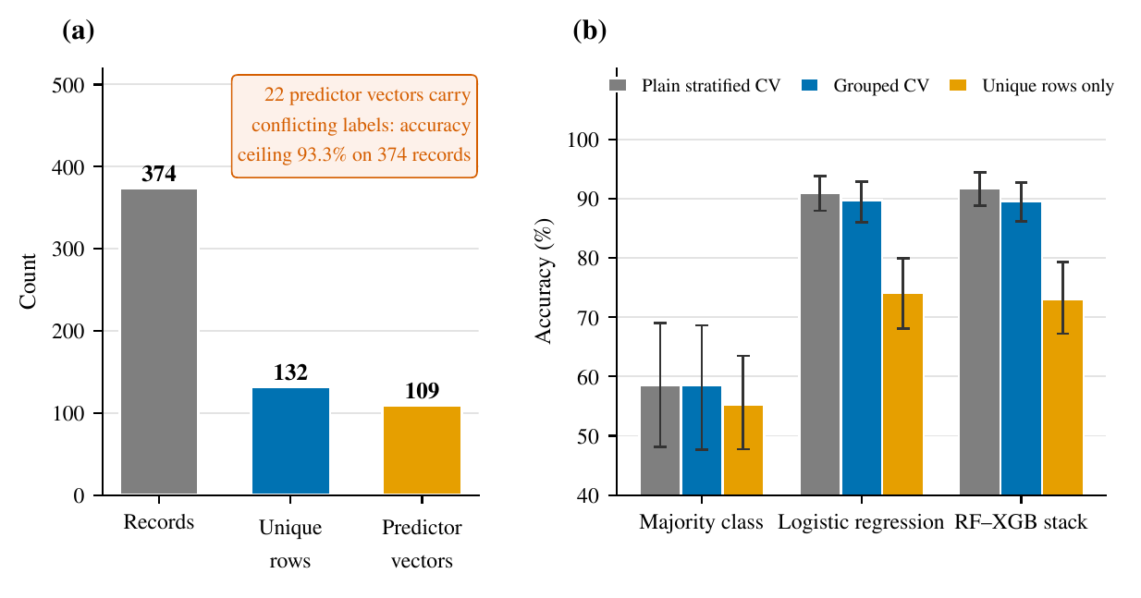
Figure 2. Dataset audit. (a) Of 374 records, 132 are unique and 109 are distinct predictor vectors; 22 vectors carry conflicting labels, so accuracy on the 374 records cannot exceed 93.3%. (b) Accuracy under three evaluation treatments of the same duplicates (plain stratified CV, grouped CV, unique rows only); error bars are 95% cluster-bootstrap intervals.
Table 2. Descriptive characteristics of the 374 observations used for model development and evaluation.
Profile item | Observed value | Interpretation
Records and variables | 374 records; 13 variables | Person-level tabular benchmark
Candidate predictors | 11 | Mixed numerical and categorical fields
Outcome coding | 219 literal “None” labels; 155 disorder labels | “None” is the no-recorded-disorder class; no imputation
Exact duplicates (excluding ID) | 242 of 374; 132 unique rows; 109 distinct predictor vectors | Evaluation grouped by predictor vector
Conflicting-label vectors | 22 vectors covering 128 records | Accuracy ceiling 93.3%
Class distribution | No recorded disorder, 219; insomnia, 77; sleep apnea, 78 | Unequal class frequencies
Age | 27–59 years; mean, 42.18 | Demographic predictor
Sleep duration | 5.8–8.5 h; mean, 7.13 h | Self-reported sleep behaviour
Heart rate | 65–86 bpm; mean, 70.17 bpm | Physiological indicator
Daily steps | 3,000–10,000; mean, 6,816.84 | Activity indicator
Source categories | Gender, 2; occupation, 11; BMI, 4 | BMI labels Normal and Normal Weight merged before encoding
Age ranged from 27 to 59 years (mean 42.18, standard deviation 8.67), and reported sleep duration ranged from 5.8 to 8.5 h (mean 7.13, standard deviation 0.80). Quality-of-sleep scores ranged from 4 to 9, physical-activity levels from 30 to 90, stress scores from 3 to 8, heart rate from 65 to 86 beats/min, and daily step counts from 3,000 to 10,000. The categorical variables comprised two gender categories, 11 occupational groups, and four body-mass-index labels. Blood pressure, originally represented as a systolic/diastolic string, was separated into two numerical variables. The synonymous labels “Normal Weight” and “Normal” were consolidated before one-hot encoding.
Table 3. Predictor groups, representative variables, and their computational treatment within the modelling pipeline.
Variable group | Examples | Treatment
Administrative | Person ID | Removed before modelling
Demographic | Age, Gender, Occupation | Categorical encoding; age standardisation
Sleep behaviour | Sleep Duration, Quality of Sleep | Numerical standardisation
Lifestyle | Physical Activity Level, Daily Steps | Numerical standardisation
Psychophysiological | Stress Level, Heart Rate | Numerical standardisation
Anthropometric | BMI Category | Category harmonisation and one-hot encoding
Cardiovascular | Blood Pressure | Split into systolic and diastolic values
Target | Sleep Disorder | Label encoding into three classes
Person ID was excluded because it contains ordering information without a plausible physiological interpretation. Occupation was retained as a contextual predictor, although its contribution requires careful scrutiny because it may encode socioeconomic structure and introduce transportability concerns. The public-source provenance, modest sample size, outcome-assignment rule, and absence of clinical adjudication therefore define the inferential boundaries of this study.

Class separability diagnostic (PCA)
To characterise the intrinsic separability of the three outcome classes independent of any specific classifier, a two-component principal component analysis was fitted to the fully preprocessed (scaled and one-hot encoded) feature matrix using all 374 observations. This projection is diagnostic only: it is fitted separately from, and never substituted into, the classification pipeline described in Sections 3.5–3.6, so it does not affect any reported classification metric.
The reported component-wise explained-variance ratios are 33.68% and 29.47%, rounded to 33.7% and 29.5% on the axes. Together they represent approximately 63.1% of the variance. Fig. 3(a) shows the scatter, and panel (b) overlays 1-sigma class ellipses. The no-recorded-disorder ellipse lies mainly below the horizontal axis, the insomnia ellipse near the centre, and the sleep-apnea ellipse mainly above it. Individual observations nevertheless overlap across classes and some lie outside their class ellipse. These regions are not classifier decision boundaries and do not explain specific test-set errors. The figure legend uses “None” for no recorded disorder. Because the projection is fitted on all 374 records, including duplicates, it describes this file and not a population.
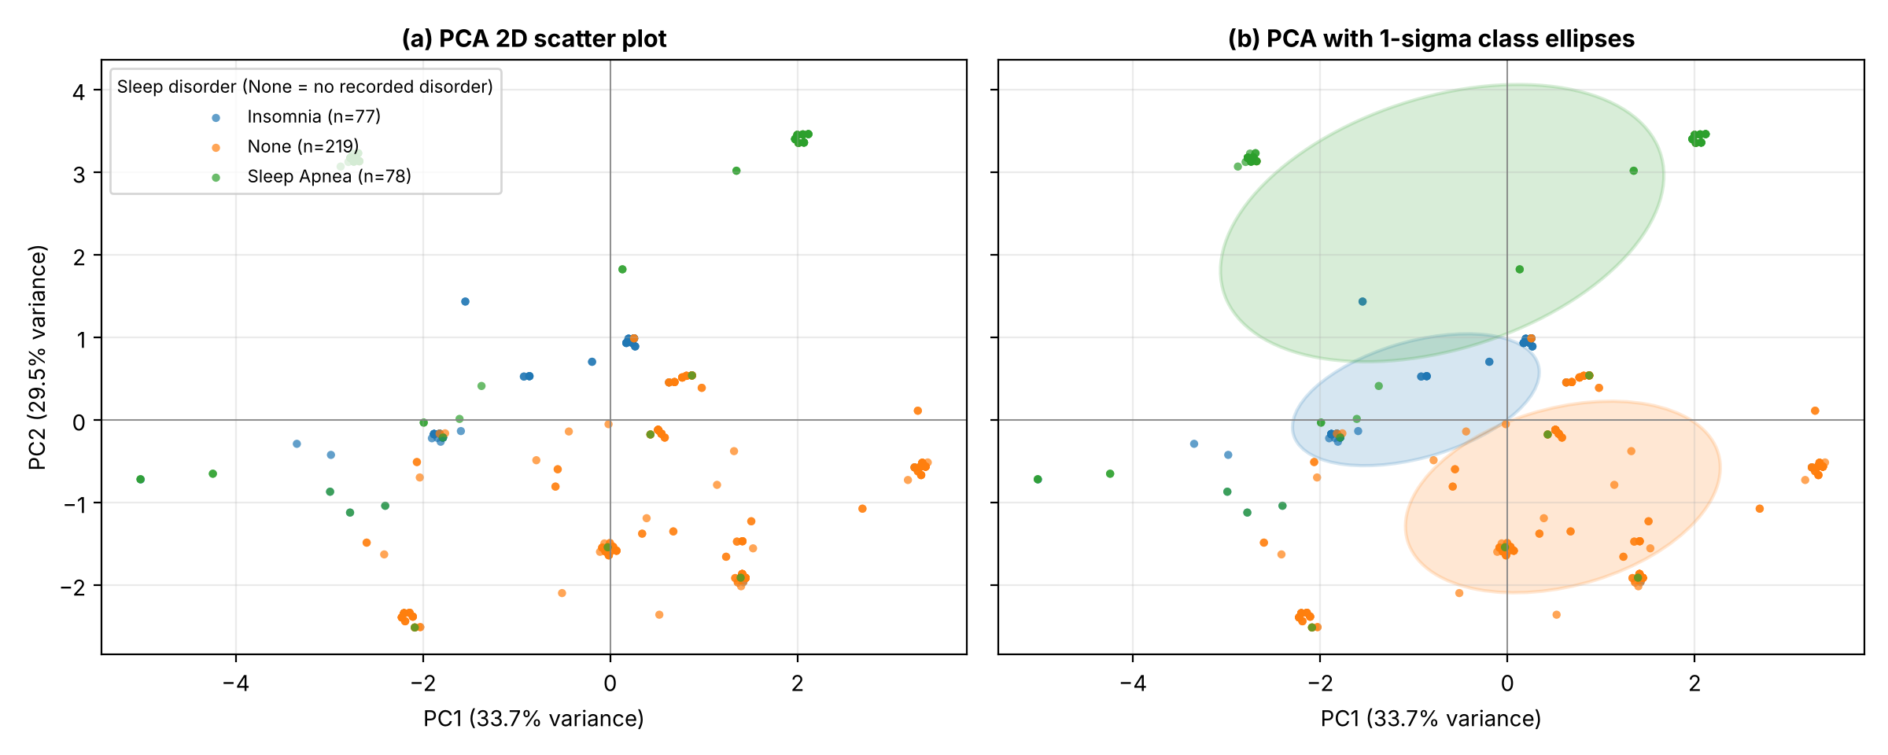
Figure 3. PCA projection of the preprocessed feature space (diagnostic only, not part of the modelling pipeline): (a) raw scatter by outcome class; (b) the same projection with 1-sigma class ellipses. PC1 and PC2 explain 33.68% and 29.47% of variance, respectively.

Data splitting and leakage control
The 80:20 stratified partition uses random seed 42 and contains 299 development and 75 test observations. Algorithm 1 specifies splitting before learned transformations and reusing training-fitted parameters on the test set. For out-of-fold base predictions, numerical scaling and categorical encoding must additionally be refitted within each training fold; fitting them once on all development records does not provide fold-isolated preprocessing. Algorithm 2 states this requirement as part of the protocol, and the released code implements it [5, 6]. Because 68 of the 75 test records of the 80:20 split share a predictor vector with a training record (Section 5.2), inference rests on the grouped cross-validation of Section 4.1.
Algorithm 1. Leakage-Controlled Data Preparation and Feature Transformation
Dataset $D$, target $y$, random seed $s=42$
Transformed development and test partitions $\left(X′_{tr},y_{tr}\right)$ and $\left(X′_{te},y_{te}\right)$
Remove administrative identifier fields from $D$
Read the outcome with missing-value conversion disabled, retaining the label “None” as the “no recorded disorder” class
Harmonise categorical labels, including BMI categories
Decompose Blood Pressure into systolic and diastolic numerical features
Perform an 80:20 stratified split:
$$\left(D_{tr},D_{te}\right)←StratifiedSplit\left(D,y,s\right)$$
Extract:
$$\left(X_{tr},y_{tr}\right), \left(X_{te},y_{te}\right)$$
Fit numerical standardisation parameters $\left(μ_{tr},σ_{tr}\right)$ using $X_{tr}$ only
Fit the categorical one-hot encoder $E_{tr}$ using $X_{tr}$ only
Construct $T_{tr}$ by concatenating standardised numerical features and one-hot encoded categorical features:
$$X′_{tr}←T_{tr}\left(X_{tr}\right)$$
Apply the same fitted transformations to the held-out data:
$$X′_{te}←T_{tr}\left(X_{te}\right)$$
Fit the label mapping $L_{tr}$ using $y_{tr}$ only
Encode:
$$y_{tr}←L_{tr}\left(y_{tr}\right), y_{te}←L_{tr}\left(y_{te}\right)$$
Preserve the resulting feature schema for both partitions
return $\left(X′_{tr},y_{tr}\right)$ and $\left(X′_{te},y_{te}\right)$

Base Learners and Stacking Design
Fig. 4 illustrates the encoded input, the two base learners, and the logistic meta-learner with predictor pass-through.
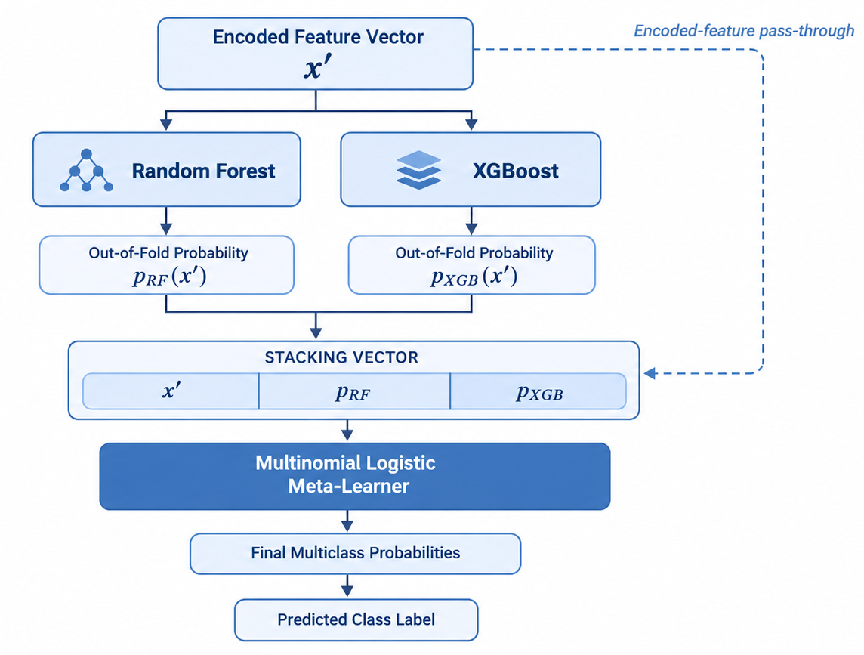
Figure 4. Architecture of the heterogeneous stack. Out-of-fold Random Forest and XGBoost class-probability vectors are concatenated with the encoded predictors through the pass-through connection; the logistic meta-learner then estimates the final multiclass probabilities.
The primary specification is the two-learner RF–XGBoost configuration defined in the workflow, architecture diagram, and confusion-matrix labels. The ROC, stacking SHAP, and stacking LIME displays are outputs of this stacking model. The documented Random Forest configuration [19] uses 100 trees, maximum depth 10, minimum split size 5, minimum leaf size 1, and seed 42. In general, its probability vector averages the individual tree probabilities:
$$p_{RF}\left(c∣x′\right)=\frac{1}{B}\sum_{b=1}^{B}{π_{bc}}\left(x′\right).$$
Here, $π_{bc}\left(x′\right)$ is tree $b$’s probability for class $c$; a hard class vote is only a special case, not an assumed implementation. The documented XGBoost settings [20] are 800 boosting iterations, learning rate 0.02, maximum depth 3, row and column subsampling 0.90, minimum child weight 3, $γ=0.15$, and $λ=1.2$. Its class-specific additive score and probability can be written as
scMx′=m=1Mηfmcx′, pXGBc∣x′=expscMr∈C​expsrM.
In the specified five-fold protocol, $κ\left(i\right)$ denotes the fold containing observation $i$. For learner $A∈\{RF,XGB\}$, define $p_{A,i}^{OOF}$ as its probabilities after both preprocessing and model fitting exclude fold $κ\left(i\right)$. These fold-specific probabilities, not predictions from a model fitted to observation $i$, enter the meta-level vector:
$$z_{i}^{OOF}={\left[ {x′_{i}}^{​⊤}, {p_{RF,i}^{OOF}}^{​⊤}, {p_{XGB,i}^{OOF}}^{​⊤}\right]}^{​⊤}∈R^{d+2C}.$$
For meta-training, the pass-through features are generated with the same fold-isolated preprocessing used for the corresponding OOF row, so neither the pass-through representation nor the base-model probabilities are fitted on that row’s fold. After the OOF matrix is assembled, a transformer fitted on all development data is used only for inference on unseen observations. All test records remain excluded from fitting. A multinomial logistic meta-learner then estimates
pSc∣z=expβc0+βc⊤zr∈C​expβr0+βr⊤z,
by minimising regularised multiclass log loss
β=argminβ[−1ntri=1ntrc∈C​Iyi=clogpSc∣ziOOF+λβc∈C​∥βc∥22].
Here, $λ_{β}$ denotes the L2 penalty governed by the implementation’s inverse-regularisation setting $C_{LR}=2.0$. The base models were subsequently refitted on the full development set for inference on unseen observations. Restricting meta-learner training to out-of-fold predictions is essential; using in-sample probabilities would expose the second level to optimistically biased representations [5, 15].
Table 4 summarises the documented hyperparameters of the Random Forest and XGBoost base learners, the logistic-regression meta-learner, and the validation configuration.
Table 4. Hyperparameter configuration of the Random Forest and XGBoost base learners, logistic-regression meta-learner, and validation split.
Component | Parameter | Value
Random Forest | number of trees | 100
 | maximum depth | 10
 | min. samples split / leaf | 5 / 1
XGBoost | estimators / learning rate | 800 / 0.02
 | maximum depth | 3
 | row / column subsample | 0.90 / 0.90
 | min child weight / $γ$ | 3 / 0.15
 | L2 regularisation ($λ$) | 1.2
Meta-learner | model | logistic regression
 | inverse regularisation / solver | $C_{LR}=2.0$ / L-BFGS
 | encoded-feature pass-through | enabled
Validation | split / seed | 80:20 stratified / 42
 | stacking folds | 5
Algorithm 2. Fold-Isolated RF–XGBoost Stacking Protocol
Untransformed development data $\left(X_{tr},y_{tr}\right)$, test record $x$, folds $K=5$
Predicted class $\hat{y}$
Partition the development data into $K$ stratified folds
Initialise $P_{RF},P_{XGB}∈R^{n_{tr}×C}$
for $k=1,…,K$
Let $D^{\left(k\right)}$ be the validation fold
Set $D_{train}^{\left(k\right)}=D_{tr}\backslash D^{\left(k\right)}$
Fit preprocessing $T^{\left(−k\right)}$ on this training fold only
Fit RF and XGBoost using $T^{\left(−k\right)}\left(X_{train}^{\left(k\right)}\right)$
Compute $P_{RF}^{\left(k\right)}=f_{RF}^{\left(−k\right)}\left(T^{\left(−k\right)}\left(X^{\left(k\right)}\right)\right)$
Compute $P_{XGB}^{\left(k\right)}=f_{XGB}^{\left(−k\right)}\left(T^{\left(−k\right)}\left(X^{\left(k\right)}\right)\right)$
Store $P_{RF}^{\left(k\right)}$, $P_{XGB}^{\left(k\right)}$, and the corresponding fold-transformed pass-through features at their OOF row indices
Fit $T_{tr}$ on all development predictors only
Set $X′_{tr}=T_{tr}\left(X_{tr}\right)$ and $x′=T_{tr}\left(x\right)$
Form $Z$ by concatenating the stored fold-isolated pass-through features with $P_{RF}$ and $P_{XGB}$
Fit multinomial logistic model $g\left(Z,y_{tr}\right)$ with $C_{LR}=2.0$
Refit RF and XGBoost on $\left(X′_{tr},y_{tr}\right)$
Compute $p_{RF}=f_{RF}\left(x′\right)$ and $p_{XGB}=f_{XGB}\left(x′\right)$
Form $z^{*}=\left[x′,p_{RF},p_{XGB}\right]$
Compute $p^{*}=g\left(z^{*}\right)$
Set $\hat{y}=arg\max_{c∈C}p_{c}^{*}$
return $\hat{y}$

Explainability and Auditability
Algorithm 3 summarises the permutation-SHAP procedure and the aggregation of class-specific attributions into global importance scores.
SHAP explanations were obtained through a permutation-based, model-agnostic interface [21]. A fixed background sample $B$ was drawn exclusively from the development partition, and each perturbed observation was passed through the complete preprocessing and prediction pipeline. For class $c$, local additive consistency satisfies
$$F_{c}\left(x_{i}\right)−E_{X∼B}\left[F_{c}\left(X\right)\right]=\sum_{j=1}^{d}{ϕ_{ij}^{\left(c\right)}},$$
and global importance for feature $j$ was defined as
Ij=1nCi=1nc∈C​ϕijc.
Here, $ϕ_{ij}^{\left(c\right)}$ denotes the attribution assigned to feature $j$ for observation $i$ and class $c$. LIME was used as a complementary local analysis [22]. Given perturbed neighbourhood $Z_{i}$, proximity kernel $π_{i}$, and interpretable surrogate family $G$, the local explanation is
gi*=argming∈Gz∈Zi​πizFcz−gz2+Ωg,
where $Ω\left(g\right)$ penalises surrogate complexity. Absolute LIME coefficients were aggregated only to assess broad agreement with SHAP rankings; they were not treated as a second estimate of causal importance. Both methods characterise the fitted prediction function, and their outputs depend on the chosen background distribution, perturbation mechanism, and representation of predictor dependence [8, 23].
Because permutation SHAP is stochastic and attributions can be unstable under collinearity [38], the stacking-model and soft-voting analyses were each repeated ten times with independent background samples and explanation samples, and stability was summarised by the mean pairwise Spearman rank correlation of the global importance vectors and by the overlap of the top-three sets. Because correlated predictors can share attribution, attributions were also aggregated over predictor blocks (blood pressure, sleep and stress, activity), and a held-out block-permutation importance (increase in multiclass log-loss when a block is permuted jointly) was computed for the fitted models as a model-agnostic cross-check. LIME explanations were generated for pre-specified, named records with a fixed random seed; for each we report the Person ID, reference label, predicted class probabilities, the weighted $R^{2}$ of the local surrogate (explanation fidelity), and the rank correlation of the local coefficients across repeated LIME seeds.
Algorithm 3. Permutation-SHAP Procedure for Global Model Auditing
Fitted prediction pipeline $F$, training matrix $X_{tr}$, explanation sample $X_{e}$
Ranked global feature-importance vector $I$
Sample a fixed background set:
$$B⊂X_{tr}$$
Define the complete prediction function:
$$h\left(z\right)=F\left(decode\left(z\right)\right)$$
Initialise the permutation-based SHAP explainer using $h$ and background $B$
Evaluate SHAP values for all observations in $X_{e}$:
$$Φ=SHAP\left(h,X_{e},B\right)$$
for each feature $j=1,…,d$
Aggregate absolute class-specific contributions:
Ij←1neCi=1nec∈C​Φijc
Rank features in descending order of $I_{j}$
return Ranked importance vector $I$

Feature relationships and stacking-model local effects
Two additional diagnostics were used to examine dependence structure among predictors and the fitted stack’s local behaviour. First, Spearman rank correlation was computed across the nine numerical predictors on the development partition, to characterise monotonic association independent of the standardisation applied in Eq. (3). Second, a two-dimensional Accumulated Local Effects (ALE) surface [24] was computed directly from the fitted stacking pipeline for the joint effect of Sleep Duration and Quality of Sleep on the predicted probability of insomnia, using a $6×6$ quantile grid; ties among the quality-of-sleep values merge two quantile edges, so the effective grid has six bins for sleep duration and four for quality of sleep (24 cells), and the centred surface ranges from $−0.11$ to $+0.09$ in probability. Uncertainty was quantified by 200 bootstrap resamples of the development records with the fitted model held fixed: the mean 95% band half-width of the centred surface is 0.059 (maximum 0.092) against a total range of 0.204, and 14 of the 24 cells are occupied, with the eight cells holding at least ten records containing 91.3% of the development records. The surface is therefore read as a descriptive summary of the fitted function in the populated region and not as a quantitative effect estimate. Unlike SHAP, ALE conditions on the local data density and is therefore less sensitive to feature correlation when estimating joint effects; it was accumulated by summing corner-difference finite effects across grid cells and centring the resulting surface to zero mean.
Fig. 5(a) reports a Spearman correlation of 0.88 between Sleep Duration and Quality of Sleep. Stress Level correlates negatively with them ($−0.79$ and $−0.90$, respectively). Systolic and diastolic blood pressure correlate at 0.98, and Physical Activity Level and Daily Steps at 0.82. These values describe dependence, not SHAP importance: Stress Level is absent from the displayed voting SHAP bar chart, and Quality of Sleep is its lowest displayed feature. Panel (b) shows positive and negative regions of a non-monotonic centred ALE surface. The vertical axis is a centred effect on the insomnia probability output, not an absolute probability. The plot does not establish a monotonic dose-response, a plateau beyond sample medians, or causality.
Collinearity was quantified on all 374 records by variance-inflation factors and Spearman correlations. Systolic and diastolic blood pressure are almost collinear (Spearman $ρ=0.98$; VIF 35.3 and 38.0), and Quality of Sleep (VIF 13.3), Stress Level (9.6), Physical Activity Level (5.7), and Daily Steps (6.1) are also correlated with other predictors; the strongest pairs are Quality of Sleep with Stress Level ($ρ=−0.91$) and Sleep Duration with Quality of Sleep ($ρ=0.89$). Individual attributions for such predictors are therefore interpreted only at the block level.
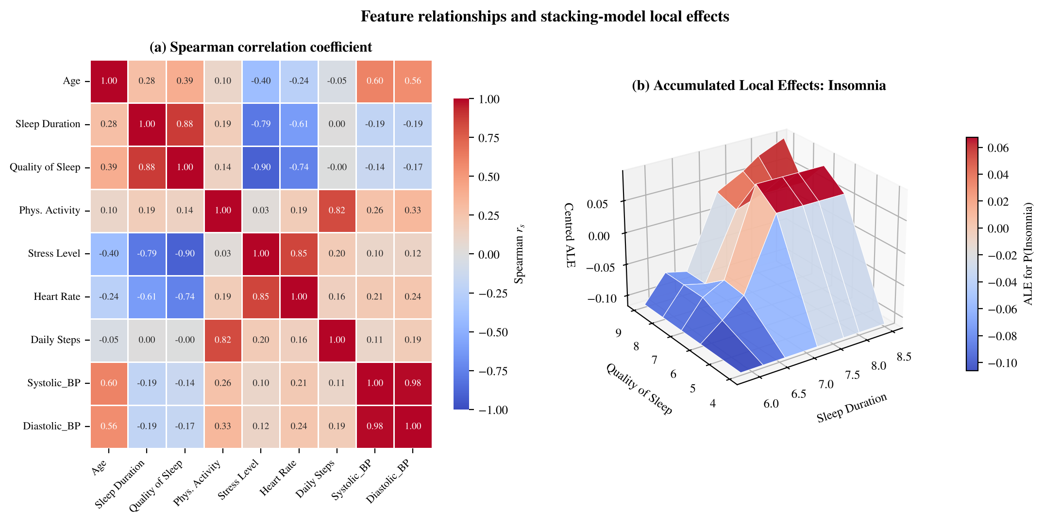
Figure 5. (a) Spearman rank correlation among numerical predictors on the development partition. (b) Two-dimensional Accumulated Local Effects surface for Sleep Duration and Quality of Sleep on the stacking classifier’s predicted probability of insomnia.

Experimental protocol
The evaluation used the isolated 75-observation test partition. Accuracy was reported alongside class-specific precision, recall, and F1 score, as well as macro- and support-weighted summaries. For class $c$, the principal relationships were
$$\begin{matrix}P_{c} & =\frac{TP_{c}}{TP_{c}+FP_{c}}, & R_{c} & =\frac{TP_{c}}{TP_{c}+FN_{c}}, \\ F1_{c} & =\frac{2P_{c}R_{c}}{P_{c}+R_{c}},\end{matrix}$$
with
Accuracy=1ntei=1nteIyi=yi, F1macro=1Cc∈C​F1c.
Macro-F1 was emphasised because it assigns equal weight to each outcome category despite unequal class frequencies. One-vs-rest ROC–AUC [25] was additionally computed from the predicted class probabilities to summarise ranking quality independently of the classification threshold, using
AUCc=01TPRcFPRc−1t dt, AUCmacro=1Cc∈C​AUCc.
The stack and soft-voting comparator were additionally evaluated through paired bootstrap resampling of test observations. For bootstrap sample $b$, the paired effect was
$$Δ^{\left(b\right)}={Accuracy}_{stack}^{\left(b\right)}−{Accuracy}_{vote}^{\left(b\right)},$$
and the 2.5th and 97.5th percentiles of $\{Δ^{\left(b\right)}\}$ formed the 95% interval. An exact McNemar test used only the discordant prediction counts between the two models on the identical test partition. The analysis assesses discrimination within the available benchmark; it does not substitute for repeated internal validation, probability calibration, subgroup analysis, or evaluation in an untouched external cohort [7, 26, 27].

Repeated grouped cross-validation
The primary protocol is 10×5 repeated stratified-grouped cross-validation over all 374 records, in which records sharing an identical predictor vector are assigned to the same fold (groups $=$ distinct predictor vectors; 109 groups). Every model, including the stack with its internal five-fold out-of-fold construction and fold-isolated preprocessing, was refitted inside each outer training fold. Three complementary treatments of the duplicates are reported: plain stratified cross-validation (duplicates may straddle folds; reported only to quantify inflation), grouped cross-validation (primary), and grouped cross-validation on the 132 unique rows only. Intervals are 95% cluster-bootstrap intervals that resample predictor-vector groups, which respect the dependence among repeated records.

Baselines and nested tuning
The comparator set contains a majority-class rule, a depth-3 decision tree, logistic regression, an RBF-kernel SVM, a (32,16) multilayer perceptron, an FT-Transformer [34] (feature-token transformer trained from scratch; 150 epochs, learning rate $2×{10}^{−3}$, batch size 64), Random Forest, extra trees, histogram gradient boosting, LightGBM [35], CatBoost [36], XGBoost, and RF–XGBoost soft voting, all implemented with scikit-learn [37] or the cited libraries and evaluated on identical folds. Because the hyperparameters in Table 4 were fixed in advance of this evaluation, a repeated nested cross-validation was added in which learner hyperparameters (and the meta-learner $C$) were selected by an inner three-fold grouped search on the outer training partition only. The pretrained tabular foundation model TabPFN [41] is the only comparator not evaluated (Section 9).

Calibration and statistical comparison
Calibration was summarised by multiclass Brier score [32], log-loss, and five-bin expected calibration error of the top-class probability [33]. Paired comparison of the stack against each comparator used the mean fold-level accuracy difference with a cluster-bootstrap interval, the exact McNemar test on the discordant predictions of each repeat (median $p$ over repeats and the number of repeats with $p<0.05$), and the Nadeau–Bengio corrected resampled $t$-test [30], which accounts for overlapping training sets [40]. Exact Clopper–Pearson intervals [31] were used for single-split proportions. For a single split with 75 test records, a difference of about 5.3 percentage points is the smallest that could be detected with conventional power, and about 1,180 test records would be needed to detect a 1.33-percentage-point difference.

Reproducibility
Python 3 with scikit-learn, XGBoost, LightGBM, CatBoost, SHAP, and LIME was used, with all random seeds fixed and recorded. The release contains the executable analysis code, library versions, seeds, split identifiers for every repeat and fold, and observation-level labels, predicted classes, and probabilities for every model.

Results
The isolated 75-observation hold-out set (stratified 80:20 split, seed 42) is reported first, as a benchmark estimate under the leakage-control protocol; Section 4.1 gives the primary evidence. The RF–XGBoost stacking configuration produced 72 correct classifications, corresponding to an accuracy of 96.00% and a macro-F1 score of 0.94. Class-level results show 13 of 15 insomnia observations, 43 of 44 no-recorded-disorder observations, and all 16 sleep-apnea observations correctly identified. The three errors were two insomnia observations and one no-recorded-disorder observation assigned to sleep apnea. On the identical test partition, RF–XGBoost soft voting also produced 72 correct classifications (96.00% accuracy) and a macro-F1 score of 0.94, so the two ensembles are tied on this partition.
Table 5. Class-specific and aggregate predictive performance of the stack on the 75-observation hold-out set.
Class/model | Precision | Recall | F1 | Support
Insomnia | 1.00 | 0.87 | 0.93 | 15
No recorded disorder | 1.00 | 0.98 | 0.99 | 44
Sleep Apnea | 0.84 | 1.00 | 0.91 | 16
Macro average | 0.95 | 0.95 | 0.94 | 75
Weighted average | 0.97 | 0.96 | 0.96 | 75
Soft voting macro average | 0.94 | 0.93 | 0.94 | 75
Table 5 reports the class-specific precision, recall, and F1 scores for the stacking model together with the aggregate metrics. The principal variation occurred for insomnia (two observations assigned to sleep apnea) and for one no-recorded-disorder observation assigned to sleep apnea, which lowers the precision for sleep apnea to 0.84. Given the limited test-set size, these class-specific results are sample-level observations rather than stable estimates of population performance.

Discrimination via ROC–AUC
One-vs-rest ROC–AUC was computed on the same test partition of 75 observations to assess ranking quality independently of the classification rule used in Table 5.
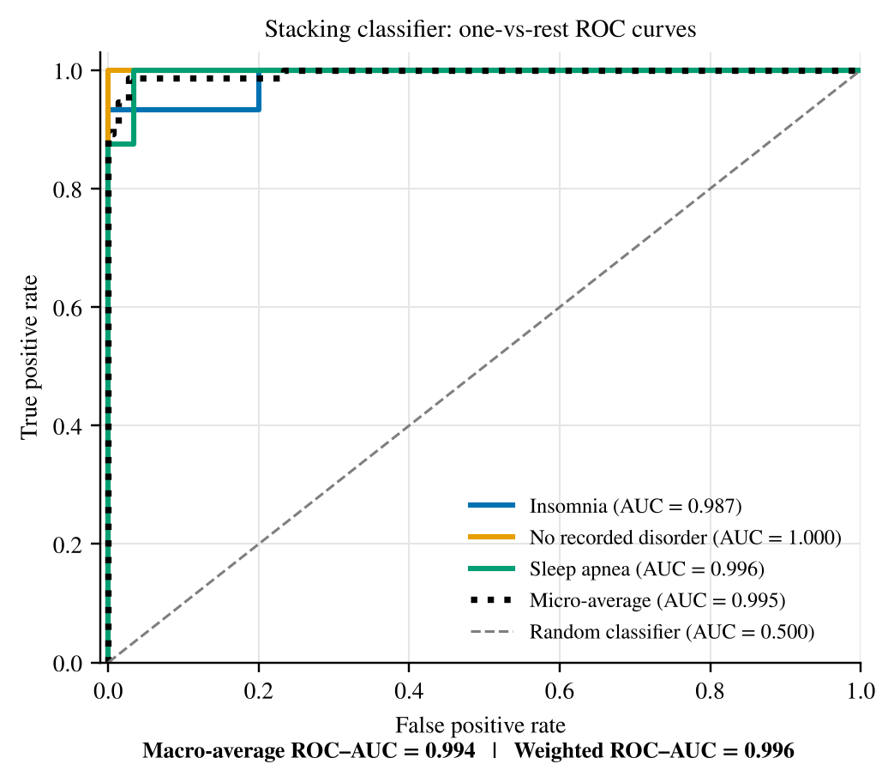
Figure 6. Stacking-classifier ROC display: insomnia (blue, AUC 0.987), no recorded disorder (orange, labelled “None”, AUC 1.000), and sleep apnea (green, AUC 0.996). The dotted curve is the micro-average (AUC 0.995), and the dashed diagonal is the random-classifier reference. Macro-average (0.994) and weighted-average (0.996) AUC appear as numerical annotations below the plot, not as separate curves.
Per-class AUC was 0.987 for insomnia, 1.000 for no recorded disorder, and 0.996 for sleep apnea, giving a macro-average ROC–AUC of 0.994 and a support-weighted average of 0.996 (Fig. 6); soft voting reached a macro-average of 0.996. These values summarise high overall ranking performance. The multiclass decision rule is the argmax in Eq. (1), not a fixed 0.5 probability threshold. Aggregate AUC values alone do not locate the three misclassified observations relative to the decision boundaries.

Single hold-out split and its leakage structure
The stratified 80:20 split with seed 42 and the documented hyperparameters (Table 4) gave 72 of 75 correct test classifications for the stack (96.00%, exact 95% CI 88.8–99.2; macro-F1 0.94); the errors were two insomnia records and one no-disorder record assigned to sleep apnea. Soft voting and Random Forest also reached 72/75; XGBoost reached 70/75 and logistic regression 71/75 (Table 6). The same result was obtained when the internal stacking folds were plain stratified rather than grouped. The single-split result is a point estimate within a 95% interval of roughly 89–99%.
The split is also structurally weak. Of the 75 test records, 68 have a predictor vector that is identical to a training record (65 with the same label), so only 7 test records are novel; the stack classified 5 of these 7 correctly, soft voting 6, and XGBoost 4. Training accuracy (91.6%) is therefore close to test accuracy not because the models generalise without optimism, but because the test set largely repeats the training set; the in-sample ceiling of the file is 93.3%. The close agreement between training and test accuracy across random seeds (Section 7.1) is explained by the same mechanism.
Table 6. The 80:20 split (seed 42): accuracy with exact Clopper–Pearson intervals, macro-F1, training accuracy, and accuracy on the 7 test records whose predictor vector does not appear in the training set.
Model | Correct/75 | Accuracy (%) [exact 95% CI] | Macro-F1 | Train acc. (%) | Unseen-vector rows correct
Logistic regression | 71 | 94.7 [86.9, 98.5] | 0.92 | 91.0 | 6/7
Random forest | 72 | 96.0 [88.8, 99.2] | 0.94 | 92.0 | 6/7
XGBoost | 70 | 93.3 [85.1, 97.8] | 0.89 | 91.6 | 4/7
Soft voting (RF+XGB) | 72 | 96.0 [88.8, 99.2] | 0.94 | 91.6 | 6/7
Stacking (RF+XGB) | 72 | 96.0 [88.8, 99.2] | 0.94 | 91.6 | 5/7

Comparison with ensemble baselines
Table 7 places the hold-out result in the context of the RF–XGBoost soft-voting comparator and published ANN ensemble results. The stacking configuration and RF–XGBoost soft voting both reached 96.00% on the hold-out set. The published ANN values are lower, but they arise from a different experimental protocol and are therefore presented only as descriptive literature context rather than as matched evidence of model superiority.
Table 7. Descriptive accuracy comparison between the RF–XGBoost stack and ensemble baselines. ANN results were reported by Alom et al. [14].
Model | Accuracy
ANN Bagging ensemble | 94.70%
ANN Boosting ensemble | 94.70%
ANN Weighted Average ensemble | 92.90%
RF–XGBoost soft voting | 96.00%
RF–XGBoost stacking | 96.00%
Table 8 and Fig. 7 complement the single-split comparison above by comparing the stack with twelve baselines under 10×5 repeated grouped cross-validation. The stack reached 89.6% accuracy (95% CI 86.1–92.7; macro-F1 0.87; Brier 0.186), against 89.8% for RF–XGBoost soft voting, 89.8% for Random Forest, 89.8% for XGBoost, 89.7% for logistic regression, and 90.0% for the RBF SVM. The intervals overlap almost completely and only the majority-class rule (58.6%) is clearly lower. Plain stratified cross-validation, which lets duplicates straddle folds, gave 91.8% for the stack, an inflation of 2.2 percentage points relative to grouped evaluation. The FT-Transformer reached 89.7% (macro-F1 0.87), matching the tree ensembles, in line with reports that tree-based models remain competitive on small tabular data [34]. The published ANN accuracies in Table 7 (92.9–94.7% [14]) are unmatched context: their partitioning and tuning differ from this protocol, and they lie above the grouped-CV range of the models here only because duplicates are not separated in a record-level split.
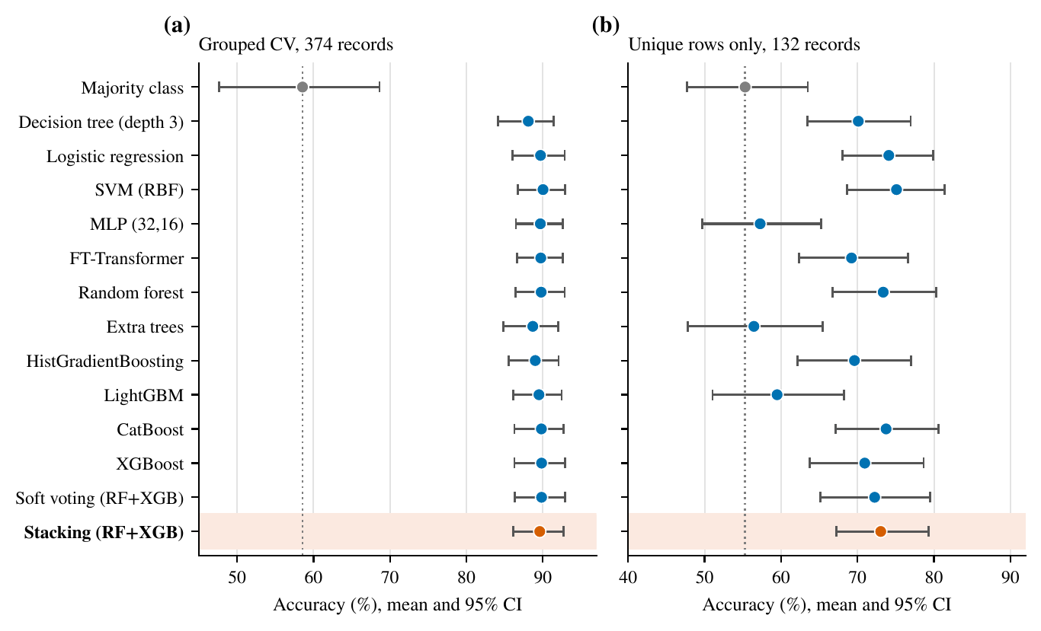
Figure 7. Accuracy (mean and 95% cluster-bootstrap interval) of the stack (red) and comparators under (a) grouped CV on all 374 records and (b) grouped CV on the 132 unique rows only. The dotted line marks the majority-class rate.

Unique rows and nested tuning
When only the 132 unique rows are evaluated, accuracy falls markedly: the stack reached 73.0% (95% CI 67.2–79.3), a drop of 16.6 percentage points relative to grouped evaluation, logistic regression 74.1%, and the RBF SVM 75.1%; the majority-class rate in this subset is 55.3%. The ordering among the competitive models is again within sampling error, and several flexible learners (extra trees, LightGBM, MLP) fall to 56–60%. This subset over-represents rare configurations and is a sensitivity analysis rather than a target population, but it shows that the level of performance on the full file is mainly attributable to repeated records. Table 9 reports repeated nested cross-validation with hyperparameters selected on the training partition only: the stack reached 90.0% on the full grouped folds, XGBoost 90.1%, soft voting 89.9%, Random Forest 89.2%, and logistic regression 89.0%. The stack-minus-Random-Forest difference narrowly excluded zero ($+0.8$ pp, 95% CI $+0.1$ to $+1.8$) and the other nested differences on the full folds did not (on unique rows the stack exceeded logistic regression by $+2.3$ pp, 95% CI $+0.7$ to $+4.2$); selected values frequently sat at the lower edge of the search grid, so tuning was not shown to be informative.

Calibration
Calibration was similar across the probabilistic models (Fig. 8; Table 8). The stack’s Brier score (0.186) and log-loss (0.446) were close to those of soft voting (0.184, 0.447) and XGBoost (0.185, 0.431), better than Random Forest (log-loss 1.119), and slightly worse than the RBF SVM (Brier 0.172) and CatBoost (0.180). Expected calibration error was about 0.06 for the stack. Random Forest assigned exactly zero probability to the true class for about 2.9% of out-of-fold predictions, which inflates its log-loss. No model was recalibrated, and calibration under a different case mix cannot be inferred.
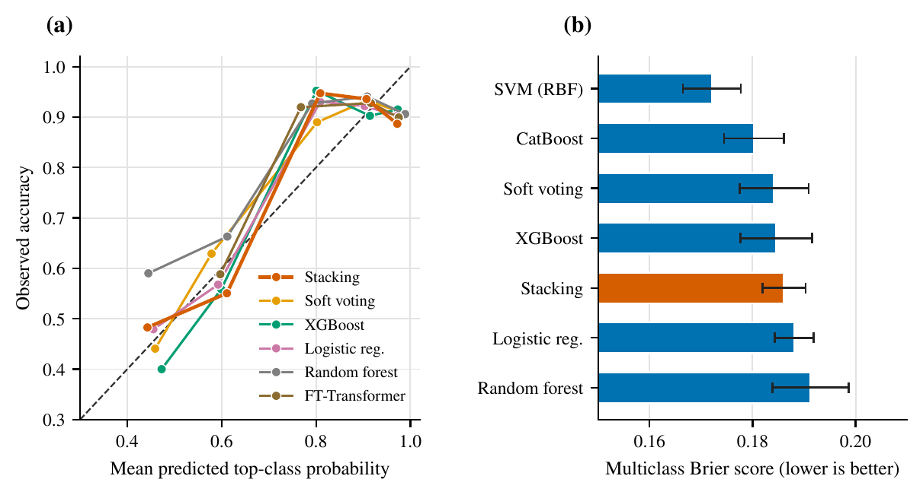
Figure 8. (a) Reliability of the top-class probability for the stack and four comparators, pooled over the ten grouped-CV repeats. (b) Multiclass Brier score (mean and 95% interval) for the best-calibrated models.

Paired Statistical Comparison
Table 6.3 presents the paired uncertainty summary; Fig. 6.4 shows the corresponding model-specific confusion matrices. Because stacking and soft voting were evaluated on identical test observations, their predictions permitted a paired comparison. A 20,000-resample bootstrap estimated a stacking-minus-soft-voting accuracy difference of 0.00 percentage points, with a 95% percentile interval of $−4.00$ to $+4.00$ percentage points.

Analysis | Result
Accuracy: soft voting | 96.00%
Accuracy: stacking | 96.00%
Point difference | 0.00 percentage points
Paired bootstrap, 20,000 resamples | 95% CI $\left[−4.00,4.00\right]$ percentage points
Exact McNemar test | $p=1.000$; null not rejected
Interpretation | No difference detected
The correctness table was $\left[\begin{matrix}71 & 1 \\ 1 & 2\end{matrix}\right]$, with rows ordered as soft voting correct/incorrect and columns as stacking correct/incorrect. Its off-diagonal counts, 1 and 1, give an exact McNemar $p=1.000$, and the paired bootstrap interval for the accuracy difference is $−4.00$ to $+4.00$ percentage points. The two models are therefore tied on this test sample, and the sample is too small to resolve a difference of a few percentage points.
The repeated-CV comparison is reported in Table 10. Against soft voting the stack’s mean accuracy difference was $−0.2$ pp (95% CI $−1.8$ to $+1.1$; stack better, equal, and worse in 15, 17, and 18 of 50 folds; median per-repeat McNemar $p=0.68$; Nadeau–Bengio $p=0.95$). Against Random Forest, XGBoost, logistic regression, SVM, MLP, FT-Transformer ($−0.1$ pp, 95% CI $−1.7$ to $+1.3$), CatBoost, and LightGBM the intervals also span zero. The decision tree was 1.5 pp below the stack (95% CI $+0.4$ to $+3.0$), but the corrected $t$-test gave $p=0.73$ and the per-repeat McNemar test was significant in only 1 of 10 repeats; all corrected $t$-tests under grouped CV gave $p≥0.73$. Besides the majority-class rule, only the MLP, FT-Transformer, extra trees, and LightGBM are clearly below the stack, and only on unique rows (corrected $t$-test $p≈0.5$). No analysis therefore supports a performance advantage of stacking, and the evidence is equally consistent with a difference of a few tenths of a percentage point in either direction.

Global SHAP Analysis
Global SHAP analysis of the RF–XGBoost soft-voting comparator revealed that systolic blood pressure was the most influential predictor in the fitted model, followed by body-mass-index (BMI) category and physical-activity level (Fig. 6.4, panel a; mean $\left|ϕ\right|$ 0.115, 0.067, and 0.041). These variables exhibited the largest mean absolute SHAP values, indicating that they contributed most strongly, on average, to variation in the model’s predicted sleep-disorder probabilities across the explanation sample. Diastolic blood pressure, sleep duration, and age formed a second tier of influential features, suggesting that the classifier also relied substantially on demographic, cardiovascular, and sleep-related characteristics when generating its predictions.
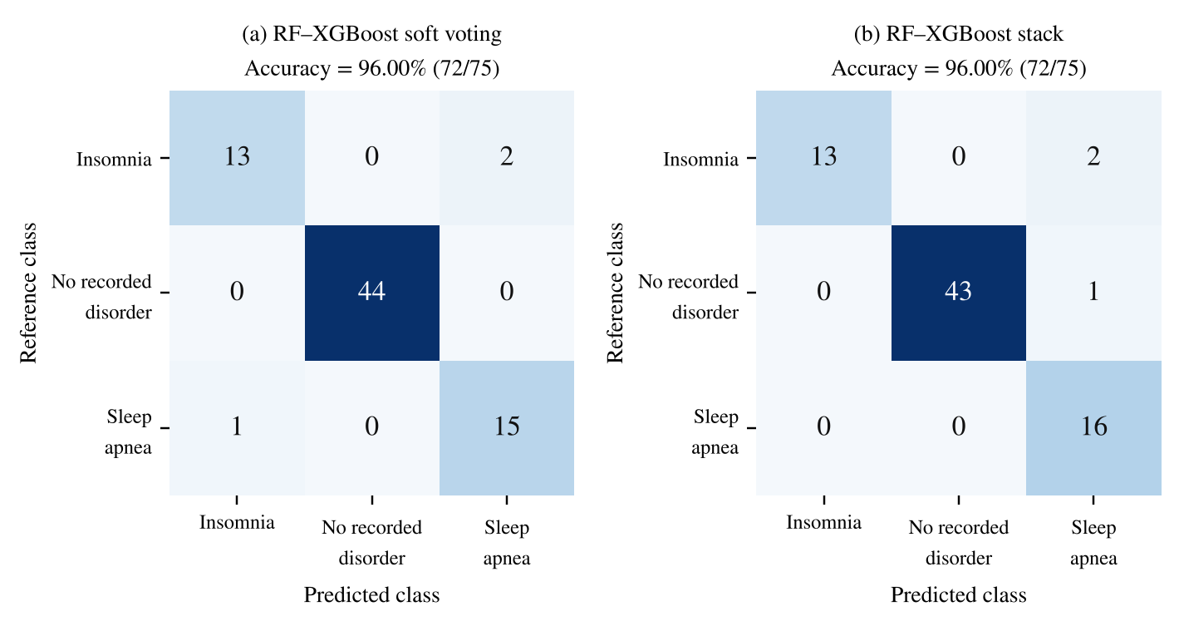

The observed SHAP ranking provides a global interpretation of feature importance by summarizing the average magnitude of each variable’s contribution to the fitted prediction function over the explanation sample. Thus, a higher mean absolute SHAP value indicates greater overall model dependence on a feature, but it does not specify whether higher or lower values of that feature increase the predicted probability of a sleep disorder for a particular individual. Moreover, these feature-attribution results should be interpreted as descriptions of the model’s predictive behavior rather than evidence of biological or causal effects.
(a)
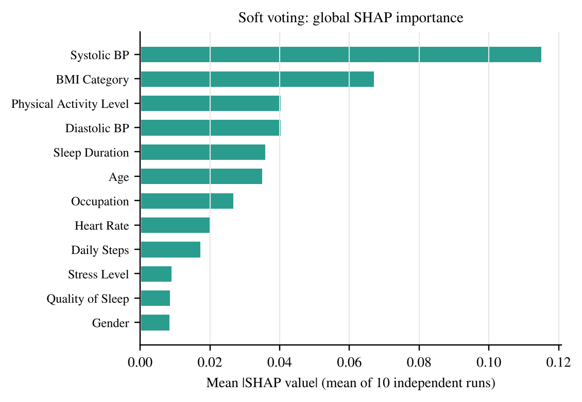
(b)
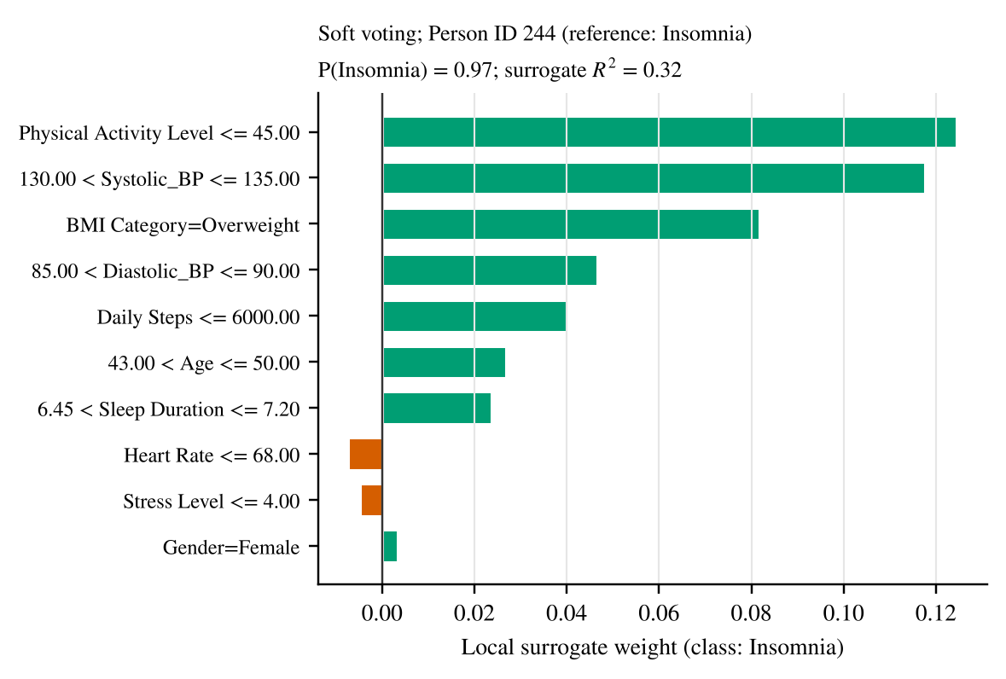

The local LIME analysis in Fig. 6.4 (panel b) characterises the decision surface around one test observation classified as insomnia. Lower physical activity, systolic blood pressure within 130–135, and an overweight body-mass-index category contributed positively to the local insomnia score, with diastolic pressure between 85 and 90 and daily steps at or below 6000 contributing smaller positive weights, whereas heart rate and stress level carried negligible negative weights. Associations captured by the RF–XGBoost ensemble may reflect nonlinear relationships, interactions among predictors, correlations between measured variables, or characteristics specific to the analyzed dataset. Accordingly, the SHAP results are most appropriately interpreted as identifying variables that were most influential for prediction within the fitted model, rather than as establishing independent causal determinants of sleep-disorder status. This explanation is observation-specific.

Stacking-model post-hoc explanation
Permutation SHAP and LIME were additionally reported for the stacking classifier itself, evaluated in its preprocessed (scaled and one-hot encoded) feature space rather than for the soft-voting comparator alone. This distinction matters because the soft-voting analysis in Section 6.4 and the stacking-specific analysis presented here characterise two different fitted functions; their attribution rankings are not expected to coincide, and any divergence between them is informative about model-specific behaviour rather than indicative of an error in either explanation. A background sample of 25 development-partition observations and an explanation sample of 35 test-partition observations were used, with max_evals set to twice the number of preprocessed features plus one as the reported evaluation budget. This setting governs the number of coalition evaluations performed by the permutation explainer and does not, by itself, establish convergence or attribution stability; a formal stability check would require repeated runs with independent background samples and a comparison of the resulting attribution variance.
To address the stability concern noted above, the permutation-SHAP analysis was repeated ten times with independent background and explanation samples (Table 11; Fig. 9). Within each model the global importance ranking was highly stable (mean pairwise rank correlation 0.98 for the stack and 0.97 for soft voting; minimum 0.94; mean top-three Jaccard overlap 0.73 and 0.72), so the attributions are reproducible for a given fitted model. Between the two models, however, the rankings differ strongly (rank correlation 0.18): the stack’s top predictors were diastolic blood pressure, occupation, and sleep duration, whereas soft voting’s were systolic blood pressure, BMI category, and physical activity. The difference is not a contradiction: systolic and diastolic pressure are near-collinear (Spearman 0.98), and the blood-pressure block carries almost the same total attribution in both models (0.148 and 0.156). A held-out block permutation confirms the block-level role of blood pressure (log-loss increase 0.647 for the stack and 0.318 for soft voting), whereas permuting sleep and stress predictors changes log-loss by 0.197 for the stack and by $−0.022$ for soft voting. Individual-predictor rankings, in particular which of two correlated predictors ranks first, should therefore not be interpreted as evidence of mechanism.
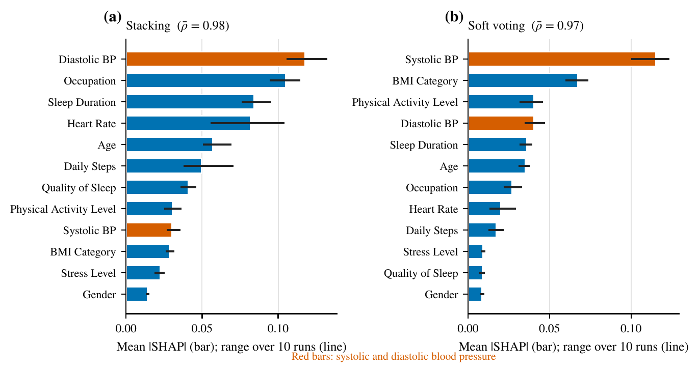
Figure 9. Mean absolute SHAP value (bars) and range over ten independent runs (lines) for (a) the stack and (b) RF–XGBoost soft voting.
Fig. 10 shows the LIME explanation of the stacking classifier’s insomnia output for the test observation with Person ID 244 (reference insomnia; predicted insomnia, $P=0.90$; probabilities for insomnia, none, and apnea 0.90, 0.08, and 0.02). Daily Steps $≤6000$ carries the largest positive local weight ($+0.14$), followed by diastolic blood pressure between 85 and 90 ($+0.10$), Stress Level $≤4$ ($+0.08$), and age between 43 and 50 ($+0.07$); the Overweight BMI category carries a negative weight ($−0.09$). The explainer discretises the numerical predictors in raw units and categorical conditions refer to one-hot indicators. For the same record the voting-model explanation of Fig. 6.4(b) ($P=0.97$) is led by Physical Activity Level $≤45$ ($+0.12$) and systolic blood pressure between 130 and 135 ($+0.12$), with Overweight BMI positive ($+0.08$). The leading local features differ between the two models, which is expected because they explain different fitted functions; it does not indicate an inconsistency in either analysis and does not generalise to a population-level effect. The surrogate in these display explainers explains little of the local variance (weighted $R^{2}$ 0.13 for the stack and 0.32 for soft voting), which is why fidelity is audited separately below.
Four test records were audited in both models with full identification (Table 12): Person IDs 244 (insomnia, correctly classified), 84 (no recorded disorder, correct), 291 (sleep apnea, correct), and 19 (insomnia, misclassified as sleep apnea by both models). The two models gave different predicted probabilities for the same record (for ID 84 the stack assigned 0.38 to the correct class against 0.84 for soft voting), and the local surrogate explained 76–79% of the local variance of the stack’s output (weighted $R^{2}$) but only 51–64% for soft voting; across LIME seeds the coefficient rank correlation was 0.97–0.98 for the stack and 0.81–0.85 for soft voting. LIME explanations of soft voting are thus less faithful and less repeatable than those of the stack on these records, and in no case should a single surrogate be read as the reason for the prediction.
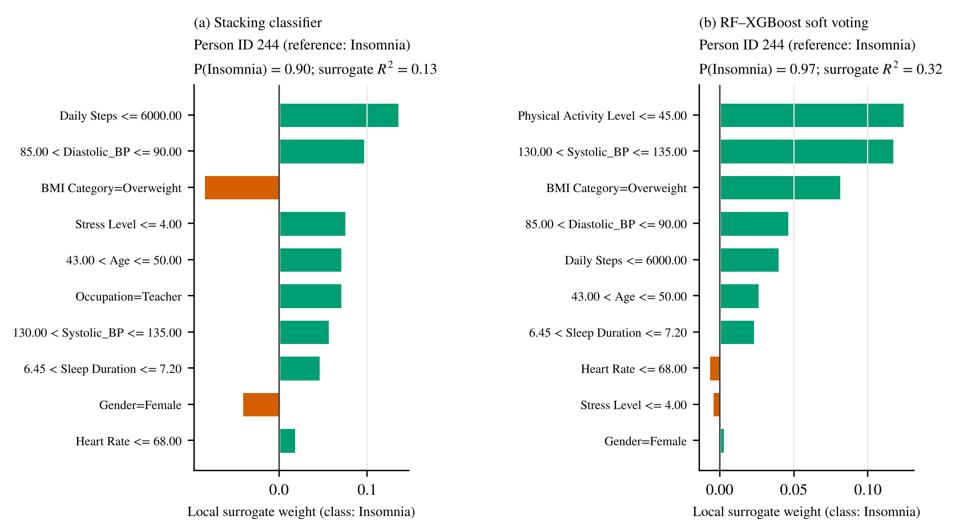
Figure 10. LIME explanation of the stacking classifier’s insomnia output for the test observation with Person ID 244 (reference insomnia; $P_{insomnia}=0.90$). Green and red bars show positive and negative local surrogate weights; numerical conditions are in raw units and categorical conditions are one-hot indicators.
Fig. 11(b) shows the stacking classifier’s SHAP beeswarm for the insomnia class on the first explanation sample. Colour denotes feature value (pink higher, blue lower) and horizontal position encodes the signed SHAP contribution for each observation. The features with the largest mean absolute attribution for this output are Sleep Duration, Diastolic Blood Pressure, Age, Quality of Sleep, Daily Steps, and the Nurse and Salesperson occupation indicators, with Systolic Blood Pressure also ranked among the leading rows. Categorical rows are individual one-hot indicators rather than continuous BMI or occupation scales, and the final row aggregates the remaining lower-ranked features. This panel characterises the insomnia output only; it does not establish attribution directions for the sleep-apnea class, nor does it support a causal interpretation.
The stack’s insomnia attributions emphasise sleep and cardiovascular predictors, as does the voting-model global ranking in Section 6.4, although the leading predictor differs between the models (Table 11). Agreement in the rank of a handful of predictors across two related models does not amount to independent confirmation of an underlying physiological relationship, particularly given the correlated predictor structure documented in Section 3.8, where sleep duration, quality of sleep, and stress level are mutually associated at magnitudes exceeding 0.75 in absolute Spearman correlation. Under such collinearity, SHAP attribution can be redistributed across correlated predictors in ways that depend on background-sample composition, so the relative ranking of sleep-duration- and stress-related features is not evidence that one variable is mechanistically more important than another.
The radar audit in Fig. 11(a) compares normalised SHAP mean absolute attributions of the stack (mean of ten runs) with LIME mean absolute local weights of the stack (the same 35 explanation rows; per-predictor sum of absolute weights), each scaled to its maximum. The two profiles are strongly rank-correlated (Spearman 0.91). Diastolic blood pressure has the largest SHAP radius and occupation the largest LIME radius (occupation is second in SHAP), whereas sleep duration is relatively more prominent in SHAP than in LIME. The stack’s ranking differs from the systolic-pressure-led ordering of the soft-voting bar chart of Fig. 6.4(a) because the two models are different fitted functions with near-collinear blood-pressure predictors (Table 11). SHAP importance reflects an expectation over the joint distribution of predictors as represented by the background sample, whereas LIME importance reflects locally weighted linear approximations around individual observations, so the two procedures can rank the same predictor differently even for an identical fitted model.
(a)  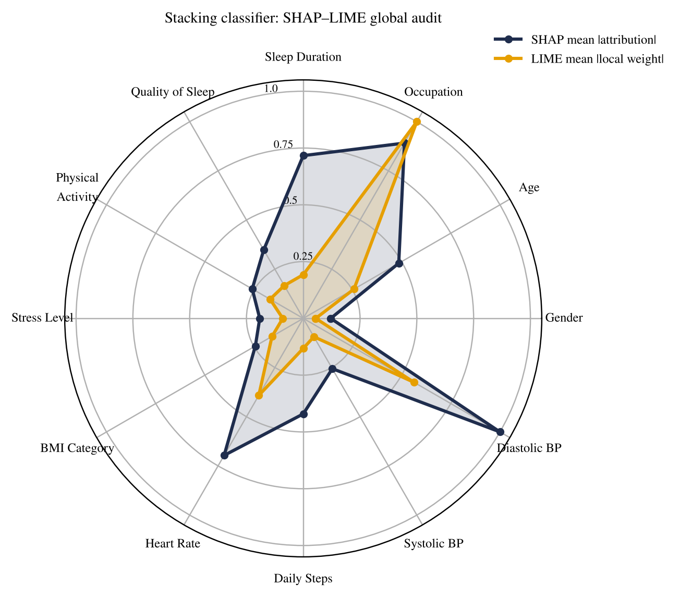 | (b)  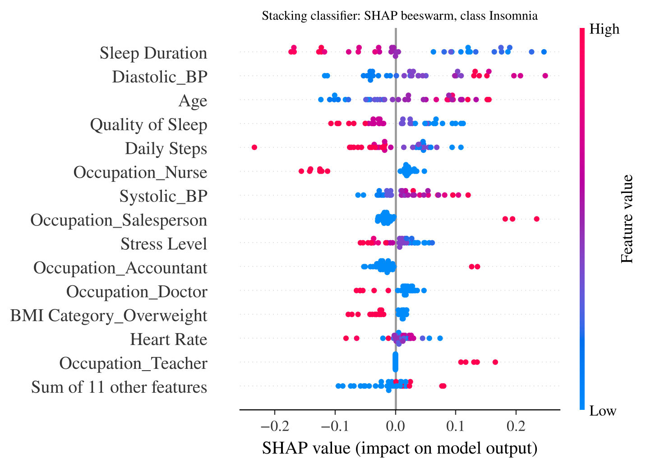
Figure 11. Attribution displays: (a) normalised SHAP–LIME radar audit for the stacking classifier (same 35 explanation rows; each profile scaled to its maximum); (b) the stacking classifier’s insomnia beeswarm, with colour denoting feature value and horizontal position denoting SHAP attribution.

Stacking Ablation Study
To assess the contribution of each component of the stack, six variants and the full stack were evaluated under the primary 10×5 grouped cross-validation, using the same outer folds and inner out-of-fold probabilities: the full stack (RF and XGBoost probabilities plus pass-through), the stack without the Random Forest, the stack without XGBoost, the stack without the pass-through features, RF–XGBoost soft voting, Random Forest alone, and XGBoost alone. Accuracy, macro-F1, and macro ROC–AUC are summarised in Fig. 7 and Table 13. All seven configurations lie within 0.3 percentage points of one another in accuracy (89.6–89.9%), well inside the fold-level standard deviation of 3.8 percentage points, so no component can be said to contribute measurably to accuracy; the pass-through variant has the lowest log-loss (0.389) and the Random Forest alone the highest (1.119).
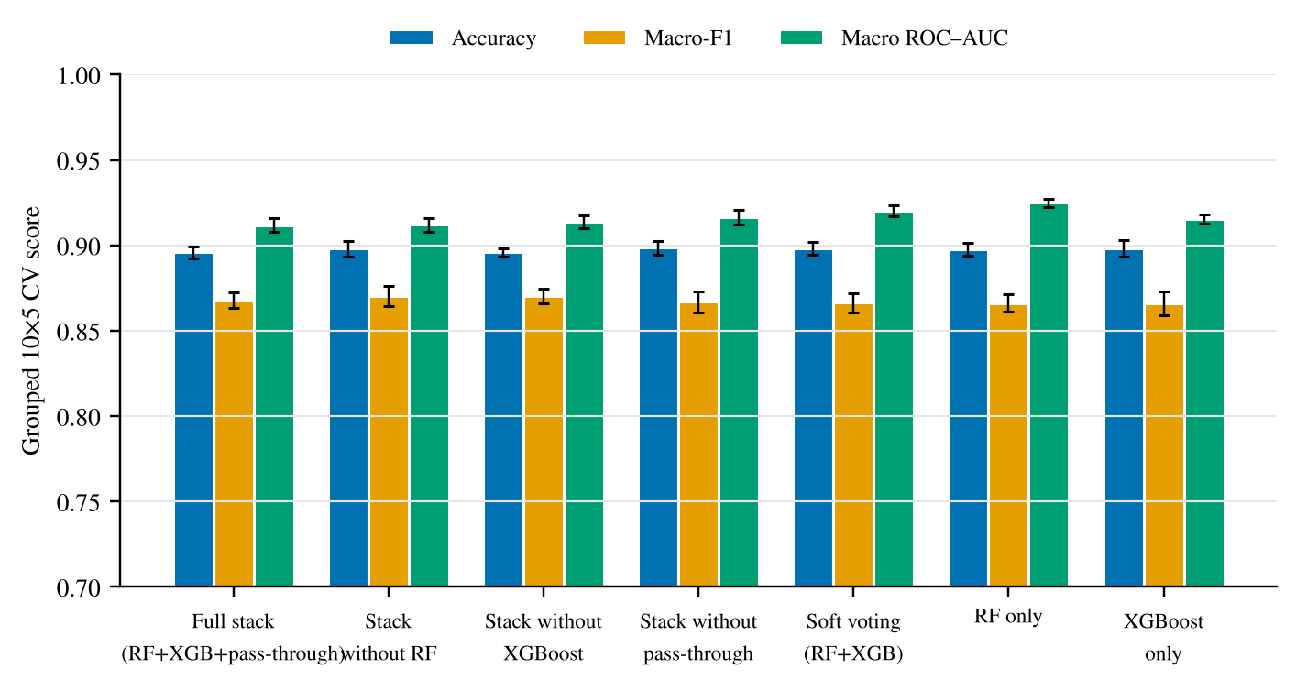

Table 13. Stack-component ablation under 10×5 grouped cross-validation (means over 50 folds).
Configuration | Accuracy (%) | Macro-F1 | Macro AUC | Log-loss
Full stack (RF + XGBoost + pass-through) | 89.6 | 0.87 | 0.91 | 0.446
Stack without Random Forest | 89.8 | 0.87 | 0.91 | 0.443
Stack without XGBoost | 89.6 | 0.87 | 0.91 | 0.445
Stack without pass-through | 89.9 | 0.87 | 0.92 | 0.389
Soft voting (RF + XGBoost) | 89.8 | 0.87 | 0.92 | 0.447
Random Forest alone | 89.8 | 0.87 | 0.92 | 1.119
XGBoost alone | 89.8 | 0.87 | 0.92 | 0.431
The ablation uses the specified two-learner architecture of Section 3.6 throughout, with preprocessing and out-of-fold construction identical across variants. Because the variants differ by no more than the fold-level sampling noise, the conclusion is the one drawn from the main comparison: the combination is statistically indistinguishable from its components on this benchmark.

Repeated-split robustness check
To examine the sensitivity of reported performance to the particular random partition used in Section 3.5, a repeated-split robustness check was performed, summarised in Fig. 12. The left panel shows RF–XGBoost soft voting and the right panel the RF–XGBoost stack, each evaluated across 13 stratified 80:20 split seeds ranging from 50 to 650 in increments of 50. The horizontal axis therefore indexes the random partition seed rather than training-set size, so the figure should be read as a partition-sensitivity display rather than as a conventional learning curve. Red lines denote training accuracy and blue lines denote test accuracy at each seed; the shaded bands are exact 95% Clopper–Pearson intervals for the accuracy at each seed.
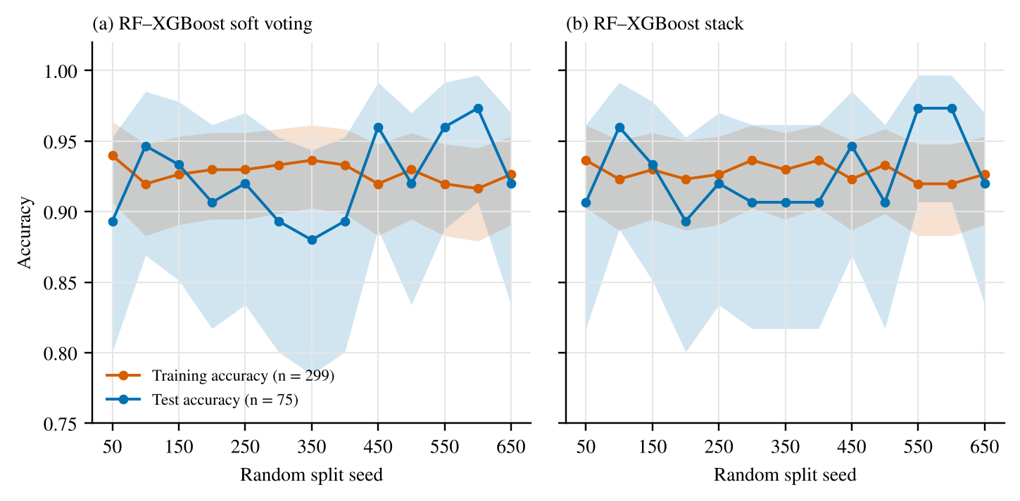
Figure 12. Random-split sensitivity: RF–XGBoost soft voting (left) and RF–XGBoost stacking (right), across seeds 50–650. Red lines denote training accuracy and blue lines test accuracy. The horizontal axis is split seed, not training-set size. Shaded bands are exact 95% Clopper–Pearson intervals.
For the stack the training accuracy was 0.928 (SD 0.006) and the test accuracy 0.925 (SD 0.027) across the 13 seeds; soft voting gave 0.928 (SD 0.007) for training. On average 88.5% of the test predictor vectors (SD 2.8 pp) also occurred in the training partition. The primary hold-out accuracy of $72/75=0.960$ lies about 1.3 standard deviations above the mean test accuracy across the 13 splits, and the sweep concerns the same two-learner stack as the primary specification. The small gap between training and test accuracy across seeds is not evidence of absent optimism: it reflects the repeated predictor vectors shared by the partitions, as explained in Section 7.2.

Predictor ablation and training–test gap
Model composition was assessed above within the specified framework: the stack, soft voting, and each single learner were evaluated on identical grouped folds (Table 8), where the components are statistically indistinguishable from the combination.
To test whether the predictors carry information beyond the repeated records and the sleep-related variables that may reflect the outcome definition, the sleep predictors were removed in stages under the grouped protocol (Table 14). Removing Sleep Duration and Quality of Sleep changed accuracy by less than 0.5 percentage points (stack 89.6% to 89.9%), and also removing Stress Level gave 89.2%; the other models changed by less than 1 percentage point. Accuracy therefore does not depend on these variables, which is consistent with the outcome label being recoverable from the remaining cardiovascular, anthropometric, and demographic fields in this file. Because the outcome definition is undocumented, circularity cannot be excluded.
Table 14. Accuracy (%) under grouped CV after removing sleep-related predictors.
Predictor set | Stacking | Soft voting | Logistic regression
All predictors | 89.6 | 89.8 | 89.7
Without sleep duration & quality | 89.9 | 89.9 | 89.1
Without sleep duration, quality & stress | 89.2 | 89.9 | 88.9
The small gap between training and test accuracy in the seed sweep above is explained by the data: when the same predictor vectors occur in both partitions, a model that memorises them scores near the ceiling of 93.3% in sample and out of sample alike. Variation across partitions is captured by the 50 grouped folds, whose fold-level standard deviation for the stack is 3.8 percentage points (0.53 pp across repeats), the relevant scale for any claim about differences of one or two percentage points.

Discussion
The principal result of this study is that the RF–XGBoost stacking configuration is statistically indistinguishable from RF–XGBoost soft voting, from its own base learners, from logistic regression, and from an FT-Transformer on this benchmark. Under 10×5 repeated grouped cross-validation the stack reached 89.6% accuracy (95% CI 86.1–92.7; macro-F1 0.87) against 89.8% for soft voting (difference $−0.2$ pp, 95% CI $−1.8$ to $+1.1$), 89.7% for logistic regression, and 89.7% for the FT-Transformer. On the single 75-observation hold-out partition the stack and soft voting both classified 72 records correctly (96.00%), and 68 of the 75 test records repeated a training record. The single-split figure is therefore a point estimate of limited weight, and the evidence supports neither a general advantage of stacking over soft voting nor an advantage over simple baselines.
The class-specific error pattern is informative. On the hold-out partition the three errors were two insomnia observations and one no-recorded-disorder observation assigned to sleep apnea, and no observation was assigned incorrectly to insomnia. The PCA projection in Section 3.4 shows partial overlap among the outcome classes, and the ROC–AUC analysis indicates slightly lower ranking performance for insomnia than for the other two categories. Together, these observations suggest that the distinction between insomnia and sleep apnea may be more difficult for the available predictor representation. However, the number of test observations is small, so the observed pattern is a dataset-specific finding rather than evidence of a stable clinical phenotype.
The methodological value of the framework lies in the way the heterogeneous models are combined. Random Forest captures nonlinear relationships through an ensemble of decision trees, whereas XGBoost constructs an additive boosting model; stacked generalisation provides a mechanism for combining their complementary probability estimates [28]. In the present formulation, the use of out-of-fold probabilities prevents the meta-learner from being trained directly on in-sample base-model predictions. Together with fold-isolated preprocessing, this construction reduces a major source of optimistic bias in two-level ensemble learning [5]. The resulting architecture therefore provides a transparent framework for studying heterogeneous stacking even though the final performance difference relative to soft voting is nil.
The stack-component ablation and the repeated-split analysis provide additional context. Removing any base learner or the pass-through connection changes grouped-CV accuracy by less than 0.3 percentage points, and the repeated-split sweep shows both the variation of single-split estimates across random partitions (test accuracy SD 2.7 pp) and the way repeated predictor vectors keep training and test accuracy close. The primary quantitative conclusions are therefore those of the grouped cross-validation.
The explainability analyses provide complementary information about the fitted prediction functions and, with the added audits, a clearer view of their limits. Within a fixed model the SHAP ranking was reproducible across independent runs (rank correlation 0.97–0.98), whereas the rankings of the stack and of soft voting differed strongly (0.18), with the stack emphasising diastolic and the voting model systolic pressure. Because the two pressures are nearly collinear (VIF 35–38), the stable quantity is the blood-pressure block, which carries similar total attribution in both models. LIME surrogates were more faithful for the stack (weighted $R^{2}$ 0.76–0.79) than for soft voting (0.51–0.64), which argues for reporting fidelity alongside every local explanation [38]. The explanations are model-audit tools and not evidence of independent causal effects [8, 39].
The predictor ablation shows that removing sleep duration, sleep quality, and stress leaves accuracy essentially unchanged, and the training–test gap in the seed sweep reflects duplicated records. A difference of the size separating stacking from soft voting on the hold-out set (0 pp; at most one record in either direction) is well inside the sampling variability of the benchmark (fold-level standard deviation 3.8 pp; minimum detectable difference about 5.3 pp for 75 test records).
From an applied perspective, the findings support the use of this dataset as a methodological test bed for explainable tabular ensemble learning, rather than as a basis for direct clinical deployment. The model uses readily structured variables, but the available outcome labels do not establish clinically adjudicated disease status. Accordingly, the present results should be understood as evidence about predictive behaviour within the benchmark dataset. Further work with larger and clinically characterised cohorts would be needed to determine whether the observed modelling behaviour transfers to real-world screening or decision-support settings.

Benchmark prediction versus clinical screening.
The task studied here is classification of a recorded category from questionnaire, vital-sign, and activity fields; it is not diagnosis. Insomnia and sleep apnea are defined clinically by history, polysomnography, or home sleep testing, none of which is present, and screening instruments for sleep apnea rely on signals and indices absent from this file. High accuracy on this dataset should not be read as screening performance.

Labelling bias and circularity.
The outcome labels are undocumented, and the near-determinism of the label given the predictors (accuracy ceiling 93.3%, insensitivity to removing sleep predictors) is more compatible with a rule-based or synthetic labelling process than with clinician adjudication. If labels were derived from the predictors, predictive performance and explanations describe that rule, not physiology.

Sample size and power.
With 75 test records, a difference of about 5.3 percentage points is the smallest detectable, and about 1180 test records would be needed to detect a difference of 1.33 percentage points. Differences of this size between ensembles cannot be resolved on a dataset of this scale, and a comparison on 374 records of which 132 are unique is similarly limited.

Reporting local explanations.
Local explanations should be reported with the record identifier, reference label, predicted probabilities, surrogate fidelity, and seed stability (Table 12), and global attributions with run-to-run stability and block-level summaries when predictors are collinear (Table 11). Consistent with TRIPOD+AI [16] and FUTURE-AI [17], such reporting makes explanations auditable.

Future work.
Priority steps are evaluation on clinician-adjudicated cohorts with polysomnographic labels, externally and temporally validated; evaluation of pretrained tabular foundation models against calibrated simple baselines; documentation of how the benchmark labels were produced; and prospective assessment of whether any explanation changes clinical decisions.

Limitations
Several limitations should be considered when interpreting the findings. First, the dataset contains only 374 observations, of which 132 are unique, and the single 75-observation hold-out set is dominated by repeated records; inference therefore rests on grouped cross-validation. Second, the label “None” is a dataset-supplied category, the outcomes were not clinically adjudicated, their provenance is undocumented, and the repetition structure (242 duplicates; 22 conflicting predictor vectors; accuracy ceiling 93.3%) is consistent with synthetic or templated data. Third, no independent validation cohort was available, limiting assessment of generalisability and clinical transportability. Fourth, the benchmark does not contain polysomnographic severity measures or other clinical variables required for diagnostic interpretation. Fifth, the pretrained tabular foundation model TabPFN [41] was not evaluated because its pretrained weights could not be obtained in the computational environment; the release contains a script that evaluates it under the identical folds. The SHAP, LIME, and ALE analyses are descriptive and should not be interpreted as causal evidence. These limitations mean that the reported results should be regarded as a computational benchmark rather than as evidence of clinical validity or deployment readiness.

Conclusion
This study presented an explainable RF–XGBoost stacking framework for multiclass sleep-disorder risk stratification using the Sleep Health and Lifestyle Dataset. The proposed framework combines heterogeneous tree-based learners through a multinomial logistic meta-learner, with out-of-fold probability generation and fold-isolated preprocessing used to construct the stacking stage. The resulting design provides a structured approach for combining nonlinear ensemble models while reducing information leakage between the base learners and the meta-learner.
Under 10×5 repeated grouped cross-validation, the RF–XGBoost stack achieved 89.6% accuracy and a macro-F1 score of 0.87, indistinguishable from RF–XGBoost soft voting (89.8%), its base learners, logistic regression (89.7%), and an FT-Transformer (89.7%). On the 75-observation hold-out partition the stack and soft voting each classified 72 observations correctly (96.00%; macro-F1 0.94). The paired analyses did not demonstrate a difference between the two ensemble strategies, so the results support the soundness of the leakage-controlled pipeline on the evaluated benchmark without implying a performance advantage of stacking.
The study also incorporated multiple complementary interpretability analyses, including PCA, correlation analysis, ALE, SHAP, and LIME, to examine class structure, feature relationships, global attribution patterns, and individual predictions. These analyses provide a more detailed view of model behaviour than predictive performance metrics alone and highlight the importance of considering feature dependence when interpreting tabular ensemble models. The component ablation and repeated-split experiments show that ensemble accuracy is insensitive to model composition and that single-split estimates vary across partitions.
Overall, the findings show that leakage-controlled heterogeneous stacking performs on a par with simpler models on a small tabular benchmark while providing a transparent framework for analysing model behaviour. The reported results are a methodological evaluation of the dataset and not evidence of clinically validated diagnosis or deployment readiness. Future studies should evaluate the framework on larger, independently collected, and clinically characterised cohorts, with externally validated outcomes and more representative clinical variables, to determine whether the observed predictive and interpretability characteristics generalise beyond the present benchmark.

Author Contributions
Rifat Bin Reza: Conceptualization, Methodology, Data curation, Software, Formal analysis, Investigation, Model development, Experimental design, Visualization, Writing–original draft, Writing–review and editing, Project administration. Md Ahadul Haque Suvo: Software, Methodology, Data preprocessing, Model implementation, Validation, Formal analysis, Investigation, Visualization, Writing–review and editing. Atair Rahman Alvi: Investigation, Validation, Writing–review and editing.

Declaration of competing interest
The authors declare that they have no known competing financial interests or personal relationships that could have appeared to influence the work reported in this paper.

Funding
This research did not receive any specific grant from funding agencies in the public, commercial, or not-for-profit sectors.

Ethics statement
This study involved secondary computational analysis of the publicly available Sleep Health and Lifestyle Dataset on Kaggle [18]. No participants were recruited or contacted, no interventions were performed, and no new human or animal data were collected. The administrative Person ID field was excluded before modelling.

Data availability
The Sleep Health and Lifestyle Dataset is publicly available on Kaggle at https://www.kaggle.com/datasets/uom190346a/sleep-health-and-lifestyle-dataset. Dataset reuse is subject to the source platform’s licence and terms. The analysis code, software versions, random seeds, split identifiers, and observation-level predictions for all models are provided in the supplementary archive.

Declaration of generative AI and AI-assisted technologies in the manuscript preparation process
During the preparation of this work, the authors used an AI language model (Claude, Anthropic) to assist with manuscript readability, grammar and spelling, literature-search planning, and LaTeX formatting. After using the tool, the authors reviewed and edited the output as needed and take full responsibility for the accuracy, integrity, and final content of the manuscript. The tool was also used for analysis scripting and for drafting added text.

References

References
[1] American Academy of Sleep Medicine. International Classification of Sleep Disorders. 3rd ed., text revision. Darien, IL, USA: American Academy of Sleep Medicine, 2023.
[2] Korkalainen H, Kainulainen S, Islind AS, Oskarsdottir M, Strassberger C et al. Review and perspective on sleep-disordered breathing research and translation to clinics. Sleep Medicine Reviews 2024; 73: 101874. doi: 10.1016/j.smrv.2023.101874.
[3] Giorgi L, Nardelli D, Moffa A, Iafrati F, Di Giovanni S et al. Advancements in obstructive sleep apnea diagnosis and screening through artificial intelligence: a systematic review. Healthcare 2025; 13 (2): 181. doi: 10.3390/healthcare13020181.
[4] Bazoukis G, Bollepalli SC, Chung CT, Li X, Tse G et al. Application of artificial intelligence in the diagnosis of sleep apnea. Journal of Clinical Sleep Medicine 2023; 19 (7): 1337–1363. doi: 10.5664/jcsm.10532.
[5] Kapoor S, Narayanan A. Leakage and the reproducibility crisis in machine-learning-based science. Patterns 2023; 4 (9): 100804. doi: 10.1016/j.patter.2023.100804.
[6] Efthimiou O, Seo M, Chalkou K, Debray T, Egger M et al. Developing clinical prediction models: a step-by-step guide. BMJ 2024; 386: e078276. doi: 10.1136/bmj-2023-078276.
[7] Collins GS, Dhiman P, Ma J, Schlussel MM, Archer L et al. Evaluation of clinical prediction models (part 1): from development to external validation. BMJ 2024; 384: e074819. doi: 10.1136/bmj-2023-074819.
[8] Jung J, Lee H, Jung H, Kim H. Essential properties and explanation effectiveness of explainable artificial intelligence in healthcare: a systematic review. Heliyon 2023; 9 (5): e16110. doi: 10.1016/j.heliyon.2023.e16110.
[9] Allen B. The promise of explainable AI in digital health for precision medicine: a systematic review. Journal of Personalized Medicine 2024; 14 (3): 277. doi: 10.3390/jpm14030277.
[10] Pesapane F, Rotili A, Penco S, Nicosia L, Cassano E. Evidence over explanations: put medical AI to the test. npj Artificial Intelligence 2026; 2 (1): 53. doi: 10.1038/s44387-026-00092-4.
[11] Tyagi PK, Agarwal D. Systematic review of automated sleep apnea detection based on physiological signal data using deep learning algorithm: a meta-analysis approach. Biomedical Engineering Letters 2023; 13 (3): 293–312. doi: 10.1007/s13534-023-00297-5.
[12] Abd-alrazaq A, Aslam H, AlSaad R, Alsahli M, Ahmed A et al. Detection of sleep apnea using wearable AI: systematic review and meta-analysis. Journal of Medical Internet Research 2024; 26: e58187. doi: 10.2196/58187.
[13] Borisov V, Leemann T, Se\ssler K, Haug J, Pawelczyk M et al. Deep neural networks and tabular data: a survey. IEEE Transactions on Neural Networks and Learning Systems 2024; 35 (6): 7499–7519. doi: 10.1109/TNNLS.2022.3229161.
[14] Alom MS, Jeba SM, Debnath A, Aurpa TT, Siddiqua R. Enhancing sleep disorder diagnosis with a machine learning approach using ensemble neural networks. In: Proceedings of the 11th International Conference on Networking, Systems, and Security; 2024. pp. 48–55. doi: 10.1145/3704522.3704533.
[15] Alabi RO, Elmusrati M, Leivo I, Almangush A, Mäkitie AA. Machine learning explainability in nasopharyngeal cancer survival using LIME and SHAP. Scientific Reports 2023; 13 (1): 8984. doi: 10.1038/s41598-023-35795-0.
[16] Collins GS, Moons KGM, Dhiman P, Riley RD, Beam AL et al. TRIPOD+AI statement: updated guidance for reporting clinical prediction models that use regression or machine learning methods. BMJ 2024; 385: e078378. doi: 10.1136/bmj-2023-078378.
[17] Lekadir K, Frangi AF, Porras AR, Glocker B, Cintas C et al. FUTURE-AI: international consensus guideline for trustworthy and deployable artificial intelligence in healthcare. BMJ 2025; 388: e081554. doi: 10.1136/bmj-2024-081554.
[18] Kaggle. Sleep Health and Lifestyle Dataset. 2023. Available at: https://www.kaggle.com/datasets/uom190346a/sleep-health-and-lifestyle-dataset (accessed 6 August 2026).
[19] Breiman L. Random forests. Machine Learning 2001; 45 (1): 5–32. doi: 10.1023/A:1010933404324.
[20] Chen T, Guestrin C. XGBoost: a scalable tree boosting system. In: Proceedings of the 22nd ACM SIGKDD International Conference on Knowledge Discovery and Data Mining; San Francisco, CA, USA; 2016. pp. 785–794. doi: 10.1145/2939672.2939785.
[21] Lundberg SM, Lee SI. A unified approach to interpreting model predictions. In: Advances in Neural Information Processing Systems 30; 2017. pp. 4765–4774.
[22] Ribeiro MT, Singh S, Guestrin C. ``Why should I trust you?'': explaining the predictions of any classifier. In: Proceedings of the 22nd ACM SIGKDD International Conference on Knowledge Discovery and Data Mining; San Francisco, CA, USA; 2016. pp. 1135–1144. doi: 10.1145/2939672.2939778.
[23] Babaei G, Giudici P. InstanceSHAP: an instance-based estimation approach for Shapley values. Behaviormetrika 2023; 51 (1): 425–439. doi: 10.1007/s41237-023-00208-z.
[24] Apley DW, Zhu J. Visualizing the effects of predictor variables in black box supervised learning models. Journal of the Royal Statistical Society: Series B 2020; 82 (4): 1059–1086. doi: 10.1111/rssb.12377.
[25] Fawcett T. An introduction to ROC analysis. Pattern Recognition Letters 2006; 27 (8): 861–874. doi: 10.1016/j.patrec.2005.10.010.
[26] Riley RD, Archer L, Snell KIE, Ensor J, Dhiman P et al. Evaluation of clinical prediction models (part 2): how to undertake an external validation study. BMJ 2024; 384: e074820. doi: 10.1136/bmj-2023-074820.
[27] Riley RD, Snell KIE, Archer L, Ensor J, Debray TPA et al. Evaluation of clinical prediction models (part 3): calculating the sample size required for an external validation study. BMJ 2024; 384: e074821. doi: 10.1136/bmj-2023-074821.
[28] Wolpert DH. Stacked generalization. Neural Networks 1992; 5 (2): 241–259. doi: 10.1016/S0893-6080(05)80023-1.
[29] Hu C, Gao C, Li T, Liu C, Peng Z. Explainable artificial intelligence model for mortality risk prediction in the intensive care unit: a derivation and validation study. Postgraduate Medical Journal 2024; 100 (1182): 219–227. doi: 10.1093/postmj/qgad144.
[30] Nadeau C, Bengio Y. Inference for the generalization error. Mach Learn 2003; 52: 239–281.
[31] Clopper CJ, Pearson ES. The use of confidence or fiducial limits illustrated in the case of the binomial. Biometrika 1934; 26(4): 404–413.
[32] Brier GW. Verification of forecasts expressed in terms of probability. Mon Weather Rev 1950; 78(1): 1–3.
[33] Guo C, Pleiss G, Sun Y, Weinberger KQ. On calibration of modern neural networks. In: Proc. 34th Int. Conf. Machine Learning, PMLR 70; 2017. pp. 1321–1330.
[34] Grinsztajn L, Oyallon E, Varoquaux G. Why do tree-based models still outperform deep learning on typical tabular data? In: Advances in Neural Information Processing Systems 35 (Datasets and Benchmarks); 2022.
[35] Ke G, Meng Q, Finley T, Wang T, Chen W et al. LightGBM: a highly efficient gradient boosting decision tree. In: Advances in Neural Information Processing Systems 30; 2017. pp. 3146–3154.
[36] Prokhorenkova L, Gusev G, Vorobev A, Dorogush AV, Gulin A. CatBoost: unbiased boosting with categorical features. In: Advances in Neural Information Processing Systems 31; 2018.
[37] Pedregosa F, Varoquaux G, Gramfort A, Michel V, Thirion B et al. Scikit-learn: machine learning in Python. J Mach Learn Res 2011; 12: 2825–2830.
[38] Kumar IE, Venkatasubramanian S, Scheidegger C, Friedler S. Problems with Shapley-value-based explanations as feature importance measures. In: Proc. 37th Int. Conf. Machine Learning, PMLR 119; 2020. pp. 5491–5500.
[39] Rudin C. Stop explaining black box machine learning models for high stakes decisions and use interpretable models instead. Nat Mach Intell 2019; 1(5): 206–215.
[40] Dietterich TG. Approximate statistical tests for comparing supervised classification learning algorithms. Neural Comput 1998; 10(7): 1895–1923.
[41] Hollmann N, Müller S, Purucker L, Krishnakumar A, Körfer M et al. Accurate predictions on small data with a tabular foundation model. Nature 2025; 637: 319–326. doi: 10.1038/s41586-024-08328-6.
[42] Cao R, Ma Z, Liu J. Enhancing traffic flow prediction in the presence of missing data through spatio-temporal causal graphs. Journal of Applied Science and Engineering 2025;28(2).
[43] Teng L, Qiao Y, Sun Y, Li H. Feature information fusion and lightweight ResNet for image semantic segmentation. Journal of Applied Science and Engineering 2026;32:26032059. doi:10.6180/jase.202609_32.059
[44] Yin S, Wang Q, Wang L, Ivanović M, Li H. Multimodal deep learning-based feature fusion for object detection in remote sensing images. Computer Science and Information Systems 2025;22(1):327–344. doi:10.2298/CSIS241110011Y

