哈尔滨工业大学计算学部
实验报告

课程名称：数据结构与算法
课程类型：专业基础（必修）
实验项目：树形结构及其应用
实验题目：哈夫曼编码与译码方法
实验日期：2022/10/23

班级：2103101
学号：2021211228
姓名：黄炜家

设计成绩 | 报告成绩 | 指导老师
 |  | 苗东菁

- 实验目的
哈夫曼编码是一种以哈夫曼树（最优二叉树，带权路径长度最小的二叉树）
为基础变长编码方法。其基本思想是：将使用次数多的代码转换成长度较短的编
码，而使用次数少的采用较长的编码，并且保持编码的唯一可解性。在计算机信息处理中，经常应用于数据压缩。是一种一致性编码法（又称"熵编码法"），用于数据的无损压缩。要求实现一个完整的哈夫曼编码与译码系统。
二、实验要求及实验环境
实验要求：
1. 从文件中读入任意一篇英文文本文件，分别统计英文文本文件中各字符（包
括标点符号和空格）的使用频率；
2. 根据已统计的字符使用频率构造哈夫曼编码树，并给出每个字符的哈夫曼编
码（字符集的哈夫曼编码表）；
3. 将文本文件利用哈夫曼树进行编码，存储成压缩文件（哈夫曼编码文件）；
4. 计算哈夫曼编码文件的压缩率；
5. 将哈夫曼编码文件译码为文本文件，并与原文件进行比较。

实验环境：
G++ x64
三、设计思想（本程序中的用到的所有数据类型的定义，主程序的流程图及各程序模块之间的调用关系、核心算法的主要步骤）
1．逻辑设计
read_file函数用于读入txt中的文章并统计各种字符出现的个数。
init函数用于初始化二叉树，将初始的节点插入树中。
selectmin函数用于找出目前节点权值最小的两个点。
createHuffman函数用于将目前权值最小的两个点合并并且插入到树中。
encode函数在一个创建好的树中进行编码。按照分岔的顺序，往左赋0，往右赋1，于是每个字符都有了新的编码。
eng2huf函数将英文asc2码转化为哈夫曼编码。
showcode函数用于展示哈夫曼编码。
write_file函数将字符串编码转化为二进制bitset串并保存为二进制文件。
back函数用于读取二进制文件并转化为01string串，然后依据编码规则转化回英文。
main:read_file,init,createhuffman,eng2huf,showcode,write_file,showcode,back依次调用。
2．物理设计
int num[128]; // 各个字符出现的次数
double weight[128];// 各个字符的权重
int n = 0; // 总节点数
int m = 0; // 总字数
int total = 0; // 总字符种类
string code[128]; // 所有出现的字符对应的编码
int before[10000]; // 初始文章的编码
typedef struct {
double weight;
int data;
int count;
int lchild;
int rchild;
int parent;
string code;
} node;
node treenode[300];
在read_file中，利用了强制类型转换和switch，较为方便的进行了字符出现次数的统计。
在selectmin中，利用了算法库中自带的快速排序，方便的找出两个权值最小的数据。
在encode中，利用了栈LIFO的特性，便于求出每个字符的编码结果。
在write_file中，利用了bitset这个数据结构，真正意义上实现了“压缩”。
在back函数中，利用不断的移位和与运算，成功得到了二进制数值。

四、测试结果
在article.txt中存入英语歌词：
出现频率：
\n 0.031485
space 0.166353
" 0.0018797
' 0.0206767
( 0.00140977
) 0.00140977
, 0.00892857
- 0.00892857
0 0.000469925
2 0.000469925
7 0.00093985
? 0.00281955
A 0.0075188
B 0.00234962
C 0.00328947
H 0.00093985
I 0.0159774
L 0.0018797
O 0.000469925
R 0.000469925
S 0.00328947
T 0.00281955
W 0.000469925
Y 0.0018797
a 0.0573308
b 0.00704887
c 0.00798872
d 0.0239662
e 0.0578008
f 0.0112782
g 0.0150376
h 0.0328947
i 0.0281955
j 0.000469925
k 0.0103383
l 0.0230263
m 0.0131579
n 0.0592105
o 0.0991541
p 0.0108083
r 0.0357143
s 0.031485
t 0.0620301
u 0.0432331
v 0.00469925
w 0.0380639
y 0.0399436
编码：
\n 10100
space 111
" 010001101
' 110011
( 1101100001
) 010001100
, 1100100
- 1100101
0 01000111001
2 10101110001
7 1010111001
? 110110010
A 1000001
B 110110001
C 01000100
H 1101100000
I 101010
L 101011101
O 01000111011
R 01000111010
S 01000101
T 110110011
W 10101110000
Y 010001111
a 0101
b 1000000
c 1010110
d 00011
e 0110
f 1101111
g 100001
h 10110
i 01001
j 01000111000
k 1101101
l 00010
m 010000
n 0111
o 001
p 1101110
r 10111
s 10001
t 1001
u 0000
v 10101111
w 11000
y 11010

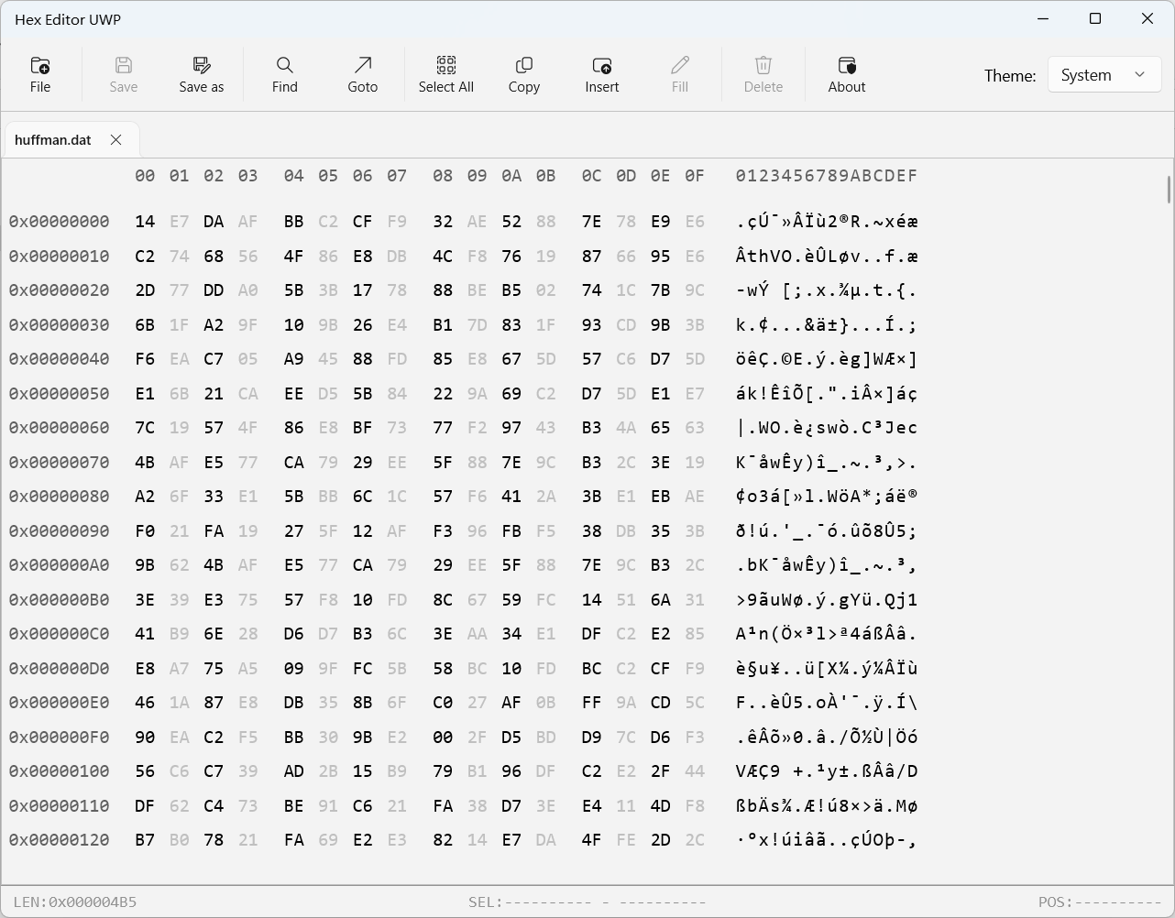
二进制代码文件如图
将二进制文件重新转化为文本：
"I Really Want To Stay At Your House"
(performed as Hallie Coggins)
(from "Cyberpunk 2077" soundtrack)

I couldn't wait for you to come clear the cupboards
But now you're going to leave with nothing but a sign
Another evening I'll be sitting reading in between your lines
Because I miss you all the time

So, get away
Another way to feel what you didn't want yourself to know
And let yourself go
You know you didn't lose your self-control
Let's start at the rainbow
Turn away
Another way to be where you didn't want yourself to go
Let yourself go
Is that a compromise

So what do you wanna do, what's your point-of-view
There's a party soon, do you wanna go?
A handshake with you, what's your point-of-view?
I'm on top of you, I don't wanna go
'Cause I really wanna stay at your house
And I hope this works out
But you know how much you broke me apart
I'm done with you, I'm ignoring you
I don't wanna know

And I'm aware that you were lying in the gutter
'Cause I did everything to be there by your side-ide
So when you tell me I'm the reason I just can't believe the lies
And why do I so want to call you (Call you, call you, call you)

So what do you wanna do, what's your point-of-view
There's a party soon, do you wanna go?
A handshake with you, what's your point-of-view?
I'm on top of you, I don't wanna go
'Cause I really wanna stay at your house
And I hope this works out
But you know how much you broke me apart
I'm done with you, I'm ignoring you
I don't wanna know

You
Oh-oh oh-oh-oh
I don't know why I'm no-one

So, get away
Another way to feel what you didn't want yourself to know
And let yourself go
You know you didn't lose your self-control
Let's start at the rainbow
Turn away
Another way to be where you didn't want yourself to go
Let yourself go
Is that a compromise

So what do you wanna do, what's your point-of-view
There's a party soon, do you wanna go?
A handshake with you, what's your point-of-view?
I'm on top of you, I don't wanna go
'Cause I really wanna stay at your house
And I hope this works out
But you know how much you broke me apart
I'm done with you, I'm ignoring you
I don't wanna know

压缩率的计算：
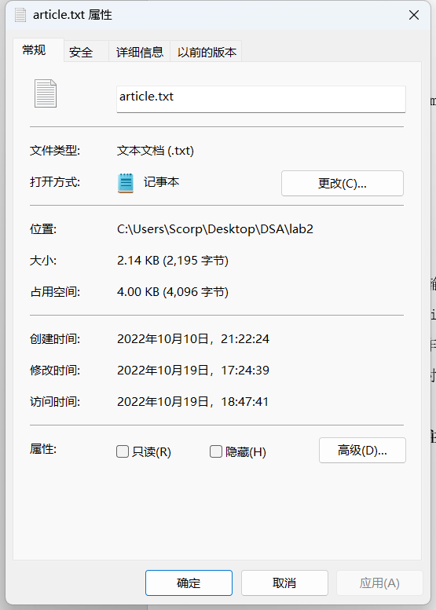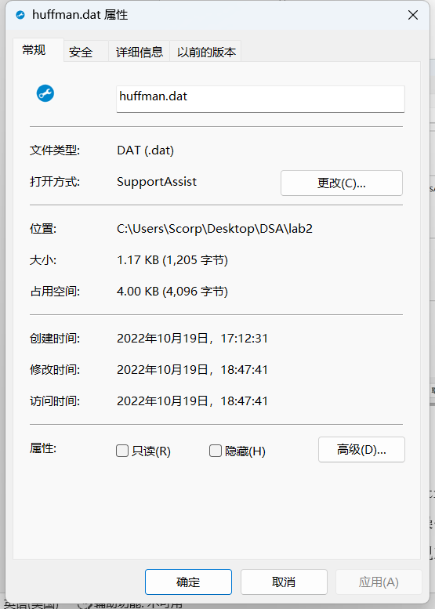
压缩率为：1205/2195*100%=54.9%
五、经验体会与不足
一开始不知道bitset，输出的是01字符串的txt文本。后来知道了bitset的用法，然后成功的将string转化为01码存入二进制文件中。在读取二进制文件时，采用了移位与的操作，成功读出每个二进制位的值。
不足之处在于为了实现对应的功能，代码的时间空间复杂度较高，没有进行很好的优化。
六、附录：源代码（带注释）
#include <iostream>
#include <stack>
#include <fstream>
#include <algorithm>
#include <bitset>
using namespace std;

int num[128]; // 各个字符出现的次数
double weight[128];// 各个字符的权重
int n = 0; // 总节点数
int m = 0; // 总字数
int total = 0; // 总字符种类
string code[128]; // 所有出现的字符对应的编码
int before[10000]; // 初始文章的编码
typedef struct {
double weight;
int data;
int count;
int lchild;
int rchild;
int parent;
string code;
} node;
node treenode[300];

void read_file(string s) { //读入txt中的文章并统计各种字符出现的个数
char c;
fstream file;
file.open(s, ios::in);
file >> noskipws;
while (file.peek() != EOF) {
c = file.get();
int x = (int)c;
before[m] = x;
num[x]++;
m++;
}
file.close();
for (int i = 0; i < 128; i++) {
if (num[i]) {
switch (i) {
case 10:
weight[i] = (double)num[i] / m;
cout << "\\n" << "\t" << weight[i] << endl;
break;
case 32:
weight[i] = (double)num[i] / m;
cout << "space" << "\t" << weight[i] << endl;
break;
default:
weight[i] = (double)num[i] / m;
cout << (char)i << "\t" << weight[i] << endl;
break;
}
}
}
}

bool cmp(node t1, node t2) {
return t1.weight < t2.weight;
}

void init() { //初始化二叉树，将初始的节点插入树中
for (int i = 0; i < 128; i++) {
if (weight[i]) {
treenode[n].weight = weight[i];
treenode[n].data = i;
n++;
}
}
for (int i = 0; i < 300; i++) {
treenode[i].count = i;
treenode[i].lchild = -1;
treenode[i].rchild = -1;
treenode[i].parent = -1;
}
total = n;
}

void selectmin(node nodetree[], int &p1, int &p2) { // 找出目前节点权值最小的两个点
node tmp[300];
int m = 0;
for (int i = 0; i < n; i++) {
if (nodetree[i].parent == -1) {
tmp[m++] = nodetree[i];
}
}
sort(tmp, tmp + m, cmp);
p1 = tmp[0].count;
p2 = tmp[1].count;
}

void createHuffman(node nodetree[]) { // 将目前权值最小的两个点合并并且插入到树中
int p1, p2;
int j = n - 1;
for (int i = 0; i < j; i++) {
selectmin(nodetree, p1, p2);
nodetree[p1].parent = n;
nodetree[p2].parent = n;
nodetree[n].lchild = p1;
nodetree[n].rchild = p2;
nodetree[n].weight = nodetree[p1].weight + nodetree[p2].weight;
n++;
}
}

string encode(int x) { //在一个创建好的树中进行编码。按照分岔的顺序，往左赋0，往右赋1，于是每个字符都有了新的编码
stack<int> s;
string code = "";
int cur = x;
while (treenode[cur].parent != -1) {
s.push(treenode[cur].parent);
cur = treenode[cur].parent;
}
int top = s.top();
s.pop();
while (!s.empty()) {
int now = s.top();
s.pop();
if (now == treenode[top].lchild) {
code += "0";
} else if (now == treenode[top].rchild) {
code += "1";
}
top = now;
}
if (x == treenode[top].lchild) {
code += "0";
} else if (x == treenode[top].rchild) {
code += "1";
}
return code;
}

void eng2huf() { // 将英文asc2码转化为哈夫曼编码
for (int i = 0; i < total; i++) {
treenode[i].code = encode(i);
code[treenode[i].data] = encode(i);
}
}

void showtree() {
for (int i = 0; i < total; i++) {
cout << i << "\t" << treenode[i].weight << "\t" << treenode[i].data << "\t" << treenode[i].parent << "\t" <<
treenode[i].lchild << "\t" << treenode[i].rchild << "\t" << endl;
}
}

void showcode() { // 展示哈夫曼编码
for (int i = 0; i < total; i++) {
switch (treenode[i].data) {
case 10:
cout << "\\n\t" << treenode[i].code << endl;
break;
case 32:
cout << "space\t" << treenode[i].code << endl;
break;
default:
cout << (char)treenode[i].data << "\t" << treenode[i].code << endl;
break;
}
}
}

int write_file(string s) { //将字符串编码转化为二进制bitset串并保存为二进制文件
string after = "";
for (int i = 0; i < m; i++) {
after += code[before[i]];
}
int bitslen = after.size();
int len = bitslen;
if (len % 8 == 0)
len /= 8;
else {
len = len / 8;
len++;
}
bitset<100000> *b = new bitset<100000>(after);
ofstream out("huffman.dat", ios::out | ios::binary);
out.write((char *)b, len);
out.close();
return bitslen;
}

string back(int len1, int len2) { //读取二进制文件并转化为01string串，然后依据编码规则转化回英文
string co;
string ans = "";
char tmp;
ifstream file("huffman.dat", ios::in | ios::binary);
string x = "";
for (int i = 1; i <= len1; i++) {
file.read(&tmp, 1);
for (int j = 0; j < 8; j++) {
x += (tmp & 1 == 1 ? '1' : '0');
tmp = tmp >> 1;
}
}
reverse(x.begin(), x.end());
int lenx = x.size();
co = x.substr(lenx - len2, len2);
cout << "读取二进制文件：" << co << endl;
// co 为01序列串
int j = 0;
int len = (int)co.size();
while (j < len) {
for (int i = 0; i < total; i++) {
int l = treenode[i].code.size();
string ss = co.substr(j, l);
if (ss == treenode[i].code) {
j += l;
ans += (char)treenode[i].data;
break;
}
}
}
return ans;
}

int main() {
read_file("article.txt");
init();
createHuffman(treenode);
cout << endl;
eng2huf();
showcode();
cout << endl;
int blen = write_file("after.txt");
int Blen = blen % 8 == 0 ? (blen / 8) : (blen / 8 + 1);
string ans = back(Blen, blen);
cout << ans << endl;
int len = ans.size();
ofstream out;
out.open("huffman.txt", ios::out);
out << ans;
out.close();
system("pause");
return 0;
}

