

Mentor

Virtual Teachers Assistant

Submission for Assignment 3
Introduction to Information Technology
RMIT Online

Proudly developed by

Jess Bayly s3766658
Chris Lai S3866221
Ian McElwaine S3863018
Charles Patterson s3865499

Contents
.
3 Introducing Team Simple </b>
4 Team Profile
5 Group Processes and Tools
6 Career Plans
7 Introduction to Mentor
9 Project Aims
10 Plans and Progress2
14 Risk Analysis
15 Skills and Jobs
22 Group Reflection
25 References

A3 Group #22 - Team Simple </b>

Simple </b> is pleased to present this report as evidence of our work for Assignment 3 in Introduction to Technology at RMIT Online.

Each team member is a different part of the puzzle. By combining our skills together, we have been able to complete this project while physically located in different parts of Australia. With this idea in find, we combined the initials of our surnames (plus a couple of vowels) to form our team name’ – Simple </b>

Team Profile
(In alphabetical order)
With a background in digital media, Jessica Bayly is now interested in pursuing a career in programming or systems administration. She is based in Adelaide SA, loves a good book, and nature photography. Her teenage obsession with Hanson led to some early exposure to digital communications with IRC and ICQ.
Jessica Bayly s3766658
Chris Lai s3866221
Chris Lai loves numbers, and is aiming for a career in sales, marketing, or finance. His IT experience has been limited to word processing and spreadsheets, but he recognises that the modern workplace demands excellent IT skills, and is currently up-skilling. While currently based in Melbourne VIC, Chris considers himself to be a global citizen, and is interested in the future of remote-working methods.

Based in Albury NSW, Ian McElwaine had a 15 year career with the NSW public service, followed by 5 yrs as a professional musician. Having grown up in the era of 16 bit computing, he considers himself to be a digital native, an expert computer user, and loves a good Linux terminal. Ian was been planning on a career as a systems administrator, but has also become interested in project management.
Charles Patterson is based in Sydney NSW, and loves working on cars and building gaming PC’s. Through his experiences with Minecraft servers, he developed an interest in server applications and programming. He is currently studying at RMIT Online so he can pursue a career as a network administration.
Charles Patterson s3865499
Ian McElwaine s3863018

Group Processes and Tools

Our project website is hosted here: https://a2-simple-b.github.io/mentor/
All team members were satisfied with the processes we developed during Assignment 2, and we have proceeded in much the same manner for Assignments 3 and 5. We continued to video conference bi-weekly using Google Meet, and kept in regular contact with Slack. Our intranet site contains detailed records of our meeting agendas and minutes, with a list of tasks designated to each team member, and the status of the project at any given time. Team members used GitHub repositories to share their project contributions.
We were dealt a heavy blow when Jayden Stewart dropped out of the course without notice. Jayden’s experience with machine learning projects was a major factor in our decision to develop a service based on machine learning. The team has done it’s best to compensate, however, without Jayden’s expertise, we were unable to fully complete our project artefact to the degree we proposed during Assignment 2. Our team morale and cohesiveness also suffered.

For this assignment, we decided that we would need two different GitHub repositories.
The team needed a repository for writing tasks for Assignment 3 and video content for Assignment 5. It is hosted here: https://github.com/a2-simple-b/A3A5_Group_22
The code-base for Mentor is a fork of the Moodle project, and is hosted here: https://github.com/a2-simple-b/mentor.

We had a much cleaner GitHub workflow during Assignment 3. The logs for our A3A5_Group_22 repo have detailed comments for commits, and each team members contributions are clearly attributed. This repo only has a master branch.
The logs for our Mentor repo contain records of the original Moodle development up till the date it was forked, plus development of our project website and intranet in the /docs directory. We were unable to fully integrate our ideas into the artefact, but Ian was able to use Moodle’s recommended IDE (Eclipse with PHP) to set up a development environment, examine the code, and read the remarks. This is discussed in more detail later in the report.
We needed a server to host our development and testing environment, so we used Google Cloud to create a virtual Ubuntu 20.04 instance, and this artefact is located here: http://35.189.23.2/mentor/
A key component of our artefact back-end is the Natural Language Processing deep learning model, however, we were unable to integrate this into our testing environment in the time frame. The model is hosted on Google Cloud AI platform, and thus cannot be directly accessed without a user account and correct permissions.

Career Plans

The table below shows that three quarters of our team members have a strong interest in Systems Administration, while Chris is interested in a career in Sales, Finance, and Marketing.
This reflects that Jess, Ian, and Charles enjoy troubleshooting and engineering challenges. They have all had some exposure to networking and server/client interactions, and enjoy the challenges involved in systems back-end. Chris, however, prefers a client-facing role, and wants the opportunity to put his bachelor degree in Finance to good use.
Due to his high degree of organisation, an understanding of the assignments, and his Assertive Protagonist personality, Ian became established as the team leader of Simple </b>. He has a background in team leadership, and is considering minoring in Management as part of his further study plans in Information Technology. This may lead to opportunities to lead project teams in the future.

Systems Administration | Director of Sales



Introduction to Mentor

Mentor is a service that aims to reduce the workload for university lecturers and tutors, and improve the online tertiary student experience, by integrating two key concepts: Natural Language Processing (NLP) machine learning, and an Issue Tracking System (ITS) (or support ticket system), into Learning Management Systems (LMS).
Online tertiary learning has existed in some form since 1982 (Harasim 1993), but the global COVID-19 pandemic has hastened the trend towards virtual learning (RMIT 2020a). It is alleged in news reports, that the current workload for university lecturers and tutors is unsustainable in the long-term, and that ‘there just simply isn't enough time to do all the work that's necessary...’ (Duffy 2020).
Compounding this issue is the significant reduction in revenues suffered by tertiary institutions as a result of the Australian governments decision to close international borders as part of the coronavirus pandemic response. RMIT University estimates ‘a potential $175 million revenue gap for RMIT in 2020” (RMIT 2020b). Arguably, a system enhancement that allows for a more efficient use of academic staff time is needed.

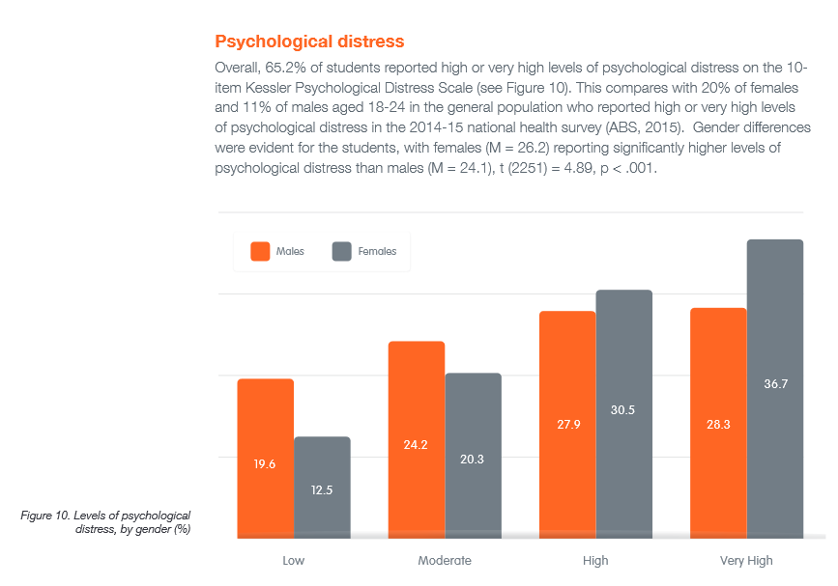Source: Headspace, National Tertiary Student Wellbeing Survey 2016

For students, tertiary study can be very stressful. In their ‘National Tertiary Student Wellbeing Survey 2016’, Headspace found that 65.2% of respondents reported ‘high or or very high levels of psychological distress’ (Headspace 2016).

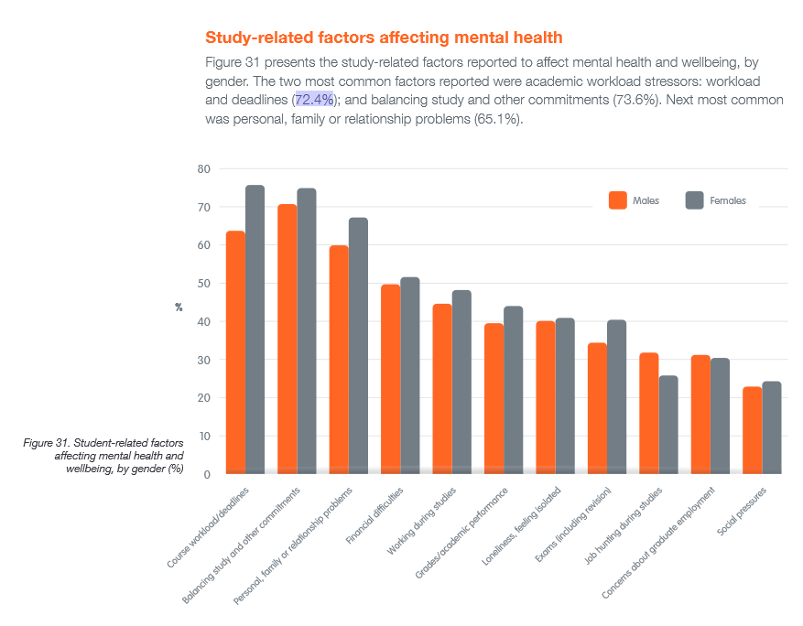Source: Headspace, National Tertiary Student Wellbeing Survey 2016

There were several reasons given by students to explain their distress, but the most statistically significant reason was related to course workload and meeting deadlines. (72.4%)

Team Simple </b> discussed our experiences as online students, and our personal stressors. A top reason we were stressed about workloads and deadlines related to requesting extra assistance from academic staff.
In particular:
- Not asking for help from lecturers or tutors because students don’t want to stand out by showing their lack of comprehension in a semi-public Canvas forum.
- Assistance from lecturers or tutors may not be received in a timely manner. ie. At the time when the student wants it.
We believe that interacting with a chatbot as a first point of contact would lower students resistance to seeking extra assistance, and deliver a more timely resolution in many cases. This would be paired with an Issue Tracking System, so that a ticket is generated each time a student raises an issue. This ensures that all student requests for academic assistance are addressed, and will generate a data-set to aid continuous improvement. ITS systems are industry-standard in the customer service, software development, and help desk spaces. They deliver a systematic approach to resolving client issues, and reduce the staffing hours required to resolve them. (Montgomery & Damien. 2017). Datasets generated in this fashion are likely to be more accurate and useful than self-reported course experience surveys.
Frankly, our team was surprised that chatbots have not been implemented in the online learning space. In 2020, 'machine learning is everywhere you look' (Wong 2020). Human to machine conversational dialogue systems in particular have made substantial breakthroughs in the last decade, and have become a mature technology (Deng. 2018). Chatbots that use third-wave deep neural network models ‘...are much more accurate, and powerful than previous generations’ (Quarteroni 2018). They '...are very sought-after in the customer care domain, where the aim is to complement the live agent experience with an artificial intelligence able to help users fulfil a task' (Quarteroni 2018, p. 106).
Thus, the idea of a virtual teachers assistant and academic pathway counsellor was conceived.
The desired benefits are two-fold.
- Academic staff workloads reduced
- Student wellbeing enhanced

Project Aims

1. Create a fork of the Moodle project. Host it on a server as a testing and development environment. Create an interface in Moodle to send/receive text with the AI model.
This gives our team a sandbox to try out our ideas and demonstrate proof-of-concept. We aim to host this on a server, configure a build environment, and determine how a chatbot and ITS could be implemented from a technical perspective in one of the leading open-source LMS systems (Pappas 2019).
2. Populate our testing environment with some sample course information:
During the testing phase, users will need to interact with course information to generate meaningful results. Based on feedback we received from assessment 2, we decided to begin with subjects like mathematics and computer programming., because would be ‘simpler to train a bot to tutor STEM subjects rather than humanities’ (U. Imtinan 2020, per conv, 23 July 2020). This will also allow us to develop the career adviser feature in Mentor.
3. Train a Natural Language Processing AI model that can be integrated as a proprietary back-end technology in major LMS software packages. Demonstrate proof of concept.
Use Google Cloud AI to start training a NLP machine learning model on initial datasets so that the model can:
a) Understand sentiment – Positive or negative responses from students.
b) Classify student requests for information into categories.
4. Hire a working group of academics and machine learning specialists to generate a dataset relating to common student queries and responses.
A large dataset is needed to train the bot to be useful in the online education context. The team would need to consider alternatives to using Google Cloud and Google AI services before proceeding past this stage.
In the customer service space, many organisations that have made progress with chatbot integration already have a large dataset containing interactions with clients developed over years to train their NLP models on. Due to ethical and legal concerns, we are unable to duplicate this approach.
5. Implement the software system to log interactions with students, generate support tickets, and escalate to an academic staff member as needed.
Students interactions with the chatbot need to be logged for further analysis, and possibly posted in a student accessible forum, depending on the policies of the institutional customer.
Queries that cannot be answered by the chatbot due to limitations or policies need to be escalated and ticketed.

Plans and Progress

Introduction
Some of the key concepts from our team members Assignment 1 projects were:
- Natural Language Processing AI based systems
- Education platforms
- Education pathways
- Timely provision of information
For Assignment 2, Ian was tasked with investigating a project idea that incorporated all of these concepts, and pitched the idea of a virtual tutor and education pathway adviser in a team meeting. The team discussed and voted to accept the idea, with the provision that our then team mate Jayden Stewart understood that he would need to shoulder much of the technical burden. Jayden was enthusiastic and confident in his ability to lead the technical investigation and deliver one or two outcomes.
We formed a working group consisting of Jayden, Ian, and Charles. We planned to investigate how to implement our top three project aims (see previous page), but unfortunately Jayden did not start his investigation, became disengaged, and eventually stopped responding to messages. This seriously affected team morale and cohesion, and lead to some disengagement in the group.
It then fell to the other technically minded members of the group, this being Ian and Charles, to investigate how we could implement the project from a technical perspective. Charles claims that he tried to implement something in Python, but quickly concluded that it could not be done, and did not contribute anything further to the technical investigation, or any supply written text for the report besides his reflection. This is evidenced in the git logs.
Our intranet site contains our project records, and this may useful when reviewing the Mentor project.

Plans and progress for Aim 1:
Create a fork of the Moodle project. Host it on a server as a testing and development environment. Create an interface in Moodle to send/receive text with the AI model.
After briefly trying to understand Amazon Web Services, Ian instead created an Ubuntu 18.04 virtual machine instance using the Google Cloud Console, and cloned the fork of Moodle with git. By following the instructions on the Installing Moodle page, he was able to get a testing and development environment operational. It is hosted at http://35.189.23.2/mentor/
Moodle is developed in PHP, and the projects recommended IDE is Eclipse, so Ian followed the instructions for setting up Eclipse as a development environment on his PC.
By reading the Moodle plugin documentation and the remarks in the code Ian was able to determine that most of the infrastructure to integrate a chatbot was already present in the Moodle code base. There is a chat daemon called chatd.php located in the mentor/mod/chat directory. This is typically used by students and academic staff as part of course delivery, however, it would enable us to create a user account for our chatbot, and configure it to send TSL encrypted text between our NLP AI model and the Moodle server in order to field enquiries from students.
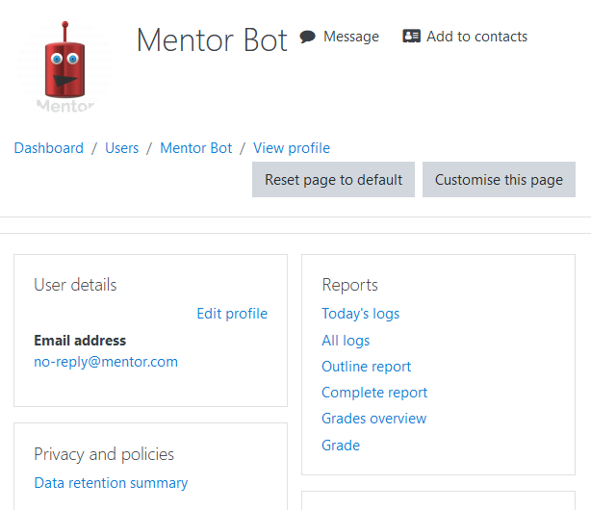Mentor Bot User account

After some testing Ian determined that at idle, the chat daemon was using around 20% of the available processing power of an n1-standard compute instance, with 1 CPU core. According to the Moodle documentation, running the chat daemon in this manner has the least effect on system resources (Moodle 2020).. This may make it difficult to scale up with many concurrent users as it could place a large load on the hosting server. Thus the chat daemon may need to be modified, or implemented in a different way to minimise system load. Further investigation is needed for a definitive answer. This may be a Moodle specific problem, and we have not researched how chat is implemented in other LMS platforms.
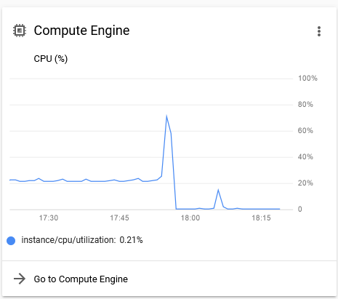Compute Engine load with chatd.php running

Plans and Progress for Aim 2:
Populate our testing environment with some sample course information:
Sample course information in Mentor
Jessica Bayly completed her task of loading in some sample content into our Mentor artefact using some STEM course information sourced from Open.edu.au
This will give our development team some data to work with. It will also help generate some meaningful data during the testing phase of the project, by allowing the bot and users to interact with course material.

Plans and Progress for Aim3:
Train a Natural Language Processing AI model that can be integrated as a proprietary back-end technology in major LMS software packages. Demonstrate proof of concept only.
It is expected that six months to a year of development would be needed to see a marketable product. The proprietary AI model component will allow Simple </b> to monetise the Mentor service as an application programming interface (API). The decision to keep the AI model proprietary, is in keeping with recent developments in the NLP space. In June 2020, the OpenAI project decided that they will only release API’s for their new AI models in order to create a revenue source (OpenAI 2020).
Most of the work for this aim is beyond the scope of this project, and funding would be needed for any meaningful progress to occur. Ian conducted some preliminary investigations in AI training using the Google Cloud AI platform, but it is expected that Simple </b> would need to hire machine learning specialists to create a model where we have complete control over the hosting and development.
The training for model would be an ongoing process, but initially, it needs to be trained for sentiment analysis so the bot understands the difference between positive and negative responses from students. It needs to be trained to categorise information in text as administrative, academic, or banter in nature.
The model would also need to be trained on the dataset generated by the education working group. This working group would consist of university tutors with at least 2 years experience, and have an understanding of the types of queries generated by students (See aim 4).
Similar chat bots exist in the customer service industry, and the concept needs to be adapted to the needs of educational institution customers through research and testing. We believe that the Google Cloud AI platform contained the tools to demonstrate proof of concept, however since we cannot submit the bot trained on sentiment analysis data, this is not a project artefact.

Plans and Progress for Aim4:
Hire a working group of academics and machine learning specialists to generate a dataset relating to common student queries and responses.
As this step requires funding, it is currently beyond the scope of this project.

Plans and Progress for Aim5:
Implement the software stack to log interactions with students, generate support tickets and escalate to an academic staff member as needed.
This step also needs funding, and is currently beyond the scope of this project.
We have some choices to make here which require further research. We could integrate an off-the-shelf solution, or develop our own ticketing system in-house based on an open source project.

Risk Analysis

Chris Lai looked into the potential risks our team faces in bringing Mentor to the marketplace.
These include:
- Mentor would be the first NLP AI in the online learning space. This is a commercial opportunity, but first movers also take on the risks of a poorly understood operating environment.
- The startup period may be too long before revenue is generated, and funding may be exhausted before the service is commercially viable.
- There is also a risk of non-adoption by institutional customers due to their own risk management principles..
- There is the risk of over-promising and under-delivering on the feature set, and that the service may not be as useful as advertised.

Skills and Jobs

These job positions to form a project team with 6 months of funding were written by Jessica Bayly.

Job Role 1: Digital Director

Primary purpose of position:
As one of Australia’s fastest-growing machine learning apps on the market, we are looking for the right candidate to join our hard-working incredible team at Mentor.
Our core beliefs of Communication, Integrity and Honesty which must resonate with you and form part of your own personal core beliefs.
You will be responsible for delivering innovative digital solutions for client needs and use key analytical and insights to measure the effectiveness of the company’s project.
Job Details including responsibilities:
1. Responsible for SEO integration and management across all platforms
2. Responsible foe course content in Moodle and training new staff on CMS
3. Overall management of digital media communications including mail clients, social media and website.
4. Provide weekly report on analytics obtaining to Mentor app and translate analytics and trends to all key stakeholders
5. Contribute where necessary to ideas and sales strategies.
6. Monitor all digital trends in the Education space and report back to team.
7. Test usability of Mentor and provide QA testing
8. Work with Product, Lead Engineer and Sales teams to market the Mentor App successfully through website and social media platforms.
9. Develop digital business rules and privacy policies for assigned product features.
10. Attend industry events representing Mentor as required.
11. Comply with safety rules, report all accidents and incidents and raise any safety issues or concerns.
12. Adhere to and comply with all Mentor policies and procedures.

Person Specification
• You are a creative, strategic thinker with a passion for producing engaging digital content
• Extensive knowledge of search engine marketing and digital technologies law
• Proficient in content management systems
• A multi-tasker that can manage web and social media channels
• Knowledge of big data technologies
• Ability to work autonomously

Qualifications:
Tertiary qualifications in Digital Media communications
4+ year’s experience in content management role or similar

Job Role 2: Lead Engineer

Primary purpose of position:
As one of Australia’s fastest-growing machine learning apps on the market, we are looking for the right candidate to join our hard-working incredible team at Mentor.
Our core beliefs of Communication, Integrity and Honesty which must resonate with you and form part of your own personal core beliefs.
You will be responsible for delivering a personalised journey for customers through Machine Learning in the Education space.
Job Details including responsibilities:
1. Manage core data infrastructure
2. Create and maintain a data pipeline
3. Collaborate with a cross-functional team
4. Provide regular technical and other progress reports relevant to Mentor
5. Optimise approaches for accuracy, deployment and rapid experimentation
6. Serve as the ‘lead’ on complex technical issues and opportunities.
7. Manage the Moodle LMS for optimum efficiency and usability
8. Work with Product and Digital teams to market the Mentor App successfully through website and social media platforms.
9. Provide responsive IT support to customers predominantly via Phone and web portal requests
10. Attend industry events representing Mentor as required.
11. Comply with safety rules, report all accidents and incidents and raise any safety issues or concerns.
12. Adhere to and comply with all Mentor policies and procedures.
Person Specification
• Proficient in PHP
• Advanced scripting and modelling skills
• Ability to work with others go design and architect data solutions
• Passionate about building automated data solutions
• Experience on big data technologies
• Ability to work autonomously
Qualifications:
Tertiary qualifications in Computer Science and 4+ year’s experience in technical analytical role or similar

Job Role 3: Sales & Marketing Manager

Primary purpose of position:
As one of Australia’s fastest-growing machine learning apps on the market, we are looking for the right candidate to join our hard-working incredible team at Mentor.
Our core beliefs of Communication, Integrity and Honesty which must resonate with you and form part of your own personal core beliefs.
You will be responsible for generating new business opportunities, fostering current relationships and identifying market segments within the Education field.
Job Details including responsibilities:
1. Provide high quality customer service aligned with Mentor’s brand and values
2. Achieving sales objectives and targets
3. Communicating activities through the company CRM and any other internal forums
4. Collaborating with internal teams (Engineering,Product and Digital)
5. Attending Educational events and other forums to make sure Mentor product is there with demonstrations.
6. Report regularly while maintaining open communication with management within the business
7. Attend industry-specific events
8. Ability to translate technical information into simple concepts to clients
9. Evaluate and secure opportunities for new business for Mentor.
10. Setting up face to face meetings
11. Achieve monthly sales targets
12. Work with Product and Digital teams to market the Mentor App successfully through website and social media platforms.
13. Attend industry events representing Mentor as required.
14. Other duties as directed by the Project Manager.
15. Comply with safety rules, report all accidents and incidents and raise any safety issues or concerns.
16. Adhere to and comply with all Mentor policies and procedures.

Person Specification
• Dynamic and sales driven
• Understanding of data analysis, reporting and presenting results
• Good understanding of machine learning and emerging trends
• Self motivated and passionate
• Ability to work autonomously

Qualifications:
Tertiary qualifications in Sales & Marketing
2 years in a business development / sales position

Job Role 4: Project Manger

Primary purpose of position:
As one of Australia’s fastest-growing machine learning apps on the market, we are looking for the right candidate to join our hard-working incredible team at Mentor.
Our core beliefs of Communication, Integrity and Honesty which must resonate with you and form part of your own personal core beliefs.
You will be responsible for delivering the project from concept to delivery, managing expectations, budgets and the entire scope.
Job Details including responsibilities:
1. Initiate the Mentor app project and approve resources and plans for the project
2. Create a budget and timeline for deployment and launch
3. Monitor and coordinate the deliverable status, scope and schedule
4. Strong group collaboration and communication skills
5. Attending Educational events and other forums to make sure Mentor product is there with demonstrations.
6. Provide team with analytical advice and training when necessary
7. Liaise with key stakeholders on project status and scope
8. Report regularly while maintaining open communication with management within the business
9. Attend industry-specific events
10. Ability to translate technical information into simple concepts to clients
11. Evaluate and secure opportunities for new business for Mentor.
12. Setting up face to face meetings
13. Achieve monthly sales targets
14. Work with Product and Digital teams to market the Mentor App successfully through website and social media platforms.
15. Attend industry events representing Mentor as required.
16. Comply with safety rules, report all accidents and incidents and raise any safety issues or concerns.
17. Adhere to and comply with all Mentor policies and procedures.

Person Specification
• Dynamic and responsible
• Understanding of programming languages such as Java, .Net, C++
• Good understanding of scripting languages such as PHP and the ability to translate
• Experience on big data technologies
• Ability to work autonomously

Qualifications:
Tertiary qualifications in Information Technology
2 years in a similar role

Group Reflection

Simple </b> started out strong, We were organised, communicated regularly, and were all engaged with the material. We were able to work together as a team, we did fairly well in Assignment 2, and we seemed happy with our direction for Assignment 5. This project turned into a problem child around week 9/10, possibly due to a lack of direction, a misunderstanding about the A3 project deliverables, unmanaged perfectionism, or some sort of life event. The loss of a team mate without notice felt like a breach of trust. We didn’t understand, and we were disheartened.
Luckily, the team managed rise to the challenge and have completed most of their agreed deliverables for assignment 3. The GitHub logs and our project records show that:
- Jessica Bayly wrote the Skills and Jobs section and submitted her work over Slack. Ian committed and pushed the content to our A3A5_Group_22 repo.
- Jessica Bayly loaded the sample course content into our Mentor artefact.
- Jessica Bayly wrote her group reflection and committed it to our A3A5_Group_22 repo.
- Chris Lai did the initial research into our risk management profile, however as the aims of the Mentor project evolved, so did the risks to the project. Chris committed this written work to our repo.
- Chris Lai submitted some writing regarding novel project funding ideas, but he did not supply references before submission. Chris committed this to our A3A5_Group_22 repo.
- Chris Lai wrote his group reflection and committed this to our A3A5_Group_22 repo.
- Charles claims to have tried to use Python to ‘glue’ an AI model to the Moodle fork, but did not supply any written work to support his claim.
- Charles wrote his group reflection and committed this to our A3A5_Group_22 repo.
- Ian wrote the bulk of the report and committed it to our A3A5_Group_22 repo.
- Ian maintained the group records on a team intranet site.
- Ian developed the team website.

Reflections by team members

Jessica Bayly:
At the beginning of this course, I did not think that 12 weeks later I would be presenting a project on Educational machine learning. I am grateful that I joined a group of professional, motivated and hard-working students that put together a product that we can all be proud of. I have learned many new skills along the way such as navigating github and understanding its common uses with repositories, pull requests, branches and files.
I have also gained confidence that I was otherwise lacking when I contributed to the team video. I am an introvert who would rather not participate in anything that showed me on camera but I enjoyed rehearsing my lines and being part of the overall exercise. With different personalities, paths and interests, I was surprised that the course had a fair amount of group assignments but I think we handled it quite well. We had a few hurdles with a tragedy in my family and also the departure of a group member, however we stuck it out and share the load of work needed to finalise our project. Overall, I feel my group members Ian, Chris and Charles brought out the best of me during this course.

Chris Lai:
I still cannot believe how fast the past 12 weeks have gone by, from knowing nothing about technology to having a basic knowledge of IT was a fruitful. I was assigned to a supportive team of amazing 4 individuals and lucky to have them throughout the semester.
The final assignments include a video and report-based presentation. At first with the experience from previous assignments, we proceed with the storyboard and script with caution and quickly constructed a decent draft for the team to work with. While one of the group members having some personal issues and dropped out of the subject, with Ian’s great effort, we managed to stay on track to finish the required work.
Having little knowledge of IT on my end was a challenge for the team and I felt like I may have dragged the team’s performance for a bit. I did my best to make it up by offered help on other tasks, hopefully I managed to take some loads off my teammates.
This Mentor idea was brilliant and I can really see this project takes off in the near future where more and more people utilise the internet to study and I look forward to seeing what this project can bring to benefits the general public.

Charles Patterson:
Similar to previous assessments I believe that communication and organisation went well.
Project Meetings helped the team stay on track and provide a ground level understanding of tasks to be completed within time frames. This time we set deadlines for specific content to ensure that tasks were not being completed last minute.
Focus on deliverables could be improved as they are generally time consuming to create. Our project idea was advanced and required a lot more research and development compared to others which had resulted in more time being spent. Despite being out of our comfort zone this project Idea was well worth it.
Unfortunately, a team member had left our group towards the end. This was surprising as we had almost finished this subject and were almost at the finish line.
This assessment has reinforced my belief that communication within the group is the most important factor. Having a team member leave the group and not notify other team members in time had an impact on changing job roles to cover that specific team members workload.

Ian McElwaine:
Around week 9/10 I was uncertain if we could actually complete Assignment 3. I’m a little surprised that we managed to generate this report. The loss of a key team member so late in the course really affected the team morale and commitment. I now feel that if I contacted Jayden more frequently during the project, he may have stayed with the team, but at the time I felt that he did not need any extra pressure, and we had already had several long conversations.
I think that some of the concepts in this project were beyond the current understanding of IT systems for some team members, and that they never gaining a full comprehension of the project aims or deliverables. When working on group assignments in the future, I may aim for more low-hanging fruit instead of trying to develop a novel innovation.

References

Harasim, Linda M. Building a Global Network: The WBSI Experience. Global Networks, MIT Press, 1993, pp. Global Networks, 1993.
RMIT University, 2020a, Update on Coronavirus (COVID-19), RMIT University, viewed 26 August 2020, <https://www.rmit.edu.au/students/news-and-events/news/2020/update-coronavirus>
Duffy, C. University underpayment so rampant tutors 'instructed to do a poor job' to avoid unpaid hours, former staff say. ABC News, 18 August 2020. viewed 27 August 2020, <https://www.abc.net.au/news/2020-08-18/rmit-uq-now-among-universities-accused-of-underpaying-staff/12565528>
RMIT University, 2020b, Statement: 2019 annual report. RMIT University. viewed 25 August 2020, <https://www.rmit.edu.au/news/media-releases-and-expert-comments/2020/jun/2019-annual-report-statement>
Headspace, 2016. National Tertiary Student Wellbeing Survey 2016. Headspace, Australia.
L. Montgomery and D. Damian, "What do Support Analysts Know About Their Customers? On the Study and Prediction of Support Ticket Escalations in Large Software Organizations," 2017 IEEE 25th International Requirements Engineering Conference (RE), Lisbon, 2017, pp. 362-371, doi: 10.1109/RE.2017.61.
Wong, S. Introduction to Kubeflow. YouTube. 29 March. Google Cloud Platform. viewed 24 August 2020, <https://www.youtube.com/watch?v=cTZArDgbIWw>
Deng, L. Deep Learning in Natural Language Processing. Singapore: Springer Singapore, 2018. https://doi.org/10.1007/978-981-10-5209-5
Quarteroni, S. Natural Language Processing for Industry. Informatik Spektrum 41, 105–112 (2018). https://doi-org.ezproxy.lib.rmit.edu.au/10.1007/s00287-018-1094-1
Pappas, C. 2019. The 20 Best Learning Management Systems (2019 Update). eLearning Industry. viewed online 27 August 2020. <https://elearningindustry.com/the-20-best-learning-management-systems>
Moodle 2020, Chat Settings, Moodle Documentation. viewed online 29 August 2020 <https://docs.moodle.org/39/en/Chat_settings>
Brockman, G. & Murati, M. & Welinder, P. 2020, Blog, Open AI, viewed online 29 August 2020 <https://openai.com/blog/openai-api/>

