1. Airline Reservation System (ARS)
The Airline Reservation System (ARS) is a complete software application aimed at modernizing airline ticket booking. It integrates a Java Swing GUI with a MySQL backend to handle flights, passengers, reservations, and reporting efficiently.
The airline industry relies heavily on accurate, fast, and secure data management. Traditional airline systems were manual or semi-automated, leading to frequent errors, data redundancy, and customer dissatisfaction. The Airline Reservation System (ARS) was designed to eliminate these inefficiencies by centralizing all airline operations into a unified relational database-driven application.
This project emphasizes database engineering principles, ensuring that all airline data is stored in a normalized, consistent, and scalable manner. The Java GUI acts as a controlled interface, ensuring users interact with validated data only.

2. Introduction
Managing an airline manually is error-prone and time-consuming. ARS automates the airline management process, ensuring:
- Seamless booking experience
- Accurate passenger and flight information
- Real-time reservation tracking
- Analytical reporting for airline management
By combining a Java-based GUI and a MySQL database, ARS demonstrates database principles such as normalization, constraints, triggers, stored procedures, and transactional integrity.

3. Problem Statement
Manual airline management has several challenges:
- Double bookings and scheduling conflicts
- Redundant or incorrect passenger information
- Difficulty generating reports for management
- Manual tracking of reservations and flights
Solution: ARS uses a structured relational database and a GUI to:
- Maintain accurate passenger and flight data
- Track reservations and ticket issuance
- Generate boarding passes and reports
- Ensure data integrity using triggers, stored procedures, and transactions

4. Project Scope
Functional Areas Covered:
- Passenger registration and management
- Flight information management
- Ticket booking and reservation tracking
- Boarding pass generation
- Retrieval of journey details
- Admin login authentication
- Analytical reporting
- Transactional integrity for bookings
Out of Scope:
- Online payment integration
- Mobile interface
- Seat-class categorization

5. Tools & Technologies
- Programming Language: Java (JDK 17+)
- IDE: Apache NetBeans
- GUI Framework: Swing
- Database: MySQL Workbench 8.0
- JDBC Driver: MySQL Connector/J
- Libraries: JDateChooser, DbUtils
- Assets: PIA logo images, background images, icons

6. System Analysis

6.1 Application Domain
Transportation and ticketing domain (airline operations), covering both administrative and customer-facing processes.

6.2 Functional Requirements
- Manage passenger information
- Manage flight schedules
- Book flights and generate PNR/ticket numbers
- Generate boarding passes
- Display journey details
- Admin login authentication
- Analytical reports
- Ensure transactional integrity

6.3 Non-Functional Requirements
- Performance: Handle large datasets efficiently
- Usability: Intuitive GUI
- Reliability: Triggers, constraints, stored procedures
- Security: Admin authentication
- Scalability: Easily add new flights and passengers

7. Conceptual Design (ERD Overview)
Entities: Passenger, Flight, Reservation, Ticket, Login, AuditLog
Relationships:
- One Passenger → many Reservations
- One Flight → many Reservations
- One Reservation → one Ticket
- AuditLog tracks actions on all tables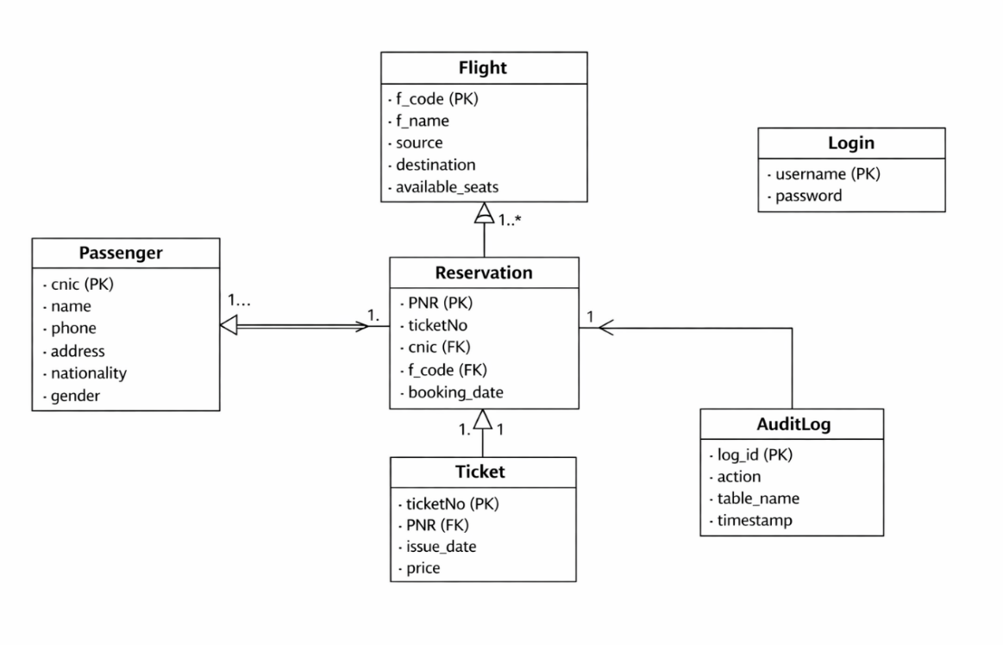
The conceptual design of the ARS database is centered around real-world airline entities. Each entity represents a real object such as Passenger, Flight, or Reservation. Relationships were carefully defined to reflect business rules. For example, a passenger can make multiple reservations, but each reservation is linked to exactly one passenger and one flight.
Associative entities like Reservation help resolve many-to-many relationships while maintaining normalization. Weak entities such as Ticket depend entirely on Reservation for identification.

8. Logical Design
- Database normalized to 3NF
- Primary, foreign, and composite keys defined
- Relationships established to prevent anomalies

9. Physical Database Implementation

9.1 Database Connectivity (Java JDBC)
Class.forName("com.mysql.cj.jdbc.Driver");
Connection c = DriverManager.getConnection("jdbc:mysql:///airline","root","random258");
Statement s = c.createStatement();

9.2 Sample SQL Data
INSERT INTO Passenger VALUES ('3740522161179','Ashir Hamid','03325232424','h 818','Pakistani','Male');
INSERT INTO Flight VALUES ('1003','AI-1112','Karachi','Skardu','150');
INSERT INTO Login VALUES ('admin','admin');

10. Triggers
Trigger: Reduce Seats After Booking
Automatically reduces available seats when a reservation is made.
CREATE TRIGGER ReduceSeats AFTER INSERT ON Reservation
FOR EACH ROW
UPDATE Flight SET available_seats = available_seats - 1
WHERE f_code = NEW.f_code;

Trigger: Prevent Overbooking
Prevents reservations if the flight is full.
CREATE TRIGGER PreventOverbooking BEFORE INSERT ON Reservation
FOR EACH ROW
BEGIN
DECLARE seats INT;
SELECT available_seats INTO seats FROM Flight WHERE f_code = NEW.f_code;
IF seats <= 0 THEN
SIGNAL SQLSTATE '45000' SET MESSAGE_TEXT = 'Flight is full';
END IF;
END;
Trigger: Log Reservation Insert
Keeps an audit trail of reservation inserts.
CREATE TRIGGER LogReservationInsert AFTER INSERT ON Reservation
FOR EACH ROW
INSERT INTO AuditLog(action, table_name) VALUES('INSERT','Reservation');

11. Stored Procedures
Procedure: SearchFlights
Search flights by source and destination.
CREATE PROCEDURE SearchFlights(IN src VARCHAR(50), IN dest VARCHAR(50))
BEGIN
SELECT * FROM Flight WHERE source = src AND destination = dest;
END;
Procedure: BookFlight
Books a flight and generates PNR and ticket number.
CREATE PROCEDURE BookFlight(IN cnic VARCHAR(20), IN f_code VARCHAR(20))
BEGIN
DECLARE pnr VARCHAR(15);
SET pnr = CONCAT('PNR-', FLOOR(RAND()*1000000));
INSERT INTO Reservation(PNR, ticketNo, cnic, f_code, booking_date)
VALUES(pnr, CONCAT('TIC-', FLOOR(RAND()*10000)), cnic, f_code, CURDATE());
END;
Procedure: MonthlyRevenue
Calculates total revenue for a given month.
CREATE PROCEDURE MonthlyRevenue(IN month_no INT)
BEGIN
SELECT SUM(price) AS revenue FROM Ticket
WHERE MONTH(issue_date) = month_no;
END;

12. Transactions
Booking a flight is handled as a transaction:
- Insert reservation
- Update flight availability
- Generate ticket
COMMIT and ROLLBACK ensure consistency on failure.

13. Complex SQL Queries
Query: Fetch Passenger Reservations
Retrieve all reservations with passenger names.
SELECT r.PNR, p.name, r.f_code, r.booking_date
FROM Reservation r INNER JOIN Passenger p ON r.cnic = p.cnic;
Query: Most Booked Flights
Count number of passengers per flight.
SELECT f.f_name, COUNT(r.PNR) AS booked_seats
FROM Flight f LEFT JOIN Reservation r ON f.f_code = r.f_code
GROUP BY f.f_code;

Query: Flights with More Than 10 Bookings
SELECT f_code, COUNT(*) AS total_bookings
FROM Reservation
GROUP BY f_code
HAVING total_bookings > 10;

Query: Passengers on a Specific Flight
SELECT name FROM Passenger
WHERE cnic IN (SELECT cnic FROM Reservation WHERE f_code = '1003');
Query: Revenue and Passenger Count per Flight
SELECT f_code, COUNT(*) AS total_passengers, SUM(price) AS revenue
FROM Reservation r JOIN Ticket t ON r.ticketNo = t.ticketNo
GROUP BY f_code;

14. Reporting & Analytics
- Most Booked Flights: Flights with the highest reservations
- Passenger Count per Flight: For operational planning
- Monthly Revenue: Helps financial analysis

15. Java GUI Integration
- GUI for adding passengers, fetching flights, booking tickets, and viewing journeys
- Real-time seat updates via triggers
- JDateChooser for selecting travel dates
- DbUtils library to convert ResultSet to JTable for visual display

16. Challenges and Lessons Learned
- Normalizing an unstructured database
- Writing triggers and procedures to ensure integrity
- Handling transactional consistency
- Integrating Java Swing with MySQL
Future Improvements:
- Password encryption
- Real-time seat availability visualization
- Enhanced reporting dashboards

17. Assets Used
- Java Libraries: Swing, JDBC, JDateChooser, DbUtils
- GUI Assets: PIA logo, background images, icons
- Database Assets: SQL scripts, triggers, procedures, sample data
- IDE: Apache NetBeans

